XXX医院

WebODF is an exciting new technology that you can find in on mobile phones and tablets, embedded in wiki’s, intranet solutions and webmail and even in browsers.

What is so exciting about it?
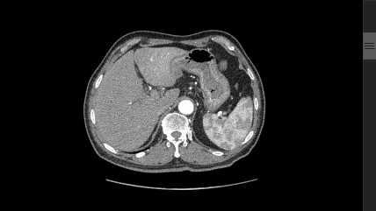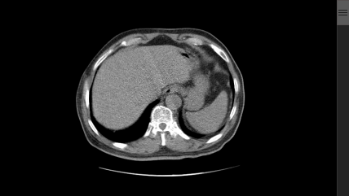
It can do one simple yet amazingly useful thing - show office documents without any other software dependency on your system and without the need for any server to translate the documents for you.

It can embed fonts too!
That means that WebODF is able to give you access to your documents everywhere, without forcing you to give others access too. WebODF can work with text documents, spreadsheets and even complete presentations. And you can use all the things you need to make great looking content: styles, fancy graphics that look sharp and crisp, as well as embedded fonts that make your creation look consistently on every device.
WebODF is entirely written in JavaScript, the language that powers the modern web. But its real power comes from the browser – making it the most portable office code in existence. And it is free software - you can copy it and add it to your website or software easily as well, completely for free. That is right: you don’t need to buy any software.

A few of the many advantages of WebODF:
- based on the internationally recognized ODF standard
- integrates perfectly into existing websites and apps
- highly modular, adding additional functionality that fits your needs is easy

How to get WebODF
- Go to WebODF.org and see if there is already a version meeting your needs
- Search for it directly in your app store
- Or download the sourcecode of WebODF and create your own application with it.

