线段和圆交点
- 线段和圆交点公式是通过直线方程联合到圆心距离方程求解得出。
- 目前没有考虑圆同时和2条线段交点。
公式：
（线段点集合：[ (x₁ , y₁) .....(x_{n-1} , y_{n-1}), (x_{n} , y_{n}) ]）
线段方程（例如：线段(x_{n-1} , y_{n-1}), (x_{n} , y_{n})）：
Y=KX+B ( K=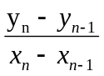 ，B = 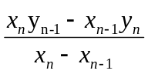 ，X∈（x₁, x_{n}）, Y∈(y₁,y_{n})) ①
(x-x_{o})² +(y-y_{o})²=R² [ (x_{o},y_{o}) 为圆心坐标 ，R 为半径即直线和圆交点距离] ②

联合方程求解：
X=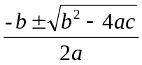 ,其中 (b²-4ac)是否大于等于0决定有解否（向量不考虑）。
a = 1+k² , b =2k(B-y_{o})-2x_{o} , c=x_{o}²+(B-y_{o})²-R²

X | Y
768993.066 | 8986418.913
769157.124 | 8986593.659
769259.255 | 8986723.796
769259.453 | 8986794.327
769255.567 | 8987087.868
769260.525 | 8987219.499
769246.107 | 8987311.280
769284.832 | 8987668.625
769281.995 | 8987727.123
769295.275 | 8987808.473
769260.701 | 8987928.291
769255.027 | 8988010.235
769227.490 | 8988081.546

X | Y
768993.066 | 8986418.913
769157.124 | 8986593.659
举例计算：
（769157.124-768993.066）² + （8986593.659-8986418.913）²
= 164.058² +174.746²
= 26915.027364 + 30536.164516 = 57451.19188

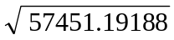 = 239.68978259408555773783955063908
两点距离 ： 239.68978259408555773783955063908

假设圆心 即第一个点，距离为 R=200
K =
= 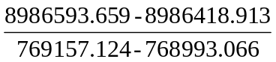
= 174.746/164.058
= 1.0651476916700191395725901815212
B =
=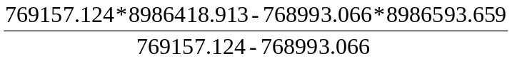
=(6911968126182.286212-6910628210730.568494)/164.058
=1339915451.717718/164.058
=8167327.7238398493215813919467505

{a = 1+k² , b =2k(B-y_{o})-2x_{o} , c=x_{o}²+(B-y_{o})²-R²}
K² ⁼ 1.0651476916700191395725901815212 ² = 1.1345396050699701603320279648667
a = 1+k²
= 2.1345396050699701603320279648667

b = 2.1302953833400382791451803630424*(8167327.7238398493215813919467505-8986418.913)
=2.1302953833400382791451803630424* (-819091.1891601506784186080532495)-2*(768993.066)
=-1744906.1788023709962444755254013-1537986.132
=-3282892.3108023709962444755254013
b² = 10777381924325.331247319854380261
C =768993.066²+(-819091.1891601506784186080532495)²-(200)²
=591350335556.080356+670910376159.78974023575685992016-40000
=1262260671715.8700962357568599202
4ac = 4*2.1345396050699701603320279648667*1262260671715.8700962357568599202
= 10777381582798.994436124628727136
b²-4ac = 10777381924325.331247319854380261 - 10777381582798.994436124628727136
= 341526.33681119522565312488238621
= 341526.336811195225653125
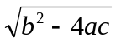 = 584.40254688972328746623690422823

X=
= （3282892.3108023709962444755254013 ± 584.40254688972328746623690422823）/2*2.1345396050699701603320279648667
{
X1=3283476.7133492607195319417623055/4.2690792101399403206640559297334
=769129.95794276406189827981863364
X2=3282307.9082554812729570092884971/4.2690792101399403206640559297334
=768856.17405723593810172018136641 不在线段内
}
X | Y
768993.066 | 8986418.913
769157.124 | 8986593.659
Y= kx + B
= 1.0651476916700191395725901815212*769129.95794276406189827981863364+8167327.7238398493215813919467505
=8986564.7231368433649104390227051

求交点XY（769129.95794276406189827981863364，8986564.7231368433649104390227051）

验证距离
D² = （769129.95794276406189827981863364-768993.066）²+（8986564.7231368433649104390227051-8986418.913）²
= 136.89194276406189827981863364² +145.8101368433649104390227051²
=18739.403993719198711252248736492+21260.596006280801288747812835259
=40000.000000000000000000061571751
D=200.00000000000000000000015392938

