**扩展卡尔曼滤波EKF与多传感器融合**

1 概述 2

2 KF与EKF 2

3 为什么要用EKF 3

4 将非线性系统线性化 3

5 多传感器融合 3

(1) lidar与radar 3

(2) 传感器融合步骤 4

(3) 初始化 4

(4) 预测未来 4

6 修正当下 5

(1) lidar 5

(2) radar 6

7 传感器融合实例 6

8 Matlab代码 7

9 C_plus_plus_code 9

(1) Main_cpp 9

(2) Kalman_filter_cpp 13

(3) Fusion_ekf_cpp 14

(4) Fusion_ekf_h 16

(5) Ground_truth_package_h 16

(6) Kalman_filter_h 17

(7) Measurement_package_h 18

(8) Utilities_h 18

(9) CMakeLists_txt 19

10 参考文献 20

# 概述

Extended Kalman Filter（扩展卡尔曼滤波）是卡尔曼滤波的非线性版本。在状态转移方程确定的情况下，EKF已经成为了非线性系统状态估计的事实标准。本文将简要介绍EKF，并介绍其在无人驾驶多传感器融合上的应用。

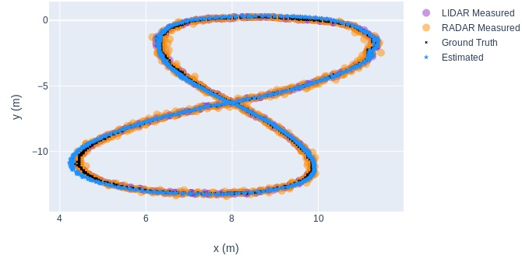

上述基于EKF的Lidar和Rader信号的融合效果不是很理想，左下角阶段，融合后的误差甚至大于融合前Lidar和Radar两个传感器独立测量的误差。可以采用无迹卡尔曼滤波，如文献4所示，获得如下的理想的融合效果。

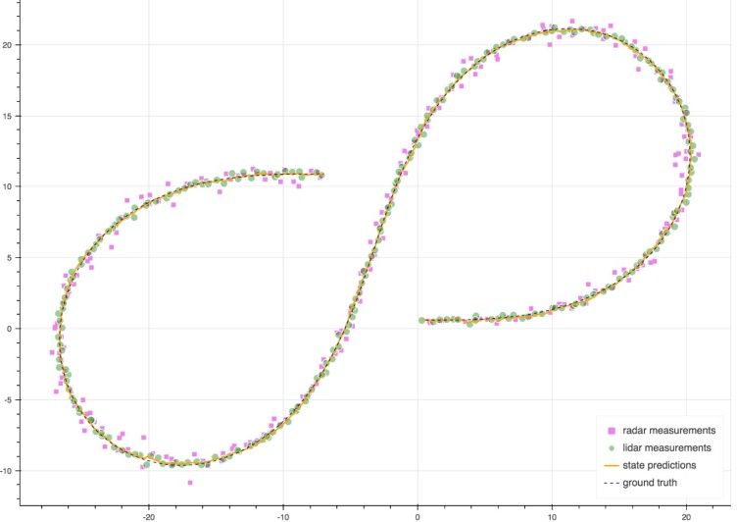

# KF与EKF

本文假定读者已熟悉KF，若不熟悉请参考卡尔曼滤波简介。

KF与EKF的区别如下：

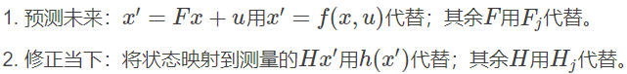





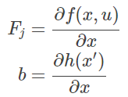

[上述公式参考黄小平著卡尔曼滤波，Eq(4.10),Eq(4.11)]

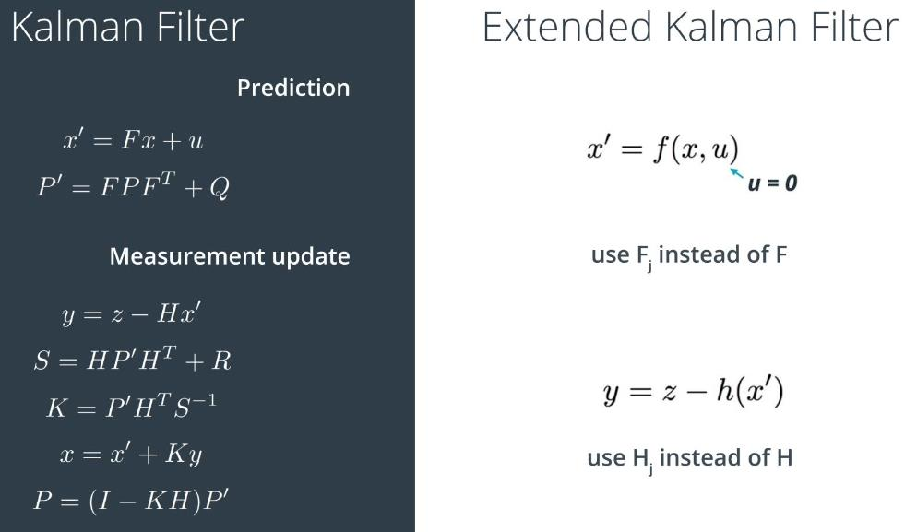

# 为什么要用EKF

KF的假设之一就是高斯分布的x预测后仍服从高斯分布，高斯分布的x变换到测量空间后仍服从高斯分布。可是，假如F、H是非线性变换，那么上述条件则不成立。

# 将非线性系统线性化

既然非线性系统不行，那么很自然的解决思路就是将非线性系统线性化。对于一维系统，采用泰勒一阶展开即可得到：



对于多维系统，仍旧采用泰勒一阶展开即可得到：





# 多传感器融合

## lidar与radar

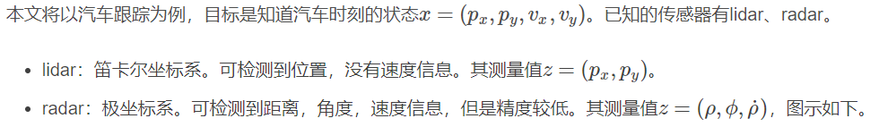

其中*ρ*为离原点的半径的距离。

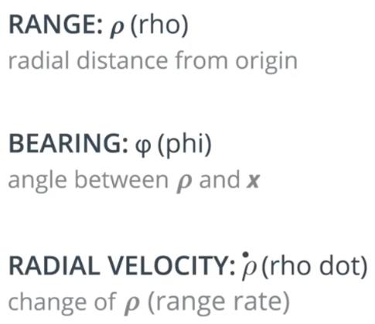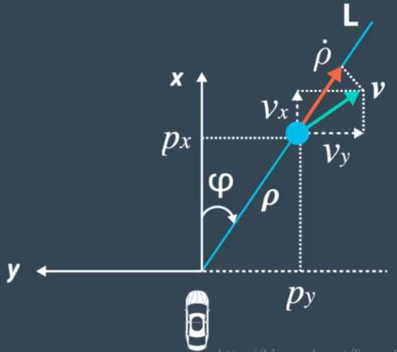

## 传感器融合步骤

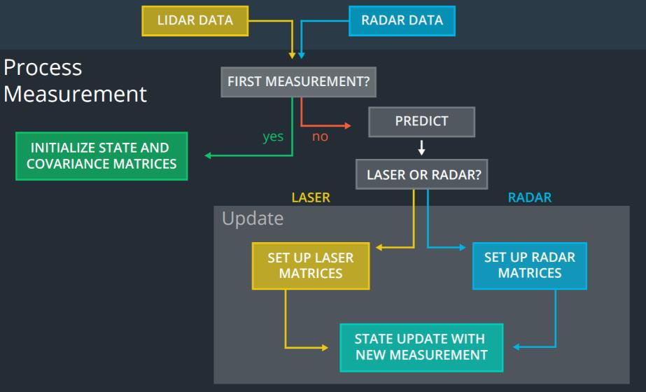

步骤图如上所示，包括：

1. 收到第一个测量值，对状态x进行初始化。
2. 预测未来
3. 修正当下

## 初始化

初始化，指在收到第一个测量值后，对状态x进行初始化。初始化如下，同时加上对时间的更新。Lidar和radar的预测方程都一样，但是他们的更新方程不一样。此处需要统一lidar和radar两者的预测方程中的状态x的表达式。

对于lidar来说，  
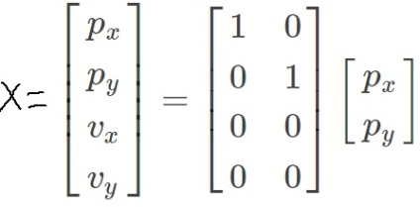

对于radar来说，

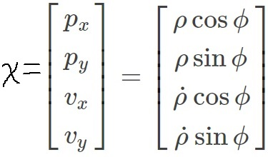

## 预测未来

预测主要涉及的公式是：

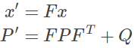

需要求解的有三个变量：F、P、Q。

F表明了系统的状态如何改变，这里仅考虑线性系统，F易得：

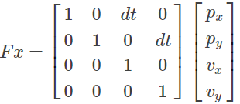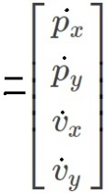

P表明了系统状态的不确定性程度，用x的协方差表示，这里自己指定为：

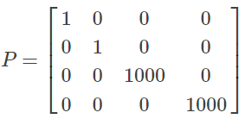

Q表明了x′=Fx未能刻画的其他外界干扰。本例子使用线性模型，因此加速度变成了干扰项。x′=Fx中未衡量的额外项目v(速度)为：

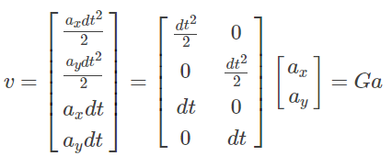

v服从高斯分布N(0,Q)。

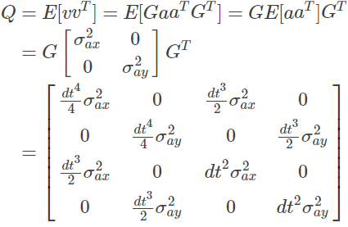

# 修正当下

## lidar

lidar使用了KF。修正当下这里牵涉到的公式主要是：

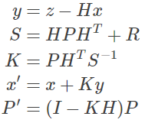

激光雷达的y只包含[px,py]。

需要求解的有两个变量：H、R。

H表示了状态空间到测量空间的映射。

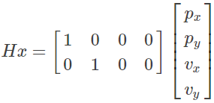

R表示了测量值的不确定度，一般由传感器的厂家提供，这里lidar参考如下：

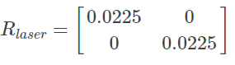

## radar

radar使用了EKF。修正当下这里牵涉到的公式主要是：

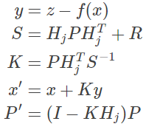

区别与上面lidar的主要有：

1. 状态空间到测量空间的非线性映射f(x)
2. 非线性映射线性化后的Jacob矩阵
3. radar的Rradar
4. y包含

状态空间到测量空间的非线性映射f(x)如下：

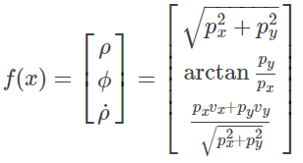

非线性映射线性化后的Jacob矩阵Hj

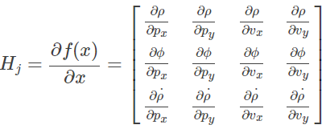 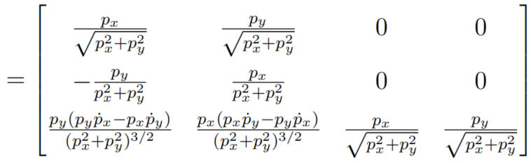

R表示了测量值的不确定度，一般由传感器的厂家提供，这里radar参考如下：

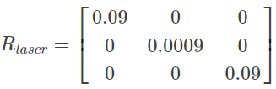=R_r

# 传感器融合实例

多传感器融合的示例如下，需要注意的有：

1. lidar和radar的预测部分是完全相同的
2. lidar和radar的参数更新部分是不同的，不同的原因是不同传感器收到的测量值是不同的
3. 当收到lidar或radar的测量值，依次执行预测、更新步骤
4. 当同时收到lidar和radar的测量值，依次执行预测、更新1、更新2步骤

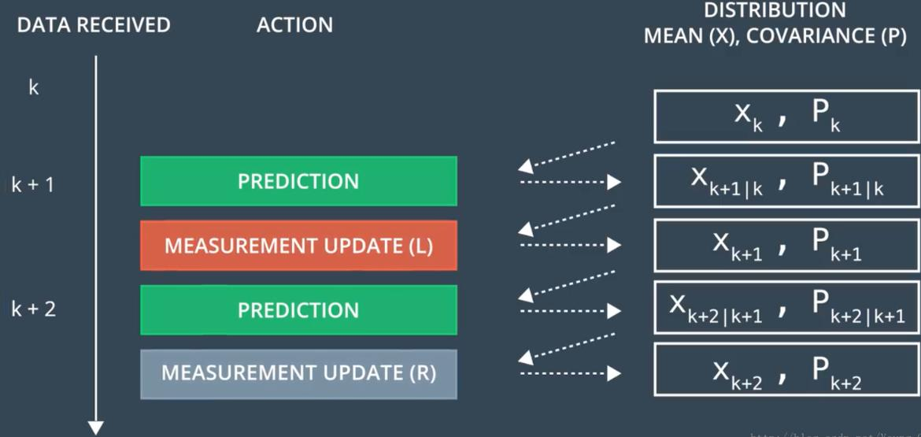

Lidar采集数据和Radar采集数据融合的步骤如下：



多传感器融合的效果如下图所示，红点和蓝点分别表示radar和lidar的测量位置，绿点代表了EKF经过多传感器融合后获取到的测量位置，取得了较低的RMSE。

# Matlab代码

dt = 0.1;

Data = csvread('Radar_Lidar_Data1.csv',1,1); % Data = csvread('Radar_Lidar_Data2.csv',1,1);

Radar_Measurement = [];

Lidar_Measurement = [];

EKF_Path = [];

F = [[1, 0, dt, 0];

[0, 1, 0, dt];

[0, 0, 1, 0];

[0, 0, 0, 1]];

u = 0;

B = [(dt^2)/2 (dt^2)/2 dt dt]';

P = [[1, 0, 0, 0];

[0, 1, 0, 0];

[0, 0, 1000, 0];

[0, 0, 0, 1000]];

R_l = [[0.0025, 0];

[0, 0.0025]];

R_r = [[0.09, 0, 0];

[0, 0.005, 0];

[0, 0, 0.09]];

Q = [(dt^2)/4 0 (dt^3)/2 0;

0 (dt^2)/4 0 (dt^3)/2;

(dt^3/2) 0 (dt^2) 0;

0 (dt^3)/2 0 (dt^2)];

H = [[1, 0, 0, 0];

[0, 1, 0, 0]];

I = eye(4);

if (Data(1,1) == 1)

x = [Data(1,2); Data(1,3); 0; 0];

else

x = [Data(1,2); Data(1,3); Data(1,4); 0];

end

for n = 1:length(Data)

if (Data(n,1) == 2)

% 右边的传感器是毫米波雷达，对应编号2；

%prediction；这里是毫米波雷达的预测部分，和毫米波雷达的预测部分相同

x = F * x + B*u; 状态向量x=[px,py,vx,vy]

P = F * P * transpose(F) + Q;

%measurement update

%毫米波雷达的直接测量数据为[*ρ, ф,* ]，需要转化为状态向量x=[px,py,vx,vy]

Z = Data(n,2:4);

X = Z(1)*cos(Z(2));

Y = Z(1)*sin(Z(2));

VX = Z(3)*cos(Z(2));

VY = Z(3)*sin(Z(2));

c1 = X^2 + Y^2;

c2 = sqrt(c1);

c3 = c1 * c2;

if (c1==0 || c2==0 || c3==0)

H_Jac = [[0, 0, 0, 0];

[0, 0, 0, 0];

[0, 0, 0, 0]];

else

H_Jac = [[X/c2, Y/c2, 0, 0];

[-Y/c1, X/c1, 0, 0];

[(Y*(VX*Y-VY*X))/c3, (X*(X*VY-Y*VX))/c3, X/c2, Y/c2]];

end

Z_Car = [X; Y; VX; VY];

y = transpose(Z) - (H_Jac * Z_Car);

S = H_Jac * P * transpose(H_Jac) + R_r;

K = P * transpose(H_Jac) * inv(S);

x = Z_Car + (K * y);

P = (I - (K * H_Jac)) * P;

EKF_Path = [EKF_Path;[x(1),x(2)]];

Radar_Measurement = [Radar_Measurement; Data(n,2:4)];

else %左边的传感器是激光雷达，对应编号1

%prediction；这里是激光雷达的预测部分，和毫米波雷达的预测部分相同

x = (F * x) + B*u; 状态向量x=[px,py,vx,vy]

P = F * P * transpose(F) + Q;

%measurement update；

% 激光雷达测量值只有px和py，然后通过增益矩阵的运算，生成状态向量x=[px,py,vx,vy]

Z = Data(n,2:3);

y = transpose(Z) - (H * x);

S = H * P * transpose(H) + R_l;

K = P * transpose(H) * inv(S);

x = x + (K * y);

P = (I - (K * H)) * P;

EKF_Path = [EKF_Path;[x(1),x(2)]];

Lidar_Measurement = [Lidar_Measurement; Data(n,2:3)];

end

end

for i = 1:length(Radar_Measurement)

Radar_Measurement_Cart(i,:) = [[Radar_Measurement(i,1),0];[0, Radar_Measurement(i,1)]]*[cos(Radar_Measurement(i,2));sin(Radar_Measurement(i,2))];

end

hold on;

plot(Data(:,6),Data(:,7),'linewidth', 2);

scatter(EKF_Path(:,1),EKF_Path(:,2),25,'filled','r');

scatter(Lidar_Measurement(:,1),Lidar_Measurement(:,2),5,'filled','blue');

scatter(Radar_Measurement_Cart(:,1),Radar_Measurement_Cart(:,2),5,'filled','g');

legend('Grundtruth','EKF Path result','Lidar Measurement','Radar Measurement','Location','northwest');

axis square;

hold off;

# C_plus_plus_code

## Main_cpp

#include <fstream>  
#include <iostream>  
#include <vector>  
#include <Eigen/Dense>  
  
#include "fusion_ekf.h"  
#include "ground_truth_package.h"  
#include "measurement_package.h"  
#include "utilities.h"  
// Calculate root mean square error.  
inline Eigen::VectorXd calculateRMSE(const std::vector<Eigen::VectorXd>& estimations,  
 const std::vector<Eigen::VectorXd>& ground_truth) {  
 Eigen::VectorXd rmse(4);  
 rmse << 0, 0, 0, 0;  
 for (std::size_t i=0; i != estimations.size(); ++i) {  
 Eigen::VectorXd residual = estimations[i] - ground_truth[i];  
 residual = residual.array()*residual.array();  
 rmse += residual;  
 }  
 rmse /= estimations.size();  
 rmse = rmse.array().sqrt();  
 return rmse;  
}  
  
int main(int argc, char* argv[]) {  
 std::string usage_instructions = "Usage instructions: ";  
 usage_instructions += argv[0];  
 usage_instructions += " input output";  
 if (argc != 3) {  
 std::cerr << usage_instructions << std::endl;  
 exit(EXIT_FAILURE);  
 }  
  
 std::ifstream ifs(std::string(argv[1]).c_str(), std::ifstream::in);  
 std::ofstream ofs(std::string(argv[2]).c_str(), std::ofstream::out);  
  
 if (!ifs.is_open()) {  
 std::cerr << "Failed to open input file!" << std::endl;  
 exit(EXIT_FAILURE);  
 }  
  
 if (!ofs.is_open()) {  
 std::cerr << "Failed to open output file!" << std::endl;  
 exit(EXIT_FAILURE);  
 }  
 std::vector<MeasurementPackage> m_hist;  
 std::vector<GroundTruthPackage> gt_hist;  
 std::string line;  
 // prepare the measurement packages (each line represents a measurement  
 // at a timestamp)  
 while (std::getline(ifs, line)) {  
 std::string sensor_type;  
 MeasurementPackage m_pkg;  
 GroundTruthPackage gt_pkg;  
 std::istringstream iss(line);  
 long long timestamp;  
 // reads first element from the current line  
 iss >> sensor_type;  
 if (sensor_type == "L") {  
 // LIDAR measurement  
 m_pkg.sensor_type = MeasurementPackage::LIDAR;  
 double x;  
 double y;  
 iss >> x;  
 iss >> y;  
 m_pkg.values = Eigen::VectorXd(2);  
 m_pkg.values << x, y;  
 } else if (sensor_type == "R") {  
 // RADAR measurement  
 m_pkg.sensor_type = MeasurementPackage::RADAR;  
 double rho;  
 double phi;  
 double v_rho;  
 iss >> rho;  
 iss >> phi;  
 iss >> v_rho;  
  
 // Normalize the angle to (-pi, pi]  
 phi = utilities::normalizeAngle(phi);  
 m_pkg.values = Eigen::VectorXd(3);  
 m_pkg.values << rho, phi, v_rho;  
 } else {  
 std::cerr << "Unknown sensor type: " << m_pkg.sensor_type << std::endl;  
 exit(EXIT_FAILURE);  
 }  
 // read the timestamp for both LIDAR and RADAR  
 iss >> timestamp;  
 m_pkg.timestamp = timestamp;  
 m_hist.push_back(m_pkg);  
 // read ground truth data to compare later  
 double x_gt;  
 double y_gt;  
 double vx_gt;  
 double vy_gt;  
 iss >> x_gt;  
 iss >> y_gt;  
 iss >> vx_gt;  
 iss >> vy_gt;  
 gt_pkg.values = Eigen::VectorXd(4);  
 gt_pkg.values << x_gt, y_gt, vx_gt, vy_gt;  
 gt_hist.push_back(gt_pkg);  
 }  
  
 // process data  
 FusionEKF fusion_ekf;  
 std::vector<Eigen::VectorXd> ret; // estimated values  
 std::vector<Eigen::VectorXd> gt; // ground truth values  
 // column names in the output file  
 ofs <<"sensor_type\tpx\tpy\tvx\tvy\tpx_m\tpy_m\tpx_gt\tpy_gt\tvx_gt\tvy_gt\ttimestamp\n";  
 for (std::size_t k = 0; k < m_hist.size(); ++k) {  
 fusion_ekf.processMeasurement(m_hist[k]);  
 // dump the sensor type  
 if (m_hist[k].sensor_type == MeasurementPackage::LIDAR) {  
 ofs << "L\t";  
 } else if (m_hist[k].sensor_type == MeasurementPackage::RADAR) {  
 ofs << "R\t";  
 }  
 // dump the estimations  
 ofs << fusion_ekf.ekf_.x_(0) << "\t";  
 ofs << fusion_ekf.ekf_.x_(1) << "\t";  
 ofs << fusion_ekf.ekf_.x_(2) << "\t";  
 ofs << fusion_ekf.ekf_.x_(3) << "\t";  
 // dump the measurements  
 if (m_hist[k].sensor_type == MeasurementPackage::LIDAR) {  
 // output the estimation  
 ofs << m_hist[k].values(0) << "\t";  
 ofs << m_hist[k].values(1) << "\t";  
 } else if (m_hist[k].sensor_type == MeasurementPackage::RADAR) {  
 // output the estimation in the cartesian coordinates  
 double rho = m_hist[k].values(0);  
 double phi = m_hist[k].values(1);  
 ofs << rho * std::cos(phi) << "\t"; // p1_meas  
 ofs << rho * std::sin(phi) << "\t"; // ps_meas  
 }  
 // dump the ground truth values  
 ofs << gt_hist[k].values(0) << "\t";  
 ofs << gt_hist[k].values(1) << "\t";  
 ofs << gt_hist[k].values(2) << "\t";  
 ofs << gt_hist[k].values(3) << "\t";  
 // dump the timestamp  
 ofs << m_hist[k].timestamp << "\n";  
 ret.push_back(fusion_ekf.ekf_.x_);  
 gt.push_back(gt_hist[k].values);  
 }  
 Eigen::IOFormat CommaInitFmt(Eigen::StreamPrecision, Eigen::DontAlignCols,  
 ", ", ", ", "", "", " << ", "");  
 std::cout << "RMSE" << calculateRMSE(ret, gt).format(CommaInitFmt) << std::endl;  
 // close files  
 if (ofs.is_open()) ofs.close();  
 if (ifs.is_open()) ifs.close();  
 return 0;  
}

## Kalman_filter_cpp

#include "kalman_filter.h"  
#include "utilities.h"  
void KalmanFilter::predict() {  
 x_ = f_ * x_;  
 Eigen::MatrixXd f_t = f_.transpose();  
 p_ = f_ * p_ * f_t + q_;  
}  
void KalmanFilter::update(const Eigen::VectorXd &z, const Eigen::MatrixXd &r) {  
 predict();  
 // Measurement update  
 Eigen::MatrixXd k;  
 k = updateKalmanGain(p_, h_, r);  
 x_ = x_ + k * (z - h_ * x_);  
 long x_size = x_.size();  
 Eigen::MatrixXd i = Eigen::MatrixXd::Identity(x_size, x_size);  
 p_ = (i - k * h_) * p_;  
}  
  
void KalmanFilter::updateEKF(const Eigen::VectorXd &z, const Eigen::MatrixXd &r) {  
 predict();  
 // Measurement update  
 Eigen::MatrixXd h_j = utilities::calculateJacobian(x_);  
 Eigen::MatrixXd k;  
 k = updateKalmanGain(p_, h_j, r);  
 Eigen::VectorXd x_polar(4);  
 x_polar = utilities::cartesian2Polar(x_);  
 x_ = x_ + k * (z - x_polar);  
 long x_size = x_.size();  
 Eigen::MatrixXd i = Eigen::MatrixXd::Identity(x_size, x_size);  
 p_ = (i - k * h_j) * p_;  
}  
Eigen::MatrixXd KalmanFilter::updateKalmanGain(const Eigen::MatrixXd &p,  
 const Eigen::MatrixXd &h,  
 const Eigen::MatrixXd &r) {  
 Eigen::MatrixXd h_t = h.transpose();  
 Eigen::MatrixXd ph_t = p * h_t;  
 Eigen::MatrixXd s = h * ph_t + r;  
 Eigen::MatrixXd s_i = s.inverse();  
 Eigen::MatrixXd k = ph_t * s_i;  
 return k;  
}

## Fusion_ekf_cpp

#include <iostream>  
#include "fusion_ekf.h"  
#include "utilities.h"  
FusionEKF::FusionEKF() {  
 is_initialized_ = false;  
 time_us_ = 0;  
 use_radar_ = true;  
 use_lidar_ = true;  
 //state covariance matrix  
 ekf_.p_ = Eigen::MatrixXd(4, 4);  
 ekf_.p_ << 1, 0, 0, 0,  
 0, 1, 0, 0,  
 0, 0, 1, 0,  
 0, 0, 0, 1;  
 //the initial transition matrix F_  
 ekf_.f_ = Eigen::MatrixXd(4, 4);  
 ekf_.f_ << 1, 0, 1, 0,  
 0, 1, 0, 1,  
 0, 0, 1, 0,  
 0, 0, 0, 1;  
 //measurement matrix for the basic Kalman fiter  
 ekf_.h_ = Eigen::MatrixXd(2, 4);  
 ekf_.h_ << 1, 0, 0, 0,  
 0, 1, 0, 0;  
 //measurement covariance matrices  
 r_lidar_ = Eigen::MatrixXd(2, 2);  
 r_lidar_ << 0.0225, 0,  
 0, 0.0225;  
 r_radar_ = Eigen::MatrixXd(3, 3);  
 r_radar_ << 0.09, 0, 0,  
 0, 0.0009, 0,  
 0, 0, 0.09;  
 //set the acceleration noise components  
 noise_ax_ = 9.0;  
 noise_ay_ = 9.0;  
}  
  
FusionEKF::~FusionEKF() = default;  
void FusionEKF::processMeasurement(const MeasurementPackage &measurement_pack) {  
 // Initialization  
 if (!is_initialized_) {  
 ekf_.x_ = Eigen::VectorXd(4);  
 if (measurement_pack.sensor_type == MeasurementPackage::RADAR) {  
 Eigen::VectorXd x_polar(3);  
 x_polar << measurement_pack.values[0],  
 measurement_pack.values[1],  
 measurement_pack.values[2];  
 // Convert positions and velocities from polar to cartesian coordinates.  
 ekf_.x_ = utilities::polar2Cartesian(x_polar);  
 } else if (measurement_pack.sensor_type == MeasurementPackage::LIDAR) {  
 ekf_.x_ << measurement_pack.values[0],measurement_pack.values[1],0, 0;  
 } else {  
 std::cerr << "Unknown sensor_type: " << measurement_pack.sensor_type << std::endl;  
 exit(EXIT_FAILURE);  
 }  
 time_us_ = measurement_pack.timestamp;  
 is_initialized_ = true;  
 return;  
 }  
  
 // Compute the time elapsed between the current and previous measurements  
 double dt = (measurement_pack.timestamp - time_us_) / 1000000.0; // In second  
 // Update the state transition matrix f according to the new elapsed time.  
 ekf_.f_(0, 2) = dt;  
 ekf_.f_(1, 3) = dt;  
 // Update the process noise covariance matrix.  
 double dt_2 = dt * dt;  
 double dt_3 = dt_2 * dt;  
 double dt_4 = dt_3 * dt;  
 ekf_.q_ = Eigen::MatrixXd(4, 4);  
 ekf_.q_ << 0.25 * dt_4 * noise_ax_, 0, 0.5 * dt_3 * noise_ax_, 0,

0, 0.25 * dt_4 * noise_ay_, 0, 0.5 * dt_3 * noise_ay_,

0.5 * dt_3 * noise_ax_, 0, dt_2 * noise_ax_, 0,

0, 0.5 * dt_3 * noise_ay_, 0, dt_2 * noise_ay_;

// Prediction and Measurement updating  
 if (measurement_pack.sensor_type == MeasurementPackage::RADAR && use_radar_) {  
 ekf_.updateEKF(measurement_pack.values, r_radar_);  
 } else if (measurement_pack.sensor_type == MeasurementPackage::LIDAR && use_lidar_) { ekf_.update(measurement_pack.values, r_lidar_);  
 } else return;  
 // Update time stamp  
 time_us_ = measurement_pack.timestamp;  
}

## Fusion_ekf_h

#ifndef FusionEKF_H_  
#define FusionEKF_H_  
#include <Eigen/Dense>  
#include "measurement_package.h"  
#include "kalman_filter.h"  
class FusionEKF {  
 // Check whether the tracking toolbox was initiallized or not  
 // (first measurement)  
 bool is_initialized_;  
 // time when the state is true, in us  
 long long time_us_;  
 // Acceleration noise components  
 double noise_ax_;  
 double noise_ay_;  
 // if this is false, lidar measurements will be ignored (except for init)  
 bool use_lidar_;  
 // if this is false, radar measurements will be ignored (except for init)  
 bool use_radar_;  
public:  
 FusionEKF();  
 ~FusionEKF();  
 KalmanFilter ekf_;  
 // Run the whole flow of the Kalman Filter from here.//  
 void processMeasurement(const MeasurementPackage &measurement_pack);  
 // Measurement covariance matrices for LIDAR and RADAR.  
 Eigen::MatrixXd r_lidar_;  
 Eigen::MatrixXd r_radar_;  
};  
#endif /* FusionEKF_H_ */

## Ground_truth_package_h

#ifndef GROUND_TRUTH_PACKAGE_H_  
#define GROUND_TRUTH_PACKAGE_H_  
#include <Eigen/Dense>  
class GroundTruthPackage {  
public:  
 long long timestamp;  
 enum SensorType{  
 LIDAR,  
 RADAR  
 } sensor_type;  
 Eigen::VectorXd values;  
};  
#endif /* GROUND_TRUTH_PACKAGE_H_ */

## Kalman_filter_h

#ifndef KALMAN_FILTER_H_  
#define KALMAN_FILTER_H_  
#include <Eigen/Dense>  
class KalmanFilter {  
public:  
 // TODO: this is a pool desired and only used for education  
 // state vector  
 Eigen::VectorXd x_;  
 // state covariance matrix  
 Eigen::MatrixXd p_;  
 // state transition matrix  
 Eigen::MatrixXd f_;  
 // process covariance matrix  
 Eigen::MatrixXd q_;  
 // Linear measurement matrix  
 Eigen::MatrixXd h_;  
  
private:  
 // Predict the state and the state covariance using the process model  
 void predict();  
 // Update the Kalman gain k. Used in both KF() and EKF()  
 // @param: p: priori error covariance matrix  
 // @param: h: measurement matrix (or the Jacobian)  
 // @param: r: measurement covariance matrix  
 Eigen::MatrixXd updateKalmanGain(  
 const Eigen::MatrixXd &p, const Eigen::MatrixXd &h,  
 const Eigen::MatrixXd &r);  
public:  
 KalmanFilter() = default;  
 ~KalmanFilter() = default;  
 // A full cycle (prediction + measurement update) using  
 // standard Kalman Filter equations  
 // @param z: measurement  
 // @param r: measurement covariance matrix  
 void update(const Eigen::VectorXd &z, const Eigen::MatrixXd &r);  
  
 // A full cycle (prediction + measurement update) using  
 // extended Kalman Filter equations  
 // @param z: measurement  
 // @param r: measurement covariance matrix  
 //  
 void updateEKF(const Eigen::VectorXd &z, const Eigen::MatrixXd &r);  
};  
#endif /* KALMAN_FILTER_H_ */

## Measurement_package_h

#ifndef MEASUREMENT_PACKAGE_H_  
#define MEASUREMENT_PACKAGE_H_  
#include <Eigen/Dense>  
class MeasurementPackage {  
public:  
 long long timestamp;  
 enum SensorType{  
 LIDAR,  
 RADAR  
 } sensor_type;  
 Eigen::VectorXd values;  
};  
#endif /* MEASUREMENT_PACKAGE_H_ */

## Utilities_h

#ifndef UTILITIES_H_  
#define UTILITIES_H_  
#include <vector>  
#include <Eigen/Dense>  
namespace utilities {  
const double kPI = std::atan(1.0)*4;  
  
// Convert Cartesian coordinates to polar coordinates.  
inline Eigen::VectorXd cartesian2Polar(const Eigen::VectorXd &x) {  
 Eigen::VectorXd x_polar(3);  
 double px = x[0];  
 double py = x[1];  
 double rho = std::sqrt(px*px + py*py);  
 double phi = std::atan2(py, px);  
 if (rho < 1e-6 ) rho = 1e-6;  
 double v_rho = (px*x[2] + py*x[3])/rho;  
 x_polar << rho, phi, v_rho;  
 return x_polar;  
}  
  
// Convert polar coordinates to Cartesian coordinates.  
// Only used in the initialization of FusionEKF().  
inline Eigen::VectorXd polar2Cartesian(const Eigen::VectorXd &x) {  
 Eigen::VectorXd x_cartesian(4);  
 double c = std::cos(x[1]);  
 double s = std::sin(x[1]);  
 double px = x[0] * c;  
 double py = x[0] * s;  
 double vx = x[2] * c;  
 double vy = x[2] * s;  
 x_cartesian << px, py, vx, vy;  
 return x_cartesian;  
}  
  
// Calculate Jacobian.  
inline Eigen::MatrixXd calculateJacobian(const Eigen::VectorXd &x) {  
 double px = x[0];  
 double py = x[1];  
 double vx = x[2];  
 double vy = x[3];  
 double c1 = px*px + py*py;  
 if (c1 < 1e-12 ) c1 = 1e-12;  
 double c2 = std::sqrt(c1);  
 double c3 = c1*c2;  
 Eigen::MatrixXd h_j(3, 4);  
  
 h_j << px/c2, py/c2, 0, 0,  
 -py/c1, px/c1, 0, 0,  
 py*(py*vx - px*vy)/c3, px*(px*vy - py*vx)/c3, px/c2, py/c2;  
 return h_j;  
}  
// Normalize the angle to [-pi, pi]  
inline double normalizeAngle(double phi) {  
 if (phi < -1.0*kPI || phi > kPI) {  
 double s = std::sin(phi);  
 phi = std::asin(s);  
 }  
 return phi;  
}  
} // utilities  
#endif /* UTILITIES_H_ */

## CMakeLists_txt

cmake_minimum_required (VERSION 3.1)

project(ExtendedKF LANGUAGES CXX)

set(CMAKE_CXX_STANDARD 11)

set(CMAKE_CXX_STANDARD_REQUIRED ON)

set(CMAKE_CXX_EXTENSIONS OFF)

find_package(Eigen3 3.3 REQUIRED CONFIG)

if(Eigen3_FOUND)

message(STATUS "Found Eigen3: ${Eigen3_VERSION}, ${Eigen3_INCLUDE_DIRS}")

endif()

set(sources

src/fusion_ekf.cpp

src/kalman_filter.cpp

src/main.cpp)

add_executable(ekf ${sources})

target_include_directories(ekf PRIVATE ${PROJECT_SOURCE_DIR}/include)

target_link_libraries(ekf PRIVATE Eigen3::Eigen)

# 参考文献

[1] <https://blog.csdn.net/Young_Gy/article/details/78468153>

[2] <https://github.com/zyqdragon/Lidar-and-Radar-sensor-fusion-with-Extended-Kalman-Filter> 数据和matlab代码

[3]<https://github.com/zhujun98/sensor-fusion> 数据及c++代码

[4]<https://github.com/mithi/fusion-ukf> 无迹卡尔曼滤波