1. S模糊模型与状态反馈控制及Matlab仿真

一、 仿射非线性系统建模 1

二、 计算T-S模糊模型子系统 2

三、 建立推理，验证开环特性 2

四、 极点配置，验证闭环特性 3

五、 使用LMI验证稳定性 3

1. 理论分析 3

2. Matlab代码 3

3. trolly_sim_m 4

4. trolly_affine_m 5

5. trolly_fuzzy_m 5

6. trolly_affine_ctrl_m 6

7. trolly_fuzzy_ctrl_m 6

六、 参考文献 6

# 仿射非线性系统建模

以overhead crane system为例，

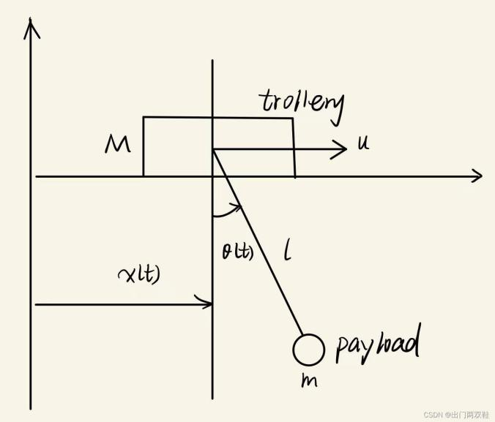

忽略摩擦，我们可以得到如下的状态空间方程，

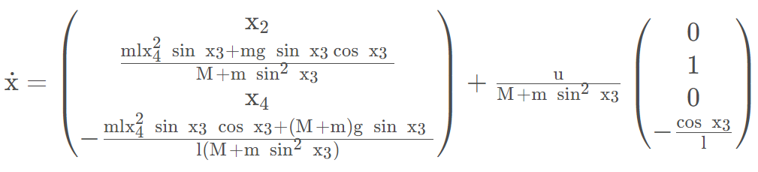

# 计算T-S模糊模型子系统

取工作点。一般地，我们会选取平衡点。

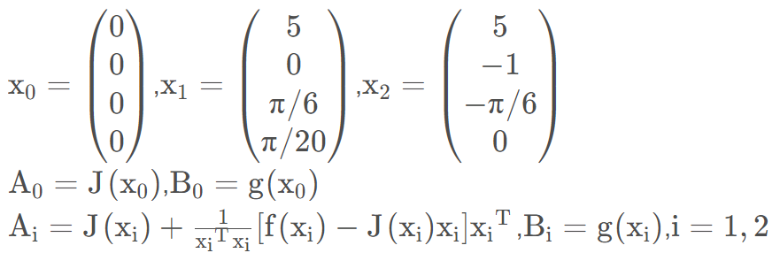

# **建立推理，验证开环特性**

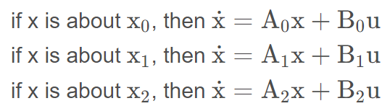

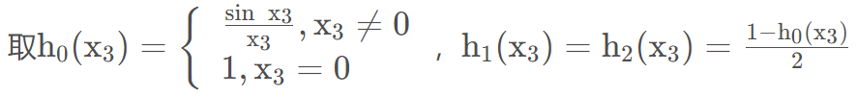

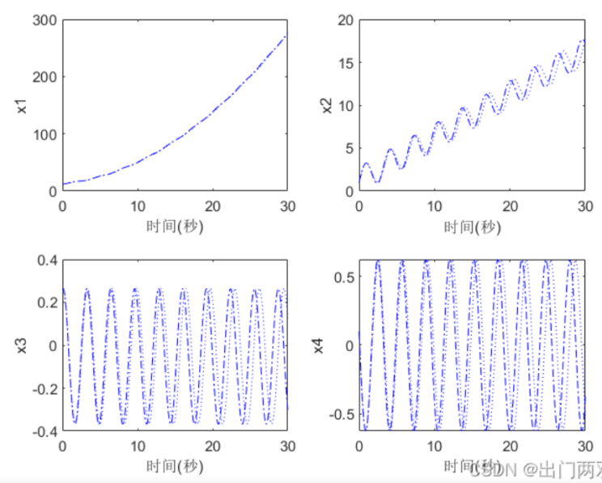

# 极点配置，验证闭环特性

选取极点p0 = (−1.1 −1.5 −1.8 −2.1 ), p1 = (−1.3 −1.6 −1.9 −2.2 ), p2 = (−1.5 −1.6 −1.8 −1.9)

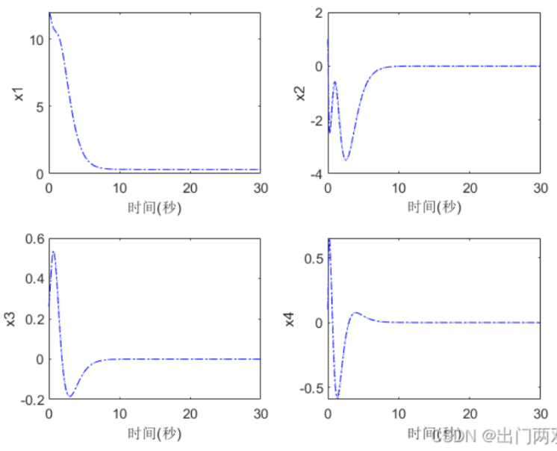

# 使用LMI验证稳定性

## 理论分析

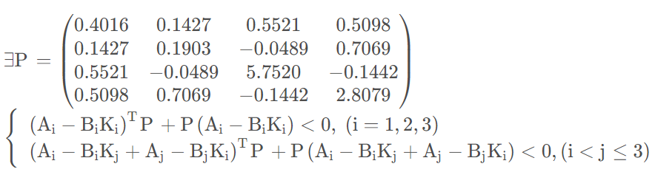

## Matlab代码

clear all;close all;

M=100;m=100;l=5;g=9.82;u=100;

syms x1 x2 x3 x4;

x00=[0 0 0 0]';x01=[5 0 pi/6 pi/20]';x02=[5 -1 -pi/6 0]';

x=[x1;x2;x3;x4];

f=[x2;(m*l*x4^2*sin(x3)+m*g*sin(x3)*cos(x3))/(M+m*sin(x3)*sin(x3));x4;-(m*l*x4^2*sin(x3)*cos(x3)+(M+m)*g*sin(x3))/l/(M+m*sin(x3)*sin(x3))];

gx=1/(M+m*sin(x3)*sin(x3))*[0;1;0;-cos(x3)/l];

J=jacobian(f,x);

Ai=J+(f-J*x)*x'/(x'*x);

A0=double(subs(J,x,x00));B0=double(subs(gx,x,x00));

A1=double(subs(Ai,x,x01));B1=double(subs(gx,x,x01));

A2=double(subs(Ai,x,x02));B2=double(subs(gx,x,x02));

a0=[-1.1 -1.5 -1.8 -2.1];

a1=[-1.3 -1.6 -1.9 -2.2];

a2=[-1.5 -1.6 -1.8 -1.9];

K0=place(A0,B0,a0);K1=place(A1,B1,a1);K2=place(A2,B2,a2);

setlmis([]);

P=lmivar(1,[4,1]);

lmiterm([1 1 1 P],1,A0-B0*K0,'s');

lmiterm([2 1 1 P],1,A1-B1*K1,'s');

lmiterm([3 1 1 P],1,A2-B2*K2,'s');

lmiterm([4 1 1 P],1,A0-B0*K1+A1-B1*K0,'s');

lmiterm([5 1 1 P],1,A1-B1*K2+A2-B2*K1,'s');

lmiterm([6 1 1 P],1,A2-B2*K0+A0-B0*K2,'s');

lmiterm([-7 1 1 P],1,1);

lmisys=getlmis;

[tmin,xfeas]=feasp(lmisys);

tmin

pmat=dec2mat(lmisys,xfeas,P)

tmin =−0.0163

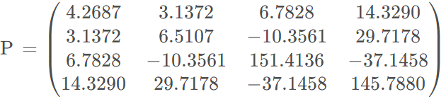

下载链接

https://download.csdn.net/download/qq_29710939/84993530

## trolly_sim_m

clear all;close all;

t0=0;tf=30;step=0.1;

x0(1:4)=[10 1 pi/10 0.1]';

global M m l u g;

global A0 A1 A2 B0 B1 B2 x3 K0 K1 K2;

M=100;m=50;l=4;g=9.81;u=100;

syms x1 x2 x3 x4;

x00=[0 0 0 0]';x01=[5 0 pi/6 pi/20]';x02=[5 -1 -pi/6 0]';

x=[x1;x2;x3;x4];

f=[x2;(m*l*x4^2*sin(x3)+m*g*sin(x3)*cos(x3))/(M+m*sin(x3)*sin(x3));x4;-(m*l*x4^2*sin(x3)*cos(x3)+(M+m)*g*sin(x3))/l/(M+m*sin(x3)*sin(x3))];

gx=1/(M+m*sin(x3)*sin(x3))*[0;1;0;-cos(x3)/l];

J=jacobian(f,x);

Ai=J+(f-J*x)*x'/(x'*x);

A0=double(subs(J,x,x00));B0=double(subs(gx,x,x00));

A1=double(subs(Ai,x,x01));B1=double(subs(gx,x,x01));

A2=double(subs(Ai,x,x02));B2=double(subs(gx,x,x02));

[t,x_fuzzy]=ode45('trolly_fuzzy',[t0:step:tf], x0);

[t,x_affine]=ode45('trolly_affine',[t0:step:tf], x0);

figure(1);

subplot(2,2,1);plot(t, x_fuzzy(:,1),'b-.',t,x_affine(:,1),'b:');xlabel('时间(秒)');ylabel('x1');

subplot(2,2,2);plot(t, x_fuzzy(:,2),'b-.',t,x_affine(:,2),'b:');xlabel('时间(秒)');ylabel('x2');

subplot(2,2,3);plot(t, x_fuzzy(:,3),'b-.',t,x_affine(:,3),'b:');xlabel('时间(秒)');ylabel('x3');

subplot(2,2,4);plot(t, x_fuzzy(:,4),'b-.',t,x_affine(:,4),'b:');xlabel('时间(秒)');ylabel('x4');

a0=[-1.1 -1.5 -1.8 -2.1];

a1=[-1.3 -1.6 -1.9 -2.2];

a2=[-1.5 -1.6 -1.8 -1.9];

K0=place(A0,B0,a0);K1=place(A1,B1,a1);K2=place(A2,B2,a2);

[t,x_fuzzy_ctrl]=ode45('trolly_fuzzy_ctrl',[t0:step:tf], x0);

[t,x_affine_ctrl]=ode45('trolly_affine_ctrl',[t0:step:tf], x0);

figure(2);

subplot(2,2,1);plot(t, x_fuzzy_ctrl(:,1),'b-.',t,x_affine_ctrl(:,1),'b:');xlabel('时间(秒)');ylabel('x1');

subplot(2,2,2);plot(t, x_fuzzy_ctrl(:,2),'b-.',t,x_affine_ctrl(:,2),'b:');xlabel('时间(秒)');ylabel('x2');

subplot(2,2,3);plot(t, x_fuzzy_ctrl(:,3),'b-.',t,x_affine_ctrl(:,3),'b:');xlabel('时间(秒)');ylabel('x3');

subplot(2,2,4);plot(t, x_fuzzy_ctrl(:,4),'b-.',t,x_affine_ctrl(:,4),'b:');xlabel('时间(秒)');ylabel('x4');

## trolly_affine_m

function xdot = trolly_affine(t, x);

global M m l u g;

f=[x(2);(m*l*x(4)^2*sin(x(3))+m*g*sin(x(3))*cos(x(3)))/(M+m*sin(x(3))*sin(x(3)));x(4);-(m*l*x(4)^2*sin(x(3))*cos(x(3))+(M+m)*g*sin(x(3)))/l/(M+m*sin(x(3))*sin(x(3)))];

gx=1/(M+m*sin(x(3))*sin(x(3)))*[0;1;0;-cos(x(3))/l];

xdot=f+gx*u;

## trolly_fuzzy_m

function xdot = trolly_fuzzy(t, x);

global A0 A1 A2 B0 B1 B2 u M m;

if(x(3)==0)

h0=1;

else

h0=sin(x(3))/x(3);

end

h1=(1-h0)/2;h2=h1;

xdot=h0*(A0*x+B0*u)+h1*(A1*x+B1*u)+h2*(A2*x+B2*u);

## trolly_affine_ctrl_m

function xdot = trolly_affine_ctrl(t, x);

global M m l u g K0 K1 K2;

f=[x(2);(m*l*x(4)^2*sin(x(3))+m*g*sin(x(3))*cos(x(3)))/(M+m*sin(x(3))*sin(x(3)));x(4);-(m*l*x(4)^2*sin(x(3))*cos(x(3))+(M+m)*g*sin(x(3)))/l/(M+m*sin(x(3))*sin(x(3)))];

gx=1/(M+m*sin(x(3))*sin(x(3)))*[0;1;0;-cos(x(3))/l];

h0=M*(sin(x(3)))^2/(M+m*sin(x(3))*sin(x(3)));

h1=M*(cos(x(3)))^2/(M+m*sin(x(3))*sin(x(3)));

h2=m*(sin(x(3)))^2/(M+m*sin(x(3))*sin(x(3)));

xdot=f+gx*(u-h0*K0*x-h1*K1*x-h2*K2*x);

## trolly_fuzzy_ctrl_m

function xdot = trolly_fuzzy_ctrl(t, x);

global A0 A1 A2 B0 B1 B2 u M m K0 K1 K2;

if(x(3)==0)

h0=1;

else

h0=sin(x(3))/x(3);

end

h1=(1-h0)/2;h2=h1;

u0=u-h0*K0*x-h1*K1*x-h2*K2*x;

xdot=h0*(A0*x+B0*u0)+h1*(A1*x+B1*u0)+h2*(A2*x+B2*u0);

# 参考文献

<https://blog.csdn.net/qq_29710939/article/details/121828964>