We estimate the final emotion expressed by users in their first four issues they posted in 13 popular (active) projects and tracked their subsequent participation in other issues within those projects after posting these issues. The result is shown in Fig.1. This figure shows that users who leave his/her issue with a sense of frustration re-participant in the project at a rate of only 58\%, which is significantly lower than that of the other two emotions.

% We thus propose that there is a potential link between users' experienced affective states during issue resolution, and their future retention in issue participation in OSS projects, which we investigate empirically using real-world data retrieved from OSS repositories.

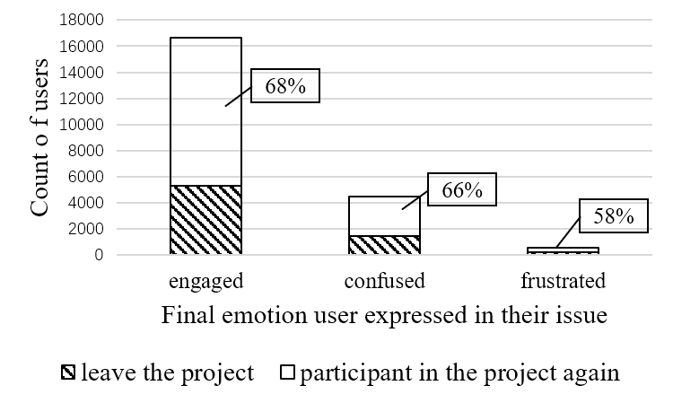

Fig. 1 Users' final emotion and their retention.