**EC 504 Data Structure**

**HW1**

**Name: Yangruirui Zhou BU ID：U16997747**

1. a)

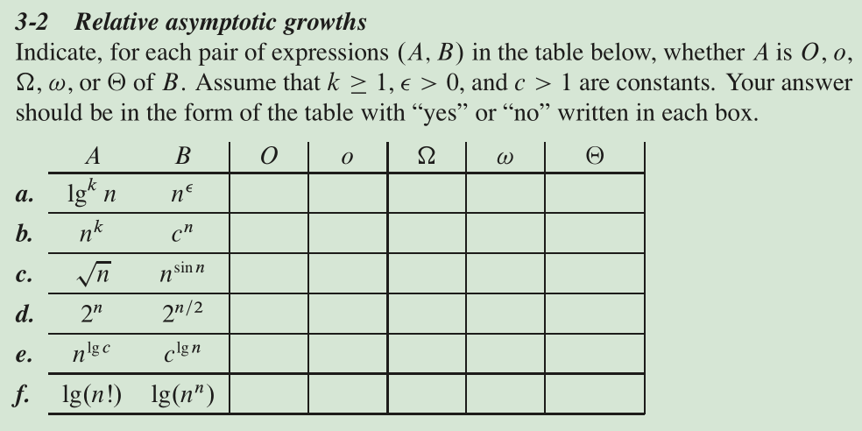

|  |  |  |  |  |  |
| --- | --- | --- | --- | --- | --- |
|  | O | o |  |  |  |
| a | y | y | n | n | n |
| b | y | y | n | n | n |
| c | n | n | n | n | n |
| d | n | n | y | y | n |
| e | y | n | y | n | y |
| f | y | n | y | n | y |

b)

$$\prod_{k=1}^{n}{\left(1-\frac{1}{k^{2}}\right)}<(1-\frac{1}{n})^{n}=1=n^{\frac{1}{n}}<\sum_{k=1}^{n}{\frac{1}{k}}<ln(ln(n))<ln(n)<3^{ln\left(n\right)}<n^{1+\cos{n}}<n^{2}+n^{-2}<n^{2}+3n+5<n^{2}+3nlog(n)+5<\sum_{k=1}^{log\left(n\right)}{\frac{n^{2}}{2^{k}}}<n!<(1+n)^{n}<n^{n^{2}-1}<n^{n^{2}}+n!$$

(c) Because $T\left(n\right)=c_{1}n+c_{2}n\log_{2}{n}$, and $T\left(n\right)=2T\left(n/2\right)+n$. We can get following equations:

$$c_{1}n+c_{2}n\log_{2}{n}=2×\left(c_{1}\frac{n}{2}+c_{2}\frac{n}{2}\log_{2}{\frac{n}{2}}\right)+n=c_{1}n+c_{2}n\log_{2}{\frac{n}{2}}+n$$

$$∵n≠0 ∴c_{2}\log_{2}{n}=c_{2}\log_{2}{\frac{n}{2}}+1$$

$$c_{2}\log_{2}{n}=c_{2}\log_{2}{n}-c_{2}+1$$

$∴c_{2}=1$, $c_{1}=T(1)$

(extra) From $T\left(n\right)=c_{1}n^{γ}+c_{2}n^{k}$, $T\left(n\right)=aT\left(n/b\right)+n^{k}$

$$c_{1}n^{γ}+c_{2}n^{k}=a[c_{1}({\frac{n}{b})}^{γ}+c_{2}({\frac{n}{b})}^{k}]+n^{k}=ac_{1}\frac{n^{γ}}{b^{γ}}+ac_{2}\frac{n^{k}}{b^{k}}+n^{k}$$

$$∵ b^{γ}=a, γ=k ∴c_{1}n^{γ}+c_{2}n^{k}=\frac{ac_{1}}{b^{γ}}n^{γ}+\frac{ac_{2}}{b^{k}}n^{k}+n^{k}=c_{1}n^{γ}+c_{2}b^{γ-k}n^{k}+n^{k}$$

$$∴\left(c_{1}+c_{2}\right)n^{γ}=\left(c_{1}+c_{2}\right)n^{γ}+n^{γ}∴n^{γ}=0$$

Thus, it means only when n=0, the equation can be satisfied.

From $T\left(n\right)=c_{1}n^{γ}+c_{2}n^{γ}\log_{2}{n}$, $T\left(n\right)=aT\left(n/b\right)+n^{γ}$

$$c_{1}n^{γ}+c_{2}n^{γ}\log_{2}{n}=a[c_{1}({\frac{n}{b})}^{γ}+c_{2}({\frac{n}{b})}^{γ}\log_{2}{\frac{n}{b}}]+n^{γ}=ac_{1}\frac{n^{γ}}{b^{γ}}+ac_{2}\frac{n^{γ}}{b^{γ}}(\log_{2}n-\log_{2}b)+n^{γ}$$

$$c_{1}n^{γ}+c_{2}n^{γ}\log_{2}{n}=\frac{ac_{1}}{b^{γ}}n^{γ}+\frac{ac_{2}}{b^{γ}}n^{γ}(\log_{2}n-\log_{2}b)+n^{γ}=c_{1}n^{γ}+c_{2}n^{γ}(\log_{2}n-\log_{2}b)+n^{γ}$$

$$0=c_{2}n^{γ}\left(-\log_{2}b\right)+n^{γ}$$

$∵n≠0 ∴c_{2}=\log_{b}{2}$, $c_{1}=T(1)$

2.

(a) In each recursion, we need to execute the conditional statement to judge if n equals to 0 and complete the multiple operation A(n-1) * A(n-1), so totally 2 executions. And in the last recursion, we will only execute 2 statements: first, is the conditional statement and the second one is “return 1”. Thus, we can have following equations:

$$T\left(0\right)=2$$

$$T\left(n\right)=2T\left(n-1\right)+2= 2 \left(2T\left(n - 2\right)+ 2\right)+ 2= 2^{ k} T\left(n - k\right)+ 2^{ k+1}-2$$

From the structure, we can assume $T\left(n\right)=c_{1}2^{n}+c_{2}$ and substitute it into $T\left(n\right)=2T\left(n-1\right)+2$

$$c_{1}2^{n}+c_{2}=2(c_{1}2^{n-1}+c_{2})+2=c_{1}2^{n}+2c_{2}+2$$

$$c_{2}=-2$$

Thus, we can substitute $c_{2}=-2$ and $T\left(n\right)=c_{1}2^{n}+c_{2}$ into $T\left(0\right)=2$, and we can get $c_{1}=4$

$$T\left(n\right)=2^{n+2}-2=Θ(2^{n})$$

(b) In each recursion (n>1), we need to execute the conditional statement to judge if n equals to 0 and if $B(n/2)≥10$ and execute one return statement, so totally 3 normal execution + twice B(n/2) call. When n=1, we will only need to call B(n/2) once, because B(1/2) = B(0) = 1 < 10. Thus, we totally need 3 normal execution + once B(n/2) call. When n=0, we will only need two execution includes judging if n equals to 0 and return 1, so T(0)=2. Thus, we can have following equations:

$$T\left(n\right)=\left\{\begin{matrix}\begin{aligned}\begin{matrix}2T\left(n/2\right)+3 \\ 2T\left((n-1)/2\right)+3\end{matrix} \\ T\left(0\right)+3=5 \\ 2\end{aligned} & \begin{matrix}\begin{matrix}n>1,n mod 2=0 \\ n>1,n mod 2=1\end{matrix} \\ n=1 \\ n=0\end{matrix}\end{matrix}\right.$$

(i) When n>1 and n is even number:

$$T\left(n\right)=2T\left(n/2\right)+3=2 \left(2T\left(n / 4\right)+ 3\right)+ 3= 2^{ k} T\left(n / 2^{ k}\right)+3×(2^{ k}-1)$$

From the structure, we can assume $T\left(n\right)=c_{1}n+c_{2}$

$$c_{1}n+c_{2}=2×(c_{1}\frac{n}{2}+c_{2})+3=c_{1}n+2c_{2}+3=c_{1}n+2c_{2}+3$$

$$∴c_{2}=-3$$

Thus, we can substitute $c_{2}=-3$ and $T\left(n\right)=2T\left(n/2\right)+3$ into $T\left(2\right)=2T\left(1\right)+3=13$

$$∴c_{1}=8$$

$$T\left(n\right)=8n-3$$

(ii) When n>1 and n is odd number:

$$T\left(n\right)=2T\left((n-1)/2\right)+3=2 \left(2T\left((n-1) / 4\right)+ 3\right)+ 3= 2^{ k} T\left((n-1) / 2^{ k}\right)+3×(2^{ k}-1)$$

From the structure, we can assume $T\left(n\right)=c_{1}\left(n-1\right)+c_{2}$

$$c_{1}n+c_{2}=2×\left(c_{1}\frac{n-1}{2}+c_{2}\right)+3=c_{1}n-c_{1}+2c_{2}+3=c_{1}n-c_{1}+2c_{2}+3$$

$$∴c_{1}-c_{2}=3$$

Thus, we can substitute $c_{1}-c_{2}=3$ and $T\left(n\right)=c_{1}n+c_{2}$ into $T\left(3\right)=2T\left(1\right)+3=13$

$$∴\left\{\begin{aligned}c_{1}=\frac{16}{3} \\ c_{2}=\frac{7}{3}\end{aligned}\right.$$

$$T\left(n\right)=\frac{16}{3}n+\frac{7}{3}$$

So, $$T\left(n\right)=\left\{\begin{matrix}\begin{aligned}\begin{matrix}8n-3 \\ \frac{16}{3}n+\frac{7}{3}\end{matrix} \\ 5 \\ 2\end{aligned} & \begin{matrix}\begin{matrix}n>1,n mod 2=0 \\ n>1,n mod 2=1\end{matrix} \\ n=1 \\ n=0\end{matrix}\end{matrix}\right.=Θ(n)$$

(c) In each recursion (n>1), we need to execute the conditional statement to judge if n equals to 0 and if n equals to 1 and execute one return statement, so totally 3 normal execution + once D(n-1) call +twice D(n-2) call. And it is very easy to know the number of executions when n equals to 0 and 1. So we can get following equations:

$$T\left(n\right)=\left\{\begin{matrix}\begin{aligned}T(n-1)+2T(n-2)+3 \\ 3 \\ 2\end{aligned} & \begin{matrix}n>1 \\ n=1 \\ n=0\end{matrix}\end{matrix}\right.$$

From the structure, we can assume $T\left(n\right)=c_{1}2^{n}+c_{2}$

$$c_{1}2^{n}+c_{2}=(c_{1}2^{n-1}+c_{2})+2(c_{1}2^{n-2}+c_{2})+3=c_{1}2^{n-1}+c_{2}+2c_{1}2^{n-2}+2c_{2}+3=c_{1}2^{n}+3c_{2}+3$$

$$c_{2}=-\frac{3}{2}$$

Thus, we can substitute $c_{2}=-\frac{3}{2}$ and $T\left(n\right)=c_{1}2^{n}+c_{2}$ into $T\left(2\right)=T(1)+2T\left(0\right)+3=10 and T(3)$ we can find $c_{1}$ is not exist. So, the assumption fails, we have to analyze the borders of it.

(i) For the lower border, note that T(n) > $S(n)=S(n-1)+2S(n-2)$ (n>1), which can be calculate by:

Let T(n)= $r^{n}$ in the difference equation $S_{n+2}=S_{n+1}+{2S}_{n}$  to obtain $r^{2}-r-2=0$ , which yields the solutions $r∈\{2,-1\}$ and leads to the general form

$$S_{n}=A2^{n}+B{(-1)}^{n}$$

. Assume the values $S_{2}$ =0 and $S_{3}$ =1 then

$S_{n}=\frac{2^{n-2}{-(-1)}^{n}}{3}=Θ(2^{n})$ and T(n) = ${Ω(2}^{n})$

(ii) For the upper border, note that T(n) < H(n) $=2H(n-1)+2=H(n-1)+2H(n-2)+4$ (n>1), which can be calculate by:

We can assume $H\left(n\right)=c_{1}2^{n}+c_{2}$ and $H_{3}$ =6

$$c_{1}2^{n}+c_{2}=2(c_{1}2^{n-1}+c_{2})+2 ∴c_{2}=-2, c_{1}=1$$

Thus, $H\left(n\right)=O(2^{n})$

From above, we can know

3. Pseudo-code description:

Get inputs from terminal, let nuts[] be the sets of nuts, bolts[] be the sets of bolts, n is their number. Swap() means value transition. PrintArray() means print two arrays on the console.

int find(char arr[], int low, int high, char midvalue, int flag)

// flag is used to remark the order of nut and bolt in TEST()

{

    int i = low;

    for(int j = low; j < high; j++)

{

if (flag > 0) a = arr[j]; b = midvalue;

else a = midvalue; b = arr[j];

// This is used to judge if midvalue is bigger than arr’s element.

// If it is true, I will put it to midvalue’s left.

if (TEST(a, b) * flag == -1)

        {

Swap(arr[i],arr[j]);

            i++;

        }

        else if (TEST(a, b) == 0)

        {

Swap(arr[j],arr[high]);

            j--;

        }

}

Swap(arr[i],arr[high]);

    return i;

}

// Function which works just like quick sort, low is the smallest subtitle of both arrays, high is the biggest subtitle of both arrays.

void Qsort(char nuts[], char bolts[], int low, int high)

{

    if (low < high)

    {

        int middle = find(nuts,low, high, bolts[high], 1)

        find(bolts, low, high, nuts[middle], -1);

        Qsort(nuts, bolts, low, middle - 1);

        Qsort(nuts, bolts, middle + 1, high);

}

PrintArray (nuts, bolts)

}

4. Coding work report

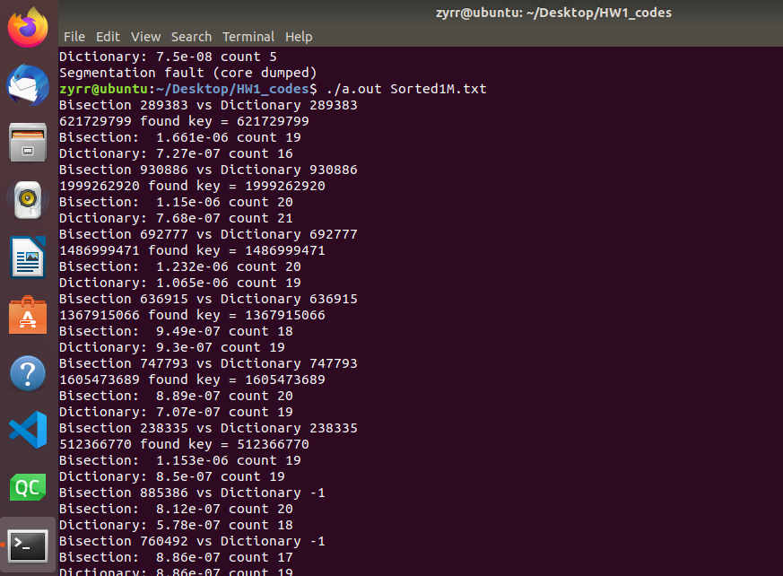

Fig1. Command line input and output

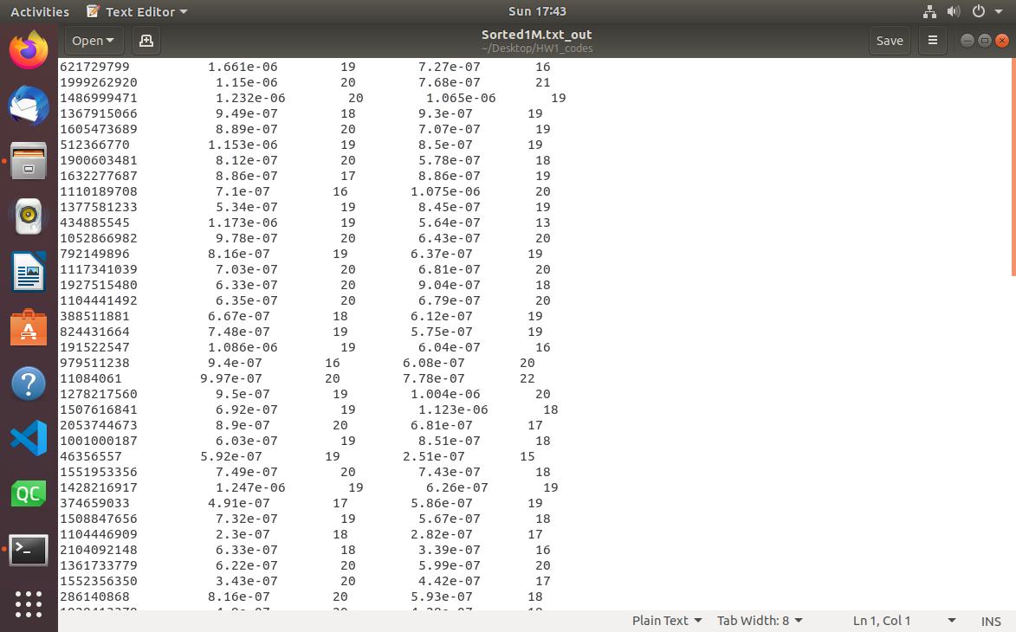

Fig2. Output file (Sorted1M.txt_out)

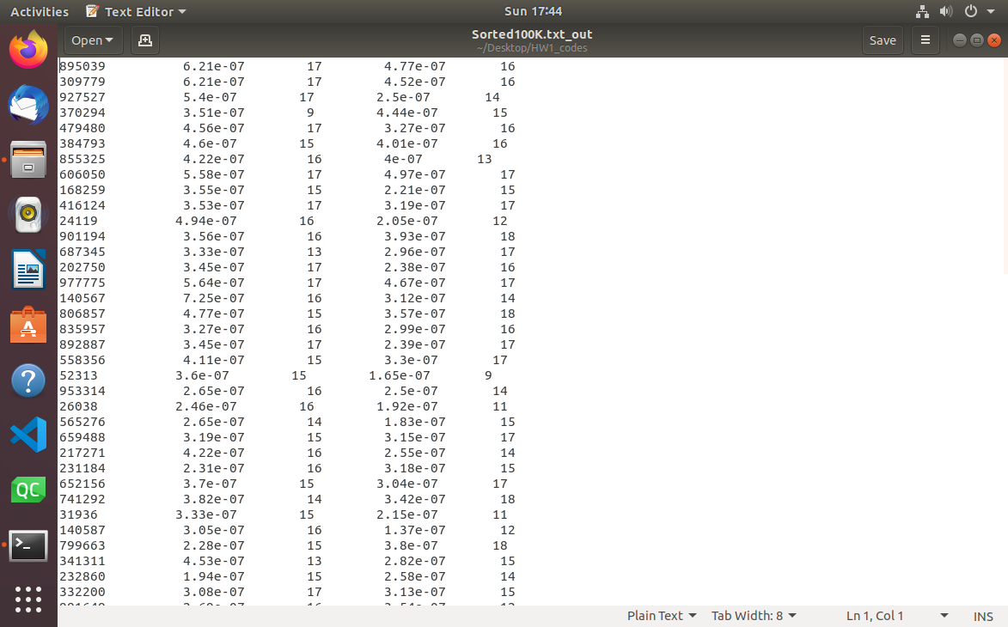

Fig3. Output file (Sorted100K.txt_out)



Fig4. All files I got in the HW1_codes folder