 |  | 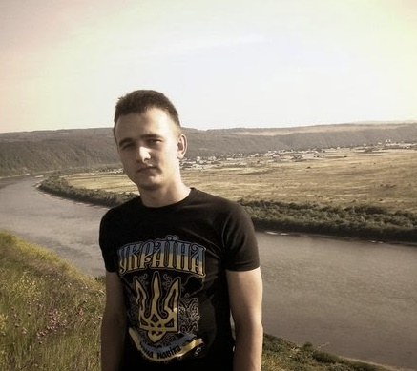
Personal information
First name(s) / Surname(s) |  | Zyryk Olexander
Address |  | 4-B, Nebesnoi Sotni, 412, Chernivtsi (Ukraine)
Telephone(s) |  | +38 0978130532
E-mail(s) |  | zyrsas@gmail.com
Nationality |  | Ukrainian
Date of birth |  | 14 July 1996
Gender |  | Male
Desired employment / Occupational field |  | ios developer
Work experience
Dates |  | March, 2015 – December 2015
Occupation or position held |  | ios developer
Main activities and responsibilities |  | Developer
Name and address of employer |  | Chernivtsi, CEIT
Type of business or sector |  | Business application developer
Mother tongue(s) |  | Ukrainian
Other language(s)
Self-assessment |  |  | Understanding |  |  |  | Speaking |  |  |  | W r i t i n g
European level (*) |  |  | Listening |  | Reading |  | Spoken interaction |  | Spoken production
English |  |  | B1 | Independent user | B2 | Independent user | A2 | Independent user | A2 | Independent user | A2 | Independent user
Ukranian |  |  | C1 | Proficient user | C1 | Proficient user | C1 | Proficient user | C1 | Proficient user | C1 | Proficient user
 |  | (*) Common European Framework of Reference (CEF) level
Social skills and competences |  | - Good communication skills.
Organisational skills and competences |  | - Basic experience in the team work.
Technical skills and competences |  | Experience in computer hardware: PC, Computer Accessories, Networking etc.,
Computer skills and competences |  | Technologies:  - Object C;  - C#;  - C++;  - Java;  - Python/Django;  - MySQL;  - SqLite;  CMS and Frameworks:  -Wordpress CMS:  Operating systems:  - Windows;  - Linux;  - MacOS  Other:  - team work in Git (software versioning and a revision control system);  IDEs:  - Xcode, PyCharm, Visual Studio
Driving licence(s) |  | B,C
Additional information |  | single

