Hierarchical Authentication system
Functional Specifications

By Authors:

Bryson Hepler
Tom Ireland
Venkat Kannan
Samir Karande
Aparna Lagu

October 14, 2002
Release 1.0

Revision History
Date | Rev | Description of Change | Originator
10-10-2002 | Draft A.1 | Initial version of draft | Aparna Lagu
10-13-2002 | Draft A.2 | Deleted an item and added flow diagrams | Tom Ireland
10-13-2002 | Draft A.3 | Added Scope and figure descriptions | Tom Ireland
10-14-2002 | Release 1.0 | Added section for links to related documents

Table Of Contents
Table Of Contents 2
Table of Figures 2
1.0 Introduction 3
2.0 Scope 3
3.0 Requirements 3
3.1 Home Page 3
3.2 Logon 4
3.3 Logout 4
3.4 Workflow 4
3.5 Client Screen density 4
3.6 Host Operating System 4
3.7 Client Operating System 5
3.8 Browser 5
3.9 Cryptography 5
3.10 Contact information Page 5
3.11 Site Map Page 5
3.12 Help Page 5
3.13 Page Controls 5
3.14 Keyboard Operation 5
3.15 Mouse Operation 5
3.16 Server Page Hierarchy 6
4.0 Control Flow 7
5.0 Data Flow 8

Table of Figures
Figure 1: Server Page Hierarchy 6
Figure 2: Control Flow Diagram 7
Figure 3: Data Flow Diagram 8

Related Documents
The following documents are referenced in and are applicable to this Design Specification:
Title | Link
Project Plan | http://groups.yahoo.com/group/608A/files/ProjectPlanV6.rtf
Design specifications | http://groups.yahoo.com/group/608A/files/ design-spec-Release-1.0.doc
Functional specifications | http://groups.yahoo.com/group/608A/files/functspec_Release 1.0.doc

1.0 Introduction
These are the functional specifications for Hierarchical Authentication System. This System involves the browsing to the home page of the application, the user logging on and displaying the appropriate page according to user role.

2.0 Scope
This document describes and details the functional requirements for the Hierarchical Authentication system. There may be implied requires that may be derived from these requirements and not documented herein. Additional requirements may be added in the future during the design phase so as to more fully specify the this system or to more completely define this system.

3.0 Requirements
The following sub-sections delineate the major requirements for eh Hierarchical Authentication system.

3.1 Home Page

There shall be an initial page displayed by all accesses to the Web Site.This shall be the Home Page of the site. The Home page of the site shall contain the following controls:

a. Logon
This control shall spawn the logon method.
b. Help
This control shall display the Help page in a new window.
c. About
This control shall display the About page in a new window.
d. Contact Info
This control shall display the Contact information page in a new window.
e. Any appropriate Hyperlinks
The controls shall activate the hyperlink in a new window.

3.2 Logon
The Host Server shall contain definitions for user names, passwords and access roles, e.g. Administrator role, Manager role, User role and Guest role. These definitions shall be local to the Host Server only and shall be inaccessible from the Client in any form. The logon method shall be displayed at the user location. The logon shall succeed or fail. In case of a failure, a default authentication page shall be displayed. The logon shall
be capable of cancellation. If cancelled the Home page shall be displayed. A logon failure shall redisplay the logon method with all field blank. The password as entered shall display the character '*' in place of each password character entered.

3.3 Logout
After a successful login and the login page is displayed, all subsequent displayed pages shall contain a logout control. When activated the logout control shall display a control asking for confirmation of logout. If confirmation id denied the logout confirmation is removed with no effect. If confirmed the Home Page is displayed and all subordinate windows are closed.

3.4 Workflow
When a user performs a successful logon, the proper page shall be sent to the client allowing the displayed information to be read, entered or changed depending upon the role of the authenticated user. Further, only subordinate pages in the page hierarchy that fit the role of the user logon shall be available for viewing beginning with the Logon Home Page.

3.5 Client Screen density
A minimum screen density of 800x600 shall be checked on the client and enforced by the Server. The initial home page shall be 640x480 in 16 colors only. This screen density shall be checked during logon and if the screen density is not high 800x600 or greater an error page shall be displayed and the user login shall fail.

3.6 Host Operating System
The Host Server shall be Windows NT Server, Windows 2000 Server or Windows XP Server.

3.7 Client Operating System
The Client Operating System may be any Operating system supporting a browser specified in requirement 8.

3.8 Browser
The web browser should be IE5 (or later) / Netscape6 (or later)

3.9 Cryptography
Cryptography may be used to hide the specifics of data transfer. Cryptography is highly recommended for communication of user names and password from the Logon method. (Note: this is not a strict requirement).

3.10 Contact information Page
This page should display the contact information for the customer support.

3.11 Site Map Page
This page will have links to the publicly accessible information on the website.

3.12 Help Page
This page should display the help for the application in HTML format.

3.13 Page Controls
No special Page controls are required.

3.14 Keyboard Operation
The client keyboard shall operate normally.

3.15 Mouse Operation
The client mouse shall operate normally.

3.16 Server Page Hierarchy
The Server page hierarchy shall be as shown in figure 1. This hierarchy shall serve as a guide to the inherent layout of the server host file structure as a traversal mechanism for the implementation of the Hierarchical Authentication system.

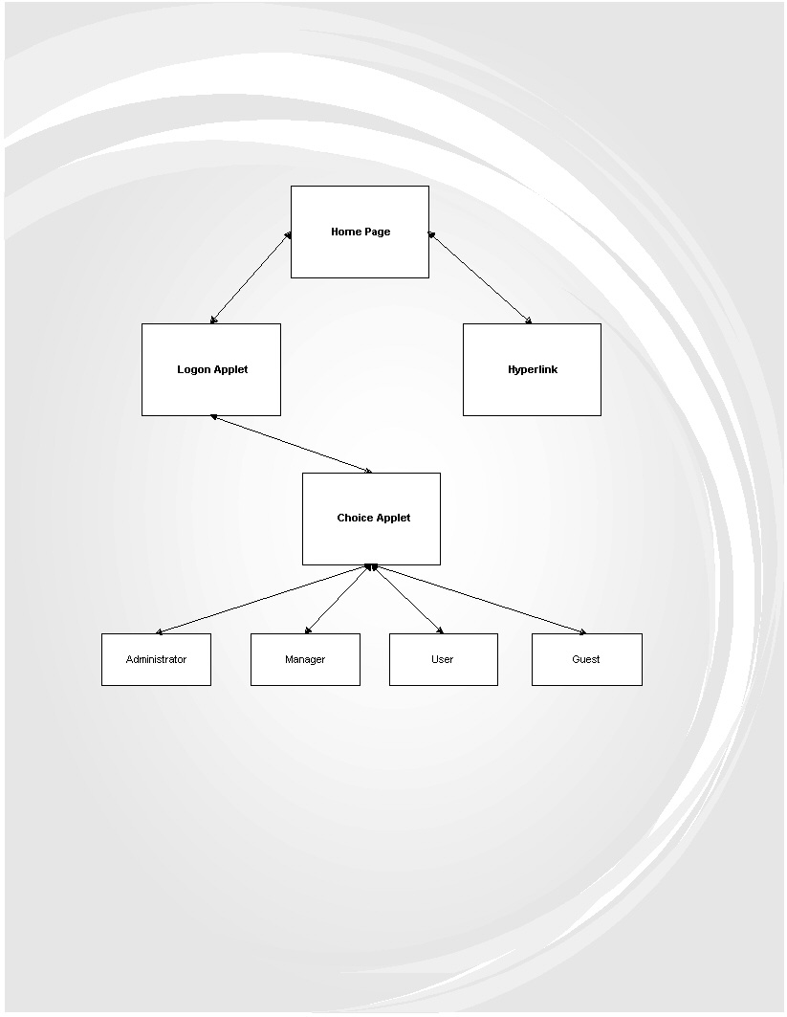

Figure 1: Server Page Hierarchy

4.0 Control Flow
The control flow is shown in figure 2 shall be used to aid in the design of the Hierarchical Authentication system.

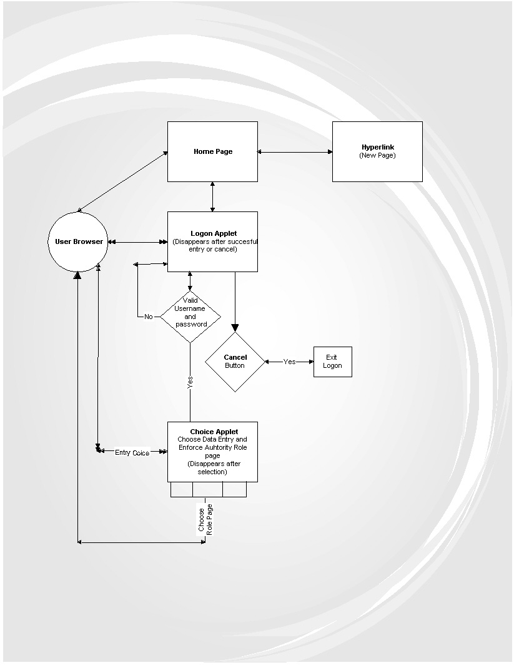

Figure 2: Control Flow Diagram

5.0 Data Flow
The Data flow diagram is shown in figure 3 is a general overview of the data flow for the Hierarchical Authentication system. Double arrows indicate a bi-directional flow of data. Single arrows indicate a single from/to pair for data flow.

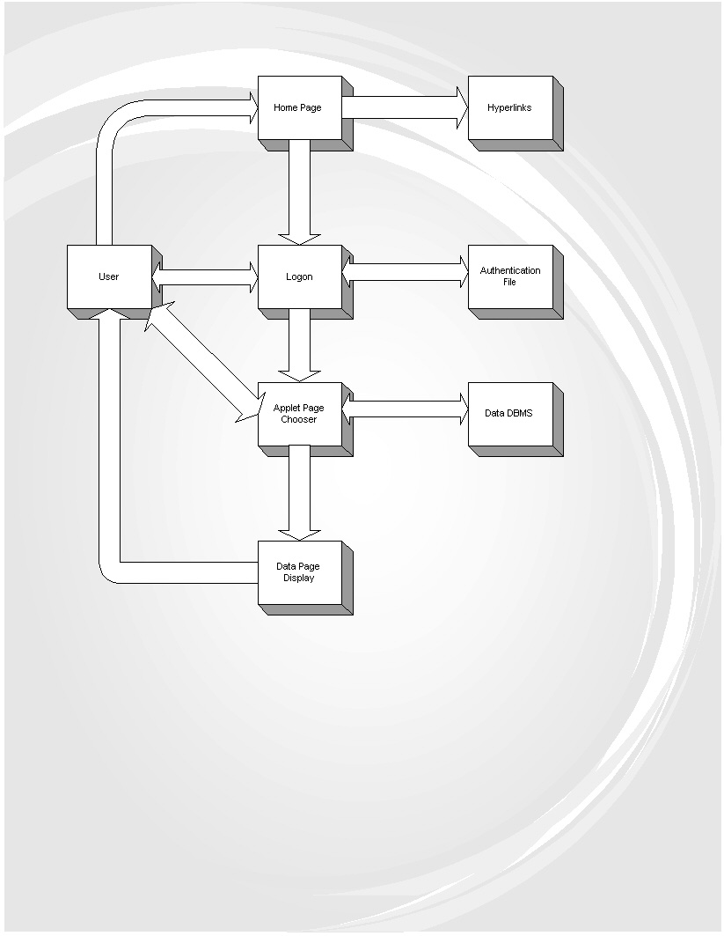
Figure 3: Data Flow Diagram

