# Report Image Segmentation Exercise

Luca Sichi, 19-928-100

My first implementation of the mean shift algorithm was more or less exactly the one from the slides. It was very slow, because it used a lot of loops. It had around 10 minutes to do one iteration of the `meanshift(X)`. The result was correct but it wasn’t feasible to investigate different bandwidths. This is why I vectorized the code similarly as in exercise 1. I also don’t calculate the gaussian with the normalisation, because I do it later in the update_point function. With the vectorized implementation one iteration of meanshift_step only took about 30 seconds on my machine.

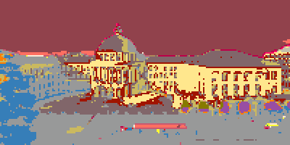

This is the result of my implementation with a bandwidth of 2.5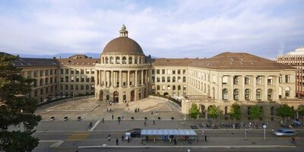

If we compare it with the original we can see how it segmented some areas very good (sky, road) and others a bit worse, it differentiated between the façade illuminated directly by the sun and the one in the shadow.