Report Luca Sichi

Bag of words classifier:
grid_points():
The implementation is pretty straightforward
descriptors_hog():
Here I implemented 3 helper functions that assist in calculating the hog descriptors. Here I also had to change the datatype of the np arrays from 16 bit to 32 bit.
[10,32.5,55,77.5,100,122.5,145,167.5] these are my bins (in degree)
create_codebook():
here my biggest issue was dealing with nan, else it is straightforward.
bow_histogram():
straightforward.
create_bow_histograms():
straightforward.
bow_recognition_nearest():
here we decide based on the norm what label we give the image.
Hyperparameters:
Finally I had to choose some k and numiter. I ran multiple tests and got the following results:
k=60
iterations=100
test pos sample accuracy: 0.7346938775510204
test neg sample accuracy: 0.78
==============================================
k=50
iterations=100
test pos sample accuracy: 0.7551020408163265
test neg sample accuracy: 0.8200000000000001
==============================================

k=40
iterations=100
test pos sample accuracy: 0.8367346938775511
test neg sample accuracy: 0.76
==============================================
k=30
iterations=100
test pos sample accuracy: 0.8775510204081632
test neg sample accuracy: 0.6
==============================================
k=20
iterations=100
test pos sample accuracy: 0.8163265306122449
test neg sample accuracy: 0.64
==============================================
As we can see there is a tradeoff between the positive accuracy and the negative accuracy.
k=40 and numiter=100 seems to give decent results.

Log with k = 30 and numiter = 100
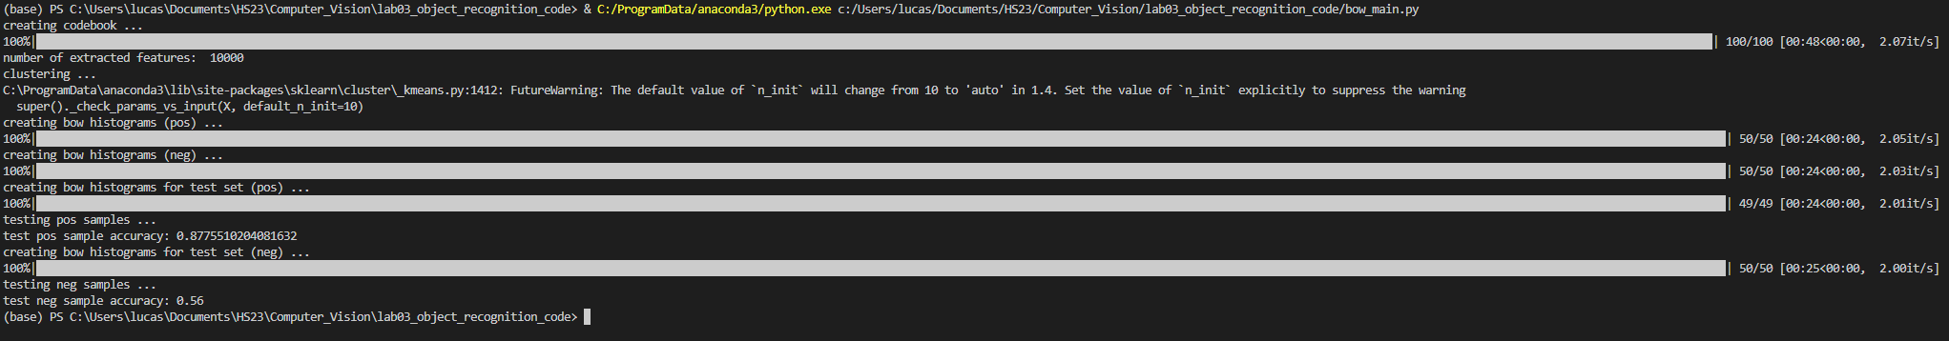

CNN Classifier
Here the main task was finding out the stride and padding. I used the formula on the documentation to calculate the corresponding values and ended up with padding=1 and stride=2 for a given kerne size of 3. Then I did the same for the max pool filters.

Test_cifar:
