ZYVOR · NETRA
Network observability and
emergency control,
without CNI lock-in.
A buyer brochure for enterprises evaluating Netra — how every major capability works, how incidents move from signal to containment, and how Netra sits next to PacketWolf in the Zyvor suite.
OBSERVE · DIAGNOSE · CONTAIN · FAIL OPEN
Standalone eBPF for Linux/Kubernetes · Apache-2.0 · Optional Cilium/Hubble enrichment
Illustrative UI captures from a live lab deployment appear later in this brochure.

When enterprises buy Netra
Modern clusters accumulate network tools faster than operators can trust them. CNI dashboards explain policy verdicts. Host stacks still drop packets in softnet, qdisc, and the NIC. Emergency denies that never expire become the next outage. Netra is built for that gap.

Buyer problems Netra addresses
- CNI-only visibility leaves node-level loss unexplained.
- Changing or mixing CNIs should not erase observability and emergency control.
- Incident kill-switches must auto-revert — permanent silent deny is unacceptable.
- Evidence (capture, alerts, SIEM, AI) must not collect payloads, argv, or secrets.

What Netra is — in one sentence
Netra is standalone eBPF network observability and leased emergency containment for Linux/Kubernetes: observe-first, CNI-independent by default, with optional Cilium/Hubble enrichment.

Architecture — how it works
Netra has two workloads: a controller (netrad) that serves the API/UI and holds desired state, and a privileged node agent that owns eBPF programs and maps under /sys/fs/bpf/netra.
01  Workloads  Pods · VMs · host | → | 02  eBPF hooks  cgroup · sockops · TCX/XDP | → | 03  Netra maps  /sys/fs/bpf/netra | → | 04  Agent  report · capture · lease | → | 05  netrad  API · UI · HA

Hook model (default)
- cgroup_skb ingress/egress — CNI-independent workload observation and control
- cgroup connect/sendmsg — process/UID context and deny for new sockets
- sockops — TCP health, RTT, retransmit, connect latency
- Optional: kfree_skb drop reasons, TCX, XDP Shield on selected interfaces
The agent never pins over Cilium-owned maps. Cilium and Hubble are read as optional data sources.

Observability
Netra records flow counters, direction, hook attribution, TCP/UDP/ICMP visibility, Kubernetes workload identity, and metadata-only L7 signals.
01  L3/L4  tuples · flags | → | 02  L7 meta  DNS · SNI · Host | → | 03  Identity  ns · pod · comm | → | 04  Health  RTT · retrans | → | 05  Topology  dependencies

Hard boundary
No application payloads. No argv/cmdline. No Secret contents. DNS is ordinary UDP/53 query names. TLS is best-effort ClientHello SNI in a single skb. HTTP is method + Host only.

Path diagnostics & edge TCP intel
Path Diagnostics measures active TCP connect-establishment latency and exports transport pressure (cwnd, packets_out, retransmits, lost_out, delivered rate) per cgroup/workload.
A standalone TCX edge observer adds handshake/RTT histograms and retransmit/RST/FIN counters that see pre-NAT forwarded flows the local socket layer never attaches to.
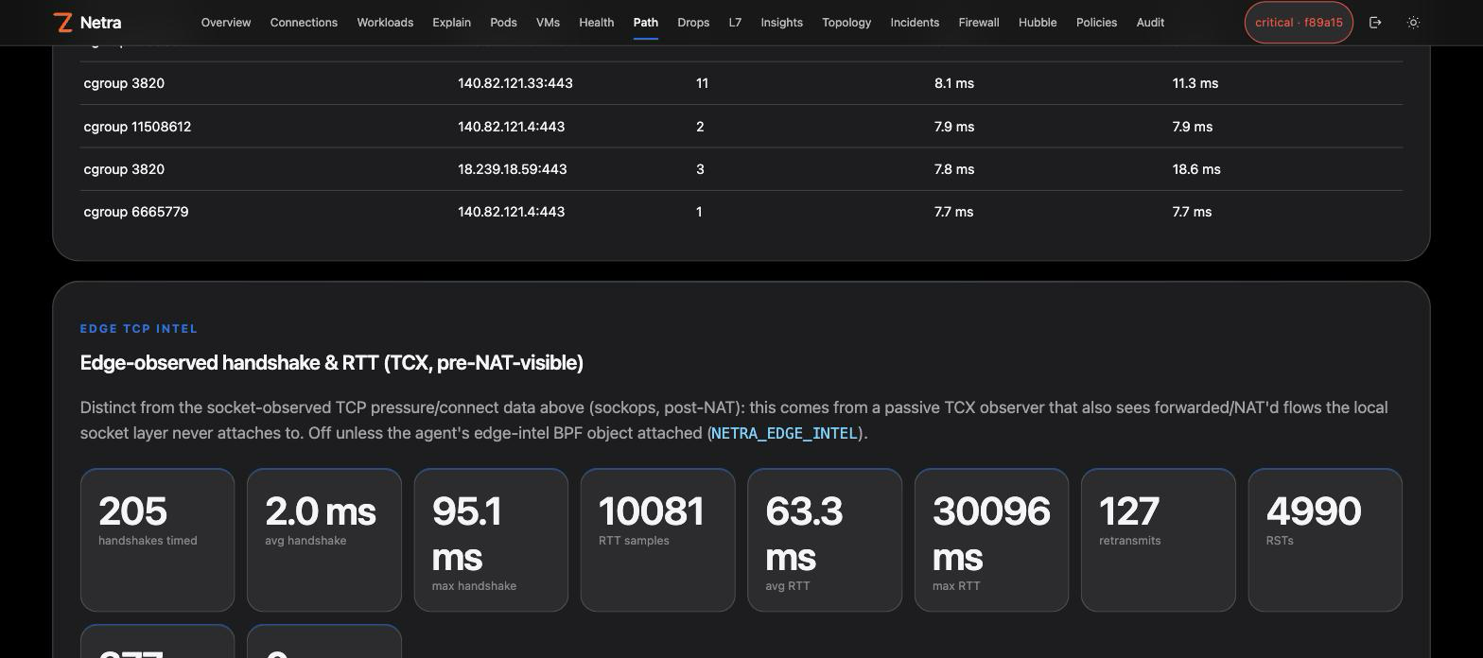
Illustrative lab UI — Path Diagnostics with edge TCP intel.

Drop diagnostics & Congestion Map
Drop Diagnostics combines optional kfree_skb drop-reason counters with Linux softnet, interface, and qdisc statistics — answering where packets die when CNI verdicts look fine.
The Congestion Map paints every stack stage across the cluster by severity. Critical findings deep-link to Capture; opt-in auto-capture can persist a PCAP automatically.
01  NIC  driver / RX | → | 02  softnet  backlog | → | 03  qdisc  egress | → | 04  socket  TCP pressure | → | 05  Capture  evidence

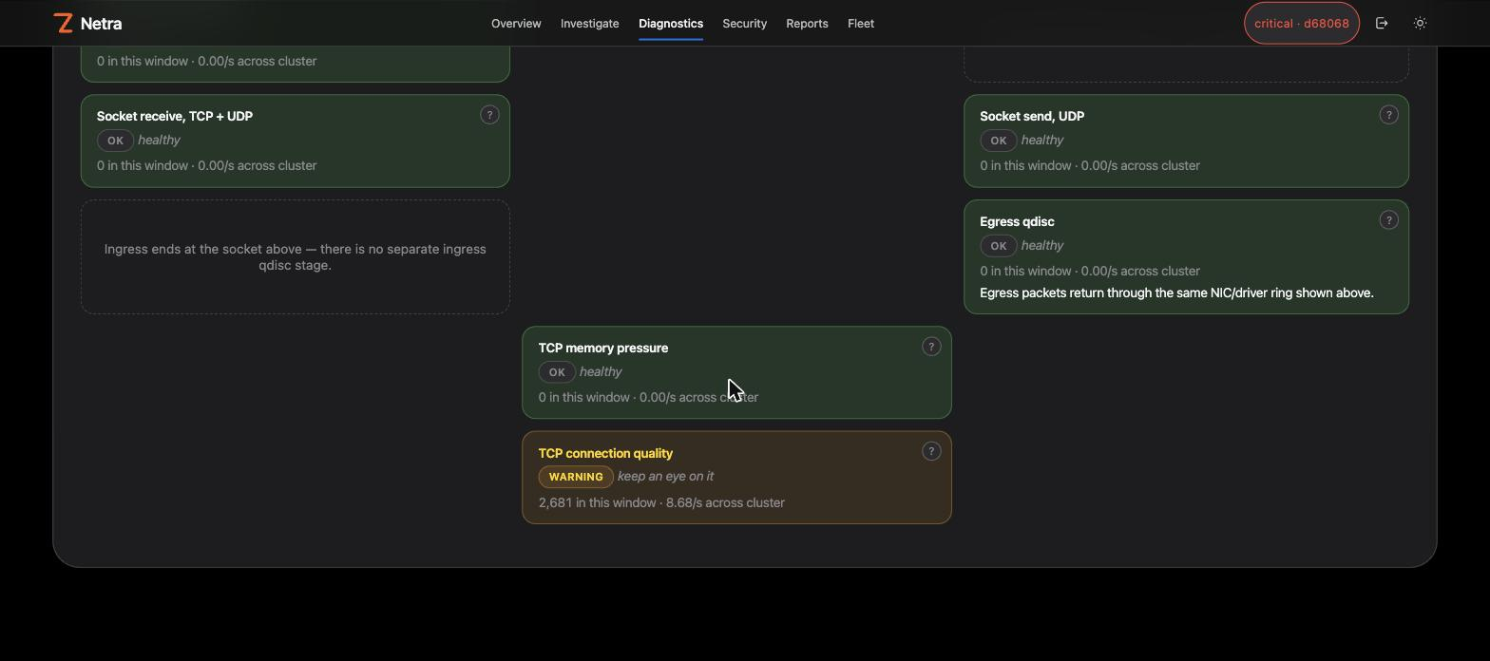
Illustrative lab UI — Congestion Map colored by severity.
Netra never writes a sysctl. Tuning guidance is review-only and reversible.

Packet capture & auto-capture
Operators start a filtered, time-bounded capture on one or many nodes. Backends: eBPF (default, in-kernel) or AF_PACKET (userspace). Live stream, Wireshark-style decode, and .pcap export.

Auto-capture (opt-in)
When NETRA_AUTO_CAPTURE is enabled, critical softnet drops (≥1000), Congestion Map critical findings, and critical drop-rate spikes start a filtered capture and write a classic PCAP under NETRA_AUTO_CAPTURE_DIR — linked from capture history for download.
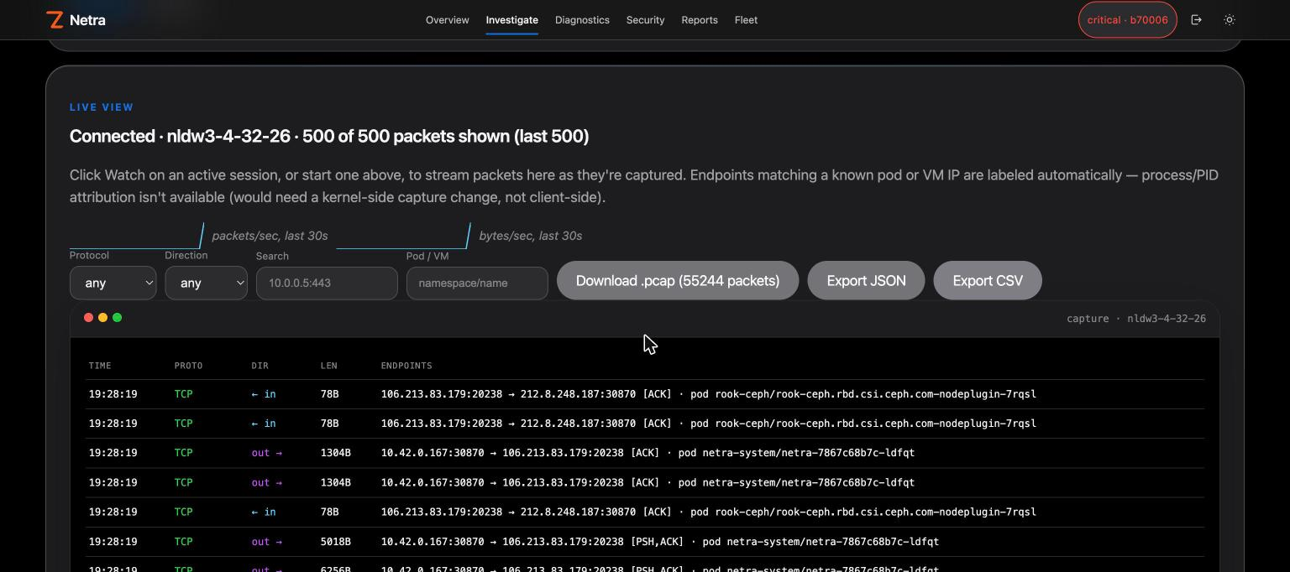
Illustrative lab UI — Capture live view.

Emergency firewall — leased enforce
Netra’s containment layer is deliberately an emergency/containment tool — not a full CNI policy engine, QoS system, L7 proxy, or IDS/IPS.

What you can deny (examples)
- Exact IPv4/IPv6 and CIDR deny (ingress/egress), optional SYN-drop mode
- Port, DNS name, TLS SNI, UID, process comm — with allow-exceptions
- PPS/BPS ceilings and per-workload new-TCP connection-rate caps
- Optional XDP early ingress on selected interfaces

Lease lifecycle
01  Observe  default | → | 02  Plan  confirm | → | 03  Enforce  leased | → | 04  Revert  fail open

Blast-radius preview matches a proposed deny against live counters and applies nothing — so operators can see impact before they confirm.

Behavior & rate insights
Controller-side insights turn eBPF metadata into baselines and drift: workload dependency graph, known-good behavior baseline, newly observed destinations/DNS/SNI/HTTP hosts/ports, time-window rate baselines with deterministic multipliers, exposure scoring, and review-only remediation proposals.
Netra never auto-applies learned policy. Baselines are explicit operator decisions.

Alerting & export
Multi-channel notify (webhook, email, Slack, Teams, Twilio SMS/WhatsApp, HTTP bridge) runs on an interval with severity-aware cooldown. HA: leader-only. Pull SIEM export supports JSON, JSONL, CEF, syslog, and OTLP. Prometheus gauges and an importable Grafana dashboard ship with the product.

AI, MCP & ChatOps
Ask Netra, digests, suggestions, explain, and draft are read-only — they never flip enforce mode or apply policy. Optional OpenAI-compatible rewrite; heuristic by default. netra-mcp exposes 133 tools (mutations gated off by default). Slack/Teams ChatOps mirrors the same confirmations as the UI.

Safety, HA, and deploy
Safety  Observe-first. Plan-token + risk confirm. Fail open on lease expiry, agent loss, restart, or HA handoff. No Cilium map overwrite. No payload/argv/Secret collection. |  | HA  Active/passive Lease election + shared RWX state. Auto-capture PCAPs should sit on the same shared volume as state so failover does not orphan artifacts.

Deploy via Helm (controller + optional agent DaemonSet). netra-doctor verifies host readiness (cgroup v2, bpffs, BTF) before privileged agent rollout.

Zyvor suite placement — Netra & PacketWolf
Netra and PacketWolf are suite counterparts, not a wired pipeline. Neither product is a dependency or API consumer of the other today.
 | Netra | PacketWolf
Default market | Mixed / non-Cilium; OSS entry | Cilium-standardized fleets
Core job | Observe + Path/Drop/Congestion + leased emergency deny | Observe + AutoPolicy + healer + platform containment
CNI dependency | None (Cilium/Hubble optional) | Cilium-first
Policy posture | Review-only drafts; enforce is time-leased, fails open | Learns and operates Cilium policy at platform depth
Maps | Owns /sys/fs/bpf/netra only | Works with Cilium datapath / policy
Relationship | Suite counterpart — not a PacketWolf agent or API consumer | Suite counterpart — no Netra control-plane sync today

Co-existence rules
- Same cluster is allowed but not required — Netra maps stay isolated.
- Do not dual-own long-lived deny: PacketWolf/Cilium for durable posture; Netra leases for incident kill-switch that auto-reverts.
- Enable Hubble/CNP in Netra only for enrichment — not as PacketWolf’s datapath.
- There is no Netra↔PacketWolf control-plane sync today.
Pick Netra when you need CNI-independent diagnostics and short-lease emergency deny. Pick PacketWolf when Cilium is already the CNI and you want full platform intelligence / AutoPolicy / healer depth.

Buying checklist
- Confirm Linux nodes meet cgroup v2 / bpffs / BPF baselines (netra-doctor).
- Start observe-only: flows, Path, Drop, Congestion Map — no enforce lease yet.
- Exercise capture (and optionally auto-capture) on a non-production signal.
- Pilot a leased deny with blast-radius preview and confirm auto-revert.
- Wire alerting / SIEM / ChatOps as needed; keep AI/MCP read-only until trusted.
- If Cilium is present, decide enrichment vs PacketWolf platform ownership explicitly.
See the network. Contain the incident.
Fail open by default.
Talk to sales → zyvor.dev/netra
© 2026 Zyvor · Apache-2.0 core · Standalone eBPF network observability and emergency network control

