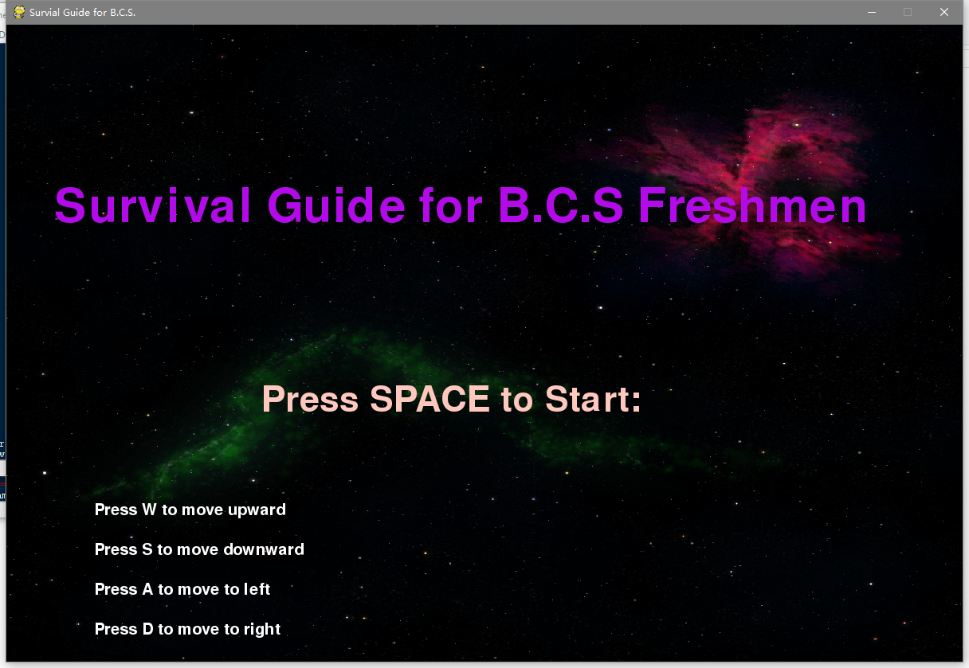

Who is the main character?

What does this character want?

What is going to try and stop the main character?

What about the game is unique and compelling?

The main character is spaceship driven by a robot, but actually this is kind of avatar or representative of a freshman in the B.C.S program. The main goal of the character is to survive until the time in the right-top corner runs out, with your CGPA of the four courses as high as possible. Generally speaking, you can also set your own goal as achieving an awful transcript in the end or some other goals .

There are four types of rotating bars, different kinds of dues from 4 courses, that are trying to hurt the player. Whenever there is a collision detected between the player and one of the bar , the grade of the corresponding would be deducted by approximately 10 point, which is the penalty you missed the due. Though you are recommended to try to avoid the collisions as possible as you can, you have different kinds of tricks to reduce the collisions.

This game provides a representative metaphor of the the academic life of a B.C.S first-year undergraduate. Imagine you are surviving between different dues and quiz in your university with limited time, how to distribute your time is almost brain-dead. Sometimes you fully prepared for one course，but considering0 conflicts between dues, you may be not prepared with the other due drawing near. As in this game, you also need to manage your time as your speed of the spaceship is a constant. Moreover, there are items that may help your gain random grade back into a random course, which are the ‘Rob’s Notes’. It is like the real life, when you consume your energy/your hair on the notes /study, that the God will reward you on grades for sure.

Gameplay Overview

The main goal of the character is to survive until the time in the right-top corner runs out, with your CGPA of the four courses as high as possible. More surprisingly, you can set your own goal as achieving an awful transcript in the end or some other goals, because you would die anyway.

There are four types of rotating bars, different kinds of dues from 4 courses, that are trying to hurt the player. Whenever there is a collision detected between the player and one of the bar , the grade of the corresponding would be deducted by approximately 10 point, which is the penalty you missed the due. The game supports 8 directions for you to move the ship in order to evade.Though you are recommended to try to avoid the collisions as possible as you can, you have different kinds of tricks to reduce the collisions. When you are hit by a bar, there is a 1s invincible time for you, so you can take advantage of this and try to go through the other bars during the time.But if you hit too much, you grade would be awful.

You should try to save your bullets on the lecture notes to make sure you can hit them, since when you do so, you can gain bullets back. If you miss, you would lose the bullet forever.Of course, if you want to shoot them out , you can.

As I say, it provides a representative metaphor of the the academic life of a B.C.S first-year undergraduate. Imagine you are surviving between different dues and quiz in your university with limited time, you can find another way to experience your university life IN THE SPACE. Though it is fiction, it is would be thrilled.

Fun

For sensation, you can feel an virtual academical life in space, and the dues are squeezing you as well in space. For fantasy, it provides a representative metaphor of the the life of a B.C.S freshman. For story narrative, there is no obvious story here, but you can imagine you are making up your own story. The challenge is how to avoid the bars , and for sure it is impossible to evade from all of them. Then you can imagine and explore what combo of lasers waiting for you. You can also express your way of university life even with bad transcript. So you can wasted/spend your time on achieve the worst GPA or single course grade ever, once and once again.