1.如何将doc文件转成txt，
首先小学和高中可以用一套方法转，打开wps，选择另存为，保存类型为txt，编码选择utf8（请无视图片中的示例是初中词汇表，初中词汇按这种方式转会出现乱码）
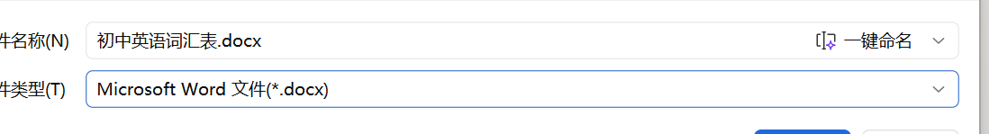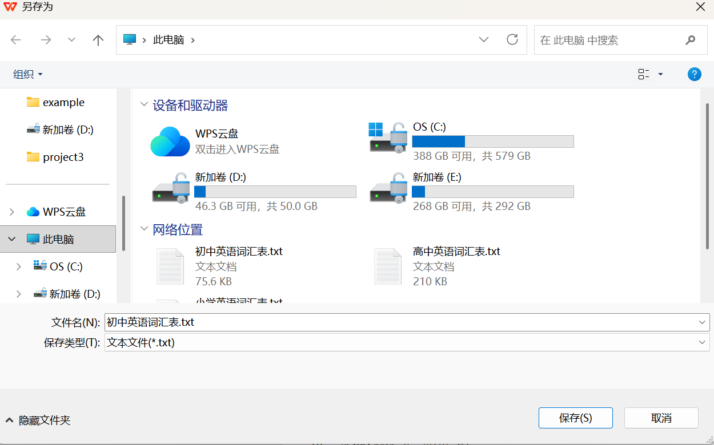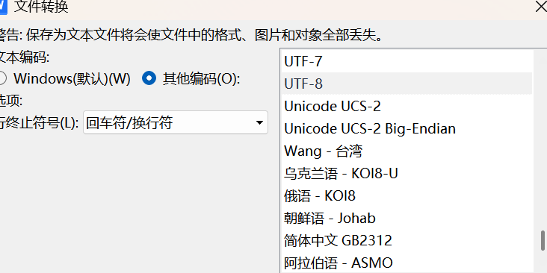

初中词汇有老旧字体，需要先转成pdf，这样pdf会强制将老旧字体转换，接下来再转回文本文件，为了统一，选择utf8字体
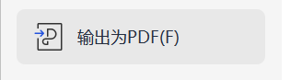
为了处理utf8字体的txt，我们需要把vscode
环境也弄成utf8
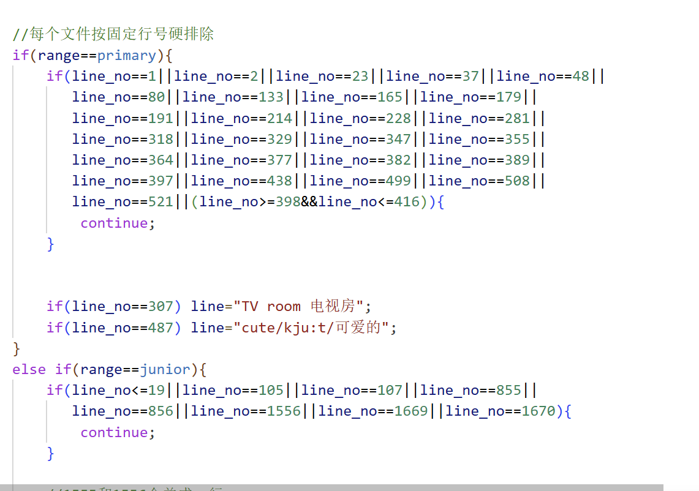
处理数据文件的第一步是先去掉一些无用行，只保留单词行
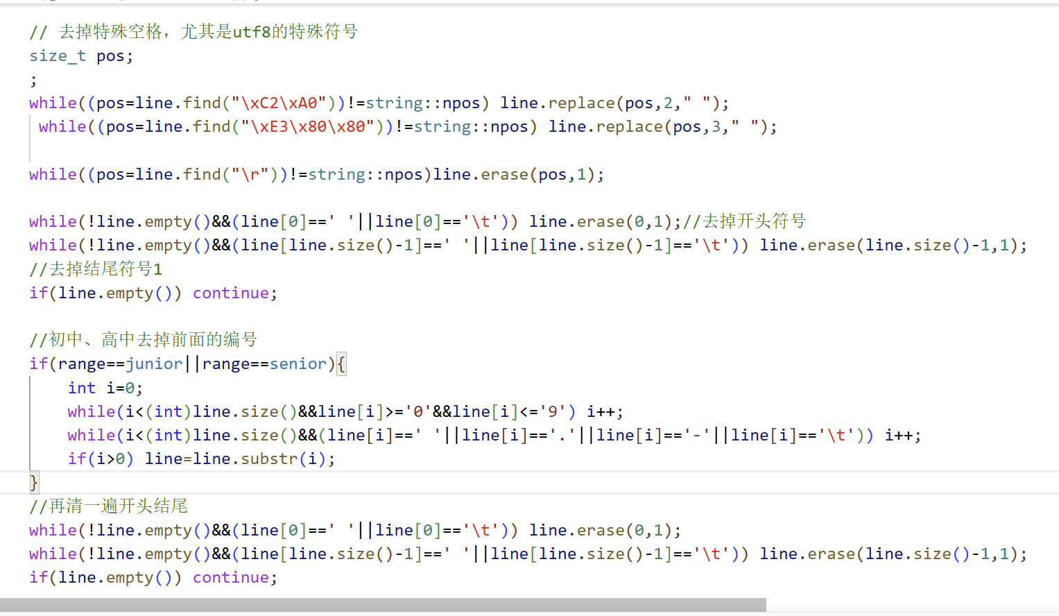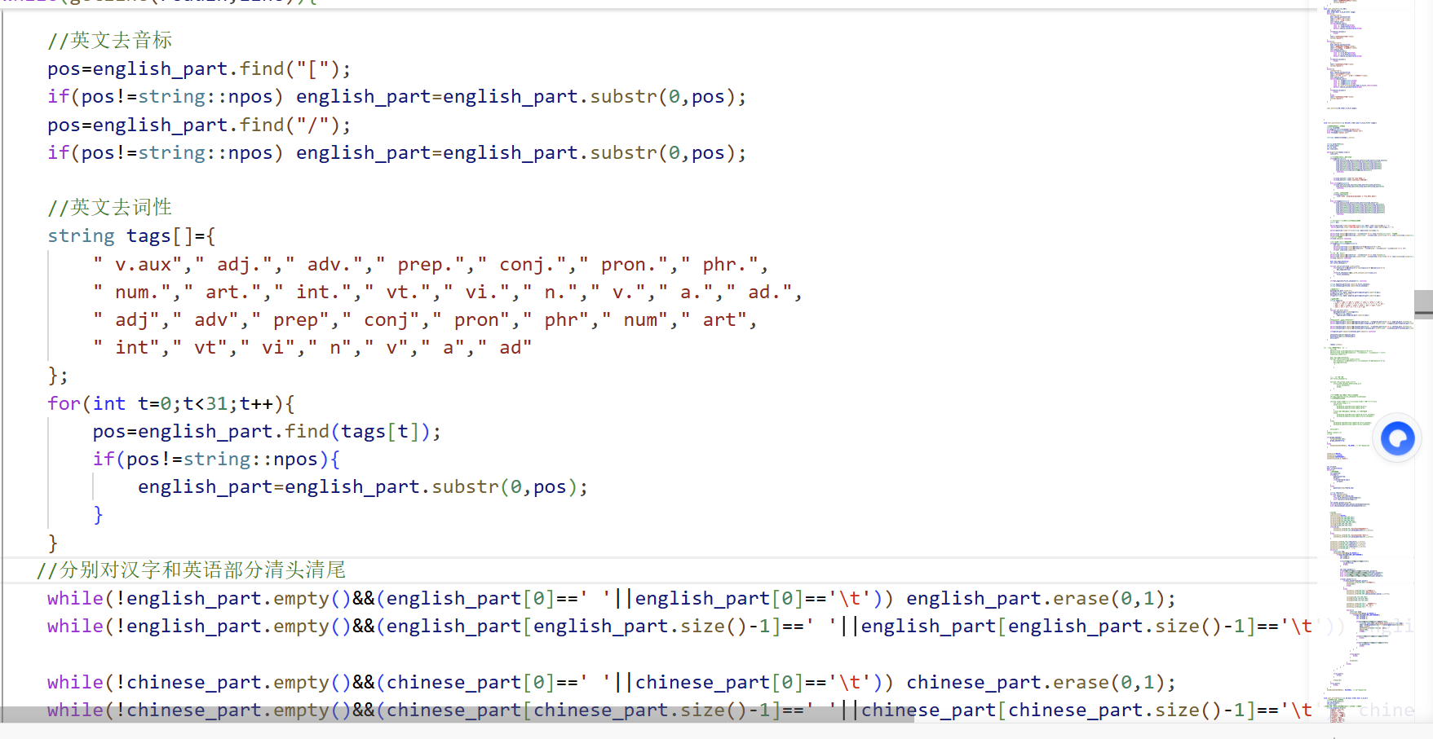
接下来我们把不是单词和汉语的部分去掉
这样只剩下汉语和英语单词就比较好分类了
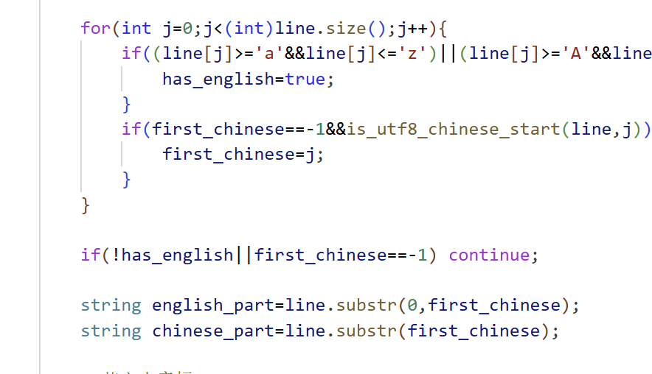
通过第一个汉字的位置，判断怎么切割

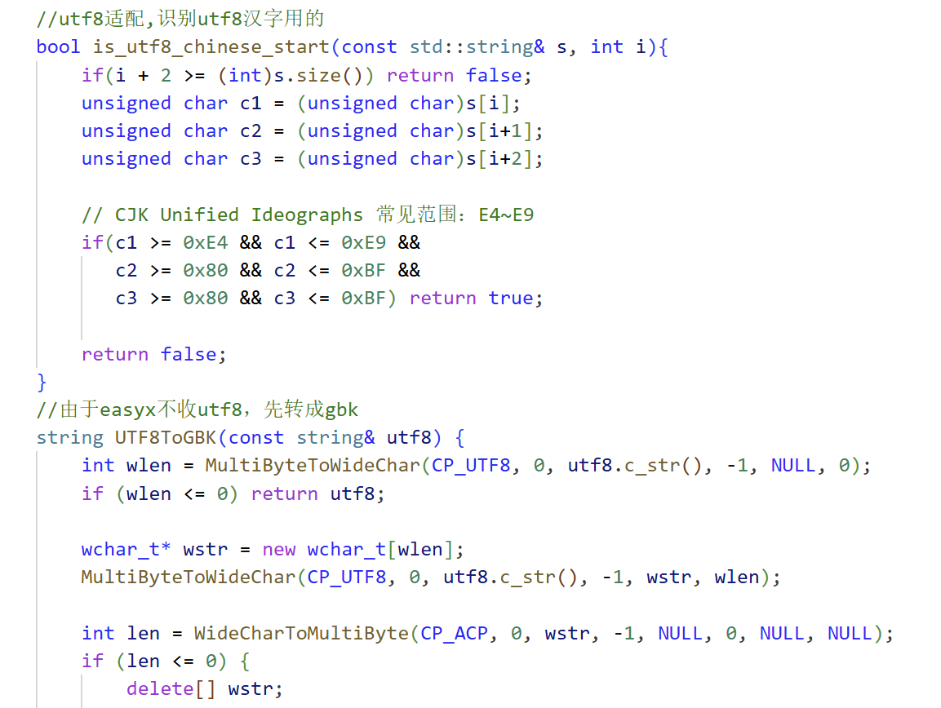
使用utf8字体不得不做出牺牲，第一个是判断是否是汉字时utf8和gbk的逻辑是不同的，第二个是easyx只收gbk，不收utf8，需要我们代码做出如图片一样的适应性调整

2.
原数据文件的中文名对vscode有点不太好用，需要我们自己把数据文件名称改为英文，否则读取会失败

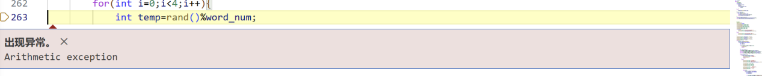
反复开关绘画窗口，easyx会卡死，最好用完暂时把它隐藏起来

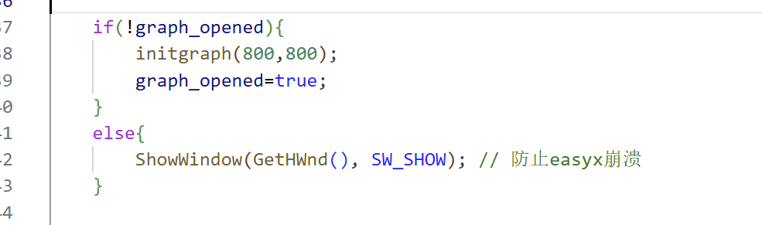
被注释掉的代码是个失败的提取数据的例子，事实上它对边缘情况处理得不够详尽，而且提取方法太过简单粗暴，直接把汉字部分和非汉字部分隔开
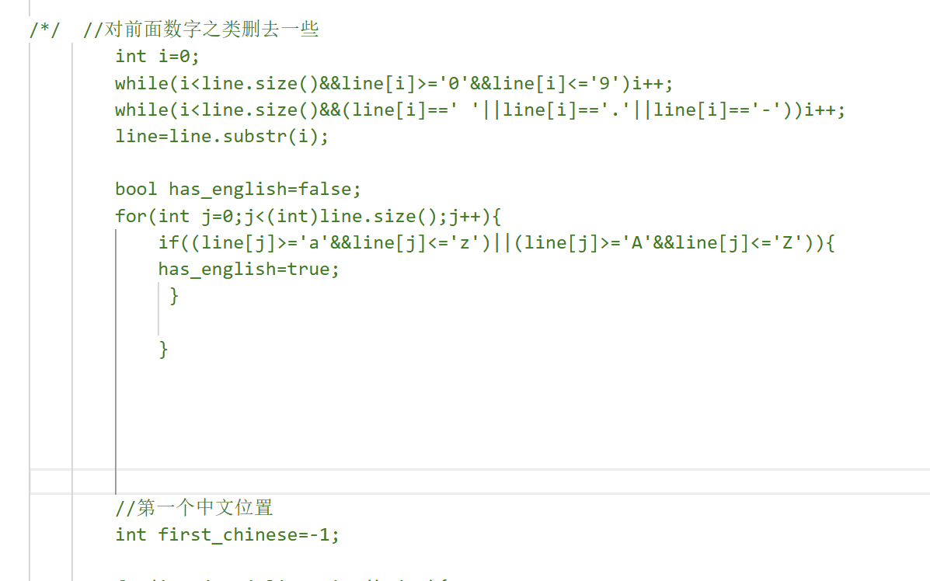
每个控制台都需要判断是否用户进行了正确选择，用choice_success做判断是否终止循环

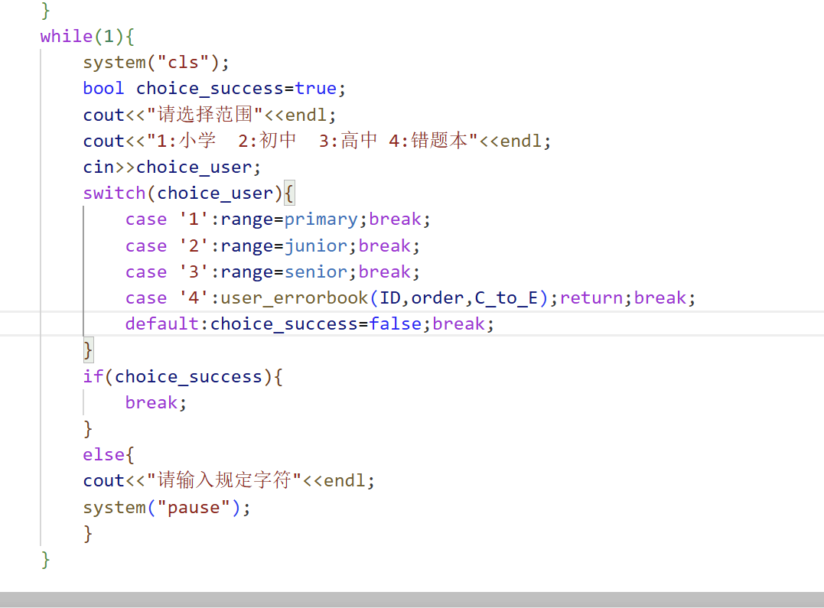
UTF8有特殊符号，需要特殊关注，尤其是特殊空格和换行符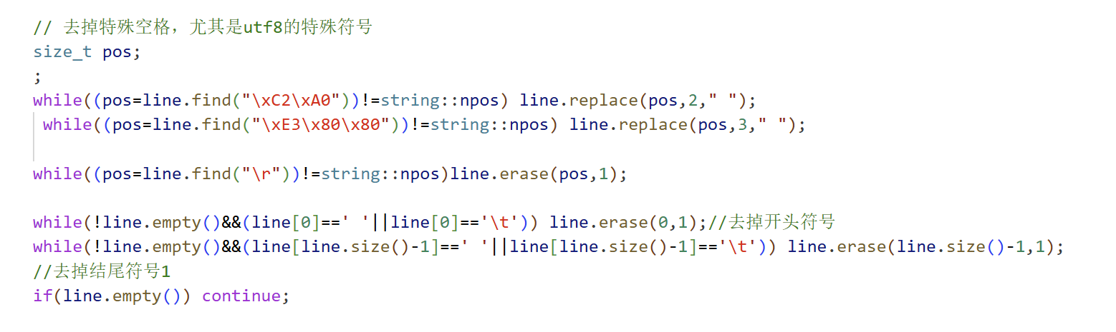
- 代码
#include <conio.h>
#include <windows.h>
#include<iostream>
#include<string>
#include<map>
#include<fstream>
#include<cstdlib>
#include<ctime>
#include<graphics.h>
enum RANGE{
primary,junior,senior,errorbook
};
using namespace std;

bool graph_opened=false;

//utf8适配,识别utf8汉字用的
bool is_utf8_chinese_start(const std::string& s, int i){
if(i + 2 >= (int)s.size()) return false;
unsigned char c1 = (unsigned char)s[i];
unsigned char c2 = (unsigned char)s[i+1];
unsigned char c3 = (unsigned char)s[i+2];

// CJK Unified Ideographs 常见范围：E4~E9
if(c1 >= 0xE4 && c1 <= 0xE9 &&
c2 >= 0x80 && c2 <= 0xBF &&
c3 >= 0x80 && c3 <= 0xBF) return true;

return false;
}
//由于easyx不收utf8，先转成gbk
string UTF8ToGBK(const string& utf8) {
int wlen = MultiByteToWideChar(CP_UTF8, 0, utf8.c_str(), -1, NULL, 0);
if (wlen <= 0) return utf8;

wchar_t* wstr = new wchar_t[wlen];
MultiByteToWideChar(CP_UTF8, 0, utf8.c_str(), -1, wstr, wlen);

int len = WideCharToMultiByte(CP_ACP, 0, wstr, -1, NULL, 0, NULL, NULL);
if (len <= 0) {
delete[] wstr;
return utf8;
}

char* gbk = new char[len];
WideCharToMultiByte(CP_ACP, 0, wstr, -1, gbk, len, NULL, NULL);

string result(gbk);

delete[] wstr;
delete[] gbk;

return result;
}
//再来个函数嵌套
void outtextxy_utf8(int x, int y, const string& s) {
string gbk = UTF8ToGBK(s);
outtextxy(x, y, gbk.c_str());
}

void user_register();
void user_log_in();
void user_choose(string ID);
void user_practise(string ID,bool order,bool C_to_E,RANGE range);
void user_errorbook(string ID,bool order,bool C_to_E);
int main(){
SetConsoleCP(65001);
SetConsoleOutputCP(65001);//把控制台改成utf8

srand((unsigned int)time(0));
while(1){
system("cls");
bool is_exit=false;
cout<<"请选择一个选项"<<endl;
cout<<"1:登录 ";
cout<<"2:注册 ";
cout<<"3:退出"<<endl;
char choice_user;
cin>>choice_user;

switch(choice_user){
case '1':user_log_in();break;
case '2':user_register();break;
case '3':is_exit=true; break;
default:cout<<"请输入正确的字符"<<endl;system("pause");
}
if(is_exit){
break;
}
}

if(graph_opened){
closegraph();
}

return 0;
}
void user_register(){
string ID;
string password;
string check_ID;
string check_password;
while(1){
system("cls");
cout<<"请输入账号名"<<endl;
cin>>ID;
ifstream search_ID("user.txt");
if(!search_ID){
ofstream temp("user.txt");
temp.close();
search_ID.clear();
search_ID.open("user.txt");
}
bool able_continue=true;
while(search_ID>>check_ID>>check_password){
if(check_ID==ID){
cout<<"账号已重复"<<endl;
system("pause");
able_continue=false;
break;
}
}
search_ID.close();
if(able_continue){
cout<<"请输入密码"<<endl;
cin>>password;
ofstream record_information("user.txt",ios::app);
record_information<<ID<<" "<<password<<endl;
record_information.close();
user_choose(ID);
return;
}

}
}
void user_log_in(){
string ID;
string password;
string check_ID;
string check_password;
while(1){
system("cls");
cout<<"请输入账号名"<<endl;
cin>>ID;
cout<<"请输入密码"<<endl;
cin>>password;
ifstream search_information("user.txt");
if(!search_information){
ofstream temp("user.txt");
temp.close();
cout<<"账号不存在"<<endl;
system("pause");
return;
}
bool is_success=false;
while(search_information>>check_ID>>check_password){
if(check_ID==ID&&check_password==password){
is_success=true;
break;
}
}
search_information.close();
if(is_success){
user_choose(ID);
return;
}
else{
cout<<"账号或密码错误"<<endl;
system("pause");
}
}
}
void user_choose(string ID){
char choice_user;
bool order;bool C_to_E;RANGE range;
while(1){
system("cls");
bool choice_success=true;
cout<<"是否按顺序"<<endl;
cout<<"1:是 2:否"<<endl;
cin>>choice_user;
switch(choice_user){
case '1':order=true;break;
case '2':order=false;break;
default:choice_success=false;break;
}
if(choice_success){
break;
}
cout<<"请输入规定字符"<<endl;
system("pause");
}
while(1){
system("cls");
bool choice_success=true;
cout<<"英译汉还是汉译英"<<endl;
cout<<"1:汉译英 2:英译汉"<<endl;
cin>>choice_user;
switch(choice_user){
case '1':C_to_E=true;break;
case '2':C_to_E=false;break;
default:choice_success=false;break;
}
if(choice_success){
break;
}
cout<<"请输入规定字符"<<endl;
system("pause");
}
while(1){
system("cls");
bool choice_success=true;
cout<<"请选择范围"<<endl;
cout<<"1:小学 2:初中 3:高中 4:错题本"<<endl;
cin>>choice_user;
switch(choice_user){
case '1':range=primary;break;
case '2':range=junior;break;
case '3':range=senior;break;
case '4':user_errorbook(ID,order,C_to_E);return;break;
default:choice_success=false;break;
}
if(choice_success){
break;
}
else{
cout<<"请输入规定字符"<<endl;
system("pause");
}
}

user_practise(ID,order,C_to_E,range);

}

void user_practise(string ID,bool order,bool C_to_E,RANGE range){

//将词汇表存入二维数组
string filename;
if(range==primary)filename="primary.txt";
else if(range==junior)filename="junior.txt";
else filename="senior.txt";

ifstream readin(filename.c_str());

string word[5000][2];
int word_num=0;
string line;
int line_no=0;

while(getline(readin,line)){
line_no++;

//每个文件按固定行号硬排除
if(range==primary){
if(line_no==1||line_no==2||line_no==23||line_no==37||line_no==48||
line_no==80||line_no==133||line_no==165||line_no==179||
line_no==191||line_no==214||line_no==228||line_no==281||
line_no==318||line_no==329||line_no==347||line_no==355||
line_no==364||line_no==377||line_no==382||line_no==389||
line_no==397||line_no==438||line_no==499||line_no==508||
line_no==521||(line_no>=398&&line_no<=416)){
continue;
}

if(line_no==307) line="TV room 电视房";
if(line_no==487) line="cute/kju:t/可爱的";
}
else if(range==junior){
if(line_no<=19||line_no==105||line_no==107||line_no==855||
line_no==856||line_no==1556||line_no==1669||line_no==1670){
continue;
}

//1555和1556合并成一行
if(line_no==1555){
line="1532 program(programme) n 程序,项目,节目";
}
}
else if(range==senior){
if(line_no==1||line_no==2||line_no==316||line_no==571||
line_no==940||line_no==1141||line_no==1293||line_no==1487||
line_no==1593||line_no==1732||line_no==1827||line_no==1862||
line_no==1889||line_no==2006||line_no==2190||line_no==2278||
line_no==2373||line_no==2664||line_no==2681||line_no==2874||
line_no==3363||line_no==3599||line_no==3667||line_no==3721||
line_no==3874||line_no==3876||line_no==3894||line_no>=3904){
continue;
}
}

// 去掉特殊空格，尤其是utf8的特殊符号
size_t pos;
;
while((pos=line.find("\xC2\xA0"))!=string::npos) line.replace(pos,2," ");
while((pos=line.find("\xE3\x80\x80"))!=string::npos) line.replace(pos,3," ");

while((pos=line.find("\r"))!=string::npos)line.erase(pos,1);

while(!line.empty()&&(line[0]==' '||line[0]=='\t')) line.erase(0,1);//去掉开头符号
while(!line.empty()&&(line[line.size()-1]==' '||line[line.size()-1]=='\t')) line.erase(line.size()-1,1);
//去掉结尾符号1
if(line.empty()) continue;

//初中、高中去掉前面的编号
if(range==junior||range==senior){
int i=0;
while(i<(int)line.size()&&line[i]>='0'&&line[i]<='9') i++;
while(i<(int)line.size()&&(line[i]==' '||line[i]=='.'||line[i]=='-'||line[i]=='\t')) i++;
if(i>0) line=line.substr(i);
}
//再清一遍开头结尾
while(!line.empty()&&(line[0]==' '||line[0]=='\t')) line.erase(0,1);
while(!line.empty()&&(line[line.size()-1]==' '||line[line.size()-1]=='\t')) line.erase(line.size()-1,1);
if(line.empty()) continue;

bool has_english=false;
int first_chinese=-1;

for(int j=0;j<(int)line.size();j++){
if((line[j]>='a'&&line[j]<='z')||(line[j]>='A'&&line[j]<='Z')){
has_english=true;
}
if(first_chinese==-1&&is_utf8_chinese_start(line,j)){
first_chinese=j;
}
}

if(!has_english||first_chinese==-1) continue;

string english_part=line.substr(0,first_chinese);
string chinese_part=line.substr(first_chinese);

//英文去音标
pos=english_part.find("[");
if(pos!=string::npos) english_part=english_part.substr(0,pos);
pos=english_part.find("/");
if(pos!=string::npos) english_part=english_part.substr(0,pos);

//英文去词性
string tags[]={
" v.aux"," adj."," adv."," prep."," conj."," pron."," phr.",
" num."," art."," int."," vt."," vi."," n."," v."," a."," ad.",
" adj"," adv"," prep"," conj"," pron"," phr"," num"," art",
" int"," vt"," vi"," n"," v"," a"," ad"
};
for(int t=0;t<31;t++){
pos=english_part.find(tags[t]);
if(pos!=string::npos){
english_part=english_part.substr(0,pos);
}
}
//分别对汉字和英语部分清头清尾
while(!english_part.empty()&&(english_part[0]==' '||english_part[0]=='\t')) english_part.erase(0,1);
while(!english_part.empty()&&(english_part[english_part.size()-1]==' '||english_part[english_part.size()-1]=='\t')) english_part.erase(english_part.size()-1,1);

while(!chinese_part.empty()&&(chinese_part[0]==' '||chinese_part[0]=='\t')) chinese_part.erase(0,1);
while(!chinese_part.empty()&&(chinese_part[chinese_part.size()-1]==' '||chinese_part[chinese_part.size()-1]=='\t')) chinese_part.erase(chinese_part.size()-1,1);

if(english_part.empty()||chinese_part.empty()) continue;

word[word_num][0]=english_part;
word[word_num][1]=chinese_part;
word_num++;
}

readin.close();

/*/ //对前面数字之类删去一些
int i=0;
while(i<line.size()&&line[i]>='0'&&line[i]<='9')i++;
while(i<line.size()&&(line[i]==' '||line[i]=='.'||line[i]=='-'))i++;
line=line.substr(i);

bool has_english=false;
for(int j=0;j<(int)line.size();j++){
if((line[j]>='a'&&line[j]<='z')||(line[j]>='A'&&line[j]<='Z')){
has_english=true;
}

}

//第一个中文位置
int first_chinese=-1;

for(int j=0;j<line.size();j++){
if(is_utf8_chinese_start(line,j)){
first_chinese=j;
break;
}
}

//看看此词是不是既有中文，又有英文
if(!has_english||first_chinese==-1)continue;
//if来处理特殊情况

if(line.find("缩写形式")!=-1||line.find("复数形式")!=-1){
int p=line.find(']');
if(p!=-1){
word[word_num][0]=line.substr(0,p+1);
word[word_num][1]=line.substr(p+1);
}
//else 就是正常的把中文字符和非中文字符隔开
else{
word[word_num][0]=line.substr(0,first_chinese);
word[word_num][1]=line.substr(first_chinese);
}
}
else{
word[word_num][0]=line.substr(0,first_chinese);
word[word_num][1]=line.substr(first_chinese);
}

word_num++;
}
readin.close();/*/
//画布

if(!graph_opened){
initgraph(800,800);
graph_opened=true;
}
else{
ShowWindow(GetHWnd(), SW_SHOW); // 防止easyx崩溃
}

setbkcolor(WHITE);
settextcolor(BLACK);
setbkmode(TRANSPARENT);
settextstyle(28,0,"宋体");

int array=0;
bool is_quit=false;
while(1){
//先编号号
int question;
if(order){
question=array;
array++;
if(array>=word_num){
array=0;
}
}
else{
question=rand()%word_num;
}

string choice[4];
for(int i=0;i<4;i++){
int temp=rand()%word_num;
if(C_to_E)choice[i]=word[temp][0];
else choice[i]=word[temp][1];
}
int answer_place=rand()%4;
if(C_to_E)choice[answer_place]=word[question][0];
else choice[answer_place]=word[question][1];

//展示UI
cleardevice();
setfillcolor(BLACK);
solidrectangle(0,200,800,202);
solidrectangle(0,400,800,402);
solidrectangle(0,600,800,602);
solidrectangle(400,200,402,600);
rectangle(100,650,300,730);
rectangle(500,650,700,730);
if(C_to_E){
outtextxy_utf8(40,60,"请选择对应的英文：");
outtextxy_utf8(40,110,word[question][1].c_str());
}
else{
outtextxy_utf8(40,60,"请选择对应的中文：");
outtextxy_utf8(40,110,word[question][0].c_str());
}

outtextxy_utf8(40,270,(choice[0]).c_str());
outtextxy_utf8(440,270,(choice[1]).c_str());
outtextxy_utf8(40,470,(choice[2]).c_str());
outtextxy_utf8(440,470,(choice[3]).c_str());
outtextxy_utf8(560,680,"退出");
while(1){
ExMessage msg;
if(peekmessage(&msg,EX_MOUSE)){
if(msg.message==WM_LBUTTONDOWN){
int x=msg.x;
int y=msg.y;

if(x>=500&&x<=700&&y>=650&&y<=730){
is_quit=true;
break;
}

int user_answer=-1;
if(x>=0&&x<=400&&y>=200&&y<=400)user_answer=0;
else if(x>=400&&x<=800&&y>=200&&y<=400)user_answer=1;
else if(x>=0&&x<=400&&y>=400&&y<=600)user_answer=2;
else if(x>=400&&x<=800&&y>=400&&y<=600)user_answer=3;

if(user_answer!=-1){
if(user_answer==answer_place){
outtextxy_utf8(330,680,"回答正确");
Sleep(800);
break;
}
else{
outtextxy_utf8(330,620,"回答错误");
outtextxy_utf8(330,660,"正确答案：");
outtextxy_utf8(480,660,choice[answer_place].c_str());

rectangle(80,710,280,780);
rectangle(310,710,510,780);
rectangle(540,710,740,780);

outtextxy_utf8(110,735,"加入错题本");
outtextxy_utf8(370,735,"下一题");
outtextxy_utf8(610,735,"退出");

while(1){
ExMessage msg2;
if(peekmessage(&msg2,EX_MOUSE)){
if(msg2.message==WM_LBUTTONDOWN){
int x2=msg2.x;
int y2=msg2.y;

if(x2>=80&&x2<=280&&y2>=710&&y2<=780){
ofstream fout((ID+"_errorbook.txt").c_str(),ios::app);
fout<<word[question][0]<<"|"<<word[question][1]<<endl;
fout.close();
outtextxy_utf8(330,735,"已加入");
Sleep(200);
break;
}

if(x2>=310&&x2<=510&&y2>=710&&y2<=780){
break;
}

if(x2>=540&&x2<=740&&y2>=710&&y2<=780){
is_quit=true;
break;
}
}
}

if(is_quit){
break;
}

Sleep(10);
}
break;
}
}
}
}

if(is_quit){
break;
}

Sleep(10);
}
if(is_quit){
break;
}
}
ShowWindow(GetHWnd(), SW_HIDE); // 防止easyx崩溃

}

void user_errorbook(string ID,bool order,bool C_to_E){
//把错题本存二维数组
string word[5000][2];
int word_num=0;
string line;
//下面是防止错题本错题数目不够四个时的备用词汇
string prepare[10][2]={
{"apple","苹果"},
{"book","书"},
{"school","学校"},
{"teacher","老师"},
{"student","学生"},
{"water","水"},
{"friend","朋友"},
{"family","家庭"},
{"help","帮助"},
{"answer","回答"}
};

ifstream readin((ID+"_errorbook.txt").c_str());

while(getline(readin,line)){
int p=line.find("|");
if(p==-1)continue;

word[word_num][0]=line.substr(0,p);
word[word_num][1]=line.substr(p+1);
word_num++;
}

readin.close();

if(word_num==0){
cout<<"错题本为空"<<endl;
system("pause");
return;
}
//画布

if(!graph_opened){
initgraph(800,800);
graph_opened=true;
}
else{
ShowWindow(GetHWnd(), SW_SHOW); // 防止easyx崩溃
}

setbkcolor(WHITE);
settextcolor(BLACK);
setbkmode(TRANSPARENT);
settextstyle(28,0,"宋体");

int array=0;
bool is_quit=false;
while(1){
int question;
if(order){
question=array;
array++;
if(array>=word_num){
array=0;
}
}
else{
question=rand()%word_num;
}

string choice[4];

for(int i=0;i<4;i++){
if(word_num>=4){
int temp=rand()%word_num;
if(C_to_E)choice[i]=word[temp][0];
else choice[i]=word[temp][1];
}
else{
int temp=rand()%10;
if(C_to_E)choice[i]=prepare[temp][0];
else choice[i]=prepare[temp][1];
}
}

int answer_place=rand()%4;
if(C_to_E)choice[answer_place]=word[question][0];
else choice[answer_place]=word[question][1];

cleardevice();
setfillcolor(BLACK);
solidrectangle(0,200,800,202);
solidrectangle(0,400,800,402);
solidrectangle(0,600,800,602);
solidrectangle(400,200,402,600);
rectangle(500,650,700,730);

if(C_to_E){
outtextxy_utf8(40,60,"请选择对应的英文：");
outtextxy_utf8(40,110,word[question][1].c_str());
}
else{
outtextxy_utf8(40,60,"请选择对应的中文：");
outtextxy_utf8(40,110,word[question][0].c_str());
}

outtextxy_utf8(40,270,(choice[0]).c_str());
outtextxy_utf8(440,270,(choice[1]).c_str());
outtextxy_utf8(40,470,(choice[2]).c_str());
outtextxy_utf8(440,470,(choice[3]).c_str());
outtextxy_utf8(560,680,"退出");

while(1){
ExMessage msg;
if(peekmessage(&msg,EX_MOUSE)){
if(msg.message==WM_LBUTTONDOWN){
int x=msg.x;
int y=msg.y;

if(x>=500&&x<=700&&y>=650&&y<=730){
is_quit=true;
break;
}

int user_answer=-1;
if(x>=0&&x<=400&&y>=200&&y<=400)user_answer=0;
else if(x>=400&&x<=800&&y>=200&&y<=400)user_answer=1;
else if(x>=0&&x<=400&&y>=400&&y<=600)user_answer=2;
else if(x>=400&&x<=800&&y>=400&&y<=600)user_answer=3;

if(user_answer!=-1){
if(user_answer==answer_place){
outtextxy_utf8(330,680,"回答正确");
Sleep(800);
break;
}
else{
outtextxy_utf8(330,620,"回答错误");
outtextxy_utf8(330,660,"正确答案：");
outtextxy_utf8(480,660,choice[answer_place].c_str());
Sleep(800);
break;
}
}
}
}

if(is_quit){
break;
}

Sleep(10);
}
if(is_quit){
break;
}
}
ShowWindow(GetHWnd(), SW_HIDE); // 防止easyx崩溃

}

