

SPARDA
Complete Technical Reference
The LLVM of web applications
v0.26.0 - Residual Labs
Compilateur de Comportement Backend | Unified Behavior Graph | MCP Runtime

Table of Contents
1. Introduction & Philosophie
The Problem
The Solution: SPARDA
AI Writes. SPARDA Proves.
2. Installation & Quickstart
Prerequisites
Step 1: Initialize SPARDA
Step 2: Start the MCP Bridge
Step 3: Standalone Demo
Removal
3. CLI Reference
sparda ubg
sparda apocalypse
sparda dossier
sparda review
sparda timeless
sparda heal
sparda mirror
sparda doctor
sparda verify
sparda report
4. AI Integration - MCP Server & Immunity
The /mcp Router & AST Injection
Write Safety: Disabled by Default
Collective Immunity
The Flywheel: Token Recycling
Twin Mode: Simulation Clone
Circuit Crystallization
5. Supported Frameworks
Next.js App Router
NestJS
Express 4/5 & MedusaJS
OpenAPI 3.1
6. Security & Threat Model
100% Local Execution
Dynamic Local Key Resolution
Honest Posture: Guarantees vs Limits
Appendix: sparda.json Schema

1. Introduction & Philosophie

The Problem
For twenty years, software systems communicated through APIs - predictable interfaces with deterministic contracts. Then AI agents arrived. The industry's response was to expose more endpoints (MCP). But an agent does not understand an application from a list of disconnected tools.
Neither can a linter, a debugger, or a deploy gate reason about a codebase they only read line by line. Current static analysis tools operate on surface syntax; they see app.get('/user', ...) as a string match, not as a behavioral node in a graph of effects. They cannot prove that a mutation is guarded, that an aggregate write is atomic, or that a permission boundary spans exactly the routes it should.
The result: AI agents that can read but not operate safely. Deploy gates that check formatting but not behavioral correctness. Debuggers that show state but cannot reason about state transitions.

The Solution: SPARDA
SPARDA (System for Program Analysis, Runtime Determination and Assurance) compiles your backend - routes, database queries, state mutations, permissions, side-effects - into one language-agnostic, mathematical graph: the Unified Behavior Graph (UBG), serialized as .sparda/ubg.json under the SBIR specification (SPARDA Behavior IR).
The compilation pipeline follows a rigorous multi-stage process:
- Detection (detect.js): Framework identification, entry file resolution, port inference, module type detection (ESM/CJS).
- Extraction (parser/*): Babel AST walk for Express, stdlib ast for FastAPI, file-system routing for Next.js. Extracts literal-path routes, path params, query params, leading comments as descriptions.
- Translation (translate.js): Framework-neutral facts become UBG graph nodes.
- Linking (link.js): Database effects wired to state nodes - SQL/Prisma declared truth populates invariants and aggregates.
- Optimization (8 passes): DeadPath, StateMin, TypeProp, EffectAlgebra, ConsistencyDomains, Capabilities, Lifetimes, StateMachines.
- Serialization (serialize.js): Canonical, content-hashed artifact: .sparda/ubg.json.
Compile once; then every tool is a simple pass over that graph.
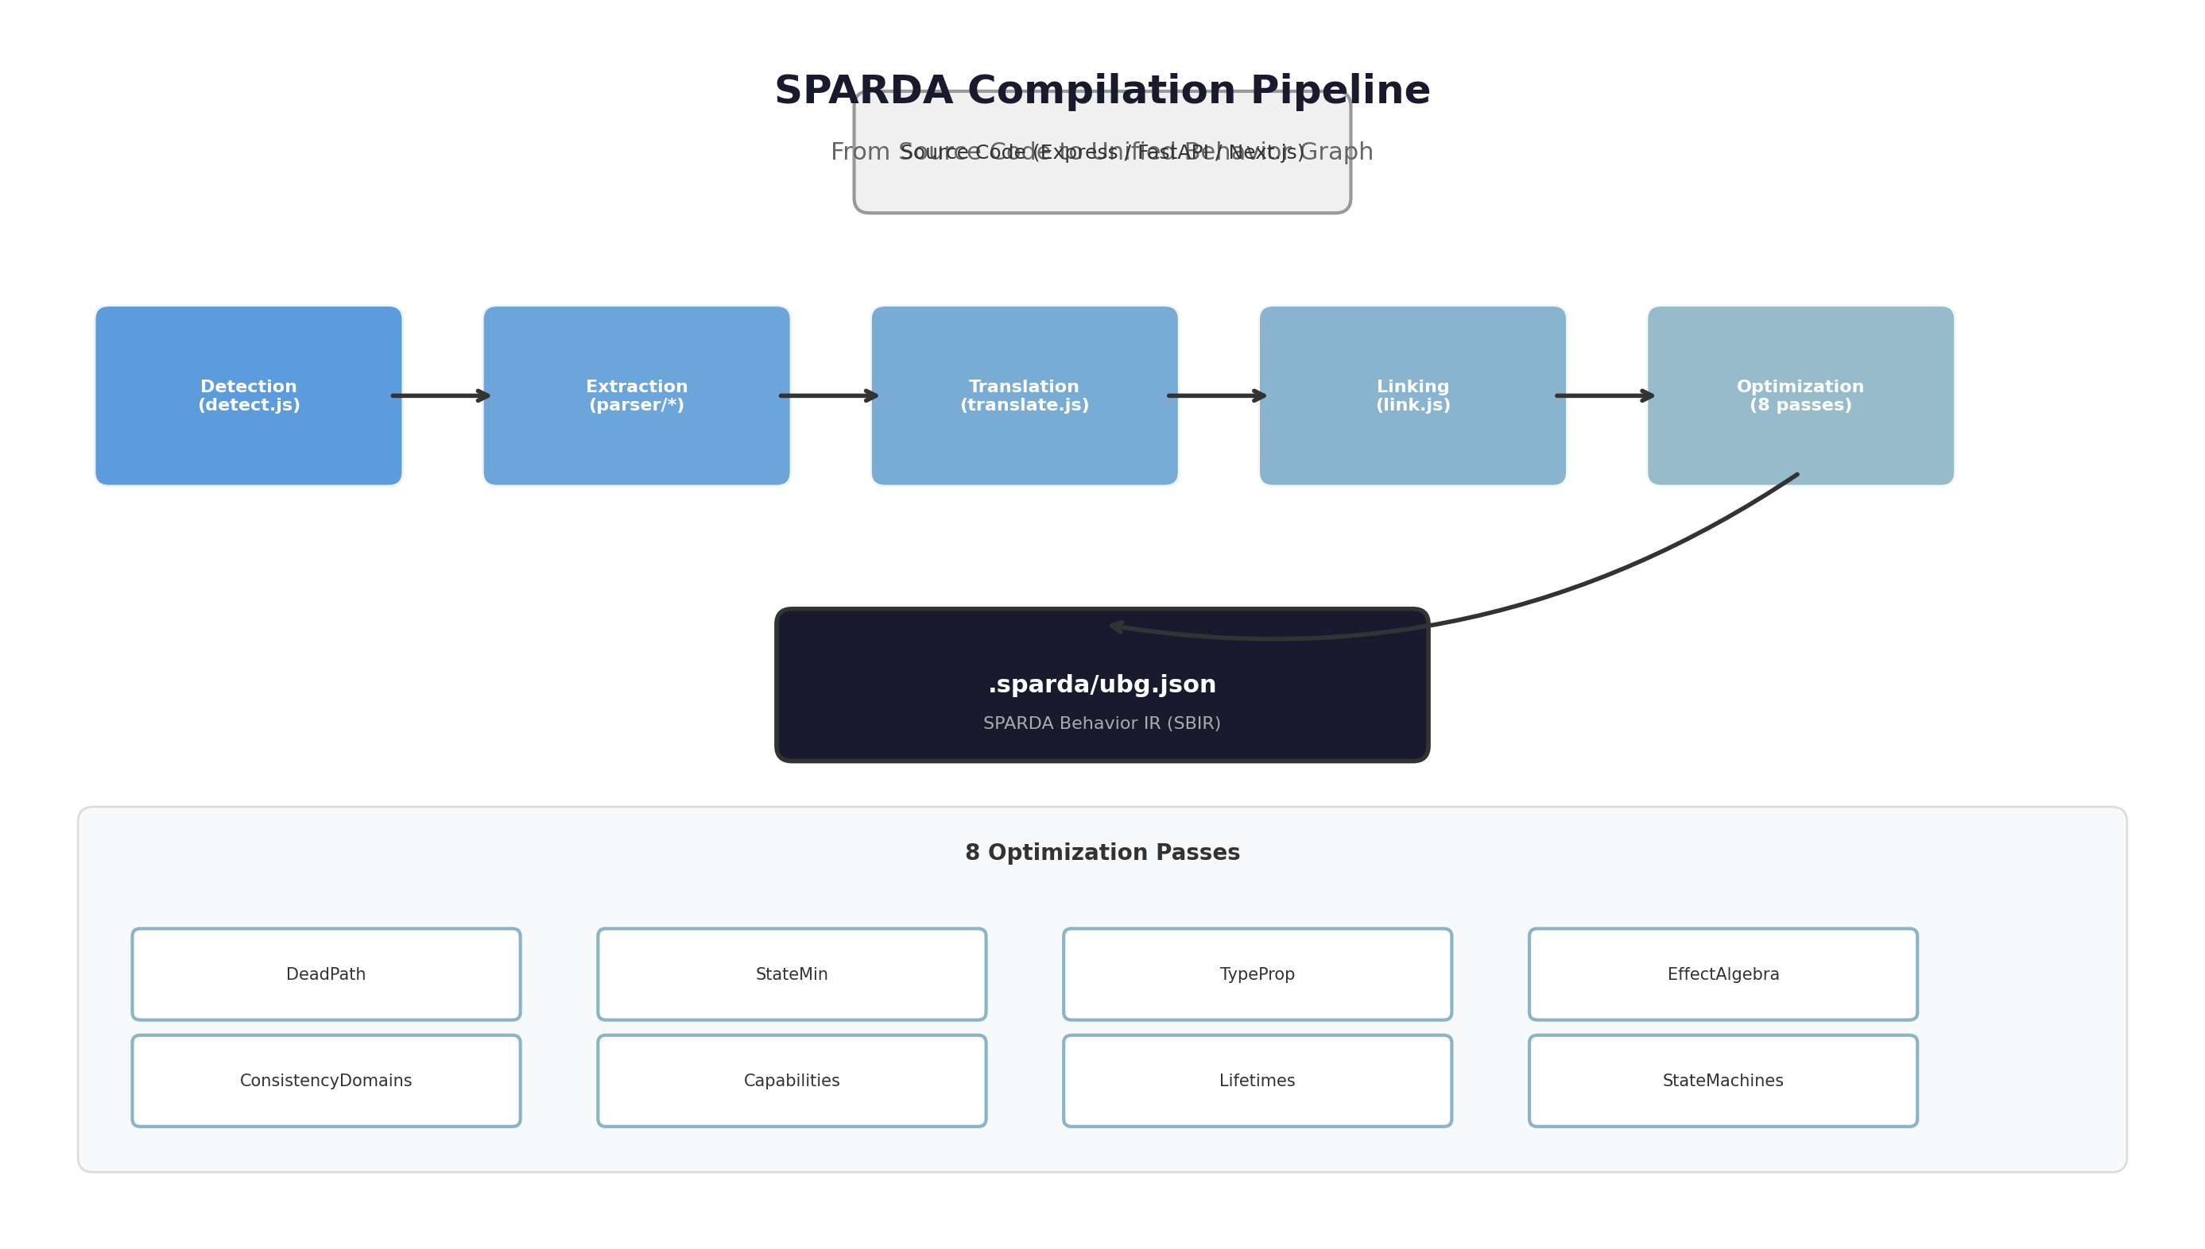
Figure 1: SPARDA Compilation Pipeline - From Source Code to UBG

AI Writes. SPARDA Proves.
The core value proposition is mathematical rigor applied to backend behavior. In v0.26.0, the engine audited 3,700+ routes across Next.js Dub, NestJS Immich, and MedusaJS in under 2.2 seconds without a single crash.
This is not marketing. This is a deterministic compiler producing a mathematical artifact (the UBG) from which proofs are derived:
- No guard can be silently deleted - apocalypse diffs against baseline and blocks CI on any Critical finding.
- No mutation goes unproven - write tools ship disabled; proof-after-write confirms the real effect.
- No regression passes undetected - behavioral diff in CI catches blast radius expansion.

2. Installation & Quickstart

Prerequisites
- Node.js >= 18.0 (LTS recommended)
- Git repository initialized in your project
- Supported framework: Express 4/5, FastAPI (Python >= 3.9), or Next.js App Router (13/14/15)

Step 1: Initialize SPARDA
Run once from your application's root directory. SPARDA parses your routes (AST), generates a marked /mcp router, injects it into your app (with a full backup), and writes sparda.json. Every step is reversible.
npx sparda-mcp init
The init command performs the following operations:
- Framework detection via dependency analysis (package.json, requirements.txt)
- Entry file resolution (package.main, scripts, conventional paths, content check for express()/FastAPI())
- Port inference (literal, .env, PORT=n patterns; defaults 3000/8000)
- Module type detection (ESM/CJS via extension, pkg.type, import/require heuristics)
- AST-based route extraction with toolNameFor() collision-free snake_case naming
- Docstring sanitization (prompt-injection defense - regex deny-list, 300-char cap)
- Marked router injection with automatic backup and post-injection re-parse

Step 2: Start the MCP Bridge
Start your application normally, then launch the SPARDA bridge in a separate terminal:
npx sparda-mcp dev
The bridge connects to your running app and exposes the UBG as MCP tools. The init command printed a ready-to-paste block for claude_desktop_config.json:
{
"mcpServers": {
"your-app": {
"command": "npx",
"args": ["sparda-mcp", "dev"],
"cwd": "/absolute/path/to/your-app"
}
}
}
Claude Code, Claude Desktop, and any MCP-compatible client can connect to this bridge. Your running app is now a set of MCP tools your AI can call - with warm DB pools, real auth chain, real data.

Step 3: Standalone Demo
To see SPARDA in action instantly, without modifying your codebase:
npx sparda-mcp demo
This runs the entire MCP lifecycle (detect, parse, generate, inject, remove) on a bundled demo app in a temporary folder, in approximately 10 seconds.

Removal
SPARDA leaves your codebase byte-for-byte when removed. Tested on JS, TS, Python, even Windows CRLF files. No trace, no lock-in.
npx sparda-mcp remove

3. CLI Reference
Every SPARDA command is a pass over the Unified Behavior Graph. No command re-parses source code; all operate on the compiled .sparda/ubg.json artifact.
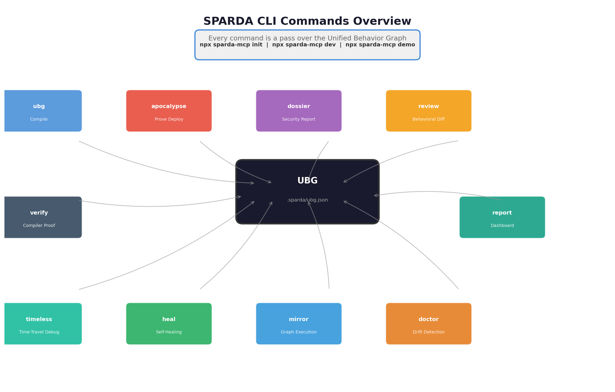
Figure 2: SPARDA CLI Commands - All operations pass over the UBG

sparda ubg - Behavior Compilation
Compiles the codebase into its behavior graph. This is the foundational command upon which all others depend.
npx sparda-mcp ubg [options]
Options:
- --openapi <spec.yaml>: Compile any backend (Go, Java, Laravel, .NET) via an OpenAPI 3.1 specification instead of native AST parsing.
- --output <path>: Custom output path for ubg.json (default: .sparda/ubg.json).
The compilation pipeline executes eight optimization passes:
Pass | Description
DeadPath | Eliminates unreachable graph nodes (routes with no handler, orphaned middleware).
StateMin | Minimizes state representations by deduplicating identical state nodes.
TypeProp | Propagates type information through the graph (request body, query params, path params).
EffectAlgebra | Composes side-effect annotations (db read, db write, HTTP call, file system, random/clock).
ConsistencyDomains | Identifies transaction boundaries and aggregate consistency scopes.
Capabilities | Infers permission requirements from middleware chains and guard annotations.
Lifetimes | Tracks resource lifecycle (connection pool, transaction scope, request context).
StateMachines | Extracts state machines from Prisma enums and explicit state transitions.

Output: .sparda/ubg.json - a canonical, content-hashed artifact conforming to the SBIR specification.

sparda apocalypse - Formal Deploy Proof
Proves the current tree is safe to deploy. No guard, invariant, transaction, or aggregate boundary can be broken. Outputs SARIF for GitHub Security tab integration.
npx sparda-mcp apocalypse [options]
Options:
- --save-baseline: Save current UBG as the security baseline for subsequent diff comparison.
- --sarif: Output findings in SARIF format for GitHub Security tab ingestion.
- --ci: Non-interactive mode; exits with non-zero code on Critical/High findings to block CI pipeline.
The five formal proof rules:
Rule | Severity | Description
UNGUARDED_MUTATION | Critical | A POST/PUT/DELETE route lacks an explicit guard, permission check, or transaction boundary.
NON_ATOMIC_AGGREGATE_WRITE | Critical | An aggregate (entity cluster) is modified across multiple non-transactional operations.
GUARD_DELETION | Critical | A security guard present in the baseline is absent in the current graph. Blocks CI.
INVARIANT_VIOLATION | High | A database invariant (uniqueness, foreign key, check constraint) is not enforced by the code path.
BLAST_RADIUS_EXPANSION | Medium | An existing route's capability set has grown (new params, new db effects) compared to baseline.

CI Integration (GitHub Actions):
- uses: zyx77550/sparda@main
with:
sarif: 'true'

sparda dossier - Security Matrix Report
Generates a premium HTML security report aggregating all proof results, tool inventory, and behavioral metrics into a single navigable document.
npx sparda-mcp dossier [options]
Options:
- --output <path>: Custom output path (default: .sparda/dossier.html).
- --theme <dark|light>: Report color scheme (default: dark).
The dossier includes: route inventory with method/path/tool mapping, guard coverage heatmap, effect type distribution, permission matrix, UBG topology visualization, and apocalypse findings with severity coloring.

sparda review - Behavioral Diff in CI
Computes the behavioral diff between the current working tree and the compiled baseline. Detects semantic changes that syntactic diffs miss.
npx sparda-mcp review [options]
Detectable changes:
- Route addition/deletion (new endpoints, removed endpoints).
- Parameter schema changes (new required params, type widening).
- Effect kind changes (a read-only route now writes to the database).
- Guard changes (permission requirements added or removed).
- Blast radius changes (response shape modifications affecting downstream consumers).

sparda timeless - Time-Travel Debugging
Records production requests at deterministic points (db, HTTP, clock, random, UUID - the effect nodes), then replays byte-identically against current code with virtualized dependencies.
npx sparda-mcp timeless # list recorded flights
npx sparda-mcp timeless replay <id> # re-fly byte-identical
npx sparda-mcp timeless export <id> # export as vitest test
Recording setup in your application (ESM):
import { getFlightBox } from 'sparda-mcp/src/flight/box.js';
const box = getFlightBox();
box.arm();
app.use(box.middleware({ sample: 100 })); // 1 in 100; passwords/tokens redacted
const db = box.wrapClient(pgPool); // your query client, tapped
The closed loop: production bug -> recorded flight -> failing test -> AI writes fix -> apocalypse proves fix correctness -> deploy.
Note: Replay is per-request. Concurrent-race capture is out of scope for v1 - stated, not hidden.

sparda heal - Closed-Loop Self-Healing
The complete healing loop as one gesture. The machine judges the fix, whoever wrote it.
npx sparda-mcp heal <flightId> # diagnose + write fix brief
# ...apply the fix (human or --agent your-ai-cli)...
npx sparda-mcp heal <flightId> --check --expect '{"status":404}'
The brief is built from the graph itself: handler file:line, capabilities the fix must not grow, guards it must not remove. The gate proves the fix on three axes simultaneously:
- Behavior: Lenient replay produces the expected response, not the recorded bug. The fix may reformulate a query (tap relabeling allowed); it may not change effect order or kinds.
- Compiler laws: verify still passes - the graph remains sound and deterministic.
- No regression: apocalypse diff against frozen pre-fix graph - zero new critical/high findings, no guard removed, no blast radius grown.
Output: HEALED & PROVEN - same recorded inputs, correct output, zero law broken, zero protection lost. Ship it. An unfixed bug or a fix that silently drops a guard keeps the gate closed (exit 1).

sparda mirror - Graph Execution
Serves the compiled behavior over HTTP with no framework and no source code. Mock HTTP directly from the UBG.
npx sparda-mcp mirror [options]
Options:
- --port <n>: Override the default port (uses the port from detect).
- --ubg <path>: Use a specific UBG file instead of .sparda/ubg.json.
Useful for: integration testing without the full app, API prototyping from the behavior graph, contract testing against the compiled specification.

sparda doctor - Drift Detection
Audits the codebase for drift: stale tools (AI seeing ghosts), unsynced routes, schema drift via fingerprints, and zombie configurations.
npx sparda-mcp doctor --app
Detects: routes that exist in code but not in the manifest, routes that exist in the manifest but not in code, schema fingerprint mismatches (request/response shapes changed), configuration drift (sparda.json out of sync with generated files). High severity issues trigger non-zero exit code for CI pipeline integration.

sparda verify - Compiler Law Proof
Proves the compiler's own mathematical laws on your application: determinism, soundness, and round-trip correctness.
npx sparda-mcp verify
Three proofs:
- Determinism: Same source code always produces the same UBG (content-hash stable).
- Soundness: Every UBG node corresponds to a construct in the source; no synthetic nodes introduced.
- Round-trip: UBG -> OpenAPI emission -> re-compilation produces an equivalent graph.

sparda report - System Dashboard
Prints a terminal dashboard aggregating the SPARDA organism's current state.
npx sparda-mcp report
Displays: exposed tools (count, method breakdown), write opt-ins (enabled vs total write tools), proof journal decisions (apocalypse run history), crystallized composite tools, immune system state (antibodies, quarantine status), recycling metrics (tokens saved via semantic cache and antibody hits).

4. AI Integration - MCP Server & Immunity
The MCP runtime is the interactive output of the behavior compiler. It is not a separate product - it is one consumer of the UBG, alongside apocalypse, mirror, and verify.
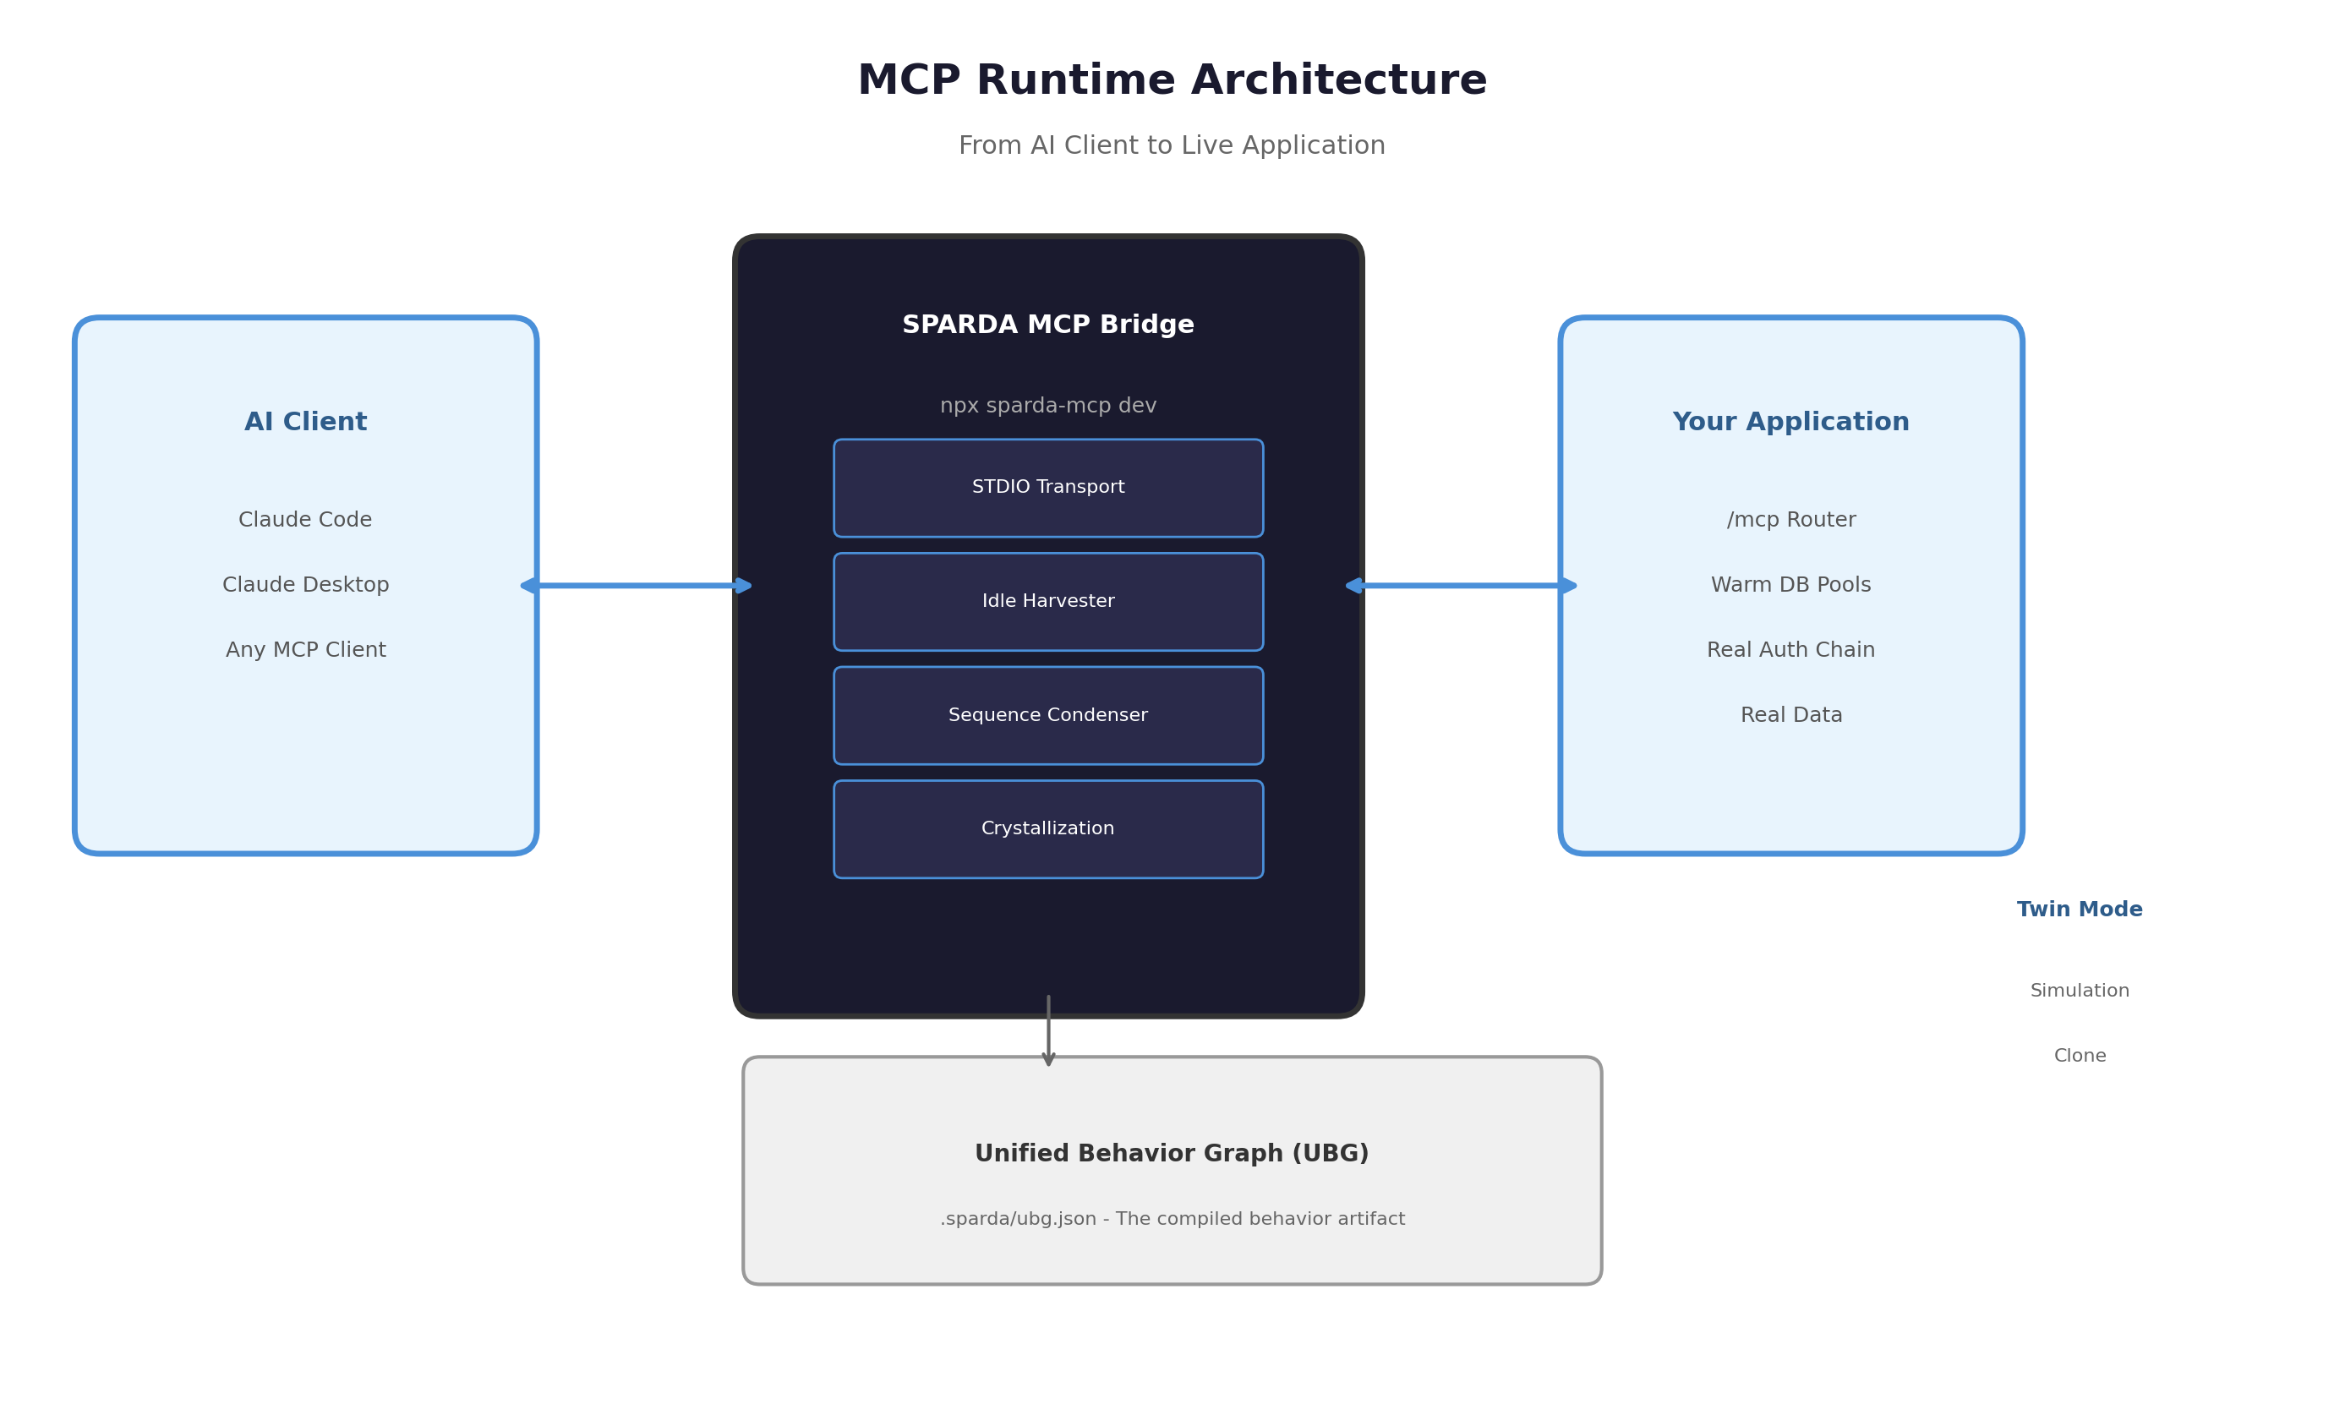
Figure 3: MCP Runtime Architecture - AI Client to Live Application

The /mcp Router & AST Injection
During init, SPARDA injects a tiny marked router at /mcp into your application. The injection is AST-positioned, backed up, and fully reversible. Tool calls run inside your live app process - warm DB pools, real auth chain, real data.
The bridge (npx sparda-mcp dev) connects your running app to MCP clients. It adds no infrastructure: compute comes from your host process, intelligence from your AI client's own model (MCP sampling), storage from sparda.json + git.
Key runtime components:
Component | File | Function
MCP Bridge | src/server/stdio.js | STDIO transport connecting the app to MCP clients.
Idle Harvester | src/server/idle.js | Internal jobs run only when event loop is quiet.
Sequence Condenser | src/server/condenser.js | Records session calls in a 20-entry ring.
Crystallization | src/server/crystallize.js | At 3 observations, circuits become composite tools.
Sync Engine | src/commands/sync.js | Re-parses source, diffs against manifest.
Git Hook | src/commands/hook.js | Marked post-commit hook running sync --quiet.

Write Safety: Disabled by Default
Every POST/PUT/DELETE tool ships disabled. You enable per tool in sparda.json; your choice survives every re-init.
An enabled write is never executed on the first call. SPARDA returns an awaiting_confirmation envelope - a single-use token plus a preview of the action - and commits only after an explicit confirm step:
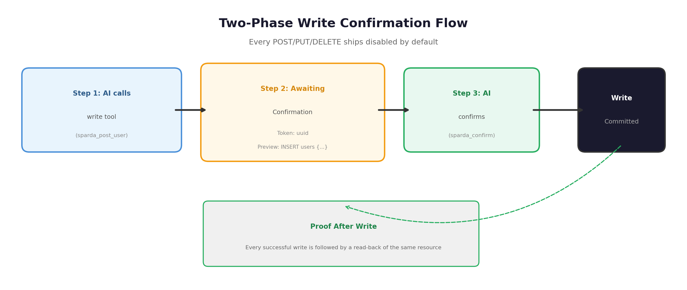
Figure 4: Two-Phase Write Confirmation Flow
// Step 1: AI calls the write tool
const result = await client.callTool('sparda_post_user', { name: 'Alice', role: 'admin' });
// Returns: { status: 'awaiting_confirmation', token: 'uuid', preview: { operation: 'INSERT', table: 'users', row: {...} } }

// Step 2: AI must call sparda_confirm with the token
await client.callTool('sparda_confirm', { token: 'uuid' });
// Only then is the write committed.
When your client supports MCP elicitation, the confirmation prompt appears in the AI's own UI. After confirmation, proof-after-write: every successful write is followed by a read-back of the same resource, so the AI - and you - see the real effect, not a hopeful guess.
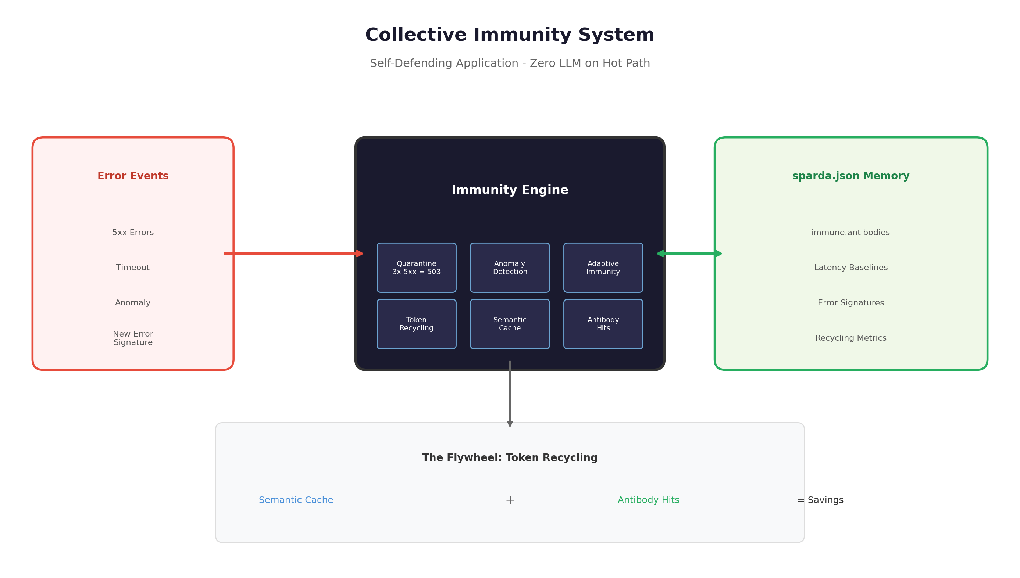
Figure 5: Collective Immunity System - Self-Defending Application

Collective Immunity
Your app defends itself. Zero LLM on the hot path.
Quarantine: A tool that returns 3 consecutive 5xx is quarantined. Further calls get a 503 with a reason and a retry delay instead of hammering your broken route. After a cooldown period, the route half-opens for a single probe.
Latency & Anomaly Flags: The router learns each route's baseline latency and flags deviations locally using a few lines of mathematical anomaly detection.
Adaptive Immunity: Each error event is matched against manifest.immune.antibodies by signature source|tool|status. Known errors -> cached diagnosis attached, zero tokens. Unknown -> one sampling call (sanitized, capped at 50 antibodies) -> stored in sparda.json.
The immunity data structure in sparda.json:
"immune": {
"antibodies": {
"source|tool|status": {
"diagnosis": "Foreign key constraint failed on users.role_id",
"firstSeen": "2025-01-15T10:30:00Z",
"lastSeen": "2025-07-13T14:22:00Z",
"hits": 47
}
}
}

The Flywheel: Token Recycling
The bridge counts sampling calls avoided by cached knowledge. Two mechanisms:
- Semantic Cache: Tool descriptions and workflow suggestions cached at startup. Avoids redundant sampling calls for identical context.
- Antibody Hits: Known error diagnoses served from local cache instead of triggering LLM sampling.
Recycling metrics are exposed in sparda_get_context under recycling.lifetime_savings (derived from antibody hit count).

Twin Mode: Simulation Clone
Starts a safe, simulated mock server of your backend on the original port. Serves GET calls from learned exemplars (observed response shapes and mock data) and returns simulated 202 writes without ever touching your real database or production APIs.
npx sparda-mcp twin # start the twin server
npx sparda-mcp twin --learn # learn exemplars from real traffic
Useful for: frontend development without the backend running, integration testing with deterministic responses, safe AI experimentation without production data risk.

Circuit Crystallization (Labs)
An experimental feature (default OFF) that detects and crystallizes frequently-observed tool call sequences into composite tools.
Sequence detection: The condenser records session calls in a 20-entry ring buffer and detects circuits - an output value of tool A feeding an argument of tool B (deterministic value match, conservative noise floor). Persists structure only (tool names, arg names, link fromKeys, counts - never values).
Crystallization trigger: At 3 observations, an enabled-GET-only circuit with traceable data flow becomes a composite tool. The composite is named via sanitized sampling (deterministic fallback without sampling), announced via tools/list_changed mid-session, and calling it runs the chain step-by-step with auto-fed linked args via fromKey.
Safety constraints: Write steps are never absorbed (per-call confirmation stands, ADR-004). Composites are re-validated against current tools at every bridge start. Maximum 30 circuits tracked.
// Enable in sparda.json
"labs": {
"recordSequences": true
}

5. Supported Frameworks
SPARDA parses Express, FastAPI, and Next.js natively. Every other stack compiles via OpenAPI 3.1 - the format the industry already agreed on.
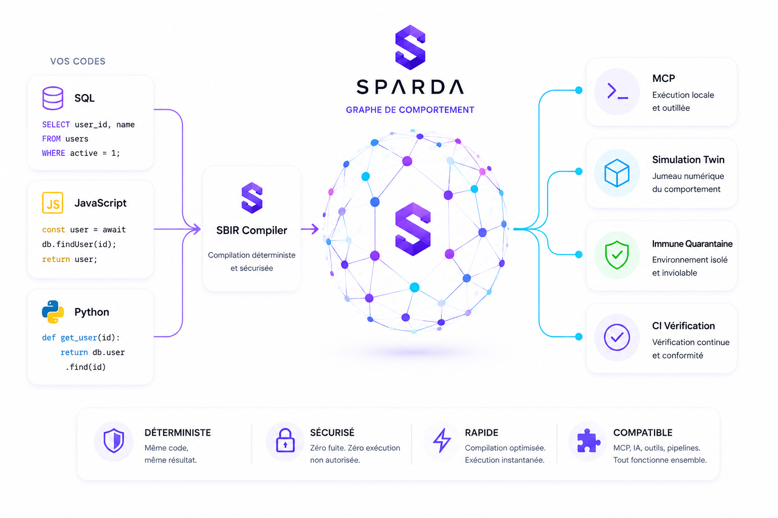
Figure 6: SPARDA Feature Overview

Next.js App Router (13/14/15)
File-system routing detection. SPARDA creates a catch-all route handler under app/mcp/[...sparda]/route.js. Nothing in your existing codebase is touched; running remove simply deletes the generated file.
Capabilities:
- Route extraction from app/ directory tree (page.js, route.js, layout.js boundaries).
- Server Component vs Client Component detection (use server directives).
- Middleware chain resolution (auth, rate limiting, CORS).
- Dynamic route segment extraction ([id], [...catchall]).
- Revalidation and cache control annotation detection.

NestJS - Deep Dependency Injection Resolution
Multi-hop DI resolution: Controller -> Service -> Repository. SPARDA follows the NestJS decorator chain to understand the full behavior graph including injected services, guards, interceptors, and pipes.
Capabilities:
- @Controller, @Injectable, @Module decorator parsing.
- Guard and interceptor chain resolution (@UseGuards, @UseInterceptors).
- DTO validation pipe detection (@Body, @Query, @Param with class-validator).
- Custom provider and factory provider resolution.
- TypeORM/Prisma/Mongoose repository pattern detection.

Express 4/5 & MedusaJS
AST-based router injection for JavaScript and TypeScript (ESM and CJS). The most mature extraction path.
Capabilities:
- Literal-path route extraction (app.get('/user', ...), routers, mounted prefixes).
- Path param and query param extraction from inline handler bodies.
- Middleware chain resolution (app.use ordering, router-level middleware).
- External controller file detection and analysis.
- MedusaJS plugin and service pattern recognition.

OpenAPI 3.1 - Any Backend On Earth
Go, Java, Rails, Laravel, .NET: if it has an OpenAPI spec, it compiles. This is the universal lowering path.
npx sparda-mcp ubg --openapi ./specs/api.yaml
The OpenAPI extractor maps paths to UBG routes, requestBody to effect annotations, responses to state nodes, and securitySchemes to capability requirements. Three minutes, one command.

6. Security & Threat Model
Honest by design: defenses first, known gaps last. No false promises.
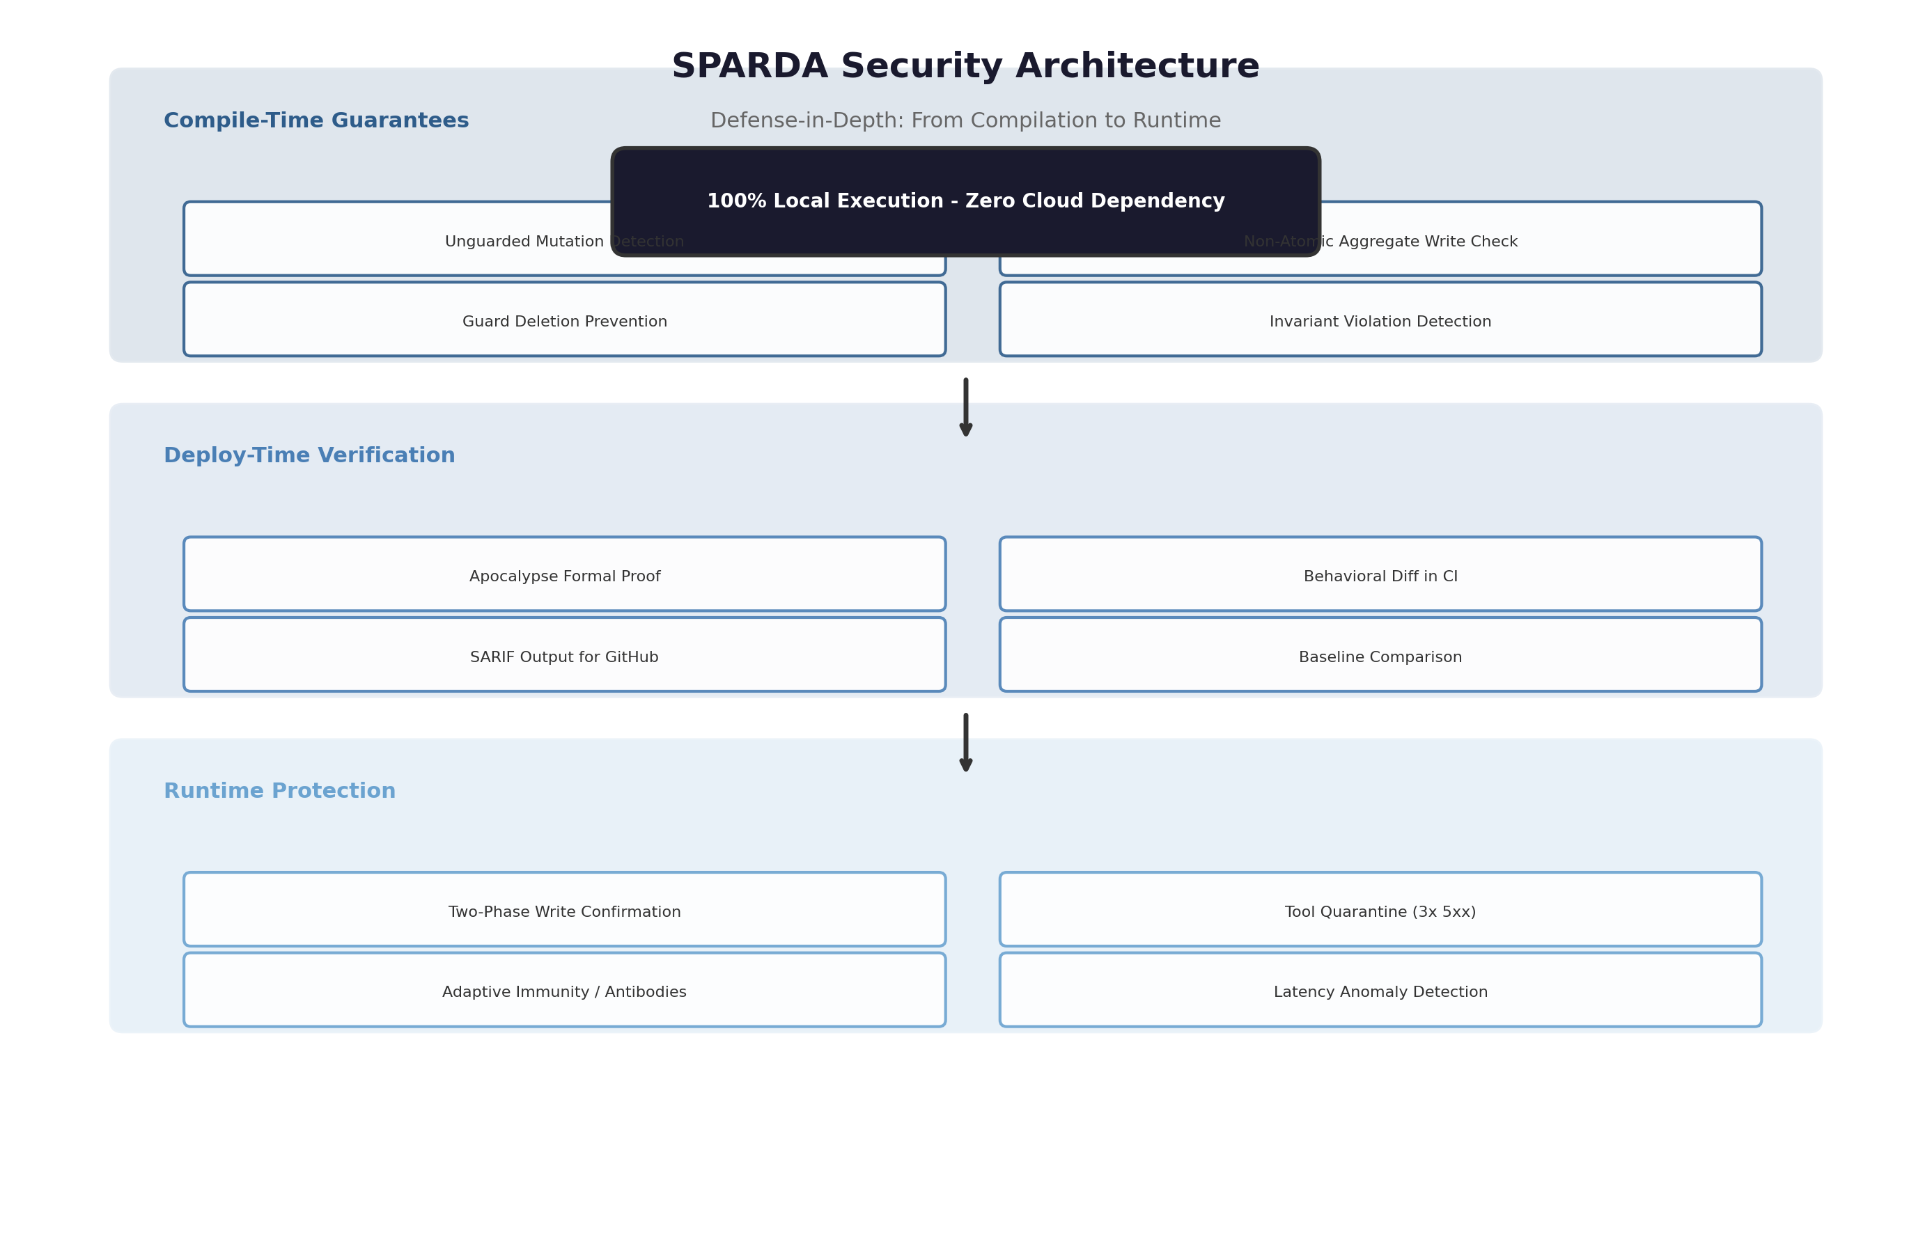
Figure 7: SPARDA Security Architecture - Defense in Depth

100% Local Execution
No telemetry to Residual Labs. No cloud account required. No server to host. Four runtime dependencies, exact-pinned. SPARDA is a local organism: compute from your host process, intelligence from your AI client's own model, storage from sparda.json + git.
Dependencies (exact-pinned in package.json):
- @babel/parser: AST parsing for Express/Next.js extraction.
- @babel/traverse: AST traversal for route discovery.
- @modelcontextprotocol/sdk: MCP protocol implementation.
- minimatch: Glob pattern matching for file inclusion/exclusion.

Dynamic Local Key Resolution
ADR-022: No plaintext key in sparda.json or generated routes. Authorization keys resolved at runtime from SPARDA_LOCAL_KEY environment variable or the local gitignored .sparda/key file. Fails closed (503) when neither is found. An accidental commit or deploy of /mcp routes is safe by construction.
Security controls on every router call:
Control | Implementation
Key requirement | x-sparda-key (UUID) required on every /mcp/* endpoint; 401 otherwise.
Key at rest | Resolved at runtime from SPARDA_LOCAL_KEY env -> .sparda/key; never in source.
Self-reference protection | /mcp* paths blocked at parse time and invoke time.
Timeout | 30-second hard timeout on all tool invocations.
Output truncation | 8KB maximum output per tool call.
Resource limits | 100-entry events ring buffer, 50-antibody cap, O(tools) stats.

Honest Posture: Guarantees vs Limits
What SPARDA guarantees:
- Every POST/PUT/DELETE ships disabled. No write tool is ever enabled by default.
- Every enabled write requires explicit two-phase confirmation (awaiting_confirmation + sparda_confirm).
- Prompt injection defense: suspicious docstrings are sanitized before reaching the AI (regex deny-list, 300-char cap, <>{} stripped).
- Quarantine after 3 consecutive 5xx errors prevents error-loop hammering.
- All persistence is value-free: tool names, field names, fingerprints - never your payloads.
Known gaps (honestly stated):
- Key comparison is ==, not constant-time. The key guards a loopback interface (not internet-exposed), so timing side-channel is low-impact - but it is a deviation from best practice.
- Replay is per-request. Concurrent-race capture is out of scope for v1.
- Sampling responses (semantic pass, immune diagnoses) are untrusted input that we persist and re-show. The sanitizer mitigates but does not eliminate this risk.
Full threat model: github.com/zyx77550/sparda/blob/HEAD/docs/SECURITY.md

Appendix: sparda.json Schema
The organism's memory - lives in your repo, versioned with git, surviving every re-init.
{
"version": 1,
"framework": "express" | "fastapi" | "nextjs",
"entryFile": "src/app.js",
"moduleType": "esm",
"port": 3000,
"localKey": "<uuid>",
"generatedFiles": ["src/sparda-router.js"],
"injectedFiles": ["src/app.js"],
"createdAt": "...",
"tools": {
"<name>": { "method", "path", "enabled", "write": false }
},
"semantic": {
"enrichedAt", "source",
"descriptions": {},
"workflows": []
},
"immune": {
"antibodies": {
"source|tool|status": {
"diagnosis", "firstSeen", "lastSeen", "hits"
}
}
},
"labs": {
"recordSequences": false,
"circuits": {
"toolA>toolB": {
"steps": [],
"links": [{"from", "to", "arg", "fromKey"}],
"seen", "firstSeen", "lastSeen",
"composite": {"name", "description", "source", "createdAt"}
}
}
}
}
All fields under immune and labs contain structure only - tool names, argument names, counts. No user data, no payload values, no business logic.

SPARDA
The LLVM of web applications
github.com/zyx77550/sparda | npm: sparda-mcp
Residual Labs | Business Source License 1.1 | v0.26.0

