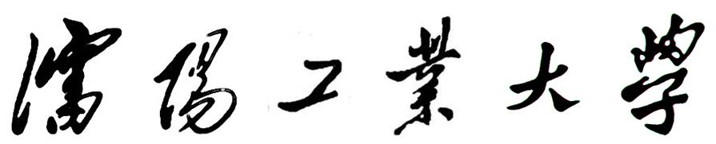

**实验报告**

**（程序设计课程实践类）**

|  |  |  |  |
| --- | --- | --- | --- |
| **课程名称：** | **软件开发实践** | | |
| **实验时间:** | **2022.2.26** | **~** | **2022.3.17** |
| **实验地点：** | **图书馆-中央2** | | |
| **学 院：** | **软件学院** | | |
| **姓 名：** | **宗艺萱** | | |
| **学 号：** | **211230218** | | |
| **专 业：** | **软件工程** | | |
| **班 级：** | **软件工程2102班** | | |
| **指导教师：** | **孙淑杰** | | |
| **评阅时间：** |  | | |
| **成 绩：** |  | | |

**沈阳工业大学软件学院**

**2022年 3月 17日**

**实验 酒店管理系统**

1. **实验目的**

(1)了解JAVA语言的swing组件的使用。

(2)拥有良好的程序逻辑并能通过基本语句具现化

(3)了解MYSQL的基本语句，如增、删、改、查。

(4)能够利用jdbc连接程序与数据库。

(5)能够利用navicat简化数据库的设计。

(6)能够通过查阅资料正确设置各种驱动、参数。

(7)小组能够完成程序的排查报错和修复。

(8)能够封装出可移植、鲁棒性强的api

1. **实验内容**

使用java编写酒店管理系统，使用mysql存储相关数据，力求软件具有高可用性

本项目已发布在 gitee(国内)：<https://gitee.com/cnzyx/hotel-management>

github(国外): <https://github.com/zyxcn/hotel-management>

1. **分析与设计**

1.开发环境：openjdk17, IntelliJ IDEA IDE,jar打包于jdk1.8。

2. 文件架构：

软件包名：cn.edu.sut.hotel_management

主类：cn.edu.sut.hotel_management.Main

模块说明：model --用于存储文件模型

sql --用于存储封装好的数据库操作

ui --用于存储用于存储界面代码

ui.component -- 用于存储ui组件

util --存储比较底层的接口封装

3.文件结构：

1. **代码设计**

|  |
| --- |
| Main.java |
| package cn.edu.sut.hotel_management;  import cn.edu.sut.hotel_management.ui.Login;  public class Main {  public static void main(String[] args) {  Login l = new Login();  l.setVisible(true);  } } |

|  |
| --- |
| admin.java |
| package cn.edu.sut.hotel_management.model;  import java.util.Objects;  public class admin {  private int id;  private String name;  private String account;  private String password;  private String user_name;  private String img_url;  private String id_card;  private String tel;   public admin(String account, String password) {  this.account = account;  this.password = password;  }   public admin() {  }   public admin(int id, String name, String account, String password, String user_name, String img_url, String id_card, String tel) {  this.id = id;  this.name = name;  this.account = account;  this.password = password;  this.user_name = user_name;  this.img_url = img_url;  this.id_card = id_card;  this.tel = tel;  }   @Override  public String toString() {  return "admin{" +  "id=" + id +  ", name='" + name + '\'' +  ", account='" + account + '\'' +  ", password='" + password + '\'' +  ", user_name='" + user_name + '\'' +  ", img_url='" + img_url + '\'' +  ", id_card='" + id_card + '\'' +  ", tel='" + tel + '\'' +  '}';  }   @Override  public boolean equals(Object o) {  if (this == o) return true;  if (o == null || getClass() != o.getClass()) return false;  admin admin = (admin) o;  return account.equals(admin.account) && password.equals(admin.password);  }   @Override  public int hashCode() {  return Objects.hash(account, password);  } } |

|  |
| --- |
| curuser.java |
| package cn.edu.sut.hotel_management.model;  import java.util.Objects;  public class curuser {  public static long id;  private static String img_url;  private static String name;  private static String id_card;  private static String sex;  private static String tel;  private static String status;  private static String account;  private static String user_name;  private static String password;   public curuser(long id, String img_url, String name, String id_card, String sex, String tel, String status, String account, String user_name, String password) {  curuser.id = id;  curuser.img_url = img_url;  curuser.name = name;  curuser.id_card = id_card;  curuser.sex = sex;  curuser.tel = tel;  curuser.status = status;  curuser.account = account;  curuser.user_name = user_name;  curuser.password = password;  }   public static long getId() {  return id;  }   public static void setId(long id) {  curuser.id = id;  }   public static String getImg_url() {  return img_url;  }   public static void setImg_url(String img_url) {  curuser.img_url = img_url;  }   public static String getName() {  return name;  }   public static void setName(String name) {  curuser.name = name;  }   public static String getId_card() {  return id_card;  }   public static void setId_card(String id_card) {  curuser.id_card = id_card;  }   public static String getSex() {  return sex;  }   public static void setSex(String sex) {  curuser.sex = sex;  }   public static String getTel() {  return tel;  }   public static void setTel(String tel) {  curuser.tel = tel;  }   public static String getStatus() {  return status;  }   public static void setStatus(String status) {  curuser.status = status;  }   public static String getAccount() {  return account;  }   public static void setAccount(String account) {  curuser.account = account;  }   public static String getUser_name() {  return user_name;  }   public static void setUser_name(String user_name) {  curuser.user_name = user_name;  }   public static String getPassword() {  return password;  }   public static void setPassword(String password) {  curuser.password = password;  }   public static void logout() {  curuser.id = 0;  curuser.img_url = null;  curuser.name = null;  curuser.id_card = null;  curuser.sex = null;  curuser.tel = null;  curuser.status = null;  curuser.account = null;  curuser.user_name = null;  curuser.password = null;  }   @Override  public boolean equals(Object o) {  if (this == o) return true;  if (o == null || getClass() != o.getClass()) return false;  curuser curuser = (curuser) o;  return account.equals(account) && password.equals(password);  }   @Override  public int hashCode() {  return Objects.hash(account, password);  }   @Override  public String toString() {  return "user{" +  "id=" + id +  ", img_url='" + img_url + '\'' +  ", name='" + name + '\'' +  ", id_card='" + id_card + '\'' +  ", sex='" + sex + '\'' +  ", tel='" + tel + '\'' +  ", status='" + status + '\'' +  ", account='" + account + '\'' +  ", user_name='" + user_name + '\'' +  ", password='" + password + '\'' +  '}';  } } |

|  |
| --- |
| order.java |
| package cn.edu.sut.hotel_management.model;  import java.util.Objects;  public class order {  private long id;  private String begin;  private int stay;  private float prepay;  private float pay;  private float rental;  private String id_card;  private String name;  private String phone;   public order(long id) {  this.id = id;  }   public order(long id, String begin, int stay, float prepay, float pay, float rental) {  this.id = id;  this.begin = begin;  this.stay = stay;  this.prepay = prepay;  this.pay = pay;  this.rental = rental;  }   public order(long id, String begin, int stay, float prepay, float pay, float rental, String id_card, String name, String phone) {  this.id = id;  this.begin = begin;  this.stay = stay;  this.prepay = prepay;  this.pay = pay;  this.rental = rental;  this.id_card = id_card;  this.name = name;  this.phone = phone;  }   public order() {  }   public long getId() {  return id;  }   public void setId(long id) {  this.id = id;  }   public String getBegin() {  return begin;  }   public void setBegin(String begin) {  this.begin = begin;  }   public int getStay() {  return stay;  }   public void setStay(int stay) {  this.stay = stay;  }   public float getPrepay() {  return prepay;  }   public void setPrepay(float prepay) {  this.prepay = prepay;  }   public float getPay() {  return pay;  }   public void setPay(float pay) {  this.pay = pay;  }   public float getRental() {  return rental;  }   public void setRental(float rental) {  this.rental = rental;  }   public String getId_card() {  return id_card;  }   public void setId_card(String id_card) {  this.id_card = id_card;  }   public String getName() {  return name;  }   public void setName(String name) {  this.name = name;  }   public String getPhone() {  return phone;  }   public void setPhone(String phone) {  this.phone = phone;  }   @Override  public boolean equals(Object o) {  if (this == o) return true;  if (o == null || getClass() != o.getClass()) return false;  order order = (order) o;  return id == order.id;  }   @Override  public int hashCode() {  return Objects.hash(id);  }   @Override  public String toString() {  return "order{" +  "id=" + id +  ", begin='" + begin + '\'' +  ", stay='" + stay + '\'' +  ", prepay='" + prepay + '\'' +  ", pay='" + pay + '\'' +  ", rental='" + rental + '\'' +  '}';  }   } |

|  |
| --- |
| price.java |
| package cn.edu.sut.hotel_management.model;  public class price {  private final int id;  private final float money;  private final float prepay;   public price(int id, float money, float prepay) {  this.id = id;  this.money = money;  this.prepay = prepay;  }  } |

|  |
| --- |
| relation.java |
| package cn.edu.sut.hotel_management.model;  import java.util.Objects;  public class relation {  private final int id;  private final long user_id;  private final int room_id;  private final long order_id;  private final int admin_id;  private final String status;   public relation(int id, long user_id, int room_id, long order_id, int admin_id, String status) {  this.id = id;  this.user_id = user_id;  this.room_id = room_id;  this.order_id = order_id;  this.admin_id = admin_id;  this.status = status;  }   @Override  public boolean equals(Object o) {  if (this == o) return true;  if (o == null || getClass() != o.getClass()) return false;  relation relation = (relation) o;  return id == relation.id && user_id == relation.user_id && room_id == relation.room_id && order_id == relation.order_id && admin_id == relation.admin_id;  }   @Override  public String toString() {  return "relation{" +  "id=" + id +  ", user_id=" + user_id +  ", room_id=" + room_id +  ", order_id=" + order_id +  ", admin_id=" + admin_id +  ", status='" + status + '\'' +  '}';  }   @Override  public int hashCode() {  return Objects.hash(id, user_id, room_id, order_id, admin_id);  } } |

|  |
| --- |
| room.java |
| package cn.edu.sut.hotel_management.model;  import java.util.Objects;  public class room {  private int id;  private String num;   private String type;   private float money;  private float prepay;   private String status;   public room(int id, String num, String type, float prepay, float money, String status) {  this.id = id;  this.num = num;  this.type = type;  this.money = money;  this.prepay = prepay;  this.status = status;  }   public int getId() {  return id;  }   public void setId(int id) {  this.id = id;  }   public String getNum() {  return num;  }   public void setNum(String num) {  this.num = num;  }   public String getType() {  return type;  }   public void setType(String type) {  this.type = type;  }   public float getMoney() {  return money;  }   public void setMoney(float money) {  this.money = money;  }   public float getPrepay() {  return prepay;  }   public void setPrepay(float prepay) {  this.prepay = prepay;  }   public String getStatus() {  return status;  }   public void setStatus(String status) {  this.status = status;  }   @Override  public String toString() {  return "room{" +  "id=" + id +  ", num='" + num + '\'' +  ", type='" + type + '\'' +  ", money=" + money +  ", prepay=" + prepay +  ", status='" + status + '\'' +  '}';  }   @Override  public boolean equals(Object o) {  if (this == o) return true;  if (o == null || getClass() != o.getClass()) return false;  room room = (room) o;  return id == room.id;  }   @Override  public int hashCode() {  return Objects.hash(id);  } } |

|  |
| --- |
| room_type.java |
| package cn.edu.sut.hotel_management.model;  public class room_type {  private final int id;  private final String type;   public room_type(int id, String type) {  this.id = id;  this.type = type;  }   @Override  public String toString() {  return "room_type{" +  "id=" + id +  ", type='" + type + '\'' +  '}';  } } |

|  |
| --- |
| user.java |
| package cn.edu.sut.hotel_management.model;  public class user {  public long id;  private String img_url;  private String name;  private String id_card;  private String sex;  private String tel;  private String status;  private String account;  private String user_name;  private String password;   public user(long id, String img_url, String name, String id_card, String sex, String tel, String status, String account, String user_name, String password) {  this.id = id;  this.img_url = img_url;  this.name = name;  this.id_card = id_card;  this.sex = sex;  this.tel = tel;  this.status = status;  this.account = account;  this.user_name = user_name;  this.password = password;  }   public user(long id, String name, String tel, String account, String user_name) {  this.id = id;  this.name = name;  this.tel = tel;  this.account = account;  this.user_name = user_name;  }   public long getId() {  return id;  }   public void setId(long id) {  this.id = id;  }   public String getImg_url() {  return img_url;  }   public void setImg_url(String img_url) {  this.img_url = img_url;  }   public String getName() {  return name;  }   public void setName(String name) {  this.name = name;  }   public String getId_card() {  return id_card;  }   public void setId_card(String id_card) {  this.id_card = id_card;  }   public String getSex() {  return sex;  }   public void setSex(String sex) {  this.sex = sex;  }   public String getTel() {  return tel;  }   public void setTel(String tel) {  this.tel = tel;  }   public String getStatus() {  return status;  }   public void setStatus(String status) {  this.status = status;  }   public String getAccount() {  return account;  }   public void setAccount(String account) {  this.account = account;  }   public String getUser_name() {  return user_name;  }   public void setUser_name(String user_name) {  this.user_name = user_name;  }   public String getPassword() {  return password;  }   public void setPassword(String password) {  this.password = password;  }   @Override  public String toString() {  return "user{" +  "id=" + id +  ", img_url='" + img_url + '\'' +  ", name='" + name + '\'' +  ", id_card='" + id_card + '\'' +  ", sex='" + sex + '\'' +  ", tel='" + tel + '\'' +  ", status='" + status + '\'' +  ", account='" + account + '\'' +  ", user_name='" + user_name + '\'' +  ", password='" + password + '\'' +  '}';  } } |

|  |
| --- |
| delete.java |
| package cn.edu.sut.hotel_management.sql;  import cn.edu.sut.hotel_management.util.Api;  import java.sql.PreparedStatement; import java.sql.SQLException;  public class delete {   public static int deleteOrder(Long id) throws SQLException {  Api api = new Api();  String sql = "DELETE FROM `order` WHERE `id` = ?";  PreparedStatement pStatement = api.getPreparedStatement(sql);  pStatement.setLong(1, id);  return api.update(pStatement);  }   public static int deleteUser(String id) throws SQLException {  Api api = new Api();  String sql = "DELETE FROM `user` WHERE `id` = ?";  PreparedStatement pStatement = api.getPreparedStatement(sql);  pStatement.setString(1, id);  return api.update(pStatement);  } } |

|  |
| --- |
| insert.java |
| package cn.edu.sut.hotel_management.sql;  import cn.edu.sut.hotel_management.model.curuser; import cn.edu.sut.hotel_management.util.Api;  import java.io.FileInputStream; import java.io.IOException; import java.sql.*;  public class insert {  public static int addUser(String id, String nameString, String phoneString, String roomid, int duration, float deposit, String checkin) throws SQLException {  Api api = new Api();  String sql = "insert into user values(?, ?, ?, ?, ?,?,?)";  PreparedStatement pStatement = api.getPreparedStatement(sql);  pStatement.setString(1, id);  pStatement.setString(2, nameString);  pStatement.setString(3, phoneString);  pStatement.setString(4, roomid);  pStatement.setInt(5, duration);  pStatement.setFloat(6, deposit);  pStatement.setString(7, checkin);  return api.update(pStatement);  }   public static int addOrder(String begin, int stay, float prepay, float pay, float rental, String id_card, String name, String phone) throws SQLException {  Api api = new Api();  String sql = "INSERT INTO `order` (`begin`, `stay`, `prepay`, `pay`, `rental`, `id_card`, `name`, `phone`) VALUES (?, ?, ?, ?, ?, ?, ?, ?)";  PreparedStatement pStatement = api.getPreparedStatementWithKey(sql);   pStatement.setString(1, begin);  pStatement.setInt(2, stay);  pStatement.setFloat(3, prepay);  pStatement.setFloat(4, pay);  pStatement.setFloat(5, rental);  pStatement.setString(6, id_card);  pStatement.setString(7, name);  pStatement.setString(8, phone);   pStatement.executeUpdate();  ResultSet resultSet = pStatement.getGeneratedKeys();  int idx;  if (resultSet.next()) {  idx = resultSet.getInt(1);  return idx;  }  return -1;  }    public static int addRealtion(String user_id, String room_id, String order_id, String status) throws SQLException {  Api api = new Api();  String sql = "INSERT INTO `hotel_management`.`relation` (`user_id`, `room_id`, `order_id`, `status`) VALUES (?, ?, ?, ?)";  PreparedStatement pStatement = api.getPreparedStatement(sql);  pStatement.setString(1, user_id);  pStatement.setString(2, room_id);  pStatement.setString(3, order_id);  pStatement.setString(4, status);  return api.update(pStatement);  }    public static int register(String account, String password) throws SQLException {  Api api = new Api();  String sql = "INSERT INTO `user` (`account`, `password`) VALUES (?,?)";  PreparedStatement pStatement = api.getPreparedStatement(sql);  pStatement.setString(1, account);  pStatement.setString(2, password);  return api.update(pStatement);  }   public static int addRoom(String num, String type_id, String price_id) throws SQLException {  Api api = new Api();  String sql = "INSERT INTO `room` (`num`, `type_id`, `price_id`, `status`) VALUES (?, ?, ?, '新增')";  PreparedStatement pStatement = api.getPreparedStatement(sql);  pStatement.setString(1, num);  pStatement.setString(2, type_id);  pStatement.setString(3, price_id);  return api.update(pStatement);  }   public static int addPrice(float prepay, float money) throws SQLException {  Api api = new Api();  String sql = "INSERT INTO `price` (`prepay`,`money`) VALUES (?, ?)";  Connection conn = api.getConnection();  PreparedStatement pStatement = conn.prepareStatement(sql, Statement.RETURN_GENERATED_KEYS);   pStatement.setFloat(1, prepay);  pStatement.setFloat(2, money);  System.out.println(pStatement);  api.update(pStatement);  ResultSet resultSet = pStatement.getGeneratedKeys();  int idx;  if (resultSet.next()) {  idx = resultSet.getInt(1);  return idx;  }  return -1;  }   public static int addPicture(String path) {  Api api = new Api();  try {  String sql = "UPDATE `user` SET `img` = ? WHERE `id` = ?";  FileInputStream in = new FileInputStream(path);  Connection conn = api.getConnection();  PreparedStatement pStatement = conn.prepareStatement(sql, Statement.RETURN_GENERATED_KEYS);  pStatement.setBlob(1, in);  pStatement.setLong(2, curuser.getId());  api.update(pStatement);  ResultSet resultSet = pStatement.getGeneratedKeys();  int idx;  if (resultSet.next()) {  idx = resultSet.getInt(1);  return idx;  }  return -1;  } catch (SQLException | IOException e) {  throw new RuntimeException(e);  }  }  } |

|  |
| --- |
| select.java |
| package cn.edu.sut.hotel_management.sql;  import cn.edu.sut.hotel_management.model.*; import cn.edu.sut.hotel_management.util.Api;  import java.io.InputStream; import java.sql.*;  public class select {   public static order getOrder(long id) throws SQLException {  Api api = new Api();  String sql = "select * from `order` where id = ?";  PreparedStatement pStatement = api.getPreparedStatement(sql);  pStatement.setLong(1, id);  ResultSet rSet = api.select(pStatement);   if (rSet.next()) {  return new order(rSet.getInt(1), rSet.getString(2), rSet.getInt(3), rSet.getFloat(4), rSet.getFloat(5), rSet.getFloat(6), rSet.getString(7), rSet.getString(8), rSet.getString(9));  } else {  return null;  }  }   public static Object[][] getAllMyOrder(long id) throws SQLException {  Api api = new Api();  String sql = "SELECT `order`.* FROM `order` INNER JOIN relation ON `order`.id = relation.order_id INNER JOIN `user` ON relation.user_id = `user`.id WHERE `user`.id = ?";  PreparedStatement pStatement = api.getPreparedStatement(sql);  pStatement.setLong(1, id);  ResultSet rSet = api.select(pStatement);   int row = 0;  int col = 0;  while (rSet.next()) {  row++;  }  if (row == 0) {  return null;  }  Object[][] data;  data = new Object[row][6];  rSet.beforeFirst();//这里需要将指针移回到第一行之前  for (; row > 0; row--) {  rSet.next();  data[col][0] = rSet.getLong(1);  data[col][1] = rSet.getString(2);  data[col][2] = rSet.getString(3);  data[col][3] = rSet.getString(4);  data[col][4] = rSet.getString(5);  data[col][5] = rSet.getInt(6);  col++;  }  return data;  }   public static int getDateCur(String start) throws SQLException {  Api api = new Api();  String sql = "SELECT DATEDIFF(?,CURDATE())";  PreparedStatement pStatement = api.getPreparedStatement(sql);  pStatement.setString(1, start);  ResultSet rSet = api.select(pStatement);  if (rSet.next()) {  return rSet.getInt(1);  }  return -1;  }   public static Object[][] getAllRoom() throws SQLException {  Api api = new Api();  String sql = "SELECT room.id, room.num, room_type.type, price.prepay, price.money, room.`status` FROM room INNER JOIN room_type ON room.type_id = room_type.id INNER JOIN price ON room.price_id = price.id";  PreparedStatement pStatement = api.getPreparedStatement(sql);  ResultSet rSet = api.select(pStatement);   int row = 0;  int col = 0;  while (rSet.next()) {  row++;  }  if (row == 0) {  return null;  }  Object[][] data;  data = new Object[row][6];  rSet.beforeFirst();//这里需要将指针移回到第一行之前  for (; row > 0; row--) {  rSet.next();  data[col][0] = rSet.getString(1);  data[col][1] = rSet.getString(2);  data[col][2] = rSet.getString(3);  data[col][3] = rSet.getString(4);  data[col][4] = rSet.getString(5);  data[col][5] = rSet.getString(6);  col++;  }  return data;  }   public static Object[][] getAllUser() throws SQLException {  Api api = new Api();  String sql = "SELECT `user`.id, `user`.account,`user`.user_name, `user`.`name`, `user`.tel FROM `user`";  PreparedStatement pStatement = api.getPreparedStatement(sql);  ResultSet rSet = api.select(pStatement);   int row = 0;  int col = 0;  while (rSet.next()) {  row++;  }  if (row == 0) {  return null;  }  Object[][] data;  data = new Object[row][6];  rSet.beforeFirst();//这里需要将指针移回到第一行之前  for (; row > 0; row--) {  rSet.next();  data[col][0] = rSet.getString(1);  data[col][1] = rSet.getString(2);  data[col][2] = rSet.getString(3);  data[col][3] = rSet.getString(4);  data[col][4] = rSet.getString(5);  data[col][5] = (select.isAdmin(rSet.getString(1)) ? "是" : "否");  col++;  }  return data;  }   public static relation getRelation(int id) throws SQLException {  Api api = new Api();  String sql = "select * from `relation` where id = ?";  PreparedStatement pStatement = api.getPreparedStatement(sql);  pStatement.setInt(1, id);  ResultSet rSet = api.select(pStatement);  if (rSet.next()) {  return new relation(rSet.getInt(1), rSet.getLong(2), rSet.getInt(3), rSet.getLong(4), rSet.getInt(5), rSet.getString(6));   } else {  return null;  }  }    public static String[] getAllRoomType() throws SQLException {  Api api = new Api();  String sql = "SELECT DISTINCT room_type.type FROM room_type";  PreparedStatement pStatement = api.getPreparedStatement(sql);  ResultSet rSet = api.select(pStatement);   int row = 0;  int col = 0;  while (rSet.next()) {  row++;  }  if (row == 0) {  return null;  }  String[] data;  data = new String[row];  rSet.beforeFirst();//这里需要将指针移回到第一行之前  for (; row > 0; row--) {  rSet.next();  data[col] = rSet.getString(1);  col++;  }  return data;  }   public static String[] getAllRoomNum(String type) throws SQLException {  Api api = new Api();  String sql = "SELECT room.num FROM room_type INNER JOIN room ON room_type.id = room.type_id WHERE room_type.type = ?";  PreparedStatement pStatement = api.getPreparedStatement(sql);  pStatement.setString(1, type);  ResultSet rSet = api.select(pStatement);   int row = 0;  int col = 0;  while (rSet.next()) {  row++;  }  if (row == 0) {  return null;  }  String[] data;  data = new String[row];  rSet.beforeFirst();//这里需要将指针移回到第一行之前  for (; row > 0; row--) {  rSet.next();  data[col] = rSet.getString(1);  col++;  }  return data;  }   public static room getRoom(int id) throws SQLException {  Api api = new Api();  String sql = "SELECT room.id, room.num, room_type.type, price.prepay, price.money, room.`status` FROM room INNER JOIN room_type ON room.type_id = room_type.id INNER JOIN price ON room.price_id = price.id WHERE room.id = ?";  PreparedStatement pStatement = api.getPreparedStatement(sql);  pStatement.setInt(1, id);  ResultSet rSet = api.select(pStatement);  if (rSet.next()) {  return new room(rSet.getInt(1), rSet.getString(2), rSet.getString(3), rSet.getFloat(4), rSet.getFloat(5), rSet.getString(6));  } else {  return null;  }  }   public static float[] getRoomPrice(String id) throws SQLException {  Api api = new Api();  String sql = "SELECT\n" + " price.prepay,\n" + " price.money\n" + " FROM\n" + " price\n" + " INNER JOIN\n" + " room\n" + " ON\n" + " price.id = room.price_id\n" + " WHERE\n" + " room.num = ?\n";  PreparedStatement pStatement = api.getPreparedStatement(sql);  pStatement.setString(1, id);  ResultSet rSet = api.select(pStatement);  if (rSet.next()) {  return new float[]{rSet.getFloat(1), rSet.getFloat(2)};  } else {  return null;  }  }    public static boolean isAccountExist(String account) throws SQLException {  Api api = new Api();  String sql = "SELECT account FROM `user` WHERE `user`.account = ?";  PreparedStatement pStatement = api.getPreparedStatement(sql);  pStatement.setString(1, account);  ResultSet rSet = api.select(pStatement);  return rSet.next();  }   public static String getPriceId(float prepay, float money) throws SQLException {  Api api = new Api();  String sql = "SELECT price.id FROM price WHERE price.prepay = ? AND price.money = ?";  PreparedStatement pStatement = api.getPreparedStatement(sql);  pStatement.setFloat(1, prepay);  pStatement.setFloat(2, money);  ResultSet rSet = api.select(pStatement);  if (rSet.next()) {  return rSet.getString(1);  }  return null;  }   public static String getRoomId(String num) throws SQLException {  Api api = new Api();  String sql = "SELECT room.id FROM room WHERE room.num = ? ";  PreparedStatement pStatement = api.getPreparedStatement(sql);  pStatement.setString(1, num);  ResultSet rSet = api.select(pStatement);  if (rSet.next()) {  return rSet.getString(1);   }  return null;  }   public static String getTypeId(String num) throws SQLException {  Api api = new Api();  String sql = "SELECT room_type.id FROM room_type WHERE room_type.type = ?";  PreparedStatement pStatement = api.getPreparedStatement(sql);  pStatement.setString(1, num);  ResultSet rSet = api.select(pStatement);  if (rSet.next()) {  return rSet.getString(1);   }  return null;  }   public static String getOrderNum() throws SQLException {  Api api = new Api();  String sql = "SELECT COUNT(`order`.id) FROM `order` INNER JOIN relation ON `order`.id = relation.order_id INNER JOIN `user` ON `user`.id = relation.user_id WHERE `user`.id = ?";  PreparedStatement pStatement = api.getPreparedStatement(sql);  pStatement.setLong(1, curuser.getId());  ResultSet rSet = api.select(pStatement);  if (rSet.next()) {  return rSet.getString(1);  }  return null;  }   public static int getDateDiff(String end,String start) throws SQLException {  Api api = new Api();  String sql = "SELECT DATEDIFF(?,?)";  PreparedStatement pStatement = api.getPreparedStatement(sql);  pStatement.setString(1, start);  pStatement.setString(2, end);  ResultSet rSet = api.select(pStatement);  if (rSet.next()) {  return rSet.getInt(1);  }  return -1;  }   public static curuser getCurUser(long id) throws SQLException {  Api api = new Api();  String sql = "select * from `user` where id = ?";  PreparedStatement pStatement = api.getPreparedStatement(sql);  pStatement.setLong(1, id);  ResultSet rSet = api.select(pStatement);  if (rSet.next()) {  return new curuser(rSet.getLong(1), rSet.getString(2), rSet.getString(3), rSet.getString(4), rSet.getString(5), rSet.getString(6), rSet.getString(7), rSet.getString(8), rSet.getString(9), rSet.getString(10));  } else {  return null;  }  }   public static user getUser(long id) throws SQLException {  Api api = new Api();  String sql = "SELECT `user`.`name`, `user`.tel, `user`.account, `user`.user_name FROM `user` WHERE `user`.id = ?";  PreparedStatement pStatement = api.getPreparedStatement(sql);  pStatement.setLong(1, id);  ResultSet rSet = api.select(pStatement);  if (rSet.next()) {  return new user(id, rSet.getString(1), rSet.getString(2), rSet.getString(3), rSet.getString(4));  } else {  return null;  }  }   public static boolean login(String id, String password) throws SQLException {  Api api = new Api();  String sql = "SELECT `password` FROM `user` WHERE account = ?";  PreparedStatement pStatement = api.getPreparedStatement(sql);  pStatement.setString(1, id);  ResultSet rSet = api.select(pStatement);  if (rSet.next()) {  String pwd = rSet.getString(1);  return password.equals(pwd);  }  return false;  }   public static boolean isAdmin() throws SQLException {  Api api = new Api();  String sql = "SELECT `user`.admin FROM `user` WHERE `user`.id = ?";  PreparedStatement pStatement = api.getPreparedStatement(sql);  pStatement.setLong(1, curuser.getId());  ResultSet rSet = api.select(pStatement);  if (rSet.next()) {  int isad = rSet.getInt(1);  return isad == 1;  }  return false;  }   public static boolean isAdmin(String id) throws SQLException {  Api api = new Api();  String sql = "SELECT `user`.admin FROM `user` WHERE `user`.id = ?";  PreparedStatement pStatement = api.getPreparedStatement(sql);  pStatement.setString(1, id);  ResultSet rSet = api.select(pStatement);  if (rSet.next()) {  int isad = rSet.getInt(1);  return isad == 1;  }  return false;  }   public static String getPassword() throws SQLException {  Api api = new Api();  String sql = "SELECT `password` FROM `user` WHERE id = ?";  PreparedStatement pStatement = api.getPreparedStatement(sql);  pStatement.setLong(1, curuser.getId());  ResultSet rSet = api.select(pStatement);  if (rSet.next()) {  return rSet.getString(1);  }  return null;  }   public static long getId(String account) throws SQLException {  Api api = new Api();  String sql = "SELECT `id` FROM `user` WHERE account = ?";  PreparedStatement pStatement = api.getPreparedStatement(sql);  pStatement.setString(1, account);  ResultSet rSet = api.select(pStatement);  if (rSet.next()) {  return rSet.getLong(1);   }  return -1;  }   public static InputStream loadPicture() throws SQLException {   Api api = new Api();  String sql = "SELECT img from `user` WHERE id= ?";  Connection conn = api.getConnection();  PreparedStatement ps = conn.prepareStatement(sql, Statement.RETURN_GENERATED_KEYS);  ps.setLong(1, curuser.getId());  ResultSet resultSet = ps.executeQuery();  InputStream img;  if (resultSet.next()) {  img = resultSet.getBinaryStream(1);  return img;  }  return null;  } } |

|  |
| --- |
| update.java |
| package cn.edu.sut.hotel_management.sql;  import cn.edu.sut.hotel_management.util.Api;  import java.sql.PreparedStatement; import java.sql.SQLException;  public class update {  public static int updateCurUser(Long id, String name, String id_card, String tel, String user_name) throws SQLException {  Api api = new Api();  String sql = "UPDATE `user` SET `name` = ?, `id_card` = ?, `tel` = ?, `user_name` = ? WHERE `id` = ?";  PreparedStatement pStatement = api.getPreparedStatement(sql);  pStatement.setString(1, name);  pStatement.setString(2, id_card);  pStatement.setString(3, tel);  pStatement.setString(4, user_name);  pStatement.setLong(5, id);  return api.update(pStatement);  }   public static int updateUser(Long id, String name, String tel, String user_name) throws SQLException {  Api api = new Api();  String sql = "UPDATE `user` SET `name` = ?, `tel` = ?, `user_name` = ? WHERE `id` = ?";  PreparedStatement pStatement = api.getPreparedStatement(sql);  pStatement.setString(1, name);  pStatement.setString(2, tel);  pStatement.setString(3, user_name);  pStatement.setLong(4, id);  return api.update(pStatement);  }   public static int updatePassword(Long id, String password) throws SQLException {  Api api = new Api();  String sql = "UPDATE `user` SET `password` = ? WHERE `id` = ?";  PreparedStatement pStatement = api.getPreparedStatement(sql);  pStatement.setString(1, password);  pStatement.setLong(2, id);  return api.update(pStatement);  }   public static int setAdmin(String id) throws SQLException {  Api api = new Api();  String sql = "UPDATE `user` SET `admin` = 1 WHERE `id` = ?";  PreparedStatement pStatement = api.getPreparedStatement(sql);  pStatement.setString(1, id);  return api.update(pStatement);  }   public static int unsetAdmin(String id) throws SQLException {  Api api = new Api();  String sql = "UPDATE `user` SET `admin` = 0 WHERE `id` = ?";  PreparedStatement pStatement = api.getPreparedStatement(sql);  pStatement.setString(1, id);  return api.update(pStatement);  }   public static int updateRoom(String id, String num, String type_id, String price_id) throws SQLException {  Api api = new Api();  String sql = "UPDATE `room` SET `num` = ?, `type_id` = ?, `price_id` = ? WHERE `id` = ?";  PreparedStatement pStatement = api.getPreparedStatement(sql);  pStatement.setString(1, num);  pStatement.setString(2, type_id);  pStatement.setString(3, price_id);  pStatement.setString(4, id);  return api.update(pStatement);  } } |

|  |
| --- |
| test.java |
| package cn.edu.sut.hotel_management.test;  import cn.edu.sut.hotel_management.sql.insert; import cn.edu.sut.hotel_management.sql.select;  import java.sql.SQLException;  public class test {  public static void main(String[] args) throws SQLException {  select.getRelation(1);  insert.addUser("", "", "", "", 1, 1, "");  } } |

|  |
| --- |
| AddRoom.java |
| package cn.edu.sut.hotel_management.ui;  import cn.edu.sut.hotel_management.sql.insert; import cn.edu.sut.hotel_management.sql.select;  import javax.swing.*; import java.awt.*; import java.awt.event.ActionEvent; import java.awt.event.ActionListener; import java.sql.SQLException;  public class AddRoom extends JFrame {  public AddRoom() {  this.setSize(350, 280);  this.setLocationRelativeTo(null);   GridBagLayout layout = new GridBagLayout();  GridBagConstraints constraint = new GridBagConstraints();  this.setLayout(layout);   JPanel room_inf = new JPanel();  GridBagLayout room_inf_layout = new GridBagLayout();  GridBagConstraints room_inf_constraint = new GridBagConstraints();  room_inf.setLayout(room_inf_layout);  // JLabel r_num_label = new JLabel("房间号："); // r_num_label.setFont(new Font("宋体", Font.BOLD, 16)); // room_inf_constraint.insets = new Insets(0, 0, 0, 0); // room_inf_constraint.gridx = 0; // room_inf_constraint.gridy = 0; // room_inf_layout.setConstraints(r_num_label, room_inf_constraint); // room_inf.add(r_num_label); // // JTextField r_num = new JTextField(20); // room_inf_constraint.insets = new Insets(0, 0, 0, 0); // room_inf_constraint.gridx = 1; // room_inf_constraint.gridy = 0; // room_inf_layout.setConstraints(r_num, room_inf_constraint); // room_inf.add(r_num);   JLabel num_label = new JLabel("房间号：");  num_label.setFont(new Font("宋体", Font.BOLD, 16));  room_inf_constraint.insets = new Insets(0, 0, 0, 0);  room_inf_constraint.gridx = 0;  room_inf_constraint.gridy = 1;  room_inf_layout.setConstraints(num_label, room_inf_constraint);  room_inf.add(num_label);   JTextField num = new JTextField(20);  room_inf_constraint.insets = new Insets(0, 0, 0, 0);  room_inf_constraint.gridx = 1;  room_inf_constraint.gridy = 1;  room_inf_layout.setConstraints(num, room_inf_constraint);  room_inf.add(num);   JPanel room_bar = new JPanel();  GridBagLayout room_bar_layout = new GridBagLayout();  GridBagConstraints room_bar_constraint = new GridBagConstraints();  room_bar.setLayout(room_bar_layout);   JLabel room_type_label1 = new JLabel("房型:");  room_type_label1.setFont(new Font("宋体", Font.BOLD, 16));  room_bar_constraint.insets = new Insets(0, 0, 0, 0);  room_bar_constraint.gridheight = 1;  room_bar_constraint.gridwidth = 1;  room_bar_constraint.gridx = 0;  room_bar_constraint.gridy = 0;  room_bar_layout.setConstraints(room_type_label1, room_bar_constraint);  room_bar.add(room_type_label1);   JComboBox<String> room_type = new JComboBox<>();  room_type.addItem("-请选择-");  try {  String[] datas = select.getAllRoomType();  assert datas != null;  for (String data : datas) {  room_type.addItem(data);  }  } catch (SQLException e) {  throw new RuntimeException(e);  }  room_bar_constraint.insets = new Insets(0, 0, 0, 0);  room_bar_constraint.gridx = 1;  room_bar_constraint.gridy = 0;  room_bar_layout.setConstraints(room_type, room_bar_constraint);  room_bar.add(room_type);   constraint.insets = new Insets(0, 0, 0, 0);  constraint.gridx = 0;  constraint.gridy = 2;  layout.setConstraints(room_bar, constraint);  this.add(room_bar);   JLabel prepay_label = new JLabel("预付款：");  prepay_label.setFont(new Font("宋体", Font.BOLD, 16));  room_inf_constraint.insets = new Insets(0, 0, 0, 0);  room_inf_constraint.gridx = 0;  room_inf_constraint.gridy = 3;  room_inf_layout.setConstraints(prepay_label, room_inf_constraint);  room_inf.add(prepay_label);   JTextField prepay = new JTextField(20);  room_inf_constraint.insets = new Insets(0, 0, 0, 0);  room_inf_constraint.gridx = 1;  room_inf_constraint.gridy = 3;  room_inf_layout.setConstraints(prepay, room_inf_constraint);  room_inf.add(prepay);   JLabel money_label = new JLabel("租金：");  money_label.setFont(new Font("宋体", Font.BOLD, 16));  room_inf_constraint.insets = new Insets(0, 0, 0, 0);  room_inf_constraint.gridx = 0;  room_inf_constraint.gridy = 5;  room_inf_layout.setConstraints(money_label, room_inf_constraint);  room_inf.add(money_label);   JTextField money = new JTextField(20);  room_inf_constraint.insets = new Insets(0, 0, 0, 0);  room_inf_constraint.gridx = 1;  room_inf_constraint.gridy = 5;  room_inf_layout.setConstraints(money, room_inf_constraint);  room_inf.add(money);   JPanel btn_bar = new JPanel();  GridBagLayout btn_bar_layout = new GridBagLayout();  GridBagConstraints btn_bar_constraint = new GridBagConstraints();  btn_bar.setLayout(btn_bar_layout);   JButton btnA = new JButton("修改");  btnA.setFont(new Font("宋体", Font.BOLD, 16));  btn_bar_constraint.gridx = 0;  btn_bar_constraint.gridy = 0;  btn_bar_layout.setConstraints(btnA, btn_bar_constraint);  btn_bar.add(btnA);  JButton btnB = new JButton("返回");  btnB.setFont(new Font("宋体", Font.BOLD, 16));  btn_bar_constraint.gridx = 1;  btn_bar_constraint.gridy = 0;  btn_bar_layout.setConstraints(btnB, btn_bar_constraint);  btn_bar.add(btnB);   btnA.addActionListener(new ActionListener() {  @Override  public void actionPerformed(ActionEvent e) {  String snum = num.getText();  float sprepay = Float.parseFloat(prepay.getText());  float smoney = Float.parseFloat(money.getText());  String sroomtype = null;  String spriceid = null;  try {  sroomtype = select.getTypeId((String) room_type.getSelectedItem());  spriceid = select.getPriceId(sprepay, smoney);  if (spriceid == null) {  int priceid = insert.addPrice(sprepay, smoney);  spriceid = String.valueOf(priceid);  }  insert.addRoom(snum, sroomtype, spriceid);  JOptionPane.showMessageDialog(null, "添加成功！", "提示", JOptionPane.INFORMATION_MESSAGE);  } catch (SQLException ex) {  JOptionPane.showMessageDialog(null, "添加失败！", "提示", JOptionPane.ERROR_MESSAGE);  throw new RuntimeException(ex);  }  }  });   btnB.addActionListener(new ActionListener() {  @Override  public void actionPerformed(ActionEvent e) {  dispose();  }  });   constraint.insets = new Insets(0, 0, 0, 0);  constraint.gridx = 0;  constraint.gridy = 1;  layout.setConstraints(room_inf, constraint);  this.add(room_inf);   constraint.insets = new Insets(50, 0, 0, 0);  constraint.gridx = 0;  constraint.gridy = 3;  layout.setConstraints(btn_bar, constraint);  this.add(btn_bar);  }   public static void create() {  AddRoom addRoom = new AddRoom();  addRoom.setSize(600, 350);  addRoom.setTitle("添加房间");  addRoom.setLocationRelativeTo(null);  addRoom.setVisible(true);  } } |

|  |
| --- |
| ChangePassword.java |
| package cn.edu.sut.hotel_management.ui;  import cn.edu.sut.hotel_management.model.curuser; import cn.edu.sut.hotel_management.sql.select; import cn.edu.sut.hotel_management.sql.update;  import javax.swing.*; import java.awt.*; import java.awt.event.ActionEvent; import java.awt.event.ActionListener; import java.sql.SQLException;  public class ChangePassword extends JFrame {  public ChangePassword() {  GridBagLayout layout = new GridBagLayout();  GridBagConstraints constraint = new GridBagConstraints();  this.setLayout(layout);   JPanel change_pwd = new JPanel();  GridBagLayout change_pwd_layout = new GridBagLayout();  GridBagConstraints change_pwd_constraint = new GridBagConstraints();  change_pwd.setLayout(change_pwd_layout);   JLabel old_pwd_label = new JLabel("旧密码：");  old_pwd_label.setFont(new Font("宋体", Font.BOLD, 16));  change_pwd_constraint.insets = new Insets(0, 0, 0, 0);  change_pwd_constraint.gridx = 0;  change_pwd_constraint.gridy = 2;  change_pwd_layout.setConstraints(old_pwd_label, change_pwd_constraint);  change_pwd.add(old_pwd_label);   JTextField old_pwd = new JTextField(20);  change_pwd_constraint.insets = new Insets(0, 0, 0, 0);  change_pwd_constraint.gridx = 1;  change_pwd_constraint.gridy = 2;  change_pwd_layout.setConstraints(old_pwd, change_pwd_constraint);  change_pwd.add(old_pwd);   JLabel new_pwd_label = new JLabel("新密码：");  new_pwd_label.setFont(new Font("宋体", Font.BOLD, 16));  change_pwd_constraint.insets = new Insets(0, 0, 0, 0);  change_pwd_constraint.gridx = 0;  change_pwd_constraint.gridy = 3;  change_pwd_layout.setConstraints(new_pwd_label, change_pwd_constraint);  change_pwd.add(new_pwd_label);   JTextField new_pwd = new JTextField(20);  change_pwd_constraint.insets = new Insets(0, 0, 0, 0);  change_pwd_constraint.gridx = 1;  change_pwd_constraint.gridy = 3;  change_pwd_layout.setConstraints(new_pwd, change_pwd_constraint);  change_pwd.add(new_pwd);   JLabel confirm_pwd_label = new JLabel("确认密码：");  confirm_pwd_label.setFont(new Font("宋体", Font.BOLD, 16));  change_pwd_constraint.insets = new Insets(0, 0, 0, 0);  change_pwd_constraint.gridx = 0;  change_pwd_constraint.gridy = 4;  change_pwd_layout.setConstraints(confirm_pwd_label, change_pwd_constraint);  change_pwd.add(confirm_pwd_label);   JTextField confirm_pwd = new JTextField(20);  change_pwd_constraint.insets = new Insets(0, 0, 0, 0);  change_pwd_constraint.gridx = 1;  change_pwd_constraint.gridy = 4;  change_pwd_layout.setConstraints(confirm_pwd, change_pwd_constraint);  change_pwd.add(confirm_pwd);   JPanel btn_bar = new JPanel();  GridBagLayout btn_bar_layout = new GridBagLayout();  GridBagConstraints btn_bar_constraint = new GridBagConstraints();  btn_bar.setLayout(btn_bar_layout);   JButton btnA = new JButton("确认");  btnA.setFont(new Font("宋体", Font.BOLD, 16));  btn_bar_constraint.gridx = 0;  btn_bar_constraint.gridy = 0;  btn_bar_layout.setConstraints(btnA, btn_bar_constraint);  btn_bar.add(btnA);  JButton btnB = new JButton("取消");  btnB.setFont(new Font("宋体", Font.BOLD, 16));  btn_bar_constraint.gridx = 1;  btn_bar_constraint.gridy = 0;  btn_bar_layout.setConstraints(btnB, btn_bar_constraint);  btn_bar.add(btnB);   btnA.addActionListener(new ActionListener() {   @Override  public void actionPerformed(ActionEvent e) {  String sold = old_pwd.getText();  String snew = new_pwd.getText();  String scon = confirm_pwd.getText();  try {  if (sold.equals(select.getPassword()) && snew.equals(scon)) {  update.updatePassword(curuser.getId(), confirm_pwd.getText());  JOptionPane.showMessageDialog(null, "修改成功！", "提示", JOptionPane.INFORMATION_MESSAGE);  } else {  JOptionPane.showMessageDialog(null, "修改失败！", "提示", JOptionPane.ERROR_MESSAGE);  }  } catch (SQLException ex) {  JOptionPane.showMessageDialog(null, "修改失败！", "提示", JOptionPane.ERROR_MESSAGE);  throw new RuntimeException(ex);  }  }  });   btnB.addActionListener(new ActionListener() {  @Override  public void actionPerformed(ActionEvent e) {  dispose();  }  });   constraint.insets = new Insets(0, 0, 0, 0);  constraint.gridx = 0;  constraint.gridy = 0;  layout.setConstraints(change_pwd, constraint);  this.add(change_pwd);   constraint.insets = new Insets(0, 0, 0, 0);  constraint.gridx = 0;  constraint.gridy = 1;  layout.setConstraints(btn_bar, constraint);  this.add(btn_bar);  }   public static void create() {  ChangePassword changePassword = new ChangePassword();  changePassword.setSize(350, 200);  changePassword.setLocationRelativeTo(null);  changePassword.setTitle("修改密码");  changePassword.setVisible(true);  } } |

|  |
| --- |
| ContainerComponent.java |
| package cn.edu.sut.hotel_management.ui.component;  import javax.swing.*;  public class ContainerComponent extends JFrame {  public ContainerComponent() {  super("酒店管理系统");  this.getContentPane().add(new Tab());  this.pack();  this.setSize(800, 500);  this.setLocationRelativeTo(null);  this.setDefaultCloseOperation(WindowConstants.EXIT_ON_CLOSE);  } } |

|  |
| --- |
| OrderTable.java |
| package cn.edu.sut.hotel_management.ui.component;  import cn.edu.sut.hotel_management.sql.select;  import javax.swing.*; import javax.swing.table.DefaultTableModel; import java.sql.SQLException;   public class OrderTable extends JScrollPane {  public DefaultTableModel getModel(long id) throws SQLException {  DefaultTableModel tableM = new DefaultTableModel(select.getAllMyOrder(id), new String[]{"订单号", "始住时间", "居住天数", "最低预付款", "实付款", "总租金"});  return tableM;  }   public JTable getTable(long id) throws SQLException {  JTable jTable = new JTable(getModel(id));  return jTable;  } } |

|  |
| --- |
| RoomTable.java |
| package cn.edu.sut.hotel_management.ui.component;  import cn.edu.sut.hotel_management.sql.select;  import javax.swing.*; import javax.swing.table.DefaultTableModel; import java.sql.SQLException;  public class RoomTable extends JScrollPane {  public DefaultTableModel getModel() throws SQLException {  DefaultTableModel tableM = new DefaultTableModel(select.getAllRoom(), new String[]{"房间id", "房间号", "房间类型", "预付款金额", "租金金额", "状态"});  return tableM;  }   public JTable getTable() throws SQLException {  JTable jTable = new JTable(getModel());  return jTable;  } } |

|  |
| --- |
| Tab.java |
| package cn.edu.sut.hotel_management.ui.component;  import cn.edu.sut.hotel_management.sql.select; import cn.edu.sut.hotel_management.ui.*;  import javax.swing.*; import javax.swing.event.ChangeEvent; import javax.swing.event.ChangeListener; import java.awt.*; import java.sql.SQLException;  public class Tab extends JTabbedPane {   public Tab() {  super(JTabbedPane.TOP, JTabbedPane.SCROLL_TAB_LAYOUT);  try {  this.setSize(400, 500);  Home home = new Home();  this.add("主页", home);  this.addTab("酒店预订", new Reservation());  this.addTab("订单管理", new OrderManagement());  this.addTab("用户中心", new UserCenter());  if (select.isAdmin()) {  this.addTab("房间管理", new RoomManagent());  this.addTab("用户管理", new UserManagent());  }   this.setFont(new Font("宋体", Font.BOLD, 20));  this.setSelectedIndex(0);   this.getSelectedIndex();  this.addChangeListener(new ChangeListener() {  @Override  public void stateChanged(ChangeEvent e) {  if (Tab.this.getSelectedIndex() == 0) {  home.reloadImage();  }  }  });  } catch (SQLException e) {  throw new RuntimeException(e);  }  } } |

|  |
| --- |
| UserTable.java |
| package cn.edu.sut.hotel_management.ui.component;  import cn.edu.sut.hotel_management.sql.select;  import javax.swing.*; import javax.swing.table.DefaultTableModel; import java.sql.SQLException;  public class UserTable extends JScrollPane {  public DefaultTableModel getModel() throws SQLException {  DefaultTableModel tableM = new DefaultTableModel(select.getAllUser(), new String[]{"用户id", "账号", "用户名", "姓名", "手机号", "是否管理员"});  return tableM;  }   public JTable getTable() throws SQLException {  return new JTable(getModel());  } } |

|  |
| --- |
| Home.java |
| package cn.edu.sut.hotel_management.ui;  import cn.edu.sut.hotel_management.model.curuser; import cn.edu.sut.hotel_management.sql.select; import cn.edu.sut.hotel_management.util.ImageUtil;  import javax.swing.*; import java.awt.*; import java.io.IOException; import java.sql.SQLException;  public class Home extends JPanel {  JLabel image;   public Home() {  GridBagLayout layout = new GridBagLayout();  GridBagConstraints constraint = new GridBagConstraints();  this.setLayout(layout);   JPanel img_bar = new JPanel();  GridBagLayout img_bar_layout = new GridBagLayout();  GridBagConstraints img_bar_constraint = new GridBagConstraints();  img_bar.setLayout(img_bar_layout);   image = new JLabel(" 暂无照片 ");  image.setMinimumSize(new Dimension(150, 200));  image.setMaximumSize(new Dimension(150, 200));  image.setPreferredSize(new Dimension(150, 200));  img_bar_constraint.gridheight = 5;  img_bar_constraint.gridwidth = 3;  img_bar_constraint.gridx = 0;  img_bar_constraint.gridy = 1;  img_bar_layout.setConstraints(image, img_bar_constraint);  img_bar.add(image);   JPanel user_inf = new JPanel();  GridBagLayout user_inf_layout = new GridBagLayout();  GridBagConstraints user_inf_constraint = new GridBagConstraints();  user_inf.setLayout(user_inf_layout);   JLabel user_id_label = new JLabel("用户唯一id：");  user_id_label.setFont(new Font("宋体", Font.BOLD, 16));  user_inf_constraint.insets = new Insets(0, 0, 0, 0);  user_inf_constraint.gridx = 0;  user_inf_constraint.gridy = 0;  user_inf_layout.setConstraints(user_id_label, user_inf_constraint);  user_inf.add(user_id_label);   JLabel user_id = new JLabel();  user_inf_constraint.insets = new Insets(0, 0, 0, 0);  user_inf_constraint.gridx = 1;  user_inf_constraint.gridy = 0;  user_inf_layout.setConstraints(user_id, user_inf_constraint);  user_inf.add(user_id);   JLabel order_num_label = new JLabel("订单数量:");  order_num_label.setFont(new Font("宋体", Font.BOLD, 16));  user_inf_constraint.insets = new Insets(0, 0, 0, 0);  user_inf_constraint.gridx = 0;  user_inf_constraint.gridy = 1;  user_inf_layout.setConstraints(order_num_label, user_inf_constraint);  user_inf.add(order_num_label);   JLabel order_num = new JLabel();  user_inf_constraint.insets = new Insets(0, 0, 0, 0);  user_inf_constraint.gridx = 1;  user_inf_constraint.gridy = 1;  user_inf_layout.setConstraints(order_num, user_inf_constraint);  user_inf.add(order_num);   JLabel id_card_label = new JLabel("身份证号：");  id_card_label.setFont(new Font("宋体", Font.BOLD, 16));  user_inf_constraint.insets = new Insets(0, 0, 0, 0);  user_inf_constraint.gridx = 0;  user_inf_constraint.gridy = 2;  user_inf_layout.setConstraints(id_card_label, user_inf_constraint);  user_inf.add(id_card_label);   JLabel id_card = new JLabel();  user_inf_constraint.insets = new Insets(0, 0, 0, 0);  user_inf_constraint.gridx = 1;  user_inf_constraint.gridy = 2;  user_inf_layout.setConstraints(id_card, user_inf_constraint);  user_inf.add(id_card);   JLabel name_label = new JLabel("姓名：");  name_label.setFont(new Font("宋体", Font.BOLD, 16));  user_inf_constraint.insets = new Insets(0, 0, 0, 0);  user_inf_constraint.gridx = 0;  user_inf_constraint.gridy = 3;  user_inf_layout.setConstraints(name_label, user_inf_constraint);  user_inf.add(name_label);   JLabel name = new JLabel();  user_inf_constraint.insets = new Insets(0, 0, 0, 0);  user_inf_constraint.gridx = 1;  user_inf_constraint.gridy = 3;  user_inf_layout.setConstraints(name, user_inf_constraint);  user_inf.add(name);   JLabel phone_label = new JLabel("手机号：");  phone_label.setFont(new Font("宋体", Font.BOLD, 16));  user_inf_constraint.insets = new Insets(0, 0, 0, 0);  user_inf_constraint.gridx = 0;  user_inf_constraint.gridy = 4;  user_inf_layout.setConstraints(phone_label, user_inf_constraint);  user_inf.add(phone_label);   JLabel phone = new JLabel();  user_inf_constraint.insets = new Insets(0, 0, 0, 0);  user_inf_constraint.gridx = 1;  user_inf_constraint.gridy = 4;  user_inf_layout.setConstraints(phone, user_inf_constraint);  user_inf.add(phone);   JLabel welcome = new JLabel("欢迎使用 SUT酒店管理系统");  welcome.setFont(new Font("宋体", Font.BOLD, 30));  constraint.insets = new Insets(0, 0, 100, 0);  constraint.gridwidth = 2;  constraint.gridx = 0;  constraint.gridy = 0;  layout.setConstraints(welcome, constraint);  this.add(welcome);   constraint.gridwidth = 1;  constraint.insets = new Insets(0, 0, 0, 0);  constraint.gridx = 0;  constraint.gridy = 2;  layout.setConstraints(img_bar, constraint);  this.add(img_bar);   constraint.insets = new Insets(0, 0, 0, 0);  constraint.gridx = 1;  constraint.gridy = 2;  layout.setConstraints(user_inf, constraint);  this.add(user_inf);  try {  order_num.setText(select.getOrderNum());  } catch (SQLException e) {  throw new RuntimeException(e);  }  user_id.setText(String.valueOf(curuser.getId())); // username.setText(user.getUser_name());  id_card.setText(curuser.getId_card());  name.setText(curuser.getName());  phone.setText(curuser.getTel());  try {  ImageUtil.loadPicture(image);  } catch (IOException e) {  e.printStackTrace();  }  }   public void reloadImage() {  try {  ImageUtil.loadPicture(image);  } catch (IOException e) {  throw new RuntimeException(e);  }  } } |

|  |
| --- |
| Login.java |
| package cn.edu.sut.hotel_management.ui;  import cn.edu.sut.hotel_management.model.curuser; import cn.edu.sut.hotel_management.sql.select; import cn.edu.sut.hotel_management.ui.component.ContainerComponent;  import javax.swing.*; import java.awt.*; import java.awt.event.ActionEvent; import java.awt.event.ActionListener; import java.sql.SQLException;  public class Login extends JFrame {  public Login() {  setBounds(200, 200, 400, 250);  this.setLocationRelativeTo(null);  this.setDefaultCloseOperation(WindowConstants.EXIT_ON_CLOSE);  setDefaultCloseOperation(EXIT_ON_CLOSE);  Container c = getContentPane();  c.setLayout(null);  setTitle("登录");  JLabel j1 = new JLabel("账号");  j1.setFont(new Font("宋体", Font.BOLD, 16));  j1.setBounds(50, 50, 100, 20);  JLabel j2 = new JLabel("密码");  j2.setFont(new Font("宋体", Font.BOLD, 16));  j2.setBounds(50, 100, 100, 20);  JTextField username = new JTextField();  username.setBounds(150, 50, 200, 20);  JPasswordField password = new JPasswordField();  password.setBounds(150, 100, 200, 20);  JButton login = new JButton("登录");  login.setFont(new Font("宋体", Font.BOLD, 16));  login.setBounds(80, 150, 100, 30);  JButton register = new JButton("注册");  register.setFont(new Font("宋体", Font.BOLD, 16));  register.setBounds(220, 150, 100, 30);  c.add(j1);  c.add(username);  c.add(j2);  c.add(password);  c.add(login);  c.add(register);  login.addActionListener(new ActionListener() {  @Override  public void actionPerformed(ActionEvent e) {  String uname = username.getText();  String pwd = new String(password.getPassword());  try {  if (select.login(uname, pwd)) {  curuser.setId(select.getId(uname));  select.getCurUser(curuser.getId());  ContainerComponent container = new ContainerComponent();  container.setVisible(true);  System.out.println(select.getId(uname));  JOptionPane.showMessageDialog(null, "登录成功！", "提示", JOptionPane.INFORMATION_MESSAGE);  dispose();  } else {  JOptionPane.showMessageDialog(null, "登录失败！", "提示", JOptionPane.ERROR_MESSAGE);  }  } catch (SQLException ex) {  throw new RuntimeException(ex);  }  }  });  register.addActionListener(new ActionListener() {  @Override  public void actionPerformed(ActionEvent e) {  Register.create();  dispose();  }  });  } } |

|  |
| --- |
| OrderDetil.java |
| package cn.edu.sut.hotel_management.ui;  import cn.edu.sut.hotel_management.model.order; import cn.edu.sut.hotel_management.sql.delete; import cn.edu.sut.hotel_management.sql.select;  import javax.swing.*; import java.awt.*; import java.awt.event.ActionEvent; import java.awt.event.ActionListener; import java.sql.SQLException;  public class OrderDetil extends JFrame {  order o;   public OrderDetil(long idx) {  this.setSize(350, 280);  this.setLocationRelativeTo(null);   GridBagLayout layout = new GridBagLayout();  GridBagConstraints constraint = new GridBagConstraints();  this.setLayout(layout);   JPanel order_inf = new JPanel();  GridBagLayout order_inf_layout = new GridBagLayout();  GridBagConstraints order_inf_constraint = new GridBagConstraints();  order_inf.setLayout(order_inf_layout);   JLabel o_id_label = new JLabel("订单号：");  o_id_label.setFont(new Font("宋体", Font.BOLD, 16));  order_inf_constraint.insets = new Insets(0, 0, 0, 0);  order_inf_constraint.gridx = 0;  order_inf_constraint.gridy = 0;  order_inf_layout.setConstraints(o_id_label, order_inf_constraint);  order_inf.add(o_id_label);   JLabel o_id = new JLabel();  order_inf_constraint.insets = new Insets(0, 0, 0, 0);  order_inf_constraint.gridx = 1;  order_inf_constraint.gridy = 0;  order_inf_layout.setConstraints(o_id, order_inf_constraint);  order_inf.add(o_id);   JLabel id_label = new JLabel("身份证号：");  id_label.setFont(new Font("宋体", Font.BOLD, 16));  order_inf_constraint.insets = new Insets(0, 0, 0, 0);  order_inf_constraint.gridx = 0;  order_inf_constraint.gridy = 1;  order_inf_layout.setConstraints(id_label, order_inf_constraint);  order_inf.add(id_label);   JLabel id = new JLabel();  order_inf_constraint.insets = new Insets(0, 0, 0, 0);  order_inf_constraint.gridx = 1;  order_inf_constraint.gridy = 1;  order_inf_layout.setConstraints(id, order_inf_constraint);  order_inf.add(id);   JLabel name_label = new JLabel("姓名：");  name_label.setFont(new Font("宋体", Font.BOLD, 16));  order_inf_constraint.insets = new Insets(0, 0, 0, 0);  order_inf_constraint.gridx = 0;  order_inf_constraint.gridy = 2;  order_inf_layout.setConstraints(name_label, order_inf_constraint);  order_inf.add(name_label);   JLabel name = new JLabel();  order_inf_constraint.insets = new Insets(0, 0, 0, 0);  order_inf_constraint.gridx = 1;  order_inf_constraint.gridy = 2;  order_inf_layout.setConstraints(name, order_inf_constraint);  order_inf.add(name);   JLabel phone_label = new JLabel("手机号：");  phone_label.setFont(new Font("宋体", Font.BOLD, 16));  order_inf_constraint.insets = new Insets(0, 0, 0, 0);  order_inf_constraint.gridx = 0;  order_inf_constraint.gridy = 3;  order_inf_layout.setConstraints(phone_label, order_inf_constraint);  order_inf.add(phone_label);   JLabel phone = new JLabel();  order_inf_constraint.insets = new Insets(0, 0, 0, 0);  order_inf_constraint.gridx = 1;  order_inf_constraint.gridy = 3;  order_inf_layout.setConstraints(phone, order_inf_constraint);  order_inf.add(phone);   JLabel start_label = new JLabel("起租时间：");  start_label.setFont(new Font("宋体", Font.BOLD, 16));  order_inf_constraint.insets = new Insets(0, 0, 0, 0);  order_inf_constraint.gridx = 0;  order_inf_constraint.gridy = 5;  order_inf_layout.setConstraints(start_label, order_inf_constraint);  order_inf.add(start_label);   JLabel start = new JLabel();  order_inf_constraint.insets = new Insets(0, 0, 0, 0);  order_inf_constraint.gridx = 1;  order_inf_constraint.gridy = 5;  order_inf_layout.setConstraints(start, order_inf_constraint);  order_inf.add(start);   JLabel stay_label = new JLabel("居住天数：");  stay_label.setFont(new Font("宋体", Font.BOLD, 16));  order_inf_constraint.insets = new Insets(0, 0, 0, 0);  order_inf_constraint.gridx = 0;  order_inf_constraint.gridy = 6;  order_inf_layout.setConstraints(stay_label, order_inf_constraint);  order_inf.add(stay_label);    JLabel stay = new JLabel();  order_inf_constraint.insets = new Insets(0, 0, 0, 0);  order_inf_constraint.gridx = 1;  order_inf_constraint.gridy = 6;  order_inf_layout.setConstraints(stay, order_inf_constraint);  order_inf.add(stay);   JLabel pay_label = new JLabel("实付款：");  pay_label.setFont(new Font("宋体", Font.BOLD, 16));  order_inf_constraint.insets = new Insets(0, 0, 0, 0);  order_inf_constraint.gridx = 0;  order_inf_constraint.gridy = 7;  order_inf_layout.setConstraints(pay_label, order_inf_constraint);  order_inf.add(pay_label);   JLabel pay = new JLabel();  order_inf_constraint.insets = new Insets(0, 0, 0, 0);  order_inf_constraint.gridx = 1;  order_inf_constraint.gridy = 7;  order_inf_layout.setConstraints(pay, order_inf_constraint);  order_inf.add(pay);    JPanel btn_bar = new JPanel();  GridBagLayout btn_bar_layout = new GridBagLayout();  GridBagConstraints btn_bar_constraint = new GridBagConstraints();  btn_bar.setLayout(btn_bar_layout);   JButton btnA = new JButton("取消订单");  btnA.setFont(new Font("宋体", Font.BOLD, 16));  btn_bar_constraint.gridx = 0;  btn_bar_constraint.gridy = 0;  btn_bar_layout.setConstraints(btnA, btn_bar_constraint);  btn_bar.add(btnA);  JButton btnB = new JButton("返回");  btnB.setFont(new Font("宋体", Font.BOLD, 16));  btn_bar_constraint.gridx = 1;  btn_bar_constraint.gridy = 0;  btn_bar_layout.setConstraints(btnB, btn_bar_constraint);  btn_bar.add(btnB);    constraint.insets = new Insets(0, 0, 0, 0);  constraint.gridx = 0;  constraint.gridy = 1;  layout.setConstraints(order_inf, constraint);  this.add(order_inf);   constraint.insets = new Insets(0, 0, 0, 0);  constraint.gridx = 0;  constraint.gridy = 3;  layout.setConstraints(btn_bar, constraint);  this.add(btn_bar); // order o = new order(idx);  try {  o = select.getOrder(idx);  } catch (SQLException e) {  throw new RuntimeException(e);  }  o_id.setText(String.valueOf(o.getId()));  id.setText(o.getId_card());  name.setText(o.getName());  phone.setText(o.getPhone());  start.setText(o.getBegin());  stay.setText(String.valueOf(o.getStay()));  pay.setText(String.valueOf(o.getPay()));   btnA.addActionListener(new ActionListener() {  @Override  public void actionPerformed(ActionEvent e) {  try {  int datesur = select.getDateCur(o.getBegin());  if (o.getStay() + datesur < 0) {  int opt = JOptionPane.showConfirmDialog(null, "该订单已结束,您要将其删除吗？", "询问", JOptionPane.YES_NO_OPTION, JOptionPane.QUESTION_MESSAGE);  if (opt == JOptionPane.YES_OPTION) {  delete.deleteOrder(idx);  dispose();  JOptionPane.showConfirmDialog(null, "删除成功", "提示", JOptionPane.DEFAULT_OPTION);  }  return;  }  if (datesur >= 0) {  int opt = JOptionPane.showConfirmDialog(null, "将给您退款" + String.format("%.2f", o.getPay()) + "元", "退款", JOptionPane.OK_CANCEL_OPTION);  if (opt == JOptionPane.YES_OPTION) {  delete.deleteOrder(idx);  JOptionPane.showConfirmDialog(null, "退款成功", "提示", JOptionPane.DEFAULT_OPTION);   }  return;  }  float money = o.getPay() *(o.getStay()+datesur)/(float)o.getStay();  if (money <= 0) {  JOptionPane.showMessageDialog(null, "当前订单生效，但无款可退！", "提示", JOptionPane.ERROR_MESSAGE);  dispose();  return;  }  int opt = JOptionPane.showConfirmDialog(null, "将给您退款" + String.format("%.2f", money) + "元", "退款", JOptionPane.OK_CANCEL_OPTION);  if (opt == JOptionPane.YES_OPTION) {  delete.deleteOrder(idx);  JOptionPane.showConfirmDialog(null, "退款成功", "提示", JOptionPane.DEFAULT_OPTION);   }  } catch (SQLException ex) {  JOptionPane.showMessageDialog(null, "订单出错！", "提示", JOptionPane.ERROR_MESSAGE);  throw new RuntimeException(ex);  }  }  });   btnB.addActionListener(new ActionListener() {  @Override  public void actionPerformed(ActionEvent e) {  dispose();  }  });  } } |

|  |
| --- |
| OrderManagement.java |
| package cn.edu.sut.hotel_management.ui;  import cn.edu.sut.hotel_management.model.curuser; import cn.edu.sut.hotel_management.sql.select; import cn.edu.sut.hotel_management.ui.component.OrderTable;  import javax.swing.*; import javax.swing.table.DefaultTableModel; import java.awt.*; import java.awt.event.ActionEvent; import java.awt.event.ActionListener; import java.sql.SQLException;   public class OrderManagement extends JPanel {   JTable myTable;   public OrderManagement() throws SQLException {  System.out.println(curuser.getId());  OrderTable orderTableComponent = new OrderTable();   setLayout(new BorderLayout());   JPanel jPanel = new JPanel();   JLabel jl1 = new JLabel("按住CTRL可多选");  JButton look = new JButton("查看/管理");  JButton reload = new JButton("刷新");    myTable = orderTableComponent.getTable(curuser.getId());  DefaultTableModel model = (DefaultTableModel) myTable.getModel();  orderTableComponent.setViewportView(myTable);  String[] hrader = new String[]{"订单号", "始住时间", "居住天数", "最低预付款", "实付款", "总租金"};  model.setDataVector(select.getAllMyOrder(curuser.getId()), hrader);    look.addActionListener(new ActionListener() {//查看事件  public void actionPerformed(ActionEvent e) {  int selectedRow = myTable.getSelectedRow();//获得选中行的索引  int selectedRows = myTable.getSelectedRows().length;   if (selectedRows > 1) {  JOptionPane.showMessageDialog(null, "每次只能查看一个！", "提示",  JOptionPane.INFORMATION_MESSAGE);  return;  }  long id = (long) myTable.getValueAt(selectedRow, 0);  OrderDetil orderDetil = new OrderDetil(id);  orderDetil.setVisible(true);  }  });   reload.addActionListener(new ActionListener() {//刷新事件  public void actionPerformed(ActionEvent e) {  try {  model.setDataVector(select.getAllMyOrder(curuser.getId()), hrader);  } catch (SQLException ex) {  throw new RuntimeException(ex);  }  myTable.updateUI();  }  });  jPanel.add(jl1);  jPanel.add(look);  jPanel.add(reload);  add(jPanel, BorderLayout.NORTH);  add(orderTableComponent, BorderLayout.CENTER);  } } |

|  |
| --- |
| Register.java |
| package cn.edu.sut.hotel_management.ui;  import cn.edu.sut.hotel_management.sql.insert; import cn.edu.sut.hotel_management.sql.select;  import javax.swing.*; import java.awt.*; import java.awt.event.ActionEvent; import java.awt.event.ActionListener; import java.sql.SQLException;  public class Register extends JFrame {   public Register() {  GridBagLayout layout = new GridBagLayout();  GridBagConstraints constraint = new GridBagConstraints();  this.setLayout(layout);   JPanel register = new JPanel();  GridBagLayout register_layout = new GridBagLayout();  GridBagConstraints register_constraint = new GridBagConstraints();  register.setLayout(register_layout);   JLabel account_label = new JLabel("账号");  account_label.setFont(new Font("宋体", Font.BOLD, 16));  register_constraint.insets = new Insets(0, 0, 0, 0);  register_constraint.gridx = 0;  register_constraint.gridy = 0;  register_layout.setConstraints(account_label, register_constraint);  register.add(account_label);   JTextField account = new JTextField(20);  register_constraint.insets = new Insets(0, 20, 0, 0);  register_constraint.gridx = 1;  register_constraint.gridy = 0;  register_layout.setConstraints(account, register_constraint);  register.add(account);   JLabel password_label = new JLabel("密码");  password_label.setFont(new Font("宋体", Font.BOLD, 16));  register_constraint.insets = new Insets(0, 0, 0, 0);  register_constraint.gridx = 0;  register_constraint.gridy = 1;  register_layout.setConstraints(password_label, register_constraint);  register.add(password_label);   JTextField password = new JTextField(20);  register_constraint.insets = new Insets(0, 20, 0, 0);  register_constraint.gridx = 1;  register_constraint.gridy = 1;  register_layout.setConstraints(password, register_constraint);  register.add(password);   JLabel confirm_label = new JLabel("确认密码");  confirm_label.setFont(new Font("宋体", Font.BOLD, 16));  register_constraint.insets = new Insets(0, 0, 0, 0);  register_constraint.gridx = 0;  register_constraint.gridy = 2;  register_layout.setConstraints(confirm_label, register_constraint);  register.add(confirm_label);   JTextField confirm = new JTextField(20);  register_constraint.insets = new Insets(0, 20, 0, 0);  register_constraint.gridx = 1;  register_constraint.gridy = 2;  register_layout.setConstraints(confirm, register_constraint);  register.add(confirm);   JPanel btn_bar = new JPanel();  GridBagLayout btn_bar_layout = new GridBagLayout();  GridBagConstraints btn_bar_constraint = new GridBagConstraints();  btn_bar.setLayout(btn_bar_layout);   JButton btnA = new JButton("注册");  btnA.setFont(new Font("宋体", Font.BOLD, 16));  btn_bar_constraint.gridx = 0;  btn_bar_constraint.gridy = 0;  btn_bar_layout.setConstraints(btnA, btn_bar_constraint);  btn_bar.add(btnA);  JButton btnB = new JButton("返回");  btnB.setFont(new Font("宋体", Font.BOLD, 16));  btn_bar_constraint.gridx = 1;  btn_bar_constraint.gridy = 0;  btn_bar_layout.setConstraints(btnB, btn_bar_constraint);  btn_bar.add(btnB);   constraint.insets = new Insets(50, 0, 0, 0);  constraint.gridx = 0;  constraint.gridy = 0;  layout.setConstraints(register, constraint);  this.add(register);   constraint.insets = new Insets(50, 0, 0, 0);  constraint.gridx = 0;  constraint.gridy = 1;  layout.setConstraints(btn_bar, constraint);  this.add(btn_bar);   btnA.addActionListener(new ActionListener() {  @Override  public void actionPerformed(ActionEvent e) {  String saccount = account.getText();  String spwd = password.getText();  String scon = confirm.getText();  try {  if (!select.isAccountExist(saccount)) {  insert.register(saccount, spwd);  JOptionPane.showMessageDialog(null, "注册成功，请完善信息", "提示", JOptionPane.INFORMATION_MESSAGE);  } else {  JOptionPane.showMessageDialog(null, "注册失败,账号已存在", "提示", JOptionPane.ERROR_MESSAGE);  }  } catch (SQLException ex) {  JOptionPane.showMessageDialog(null, "注册失败，出现sql错误", "提示", JOptionPane.ERROR_MESSAGE);  throw new RuntimeException(ex);  }  }  });  btnB.addActionListener(new ActionListener() {  @Override  public void actionPerformed(ActionEvent e) {  dispose();  Login l = new Login();  l.setVisible(true);  }  });  }    public static void create() {  Register register = new Register();  register.setSize(400, 300);  register.setTitle("注册");  register.setLocationRelativeTo(null);  register.setVisible(true);  }  } |

|  |
| --- |
| Reservation.java |
| package cn.edu.sut.hotel_management.ui;  import javax.swing.*; import java.awt.*; import java.awt.event.ActionEvent; import java.awt.event.ActionListener;  public class Reservation extends JPanel {   public Reservation() {  GridBagLayout layout = new GridBagLayout();  GridBagConstraints constraint = new GridBagConstraints();  this.setLayout(layout);   JPanel btn_bar = new JPanel();  GridBagLayout btn_bar_layout = new GridBagLayout();  GridBagConstraints btn_bar_constraint = new GridBagConstraints();  btn_bar.setLayout(btn_bar_layout);   JButton btnA = new JButton("为自己办理");  btnA.setFont(new Font("宋体", Font.BOLD, 16));  btn_bar_constraint.gridx = 0;  btn_bar_constraint.gridy = 0;  btn_bar_layout.setConstraints(btnA, btn_bar_constraint);  btn_bar.add(btnA);  JButton btnB = new JButton("为他人办理");  btnB.setFont(new Font("宋体", Font.BOLD, 16));  btn_bar_constraint.gridx = 1;  btn_bar_constraint.gridy = 0;  btn_bar_layout.setConstraints(btnB, btn_bar_constraint);  btn_bar.add(btnB);   btnA.addActionListener(new ActionListener() {  @Override  public void actionPerformed(ActionEvent e) {  ReservationForMe.create();  }  });   btnB.addActionListener(new ActionListener() {  @Override  public void actionPerformed(ActionEvent e) {  ReservationForOther.create();  }  });   constraint.insets = new Insets(0, 50, 0, 0);  constraint.gridx = 0;  constraint.gridy = 0;  layout.setConstraints(btn_bar, constraint);  this.add(btn_bar);  } } |

|  |
| --- |
| ReservationForMe.java |
| package cn.edu.sut.hotel_management.ui;  import cn.edu.sut.hotel_management.model.curuser; import cn.edu.sut.hotel_management.sql.insert; import cn.edu.sut.hotel_management.sql.select;  import javax.swing.*; import java.awt.*; import java.awt.event.ActionEvent; import java.awt.event.ActionListener; import java.awt.event.ItemEvent; import java.awt.event.ItemListener; import java.sql.SQLException;  public class ReservationForMe extends JFrame {  public ReservationForMe() {  GridBagLayout layout = new GridBagLayout();  GridBagConstraints constraint = new GridBagConstraints();  this.setLayout(layout);  // constraint.insets = new Insets(0, 0, 0, 0); // JLabel picture_label = new JLabel("照片"); // picture_label.setFont(new Font("宋体", Font.BOLD, 16)); // constraint.gridx = 0; // constraint.gridy = 0; // layout.setConstraints(picture_label, constraint); // this.add(picture_label);    JPanel date_select = new JPanel();  GridBagLayout date_select_layout = new GridBagLayout();  GridBagConstraints date_select_constraint = new GridBagConstraints();  date_select.setLayout(date_select_layout);   JLabel date_label1 = new JLabel("入住日期:");  date_label1.setFont(new Font("宋体", Font.BOLD, 16));  date_select_constraint.insets = new Insets(0, 0, 0, 0);  date_select_constraint.gridheight = 1;  date_select_constraint.gridwidth = 1;  date_select_constraint.gridx = 0;  date_select_constraint.gridy = 0;  date_select_layout.setConstraints(date_label1, date_select_constraint);  date_select.add(date_label1);    JComboBox<String> year = new JComboBox<>();  year.addItem("-请选择-");  for (int i = 2024; i >= 2023; i--) {  year.addItem(String.valueOf(i));  }  date_select_constraint.insets = new Insets(0, 0, 0, 0);  date_select_constraint.gridx = 1;  date_select_constraint.gridy = 0;  date_select_layout.setConstraints(year, date_select_constraint);  date_select.add(year);   JLabel date_label2 = new JLabel("年");  date_label2.setFont(new Font("宋体", Font.BOLD, 16));  date_select_constraint.insets = new Insets(0, 0, 0, 0);  date_select_constraint.gridx = 2;  date_select_constraint.gridy = 0;  date_select_layout.setConstraints(date_label2, date_select_constraint);  date_select.add(date_label2);   JComboBox<String> mon = new JComboBox<>();  mon.addItem("-请选择-");  for (int i = 12; i >= 1; i--) {  mon.addItem(String.valueOf(i));  }  date_select_constraint.insets = new Insets(0, 0, 0, 0);  date_select_constraint.gridx = 3;  date_select_constraint.gridy = 0;  date_select_layout.setConstraints(mon, date_select_constraint);  date_select.add(mon);   JLabel date_label3 = new JLabel("月");  date_label3.setFont(new Font("宋体", Font.BOLD, 16));  date_select_constraint.insets = new Insets(0, 0, 0, 0);  date_select_constraint.gridx = 4;  date_select_constraint.gridy = 0;  date_select_layout.setConstraints(date_label3, date_select_constraint);  date_select.add(date_label3);   JComboBox<String> day = new JComboBox<>();  day.addItem("-请选择-");  for (int i = 31; i >= 1; i--) {  day.addItem(String.valueOf(i));  }  date_select_constraint.insets = new Insets(0, 0, 0, 0);  date_select_constraint.gridx = 5;  date_select_constraint.gridy = 0;  date_select_layout.setConstraints(day, date_select_constraint);  date_select.add(day);   JLabel date_label4 = new JLabel("日");  date_label4.setFont(new Font("宋体", Font.BOLD, 16));  date_select_constraint.insets = new Insets(0, 0, 0, 0);  date_select_constraint.gridx = 6;  date_select_constraint.gridy = 0;  date_select_layout.setConstraints(date_label4, date_select_constraint);  date_select.add(date_label4);    JLabel date1_label1 = new JLabel("离开日期:");  date1_label1.setFont(new Font("宋体", Font.BOLD, 16));  date_select_constraint.insets = new Insets(0, 0, 0, 0);  date_select_constraint.gridheight = 1;  date_select_constraint.gridwidth = 1;  date_select_constraint.gridx = 0;  date_select_constraint.gridy = 1;  date_select_layout.setConstraints(date1_label1, date_select_constraint);  date_select.add(date1_label1);   JComboBox<String> year1 = new JComboBox<>();  year1.addItem("-请选择-");  for (int i = 2024; i >= 2023; i--) {  year1.addItem(String.valueOf(i));  }  date_select_constraint.insets = new Insets(0, 0, 0, 0);  date_select_constraint.gridx = 1;  date_select_constraint.gridy = 1;  date_select_layout.setConstraints(year1, date_select_constraint);  date_select.add(year1);   JLabel date1_label2 = new JLabel("年");  date1_label2.setFont(new Font("宋体", Font.BOLD, 16));  date_select_constraint.insets = new Insets(0, 0, 0, 0);  date_select_constraint.gridx = 2;  date_select_constraint.gridy = 1;  date_select_layout.setConstraints(date1_label2, date_select_constraint);  date_select.add(date1_label2);   JComboBox<String> mon1 = new JComboBox<>();  mon1.addItem("-请选择-");  for (int i = 12; i >= 1; i--) {  mon1.addItem(String.valueOf(i));  }  date_select_constraint.insets = new Insets(0, 0, 0, 0);  date_select_constraint.gridx = 3;  date_select_constraint.gridy = 1;  date_select_layout.setConstraints(mon1, date_select_constraint);  date_select.add(mon1);   JLabel date1_label3 = new JLabel("月");  date1_label3.setFont(new Font("宋体", Font.BOLD, 16));  date_select_constraint.insets = new Insets(0, 0, 0, 0);  date_select_constraint.gridx = 4;  date_select_constraint.gridy = 1;  date_select_layout.setConstraints(date1_label3, date_select_constraint);  date_select.add(date1_label3);   JComboBox<String> day1 = new JComboBox<>();  day1.addItem("-请选择-");  for (int i = 31; i >= 1; i--) {  day1.addItem(String.valueOf(i));  }  date_select_constraint.insets = new Insets(0, 0, 0, 0);  date_select_constraint.gridx = 5;  date_select_constraint.gridy = 1;  date_select_layout.setConstraints(day1, date_select_constraint);  date_select.add(day1);   JLabel date1_label4 = new JLabel("日");  date1_label4.setFont(new Font("宋体", Font.BOLD, 16));  date_select_constraint.insets = new Insets(0, 0, 0, 0);  date_select_constraint.gridx = 6;  date_select_constraint.gridy = 1;  date_select_layout.setConstraints(date1_label4, date_select_constraint);  date_select.add(date1_label4);    JPanel room_bar = new JPanel();  GridBagLayout room_bar_layout = new GridBagLayout();  GridBagConstraints room_bar_constraint = new GridBagConstraints();  room_bar.setLayout(room_bar_layout);    JLabel room_type_label1 = new JLabel("房型:");  room_type_label1.setFont(new Font("宋体", Font.BOLD, 16));  room_bar_constraint.insets = new Insets(0, 0, 0, 0);  room_bar_constraint.gridheight = 1;  room_bar_constraint.gridwidth = 1;  room_bar_constraint.gridx = 0;  room_bar_constraint.gridy = 0;  room_bar_layout.setConstraints(room_type_label1, room_bar_constraint);  room_bar.add(room_type_label1);   JComboBox<String> room_type = new JComboBox<>();  room_type.addItem("-请选择-");  try {  String[] datas = select.getAllRoomType();  assert datas != null;  for (String data : datas) {  room_type.addItem(data);  }  } catch (SQLException e) {  throw new RuntimeException(e);  }  room_bar_constraint.insets = new Insets(0, 0, 0, 0);  room_bar_constraint.gridx = 1;  room_bar_constraint.gridy = 0;  room_bar_layout.setConstraints(room_type, room_bar_constraint);  room_bar.add(room_type);    JLabel room_id_label1 = new JLabel("房号:");  room_id_label1.setFont(new Font("宋体", Font.BOLD, 16));  room_bar_constraint.insets = new Insets(0, 0, 0, 0);  room_bar_constraint.gridheight = 1;  room_bar_constraint.gridwidth = 1;  room_bar_constraint.gridx = 0;  room_bar_constraint.gridy = 1;  room_bar_layout.setConstraints(room_id_label1, room_bar_constraint);  room_bar.add(room_id_label1);   JComboBox<String> room_id = new JComboBox<>();  room_id.addItem("-请选择-");   room_type.addItemListener(new ItemListener() {  @Override  public void itemStateChanged(ItemEvent e) {  try {  if (room_type.getSelectedItem() == null) {  itemStateChanged(e);  }  String[] datas1 = select.getAllRoomNum((String) room_type.getSelectedItem());  room_id.removeAllItems();  for (String data : datas1) {  room_id.addItem(data);  }  } catch (SQLException e1) {  throw new RuntimeException(e1);  }  }  });  room_bar_constraint.insets = new Insets(0, 0, 0, 0);  room_bar_constraint.gridx = 1;  room_bar_constraint.gridy = 1;  room_bar_layout.setConstraints(room_id, room_bar_constraint);  room_bar.add(room_id);   JPanel btn_bar = new JPanel();  GridBagLayout btn_bar_layout = new GridBagLayout();  GridBagConstraints btn_bar_constraint = new GridBagConstraints();  btn_bar.setLayout(btn_bar_layout);   JButton btnY = new JButton("确认");  btnY.setFont(new Font("宋体", Font.BOLD, 16));  btn_bar_constraint.gridx = 0;  btn_bar_constraint.gridy = 0;  btn_bar_layout.setConstraints(btnY, btn_bar_constraint);  btn_bar.add(btnY);  JButton btnN = new JButton("取消");  btnN.setFont(new Font("宋体", Font.BOLD, 16));  btn_bar_constraint.gridx = 1;  btn_bar_constraint.gridy = 0;  btn_bar_layout.setConstraints(btnN, btn_bar_constraint);  btn_bar.add(btnN);   btnY.addActionListener(new ActionListener() {  @Override  public void actionPerformed(ActionEvent e) {   int stay = -1;  String syear = null;  String smon = null;  String sday = null;  String syear1 = null;  String smon1 = null;  String sday1 = null;  try {  syear = (String) year.getSelectedItem();  smon = (String) mon.getSelectedItem();  sday = (String) day.getSelectedItem();  syear1 = (String) year1.getSelectedItem();  smon1 = (String) mon1.getSelectedItem();  sday1 = (String) day1.getSelectedItem();  stay = select.getDateDiff(syear + "-" + smon + "-" + sday, syear1 + "-" + smon1 + "-" + sday1);  if (stay <= 0) {  JOptionPane.showMessageDialog(null, "时间填写有误！", "提示", JOptionPane.ERROR_MESSAGE);  return;  }  } catch (SQLException ex) {  JOptionPane.showMessageDialog(null, "时间填写有误！", "提示", JOptionPane.ERROR_MESSAGE);  throw new RuntimeException(ex);  }  String sid = (String) room_id.getSelectedItem();  float[] fprice;  try {  fprice = select.getRoomPrice(sid);  } catch (SQLException ex) {  throw new RuntimeException(ex);  }  if (fprice[0] <= 0 || fprice[1] <= 0) {  JOptionPane.showMessageDialog(null, "房间价格有误！", "提示", JOptionPane.ERROR_MESSAGE);  return;  }   int opt = JOptionPane.showConfirmDialog(null, "您需要支付" + String.format("%.2f", fprice[0] * stay) + "元", "支付确认", JOptionPane.OK_CANCEL_OPTION);  if (opt == JOptionPane.YES_OPTION) {  try {  int order_id = insert.addOrder(syear + "-" + smon + "-" + sday, stay, fprice[0] * stay, fprice[0] * stay, fprice[1] * stay, curuser.getId_card(), curuser.getName(), curuser.getTel());  String room_id = select.getRoomId(sid);  insert.addRealtion(String.valueOf(curuser.getId()), room_id, String.valueOf(order_id), "有效");  JOptionPane.showConfirmDialog(null, "支付成功", "提示", JOptionPane.DEFAULT_OPTION);  } catch (SQLException ex) {  JOptionPane.showMessageDialog(null, "信息填写有误！", "提示", JOptionPane.ERROR_MESSAGE);  throw new RuntimeException(ex);  }  }    }  });   btnN.addActionListener(new ActionListener() {  @Override  public void actionPerformed(ActionEvent e) {  dispose();  }  });    constraint.insets = new Insets(0, 0, 0, 0);  constraint.gridx = 0;  constraint.gridy = 0;  layout.setConstraints(date_select, constraint);  this.add(date_select);   constraint.insets = new Insets(0, 0, 0, 0);  constraint.gridx = 0;  constraint.gridy = 3;  layout.setConstraints(btn_bar, constraint);  this.add(btn_bar);    constraint.insets = new Insets(0, 0, 0, 0);  constraint.gridx = 0;  constraint.gridy = 2;  layout.setConstraints(room_bar, constraint);  this.add(room_bar);   }   public static void create() {  ReservationForMe reservationForMe = new ReservationForMe();  reservationForMe.setSize(600, 350);  reservationForMe.setTitle("预定办理");  reservationForMe.setLocationRelativeTo(null);  reservationForMe.setVisible(true);  } } |

|  |
| --- |
| ReservationForOther.java |
| package cn.edu.sut.hotel_management.ui;  import cn.edu.sut.hotel_management.model.curuser; import cn.edu.sut.hotel_management.sql.insert; import cn.edu.sut.hotel_management.sql.select;  import javax.swing.*; import java.awt.*; import java.awt.event.ActionEvent; import java.awt.event.ActionListener; import java.awt.event.ItemEvent; import java.awt.event.ItemListener; import java.sql.SQLException;  public class ReservationForOther extends JFrame {  public ReservationForOther() {  GridBagLayout layout = new GridBagLayout();  GridBagConstraints constraint = new GridBagConstraints();  this.setLayout(layout);   JPanel date_select = new JPanel();  GridBagLayout date_select_layout = new GridBagLayout();  GridBagConstraints date_select_constraint = new GridBagConstraints();  date_select.setLayout(date_select_layout);   JLabel date_label1 = new JLabel("入住日期:");  date_label1.setFont(new Font("宋体", Font.BOLD, 16));  date_select_constraint.insets = new Insets(0, 0, 0, 0);  date_select_constraint.gridheight = 1;  date_select_constraint.gridwidth = 1;  date_select_constraint.gridx = 0;  date_select_constraint.gridy = 0;  date_select_layout.setConstraints(date_label1, date_select_constraint);  date_select.add(date_label1);   JComboBox<String> year = new JComboBox<>();  year.addItem("-请选择-");  for (int i = 2024; i >= 2023; i--) {  year.addItem(String.valueOf(i));  }  date_select_constraint.insets = new Insets(0, 0, 0, 0);  date_select_constraint.gridx = 1;  date_select_constraint.gridy = 0;  date_select_layout.setConstraints(year, date_select_constraint);  date_select.add(year);   JLabel date_label2 = new JLabel("年");  date_label2.setFont(new Font("宋体", Font.BOLD, 16));  date_select_constraint.insets = new Insets(0, 0, 0, 0);  date_select_constraint.gridx = 2;  date_select_constraint.gridy = 0;  date_select_layout.setConstraints(date_label2, date_select_constraint);  date_select.add(date_label2);   JComboBox<String> mon = new JComboBox<>();  mon.addItem("-请选择-");  for (int i = 12; i >= 1; i--) {  mon.addItem(String.valueOf(i));  }  date_select_constraint.insets = new Insets(0, 0, 0, 0);  date_select_constraint.gridx = 3;  date_select_constraint.gridy = 0;  date_select_layout.setConstraints(mon, date_select_constraint);  date_select.add(mon);   JLabel date_label3 = new JLabel("月");  date_label3.setFont(new Font("宋体", Font.BOLD, 16));  date_select_constraint.insets = new Insets(0, 0, 0, 0);  date_select_constraint.gridx = 4;  date_select_constraint.gridy = 0;  date_select_layout.setConstraints(date_label3, date_select_constraint);  date_select.add(date_label3);   JComboBox<String> day = new JComboBox<>();  day.addItem("-请选择-");  for (int i = 31; i >= 1; i--) {  day.addItem(String.valueOf(i));  }  date_select_constraint.insets = new Insets(0, 0, 0, 0);  date_select_constraint.gridx = 5;  date_select_constraint.gridy = 0;  date_select_layout.setConstraints(day, date_select_constraint);  date_select.add(day);   JLabel date_label4 = new JLabel("日");  date_label4.setFont(new Font("宋体", Font.BOLD, 16));  date_select_constraint.insets = new Insets(0, 0, 0, 0);  date_select_constraint.gridx = 6;  date_select_constraint.gridy = 0;  date_select_layout.setConstraints(date_label4, date_select_constraint);  date_select.add(date_label4);    JLabel date1_label1 = new JLabel("离开日期:");  date1_label1.setFont(new Font("宋体", Font.BOLD, 16));  date_select_constraint.insets = new Insets(0, 0, 0, 0);  date_select_constraint.gridheight = 1;  date_select_constraint.gridwidth = 1;  date_select_constraint.gridx = 0;  date_select_constraint.gridy = 1;  date_select_layout.setConstraints(date1_label1, date_select_constraint);  date_select.add(date1_label1);   JComboBox<String> year1 = new JComboBox<>();  year1.addItem("-请选择-");  for (int i = 2024; i >= 2023; i--) {  year1.addItem(String.valueOf(i));  }  date_select_constraint.insets = new Insets(0, 0, 0, 0);  date_select_constraint.gridx = 1;  date_select_constraint.gridy = 1;  date_select_layout.setConstraints(year1, date_select_constraint);  date_select.add(year1);   JLabel date1_label2 = new JLabel("年");  date1_label2.setFont(new Font("宋体", Font.BOLD, 16));  date_select_constraint.insets = new Insets(0, 0, 0, 0);  date_select_constraint.gridx = 2;  date_select_constraint.gridy = 1;  date_select_layout.setConstraints(date1_label2, date_select_constraint);  date_select.add(date1_label2);   JComboBox<String> mon1 = new JComboBox<>();  mon1.addItem("-请选择-");  for (int i = 12; i >= 1; i--) {  mon1.addItem(String.valueOf(i));  }  date_select_constraint.insets = new Insets(0, 0, 0, 0);  date_select_constraint.gridx = 3;  date_select_constraint.gridy = 1;  date_select_layout.setConstraints(mon1, date_select_constraint);  date_select.add(mon1);   JLabel date1_label3 = new JLabel("月");  date1_label3.setFont(new Font("宋体", Font.BOLD, 16));  date_select_constraint.insets = new Insets(0, 0, 0, 0);  date_select_constraint.gridx = 4;  date_select_constraint.gridy = 1;  date_select_layout.setConstraints(date1_label3, date_select_constraint);  date_select.add(date1_label3);   JComboBox<String> day1 = new JComboBox<>();  day1.addItem("-请选择-");  for (int i = 31; i >= 1; i--) {  day1.addItem(String.valueOf(i));  }  date_select_constraint.insets = new Insets(0, 0, 0, 0);  date_select_constraint.gridx = 5;  date_select_constraint.gridy = 1;  date_select_layout.setConstraints(day1, date_select_constraint);  date_select.add(day1);   JLabel date1_label4 = new JLabel("日");  date1_label4.setFont(new Font("宋体", Font.BOLD, 16));  date_select_constraint.insets = new Insets(0, 0, 0, 0);  date_select_constraint.gridx = 6;  date_select_constraint.gridy = 1;  date_select_layout.setConstraints(date1_label4, date_select_constraint);  date_select.add(date1_label4);    JPanel check_in_information = new JPanel();  GridBagLayout check_in_information_layout = new GridBagLayout();  GridBagConstraints check_in_information_constraint = new GridBagConstraints();  check_in_information.setLayout(check_in_information_layout);   JLabel id_label = new JLabel("身份证号：");  id_label.setFont(new Font("宋体", Font.BOLD, 16));  check_in_information_constraint.insets = new Insets(0, 0, 0, 0);  check_in_information_constraint.gridx = 0;  check_in_information_constraint.gridy = 0;  check_in_information_layout.setConstraints(id_label, check_in_information_constraint);  check_in_information.add(id_label);   JTextField id = new JTextField(30);  check_in_information_constraint.insets = new Insets(0, 0, 0, 0);  check_in_information_constraint.gridx = 1;  check_in_information_constraint.gridy = 0;  check_in_information_layout.setConstraints(id, check_in_information_constraint);  check_in_information.add(id);   JLabel name_label = new JLabel("姓名：");  name_label.setFont(new Font("宋体", Font.BOLD, 16));  check_in_information_constraint.insets = new Insets(0, 0, 0, 0);  check_in_information_constraint.gridx = 0;  check_in_information_constraint.gridy = 1;  check_in_information_layout.setConstraints(name_label, check_in_information_constraint);  check_in_information.add(name_label);   JTextField name = new JTextField(30);  check_in_information_constraint.insets = new Insets(0, 0, 0, 0);  check_in_information_constraint.gridx = 1;  check_in_information_constraint.gridy = 1;  check_in_information_layout.setConstraints(name, check_in_information_constraint);  check_in_information.add(name);   JLabel phone_label = new JLabel("手机号：");  phone_label.setFont(new Font("宋体", Font.BOLD, 16));  check_in_information_constraint.insets = new Insets(0, 0, 0, 0);  check_in_information_constraint.gridx = 0;  check_in_information_constraint.gridy = 2;  check_in_information_layout.setConstraints(phone_label, check_in_information_constraint);  check_in_information.add(phone_label);   JTextField phone = new JTextField(30);  check_in_information_constraint.insets = new Insets(0, 0, 0, 0);  check_in_information_constraint.gridx = 1;  check_in_information_constraint.gridy = 2;  check_in_information_layout.setConstraints(phone, check_in_information_constraint);  check_in_information.add(phone);    JPanel room_bar = new JPanel();  GridBagLayout room_bar_layout = new GridBagLayout();  GridBagConstraints room_bar_constraint = new GridBagConstraints();  room_bar.setLayout(room_bar_layout);    JLabel room_type_label1 = new JLabel("房型:");  room_type_label1.setFont(new Font("宋体", Font.BOLD, 16));  room_bar_constraint.insets = new Insets(0, 0, 0, 0);  room_bar_constraint.gridheight = 1;  room_bar_constraint.gridwidth = 1;  room_bar_constraint.gridx = 0;  room_bar_constraint.gridy = 0;  room_bar_layout.setConstraints(room_type_label1, room_bar_constraint);  room_bar.add(room_type_label1);   JComboBox<String> room_type = new JComboBox<>();  room_type.addItem("-请选择-");   try {  String[] datas = select.getAllRoomType();  assert datas != null;  for (String data : datas) {  room_type.addItem(data);  }  } catch (SQLException e) {  throw new RuntimeException(e);  }  room_bar_constraint.insets = new Insets(0, 0, 0, 0);  room_bar_constraint.gridx = 1;  room_bar_constraint.gridy = 0;  room_bar_layout.setConstraints(room_type, room_bar_constraint);  room_bar.add(room_type);    JLabel room_id_label1 = new JLabel("房号:");  room_id_label1.setFont(new Font("宋体", Font.BOLD, 16));  room_bar_constraint.insets = new Insets(0, 0, 0, 0);  room_bar_constraint.gridheight = 1;  room_bar_constraint.gridwidth = 1;  room_bar_constraint.gridx = 0;  room_bar_constraint.gridy = 1;  room_bar_layout.setConstraints(room_id_label1, room_bar_constraint);  room_bar.add(room_id_label1);   JComboBox<String> room_id = new JComboBox<>();  room_id.addItem("-请选择-");   room_type.addItemListener(new ItemListener() {  @Override  public void itemStateChanged(ItemEvent e) {  try {  if (room_type.getSelectedItem() == null) {  itemStateChanged(e);  }  String[] datas1 = select.getAllRoomNum((String) room_type.getSelectedItem());  room_id.removeAllItems();   for (String data : datas1) {  room_id.addItem(data);  }  } catch (SQLException e1) {  throw new RuntimeException(e1);  }  }  });  room_bar_constraint.insets = new Insets(0, 0, 0, 0);  room_bar_constraint.gridx = 1;  room_bar_constraint.gridy = 1;  room_bar_layout.setConstraints(room_id, room_bar_constraint);  room_bar.add(room_id);    JPanel btn_bar = new JPanel();  GridBagLayout btn_bar_layout = new GridBagLayout();  GridBagConstraints btn_bar_constraint = new GridBagConstraints();  btn_bar.setLayout(btn_bar_layout);   JButton btnY = new JButton("确认");  btnY.setFont(new Font("宋体", Font.BOLD, 16));  btn_bar_constraint.gridx = 0;  btn_bar_constraint.gridy = 0;  btn_bar_layout.setConstraints(btnY, btn_bar_constraint);  btn_bar.add(btnY);  JButton btnN = new JButton("取消");  btnN.setFont(new Font("宋体", Font.BOLD, 16));  btn_bar_constraint.gridx = 1;  btn_bar_constraint.gridy = 0;  btn_bar_layout.setConstraints(btnN, btn_bar_constraint);  btn_bar.add(btnN);    btnY.addActionListener(new ActionListener() {  @Override  public void actionPerformed(ActionEvent e) {  String sid_card = id.getText();  String sname = name.getText();  String sphone = phone.getText();  int stay = -1;  String syear = null;  String smon = null;  String sday = null;  String syear1 = null;  String smon1 = null;  String sday1 = null;  try {  syear = (String) year.getSelectedItem();  smon = (String) mon.getSelectedItem();  sday = (String) day.getSelectedItem();  syear1 = (String) year1.getSelectedItem();  smon1 = (String) mon1.getSelectedItem();  sday1 = (String) day1.getSelectedItem();  stay = select.getDateDiff(syear + "-" + smon + "-" + sday, syear1 + "-" + smon1 + "-" + sday1);  if (stay <= 0) {  JOptionPane.showMessageDialog(null, "时间填写有误！", "提示", JOptionPane.ERROR_MESSAGE);  return;  }  } catch (SQLException ex) {  JOptionPane.showMessageDialog(null, "时间填写有误！", "提示", JOptionPane.ERROR_MESSAGE);  throw new RuntimeException(ex);  }  String sid = (String) room_id.getSelectedItem();  float[] fprice;   try {  fprice = select.getRoomPrice(sid);  } catch (SQLException ex) {  throw new RuntimeException(ex);  }  if (fprice[0] <= 0 || fprice[1] <= 0) {  JOptionPane.showMessageDialog(null, "房间价格有误！", "提示", JOptionPane.ERROR_MESSAGE);  return;  }   int opt = JOptionPane.showConfirmDialog(null, "您需要支付" + String.format("%.2f", fprice[0] * stay) + "元", "支付确认", JOptionPane.OK_CANCEL_OPTION);  if (opt == JOptionPane.YES_OPTION) {  try {  int order_id = insert.addOrder(syear + "-" + smon + "-" + sday, stay, fprice[0] * stay, fprice[0] * stay, fprice[1] * stay, sid_card, sname, sphone);  String room_id = select.getRoomId(sid);  insert.addRealtion(String.valueOf(curuser.getId()), room_id, String.valueOf(order_id), "有效");  JOptionPane.showConfirmDialog(null, "支付成功", "提示", JOptionPane.DEFAULT_OPTION);  } catch (SQLException ex) {  JOptionPane.showMessageDialog(null, "信息填写有误！", "提示", JOptionPane.ERROR_MESSAGE);  throw new RuntimeException(ex);  }  }  }  });    btnN.addActionListener(new ActionListener() {  @Override  public void actionPerformed(ActionEvent e) {  dispose();  }  });  constraint.insets = new Insets(0, 0, 0, 0);  constraint.gridx = 0;  constraint.gridy = 0;  layout.setConstraints(date_select, constraint);  this.add(date_select);   constraint.insets = new Insets(0, 0, 0, 0);  constraint.gridx = 0;  constraint.gridy = 1;  layout.setConstraints(check_in_information, constraint);  this.add(check_in_information);   constraint.insets = new Insets(0, 0, 0, 0);  constraint.gridx = 0;  constraint.gridy = 3;  layout.setConstraints(btn_bar, constraint);  this.add(btn_bar);   constraint.insets = new Insets(0, 0, 0, 0);  constraint.gridx = 0;  constraint.gridy = 2;  layout.setConstraints(room_bar, constraint);  this.add(room_bar);  }   public static void create() {  ReservationForOther reservationForOther = new ReservationForOther();  reservationForOther.setSize(600, 350);  reservationForOther.setTitle("预定办理");  reservationForOther.setLocationRelativeTo(null);  reservationForOther.setVisible(true);  } } |

|  |
| --- |
| RoomDetil.java |
| package cn.edu.sut.hotel_management.ui;  import cn.edu.sut.hotel_management.model.room; import cn.edu.sut.hotel_management.sql.insert; import cn.edu.sut.hotel_management.sql.select; import cn.edu.sut.hotel_management.sql.update;  import javax.swing.*; import java.awt.*; import java.awt.event.ActionEvent; import java.awt.event.ActionListener; import java.sql.SQLException;  public class RoomDetil extends JFrame {  public RoomDetil(int idx) {  this.setSize(350, 280);  this.setLocationRelativeTo(null);   GridBagLayout layout = new GridBagLayout();  GridBagConstraints constraint = new GridBagConstraints();  this.setLayout(layout);   JPanel room_inf = new JPanel();  GridBagLayout room_inf_layout = new GridBagLayout();  GridBagConstraints room_inf_constraint = new GridBagConstraints();  room_inf.setLayout(room_inf_layout);   JLabel r_id_label = new JLabel("房间id：");  r_id_label.setFont(new Font("宋体", Font.BOLD, 16));  room_inf_constraint.insets = new Insets(0, 0, 0, 0);  room_inf_constraint.gridx = 0;  room_inf_constraint.gridy = 0;  room_inf_layout.setConstraints(r_id_label, room_inf_constraint);  room_inf.add(r_id_label);   JLabel r_id = new JLabel();  room_inf_constraint.insets = new Insets(0, 0, 0, 0);  room_inf_constraint.gridx = 1;  room_inf_constraint.gridy = 0;  room_inf_layout.setConstraints(r_id, room_inf_constraint);  room_inf.add(r_id);   JLabel num_label = new JLabel("房间号：");  num_label.setFont(new Font("宋体", Font.BOLD, 16));  room_inf_constraint.insets = new Insets(0, 0, 0, 0);  room_inf_constraint.gridx = 0;  room_inf_constraint.gridy = 1;  room_inf_layout.setConstraints(num_label, room_inf_constraint);  room_inf.add(num_label);   JTextField num = new JTextField(20);  room_inf_constraint.insets = new Insets(0, 0, 0, 0);  room_inf_constraint.gridx = 1;  room_inf_constraint.gridy = 1;  room_inf_layout.setConstraints(num, room_inf_constraint);  room_inf.add(num);  // JLabel type_label = new JLabel("房间类型"); // type_label.setFont(new Font("宋体", Font.BOLD, 16)); // room_inf_constraint.insets = new Insets(0, 0, 0, 0); // room_inf_constraint.gridx = 0; // room_inf_constraint.gridy = 2; // room_inf_layout.setConstraints(type_label, room_inf_constraint); // room_inf.add(type_label); // // JTextField type = new JTextField(20); // room_inf_constraint.insets = new Insets(0, 0, 0, 0); // room_inf_constraint.gridx = 1; // room_inf_constraint.gridy = 2; // room_inf_layout.setConstraints(room_bar, room_inf_constraint); // room_inf.add(room_bar);  JPanel room_bar = new JPanel();  GridBagLayout room_bar_layout = new GridBagLayout();  GridBagConstraints room_bar_constraint = new GridBagConstraints();  room_bar.setLayout(room_bar_layout);   JLabel room_type_label1 = new JLabel("房型:");  room_type_label1.setFont(new Font("宋体", Font.BOLD, 16));  room_bar_constraint.insets = new Insets(0, 0, 0, 0);  room_bar_constraint.gridheight = 1;  room_bar_constraint.gridwidth = 1;  room_bar_constraint.gridx = 0;  room_bar_constraint.gridy = 0;  room_bar_layout.setConstraints(room_type_label1, room_bar_constraint);  room_bar.add(room_type_label1);   JComboBox<String> room_type = new JComboBox<>();  room_type.addItem("-请选择-");  try {  String[] datas = select.getAllRoomType();  assert datas != null;  for (String data : datas) {  room_type.addItem(data);  }  } catch (SQLException e) {  throw new RuntimeException(e);  }  room_bar_constraint.insets = new Insets(0, 30, 0, 0);  room_bar_constraint.gridx = 1;  room_bar_constraint.gridy = 0;  room_bar_layout.setConstraints(room_type, room_bar_constraint);  room_bar.add(room_type);  // JTextField type = new JTextField(20);  room_inf_constraint.insets = new Insets(0, -175, 0, 0);  room_inf_constraint.gridx = 1;  room_inf_constraint.gridy = 2;  room_inf_layout.setConstraints(room_bar, room_inf_constraint);  room_inf.add(room_bar);   JLabel prepay_label = new JLabel("预付款：");  prepay_label.setFont(new Font("宋体", Font.BOLD, 16));  room_inf_constraint.insets = new Insets(0, 0, 0, 0);  room_inf_constraint.gridx = 0;  room_inf_constraint.gridy = 3;  room_inf_layout.setConstraints(prepay_label, room_inf_constraint);  room_inf.add(prepay_label);   JTextField prepay = new JTextField(20);  room_inf_constraint.insets = new Insets(0, 0, 0, 0);  room_inf_constraint.gridx = 1;  room_inf_constraint.gridy = 3;  room_inf_layout.setConstraints(prepay, room_inf_constraint);  room_inf.add(prepay);   JLabel money_label = new JLabel("租金：");  money_label.setFont(new Font("宋体", Font.BOLD, 16));  room_inf_constraint.insets = new Insets(0, 0, 0, 0);  room_inf_constraint.gridx = 0;  room_inf_constraint.gridy = 5;  room_inf_layout.setConstraints(money_label, room_inf_constraint);  room_inf.add(money_label);   JTextField money = new JTextField(20);  room_inf_constraint.insets = new Insets(0, 0, 0, 0);  room_inf_constraint.gridx = 1;  room_inf_constraint.gridy = 5;  room_inf_layout.setConstraints(money, room_inf_constraint);  room_inf.add(money);   JLabel status_label = new JLabel("状态：");  status_label.setFont(new Font("宋体", Font.BOLD, 16));  room_inf_constraint.insets = new Insets(0, 0, 0, 0);  room_inf_constraint.gridx = 0;  room_inf_constraint.gridy = 6;  room_inf_layout.setConstraints(status_label, room_inf_constraint);  room_inf.add(status_label);    JTextField status = new JTextField(20);  room_inf_constraint.insets = new Insets(0, 0, 0, 0);  room_inf_constraint.gridx = 1;  room_inf_constraint.gridy = 6;  room_inf_layout.setConstraints(status, room_inf_constraint);  room_inf.add(status);   JPanel btn_bar = new JPanel();  GridBagLayout btn_bar_layout = new GridBagLayout();  GridBagConstraints btn_bar_constraint = new GridBagConstraints();  btn_bar.setLayout(btn_bar_layout);   JButton btnA = new JButton("修改");  btnA.setFont(new Font("宋体", Font.BOLD, 16));  btn_bar_constraint.gridx = 0;  btn_bar_constraint.gridy = 0;  btn_bar_layout.setConstraints(btnA, btn_bar_constraint);  btn_bar.add(btnA);  JButton btnB = new JButton("返回");  btnB.setFont(new Font("宋体", Font.BOLD, 16));  btn_bar_constraint.gridx = 1;  btn_bar_constraint.gridy = 0;  btn_bar_layout.setConstraints(btnB, btn_bar_constraint);  btn_bar.add(btnB);    constraint.insets = new Insets(0, 0, 0, 0);  constraint.gridx = 0;  constraint.gridy = 1;  layout.setConstraints(room_inf, constraint);  this.add(room_inf);   constraint.insets = new Insets(0, 0, 0, 0);  constraint.gridx = 0;  constraint.gridy = 3;  layout.setConstraints(btn_bar, constraint);  this.add(btn_bar);  room ro;  try {  ro = select.getRoom(idx);  } catch (SQLException e) {  throw new RuntimeException(e);  }   r_id.setText(String.valueOf(ro.getId()));  num.setText(ro.getNum());  room_type.setSelectedItem(ro.getType());  prepay.setText(String.valueOf(ro.getPrepay()));  money.setText(String.valueOf(ro.getMoney()));  status.setText(ro.getStatus());    btnA.addActionListener(new ActionListener() {  @Override  public void actionPerformed(ActionEvent e) {  String snum = num.getText();  float sprepay = Float.parseFloat(prepay.getText());  float smoney = Float.parseFloat(money.getText());  String sroomtype = (String) room_type.getSelectedItem();  String spriceid = null;  try {  sroomtype = select.getTypeId((String) room_type.getSelectedItem());  spriceid = select.getPriceId(sprepay, smoney);  if (spriceid == null) {  int priceid = insert.addPrice(sprepay, smoney);  spriceid = String.valueOf(priceid);  }  update.updateRoom(String.valueOf(ro.getId()), snum, sroomtype, spriceid);  JOptionPane.showMessageDialog(null, "修改成功！", "提示", JOptionPane.INFORMATION_MESSAGE);  } catch (SQLException ex) {  JOptionPane.showMessageDialog(null, "修改失败！", "提示", JOptionPane.ERROR_MESSAGE);  throw new RuntimeException(ex);  }  }  });   btnB.addActionListener(new ActionListener() {  @Override  public void actionPerformed(ActionEvent e) {  dispose();  }  });   }  } |

|  |
| --- |
| RoomManagent.java |
| package cn.edu.sut.hotel_management.ui;  import cn.edu.sut.hotel_management.model.curuser; import cn.edu.sut.hotel_management.sql.select; import cn.edu.sut.hotel_management.ui.component.RoomTable;  import javax.swing.*; import javax.swing.table.DefaultTableModel; import java.awt.*; import java.awt.event.ActionEvent; import java.awt.event.ActionListener; import java.sql.SQLException;  public class RoomManagent extends JPanel {  public RoomManagent() throws SQLException {  System.out.println(curuser.getId());  RoomTable roomTable = new RoomTable();   setLayout(new BorderLayout());   JPanel jPanel = new JPanel();   JLabel jl1 = new JLabel("按住CTRL可多选");  JButton add = new JButton("添加");  JButton look = new JButton("管理");  JButton reload = new JButton("刷新");  JButton btnAddType = new JButton("新增房型");   JTable myTable = roomTable.getTable();  DefaultTableModel model = (DefaultTableModel) myTable.getModel();  roomTable.setViewportView(myTable);  String[] hrader = new String[]{"房间id", "房间号", "房间类型", "预付款金额", "租金金额", "状态"};  model.setDataVector(select.getAllRoom(), hrader);   look.addActionListener(new ActionListener() {//查看事件  public void actionPerformed(ActionEvent e) {  int selectedRow = myTable.getSelectedRow();//获得选中行的索引  int selectedRows = myTable.getSelectedRows().length;   if (selectedRows > 1) {  JOptionPane.showMessageDialog(null, "每次只能查看一个！", "提示",  JOptionPane.INFORMATION_MESSAGE);  return;  }  int id = Integer.parseInt((String) myTable.getValueAt(selectedRow, 0));  RoomDetil r = new RoomDetil(id);  r.setVisible(true);  }  });   reload.addActionListener(new ActionListener() {//刷新事件  public void actionPerformed(ActionEvent e) {  try {  model.setDataVector(select.getAllRoom(), hrader);  } catch (SQLException ex) {  throw new RuntimeException(ex);  }  myTable.updateUI();  }  });   add.addActionListener(new ActionListener() {//刷新事件  public void actionPerformed(ActionEvent e) {  AddRoom.create();  }  });   jPanel.add(jl1);  jPanel.add(add);  jPanel.add(look);  jPanel.add(reload);  add(jPanel, BorderLayout.NORTH);  add(roomTable, BorderLayout.CENTER);  } } |

|  |
| --- |
| UserCenter.java |
| package cn.edu.sut.hotel_management.ui;  import cn.edu.sut.hotel_management.model.curuser; import cn.edu.sut.hotel_management.sql.select; import cn.edu.sut.hotel_management.sql.update; import cn.edu.sut.hotel_management.util.ImageUtil;  import javax.swing.*; import java.awt.*; import java.awt.event.ActionEvent; import java.awt.event.ActionListener; import java.io.IOException; import java.sql.SQLException;  public class UserCenter extends JPanel {  public UserCenter() {  GridBagLayout layout = new GridBagLayout();  GridBagConstraints constraint = new GridBagConstraints();  this.setLayout(layout);   JPanel img_bar = new JPanel();  GridBagLayout img_bar_layout = new GridBagLayout();  GridBagConstraints img_bar_constraint = new GridBagConstraints();  img_bar.setLayout(img_bar_layout);   JLabel image = new JLabel(" 暂无照片 ");  image.setMinimumSize(new Dimension(150, 200));  image.setMaximumSize(new Dimension(150, 200));  image.setPreferredSize(new Dimension(150, 200));  img_bar_constraint.gridheight = 5;  img_bar_constraint.gridwidth = 3;  img_bar_constraint.gridx = 0;  img_bar_constraint.gridy = 1;  img_bar_layout.setConstraints(image, img_bar_constraint);  img_bar.add(image);   JPanel user_inf = new JPanel();  GridBagLayout user_inf_layout = new GridBagLayout();  GridBagConstraints user_inf_constraint = new GridBagConstraints();  user_inf.setLayout(user_inf_layout);   JLabel user_id_label = new JLabel("用户唯一id：");  user_id_label.setFont(new Font("宋体", Font.BOLD, 16));  user_inf_constraint.insets = new Insets(0, 0, 0, 0);  user_inf_constraint.gridx = 0;  user_inf_constraint.gridy = 0;  user_inf_layout.setConstraints(user_id_label, user_inf_constraint);  user_inf.add(user_id_label);   JLabel user_id = new JLabel();  user_inf_constraint.insets = new Insets(0, 0, 0, 0);  user_inf_constraint.gridx = 1;  user_inf_constraint.gridy = 0;  user_inf_layout.setConstraints(user_id, user_inf_constraint);  user_inf.add(user_id);   JLabel order_num_label = new JLabel("订单数量:");  order_num_label.setFont(new Font("宋体", Font.BOLD, 16));  user_inf_constraint.insets = new Insets(0, 0, 0, 0);  user_inf_constraint.gridx = 0;  user_inf_constraint.gridy = 1;  user_inf_layout.setConstraints(order_num_label, user_inf_constraint);  user_inf.add(order_num_label);   JLabel order_num = new JLabel();  user_inf_constraint.insets = new Insets(0, 0, 0, 0);  user_inf_constraint.gridx = 1;  user_inf_constraint.gridy = 1;  user_inf_layout.setConstraints(order_num, user_inf_constraint);  user_inf.add(order_num);   JLabel username_label = new JLabel("用户名：");  username_label.setFont(new Font("宋体", Font.BOLD, 16));  user_inf_constraint.insets = new Insets(0, 0, 0, 0);  user_inf_constraint.gridx = 0;  user_inf_constraint.gridy = 2;  user_inf_layout.setConstraints(username_label, user_inf_constraint);  user_inf.add(username_label);   JTextField username = new JTextField(20);  user_inf_constraint.insets = new Insets(0, 0, 0, 0);  user_inf_constraint.gridx = 1;  user_inf_constraint.gridy = 2;  user_inf_layout.setConstraints(username, user_inf_constraint);  user_inf.add(username);   JLabel id_card_label = new JLabel("身份证号：");  id_card_label.setFont(new Font("宋体", Font.BOLD, 16));  user_inf_constraint.insets = new Insets(0, 0, 0, 0);  user_inf_constraint.gridx = 0;  user_inf_constraint.gridy = 3;  user_inf_layout.setConstraints(id_card_label, user_inf_constraint);  user_inf.add(id_card_label);   JTextField id_card = new JTextField(20);  user_inf_constraint.insets = new Insets(0, 0, 0, 0);  user_inf_constraint.gridx = 1;  user_inf_constraint.gridy = 3;  user_inf_layout.setConstraints(id_card, user_inf_constraint);  user_inf.add(id_card);   JLabel name_label = new JLabel("姓名：");  name_label.setFont(new Font("宋体", Font.BOLD, 16));  user_inf_constraint.insets = new Insets(0, 0, 0, 0);  user_inf_constraint.gridx = 0;  user_inf_constraint.gridy = 4;  user_inf_layout.setConstraints(name_label, user_inf_constraint);  user_inf.add(name_label);   JTextField name = new JTextField(20);  user_inf_constraint.insets = new Insets(0, 0, 0, 0);  user_inf_constraint.gridx = 1;  user_inf_constraint.gridy = 4;  user_inf_layout.setConstraints(name, user_inf_constraint);  user_inf.add(name);   JLabel phone_label = new JLabel("手机号：");  phone_label.setFont(new Font("宋体", Font.BOLD, 16));  user_inf_constraint.insets = new Insets(0, 0, 0, 0);  user_inf_constraint.gridx = 0;  user_inf_constraint.gridy = 5;  user_inf_layout.setConstraints(phone_label, user_inf_constraint);  user_inf.add(phone_label);   JTextField phone = new JTextField(20);  user_inf_constraint.insets = new Insets(0, 0, 0, 0);  user_inf_constraint.gridx = 1;  user_inf_constraint.gridy = 5;  user_inf_layout.setConstraints(phone, user_inf_constraint);  user_inf.add(phone);    JPanel btn_bar = new JPanel();  GridBagLayout btn_bar_layout = new GridBagLayout();  GridBagConstraints btn_bar_constraint = new GridBagConstraints();  btn_bar.setLayout(btn_bar_layout);   JButton upload = new JButton("上传照片");  upload.setFont(new Font("宋体", Font.BOLD, 16));  btn_bar_constraint.gridx = 0;  btn_bar_constraint.gridy = 0;  btn_bar_layout.setConstraints(upload, btn_bar_constraint);  btn_bar.add(upload);   JButton btnA = new JButton("修改密码");  btnA.setFont(new Font("宋体", Font.BOLD, 16));  btn_bar_constraint.gridx = 1;  btn_bar_constraint.gridy = 0;  btn_bar_layout.setConstraints(btnA, btn_bar_constraint);  btn_bar.add(btnA);   JButton btnB = new JButton("确认修改");  btnB.setFont(new Font("宋体", Font.BOLD, 16));  btn_bar_constraint.gridx = 2;  btn_bar_constraint.gridy = 0;  btn_bar_layout.setConstraints(btnB, btn_bar_constraint);  btn_bar.add(btnB);   JButton btnC = new JButton("重置输入");  btnC.setFont(new Font("宋体", Font.BOLD, 16));  btn_bar_constraint.gridx = 3;  btn_bar_constraint.gridy = 0;  btn_bar_layout.setConstraints(btnC, btn_bar_constraint);  btn_bar.add(btnC);   JButton btnD = new JButton("退出登录");  btnD.setFont(new Font("宋体", Font.BOLD, 16));  btn_bar_constraint.gridx = 4;  btn_bar_constraint.gridy = 0;  btn_bar_layout.setConstraints(btnD, btn_bar_constraint);  btn_bar.add(btnD);   btnA.addActionListener(new ActionListener() {  @Override  public void actionPerformed(ActionEvent e) {  ChangePassword.create();  }  });  btnB.addActionListener(new ActionListener() {  @Override  public void actionPerformed(ActionEvent e) {  String sid_card = id_card.getText();  String sname = name.getText();  String stel = phone.getText();  String suname = username.getText();  try {  update.updateCurUser(curuser.getId(), sname, sid_card, stel, suname);  JOptionPane.showConfirmDialog(null, "修改成功", "提示", JOptionPane.DEFAULT_OPTION);  } catch (SQLException ex) {  JOptionPane.showMessageDialog(null, "修改失败！", "错误", JOptionPane.ERROR_MESSAGE);  throw new RuntimeException(ex);  }  }  });   btnC.addActionListener(new ActionListener() {  @Override  public void actionPerformed(ActionEvent e) {  username.setText(curuser.getUser_name());  id_card.setText(curuser.getId_card());  name.setText(curuser.getName());  phone.setText(curuser.getTel());  }  });   btnD.addActionListener(new ActionListener() {  @Override  public void actionPerformed(ActionEvent e) {  curuser.logout();  SwingUtilities.getWindowAncestor((Component) e.getSource()).dispose();  Login l = new Login();  l.setVisible(true);  }  });   upload.addActionListener(new ActionListener() {  @Override  public void actionPerformed(ActionEvent e) {  ImageUtil.addPicture(image, upload);   }  });   user_id.setText(String.valueOf(curuser.getId()));  username.setText(curuser.getUser_name());  id_card.setText(curuser.getId_card());  name.setText(curuser.getName());  phone.setText(curuser.getTel());  try {  order_num.setText(select.getOrderNum());  } catch (SQLException e) {  throw new RuntimeException(e);  }  try {  ImageUtil.loadPicture(image);  } catch (IOException e) {  e.printStackTrace();  }   constraint.insets = new Insets(0, 0, 0, 0);  constraint.gridx = 0;  constraint.gridy = 0;  layout.setConstraints(user_inf, constraint);  this.add(img_bar);   constraint.insets = new Insets(0, 0, 0, 0);  constraint.gridx = 1;  constraint.gridy = 0;  layout.setConstraints(user_inf, constraint);  this.add(user_inf);   constraint.insets = new Insets(0, 0, 0, 0);  constraint.gridx = 0;  constraint.gridwidth = 2;  constraint.gridy = 1;  layout.setConstraints(btn_bar, constraint);  this.add(btn_bar);  }   public static void create() {  Register register = new Register();  register.setSize(400, 300);  register.setTitle("注册");  register.setLocationRelativeTo(null);  register.setVisible(true);  } } |

|  |
| --- |
| UserDetil.java |
| package cn.edu.sut.hotel_management.ui;  import cn.edu.sut.hotel_management.model.user; import cn.edu.sut.hotel_management.sql.select; import cn.edu.sut.hotel_management.sql.update;  import javax.swing.*; import java.awt.*; import java.awt.event.ActionEvent; import java.awt.event.ActionListener; import java.sql.SQLException;  public class UserDetil extends JFrame {  public UserDetil(String idx) {  this.setSize(350, 280);  this.setLocationRelativeTo(null);   GridBagLayout layout = new GridBagLayout();  GridBagConstraints constraint = new GridBagConstraints();  this.setLayout(layout);   JPanel user_inf = new JPanel();  GridBagLayout user_inf_layout = new GridBagLayout();  GridBagConstraints user_inf_constraint = new GridBagConstraints();  user_inf.setLayout(user_inf_layout);   JLabel u_id_label = new JLabel("用户id：");  u_id_label.setFont(new Font("宋体", Font.BOLD, 16));  user_inf_constraint.insets = new Insets(0, 0, 0, 0);  user_inf_constraint.gridx = 0;  user_inf_constraint.gridy = 0;  user_inf_layout.setConstraints(u_id_label, user_inf_constraint);  user_inf.add(u_id_label);   JLabel u_id = new JLabel();  user_inf_constraint.insets = new Insets(0, 0, 0, 0);  user_inf_constraint.gridx = 1;  user_inf_constraint.gridy = 0;  user_inf_layout.setConstraints(u_id, user_inf_constraint);  user_inf.add(u_id);   JLabel account_label = new JLabel("账号：");  account_label.setFont(new Font("宋体", Font.BOLD, 16));  user_inf_constraint.insets = new Insets(0, 0, 0, 0);  user_inf_constraint.gridx = 0;  user_inf_constraint.gridy = 1;  user_inf_layout.setConstraints(account_label, user_inf_constraint);  user_inf.add(account_label);   JLabel account = new JLabel("");  user_inf_constraint.insets = new Insets(0, 0, 0, 0);  user_inf_constraint.gridx = 1;  user_inf_constraint.gridy = 1;  user_inf_layout.setConstraints(account, user_inf_constraint);  user_inf.add(account);   JLabel u_name_label = new JLabel("用户名：");  u_name_label.setFont(new Font("宋体", Font.BOLD, 16));  user_inf_constraint.insets = new Insets(0, 0, 0, 0);  user_inf_constraint.gridx = 0;  user_inf_constraint.gridy = 2;  user_inf_layout.setConstraints(u_name_label, user_inf_constraint);  user_inf.add(u_name_label);   JTextField u_name = new JTextField(20);  user_inf_constraint.insets = new Insets(0, 0, 0, 0);  user_inf_constraint.gridx = 1;  user_inf_constraint.gridy = 2;  user_inf_layout.setConstraints(u_name, user_inf_constraint);  user_inf.add(u_name);   JLabel name_label1 = new JLabel("姓名:");  name_label1.setFont(new Font("宋体", Font.BOLD, 16));  user_inf_constraint.insets = new Insets(0, 0, 0, 0);  user_inf_constraint.gridx = 0;  user_inf_constraint.gridy = 3;  user_inf_layout.setConstraints(name_label1, user_inf_constraint);  user_inf.add(name_label1);   JTextField name = new JTextField(20);  user_inf_constraint.insets = new Insets(0, 0, 0, 0);  user_inf_constraint.gridx = 1;  user_inf_constraint.gridy = 3;  user_inf_layout.setConstraints(name, user_inf_constraint);  user_inf.add(name);   JLabel phone_label = new JLabel("手机号：");  phone_label.setFont(new Font("宋体", Font.BOLD, 16));  user_inf_constraint.insets = new Insets(0, 0, 0, 0);  user_inf_constraint.gridx = 0;  user_inf_constraint.gridy = 4;  user_inf_layout.setConstraints(phone_label, user_inf_constraint);  user_inf.add(phone_label);   JTextField phone = new JTextField(20);  user_inf_constraint.insets = new Insets(0, 0, 0, 0);  user_inf_constraint.gridx = 1;  user_inf_constraint.gridy = 4;  user_inf_layout.setConstraints(phone, user_inf_constraint);  user_inf.add(phone);   JPanel btn_bar = new JPanel();  GridBagLayout btn_bar_layout = new GridBagLayout();  GridBagConstraints btn_bar_constraint = new GridBagConstraints();  btn_bar.setLayout(btn_bar_layout);   JButton btnA = new JButton("修改");  btnA.setFont(new Font("宋体", Font.BOLD, 16));  btn_bar_constraint.gridx = 0;  btn_bar_constraint.gridy = 0;  btn_bar_layout.setConstraints(btnA, btn_bar_constraint);  btn_bar.add(btnA);  JButton btnB = new JButton("返回");  btnB.setFont(new Font("宋体", Font.BOLD, 16));  btn_bar_constraint.gridx = 1;  btn_bar_constraint.gridy = 0;  btn_bar_layout.setConstraints(btnB, btn_bar_constraint);  btn_bar.add(btnB);   constraint.insets = new Insets(0, 0, 0, 0);  constraint.gridx = 0;  constraint.gridy = 1;  layout.setConstraints(user_inf, constraint);  this.add(user_inf);   constraint.insets = new Insets(0, 0, 0, 0);  constraint.gridx = 0;  constraint.gridy = 3;  layout.setConstraints(btn_bar, constraint);  this.add(btn_bar);  user u;  try {  u = select.getUser(Long.parseLong(idx));  } catch (SQLException e) {  throw new RuntimeException(e);  }   u_id.setText(String.valueOf(u.getId()));  u_name.setText(u.getUser_name());  name.setText(u.getName());  phone.setText(String.valueOf(u.getTel()));  account.setText(String.valueOf(u.getAccount()));   btnA.addActionListener(new ActionListener() {  @Override  public void actionPerformed(ActionEvent e) {  String sname = name.getText();  String su_name = u_name.getText();  String sphone = (phone.getText());  try {  update.updateUser(Long.parseLong(idx), sname, sphone, su_name);  JOptionPane.showMessageDialog(null, "修改成功！", "提示", JOptionPane.INFORMATION_MESSAGE);  } catch (SQLException ex) {  JOptionPane.showMessageDialog(null, "修改失败！", "错误", JOptionPane.ERROR_MESSAGE);  throw new RuntimeException(ex);  }  }  });   btnB.addActionListener(new ActionListener() {  @Override  public void actionPerformed(ActionEvent e) {  dispose();  }  });  } } |

|  |
| --- |
| UserManagent.java |
| package cn.edu.sut.hotel_management.ui;  import cn.edu.sut.hotel_management.model.curuser; import cn.edu.sut.hotel_management.sql.delete; import cn.edu.sut.hotel_management.sql.select; import cn.edu.sut.hotel_management.sql.update; import cn.edu.sut.hotel_management.ui.component.UserTable;  import javax.swing.*; import javax.swing.table.DefaultTableModel; import java.awt.*; import java.awt.event.ActionEvent; import java.awt.event.ActionListener; import java.sql.SQLException;  public class UserManagent extends JPanel {  public UserManagent() throws SQLException {  System.out.println(curuser.getId());  UserTable userTable = new UserTable();   setLayout(new BorderLayout());   JPanel jPanel = new JPanel();   JLabel jl1 = new JLabel("按住CTRL可多选");  JButton look = new JButton("管理");  JButton reload = new JButton("刷新");  JButton setadmin = new JButton("设为/取消管理员");  JButton deleteU = new JButton("删除");   JTable myTable = userTable.getTable();  DefaultTableModel model = (DefaultTableModel) myTable.getModel();  userTable.setViewportView(myTable);  String[] hrader = new String[]{"用户id", "账号", "用户名", "姓名", "手机号", "是否管理员"};  model.setDataVector(select.getAllUser(), hrader);   look.addActionListener(new ActionListener() {//查看事件  public void actionPerformed(ActionEvent e) {   int selectedRow = myTable.getSelectedRow();//获得选中行的索引  int selectedRows = myTable.getSelectedRows().length;   if (selectedRows > 1) {  JOptionPane.showMessageDialog(null, "每次只能管理一个！", "提示",  JOptionPane.INFORMATION_MESSAGE);  return;  }  String id = ((String) myTable.getValueAt(selectedRow, 0));  UserDetil r = new UserDetil(id);  r.setVisible(true);  }  });   reload.addActionListener(new ActionListener() {//刷新事件  public void actionPerformed(ActionEvent e) {  try {  model.setDataVector(select.getAllUser(), hrader);  } catch (SQLException ex) {  throw new RuntimeException(ex);  }  myTable.updateUI();  }  });   setadmin.addActionListener(new ActionListener() {  @Override  public void actionPerformed(ActionEvent e) {  int[] selectedRows = myTable.getSelectedRows();  for (int i : selectedRows) {  if (i != -1) //存在选中行  {  String id = (String) myTable.getValueAt(i, 0);  try {  boolean status = select.isAdmin(id);  if (status) {  update.unsetAdmin(id);  } else {  update.setAdmin(id);  }  } catch (SQLException ex) {  throw new RuntimeException(ex);  }  }  }  try {  model.setDataVector(select.getAllUser(), hrader);  } catch (SQLException ex) {  throw new RuntimeException(ex);  }  myTable.updateUI();   }  });  deleteU.addActionListener(new ActionListener() {  @Override  public void actionPerformed(ActionEvent e) {  int[] selectedRows = myTable.getSelectedRows();  for (int i : selectedRows) {  if (i != -1) //存在选中行  {  String id = (String) myTable.getValueAt(i, 0);  try {  delete.deleteUser(id);  } catch (SQLException ex) {  throw new RuntimeException(ex);  }  }  }  try {  model.setDataVector(select.getAllUser(), hrader);  } catch (SQLException ex) {  throw new RuntimeException(ex);  }  myTable.updateUI();  }  });   jPanel.add(jl1);  jPanel.add(look);  jPanel.add(reload);  jPanel.add(setadmin);  jPanel.add(deleteU);  add(jPanel, BorderLayout.NORTH);  add(userTable, BorderLayout.CENTER);  } } |

|  |
| --- |
| Api.java |
| package cn.edu.sut.hotel_management.util;  import javax.swing.*; import java.sql.*;  public class Api {   public ResultSet select(PreparedStatement sql) {  try {  return sql.executeQuery();  } catch (SQLException e) {  throw new RuntimeException(e);  }  }    public int insert(PreparedStatement sql) {  try {  return sql.executeUpdate();  } catch (SQLException e) {  throw new RuntimeException(e);  }  }    public int update(PreparedStatement sql) {  try {  return sql.executeUpdate();  } catch (SQLException e) {  throw new RuntimeException(e);  }  }    public int delete(PreparedStatement sql) {  try {  return sql.executeUpdate();  } catch (SQLException e) {  throw new RuntimeException(e);  }  }   public Connection getConnection() {  return JDBC.getConnection();  }   public PreparedStatement getPreparedStatement(String sql) {  try {  Connection connection = JDBC.getConnection();  return connection.prepareStatement(sql, ResultSet.TYPE_SCROLL_INSENSITIVE, ResultSet.CONCUR_READ_ONLY);  } catch (SQLException e) {  e.printStackTrace();  }  return null;  }   public PreparedStatement getPreparedStatementWithKey(String sql) {  try {  Connection connection = JDBC.getConnection();  return connection.prepareStatement(sql, Statement.RETURN_GENERATED_KEYS);  } catch (SQLException e) {  throw new RuntimeException(e);  }  } } |

|  |
| --- |
| dbconfig.java |
| package cn.edu.sut.hotel_management.util;  public interface dbconfig {  String JDBC_DRIVER = "com.mysql.cj.jdbc.Driver";  String JDBC_URL = "jdbc:mysql://localhost:3306/hotel_management?useSSL=false&allowPublicKeyRetrieval=true&serverTimezone=UTC";  String JDBC_USER = "root";  String JDBC_PASSWORD = "root"; } |

|  |
| --- |
| ImageUtil.java |
| package cn.edu.sut.hotel_management.util;  import cn.edu.sut.hotel_management.sql.insert; import cn.edu.sut.hotel_management.sql.select;  import javax.swing.*; import javax.swing.filechooser.FileNameExtensionFilter; import java.awt.*; import java.io.*; import java.sql.SQLException;  public class ImageUtil {  public static ImageIcon createAutoAdjustIcon(java.awt.Image image, boolean constrained) {  ImageIcon icon = new ImageIcon(image) {  @Override  public synchronized void paintIcon(java.awt.Component cmp, Graphics g, int x, int y) {  //初始化参数  Point startPoint = new Point(0, 0);//默认绘制起点  Dimension cmpSize = cmp.getSize();//获取组件大小  Dimension imgSize = new Dimension(getIconWidth(), getIconHeight());//获取图像大小  //计算绘制起点和区域  if (constrained) {//等比例缩放  //计算图像宽高比例  double ratio = 1.0 * imgSize.width / imgSize.height;  //计算等比例缩放后的区域大小  imgSize.width = (int) Math.min(cmpSize.width, ratio * cmpSize.height);  imgSize.height = (int) (imgSize.width / ratio);  //计算绘制起点  startPoint.x = (int)  (cmp.getAlignmentX() * (cmpSize.width - imgSize.width));  startPoint.y = (int)  (cmp.getAlignmentY() * (cmpSize.height - imgSize.height));  } else {//完全填充  imgSize = cmpSize;  }  //根据起点和区域大小进行绘制  if (getImageObserver() == null) {  g.drawImage(getImage(), startPoint.x, startPoint.y,  imgSize.width, imgSize.height, cmp);  } else {  g.drawImage(getImage(), startPoint.x, startPoint.y,  imgSize.width, imgSize.height, getImageObserver());  }  }  };  return icon;  }   public static ImageIcon createAutoAdjustIcon(String filename, boolean constrained) {  return createAutoAdjustIcon(new ImageIcon(filename).getImage(), constrained);  }   public static ImageIcon createAutoAdjustIcon(byte[] img_aray, boolean constrained) {  return createAutoAdjustIcon(new ImageIcon(img_aray).getImage(), constrained);  }   public static int addPicture(JLabel lblNewLabel, JButton button) {  JFileChooser chooser = new JFileChooser();  chooser.setMultiSelectionEnabled(true);  FileNameExtensionFilter filter = new FileNameExtensionFilter("图像文件(jpg/png/gif)", "jpg", "jpeg", "png", "gif");  chooser.setFileFilter(filter);  int returnVal = chooser.showOpenDialog(button);  String absolutePath = null;  int idx = 0;  if (returnVal == JFileChooser.APPROVE_OPTION) {  File[] arrfiles = chooser.getSelectedFiles();  if (arrfiles == null || arrfiles.length == 0) {  return -1;  }  File ff = chooser.getSelectedFile();  String fileName = ff.getName();  String prefix = fileName.substring(fileName.lastIndexOf(".") + 1);  if (!(prefix.equals("jpg") || prefix.equals("png") || prefix.equals("gif"))) {  JOptionPane.showMessageDialog(new JDialog(), ":请选择.jpg 或 .png 或 .gif 格式的图片");  return -1;  }  FileInputStream input = null;  try {  for (File f : arrfiles) {  absolutePath = chooser.getSelectedFile().getAbsolutePath();  ImageIcon imageIcon = ImageUtil.createAutoAdjustIcon(absolutePath, true);  lblNewLabel.setIcon(imageIcon);  idx = insert.addPicture(absolutePath);  input = new FileInputStream(f);  input.close();  }  JOptionPane.showMessageDialog(null, "上传成功！", "提示",  JOptionPane.INFORMATION_MESSAGE);  } catch (FileNotFoundException e1) {  JOptionPane.showMessageDialog(null, "上传失败！", "提示",  JOptionPane.ERROR_MESSAGE);  e1.printStackTrace();  } catch (IOException e1) {  JOptionPane.showMessageDialog(null, "上传失败！", "提示",  JOptionPane.ERROR_MESSAGE);  e1.printStackTrace();  }  }  return idx;  }   public static boolean loadPicture(JLabel lblNewLabel) throws IOException {  try {  InputStream img = select.loadPicture();  if (img == null) {  return false;  }  byte[] img_array = new byte[img.available()];  img.read(img_array);  if (img_array.length == 0) {  return false;  }  ImageIcon imageIcon = ImageUtil.createAutoAdjustIcon(img_array, true);  lblNewLabel.setIcon(imageIcon);  return true;  } catch (SQLException e) {  throw new RuntimeException(e);  }  } } |

|  |
| --- |
| JDBC.java |
| package cn.edu.sut.hotel_management.util;  import javax.swing.*; import java.sql.Connection; import java.sql.DriverManager; import java.sql.SQLException;  public class JDBC {   static {  try {  Class.forName(dbconfig.JDBC_DRIVER);  } catch (ClassNotFoundException e) {  e.printStackTrace();  }  }   public static Connection getConnection() {  try {  return DriverManager.getConnection(dbconfig.JDBC_URL, dbconfig.JDBC_USER, dbconfig.JDBC_PASSWORD);  } catch (  SQLException e) {  JOptionPane.showMessageDialog(null, "数据库连接失败！", "提示", JOptionPane.ERROR_MESSAGE); // throw new RuntimeException(e);  }  return null;  } } |

1. **运行结果**

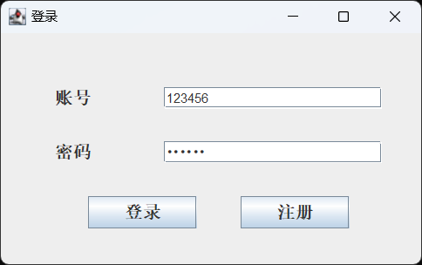

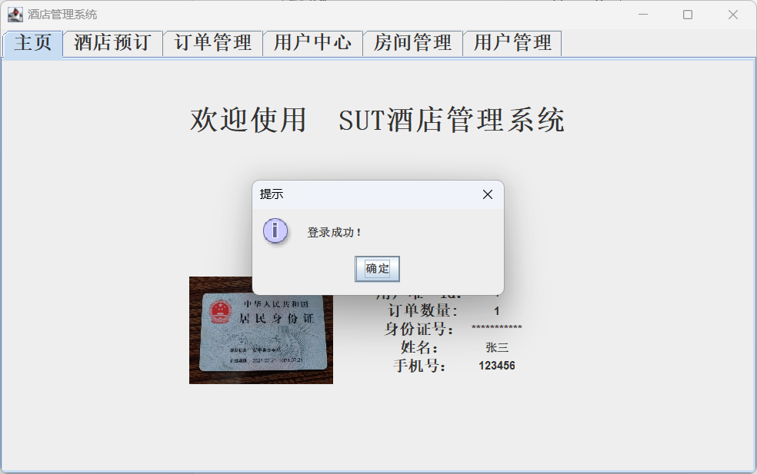

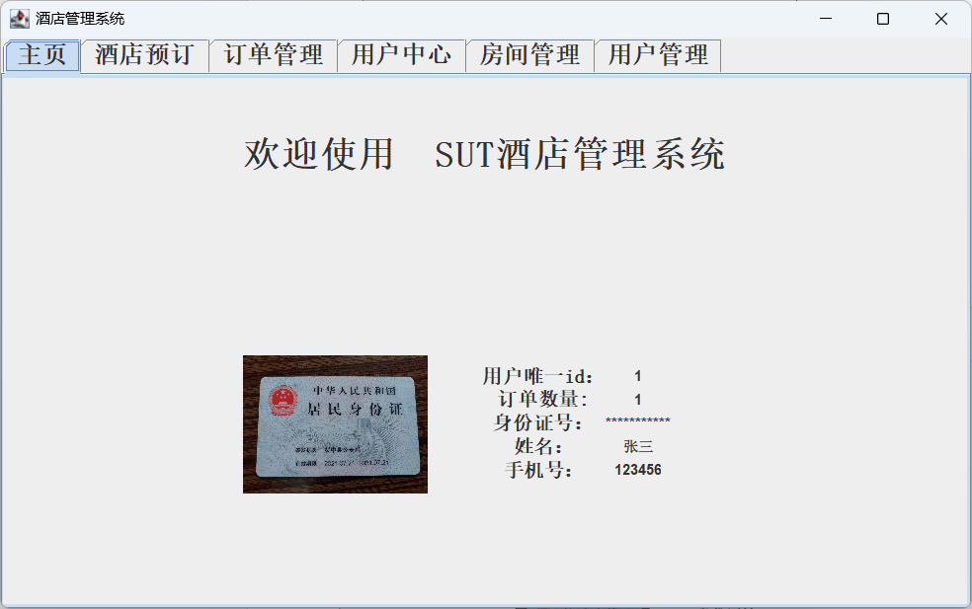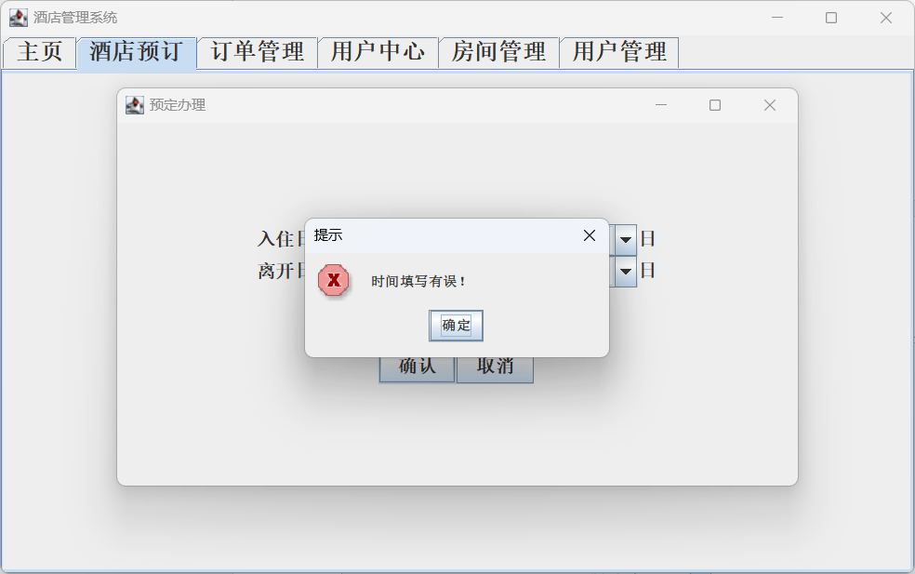

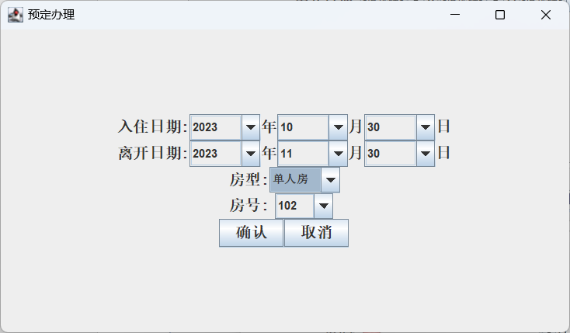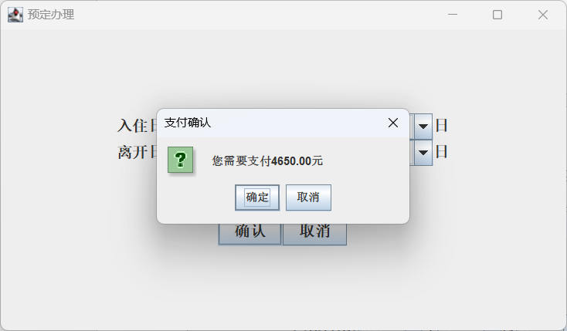

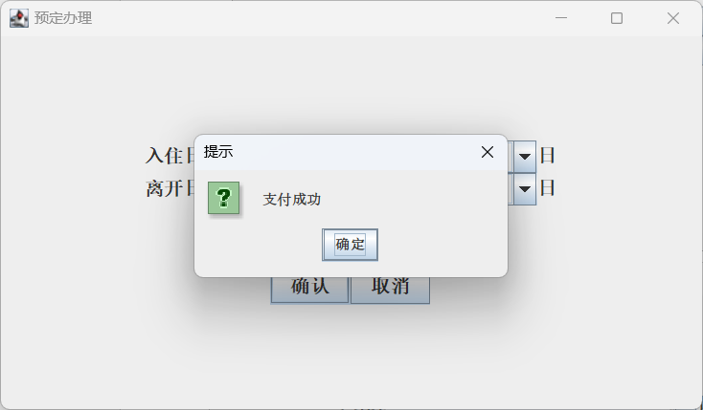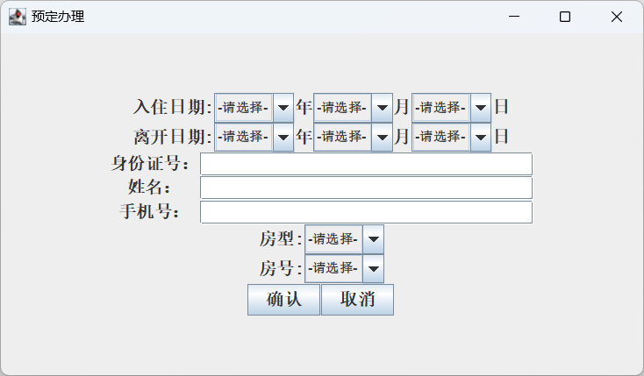

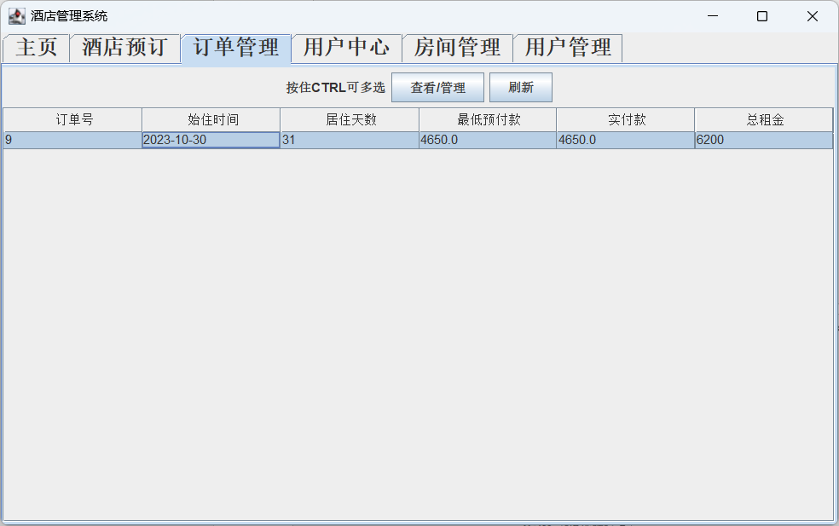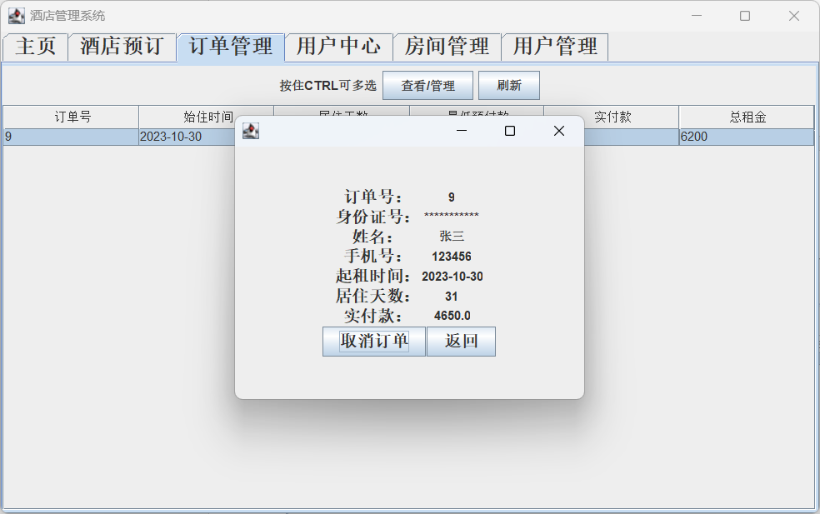

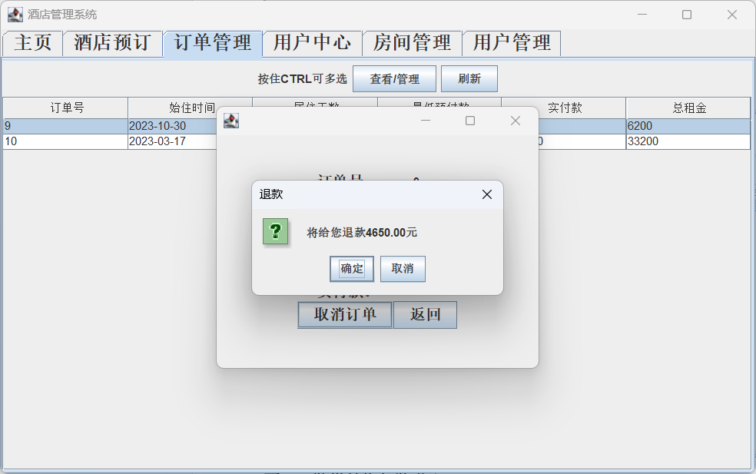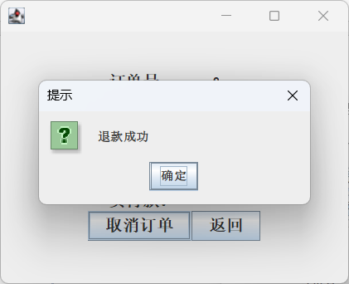

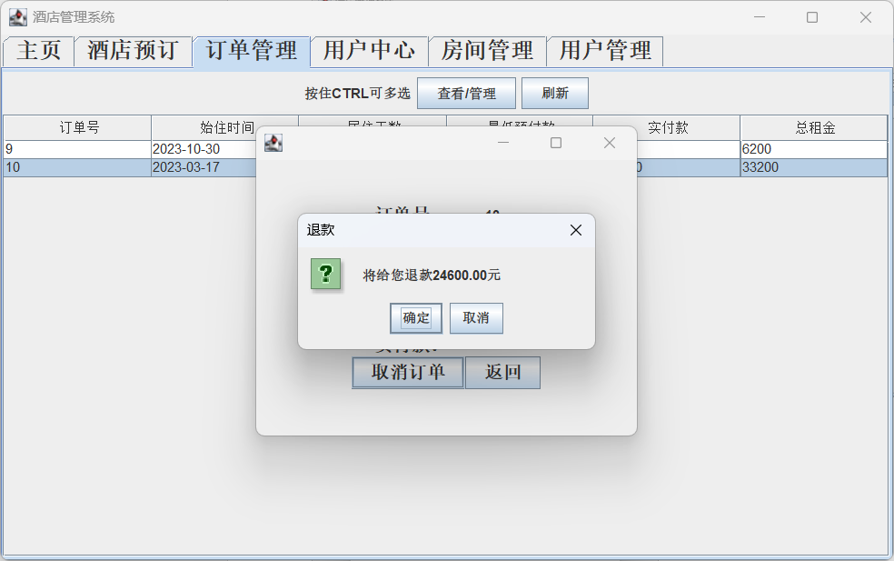

1. **结果分析与结论**

在本次实验中学到了许多关于java的知识，体验了工程化软件开发，学到了很多有用的知识