方法1：以原始數據配適模型之結果

姓名：賴泓瑜

系級：應數四乙

學號：D0856894

* 模型：CART

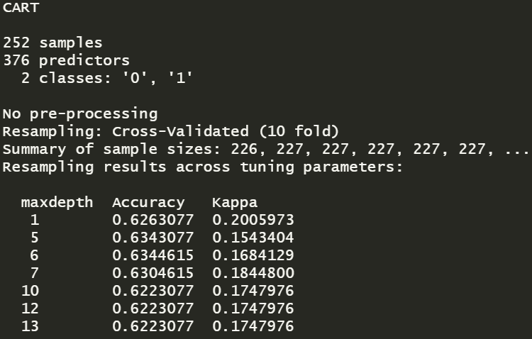

* 模型：ctree

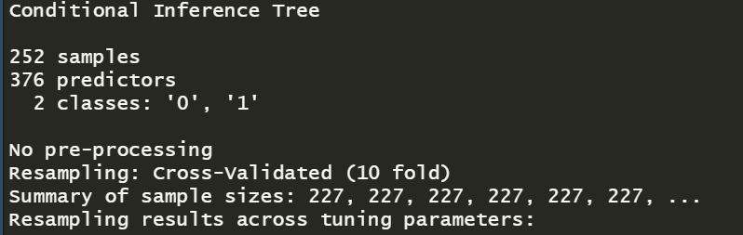

|  |  |  |
| --- | --- | --- |
| **模型** | **Tree Depth** | **準確度 (Accuracy)** |
| CART | 6 | 0.4828 |
| Ctree | 3 | 0.5172 |

方法2：將*X*中0過多的欄位移除和對數轉換配適模型之結果

* 模型：CART

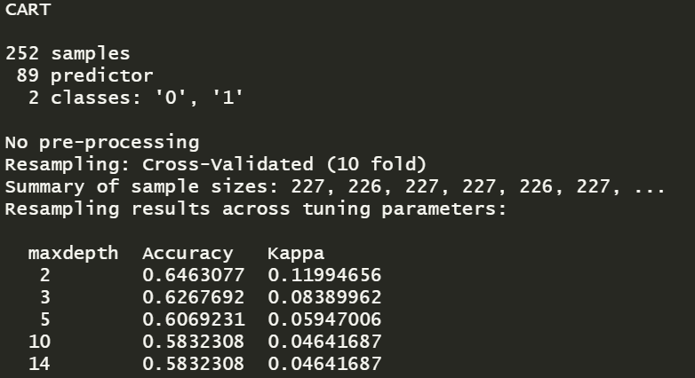

* 模型：ctree

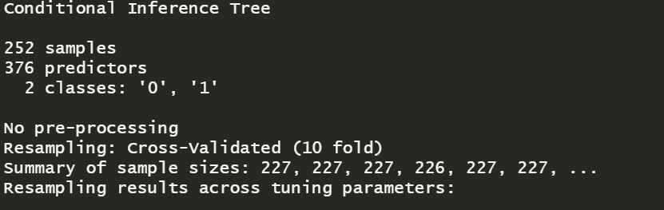

|  |  |  |
| --- | --- | --- |
| **模型** | **Tree Depth** | **準確度 (Accuracy)** |
| CART | 2 | 0.4483 |
| Ctree | 5 | 0.5172 |