1. **代码实践**

**LeetCode题目48-将矩阵旋转90度：**

class Solution {

public:

void rotate(vector<vector<int>>& matrix) {

int n = matrix.size();

//转置

for(int i = 0; i < n; ++i){

for(int j = i + 1; j < n; ++j){

int tmp = matrix[i][j];

matrix[i][j] = matrix[j][i];

matrix[j][i] = tmp;

}

}

//左右镜像交换

for(int j = 0; j < n / 2; ++j){

for(int i = 0; i < n; ++i){

int tmp = matrix[i][j];

matrix[i][j] = matrix[i][n - j - 1];

matrix[i][n - j - 1] = tmp;

}

}

}

};

**LeetCode题目53-连续子序列的最大和：**

class Solution {

public:

int maxSubArray(vector<int>& nums) {

int sum = 0, Max = INT_MIN;

for(int i = 0; i < nums.size(); ++i){

if(sum < 0) sum = nums[i];

else sum += nums[i];

Max = max(Max, sum);

}

return Max;

}

};

1. **计算机基础整理**

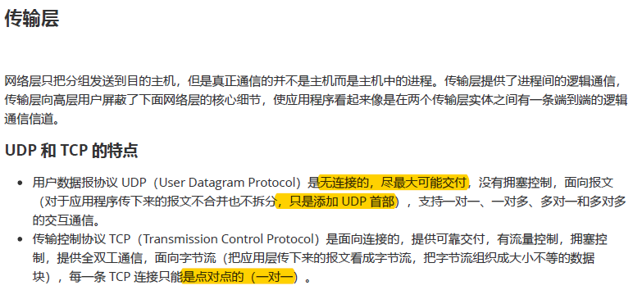

1. **开源特训营工作总结**
2. 将9月26日每日作业提交到Git仓库中。