1. **代码实践**

**LeetCode题目54-数组：**

#include <iostream>

//#include <queue>

//#include <unordered_map>

//#include <map>

//#include <queue>

#include <vector>

//#include <string>

using namespace std;

/*

//递归法

class Solution {

private:

vector<int> ans;

void dfs(vector<vector<int>>& matrix, int iBegin, int jBegin, int row, int col){

if(row > 0 && col > 0){

if(row == 1){

for(int j = jBegin; j < jBegin + col; ++j)

ans.push_back(matrix[iBegin][j]);

return;

}

if(col == 1){

for(int i = iBegin; i < iBegin + row; ++i)

ans.push_back(matrix[i][jBegin]);

return;

}

for(int j = jBegin; j < jBegin + col; ++j)

ans.push_back(matrix[iBegin][j]);

for(int i = iBegin + 1; i < iBegin + row - 1; ++i)

ans.push_back(matrix[i][jBegin + col - 1]);

for(int j = jBegin + col - 1; j >= jBegin; --j)

ans.push_back(matrix[iBegin + row - 1][j]);

for(int i = iBegin + row - 2; i > iBegin; --i)

ans.push_back(matrix[i][jBegin]);

dfs(matrix, iBegin + 1, jBegin + 1, row - 2, col - 2);

}

}

public:

vector<int> spiralOrder(vector<vector<int>>& matrix) {

int m = matrix.size();

int n = (m == 0 ? 0 : matrix[0].size());

dfs(matrix, 0, 0, m, n);

return ans;

}

};

*/

//迭代法

class Solution {

public:

vector<int> spiralOrder(vector<vector<int>>& matrix) {

vector<int> ans;

int m = matrix.size();

int n = (m == 0 ? 0 : matrix[0].size());

int row = m, col = n;

int iBegin = 0, jBegin = 0;

while(row > 0 && col > 0){

if(row == 1){

for(int j = jBegin; j < jBegin + col; ++j)

ans.push_back(matrix[iBegin][j]);

break;

}

if(col == 1){

for(int i = iBegin; i < iBegin + row; ++i)

ans.push_back(matrix[i][jBegin]);

break;

}

for(int j = jBegin; j < jBegin + col; ++j)

ans.push_back(matrix[iBegin][j]);

for(int i = iBegin + 1; i < iBegin + row - 1; ++i)

ans.push_back(matrix[i][jBegin + col - 1]);

for(int j = jBegin + col - 1; j >= jBegin; --j)

ans.push_back(matrix[iBegin + row - 1][j]);

for(int i = iBegin + row - 2; i > iBegin; --i)

ans.push_back(matrix[i][jBegin]);

++iBegin;

++jBegin;

row -= 2;

col -= 2;

}

return ans;

}

};

1. **计算机基础整理**

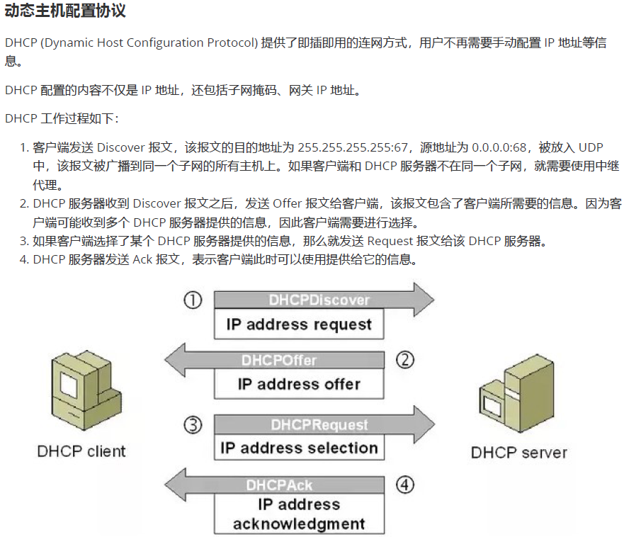

1. **开源特训营工作总结**
2. 将9月28日每日作业以PR的形式提交到Git仓库中。