IV. Physical link to the territory

A. Topography and Slope
The topography of Guimaras Island varies from flat to steeply sloping, with land elevation ranging from 0 to nearly 300 meters above sea level. The moderately undulating and rolling to steeply sloping topography and elevation of the island is highly suited for growing “Carabao” mangoes. A slope range from 0%-30% (moderately sloping to rolling and strongly sloping to moderately steep) is an important factor for the successful growth and development of the mango trees. Mango trees in low lying areas with poor drainage and subjected to floods is prone to disease infection generally die quickly.

B. Soil
The combination of calcareous and loamy soils contributes to the good quality of the Guimaras mango. Gravelly loam is the major soil type, comprising about 71.85% of the total land area of Guimaras. This is a residual soil from diuretic and basaltic rocks. Its surface soil is brown to grayish brown fine sandy loam to gravelly loam and structureless. Concretions are present and its depth is 20-25 centimeters. Its subsoil is light brown fine sand, slightly compact and structureless. Concretions and gravels are abundant and its depth is 25-80 centimeters from the surface. The mango tree has a very deep and strong root system, thus, a deep soil is ideal for easy penetration and spread of the root system. Deep and well-drained soils allow for good depth and distribution of the root system, producing trees of standard size, high yields and long life. Its substratum is dark brown fine sand, structureless, slightly compact and with gravels present. The presence of a substratum of loose gravel helps in providing good drainage.
The soil in the eastern and central part of the island is gravelly loam while on the western side the soil is clay loam. On the other hand, sandy loam soil is found in the northeast portion of Buenavista. At the same time, the soil where the trees are rooted is very abundant in nutrients which support the trees to produce fruits that are rich in flavour and nutrition. A soil that has a balanced mixture of loam, sand and, clay is the best soil for any kind of plant, according to experts. These are the qualities of Guimaras soil, and making it an ideal place to plant mango trees as well as other types of tropical fruits (Eligio, 2017).
Guimaras has a calcareous soil, abundant in calcium and magnesium and with a good drainage. Calcium is increasingly recognized as a key to mango production in terms of quality and yield. Mangoes with adequate amounts of calcium are firmer, have better appearance, have good skin color, and have better resistance to handling and transport. Pulp consistency during growth is better maintained with adequate amounts of calcium. A low calcium level and high nitrogen level leads to the collapse of the internal pulp resulting in a low quality mango.

The following figures of soil classification map and soil suitability map as shown on Figures 1 and 2 present that gravelly loam is the major soil type and seventy percent (70%) of the province’s land is agro-edaphic suitable which is suitable for mango, respectively.
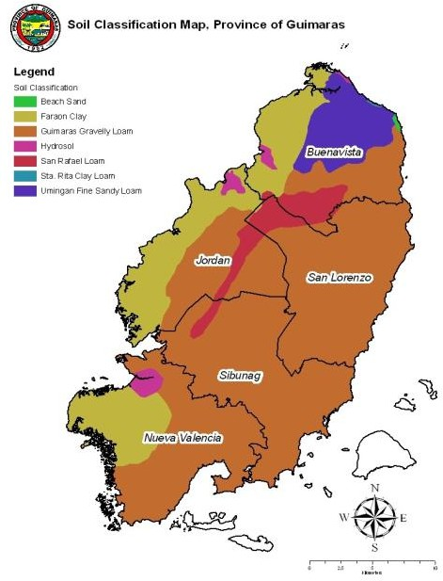

FIGURE 1. SOIL CLASSIFICATION MAP OF THE PROVINCE OF GUIMARAS
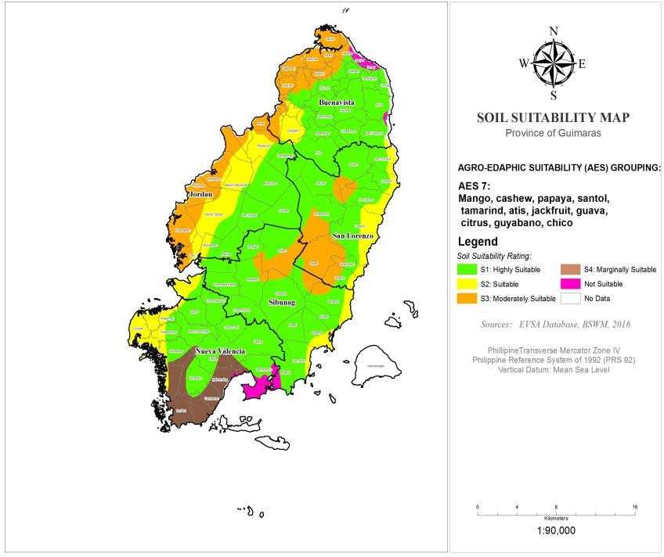
FIGURE 2. SOIL SUITABILITY MAP OF THE PROVINCE OF GUIMARAS

C. Climate
The climate in Guimaras is classified as Corona Type I, with two distinct seasons: the dry season usually from November to April, and the wet or rainy season occurring during the months from May to October.
The latest data on the temperature in Guimaras show a minimum mean temperature of 23.0 °C recorded in February and a maximum mean temperature of 33.0 °C in April and May. Temperature plays a direct role in the flowering, fruit set and fruit development of mangoes. The temperature has to be within a clearly defined range to obtain mangoes of good quality. Guimaras is located in the Western Visayas Region; the climate in this area is not as humid as the other areas of the country. The climate as well as the location directly affects the quality of any fruits.
Rainy months are from May to October. The highest average rainfall was recorded in August with 363.7 millimeters while the lowest average rainfall was observed in February at 19.1 millimeters. It is not the quantum of rainfall but the timing which is important in the growing of mangoes. The absence of rain during the flowering period is a critical pre-requisite for the successful growing of mangoes. Rain at the flowering stage not only washes away the pollen, which adversely affects fruit set, but also encourages a high incidence of mango hoppers, mealy bugs and diseases like powdery mildew and anthracnose, which damages the mango sometimes completely. This also interferes with the activity of pollinating insects, thus adversely affecting fruit set.

“Amihan” refers to the season dominated by the trade winds, which are experienced as a cool northeast wind. It is characterized by moderate temperatures, with little or no rainfall, and a prevailing wind from the east. As a general rule of thumb, the “Amihan” weather pattern begins sometime in September or October and ends sometime in May or June. However, there may be wide variations from year to year. “Amihan” affects the municipality of Buenavista and its surrounding environs.
On the other hand, the “Habagat” season is characterized by hot and humid weather, frequent heavy rainfall, and a prevailing wind from the west or southwest. “Habagat” is also known as monsoon or southwest monsoon. “Habagat” affects the municipality of Nueva Valencia and surrounding municipalities.

V. Definition of the Geographical Area
The delimited territory (geographical area) of the Guimaras Mango encompasses the entire island province of Guimaras, consisting of the 5 municipalities: Jordan, Buenavista, San Lorenzo, Sibunag and Nueva Valencia.
The following figure shows the organizational chart of the collective group, Guimaras Mango Growers and Producers Development Cooperative.

IV: Organization
The following figure shows the organizational chart of the collective group, Guimaras Mango Growers and Producers Development Cooperative.

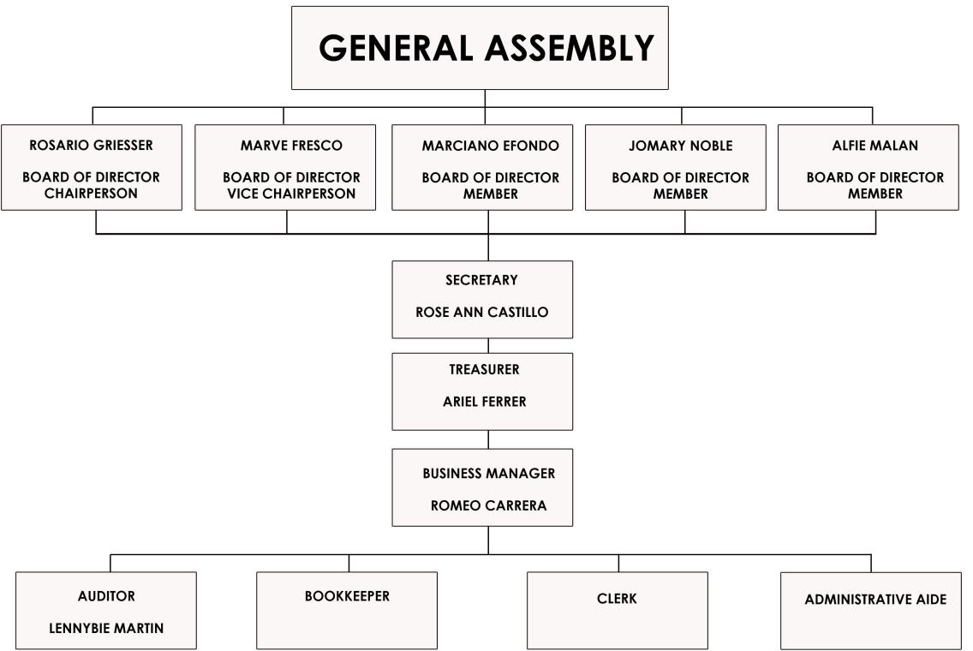
Figure 3. Organizational Chart of the Guimaras Mango Growers and Producers Development Cooperative.

