Ma. Krisha N. Rubia September 11, 2025
BSIT 3-1
01-Laboratory Exercise
Database Design Using SSMS
Diagram #1
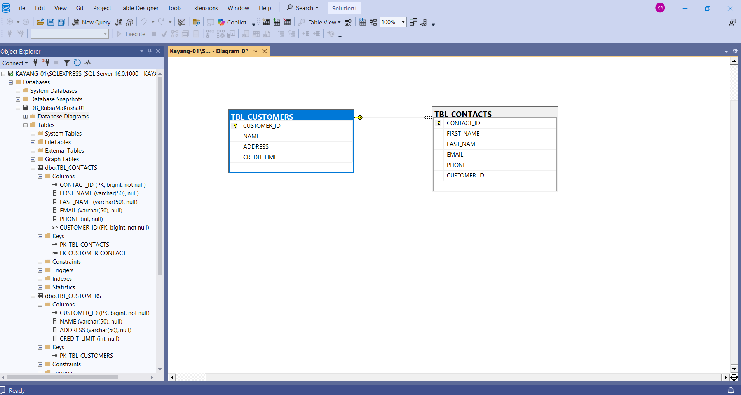
Diagram #2
