Beanthentic: A Random Forest–Driven and QR Code–Based Coffee Farmer Profiling System for Geographical Indication Recognition Readiness

A Capstone Project
Presented to the Faculty of the Information Technology
Polytechnic University of the Philippines - Sto. Tomas Campus
Sto. Tomas Batangas

In Partial Fulfillment of the Requirements for the Program
Bachelor of Science in Information Technology

by

BALAOGAN, NYCO ALEC B.
LAPITAN, REYMARC M.
MALIBIRAN, ELIAZA MAE C.
MAYNETE, ERICKA A.
RUBIA, MA. KRISHA N.
UMALI, KAZYRA M.

Month 202-

Chapter 1

THE PROBLEM AND ITS BACKGROUND

Introduction

Coffee serves as a primary source of daily energy for many Filipino people; however, the coffee industry in the Philippines has been experiencing a gradual decline due to limited technological adoption and insufficient product recognition. One community significantly affected by this is the Kapeng Barako farmers in Lipa City, a place historically known as a center of Kapeng Barako production. This coffee variety, commonly associated with Liberica, alongside Robusta and Excelsa, holds not only economic value but also cultural importance. Over time, Kapeng Barako has become a symbol of strength, hospitality, and local identity, with roots tracing back to the 18th-century coffee boom in the region and continuing through periods of decline and revival (Buenaflor, 2025).
Despite its cultural and economic significance, Lipa City faces challenges in protecting and promoting Kapeng Barako. One key solution is obtaining a Geographical Indication (GI) seal, a legally recognized mechanism that protects the identity, quality, and origin of products by linking them to a specific geographic area. Established under the Agreement on Trade-Related Aspects of Intellectual Property Rights (TRIFS) in 1994, GI systems have been widely used to support rural development, preserve cultural heritage, and enhance market competitiveness (Cei et al., 2018). In the Philippines, the Intellectual Property Office of the Philippines (IPOPHL) is responsible for administering GI protection and promoting regionally significant products.
However, the process of obtaining GI certification is complex and time-consuming. It requires detailed documentation that proves the connection between product quality and geographic origin, as well as consistent production standards and reliable records. For many small-scale farmers, the financial cost and administrative requirements present significant challenges (Crespo-Moncada et al., 2025). These difficulties are further compounded by limited institutional support, making it harder for farmers to comply with GI requirements using traditional methods.
In addition, current documentation practices among Kapeng Barako farmers in Lipa City remain fragmented. Many farmers and cooperatives rely on individually maintained spreadsheets, with no centralized system to organize or integrate data across different barangays. Important information such as farmer profiles, harvest volumes, production inputs, and sales records are often inconsistent and incomplete. As a result, it becomes difficult to produce accurate, standardized, and verifiable data needed for GI certification. This lack of organized records not only delays the certification process but also limits transparency, which may affect fair pricing and market opportunities for farmers.
While modern agricultural technologies have improved areas such as crop monitoring and yield prediction, they often do not address the need for proper documentation required in certification processes (Deng et al., 2024; ScienceDirect, 2024). This highlights a significant gap: farming communities aiming for GI recognition lack accessible tools that can help them systematically manage records and meet regulatory requirements.
To address this gap, this study proposes Beanthentic, a centralized farmer profiling system designed to support record management and production monitoring. The system aims to simplify record-keeping by organizing production data and improving accessibility of information. It also incorporates a Random Forest–based model to assist in assessing farmers’ readiness for Geographical Indication (GI) certification based on established standards. Through these features, the system seeks to support coffee farmers in Lipa City in their efforts to achieve GI recognition and strengthen the value of Kapeng Barako.

Project Context
Beanthentic is a farmer profiling system supported by a Random Forest–based model, developed to enhance and streamline the Geographical Indication (GI) certification process for coffee producers in Lipa City. The system serves as a centralized digital platform that consolidates, standardizes, and organizes comprehensive farmer data into a unified profiling framework. It also manages transactional updates, such as tracking production yield and deducting sales, to ensure accurate inventory monitoring for every harvest season. Through this, the system promotes transparency, accuracy, and data security among farmers. By integrating all registered coffee farmers into a structured and validated system, Beanthentic establishes a reliable foundation for assessing the GI readiness of Kapeng Barako in Lipa City.
To further strengthen transparency and supply chain traceability, Beanthentic incorporates QR code technology linked directly to each authenticated farmer’s digital profile. These QR codes provide authorized users, including consumers, access to see verified information on production per harvest season. This feature supports transparency in product origin and enables farmers to build trust in the market. In addition, the system includes safeguards to prevent misuse or misconduct of information. Overall, this QR-enabled traceability mechanism enhances accountability, reduces information gaps, and fosters trust among farmers and consumers in the market.
Furthermore, the system integrates a Random Forest–based model that assists in evaluating whether Lipa City meets the necessary criteria for obtaining a Geographical Indication (GI) seal. This evaluation feature is embedded within the administrative panel of Beanthentic, where only authorized administrators can input and manage the required documentation. This controlled access ensures data security and aligns with the requirements set by the Intellectual Property Office of the Philippines, where only qualified members are permitted to submit GI-related documents.
Given the complexity and one-time nature of the GI application process, the Random Forest model was developed using a scientific evidence synthesis approach. This method involves combining insights from multiple academic studies and established GI documentation standards to identify key indicators required for certification. The model is based on criteria provided by IPOPHL and supported by relevant literature. The use of synthesized data is appropriate due to the unique characteristics of Kapeng Barako, including its specific production practices and environmental conditions. In future implementation, as Lipa City progresses in its GI application, real data can be incorporated into the system to further see the potential and accuracy of assessments. This approach can help reduce both the time and cost required for evaluating GI readiness while providing meaningful insights for decision-making.
Beanthentic addresses a critical need at the intersection of agricultural governance, intellectual property, and supply chain transparency. For farmers, the system provides a structured and validated platform that supports their participation in the Geographical Indication (GI) process. Additionally, QR-enabled traceability enhances confidence in the authenticity of Kapeng Barako products among consumers and market stakeholders. The system also offers a more efficient alternative to traditionally manual and resource-intensive evaluation processes. In the context of GI development efforts in the Philippines, Beanthentic presents a potential model that can be adapted by other agricultural communities seeking formal recognition for their region-specific products.

Theoretical Framework
This study is based on the Technology Acceptance Model (TAM) developed by Fred Davis in 1989, which explains how users come to accept and use new technologies. TAM posits that system adoption is primarily influenced by two key beliefs: Perceived Usefulness (PU), or the degree to which users believe the system enhances their performance, and Perceived Ease of Use (PEOU), or the degree to which users believe the system requires minimal effort. These beliefs shape users’ behavioral intentions and ultimately their actual system usage. In the context of the proposed centralized profiling system supporting Geographical Indication (GI) documentation readiness for Kapeng Barako in Lipa City, Batangas, TAM provides a framework for assessing whether coffee farmers perceive the system as beneficial, practical, and easy to operate for improving data management and traceability.
The study also adopts the ISO/IEC 25010 developed by the International Organization for Standardization to evaluate the overall quality of the system. This model defines internationally recognized software quality characteristics, including functional suitability, performance efficiency, usability, reliability, security, and portability, which serve as benchmarks for assessing whether the system performs its profiling and monitoring functions accurately, operates efficiently, protects sensitive data, and remains stable for continuous use. By integrating TAM and ISO/IEC 25010, the study ensures that the system is both technically sound and acceptable to its intended users, thereby strengthening its effectiveness in supporting GI documentation processes.
Conceptual Framework
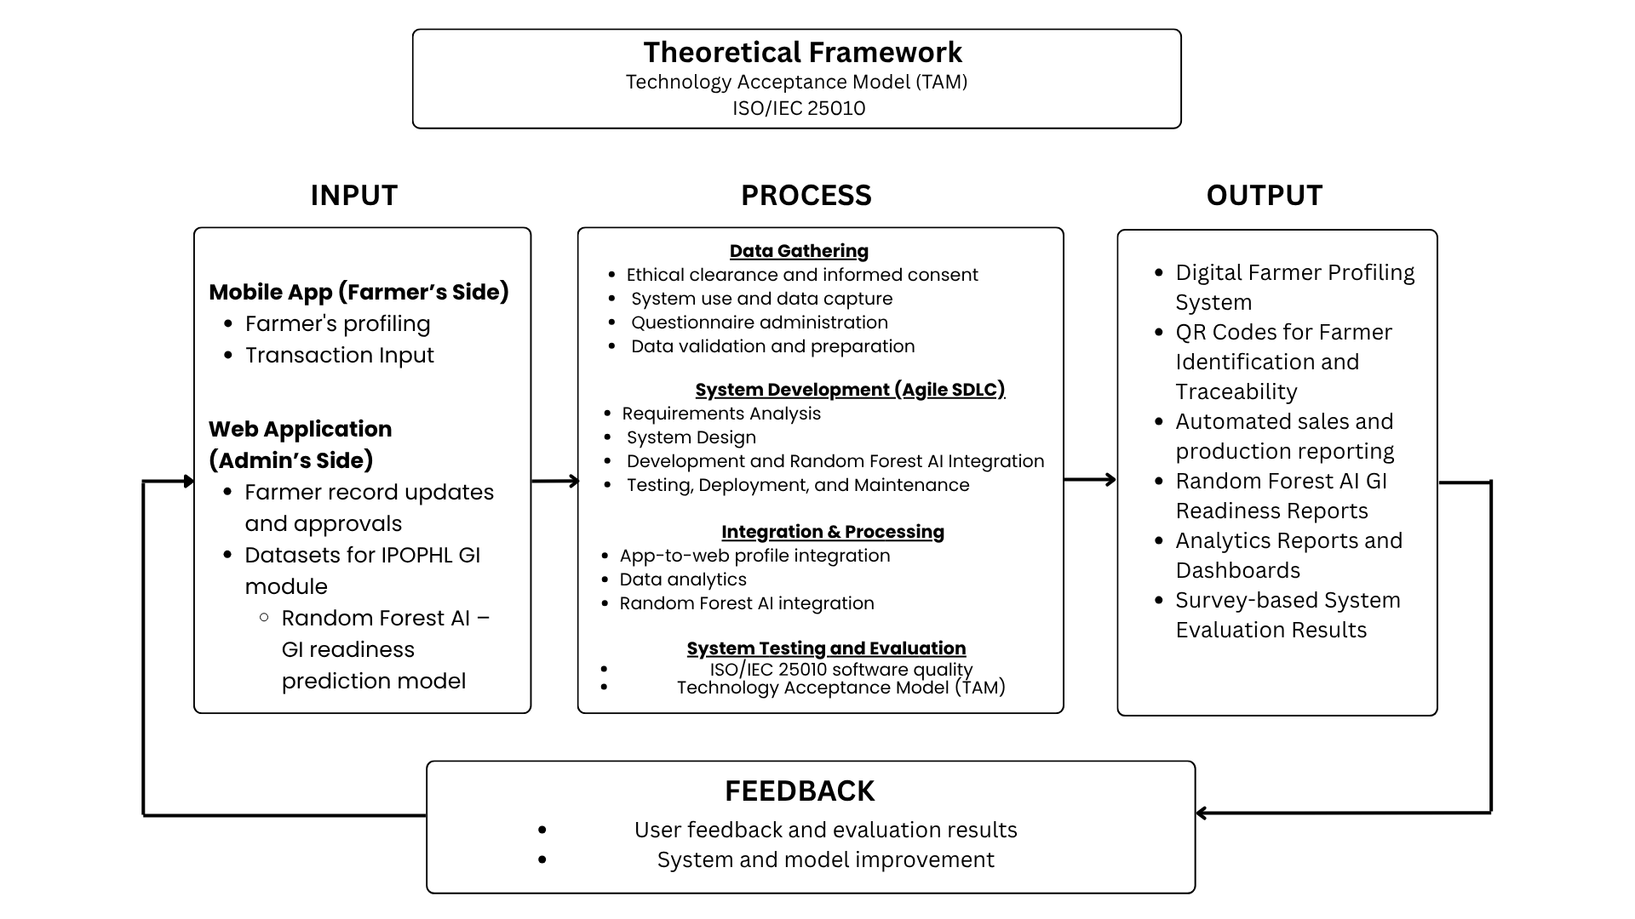
This study presents the development and evaluation of a digital farmer profiling and Geographic Indication (GI) readiness support system. The system is anchored on the Technology Acceptance Model (TAM) and the ISO/IEC 25010 Software Quality Model, which serve as the basis for assessing user acceptance and system quality. The conceptual framework adopts the Input–Process–Output (IPO) model with a feedback mechanism, as illustrated in Figure 1.

Figure 1. Paradigm of the Study

The Input phase involves the collection of multi-dimensional data and the establishment of system functionalities across two primary platforms. The Mobile App (Farmer's Side) serves as the interface for capturing farmer profiling and transaction inputs, establishing the core user data. Complementing this, the Web Application (Admin's Side) provides administrative control through farmer record updates and approvals. Furthermore, this stage incorporates specialized datasets for the POPHL GI module, which include the parameters necessary for the Random Forest AI – GI Readiness Prediction Model. These combined inputs ensure that the system has the requisite data and technical variables to perform complex analysis and decision-support tasks.
Meanwhile, the Process phase encompasses the methodological and technical transformation of inputs through four integrated stages: data gathering, system development, integration and processing, and evaluation. Data Gathering prioritizes ethical clearance and informed consent alongside data validation and preparation to ensure data integrity. System Development follows an Agile Software Development Life Cycle (SDLC), covering requirements analysis, design, and the development and integration of the Random Forest AI model. During Integration and Processing, the framework facilitates app-to-web profile integration and data analytics to generate predictive insights. Finally, system testing and evaluation assesses the platform against ISO/IEC 25010 software quality standards and the Technology Acceptance Model (TAM) to ensure both technical soundness and user viability.
The Output phase represents the deliverables and analytical products generated by the system. This includes the deployment of a functional Digital Farmer Profiling System and the issuance of QR codes for farmer identification and traceability. Additionally, administrators are provided with analytics dashboards and Random Forest AI-generated reports for assessing Lipa City's Geographical Indication readiness.
Finally, the Feedback mechanism serves as the system's iterative engine for continuous optimization. By capturing user feedback and evaluation results directly from the Output phase, the framework facilitates ongoing system and model improvement. These insights are routed back to the Input and Process phases, allowing for the refinement of predictive models, user interface enhancements, and updates to profiling parameters. This cycle ensures the platform remains adaptive, reliable, and closely aligned with the evolving needs of the agricultural sector.

Objectives of the Study
The primary goal of this study is to develop and evaluate Beanthentic, a centralized farmer profiling system designed to streamline data management and provide AI-driven support for Geographical Indication (GI) documentation readiness for Kapeng Barako in Lipa City, Batangas.
Specifically, the study aims to:
- Design and develop a QR-based centralized profiling system that consolidates coffee farmer information and provides automated sales and production reporting to facilitate efficient farmer identification and product traceability.
- Develop and integrate a Random Forest AI model to assess and predict the GI readiness of Kapeng Barako of Lipa City in alignment with IPOPHL standards.
- Evaluate the system’s user acceptance using the Technology Acceptance Model (TAM).
- Assess the system’s quality based on ISO/IEC 25010 standards, specifically measuring:
  - Functional suitability
  - Performance efficiency
  - Reliability and security
  - Portability
Scope and Limitation of the Study
This study covers the development and evaluation of Beanthentic, a centralized farmer profiling system designed to support the Geographical Indication (GI) documentation readiness of Kapeng Barako in Lipa City, Batangas. The system encompasses four primary functional areas: centralized farmer profiling, production monitoring, QR-based traceability, and a Random Forest AI-driven GI readiness assessment aligned with IPOPHL standards. The centralized profiling component consolidates and standardizes coffee farmer information across registered barangays into a unified system, while the production monitoring feature enables systematic tracking of harvest yields and sales transactions per season. The QR-based traceability mechanism links each authenticated farmer's profile to a unique QR code, allowing authorized users and consumers to access verified production information and supporting transparency in product origin. The system operates on two platforms: a mobile application for farmers and a web application for administrators.
The system is developed exclusively for the coffee farming community of Lipa City, Batangas, with a specific focus on Kapeng Barako, and is not intended for use in other regions or agricultural products without significant modifications. Beanthentic functions solely as an assistive tool and does not hold or replace any authority vested in IPOPHL. The GI certification process remains under the full jurisdiction of IPOPHL, and the system is intended only to help streamline preliminary documentation and reduce associated costs, not to substitute the legal and regulatory requirements of the actual application process. Additionally, the study does not involve any financial transactions or monetary collection from farmers, as the system is entirely non-commercial in nature. All production and sales transactions recorded in the system are solely the responsibility of the farmers themselves, and any falsification of inputs falls outside the scope of the system's accountability.
The accuracy and completeness of data within the system are dependent on the cooperation and honesty of the farmers and cooperatives who input their records, as prior documentation practices in the community were fragmented and inconsistent. The Random Forest model was developed using a scientific evidence synthesis approach drawn from academic literature and established IPOPHL GI standards, given the absence of actual GI application data for Kapeng Barako. As a result, the model's predictive accuracy has not yet been validated against real-world outcomes, and future integration of actual application data will be necessary to further refine its performance. Furthermore, the effective use of the system is subject to hardware and software requirements, including a stable internet connection, sufficient device storage, capable smartphone specifications for farmers, and appropriate computer specifications for administrators. Limited digital literacy among small-scale farmers and inadequate access to devices or connectivity may also affect the adoption and full utilization of the system.

Chapter 2

LITERATURE AND SYSTEM REVIEW

This chapter presents a review of available related literature and studies, local and foreign. Likewise, discussion of this chapter is derived from extensive research efforts and readings from books, journals, other published and unpublished papers and excerpts from meetings and conferences which have bearing on the subject of this study.
It also presents the synthesis of the reading on the available conceptual and research literature to the study.

Geographical Indications and Legal Frameworks for Agricultural Products
According to Almusawir et al. (2025), Geographical Indications (GIs) are protected under national and international legal frameworks, particularly the Agreement on Trade-Related Aspects of Intellectual Property Rights (TRIPS) and Intellectual Property Office of the Philippines (IPOPHL), which aims to safeguard agricultural products whose quality and reputation are linked to their place of origin. Their study emphasizes that GI protection prevents product misrepresentation, strengthens producer rights, and preserves the authenticity of region-based agricultural goods.
Similarly, Hofmeier et al. (2023) examined the adoption of Geographical Indications among small and medium-sized enterprises and highlighted the importance of clear legal structures and institutional support in effective GI implementation. The authors noted that despite the availability of legal protection, GI adoption is often constrained by complex registration procedures, limited awareness among producers, and weak enforcement mechanisms.
In the context of agri-food supply chains, Rackl and Menapace (2024) explained that Geographical Indication certification functions as a legally recognized quality signal that reduces information asymmetry between producers and consumers. Their findings show that GI frameworks can enhance coordination and trust within supply chains; however, their effectiveness depends on reliable verification and monitoring systems.
Likewise, Li and Ouyang (2025) investigated the socio-economic impacts of GI certification and found that legally protected GIs contribute to improved farmer income, market access, and overall well-being. The study also pointed out that these benefits are lessened when governance structures are weak and when traceability and compliance mechanisms are insufficient.
Finally, the Department of Trade and Industry (2025) documented the recognition of Guimaras mangoes as the Philippines’ first officially registered Geographical Indication product. This case demonstrates the role of government institutions in establishing and enforcing GI legal frameworks while also highlighting the need for strengthened systems to support monitoring, enforcement, and consumer verification of GI-certified agricultural products.
Geographical Indication Recognition and Documentation Readiness
According to Silva et al. (2023), major coffee-producing countries such as Brazil, Vietnam, Colombia, and Indonesia utilize Geographical Indications (GIs) to protect and differentiate their coffee in the global market. Their bibliographical and documental analysis showed that GI protection is implemented either through specific legislation or trademark systems, with Brazil recognizing Indication of Origin (IO) and Denomination of Origin (DO). The study highlights the importance of strong legal frameworks and institutional support in sustaining GI protection.
Furthermore, Juwita et al. (2025) conducted a bibliometric analysis of GI coffee research to identify trends, leading journals, top contributing countries, and thematic focuses. Their review of Scopus-indexed publications from 2003–2024 revealed a notable increase in GI coffee research after 2016, peaking in 2022, with Italy and the Slovak University of Agriculture as top contributors. Recent studies emphasized chemometrics, adulteration, and food quality, highlighting opportunities for integrating digital systems, traceability, and proper documentation. These bibliometric findings reinforce the importance of systematic GI recognition and documentation readiness to support future research and ensure product authenticity.
In addition, Barjolle et al. (2017) analyzed the role of the state in implementing and managing GIs in the coffee sectors of Colombia and Kenya. Their comparative case study showed that GI recognition and documentation require active governance, including legal protection, quality control, and institutional coordination between public authorities and private actors. The study highlights that legal registration alone is insufficient; effective management, collective action, and flexible state involvement are crucial to ensure that GI benefits reach producers. These insights underscore that structured GI recognition and documentation systems are key to maintaining authenticity, supporting value creation, and empowering coffee producers.
Moreover, Artêncio et al. (2021) investigated the influence of Geographical Indication (GI) labeling on consumer perception and preference during coffee tasting, including unconscious neural responses measured via EEG. Their experiment with 40 participants compared GI and non-GI labeled coffee samples and analyzed neural responses across multiple brain waves. The study found that GI labeling significantly influenced consumer responses, with women showing broader sensitivity to GI cues than men. EEG results indicated men preferred GI-labeled coffee, while women’s preferences were less consistent between neural responses and verbal reporting. Overall, GI labeling acts as a strong extrinsic cue affecting perception and expectation, highlighting its value as a marketing tool and the need to integrate neuromarketing insights into consumer education and traceability awareness.
Lastly, the Department of Trade and Industry (DTI, 2025) announced the recognition of Guimaras mangoes as the first Philippine product granted Geographical Indication (GI) status. This official recognition ensures legal protection against imitation, strengthens consumer trust, and positions the product alongside internationally recognized GI goods. The GI status is expected to increase market value, protect cultural heritage, and improve farmer livelihoods. DTI also encourages continued capacity building for farmers, wider promotion of the GI seal, expansion of domestic and international market access, and stronger consumer awareness campaigns to maximize the benefits of GI recognition.
Centralized Digital Profiling Systems in Agricultural Management
According to Buraga et al. (2024), their developed profiling system successfully generated reports including farmer lists, planting records, crop forecasts, and cost-and-return analyses to support agricultural planning and e-governance initiatives. The study demonstrated that farmer profiling helps improve agricultural monitoring, record management, and data-driven decision-making among farmers and government offices. The authors also emphasized the importance of maintaining updated farmer profiles and conducting continuous training programs to ensure the effectiveness and long-term usability of the system.
Similarly, Eitzinger et al. (2019) demonstrated that centralizing farmer data through an ICT-based platform supports more informed agricultural management across diverse production conditions. Using GeoFarmer, a cloud-based monitoring and feedback system, the study showed that systematically profiling farmers by capturing demographic information, farm locations, crop species, and practice adoption enabled researchers and extension agents to track agricultural performance and tailor interventions to specific geographical domains. Factors such as internet connectivity, ICT literacy, and local cultural context were found to significantly influence data collection, leading the authors to emphasize the importance of adopting centralized, modular profiling systems tailored to local agricultural conditions.
Furthermore, Guldal et al. (2025) demonstrated that profiling farmers based on their socio-demographic and farm-level characteristics can significantly inform agricultural decision-making and technology adoption strategies. Through a survey of 325 farmers across six regions in Türkiye, the study identified four distinct farmer profiles, namely technology users, non-users, young educated female farmers, and traditionalists, each exhibiting unique attributes related to land size, credit utilization, agricultural insurance, tractor ownership, and awareness of smart farming systems. The findings revealed that financial accessibility and knowledge dissemination are critical determinants of technology adoption behavior, with non-users facing structural barriers such as smaller landholdings and limited credit access. The authors recommended tailored financial solutions and targeted extension programs as key interventions to bridge adoption gaps, while emphasizing the role of young, educated women farmers as essential drivers of agricultural innovation.
In addition, Flordeliz and Abuan (2025) found that farmer profiling can support agricultural recommendations and training assessment by analyzing farmer characteristics, farm conditions, and environmental data. The study used synthetic user profiling and deep learning techniques to address data limitations in agricultural crop recommendation systems, particularly for new users or regions with limited historical records. Findings revealed that farmers in Bangkal and Palili commonly manage small farms, depend on multiple income sources, and apply mixed fertilizers in their farming activities. The researchers also noted that while farmers already possess agricultural knowledge, many showed low interest in additional training programs, indicating an attitudinal gap rather than a lack of knowledge.
Finally, Reeve (2018) highlighted that farmer profiling can provide tailored agricultural services and improve access to resources for smallholder farmers through data-driven agriculture initiatives. Profile data can be used to support credit access, targeted farm inputs, market linkages, and agricultural advisory services based on the specific needs of farmers. Several digital platforms and farmer profiling initiatives demonstrated how centralized agricultural data can help improve service delivery and support smallholder farming communities across Africa and the Pacific. The study also emphasized that despite the benefits of farmer profiling, issues related to data privacy, consent, and unequal access to digital technologies remain significant concerns that must be addressed to protect farmers' interests.
Random Forest and Machine Learning for Compliance Pattern Analysis
According to Mingming Wen et al. (2024), integrating AI-assisted multi-source data fusion with Random Forest analysis enables the detection of complex patterns that traditional statistical methods cannot effectively capture. By combining heterogeneous datasets such as geographic and socioeconomic data, the study modeled nonlinear relationships and identified key factors influencing regional variations through feature importance analysis. The findings demonstrate that using fused data with Random Forest improves analytical accuracy, highlighting its relevance for compliance pattern analysis where diverse data integration and pattern detection are essential for monitoring and regulatory assessment.
Furthermore, Nizam et al., (2023) demonstrated that Random Forest combined with Explainable AI (XAI) enhances not only prediction accuracy but also interpretability and transparency of model decisions. By integrating feature importance analysis and interpretability measures into a recommendation system, the study allowed users to understand the factors influencing predictions. Although applied in an educational context, the findings highlight the importance of transparency in machine learning models, which is essential for compliance pattern analysis systems that require clear justification of decisions, accountability, and increased stakeholder trust.
According to Li et al. (2024), recent advances in machine learning for geographical origin traceability demonstrate that algorithms such as Random Forest are highly effective in analyzing complex food and agro-product datasets for origin verification and compliance assessment. Their review highlighted that Random Forest performs well when handling heterogeneous data sources, including chemical, environmental, and sensor-based inputs, which are commonly used in traceability and certification systems. The study also emphasized challenges related to data integration and interpretability, noting that Random Forest’s feature importance capability supports transparent decision-making. These findings reinforce the relevance of Random Forest for compliance pattern analysis, particularly in systems that require reliable verification of origin and adherence to certification standards
Furthermore, Sim et al. (2024) demonstrated that non-linear machine learning models, especially Random Forest, significantly improve classification accuracy in coffee origin traceability using near-infrared spectroscopy data. The study showed that Random Forest not only achieved high predictive performance but also identified discriminative features and spectral regions critical for origin differentiation. Although the research focused on analytical validation rather than regulatory implementation, its findings support the application of Random Forest in compliance pattern analysis, where detecting inconsistencies, anomalies, or deviations from certified origin profiles is essential for monitoring and certification validation
Finally, Pang et al. (2024) conducted a comprehensive evaluation of blockchain-based agricultural traceability systems and identified major challenges related to compliance verification, data fragmentation, and protocol enforcement. The study emphasized that effective compliance monitoring requires advanced analytical mechanisms capable of detecting inconsistencies, incomplete records, and violations across complex supply chains. While the research focused on blockchain frameworks, the authors highlighted the need for intelligent data analysis to support compliance assessment. These requirements align with the strengths of Random Forest–based machine learning, which can analyze large-scale traceability datasets, identify compliance-related patterns, and support automated regulatory monitoring in digital certification systems
Overall, Random Forest and machine learning approaches provide a systematic framework for compliance pattern analysis. These models enable the identification of relationships among multiple indicators and support efficient screening processes, while remaining decision-support tools that complement rather than replace formal regulatory evaluation.
QR Code–Based Traceability and Transparency Mechanisms
According to Querme and Lima (2023), QR code–based traceability systems play a significant role in improving transparency and efficiency in coffee production and supply chains. Their case study on traceability automation demonstrated that integrating QR codes into coffee production workflows such as harvesting, processing, storage, and certification reduces manual documentation, minimizes human error, and improves the accuracy of traceability records. This is particularly important because delayed records can undermine reliability of certification systems and reduce stakeholder trust. The study emphasized that QR codes enable real-time access to production data for multiple stakeholders, including farmers, inspectors, and quality personnel, thereby strengthening transparency and accountability across the supply chain.
Furthermore, Li et al. (2023) explored blockchain-enabled traceability systems for Geographical Indication (GI) agricultural products and highlighted the importance of QR codes as consumer-facing access points to trusted product information. Their conceptual framework showed that QR codes, when linked to secure digital ledgers, allow consumers to verify product origin, certification status, and production history instantly. This matters because without reliable verification mechanisms, GI products remain vulnerable to fraud and misrepresentation, which directly damages producer credibility and market value. The study found that QR-based transparency mechanisms enhance consumer trust, reduce fraud, and protect GI brands by ensuring that product information cannot be easily altered or misrepresented. These findings underscore the role of QR codes in bridging institutional certification systems and end-user transparency.
In addition, Pang et al. (2024) conducted a survey on blockchain-based agricultural traceability and identified standardized product identification and data accessibility as critical challenges in traceability adoption. After all, traceability systems often fail to gain widespread adoption precisely because of inconsistent labeling and data that stakeholders simply cannot access. This is important because unclear labeling and inaccessible data are among the primary reasons why traceability systems fail to gain widespread adoption among supply chain actors. Their evaluation framework emphasized that QR codes serve as a practical and scalable solution for product identification, especially in agri-food supply chains and that traceability systems are designed to assign specific data responsibilities to each actor, including the transparent recording of crop yield data by farmers, ensuring that production volume information remains verifiable across all stakeholders. By enabling consistent labeling and easy data retrieval, QR code mechanisms support interoperability and improve stakeholder participation, which are essential for effective traceability systems.
Moreover, Nguyen and Nguyen (2025) demonstrated that QR code traceability systems significantly enhance consumer trust by enabling access to verified product information at the point of purchase, thereby reducing information asymmetry and supporting more informed purchasing decisions. Their findings further indicate that when product data is transparent and easily accessible, consumer confidence in brand accountability increases, highlighting the importance of technology-enabled transparency in trust formation. However, this need for reliable and verifiable information extends beyond consumer-facing applications, as data integrity across the entire supply chain is equally critical, particularly in agricultural contexts. Rajesh et al. (2025) emphasized that fragmented datasets and inconsistent reporting practices undermine the reliability of key production information, including crop yield data. Therefore, traceability systems must ensure data accuracy from the point of production onward, establishing a transparent and dependable foundation for reliable crop yield forecasting.
Finally, Sriyom and Buangam (2024) developed a QR code-based traceability system for chemical-free vegetables that enabled consumers to access product information including farm origin, cultivation details, harvest date, and storage methods simply by scanning a QR code with their smartphones. Their findings confirmed that QR codes serve as an effective transparency mechanism by bridging the information gap between farmers and consumers, allowing real-time access to verified production data across the entire supply chain from cultivation to storage. Expert evaluation of the system yielded an average score at the highest level, reinforcing that QR code-based traceability not only improves data accessibility but also strengthens consumer trust in the authenticity and quality of agricultural products.
Synthesis and Relevance of the Literature and Systems Reviewed
The research studies discussed above provide a comprehensive understanding of the researcher’s study which focuses on Geographical Indication certification, coffee origin authentication, and the integration of machine learning and digital traceability systems in agri-food supply chains. Collectively, these studies provided the legal, analytical, technological, and socio-economic foundations necessary to frame the present research within both established GI frameworks and emerging data-driven verification approaches.
The researcher supports the idea that Geographical Indications function as legally recognized quality signals whose effectiveness relies on strong enforcement mechanisms, reliable traceability systems, and institutional support. This view is supported by Almusawir et al. (2025), Rackl and Menapace (2024), and Li and Ouyang (2025), who emphasize that GI protection enhances producer rights, builds consumer trust, and improves socio-economic outcomes when compliance mechanisms are effective. Hofmeier et al. (2023) also highlight that smallholder participation remains limited due to complex registration procedures and low awareness, emphasizing the importance of clear legal structures and institutional assistance in supporting GI adoption.
The study also aligns with Juwita et al. (2025), Silva et al. (2023), and Artêncio et al. (2021), who highlights the importance of documentation readiness, research development, and consumer perception in sustaining GI systems. Juwita et al. (2025) identify increasing research trends in GI coffee authentication, particularly in chemometrics and quality analysis, while Silva et al. (2023) emphasize the role of strong institutional frameworks in leading coffee-producing countries. Artêncio et al. (2021) further demonstrate that GI labeling significantly influences consumer preference, reinforcing the need for transparent and accessible verification mechanisms.
On the other hand, the researcher finds a gap in studies that highlight the growing role of machine learning and digital traceability in improving supply chain transparency and verification. Research by Mingming Wen et al. (2024), Nizam et al. (2023), Li et al. (2024), Sim et al. (2024), and Pang et al. (2024) demonstrates that Random Forest and other machine learning models are effective in detecting complex compliance patterns, verifying geographical origin, and supporting data-driven decision-making across diverse datasets. However, despite these capabilities, these approaches are often implemented independently and lack integration within a centralized system.
A significant gap remains in the absence of structured, farmer-level digital profiling systems that support long-term data management and targeted agricultural interventions, as emphasized by Buraga et al. (2024), Eitzinger et al. (2019), and Reeve (2018). Existing studies also fail to incorporate comprehensive socio-demographic, farm-level, and livelihood data necessary for validating producer eligibility and monitoring GI compliance at the local level, as highlighted by Guldal et al. (2025) and Flordeliz and Abuan (2025).
Finally, QR code–based traceability systems are identified as practical tools for improving transparency and accessibility of product information across the supply chain. Querme and Lima (2023), Li et al. (2023), and Sriyom and Buangam (2024) demonstrate that QR codes enable real-time data access, reduce manual errors, and strengthen trust between producers and consumers. Nguyen and Nguyen (2025) further emphasize their role in influencing consumer confidence and purchasing decisions. However, Pang et al. (2024) identify issues related to data fragmentation and compliance verification in traceability systems, while Rajesh et al. (2025) note that inconsistent reporting practices undermine data reliability, especially when not supported by reliable data infrastructure.

Chapter 3

RESEARCH METHODOLOGY

This chapter presents the key research elements namely: research methods used, the population and sample size, the research instrument, the data gathering procedure and the statistical treatments of the data. It also provides discussions of the methods to be used in developing the system output of the study.

Research Method & Participants
This study utilizes a descriptive-quantitative research method to evaluate the technical performance and user acceptance of the system. As a descriptive study, it systematically characterizes the system's alignment with the ISO/IEC 25010 software quality standards and the Technology Acceptance Model (TAM) through numerical data. This approach allows the researchers to transform subjective experiences into objective, statistical evidence, providing a clear basis for determining the system’s effectiveness in coffee farmer profiling to support Geographic Indication (GI) readiness assessment in Lipa City.
The participants of the study consist of fifty (50) coffee farmers in Lipa City, Batangas, selected through purposive sampling to ensure the collection of relevant data from the primary end-users. The sample size of 50 participants was considered sufficient to obtain reliable and meaningful evaluation results while remaining manageable within the study’s time and resource constraints. The selected participants share common characteristics, including active involvement in coffee farming, engagement in the production and sale of coffee beans, and residency within the designated geographical area of Lipa City. As primary stakeholders, these farmers are responsible for evaluating the system’s usability, practical utility, and overall quality in a real-world agricultural context.
Research Instrument
The study utilizes a structured research questionnaire as the primary instrument for evaluating the Beanthentic system. The questionnaire is designed to quantitatively assess both the software quality and user acceptance centralized coffee farmer profiling system. To ensure a comprehensive evaluation, the instrument is grounded in two established frameworks: the ISO/IEC 25010 Software Quality Model and the Technology Acceptance Model (TAM). By integrating these models, the instrument captures both the system’s technical performance and its practical viability for users in the agricultural sector of Lipa City, Batangas.
The questionnaire is divided into two primary sections, both administered to the participating coffee farmers. The first section focuses on user acceptance based on the Technology Acceptance Model (TAM), measuring the key constructs of Perceived Usefulness defined as the system’s effectiveness in managing farmers’ profiling information in support of Kapeng Barako Geographic Indication (GI) readiness assessment and Perceived Ease of Use, which refers to how easily farmers can navigate and utilize the profiling features in their daily activities.
The second section is based on the ISO/IEC 25010 model and evaluates the system’s software quality characteristics from the users’ perspective. This includes assessing functional suitability, particularly the consistency and accuracy of the Random Forest algorithm in determining GI readiness in Lipa City; performance efficiency, especially in relation to the QR code–based features used in managing farmer profiles; the reliability of the profiling database, as well as the system’s security and portability.
All items in the instrument are close-ended and quantitative, utilizing a five-point Likert scale to encourage more definitive responses and reduce neutral bias. To ensure clarity and inclusivity for the coffee farmers, the questionnaire is presented in a bilingual format, with Tagalog translations provided alongside the English technical terms.

Data Gathering Procedures
The data gathering procedure for this study was conducted in systematic phases to ensure the accuracy, consistency, and reliability of the collected data. Prior to data collection, ethical clearance was secured from the appropriate research ethics review body. Informed consent forms were prepared and distributed to all participants, clearly explaining the purpose of the study, the voluntary nature of participation, the confidentiality of responses, and the participants’ right to withdraw at any time without any consequences.
The researchers conducted in-person data collection, assisting participants strictly with technical registration procedures such as account creation and system navigation within the Beanthentic platform. Each farmer created an account linked to a unique QR code, and their profiling data was recorded to support documentation for GI readiness. It is important to note that the researchers limited their role to technical assistance only and did not influence or interfere with any participant responses. All questionnaire responses were accomplished independently by the participants. After registration, the data were automatically received on the admin side of the system for monitoring and management of registered participants.
Following the profiling process, a paper-based survey questionnaire was administered. The researchers demonstrated the system and guided participants through its features prior to answering. All completed questionnaires were checked, organized, and encoded for statistical analysis to ensure that the collected farmer profiling data and evaluation responses were accurate, reliable, and aligned with Beanthentic’s role as a centralized profiling and Random Forest AI based to support GI documentation.

Statistical Treatment of Data
The data gathered through the structured questionnaire were analyzed using appropriate descriptive statistical tools to objectively evaluate the technical quality and user acceptance of the Beanthentic system. The following statistical techniques were employed in the analysis and interpretation of the data.

- Percentage, Frequency Distribution, and Ranking
Percentage, frequency distribution, and ranking were used to describe the profile and distribution of participants and to summarize the responses obtained from the structured questionnaire. Frequency distribution determined the number of responses for each item, while percentage was computed to present the proportion of responses in a clearer and more meaningful form. Ranking was applied to arrange the results from highest to lowest, allowing the researchers to identify the most and least significant software quality characteristics and user acceptance factors of the Beanthentic system.
The formula used to compute percentage was:
$\%=\frac{f}{N}​ × 100$

Where:
% = Percentage
f = Frequency of responses
N = Total number of participants
100 = Constant factor

- Weighted Mean
The weighted mean was used to determine the overall evaluation of the Beanthentic system based on the participants’ ratings. This statistical tool was applied to assess both the ISO/IEC 25010 software quality characteristics and the Technology Acceptance Model (TAM) constructs, namely Perceived Usefulness and Perceived Ease of Use.
The formula for weighted mean is:
$X̄ = \frac{ΣfX}{N}$
Where:
X̄= Weighted Mean
f = Frequency of responses
X = Weight of each scale
N = Total number of participants

- Likert Rating Scale and Verbal Interpretation
To interpret the computed weighted means, a five-point Likert scale was used.
It is used to provide a simple, reliable, and standardized way to measure participants’ responses while allowing for clear interpretation of the computed weighted means.
Range | Verbal Interpretation | Symbol
4.21 – 5.00 | Strongly Agree / Excellent | SA / E
3.41 – 4.20 | Agree / Very Satisfactory | A / VS
2.61 – 3.40 | Neutral / Satisfactory | N/S
1.81 – 2.60 | Disagree / Fair | D / S
1.00 – 1.80 | Strongly Disagree / Poor | SD / P

The verbal interpretations were used to determine the level of quality and acceptability of the Beanthentic system based on the ISO/IEC 25010 model and the Technology Acceptance Model.

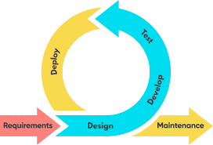
System Development Methodology

Figure 2. Agile Software Development Life Cycle (SDLC) Model
This study adopted the Agile Software Development Life Cycle (SDLC) Model in developing Beanthentic. Agile was selected to enable iterative development, continuous refinement, and regular user feedback, ensuring that the system effectively meets the needs of coffee farmers and stakeholders, particularly the “Samahan ng Magkakape ng Lipa” and IPOPHL Calamba Office.

- Requirements Phase
System requirements were identified through interviews and meetings with the Samahan ng Magkakape ng Lipa and IPOPHL Calamba, along with field observations and review of existing GI guidelines.
Based on this phase, the core system components were defined:
- Centralized digital coffee farmer profiling
- Random Forest–based GI compliance pattern analysis
- QR code–enabled traceability of farmer profiles
- User-friendly web and mobile-accessible interfaces
These requirements aimed to address fragmented farmer records and limited documentation systems supporting GI recognition readiness.
- Design Phase
Architectural planning was conducted using diagrams and system flowcharts. The design process also included the development of the system’s UI/UX using Figma to ensure a user-friendly and intuitive interface.
- Development Phase
The development of Beanthentic was carried out in iterative sprints, enabling incremental backend, database, and frontend implementation with continuous refinements.
Key processes for the Random Forest algorithm included:
- Data cleaning and validation
- Encoding categorical variables
- Splitting datasets into training and testing sets
- Model training and evaluation based on GI readiness indicators
QR codes were integrated to link each farmer profile with a unique scannable identifier, supporting traceability and organized GI documentation readiness.
- Testing Phase
System quality was evaluated using the ISO/IEC 25010 Software Quality Model, measuring:
- Functional Suitability
- Performance Efficiency
- Reliability and Security
- Portability
User acceptance was assessed using the Technology Acceptance Model (TAM), focusing on Perceived Usefulness and Perceived Ease of Use among intended users.
The Random Forest AI was tested using GI documentation datasets to ensure it correctly supports the profiling and GI readiness assessment processes, providing reliable guidance for decision-making and traceability within the system.
- Deployment Phase
After testing and refinement, Beanthentic was deployed in a testing environment, accessible via a web-based administrative panel and a mobile application for farmers. The deployment allowed users to interact with the system for farmer profiling, submit and manage supporting documents, support GI readiness assessment, and utilize QR-code–enabled traceability for improved data management and verification.
- Maintenance Phase
The Maintenance Phase ensures the continued reliability and relevance of Beanthentic by addressing system updates and enhancements. This includes fixing bugs, and improving usability and performance based on user feedback.

Requirements Analysis & Documentation
Functional Requirements
Additional Entries – Farmer’s App
Functionality | Description | Validation
App Login | Allows registered farmers to securely log in using credentials. | Verify correct login with valid credentials and error prompts for invalid inputs.
App Sign-Up | Enables new users to create an account with required details. | Confirm account creation and proper input validation.
Tutorial Module | Guides first-time users on app usage. | Check if tutorial displays and functions properly.
Homepage Feed | Displays announcements and updates. | Ensure content loads correctly.
Notification | Sends alerts and updates to users. | Verify notifications are received accurately.
Messaging System | Enables communication within the app. | Test sending and receiving messages
Transactions input | Allows entry of transaction data. | Validate input and data saving
Receipts Generation | Provides digital receipts | Check correctness of generated receipts.
Transaction History | Displays past transactions. | Ensure records are complete and complete
QR Code Display | Generates QR codes for traceability. | Verify QR code functionality
QR Code Enlargement | Allow QR code zooming. | Confirm QR remains scannable when enlarged
Personal Information | Display and Edits User details. | Validate updates are saved correctly.
Settings | Allows preference customization. | Check if settings are applied.
Help/Support | Provides assistance features. | Verify accessibility of help options.
Logout | Logs the user out securely. | Confirm session termination.

WebsiteAdmin System
Functionality | Description | Validation
Admin Login | Allows administrators to securely access the system using credentials. | Verify login with correct credentials and error handling for invalid inputs.
Dashboard | Displays summary of system data such as farmer count, production stats, and analytics. | Check if dashboard data is accurate and loads properly.
Farmer Records Module | Allows the admin to encode and manage comprehensive farmer data including basic information, affiliations, farm details, tree counts, and production records | Ensures accurate data entry, proper computation, and reliable storage, updating, and retrieval of all farmer-related information
Farmer Profile View | Displays detailed profiles of individual farmers. | Check if all farmer data is displayed correctly.
Maps Module | Displays geographic location of farms for monitoring and mapping. | Verify map loads and locations are accurately plotted.
IPOPHL Module | Manages Intellectual Property/Geographical Indication application process. | Confirm correct workflow and document tracking.
GI Seal Management | Displays and manages Geographical Indication seal status. | Check if GI status is correctly reflected.
Analytics | Provides reports and visual data on production, farmers, and system usage. | Ensure charts and reports display accurate data.
Transactions | Records and manages all farmer-related transactions. | Validate transaction entries and history tracking.
Settings | Allows admin to configure system preferences. | Confirm settings changes are applied correctly.
Account Security | Enables password change and account protection settings. | Test password update and security validation.
Admin Logout | Allows secure exit from the system. | Confirm session termination and redirection to login.
FAQ Module | Displays frequently asked questions for user guidance. | Verify content accessibility and readability.
Profile Actions | Allows admin to update profile details or manage accounts. | Check if profile updates are saved successfully.
Non-Functional Requirements
Category | Requirements | Description | Validation
Performance | Response Time | The system should load pages within 2–3 seconds. | Measure system response under normal conditions.
Performance | Scalability | The system should support multiple users simultaneously. | Conduct load testing.
Usability | Ease of Use | The interface should be simple and intuitive for farmers. | Conduct user testing (TAM results).
Usability | Accessibility | The system should be usable on mobile devices and low-end phones. | Test on different devices.
Reliability | System Availability | The system should be available 24/7 with minimal downtime. | Monitor uptime.
Reliability | Data Accuracy | The system must store and display correct data. | Validate outputs vs inputs.
Security | Authentication | Secure login with password protection. | Test login security.
Security | Data Privacy | Protect farmer data from unauthorized access. | Conduct security checks.
Security | Two-Factor Authentication | security for admin accounts. | Verify OTP/authentication process.
Maintainability | System Updates | The system should allow updates without major downtime. | Test update deployment.
Maintainability | Code Structure | The system should follow clean and modular coding. | Code review validation.
Compatibility | Device Compatibility | Works across different devices and browsers. | Cross-platform testing.
Compatibility | Network Adaptability | Functions under slow internet conditions. | Test under low bandwidth.

Systems Designs

Flowchart
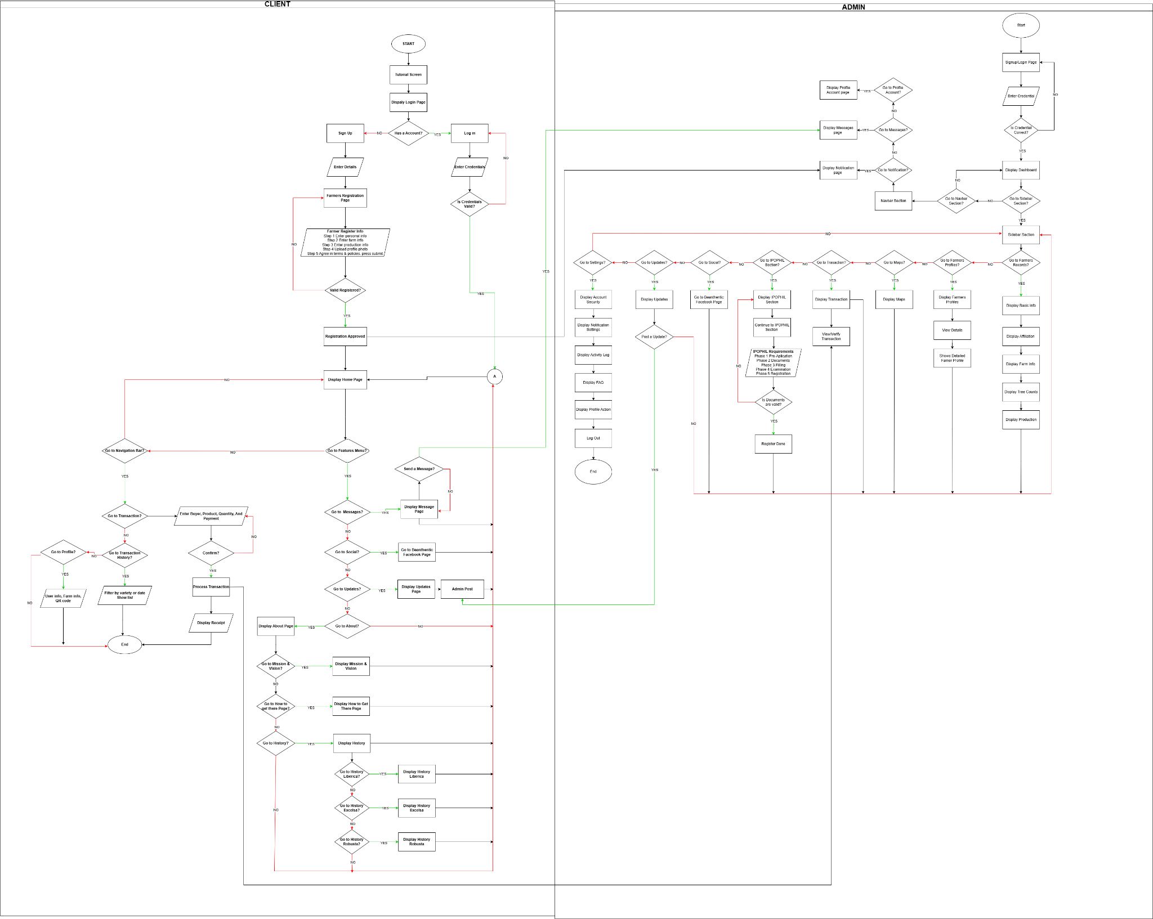

Figure 3. Flowchart of Beanthentic System

This flowchart illustrates how the system operates, beginning with the client-side flow, where a user enters the application through a start screen, proceeds to a tutorial and login page, and chooses whether to sign up or log in. During registration, the user inputs personal details, submits requirements, and waits for approval before accessing the home page. Once inside, the user can navigate different features such as messaging, transactions, profile viewing, and history tracking. The flow also includes conditional paths where the user decides actions like sending messages, viewing notifications, or accessing transaction records, with each choice leading to corresponding pages such as receipts, transaction details, or history logs.
On the admin side, the process focuses on system management and verification. The admin logs in through a secure page and gains access to a dashboard where they can manage users, review registrations, verify documents, and handle transactions. Decision points allow the admin to approve or reject accounts, monitor activities, and update system data such as posts, messages, and user information. The admin also oversees reporting and history tracking, ensuring that all user actions and transactions are properly recorded. Overall, the flowchart shows a structured interaction between client and admin, emphasizing authentication, data validation, and smooth navigation across features

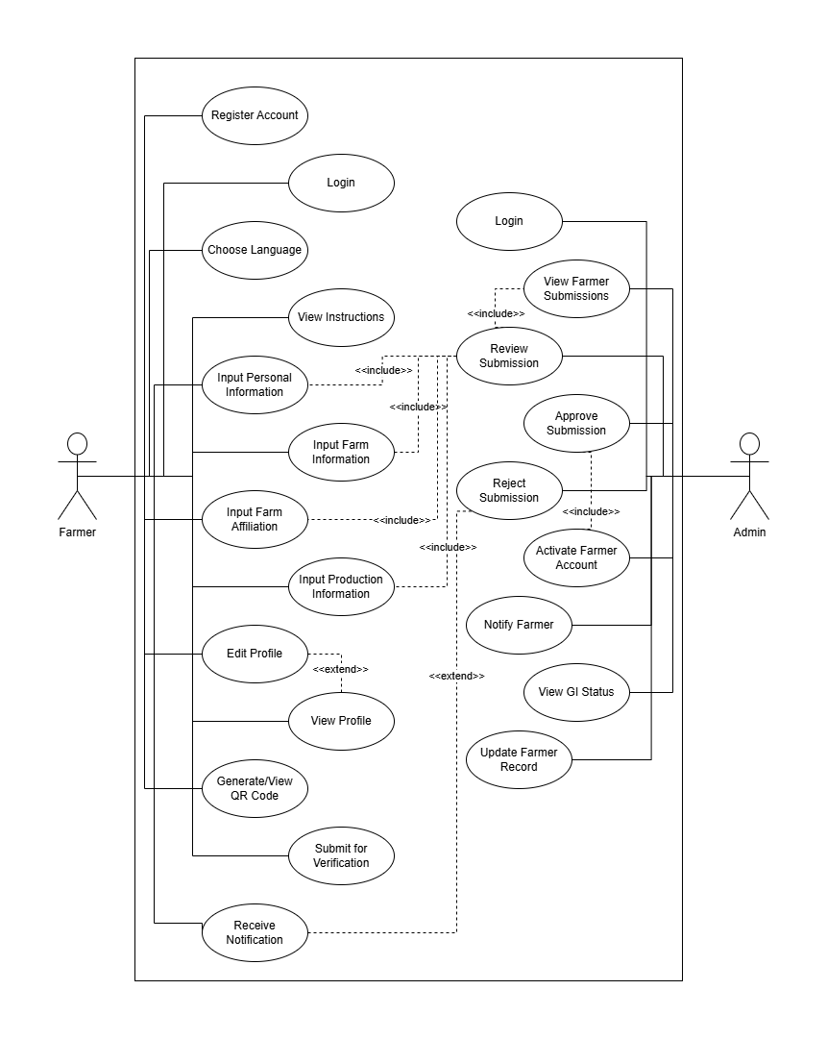
Use-Cases Diagrams

Figure 4. Use Case Diagram of Beanthentic System

The diagram shows the structured interaction between the Farmer and the Admin within the Brewthentic system, emphasizing controlled data submission and verification. On the farmer's side, the process begins with account registration and login, followed by language selection and viewing of system instructions to ensure proper guidance. The farmer then inputs detailed and categorized information, including personal details, farm information, farm affiliation, and production data. These inputs are essential components included in the submission for verification. The system allows the farmer to edit and review their profile before final submission, promoting accuracy and completeness. Once submitted, the farmer waits for verification and receives notifications regarding approval or required corrections. Upon approval, the farmer can generate and view a QR code, which serves as verified identification within the system. This structured process benefits farmers by organizing their records digitally, reducing manual documentation, improving credibility, and providing official verification that can support traceability and potential market opportunities.
In addition to the admin side, the process begins with secure login and access to submitted farmer records. The admin reviews each submission thoroughly, ensuring that all required personal, farm, affiliation, and production details are complete and valid. The review process directly includes approval or rejection decisions. If approved, the system activates the farmer’s account, granting verified status and QR code access. If rejected, the admin notifies the farmer to update specific information, ensuring data accuracy before activation. The admin can also view GI status and update farmer records when necessary, maintaining an up-to-date and reliable database. Overall, the system promotes data integrity, accountability, and transparency by requiring validation before activation. It benefits administrators by centralizing farmer information into a manageable digital database, while ensuring that only verified and qualified farmers are officially recognized within the platform.

Conceptual Data Flow Diagram

Figure 5. Conceptual DFD of Beanthentic System

This figure presents a high-level overview of the interaction between the Farmer, the Beanthentic System, and the Admin, highlighting the flow of registration, validation, and feedback within the platform. The process begins when the farmer submits profiling data through a registration form, which includes essential information such as personal details, farm profile, affiliations, and production records. The Beanthentic System then stores the submitted data in the database and forwards the registration details to the admin for review and approval.
On the admin side, the administrator evaluates the submitted information and decides whether to approve or reject the registration. The decision is sent back to the system, which then communicates the result to the farmer through a single response that includes registration confirmation, generated QR code, and notification of registration status. This process ensures efficient data management, proper validation, and clear communication between the farmer and the admin while maintaining a secure and organized system.

Low Level Data Flow Diagram

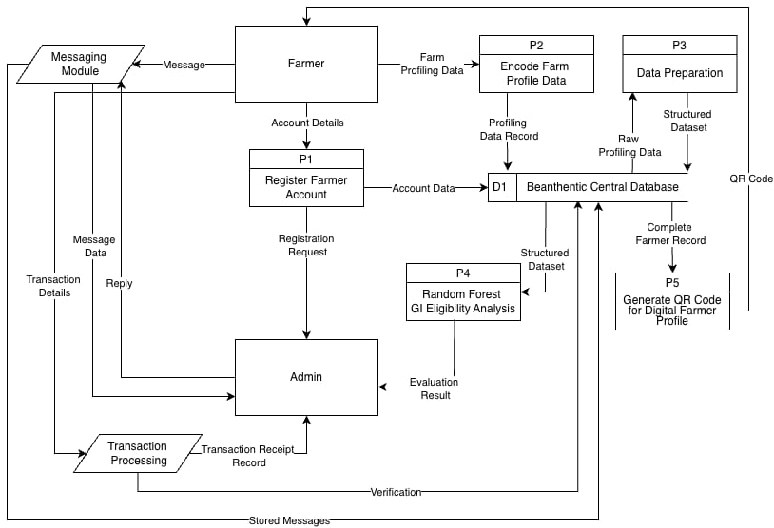

Figure 6. Low Level DFD of Beanthentic System

The diagram illustrates how data flows through the system, beginning with the farmer as the primary source of information. The process starts when the farmer submits account details through P1 (Register Farmer Account), which are forwarded to the admin for approval and then stored in the Beanthentic Central Database (D1). At the same time, the farmer provides farm profiling data through P2 (Encode Farm Profile Data). This profiling data is saved in the database and later retrieved by P3 (Data Preparation), where raw profiling inputs are cleaned and converted into a structured dataset. This structured data is then sent back to the central database, making it available for further processing and analysis.
Once the data is prepared, P4 (Random Forest GI Eligibility Analysis) accesses the structured dataset from the database to evaluate the farmer’s eligibility for Geographic Indication (GI). The evaluation results are sent to the admin for review and verification, ensuring that decisions are validated before proceeding. After the farmer is approved and verified, P5 (Generate QR Code for Digital Farmer Profile) retrieves the complete farmer record from the database and generates a unique QR code for identification. In addition, the system supports communication and transaction handling through the messaging module and transaction processing components, which exchange messages, store records, and generate receipts between the farmer and admin. Overall, the Beanthentic Central Database serves as the central hub that connects all processes, enabling efficient data storage, validation, analysis, and output generation.

Entity Relationship Diagram
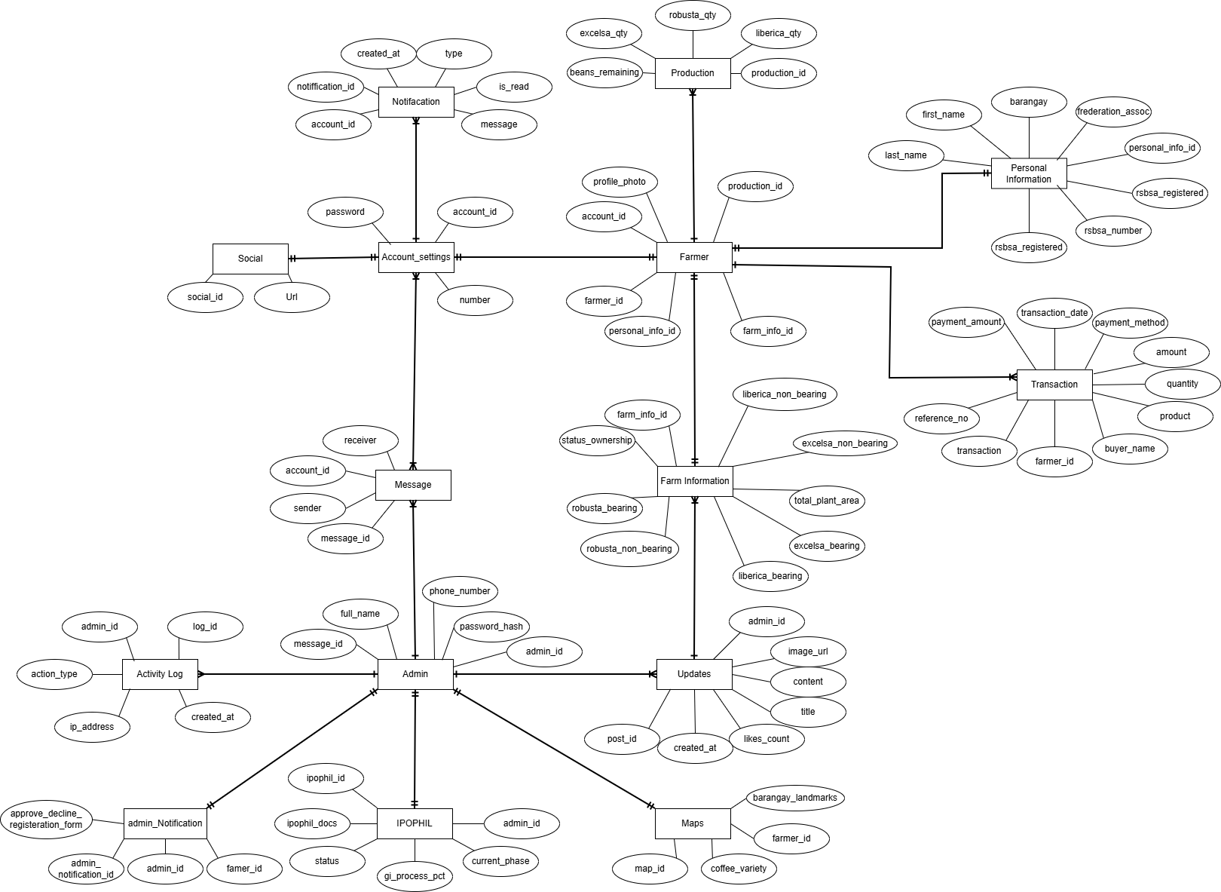

Figure 7. ERD of Beanthentic System

Figure 7 presents the major entities, their attributes, and the relationships within the Beanthentic system as illustrated in the diagram. The central entity is Farmer, which serves as the core of the system and is linked to both Personal Information and Farm Information. The Personal Information entity stores details such as first name, last name, barangay, and RSBSA registration data, while Farm Information captures agricultural data including total plant area, ownership status, and the number of bearing and non-bearing coffee trees categorized into varieties such as robusta, liberica, and excelsa. The Farmer entity is also associated with the Production entity, which records the quantity of harvested coffee per variety and tracks remaining beans, providing a clear view of each farmer’s production output.
In addition, the system includes operational and support entities that facilitate transactions and communication. The Transaction entity records sales data such as product, quantity, amount, payment method, and transaction date, all linked to a specific farmer. Communication within the system is handled through Message and Notification entities, enabling user interaction and system alerts. Administrative control is managed through the Admin and Activity Log entities, which track user activities and system changes. Furthermore, the Updates entity allows posting of announcements or content with titles, images, and engagement metrics, while the Maps entity stores location-related data and coffee variety distribution per farmer. The IPOPHIL entity is also included to manage intellectual property-related records of farmers. Overall, the diagram reflects an integrated system that supports farmer profiling, farm management, production monitoring, transactions, and administrative functions

Database Schema
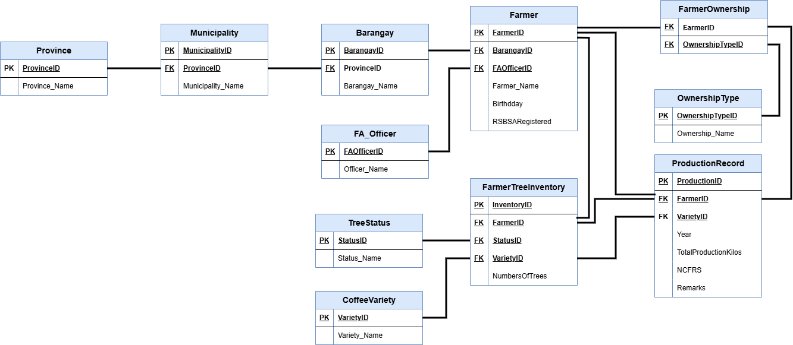

Figure 8. Data Schema of Beanthentic System

This figure illustrates the structured tables, their primary keys (PK), foreign keys (FK), and relationships of the Beanthentic system. Three related tables make up the geographical hierarchy: Province (ProvinceID, Province_Name), which is connected to Municipality via ProvinceID, and Municipality, which is further connected to Barangay to form the entire location structure. The Farmer table, which has FarmerID (PK), BarangayID (FK), FAOfficerID (FK), Farmer_Name, Birthday, and RSBARegistered, is at the core of the structure. This table connects each farmer to a designated agricultural officer listed in the FA_Officer database (FAOfficerID, Officer_Name) as well as to a particular barangay.
The FarmerOwnership table, which links FarmerID and OwnershipTypeID to the OwnershipType table that describes several ownership categories, is used to manage farm ownership information. InventoryID (PK), FarmerID (FK), StatusID (FK), VarietyID (FK), and NumberOfTrees are among the tree inventory information kept in the FarmerTreeInventory table, which is linked to the TreeStatus and CoffeeVariety tables to categorize tree condition and variety. The ProductionRecord table, which links production statistics to both farmers and certain coffee types, provides ProductionID (PK), FarmerID (FK), VarietyID (FK), Year, TotalProductionKilos, NCPRS, and Remarks.

Development & Implementation Plan
The development of Beanthentic followed the Agile Software Development Life Cycle (SDLC) Model, enabling iterative development, continuous refinement, and regular validation through structured phases such as requirements analysis, design, development, testing, deployment, and maintenance.
Deployment & Testing Plan (Infrastructure/Deployment)
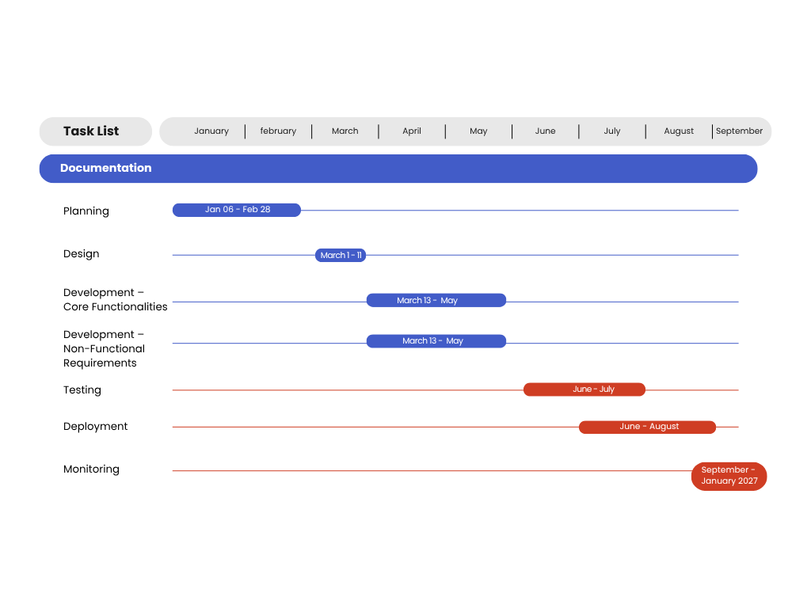
Project Schedule

Figure 9. Development Plan of Beanthentic System

Planning (January 06 – February 28, 2026)
The planning phase began on January 6 and concluded on February 28, 2026. During this period, the foundation of Beanthentic was established through literature review, problem identification, and consultations with coffee farmers. An adviser orientation ensured alignment with academic standards. The Software Requirements Specification (SRS) was completed, detailing functional and non-functional requirements, system objectives, QR code traceability framework, and the initial product backlog.
Design (March 1 – March 11, 2026)
The design phase focused on developing the system architecture, database schema, and UI/UX wireframes for both web and mobile platforms. Data Flow Diagrams (DFDs) mapped the movement of data from farmer registration to QR-enabled traceability. The design was finalized and validated before development began.
Development – Core Functionalities (March 13 – May)
Core features were developed, including farmer profiling, data management, QR code generation, and the analytics dashboard. These features formed the primary operational components of the system.
Development – Non-Functional Requirements (April 3 – May)
This phase focused on enhancing system performance, usability, security, responsiveness, and interface improvements to ensure efficiency and user satisfaction.
Testing (June - July)

System testing was conducted from June to August 2026. This included unit testing, integration testing, system testing, and User Acceptance Testing (UAT) to ensure reliability, functionality, and usability.
Deployment (July – August)

Deployment activities began in June and continued until August 2026. The system was prepared for implementation, configured for actual use, and finalized for operational readiness.
Monitoring (September - January 2027)

Post-deployment monitoring was conducted in August 2026 to evaluate system performance, address potential issues, and ensure stability after implementation.

Ethical Considerations
This study strictly adhered to established ethical standards in the development and evaluation of the Beanthentic system involving coffee farmers in Lipa City, Batangas. Prior to participation, informed consent was obtained from all participants. The purpose of the study, the nature of the Random Forest–driven and QR code–based profiling system, and the procedures involved in data collection were clearly explained to ensure transparency and understanding. Participation was entirely voluntary, and participants were informed of their right to withdraw at any time without penalty or negative consequences.
Data collection was limited to structured profiling forms and system evaluation questionnaires grounded in the ISO/IEC 25010 and Technology Acceptance Model frameworks. No interviews, audio recordings, video recordings, or covert observations were conducted. All collected data were treated with strict confidentiality, and sensitive personal identifiers were protected within the system database. QR codes generated by the system were designed to support traceability while ensuring controlled and authorized access to farmer profile information.
The Random Forest–based GI eligibility profiling feature of Beanthentic functions solely as a decision-support and documentation-readiness tool and does not replace official certification authorities such as the Intellectual Property Office of the Philippines. AI-generated outputs reflect compliance patterns based on submitted data and predefined parameters and are not official eligibility determinations. All data were used exclusively for academic and research purposes, and ethical clearance was secured prior to implementation to ensure that the study was conducted responsibly, truthfully, and with full respect for the rights and welfare of the participants.

