1.

操作流程:

先打開檔案

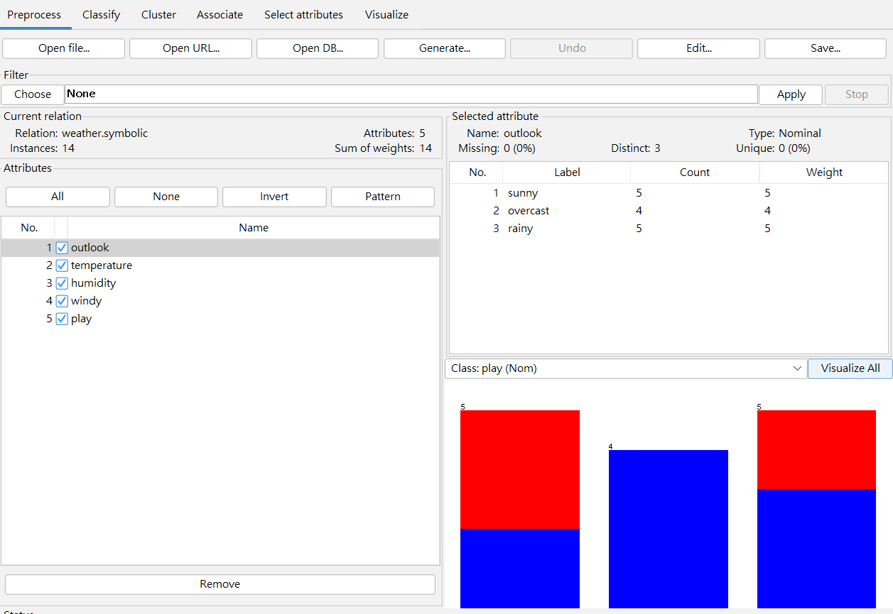

接著進classify選J48並在cross-validation 輸入10再按start

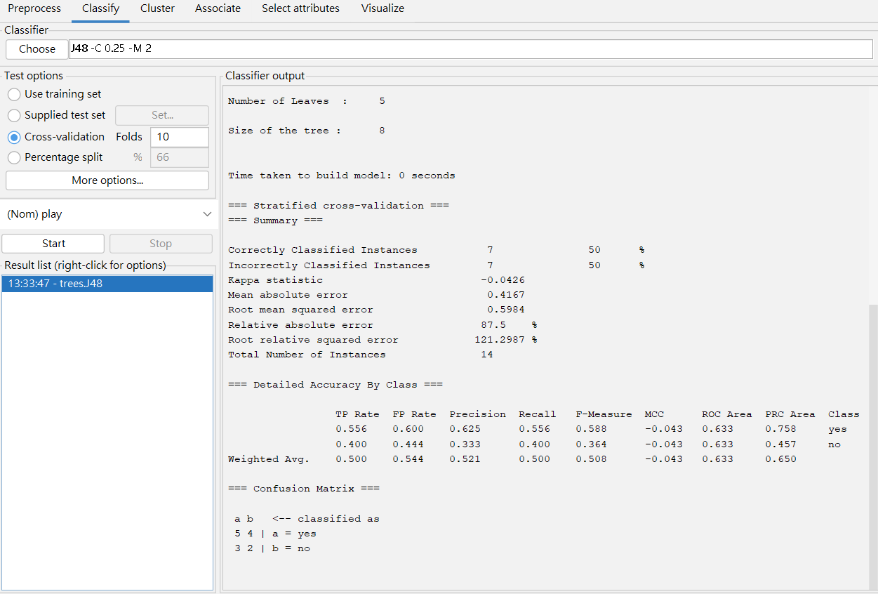

(1)

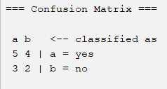

(2)

Sensitivity = $\frac{5}{5+4}$ = 0.55

(3)

Specificity = $\frac{2}{3+2}$ = 0.4

(4)

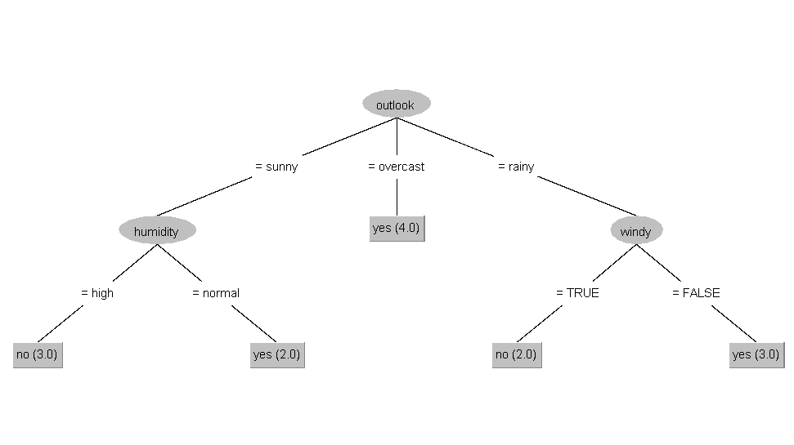

2.

操作流程

開檔案

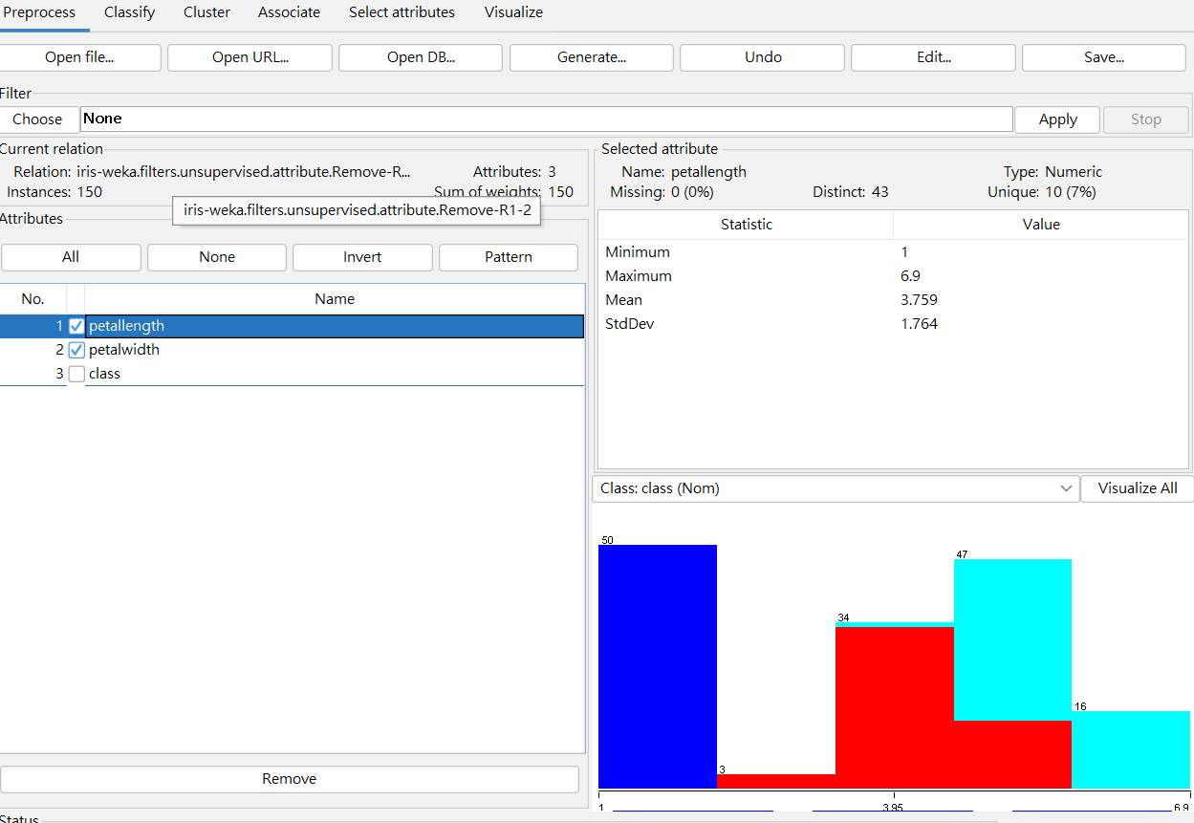

接著把前2個attribute做discretize (bin = 5)

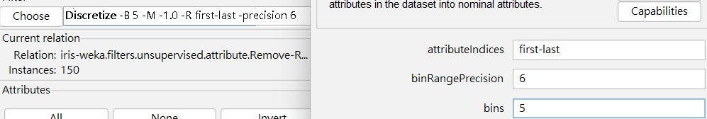

進classify選NaiveBayes, cv輸入10, 接著按start

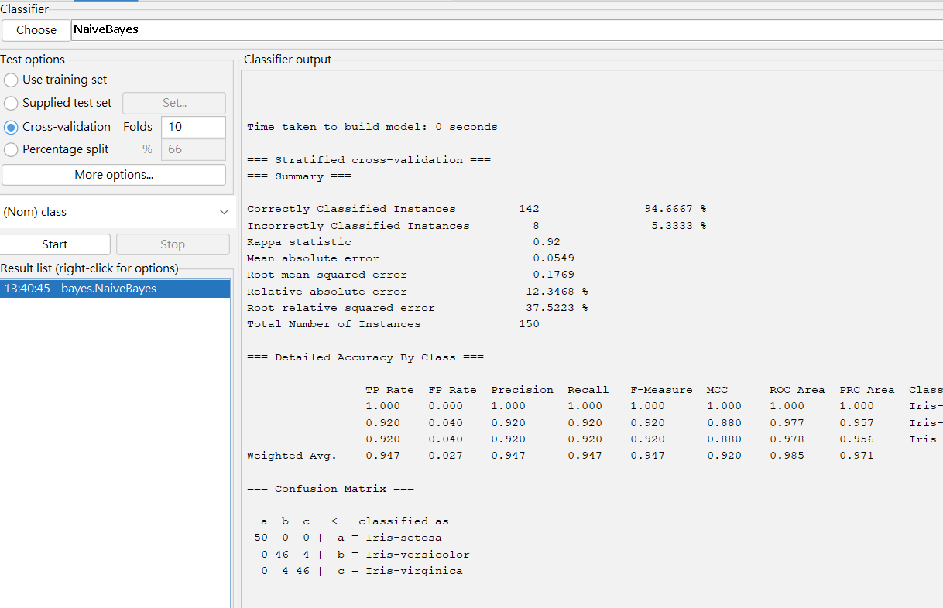

(1)

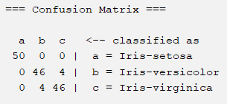

(2)

Sensitivity :

Setosa = $\frac{50}{50+0+0}$ = 1

versicoclor = $\frac{46}{0+46+4}$ = 0.92

virginica = $\frac{46}{0+4+46}$ = 0.92

(3)

Specificity:

Setosa = $\frac{46+46}{50+50}$ = 0.92

versicoclor = $\frac{50+46}{50+50}$ = 0.96

virginica = $\frac{50+46}{50+50}$ = 0.96

3.

操作過程

開檔案

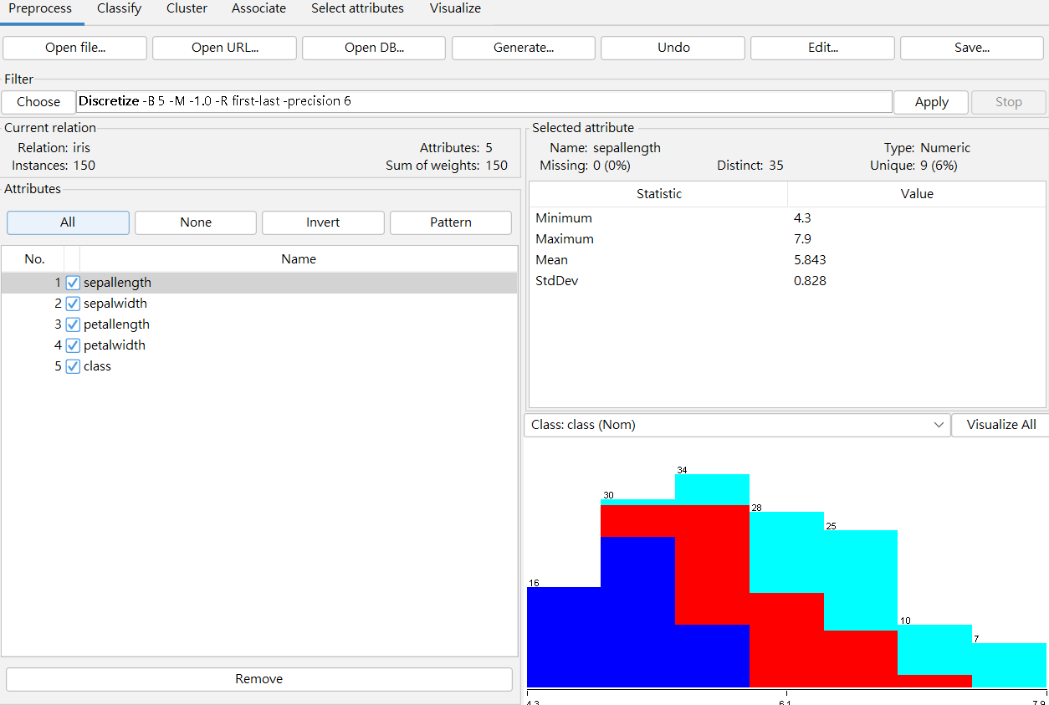

進classify選IBk

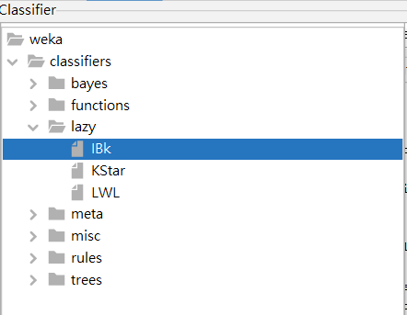

進IBk調參數(k = 3, distance = Euclidean distance)

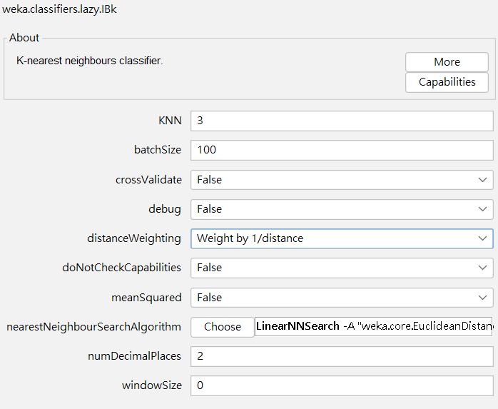

Cv輸入10後, 按start

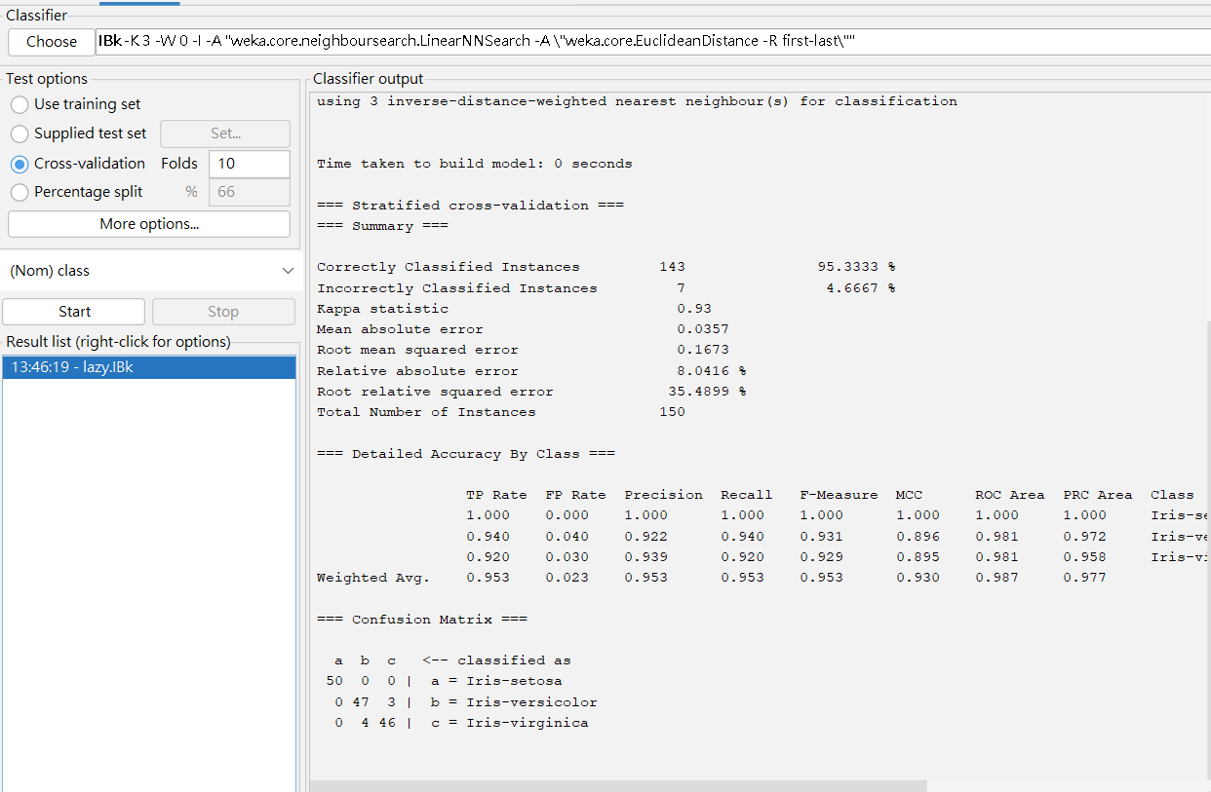

(1)

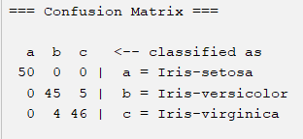

(2)

Sensitivity:

Setosa = $\frac{50}{50+0+0}$ = 1

versicoclor = $\frac{45}{0+45+5}$ = 0.90

virginica = $\frac{46}{0+4+46}$ = 0.92

(3)

Specificity:

Setosa = $\frac{45+46}{50+50}$ = 0.91

versicoclor = $\frac{50+46}{50+50}$ = 0.96

virginica = $\frac{50+45}{50+50}$ = 0.95