1.

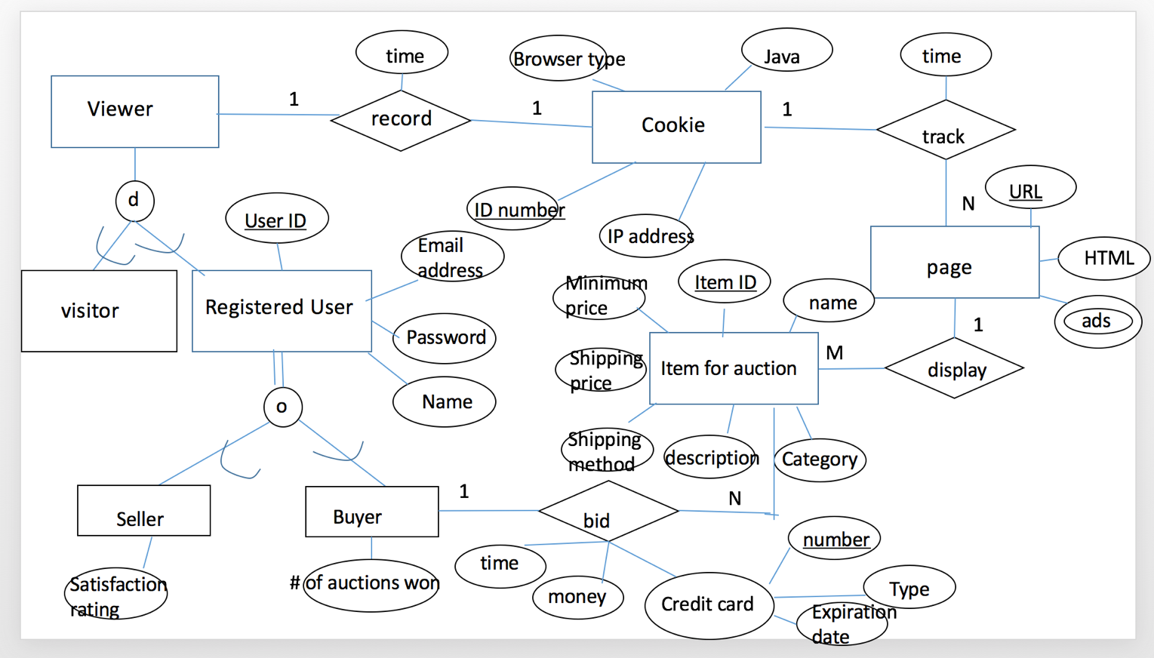

2.

create table **Employee**

(Emp_no char(10),

Emp_name char(20),

Room_no char(10),

primary key(Emp_no),

foreign key( Dept_no) references **Department** on delete set null on update cascade,

foreign key(manager_id) references **Employee** on delete set default on update cascade);

create table **Department**

( Dept_no char(10),

Dept_name char(20),

Dept_head char(20),

primary key( Dept_no),

foreign key(Emp_no) references **Employee** on delete set null on update cascade);

create table **Project**

(Proj_code char(10),

Proj_name char(20),

Start_date char(10),

End_date char(10),

primary key(Proj_code),

foreign key(Emp_no) references **Employee** on delete set default on update cascade);

create table **works-on**

(Emp_no char(10),

Proj_code char(10),

primary key(Emp_no, Proj_code),

foreign key(Emp_no) references **Employee** on delete cascade on update cascade,

foreign key(Proj_code) references **Project** on delete cascade on update cascade);

create table **Salary**

(Salary_level char(10),

Mon_Salary char(10),

primary key(Salary_level));

create table **Job**

(Job_code char(10),

Job_title char(20),

primary key(Job_code));

create table **salary_hist**

(Emp_no char(10),

Salary_level char(10),

Job_code char(10) not null,

primary key(Salary_level, Emp_no)

foreign key (Salary level) references **Salary** on delete cascade on update cascade,

foreign key (Emp_no) references **Employee** on delete cascade on update cascade,

foreign key (Job_code) references **Job** on delete cascade on update cascade,