1.a.

DECLARE @Q1 TABLE(

EnglishCountryRegionName nvarchar(50),

EnglishEducation nvarchar(40),

[All Customers] INT,

Female INT,

Male INT);

INSERT INTO @Q1

SELECT EnglishCountryRegionName,EnglishEducation,

COUNT(*) AS [All Customers],

COUNT(CASE WHEN Gender = 'F' THEN 1 ELSE NULL END) AS Female,

COUNT(CASE WHEN Gender = 'M' THEN 1 ELSE NULL END) AS Male

FROM dbo.DimCustomer,dbo.DimGeography

WHERE EnglishCountryRegionName IN ( 'France', 'Germany')

AND dbo.DimCustomer.GeographyKey = dbo.DimGeography.GeographyKey

GROUP BY EnglishCountryRegionName,EnglishEducation

ORDER BY EnglishCountryRegionName,EnglishEducation;

INSERT INTO @Q1

SELECT EnglishCountryRegionName, 'All Customers',

SUM([All Customers]),SUM(Female),SUM(Male)

FROM @Q1

GROUP BY EnglishCountryRegionName

ORDER BY EnglishCountryRegionName;

SELECT * FROM @Q1

ORDER BY EnglishCountryRegionName,EnglishEducation;

Output:

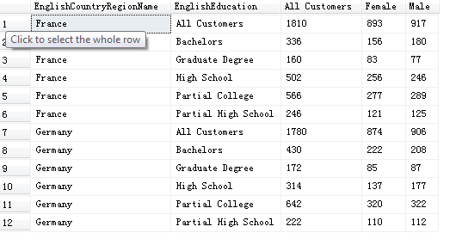

b.Output:

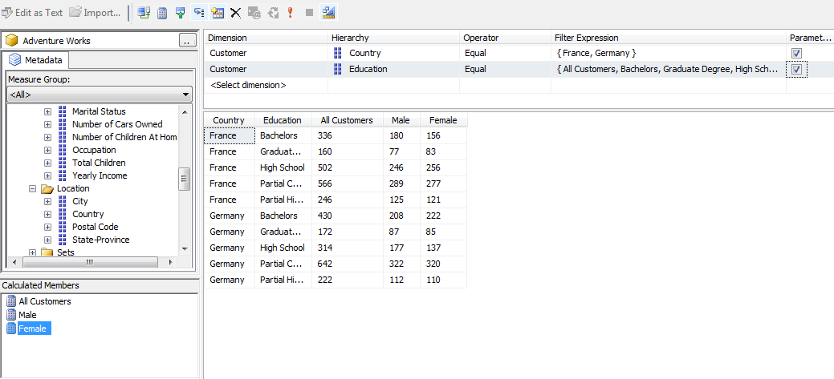

2.

SELECT

[Customer].[Gender].[Gender].members on columns,

( { [France], [Germany] }, education.education.members ) on rows

FROM [Adventure Works]

WHERE [Measures].[Customer Count]

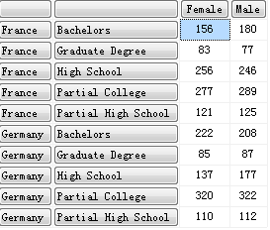

3.

SELECT

[Customer].[Gender].&[M] on columns,

( [Customer].[Customer Geography].[Country], education.members ) on rows

FROM [Adventure Works]

WHERE [Measures].[Customer Count]

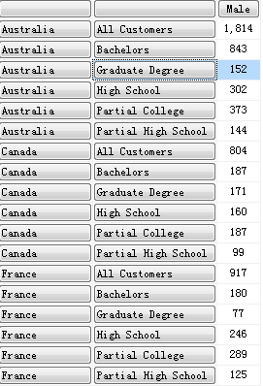

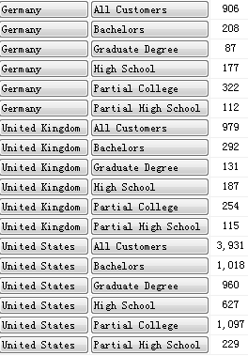

4.

with member measures.percentage as

'([Customer].[Gender].&[M], [Measures].[Customer Count])/

([Customer].[Gender].[All Customers],[Measures].[Customer Count])'

SELECT

[Customer].[Gender].male on columns,

([Customer].[Customer Geography].[Country], [Date].[Calendar Year].[Calendar Year]) on rows

FROM [Adventure Works]

WHERE [Measures].[percentage]

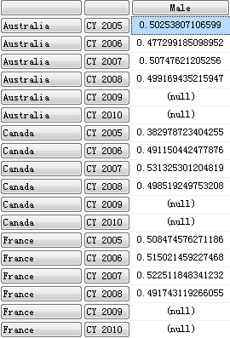

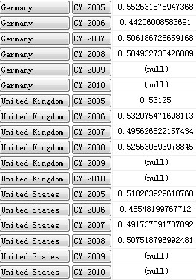  
5.SELECT

NON EMPTY { [Measures].[Internet Sales Amount] } on columns ,

NON EMPTY { Filter([Customer].[Customer Geography].[City].members, [Customer].[Country].Member_Value = "France" or [Customer].[Country].Member_Value = "Germany") } on rows

FROM [Adventure Works]s

Output:

