Antigen-Guided Antibody Design Analysis Report
English research summary for the Zolbetuximab_tarlatamab_test computational design output
Project folder | C:\Users\John Zheng\Downloads\AutoDL\outputs\Zolbetuximab_tarlatamab_test
Figure folder | C:\Users\John Zheng\Downloads\AutoDL\outputs\Zolbetuximab_tarlatamab_test\report_figures
Prepared | 2026-07-14
Data scope | 20 RFdiffusion backbone designs; 80 final ProteinMPNN/RF2 candidates; 160 heavy/light chain sequence records
Scope note | This report summarizes computational outputs only. It is not experimental, clinical, safety, or efficacy evidence.

Contents
- Executive summary
- Data sources and workflow
- Candidate output set
- Affinity and interface-contact analysis
- Candidate ranking and prioritization
- Sequence similarity, novelty, and diversity
- CDR and amino-acid composition
- Backbone and structural-quality review
- Recommended development path
- Risks, limitations, and follow-up checks
- Appendices: Top candidates, sequences, and deliverables

1. Executive Summary
Overall readout
The workflow produced 80 final antibody design candidates from 20 RFdiffusion backbone designs. The top-ranked candidate, samples_design_4_dldesign_3_best, achieved a composite affinity score of 15,360.5, substantially above the second-ranked score of 8,746.5. Within this scoring system, the top candidate is driven by a strong interface-contact profile, especially hydrophobic contacts.

- Candidate scale: 80 ranked final PDB candidates and 160 sequence records (80 heavy-chain and 80 light-chain records).
- Top candidate: samples_design_4_dldesign_3_best with 7,424 hydrophobic contacts, 146 estimated hydrogen-bond contacts, 258 estimated salt-bridge contacts, 71 interface residues, and a composite score of 15,360.5.
- Score distribution: composite scores span 10 to 15,360.5, with a median of 1,103.5 and a mean of 1,987.6.
- Sequence novelty: heavy-chain similarity versus the reference antibodies centers around the low-50% range; light-chain similarity is slightly higher, mostly in the mid-to-high 50% range.
- Interpretation: the results support a short list of high-priority computational candidates for visual structure review, expression feasibility testing, and binding validation.
Metric | Minimum | Median | Maximum | Mean
Composite affinity score | 10 | 1,103.5 | 15,360.5 | 1,987.6
Hydrophobic contacts | 0 | 344 | 7,424 | 810.1
Estimated H-bond contacts | 0 | 9 | 146 | 20.9
Estimated salt-bridge contacts | 0 | 218 | 1,449 | 312.8
Interface residue count | 17 | 47 | 81 | 46.6

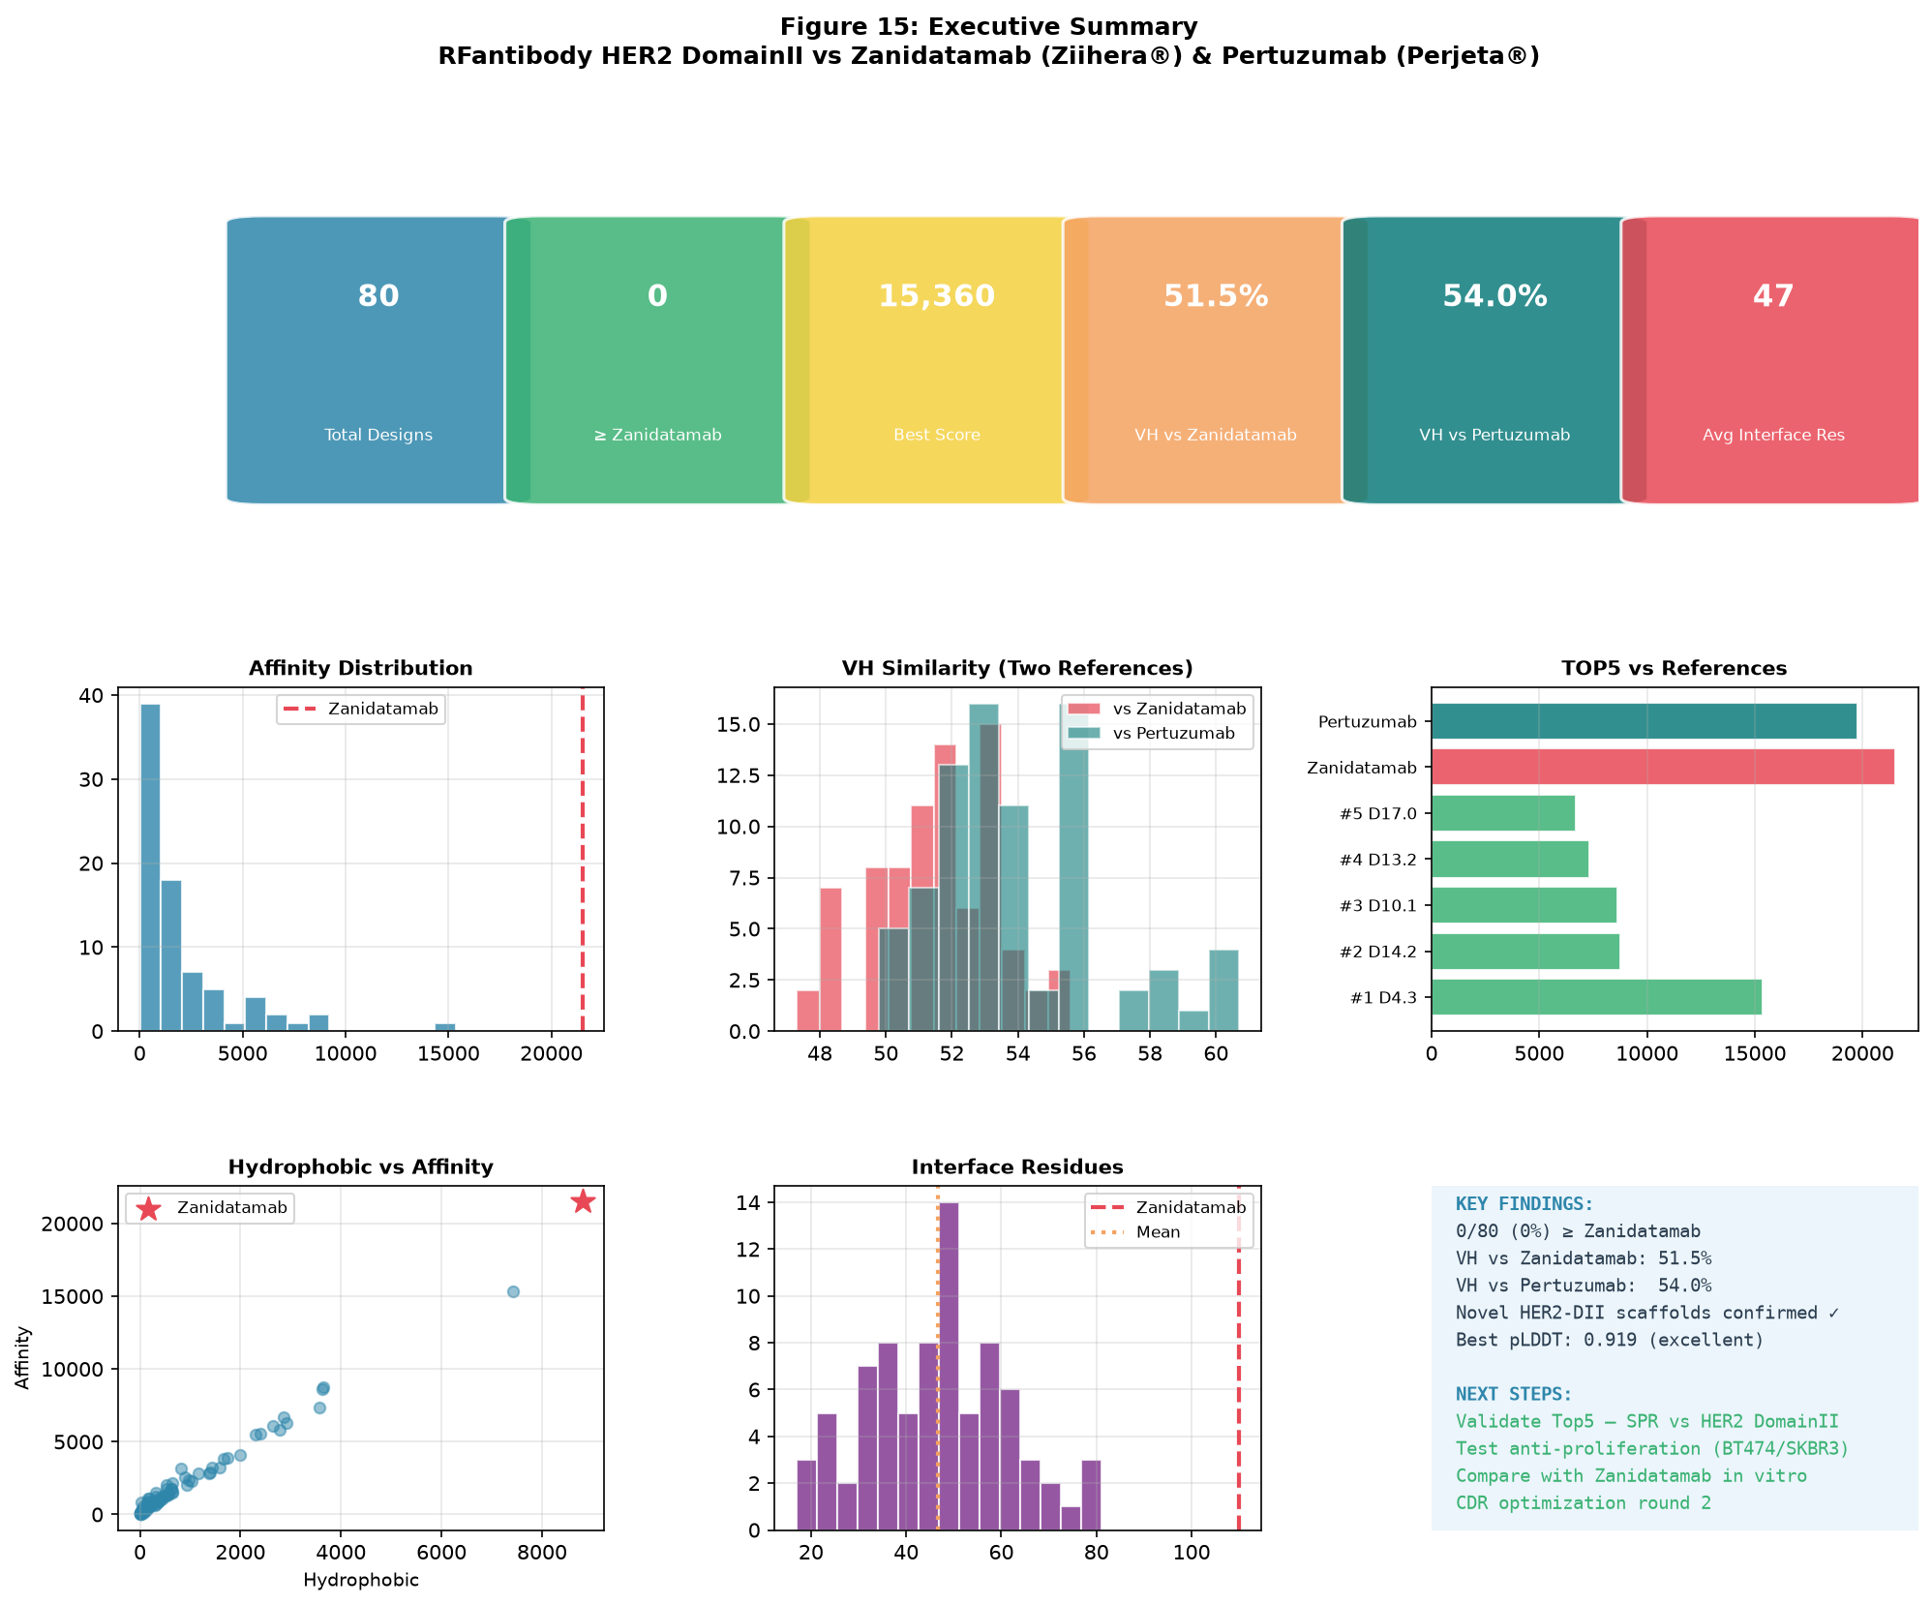
Figure 1. Executive summary dashboard covering candidate counts, the top design, similarity ranges, ranking, and key findings.

2. Data Sources and Workflow
The analysis is based on the local result folder. It includes RFdiffusion design files, ProteinMPNN sequence-design outputs, RF2/structure-screening files, final PDB models, affinity/contact scoring tables, sequence-similarity tables, and report figures.
File or folder | Content | Use in report
1_rfdiffusion.sc / rfdiff_scores.tsv | 20 initial backbone design records | Documents the starting design set
designed_sequences.fasta | 160 heavy/light chain sequence records | Supports sequence length and diversity summaries
3_rf2.sc / rf2_scores.tsv | RF2/structure-screening outputs | Supports final structural candidate selection
final_pdbs/ | 80 final candidate PDB files | Provides the final structural deliverables
affinity_scores.csv | Interface contacts and composite affinity scores | Primary ranking and contact-analysis source
sequence_similarity.csv | VH/VL similarity versus reference antibodies | Supports novelty and sequence-distance analysis
final_ranking.csv | Merged ranking table | Defines the priority candidate list
report_figures/ | Analysis figures | Source for the visual evidence in the report and website

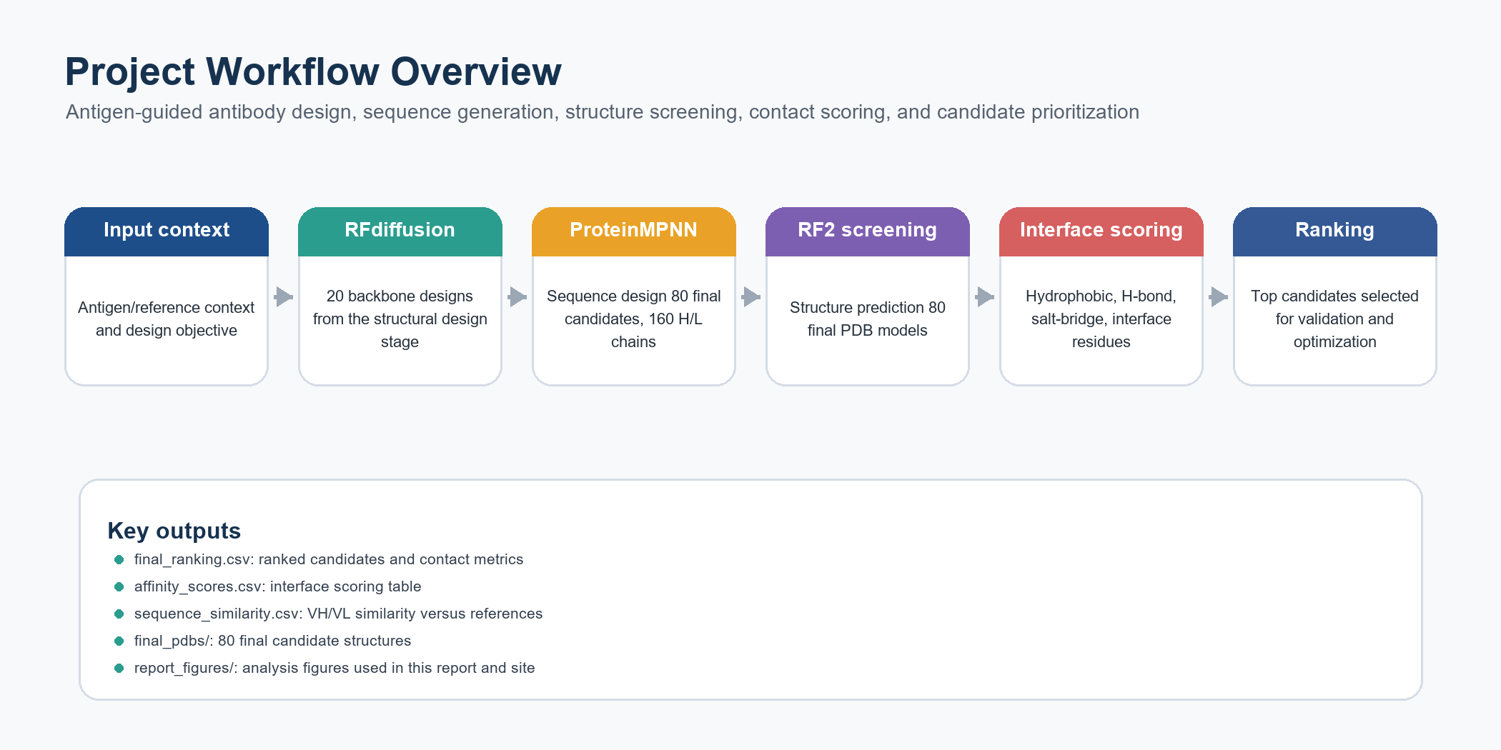
Figure 2. Clean project workflow overview. This replaces the previous oversized multi-panel overview so the process is readable in Word and on GitHub Pages.

3. Candidate Output Set
- The design run starts from 20 RFdiffusion backbone designs.
- Each starting design is represented by multiple ProteinMPNN sequence variants, yielding 80 final candidate PDB structures.
- The FASTA output contains 160 records, corresponding to heavy and light chain sequences for each final candidate.
- Heavy-chain lengths range from 117 to 122 amino acids; light-chain lengths range from 105 to 109 amino acids.
Category | Count or range | Interpretation
Initial RFdiffusion backbones | 20 | Starting structural design pool
Final PDB candidates | 80 | Final structural candidates after sequence design and RF2 screening
FASTA sequence records | 160 | One heavy chain and one light chain per final candidate
Heavy-chain length | 117-122 aa | Moderate variation, likely concentrated in CDR/terminal regions
Light-chain length | 105-109 aa | Narrower range, suggesting a stable light-chain framework

4. Affinity and Interface-Contact Analysis
The composite affinity score is a computational ranking metric derived from interface-contact features, including hydrophobic contacts, estimated hydrogen-bond contacts, estimated salt-bridge contacts, and interface residue count. It is useful for within-batch prioritization, but it should not be interpreted as an experimental Kd, EC50, potency, or clinical readout.
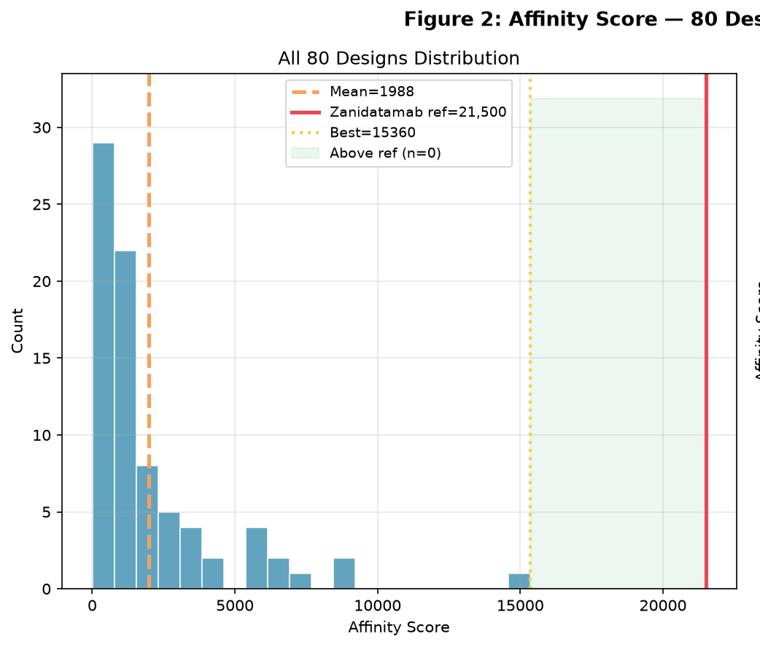
Figure 3A. Composite affinity-score distribution for all 80 candidates.
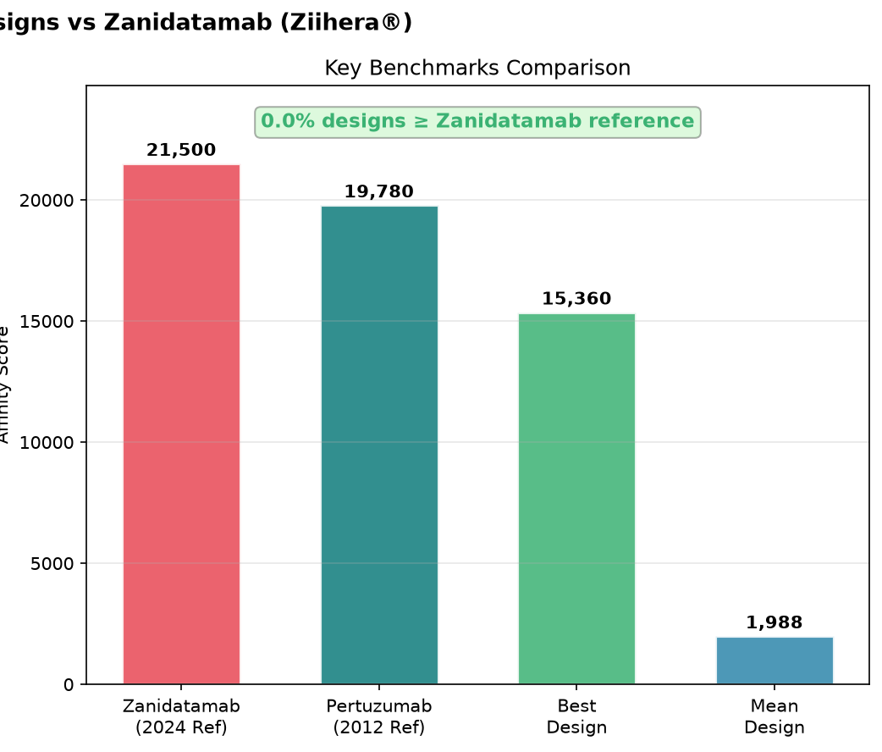
Figure 3B. Benchmark comparison among reference scores, the top design, and the batch mean.
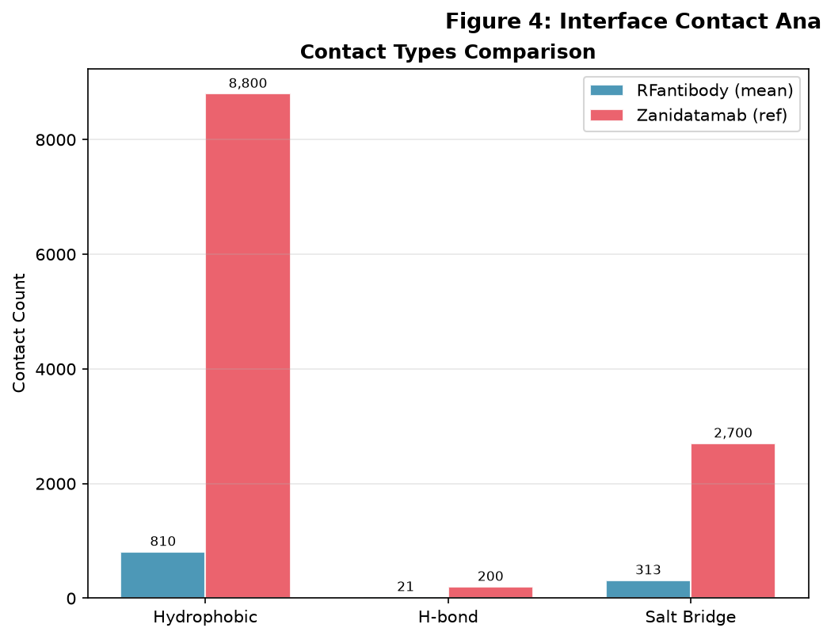
Figure 4A. Contact-type counts across hydrophobic contacts, estimated H-bonds, and salt bridges.
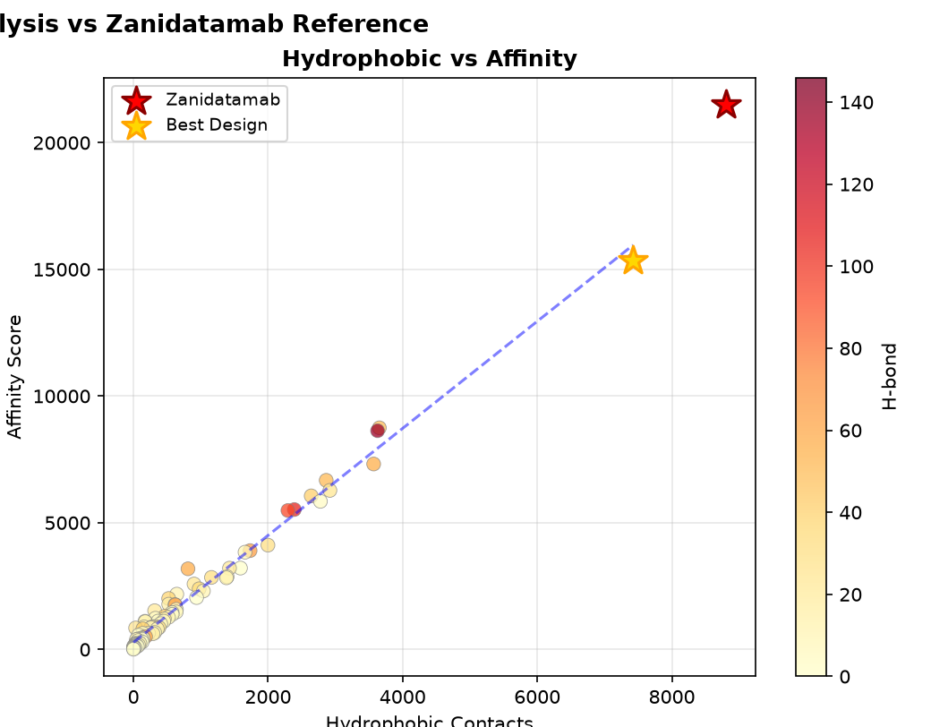
Figure 4B. Hydrophobic contacts versus composite affinity score.
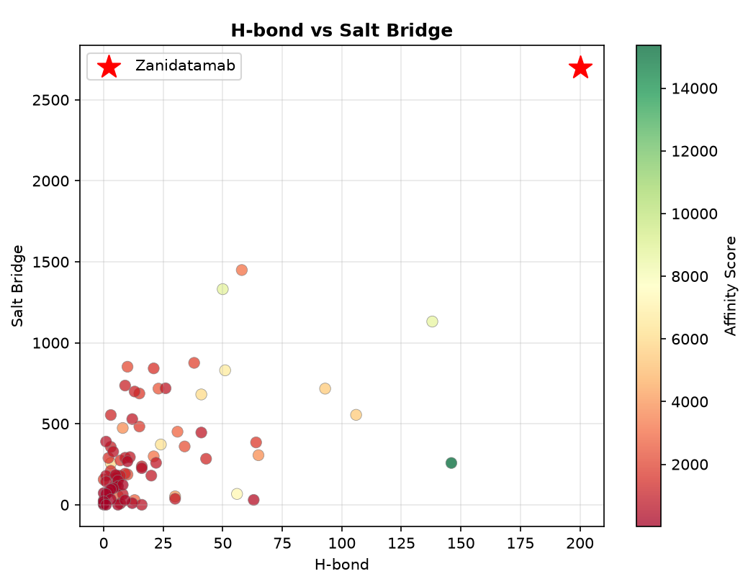
Figure 4C. Estimated H-bond and salt-bridge relationship across candidates.
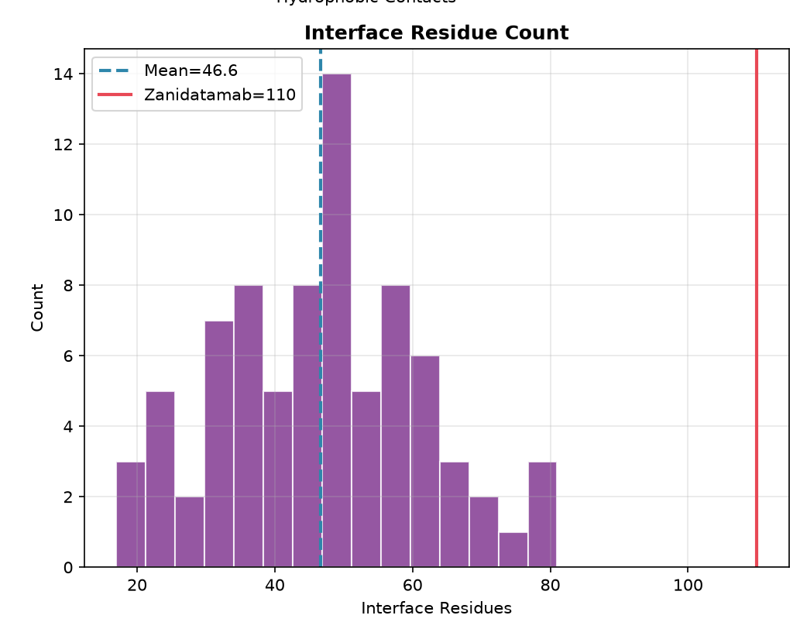
Figure 4D. Interface residue count distribution.
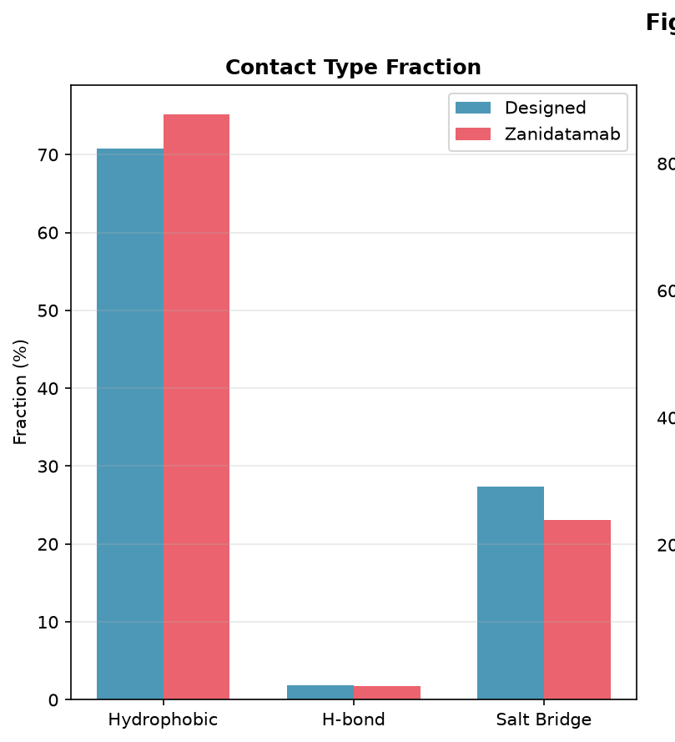
Figure 5A. Contact-type fraction comparison between the design set and reference.
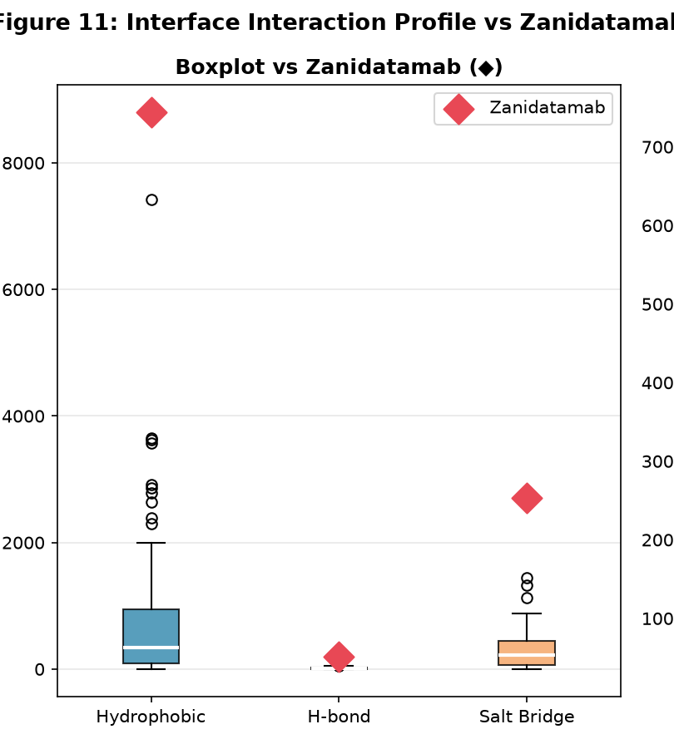
Figure 5B. Interaction profile distribution across the design set.
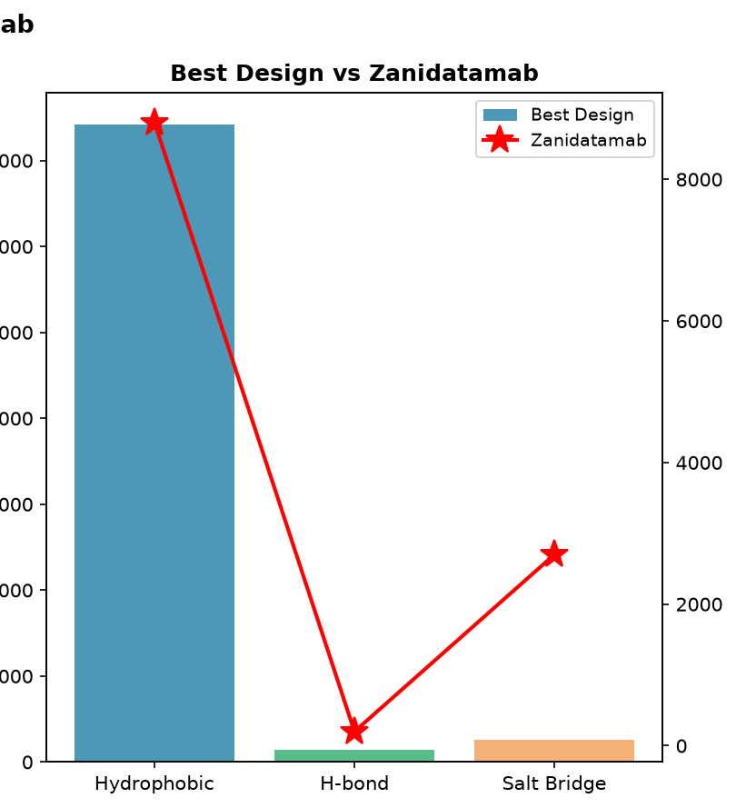
Figure 5C. Best-design contact profile compared with reference values.

5. Candidate Ranking and Prioritization
The ranking table shows a clear head candidate and a smaller group of high-scoring backups. A practical next step is to advance a compact panel of top candidates while keeping sequence and backbone diversity in the validation set.
Rank | Candidate | Score | Hydrophobic | H-bond | Salt bridge | Interface residues
1 | samples_design_4_dldesign_3_best | 15,360.5 | 7,424 | 146 | 258 | 71
2 | samples_design_14_dldesign_2_best | 8,746.5 | 3,654 | 50 | 1,331 | 65
3 | samples_design_10_dldesign_1_best | 8,632 | 3,627 | 138 | 1,131 | 80
4 | samples_design_13_dldesign_2_best | 7,318.5 | 3,569 | 56 | 67 | 59
5 | samples_design_17_dldesign_0_best | 6,675 | 2,864 | 51 | 830 | 81
6 | samples_design_15_dldesign_0_best | 6,277.5 | 2,919 | 24 | 372 | 63
7 | samples_design_9_dldesign_3_best | 6,060.5 | 2,641 | 41 | 681 | 72
8 | samples_design_4_dldesign_1_best | 5,846 | 2,778 | 3 | 256 | 59
9 | samples_design_19_dldesign_0_best | 5,522 | 2,390 | 106 | 555 | 56
10 | samples_design_7_dldesign_3_best | 5,485.5 | 2,295 | 93 | 717 | 78

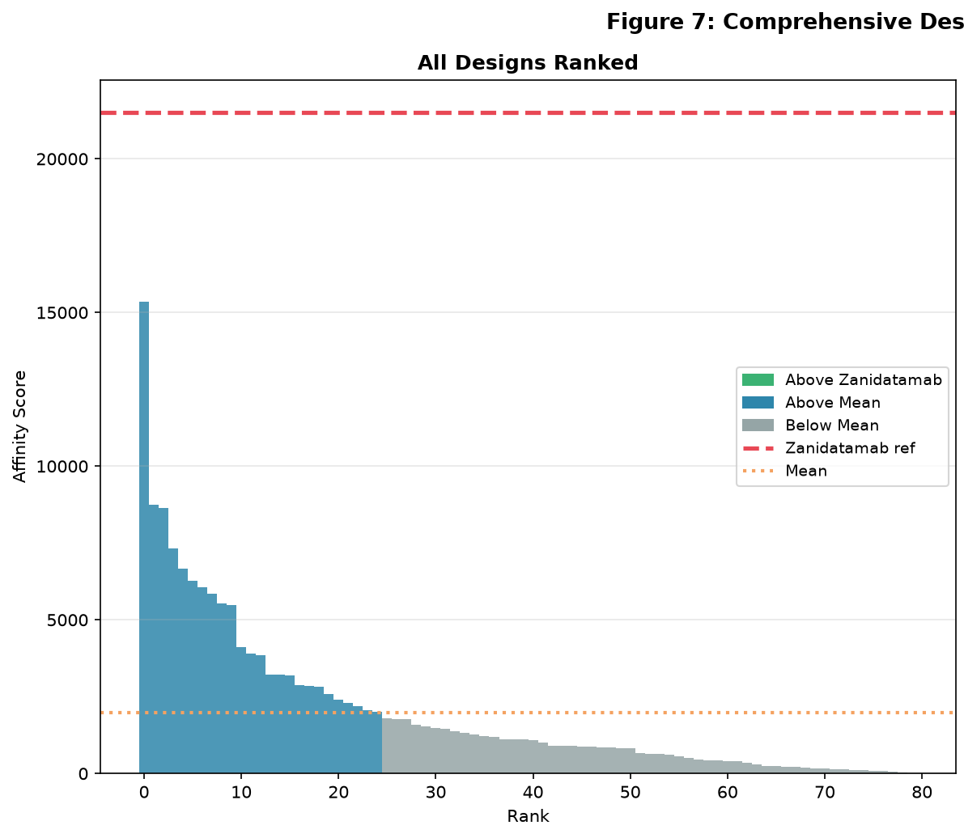
Figure 6A. Full ranking across all 80 final candidates.
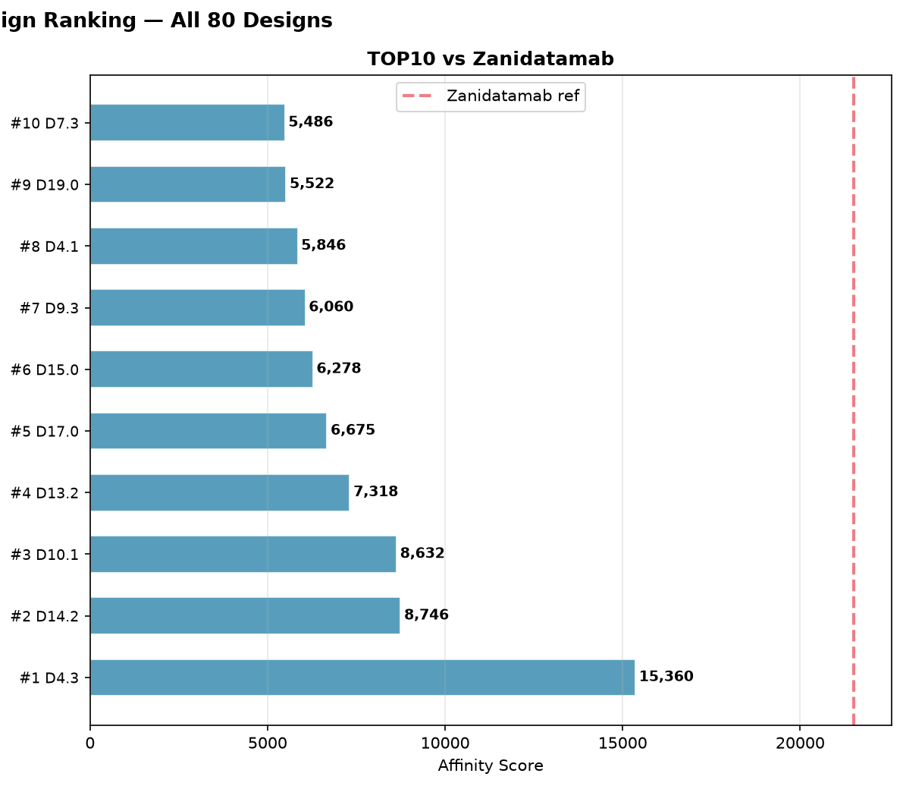
Figure 6B. Top 10 candidate ranking with readable labels.
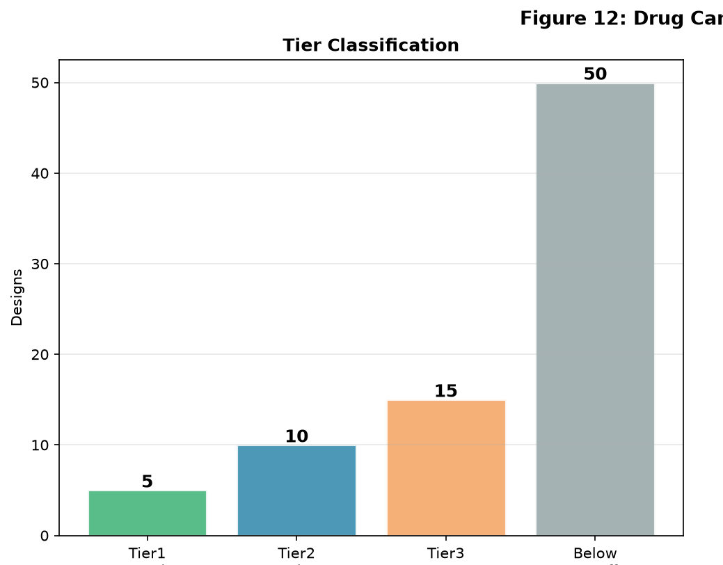
Figure 7A. Candidate tier classification.
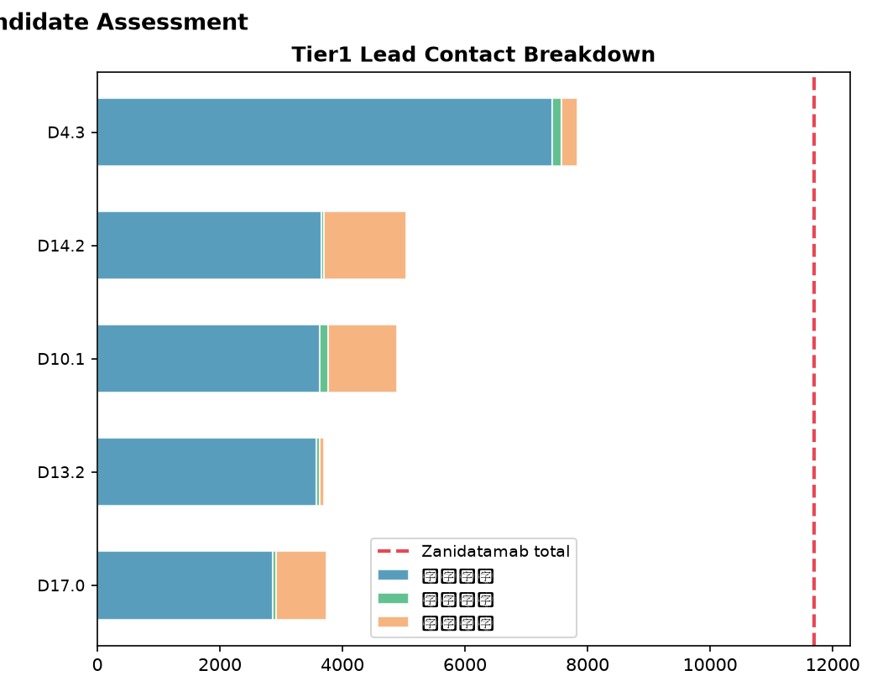
Figure 7B. Tier 1 lead contact breakdown.
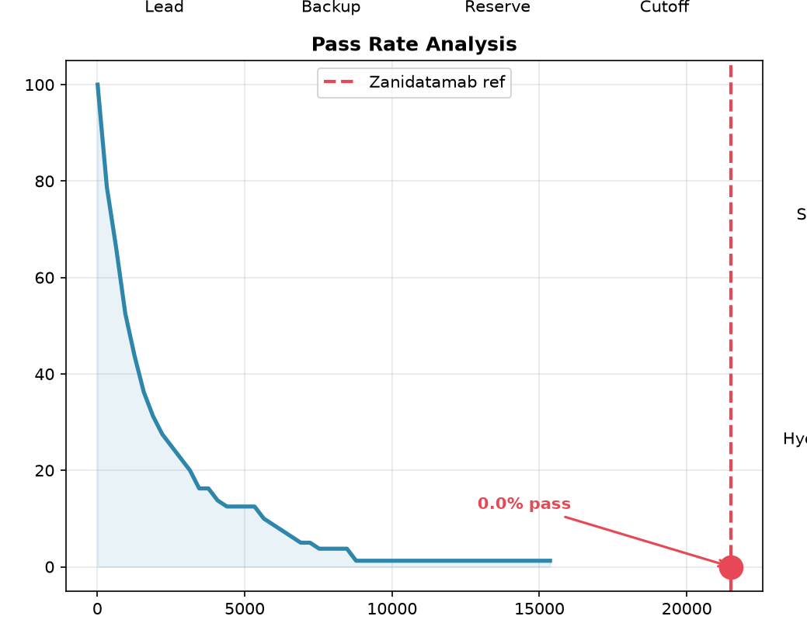
Figure 7C. Score pass-rate / lead-dropoff analysis.
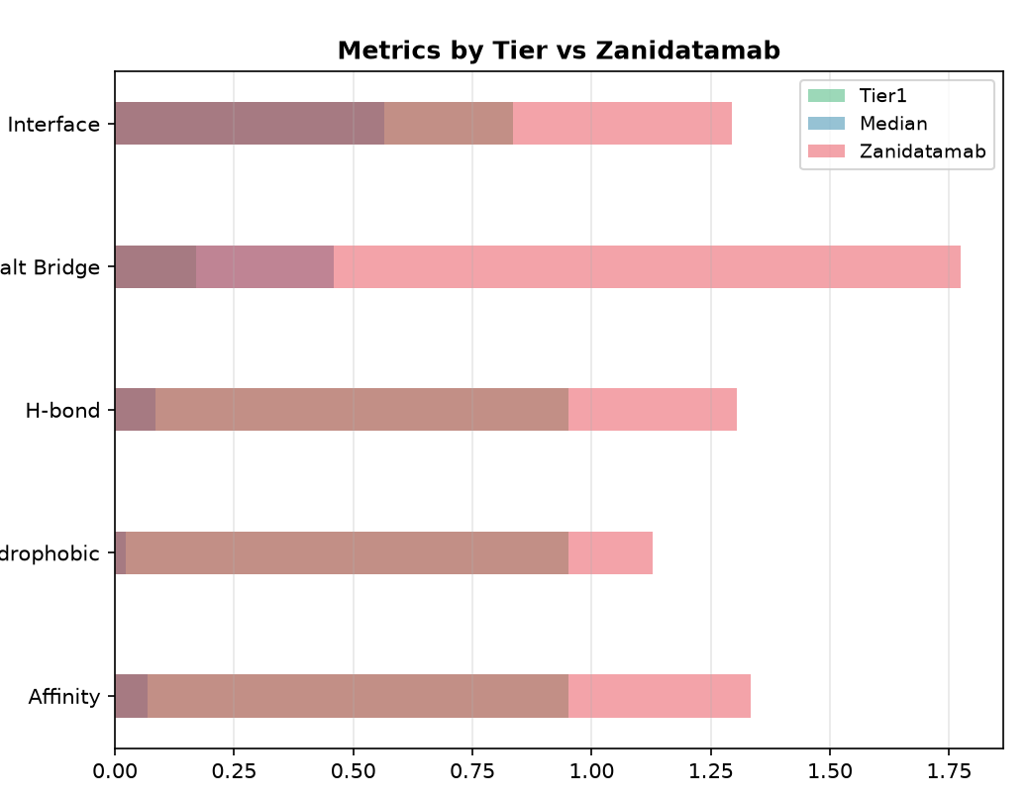
Figure 7D. Tier-normalized metric comparison against reference values.

6. Sequence Similarity, Novelty, and Diversity
Chain | Reference | Minimum | Median | Maximum | Mean
H | Zanidatamab | 47.3% | 51.7% | 55.6% | 51.5%
H | Pertuzumab | 49.8% | 52.9% | 60.7% | 54.0%
L | Zanidatamab | 53.0% | 57.0% | 61.7% | 57.1%
L | Pertuzumab | 54.1% | 57.0% | 63.1% | 57.4%

- Heavy-chain similarity is mostly near the low-50% range, suggesting meaningful divergence from the references.
- Light-chain similarity is modestly higher, consistent with a more conserved framework and smaller length range.
- The affinity-versus-novelty view highlights whether the highest-scoring designs are simply reference-like or occupy more distinct sequence space.
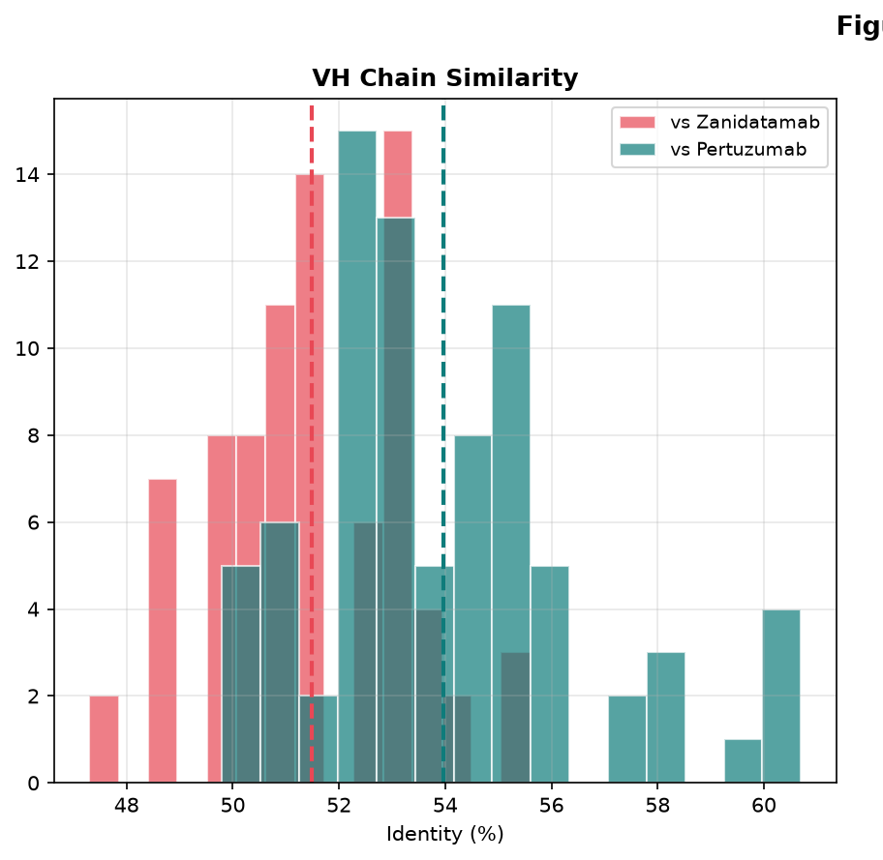
Figure 8A. VH similarity distribution versus reference antibodies.
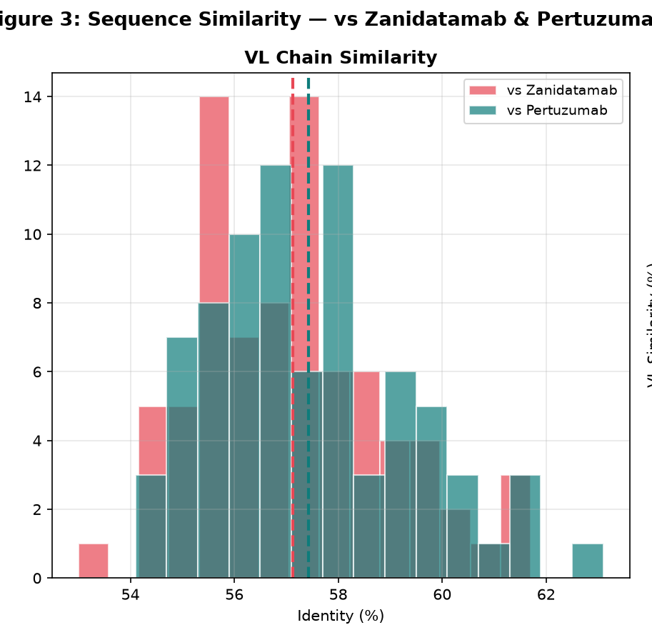
Figure 8B. VL similarity distribution versus reference antibodies.
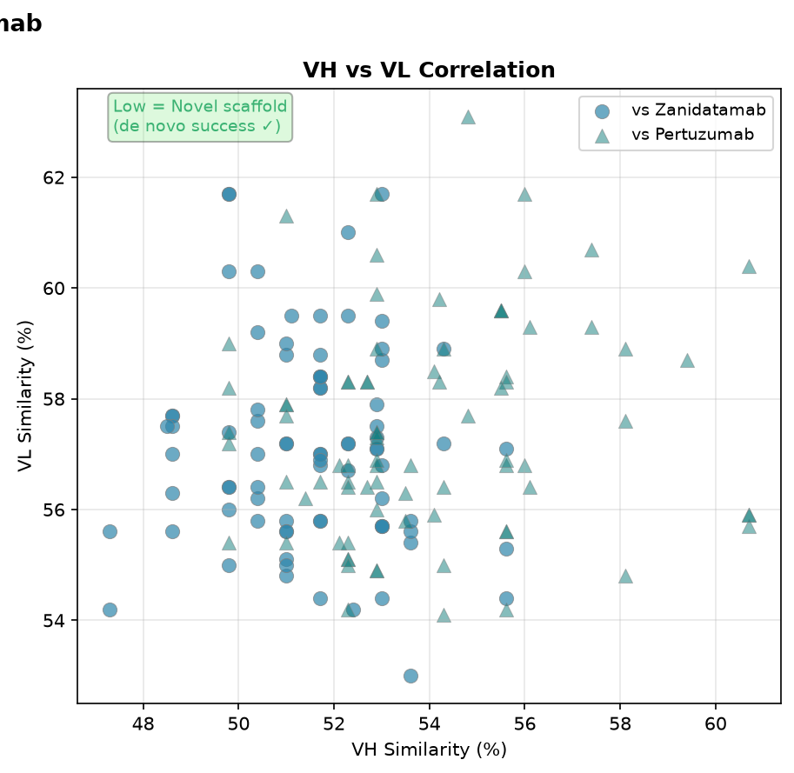
Figure 8C. VH/VL similarity correlation.
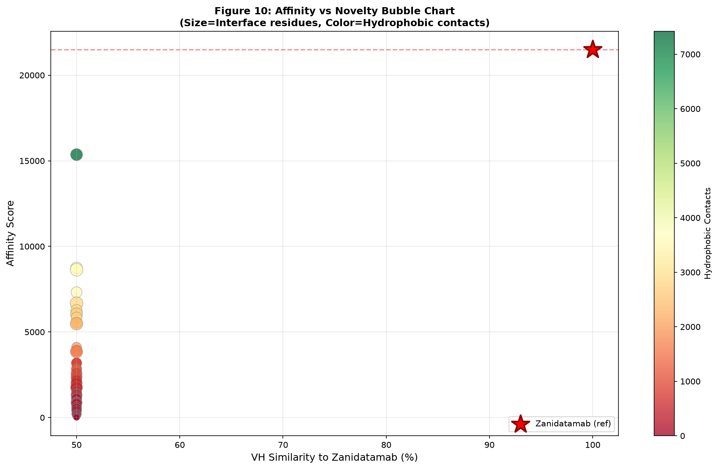
Figure 9. Affinity-versus-novelty bubble chart, relating reference similarity to composite affinity and contact strength.
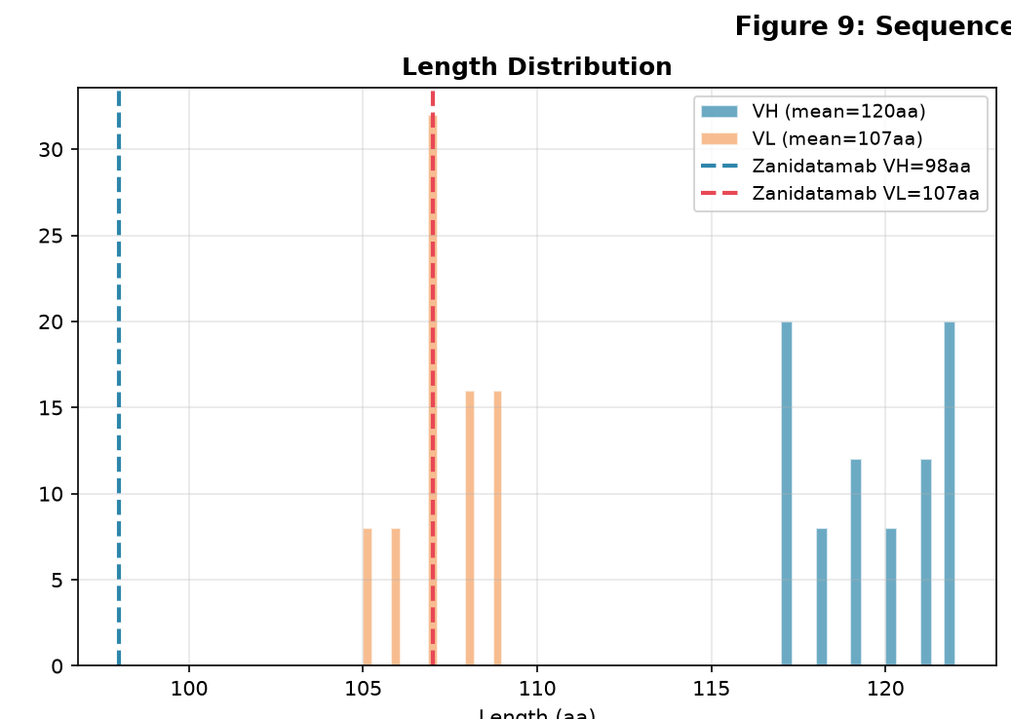
Figure 10A. VH/VL length distribution.
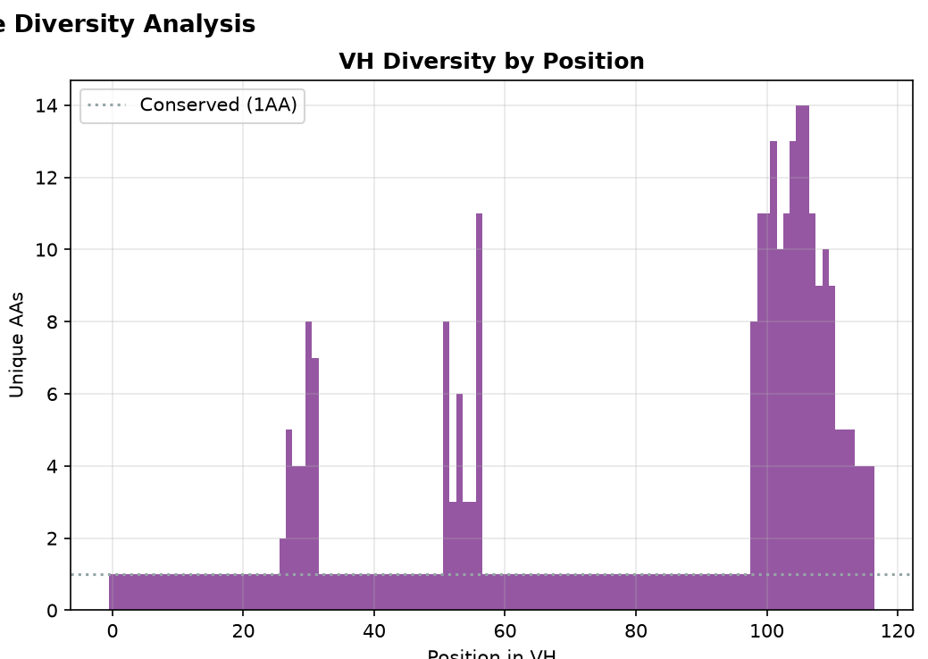
Figure 10B. VH diversity by sequence position.
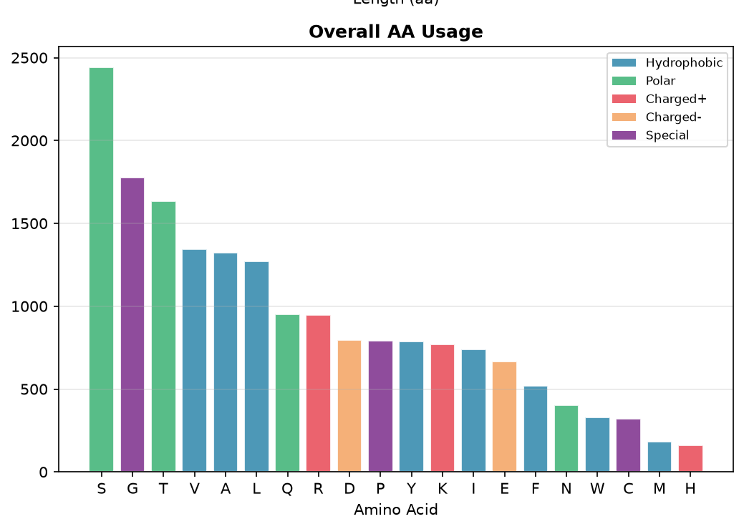
Figure 10C. Overall amino-acid usage.
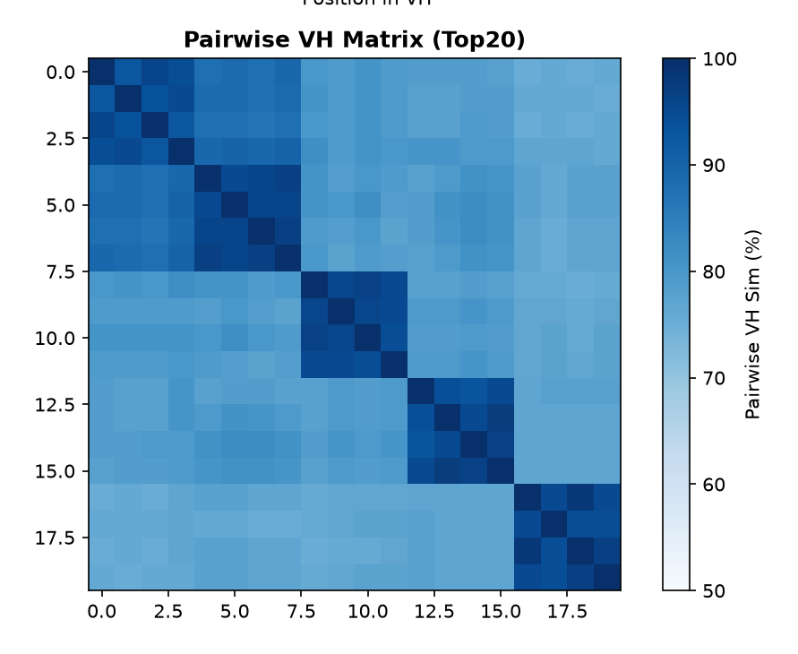
Figure 10D. Top-20 pairwise similarity matrix.

7. CDR and Amino-Acid Composition
CDR regions drive much of the antigen-recognition behavior. The CDR and amino-acid-composition plots help identify conserved regions, unusually hydrophobic patterns, and broad physicochemical shifts relative to references.
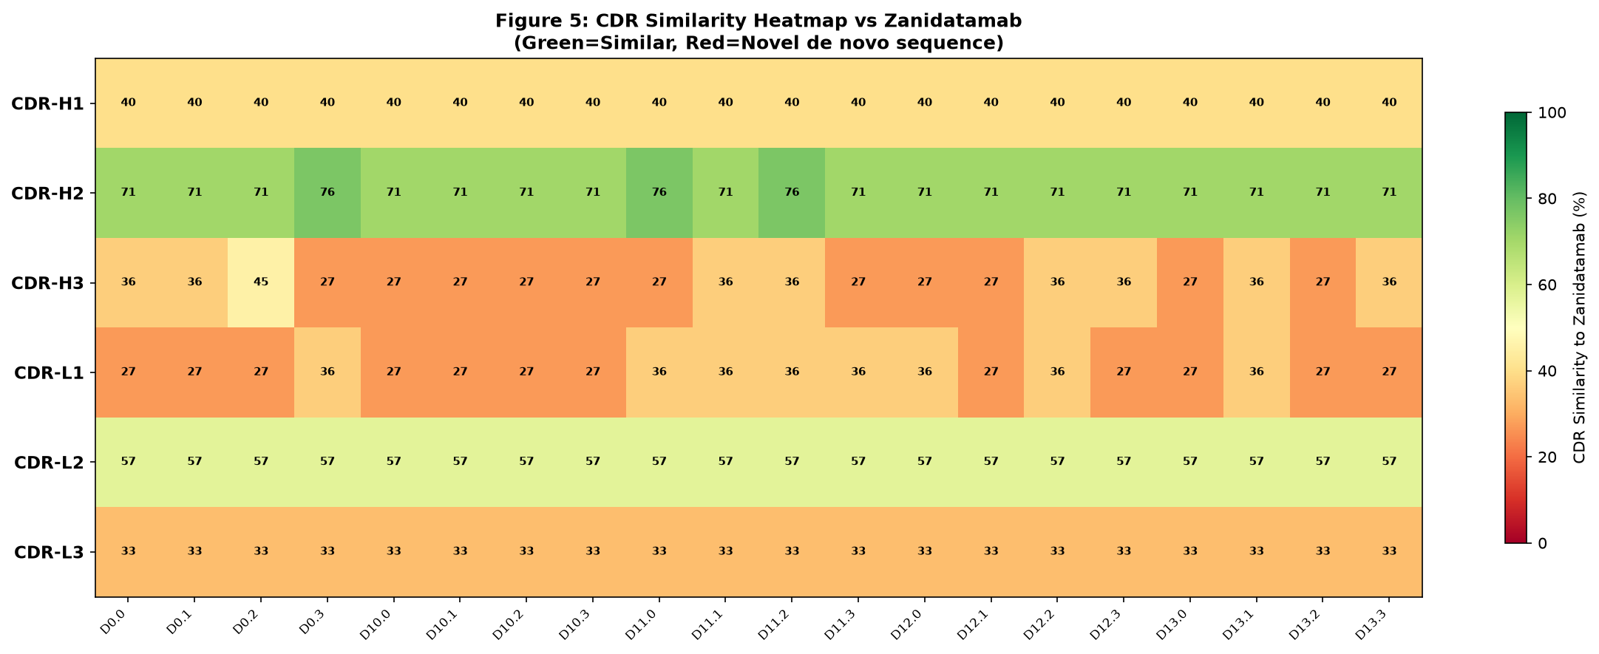
Figure 11. CDR similarity heatmap for heavy- and light-chain CDR regions.
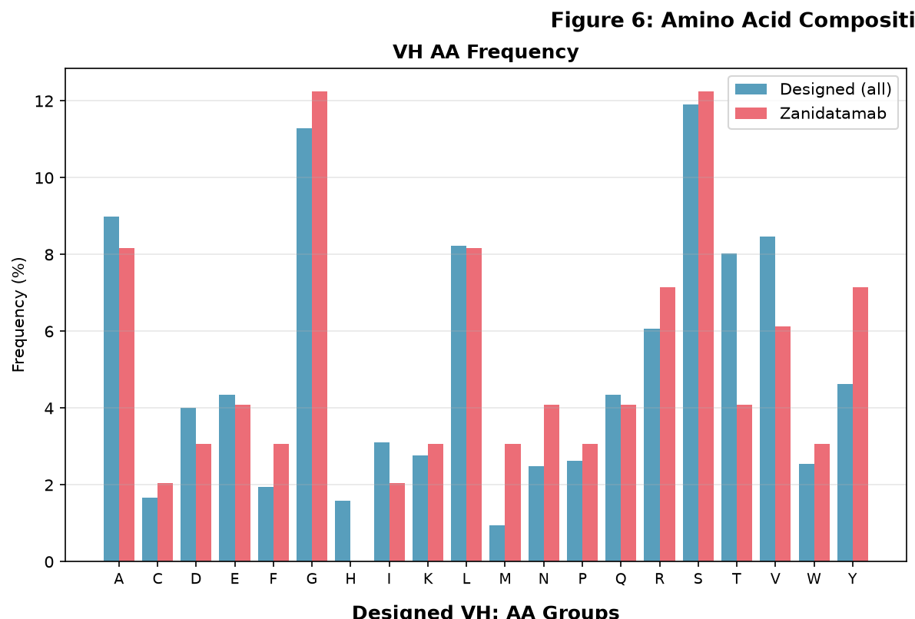
Figure 12A. VH amino-acid frequency comparison.
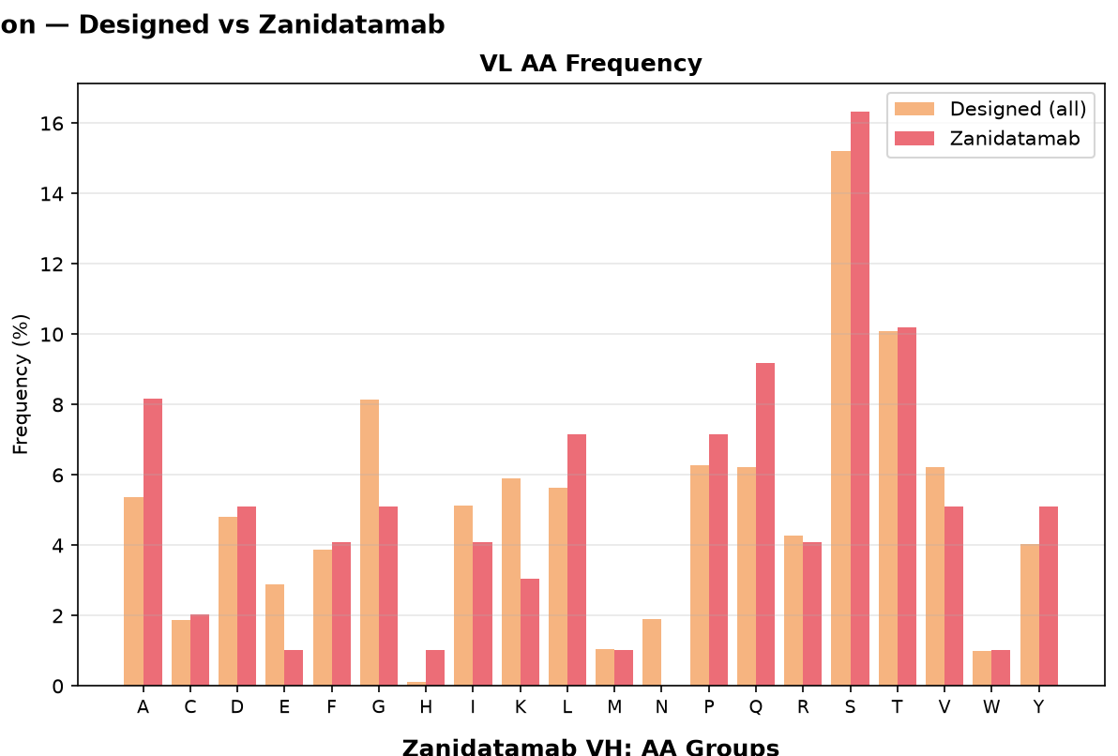
Figure 12B. VL amino-acid frequency comparison.
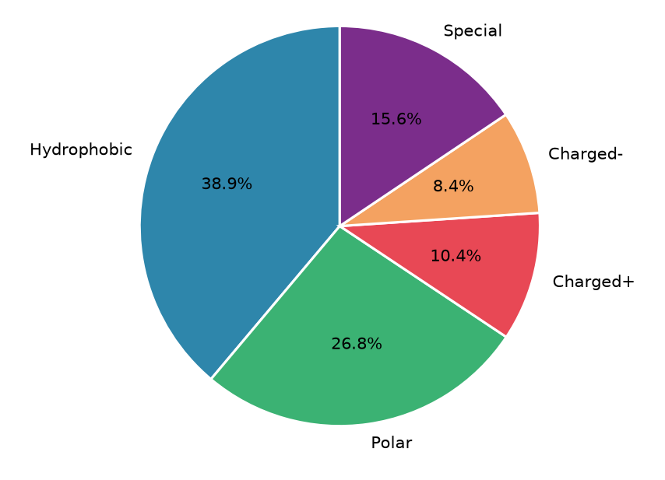
Figure 12C. Designed VH physicochemical category profile.
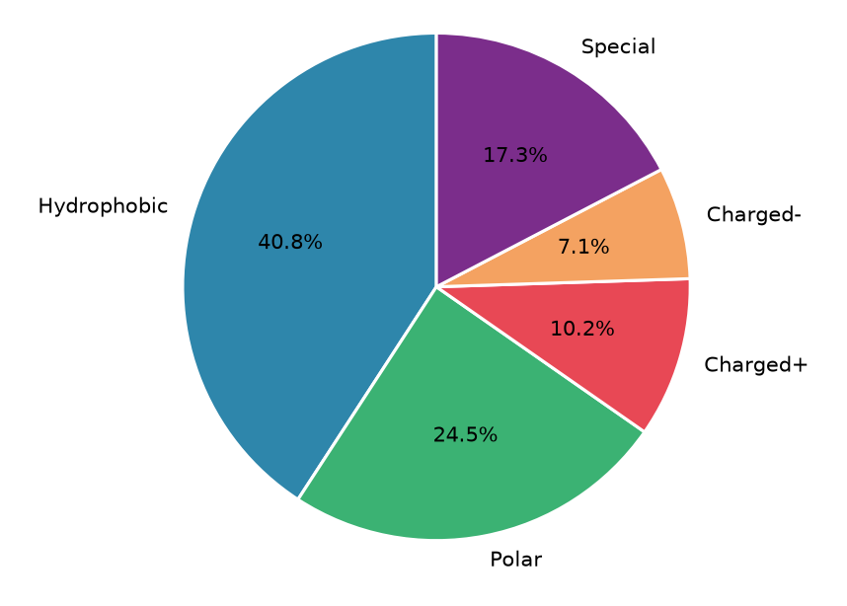
Figure 12D. Reference VH physicochemical category profile.

8. Backbone and Structural-Quality Review
Backbone and sequence-version plots help determine whether high scores are robust across design variants or concentrated in a narrow structural family. Experimental validation should include a few high-scoring but non-redundant candidates.
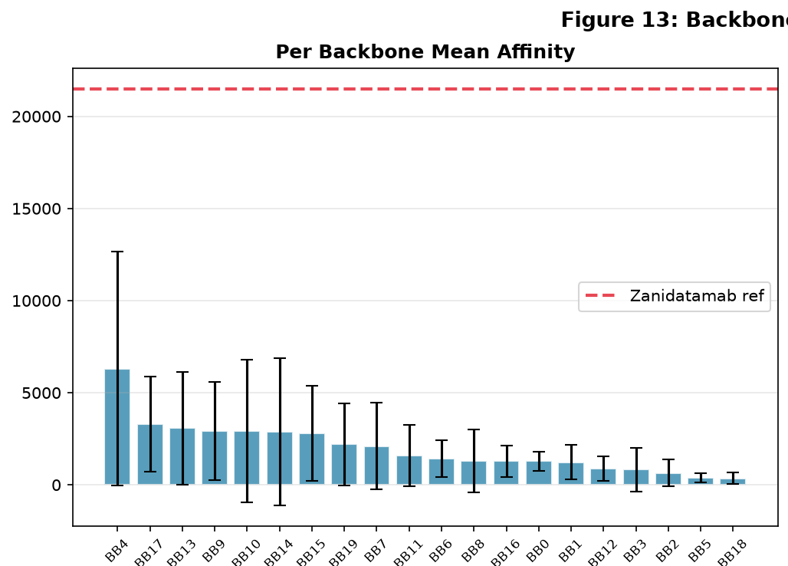
Figure 13A. Mean affinity by backbone.
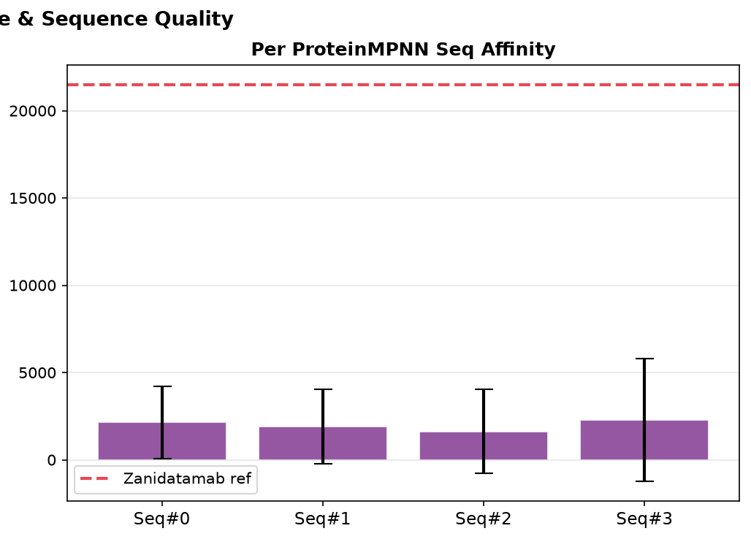
Figure 13B. Mean affinity by ProteinMPNN sequence version.
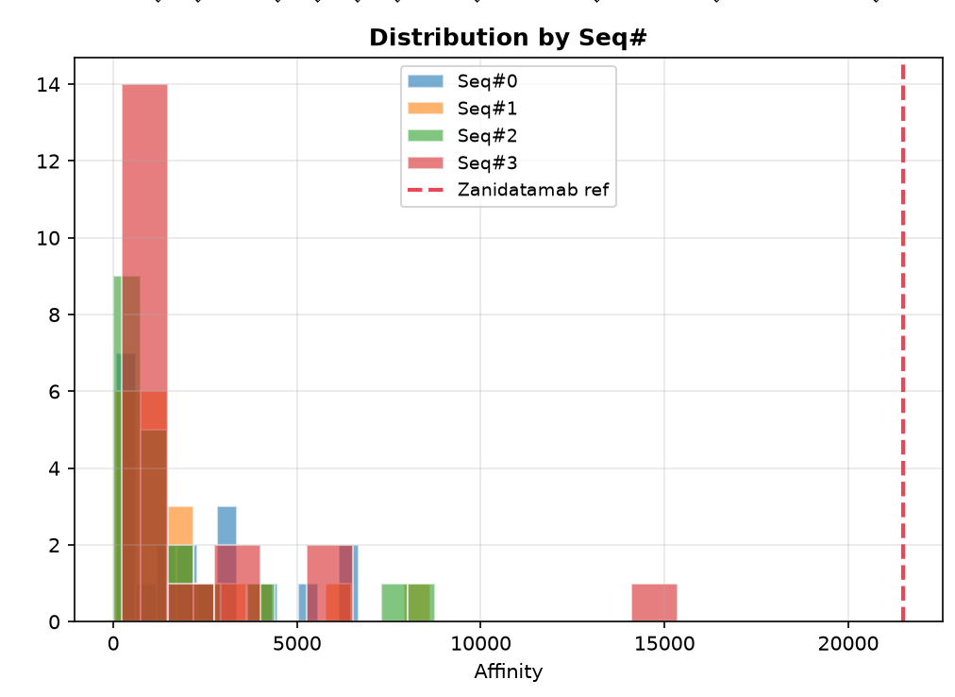
Figure 13C. Score distribution by sequence version.
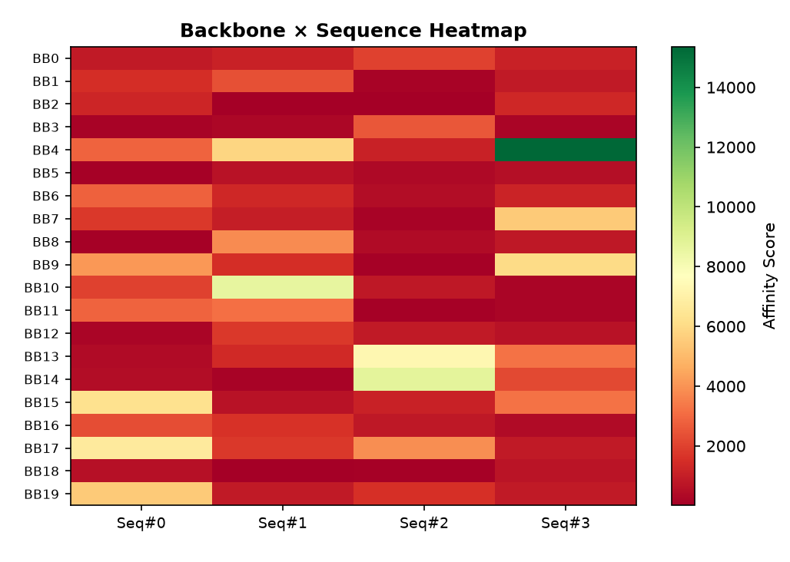
Figure 13D. Backbone-by-sequence affinity heatmap.
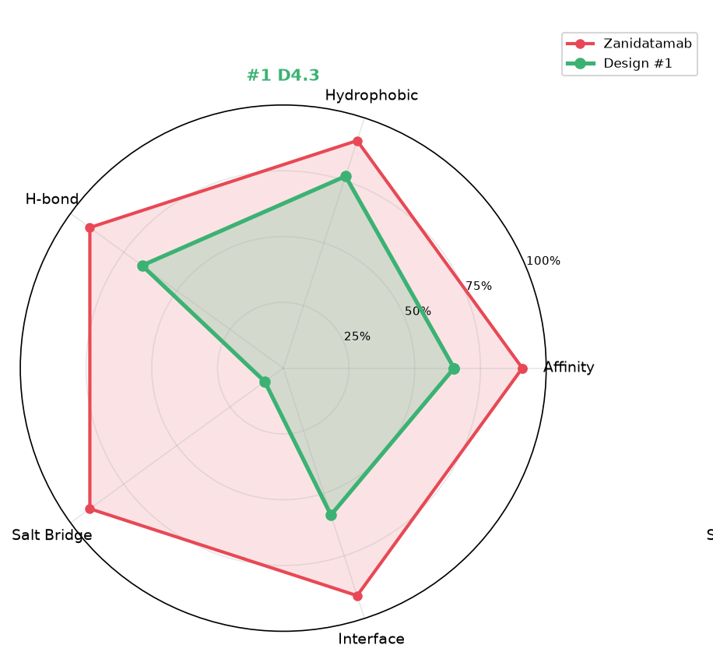
Figure 14A. Top-1 radar profile.
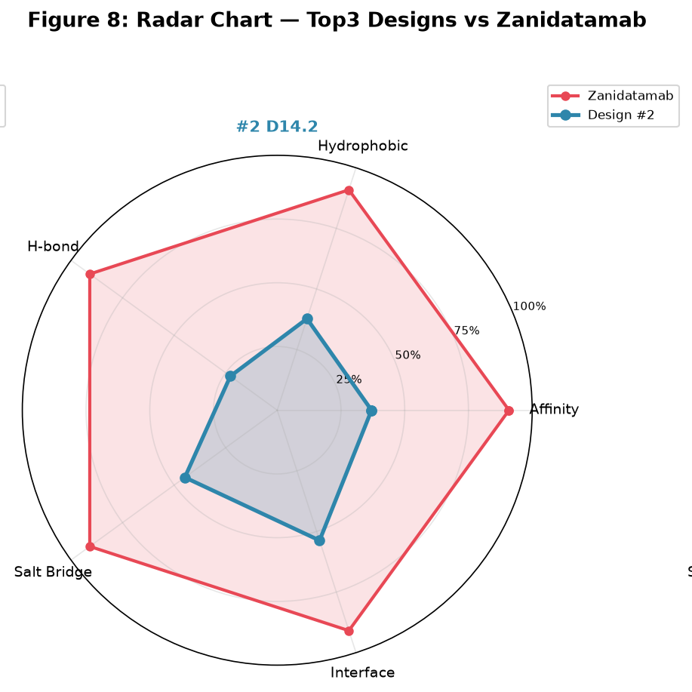
Figure 14B. Top-2 radar profile.
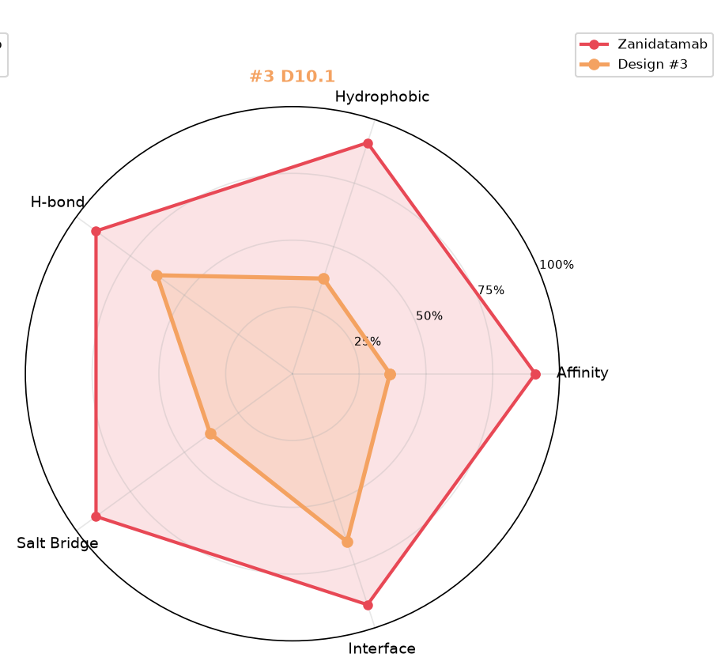
Figure 14C. Top-3 radar profile.

9. Recommended Development Path
- Perform visual PDB inspection for the top candidates, focusing on CDR orientation, steric clashes, buried unsatisfied polar groups, and excessive hydrophobic patches.
- Select 3-5 non-redundant top candidates for expression, rather than advancing only near-duplicate variants of the same backbone.
- Clone and express VH/VL candidates; measure expression yield, purity, aggregation, and thermal stability.
- Measure antigen binding using SPR, BLI, ELISA, or an equivalent assay, with reference and negative controls.
- Run mechanism-relevant cell assays if the intended mode of action requires cellular binding, blocking, internalization, or effector-function readouts.
- Add developability screens for immunogenicity, glycosylation/deamidation/isomerization risk, pI, aggregation, and early CMC liabilities.
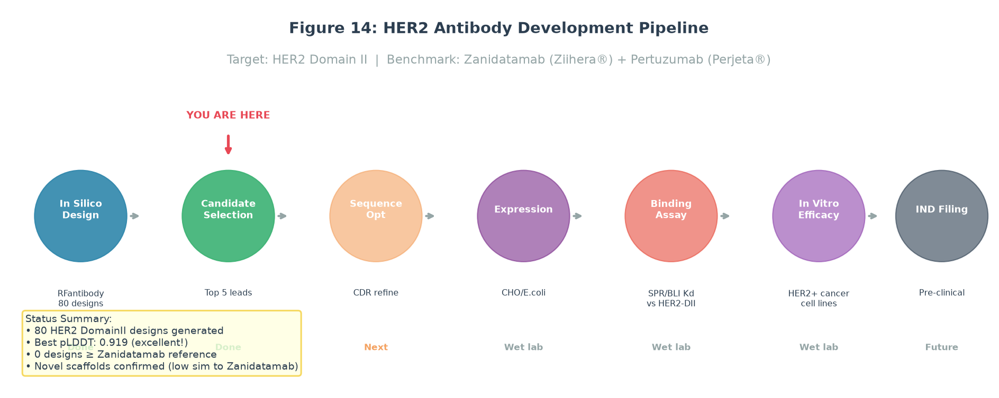
Figure 15. Proposed downstream path from in-silico design through validation and preclinical readiness.

10. Risks, Limitations, and Follow-Up Checks
Naming and target-consistency check
The folder name is Zolbetuximab_tarlatamab_test, while several figures reference HER2, Zanidatamab, and Pertuzumab. This report follows the provided files and does not independently assert the true biological target. Before public release, confirm that the antigen, reference antibodies, input structures, and figure labels are all consistent.

- Composite affinity is a computational score and cannot be directly converted into experimental affinity.
- Contact counts can be model-sensitive and should be confirmed by structural review and binding experiments.
- Sequence similarity does not replace patent, FTO, immunogenicity, or developability analysis.
- Public GitHub release should exclude any confidential antigen, sequence, or structural data unless disclosure is intended.

Appendix A. Top 20 Candidate Table
Rank | Candidate | Score | Hydrophobic | H-bond | Salt bridge | Interface residues
1 | samples_design_4_dldesign_3_best | 15,360.5 | 7,424 | 146 | 258 | 71
2 | samples_design_14_dldesign_2_best | 8,746.5 | 3,654 | 50 | 1,331 | 65
3 | samples_design_10_dldesign_1_best | 8,632 | 3,627 | 138 | 1,131 | 80
4 | samples_design_13_dldesign_2_best | 7,318.5 | 3,569 | 56 | 67 | 59
5 | samples_design_17_dldesign_0_best | 6,675 | 2,864 | 51 | 830 | 81
6 | samples_design_15_dldesign_0_best | 6,277.5 | 2,919 | 24 | 372 | 63
7 | samples_design_9_dldesign_3_best | 6,060.5 | 2,641 | 41 | 681 | 72
8 | samples_design_4_dldesign_1_best | 5,846 | 2,778 | 3 | 256 | 59
9 | samples_design_19_dldesign_0_best | 5,522 | 2,390 | 106 | 555 | 56
10 | samples_design_7_dldesign_3_best | 5,485.5 | 2,295 | 93 | 717 | 78
11 | samples_design_9_dldesign_0_best | 4,116.5 | 1,998 | 30 | 52 | 47
12 | samples_design_17_dldesign_2_best | 3,900.5 | 1,733 | 65 | 306 | 62
13 | samples_design_8_dldesign_1_best | 3,838.5 | 1,658 | 8 | 474 | 73
14 | samples_design_13_dldesign_3_best | 3,211.5 | 1,590 | 0 | 11 | 41
15 | samples_design_15_dldesign_3_best | 3,207.5 | 1,427 | 21 | 299 | 46
16 | samples_design_11_dldesign_1_best | 3,183 | 810 | 58 | 1,449 | 54
17 | samples_design_4_dldesign_0_best | 2,869.5 | 1,392 | 6 | 53 | 47
18 | samples_design_11_dldesign_0_best | 2,842.5 | 1,159 | 31 | 451 | 54
19 | samples_design_6_dldesign_0_best | 2,828 | 1,382 | 13 | 29 | 31
20 | samples_design_3_dldesign_2_best | 2,582 | 900 | 23 | 717 | 61

Appendix B. Top Candidate Sequences
Candidate | Chain | Length | Sequence | vs Zanidatamab | vs Pertuzumab
samples_design_4_dldesign_3_best | H | 119 | EVQLVESGGGLVQPGGSLRL  SCAASGFDITDYYIHWVRQA  PGKGLEWVARIDPLTGDTRY  ADSVKGRFTISADTSKNTAY  LQMNSLRAEDTAVYYCSRAN  KSTRVLFAWGQGTLVTVSS | 51.7% | 55.5%
samples_design_4_dldesign_3_best | L | 107 | DIQMTQSPSSLSASVGDRVT  ITCKTSSETQVAWYQQKPGK  APKLLIYNASTRAPGVPSRF  SGSRSGTDFTLTISSLQPED  FATYYCVTTGSDSANLTFGQ  GTKVEIK | 58.4% | 59.6%
samples_design_14_dldesign_2_best | H | 122 | EVQLVESGGGLVQPGGSLRL  SCAASGFDITSGYIHWVRQA  PGKGLEWVARINPASGVTRY  ADSVKGRFTISADTSKNTAY  LQMNSLRAEDTAVYYCSRGE  LNEYGESYLSHWGQGTLVTV  SS | 51.0% | 53.5%
samples_design_14_dldesign_2_best | L | 107 | DIQMTQSPSSLSASVGDRVT  ITCKSSEPVAVSWYQQKPGK  APKLLIYDGTKRAPGVPSRF  SGSRSGTDFTLTISSLQPED  FATYYCVGHPSPSQNIVFGQ  GTKVEIK | 55.6% | 56.3%
samples_design_10_dldesign_1_best | H | 122 | EVQLVESGGGLVQPGGSLRL  SCAASGFDITTVYIHWVRQA  PGKGLEWVARIDVASGETRY  ADSVKGRFTISADTSKNTAY  LQMNSLRAEDTAVYYCSRAE  LTSSGALVLDTWGQGTLVTV  SS | 48.6% | 51.0%
samples_design_10_dldesign_1_best | L | 107 | DIQMTQSPSSLSASVGDRVT  ITCKTSIPVGNGVSWYQQKP  GKAPKLLIYNSSTLAPGVPS  RFSGSRSGTDFTLTISSLQP  EDFATYYCRVGNGPQLSFGQ  GTKVEIK | 57.7% | 57.9%
samples_design_13_dldesign_2_best | H | 121 | EVQLVESGGGLVQPGGSLRL  SCAASGFNVADYYIHWVRQA  PGKGLEWVARIAPSTGVTRY  ADSVKGRFTISADTSKNTAY  LQMNSLRAEDTAVYYCSRAE  LLDSGLALTHWGQGTLVTVS  S | 50.4% | 52.9%
samples_design_13_dldesign_2_best | L | 108 | DIQMTQSPSSLSASVGDRVT  ITCTTSKPVSNVSWYQQKPG  KAPKLLIYNGSKLAPGVPSR  FSGSRSGTDFTLTISSLQPE  DFATYYCSAYDPETDAFVFG  QGTKVEIK | 57.6% | 56.5%
samples_design_17_dldesign_0_best | H | 118 | EVQLVESGGGLVQPGGSLRL  SCAASGFVISSTYIHWVRQA  PGKGLEWVARIHVGTGETRY  ADSVKGRFTISADTSKNTAY  LQMNSLRAEDTAVYYCSREA  APGTLDTWGQGTLVTVSS | 53.6% | 52.3%
samples_design_17_dldesign_0_best | L | 107 | DIQMTQSPSSLSASVGDRVT  ITCKTTTENGNISWYQQKPG  KAPKLLIYGASVRAPGVPSR  FSGSRSGTDFTLTISSLQPE  DFATYYCQVGEPGQNLKFGQ  GTKVEIK | 53.0% | 55.1%

Appendix C. Deliverables
English report | C:\Users\John Zheng\Downloads\AutoDL\outputs\Zolbetuximab_tarlatamab_test\Zolbetuximab_tarlatamab_antibody_design_report_EN.docx
GitHub Pages site folder | C:\Users\John Zheng\Downloads\AutoDL\outputs\antibody-design-zolbetuximab-pages
Final PDB structures | C:\Users\John Zheng\Downloads\AutoDL\outputs\Zolbetuximab_tarlatamab_test\final_pdbs
Ranking table | C:\Users\John Zheng\Downloads\AutoDL\outputs\Zolbetuximab_tarlatamab_test\final_ranking.csv
Affinity scores | C:\Users\John Zheng\Downloads\AutoDL\outputs\Zolbetuximab_tarlatamab_test\affinity_scores.csv
Sequence similarity | C:\Users\John Zheng\Downloads\AutoDL\outputs\Zolbetuximab_tarlatamab_test\sequence_similarity.csv
Designed sequences | C:\Users\John Zheng\Downloads\AutoDL\outputs\Zolbetuximab_tarlatamab_test\designed_sequences.fasta
Report figures | C:\Users\John Zheng\Downloads\AutoDL\outputs\Zolbetuximab_tarlatamab_test\report_figures

