System Settings Manual of KES1 Barcode System

Version 1.0
Dickens Xu
2006-5-29

Contents

- Line settings
- Part settings
- Station settings
- Action settings
- Machine settings
- DefectCode settings
- Group settings
- Operators Authority

- Line settings return to contents
  - To browse Line list, click “System Settings” -> “Lines” in left menu.
  - To create a new Line, click” Add a New Line” in the top-right of list.
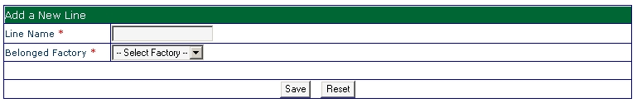
    - Line Name: input the name of Line.
    - Belonged Factory: which Factory of this Line belongs?
  - To edit a Line, click “” to open edit window. Explanation is the same as above.
  - To delete a Line, click “” to delete this line.
- Part settings return to contents
  - To browse Part list, click “System Settings” -> “Parts” in left menu.
  - To create a new Part, click” Add a New Part” in the top-right of list.
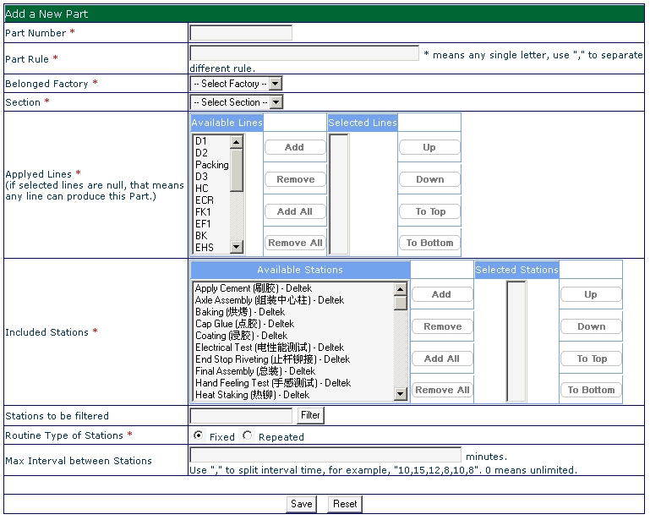
    - Part number: input the number of Part.
    - Part Rule: input the part origination rule for this Part.
    - Belonged Factory: which Factory of this Part belongs?
    - Section: which Section of this Part belongs?
    - Applied Lines: which line can produce this Part.
    - Included Stations: select the transacted stations for this Part. The sequence of selection is the sequence of process routine of this Part. Before you select stations, you must create wanted stations in Station settings.
    - Routine Type of Station: what kind of routing type of stations. Fixed means A -> B -> C -> D -> E ->; Repeated means A -> B -> C-> E-> F-> A -> C -> B -> A ->
    - Max Interval between Stations: set the max interval minutes for each two stations. If max number is not zero, when interval minutes between two stations exceed number, system will lock job and send notification email to engineers. Use “,” to separate this number.
  - To edit a Part, click “” to open edit window. Explanation is the same as above.
  - To delete a Part, click “” to delete this part. In background database, this Part is marked as disabled, instead of deleting records. The old jobs continue to need use this Part, but new job can not apply this Part.
- Station settings return to contents
  - To browse Part list, click “System Settings” -> “Stations” in left menu.
  - To create a new part, click” Add a New Station” in the top-right of list.
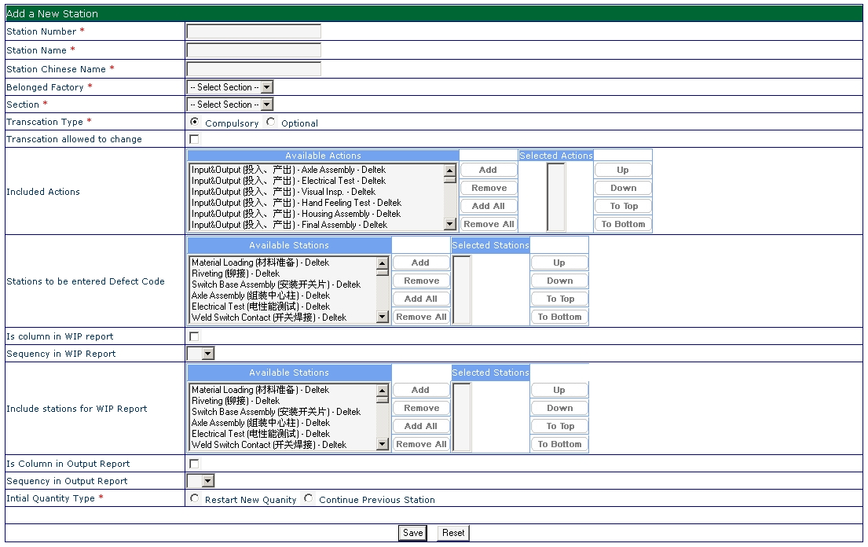
    - Station Number: input the number of Station.
    - Station Name: input the name of station.
    - Station Chinese Name: input the Chinese name of station.
    - Belonged Factory: which Factory of this Part belongs?
    - Section: which Section of this Part belongs?
    - Transaction Type: which type of transaction for this station? Compulsory means this station must be transacted process routine of Part; optional means this station can be transacted or not. Engineer can change station’s transacted type in a job. The default type is compulsory.
    - Transaction allowed changing: does the transaction type of this station allowed to be changed. If so, check it; if not, uncheck it.
    - Included Actions: select the transacted actions for this Station. The sequence of selection is the sequence of display routine of this Station. Before you select actions, you must create wanted actions in action settings. There are maybe several actions have the same name, but the belonged station is not the same.
    - Stations to be entered Defect Code: in this station, which defectcodes to be displayed and entered quantity. It is allowed to select multi-stations.
    - Is column in WIP report: does this station display in WIP report as a column?
    - Sequence in WIP report: the sequence of display in WIP report.
    - Include stations for WIP Reports: in WIP reports, some WIP in stations will be combined with this station. Select which station’s WIP will be combined with it.
    - Is Column in Output Report: does this station display in Output report as a column?
    - Sequence in Output Report: the sequence of display in Output report.
    - Initial Quantity Type: the method to record initial quantity. Restart new quantity means to key in a new quantity; Continue Previous Station means to inhere good quantity from previous station.
  - To edit a station, click “” to open edit window. Explanation is the same as above.
  - To delete a station, click “” to delete this part. In background database, this Part is marked as disabled, instead of deleting records. The old jobs continue to need use this Part, but new job can not apply this Part.
- Action settings return to contents
  - To browse Actions list, click “System Settings” -> “Actions” in left menu.
  - To create a new Action, click” Add a New Action” in the top-right of list.
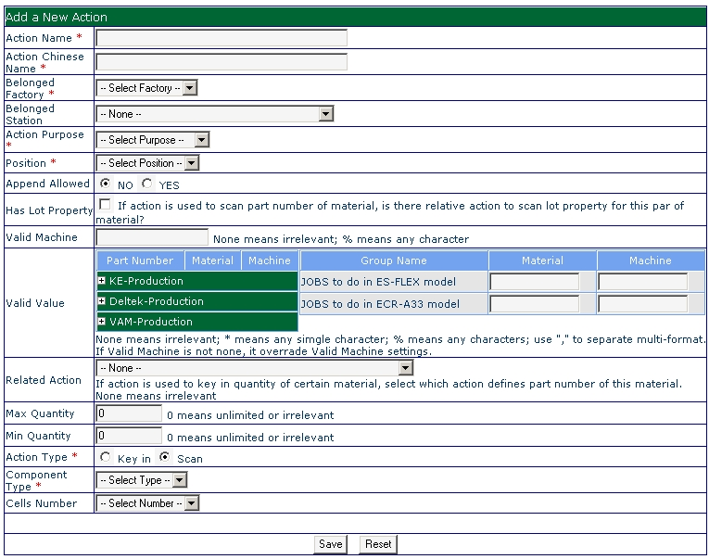
    - Action Name: input the name of Action.
    - Action Chinese Name: input the Chinese name of Action.
    - Belonged Factory: which Factory of this Part belongs?
    - Section: which Section of this Part belongs?
    - Belonged Station: select which station this station belonged.
    - Action Purpose: select the purpose type of action.
Purpose Type | Description
Machine Code | To scan code of machine
Material Part Number | To scan part number of material
Material Lot Number | To scan lot number of material
Material Quantity | To key in quantity of material
Job Quantity | To key in unit quantity of job

    - Position: when this action display in client system, before real working or after real working.
    - Append Allow: whether allow operator to append info about this action when she enter defectcode even if this action has been entered data before in the same job.
    - Has Lot Properties: If this action is used for material part number, is there any relative action to enter lot number for this material. If so, system will force to enter the first lot number for this material.
    - Valid Machine: if this action is used for machine code, that’s the valid code. % means any multi-characters, i.e., ADB%, means ADB01, ADB001, ADB10 or ADB 23.
    - Valid Value: if you need to define special valid code of material lot number or machine code for Part or Group, please enter format. * means any single character; % means any multi-characters; use “,” to separate multi-format.
    - Related Action: If this action is used for material lot number, is there any relative action to enter part number for this material. If so, system will force to enter the first part number for this material.
    - Max Quantity: if this action is used for material quantity, what’s the maximum number? If entered number is large than Max value, system will alert.
    - Min Quantity: if this action is used for material quantity, what’s the minimum number? If entered number is less than Min value, system will alert.
    - Action Type: how data enter for this action, key in or scan. System will remind operator how to enter data.
    - Component Type: what’s the web component to display? Default is TEXT cell.
    - Cells Number: how many cells will be displayed in client, if this action is used for Material Lot Number and Material Quantity.
  - To edit an Action, click “” to open edit window. Explanation is the same as above.
  - To delete an Action, click “” to delete this Action.
- Machine settings return to contents
  - To browse Machine list, click “System Settings” -> “Machine” in left menu.
  - To create a new Machine, click” Add a New Machine” in the top-right of list.
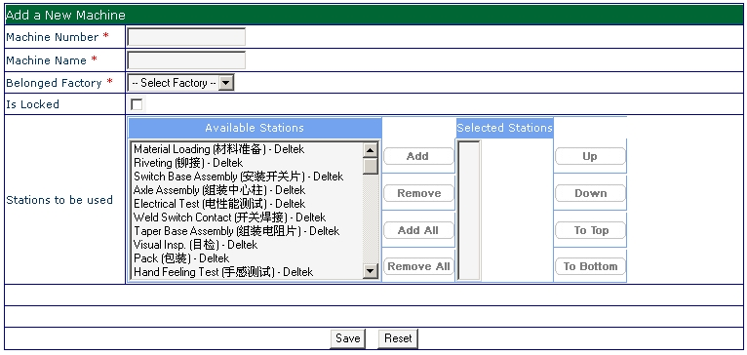
    - Machine Number: input the number of Machine.
    - Machine Name: input the name of Machine.
    - Belonged Factory: which Factory of this Part belongs?
    - Is Locked: if machine is locked, operator can not enter this machine code in barcode system.
    - Stations to be used: in machine yield report, which stations will use this machine?
  - To edit a Machine, click “” to open edit window. Explanation is the same as above.
  - To delete a Machine, click “” to delete this Machine.
- DefectCode settings return to contents
  - To browse DefectCode list, click “System Settings” -> “Defect” in left menu.
  - To create a new DefectCode, click” Add a New DefectCode” in the top-right of list.
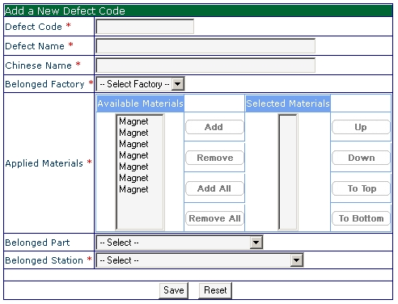
    - Defect Code: input the code of Defect.
    - Defect Name: input the name of Defect.
    - Chinese Name: input the Chinese name of Defect
    - Belonged Factory: which Factory of this Part belongs?
    - Applied Materials: select related material. If you don't know exact material, please select any one.
    - Belonged Part: which part will use this DefectCode, if this defect belong Deltek.
    - Belonged Stations: which station will use this DefectCode.
  - To edit a DefectCode, click “” to open edit window. Explanation is the same as above.
  - To delete a DefectCode, click “” to delete this Machine.
- Group settings return to contents
  - To browse Group list, click “System Settings” -> “Group” in left menu.
  - To create a new Group, click” Add a New Group” in the top-right of list.
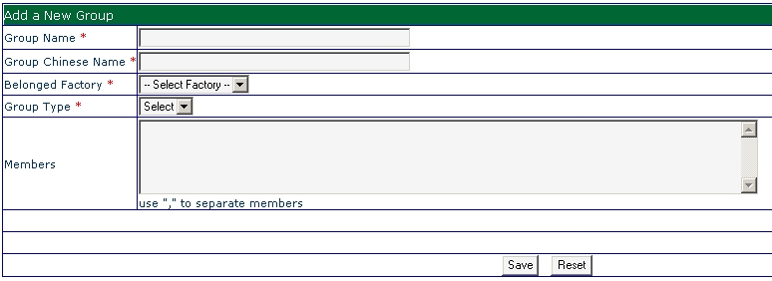
    - Group Name: input the name of Group.
    - Group Chinese Name: input the Chinese name of Group.
    - Belonged Factory: which Factory of this Part belongs?
    - Group Type: select the type of Group.
    - Members: enter the job numbers and use “,” to separate them.
    - Click “Save” to save settings.
  - To edit a Group, click “” to open edit window. Explanation is the same as above.
  - To delete a Group, click “” to delete this Group.
- Operators Authority return to contents
  - To browse operators list, click “System Settings” -> “Authority” in left menu.
  - To create a new operator, click” Add a New Operator” in the top-right of list.
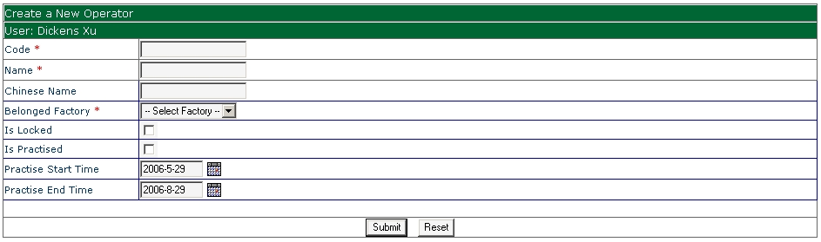
    - Code: input the badge code of employee.
    - Name: input the name of employee.
    - Chinese name: input the Chinese name of employee.
    - Belonged Factory: which Factory of this Part belongs?
    - Is Locked: if operator is locked, operator can not enter barcode system.
    - Is Practiced: if operator is locked, operator can not enter barcode system.
    - Practiced Start Time: the start time of employee’s practiced period.
    - Practiced End Time: the end time of employee’s practiced period.
    - Click “submit” to save settings.
  - To edit an operator, click “” to open edit window. Explanation is the same as above.
  - To change authority of an operator, click “XXXX” to open change window.
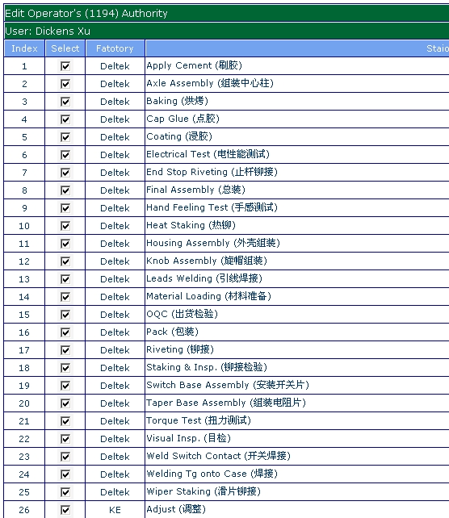
    - Check the box before the station and part which operator can be transacted and uncheck which can not be transacted.
    - Click “Update” to update changes.
  - To delete an Operator, click “” to delete this Operator.

