Project Descriptions

Yizhe Zhao, U75677440

# Project name: Web Crawler

# Project goal: using python’s requests library to gather links by crawling a specific website to collect useful links

# Project instructions:

Input:

Project name: enter a string

Homepage: enter a string

Output:

Outcome of crawling the homepage

If homepage is not allowed to crawl: Error

If homepage is able to crawl:

File “Queue” to store links that have not been crawled

File “Crawled” to store links that have been crawled

# Sample run

## python tutor

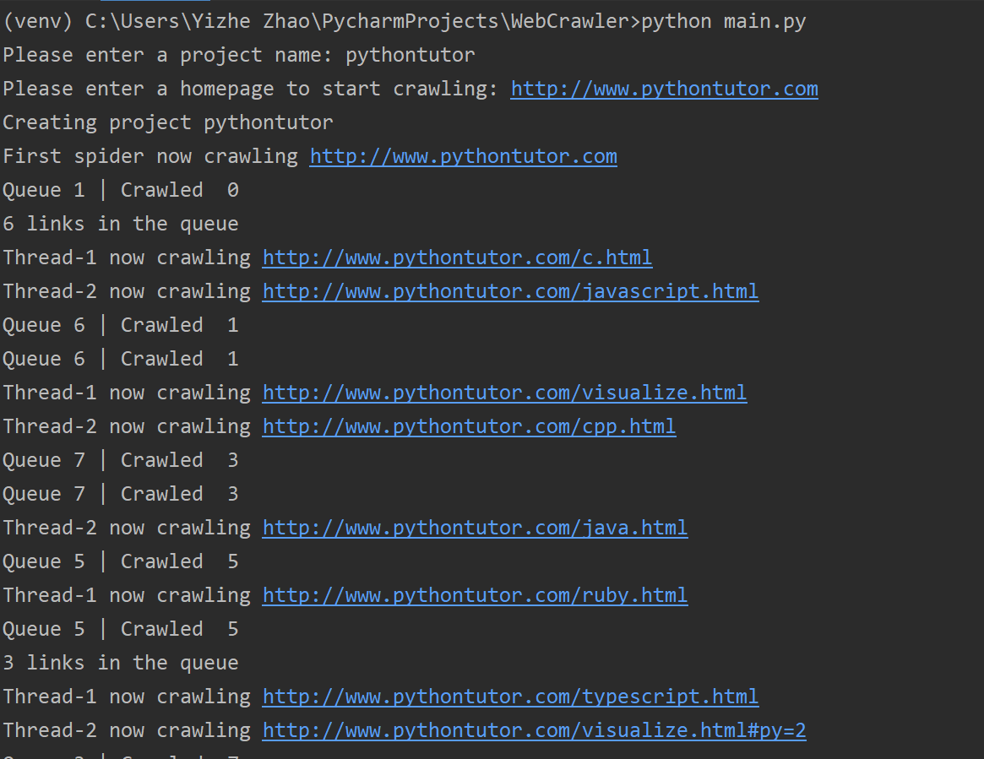

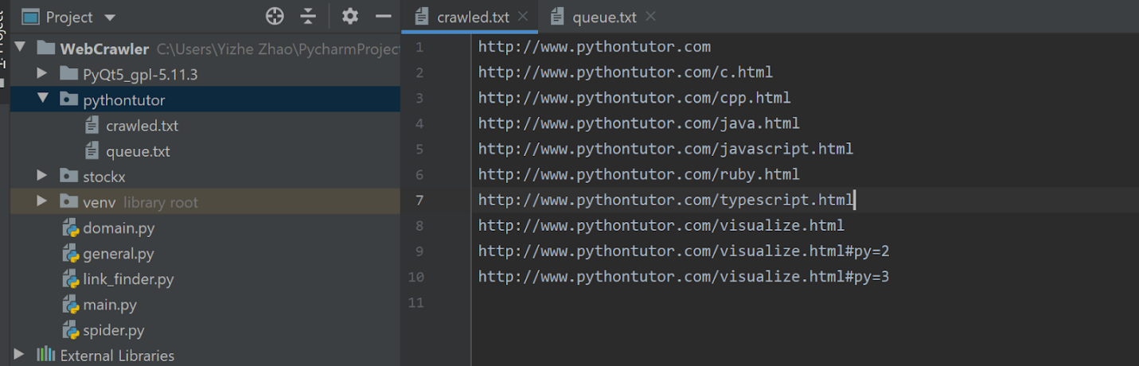

## stock

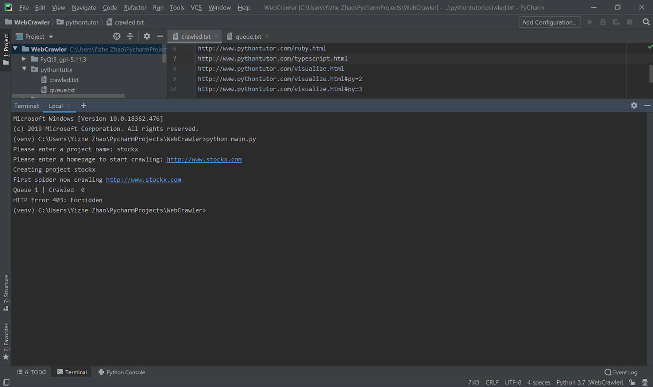

## Dealmoon

