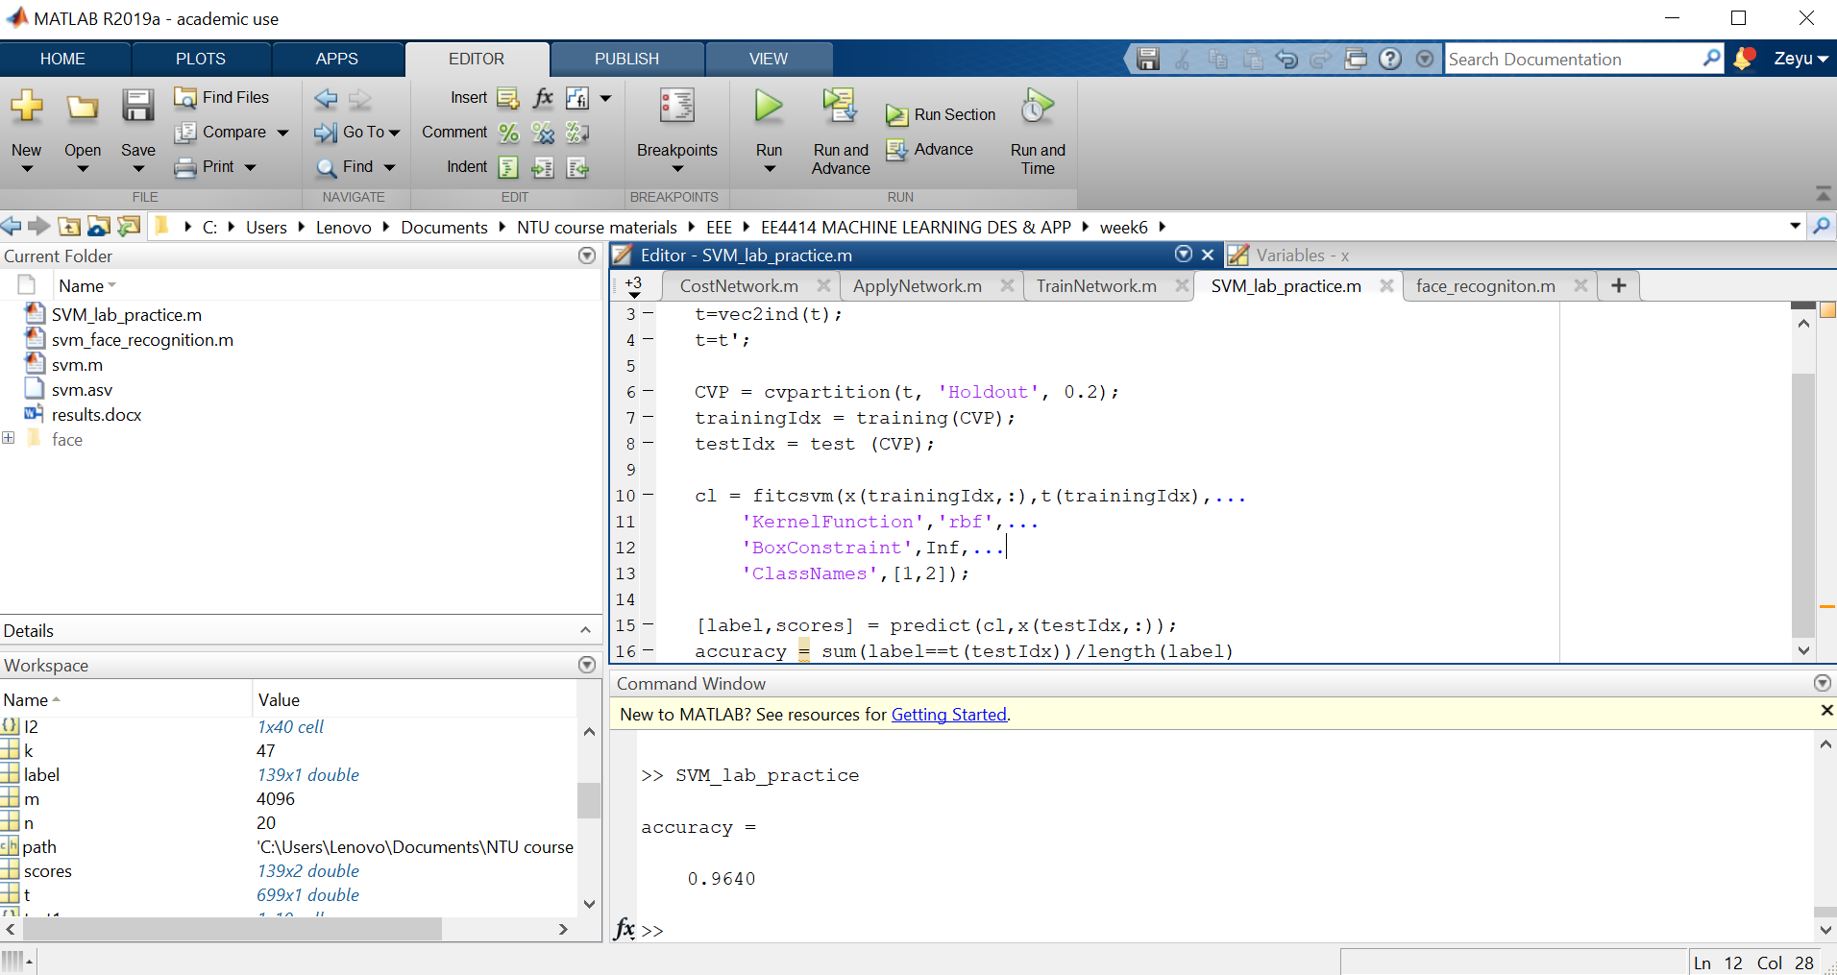

Testing accuracy for lab practice

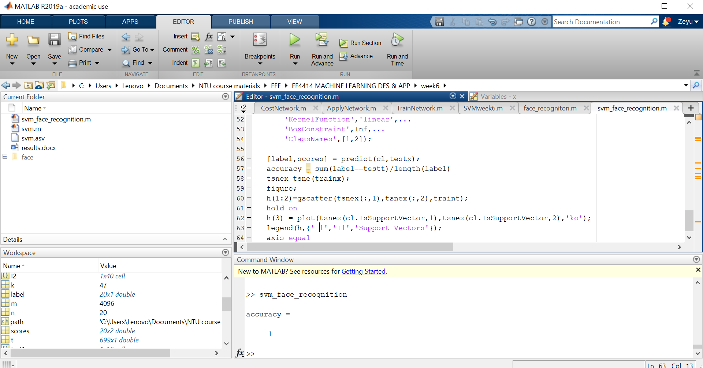

Testing accuracy for face recognition

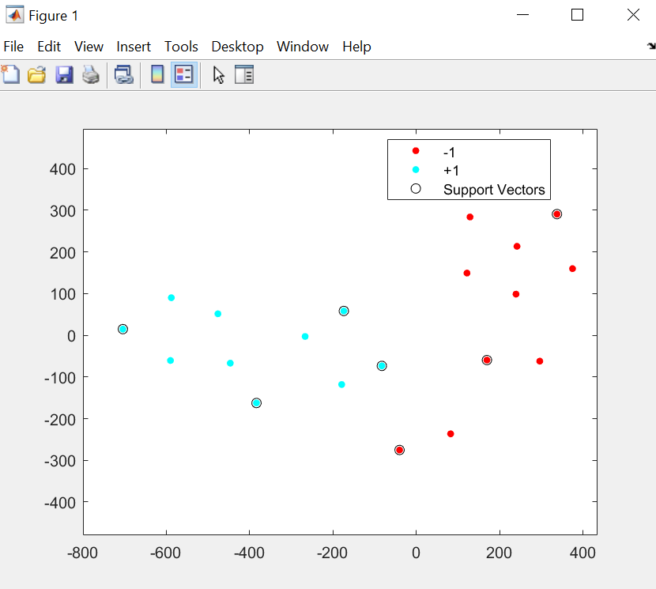

This plot is generated by projecting the original data (face) onto a 2-D plane. Due to the fact that the projection bases are randomly selected, some of the support vectors might not be near to the decision boundary.