425 Forensics Report

Searching for ASCII strings
The ASCII string search function can be found via the command search from the program's main screen. The program will prompt the user for a target directory, followed by multiple keywords. The inputs should be entered in the following format:
Directory: /home/cosc/student/jam296/Desktop
Keyword: keyword otherkeyword
The keywords will be converted to lowercase to maximise search results.
The directory is traversed via a depth-first in order method. Any file names containing the keywords are added to a results list (a vector) containing the path to the file. If the title does not contain a keyword, the file is then read line-by-line into a buffer, which is converted to lowercase and searched for the keywords. If a keyword is found within the file, the file's path is also added to the results list. Only Directories and Regular files are searched - other file types such as pipes are not searched as it would cause the program to hang.
When the directory traversal is complete the results list is displayed in a numbered order. From this state the user can enter the following commands:
open #: This will open the file with the program assigned to handling this file's type.
hexedit #: This will pass the file through to the program's hex editor. See Hexadecimal Editor for more.
back: returns the user to the main screen.
Multiple files can be opened and edited without having to re-search. The results are held until the user returns to the main menu.

Searching for Hexadecimal strings
The Hexadecimal search function can be accessed via the command hexfind from the program's main screen. This program prompts the user for a directory and a hex string to search for. Unlike the search function, the hexadecimal value is not converted to lowercase. Hexadecimal values are interpreted case-sensitively, and the string input should consist of uppercase characters. For example:
Correct: 46757A7A [will search for "Fuzz"]
Correct: 66757A7A [will search for "fuzz"]
Incorrect: 66757a7a [all characters in the input should be uppercase]
Search methods here are similar to the ASCII string search function, with the notable exception of file parsing; the lines are not converted to lowercase, they are converted to hex and then searched.
The search results are displayed in the same way as ASCII results, and the same operations can be performed on them.

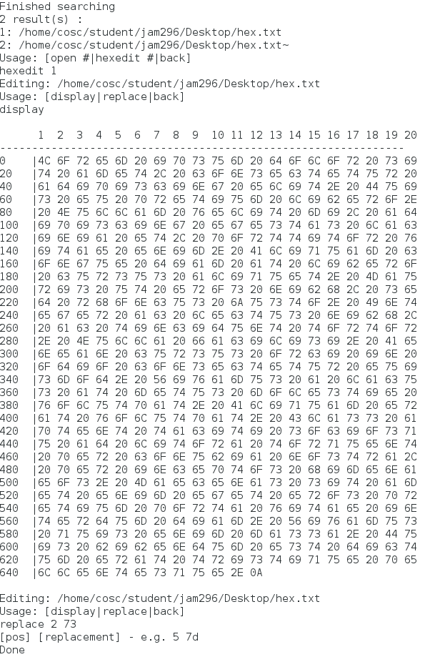
Hexadecimal editor
The Hexadecimal editor can be accessed from both the main menu via the command hexedit, or calling it from within the search results function.
Accessing it from the main menu prompts the user for a file path, which should be entered without quotes as follows:
/home/cosc/student/jam296/Desktop/findme.txt
To access it from the search results, the user should type "hexedit #" where # is the listed number of the file they wish to edit.
From the main screen of the hex editor the user can type:
display: Displays the contents of the file in hexadecimal
replace [pos] [val]: replace the value at position pos with value val
back: returns the user to the previous screen - either the search results screen or the main screen.

search | hexfind
replace [pos] [val]
open #
hexedit #
path
dir
keyword
Enter Directory
back
Convert to Lowercase
Convert to Hexadecimal
Output Results
display
Replace Function
hexedit
Traverse & Search
Hex Editor
Display
Open File
Enter File Path
Enter Hex String
Enter Keyword
Traverse & Search
Main Interface
Case management
Overview
Each case is given its own folder, located in ./cases/ . This folder contains the files related to the case, including a log file of forensic operations.

Creating a case
A case can be created from the main menu with the command “new <casename>”. For example:
local> new Hamburgler
When a case is first created, it is automatically opened. Case names may not contain spaces.

Opening a case
Cases can be opened with the “open <casename>” command. To see a list of available cases, there is a “list” command.
Example:
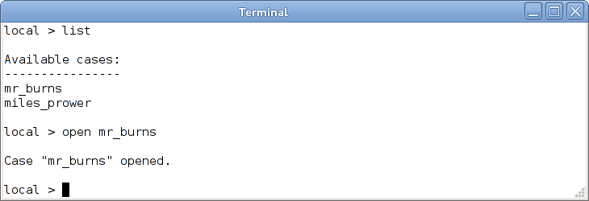

Closing a case
When your session on a case is complete, the case can be closed with “close”.
Copying a file to a case folder
Files available to the host system can be copied to the case directory with the “copy” command. Files are copied byte-for-byte with no modification, and a timestamp of the copy is written to the case log.
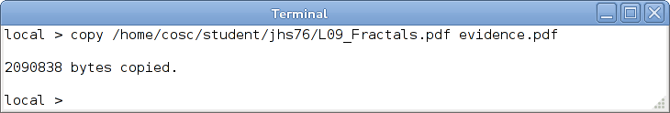
Viewing files related to the case
A list of the files related to the currently opened case can be displayed with the “files” command.
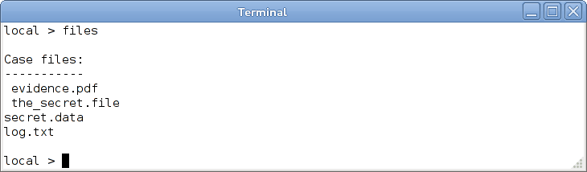
Adding a note to the case
Notes can be added to the case log with the “Note” command, for example:
local> note Found a deleted file on the hard drive.
Viewing the case log
The log of the case can be viewed with the “log” command.
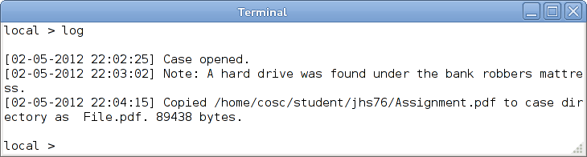
Disk Geometry
Disk geometry can be displayed for hard disks attached to the host.
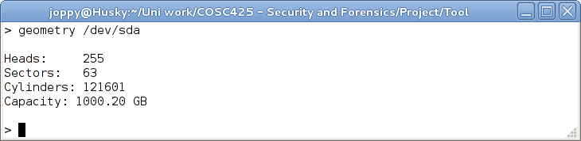
Note: This command requires root access.
Partitions
Primary and extended partitions for attached hard disks or dd copies of hard disks can be shown.
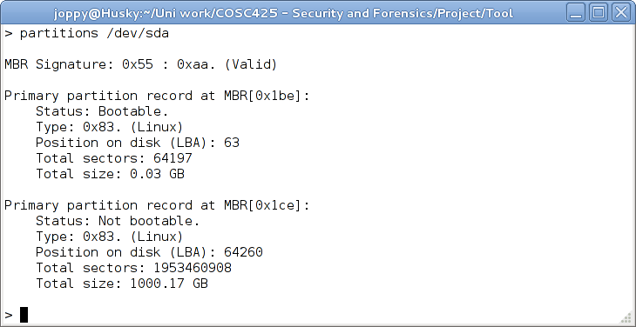
Note: This command requires root access.
Remote Access
Server
A server can be started to allow remote users to connect to the forensics tool.
local > server on
local > server off
Client
To connect to a remote host, use the “connect” command, followed by the IP address of the target host.
Upon successful connection, the local > prompt should be replaced with a remote > prompt.
local > connect 127.0.0.1
remote >
To return to the local prompt, use the “exit” command.

