Income and Poverty Across US States in 2022 and 2023
  - Revised Pair Project Proposal
Course: CISC7204 Data Science and Data Visualization
Coursework: Assignment 02
Class: E Pair: 03
Team: ZHANG YIFAN — MC653871; LI XINHANG — MC653425
Revised: 24 October 2026

1 Project Title and Research Question
We will refine our Assignment 01 analysis of household income and poverty across US jurisdictions. The preliminary notebook joins two USDA Economic Research Service tables and produces three figures. This proposal defines the remaining validation, interpretation and presentation work.
Research question: Across the 50 US states and the District of Columbia, how do 2023 median household income and all-age poverty rates vary and relate, and how did the nominal mean income gap between the same highest-income five and lowest-income five jurisdictions, selected using 2023 income, change from 2022 to 2023?
Region: United States, covering 50 states plus DC. Domain: socioeconomic conditions, household income, poverty and regional disparities. The unit of analysis is a state-level jurisdiction. Income is measured in dollars and poverty in percent. Household income is not a direct measure of accumulated wealth.

2 Purpose

2.1 Outcomes
We aim to demonstrate the data science workflow practised in CISC7204: acquiring public data, cleaning and joining tables, analysing patterns, and communicating findings through visualizations. A reproducible notebook and three explained charts will demonstrate these outcomes. Evaluating sources and communicating uncertainty will also prepare us for future research and professional work involving public statistics and evidence-based decisions.

2.2 Skills
We will practise Python and Pandas filtering, reshaping, numeric conversion and one-to-one merging; descriptive statistics and sensitivity checks; and Matplotlib chart design. We will also develop reproducible notebook workflows, source documentation, concise analytical writing, and collaborative review. These skills support reliable analysis and clear communication in coursework and professional projects.

2.3 Knowledge
We will learn how median household income and all-age poverty rates describe different aspects of socioeconomic conditions. We will distinguish income from wealth, nominal from inflation-adjusted change, and jurisdiction averages from household inequality. Interpreting model-based estimates, confidence intervals and aggregate correlations will help us avoid unsupported causal conclusions.

3 Datasets and Methods
Both supplied CSVs are USDA ERS releases derived from official statistics. The ERS documentation identifies SAIPE as the source of poverty estimates [1–3]. We will retain the supplied releases to keep the 2022–2023 comparison consistent, document download provenance, and cite the original providers. Only aggregate public statistics are required; no personal records or credentials are used.
Dataset and local file | Fields used and purpose
USDA ERS Poverty estimates 2023  Poverty2023.csv | Stabr, FIPS_Code, MEDHHINC_2023 and PCTPOVALL_2023; 2023 income and poverty. CI90LBINC_2023 and CI90UBINC_2023 are available for income uncertainty checks.
USDA ERS Unemployment and median household income 2000–23  Unemployment2023.csv | State, FIPS_Code and Median_Household_Income_2022; supplies 2022 income. Its filename does not imply that unemployment must be an analysis variable.

3.1 Dataset Links
Dataset 1: https://www.ers.usda.gov/media/5496/poverty-estimates-for-the-united-states-states-and-counties-2023.csv
Dataset 2: https://www.ers.usda.gov/media/5497/unemployment-and-median-household-income-for-the-united-states-states-and-counties-2000-23.csv
If a direct link changes, use the official download page [1] and select the matching named release. Public accessibility alone is not a blanket license for unrelated reuse; we will retain attribution and check relevant agency reuse terms before wider redistribution.

3.2 Preparation and Comparisons
We will retain records whose numeric state FIPS code is divisible by 1,000, exclude the national row, and validate an explicit list of 50 state abbreviations plus DC. Before pivoting, check duplicate jurisdiction–attribute keys rather than silently taking the first value. Convert measures to numeric, log missing values, and merge one-to-one by jurisdiction. The required result is 51 distinct complete rows; unmatched rows must be reported.
For 2023, rank income, describe the poverty range and compute the unweighted Pearson income–poverty correlation. A sensitivity calculation will exclude DC. For change, freeze the top and bottom five memberships using the 2023 ranking, then calculate G(t) = mean income of top five in year t minus mean income of bottom five in year t. Report G(2023) − G(2022), group membership and the selection rule explicitly.
The current notebook uses the supplied year-specific dollar amounts without inflation adjustment. We will label this as a nominal comparison and verify the documented price basis before interpreting change. A common-dollar calculation is an optional extension, not a result already established. No causal or statistically significant widening claim will be made from the current point estimates alone.

4 Tasks
The task plan builds on our existing notebook and three figures. It specifies the remaining steps, responsible members and outputs. We will agree the analysis schedule together; this revised Word proposal is due on 25 October 2026 at 11:00 pm.
Stage | Action and deliverable | Lead
Existing baseline | Two CSVs, a notebook, 51 merged jurisdictions and three preliminary figures are available. Preserve them as the baseline. | Both
Step 1 | Audit variables, duplicate keys, missing values, units and geography. Deliver a data dictionary and merge-validation output. | ZHANG
Step 2 | Refine the income ranking and poverty scatter. Add complete source notes and readable labels; test the correlation with and without DC. | ZHANG
Step 2 | Refine the fixed-group change chart, separate overlapping labels, and show both group mean gaps and their difference. | LI
Step 3 | Integrate code, write the two-paragraph interpretation, rerun from a fresh kernel, and complete the joint quality checklist. | LI; both review
Project deliverables are a Python 3 notebook with relative paths and saved outputs; three labelled PNG figures; a cleaned analysis table and data dictionary; reproduction instructions and dependencies; and a two-paragraph visual justification. This assignment submission is the revised Word proposal. We will use the course plotting examples, USDA ERS documentation, SAIPE guidance and the checklist below [1–3].

5 Success Criteria
Criterion | Successful Product and Verification
Coverage | Exactly 51 unique jurisdictions, with no unexplained missing measures or merge losses.
Reproducibility | A fresh-kernel Run All regenerates tables and figures using the documented CSV names and relative paths, with no manual cell edits.
Chart quality | All figures identify year, measure, units and source. Bars start at zero; labels do not overlap; the change chart states the fixed-group rule.
Evidence | The narrative reports the computed correlation and both gap estimates accurately and distinguishes association, uncertainty and nominal change.
Communication | A reader can identify the question, principal findings and at least one limitation from the figures and accompanying paragraphs.
Collaboration | Each member reviews the other’s work and the final checklist; the notebook and proposal agree on variables and methods.
This table is our acceptance checklist. Each member will record pass or revise for every criterion, inspect the figures and rerun the notebook. We will resolve failed checks before approving the completed analysis.

6 Visual Justification and Preliminary Findings
The results below were independently recalculated from the two supplied CSVs. They are descriptive baseline findings, not confirmation that the proposed uncertainty and sensitivity checks have been completed.
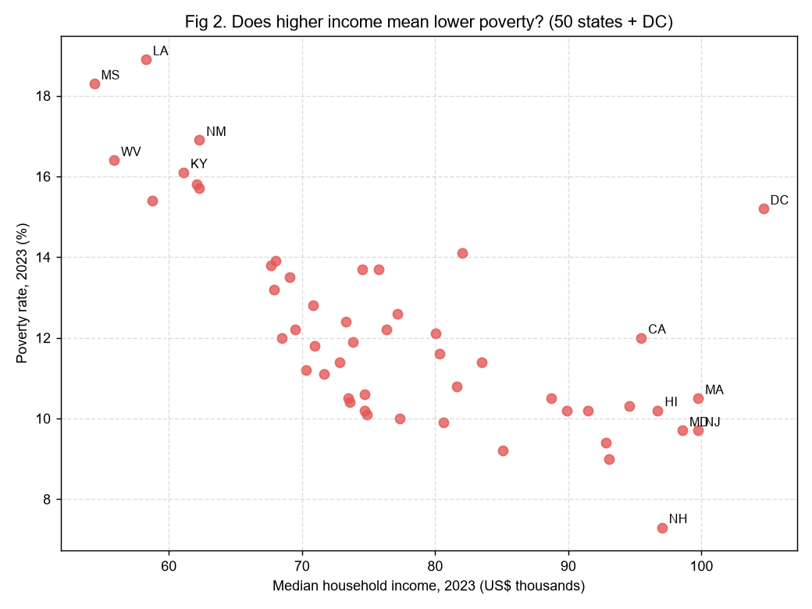
Preliminary Figure 2 from Assignment 01. Source: supplied USDA ERS CSVs. The final version will add a full source note and separate the overlapping state labels.
The ranked income bars answer the size and location of the 2023 income differences, while the scatter examines how income relates to poverty across all 51 jurisdictions. The unweighted Pearson correlation is −0.692. DC has median household income of $104,643 and poverty of 15.2%, illustrating why a high jurisdiction-level median does not imply universally low poverty. This is an aggregate association; it does not explain why an individual household is poor or establish that higher income causes lower poverty. SAIPE values are estimates with published uncertainty [2–3].
The slope chart addresses change by following the same 2023-selected groups: DC, MA, NJ, MD and NH versus MS, WV, LA, AR and KY. Their mean income gap is $39,877.80 in 2022 and $42,265.40 in 2023, a nominal increase of $2,387.60, about 6.0%. This is a difference between two group means of jurisdiction medians, not the gap between individual rich and poor households. It also is not the single highest-minus-lowest jurisdiction gap. We will retain the explicit selection rule, improve label spacing, and qualify the interpretation for inflation, model uncertainty and the short two-year window.

7 Collaboration
We retain our Assignment 01 division of work. The table assigns all four required team roles across two members. Each lead will produce the listed outputs and the other member will review them.

7.1 Division of Work and Team Roles
Member and roles | Responsibilities
ZHANG YIFAN  MC653871  Coordinator and progress tracker | Audit and clean the two sources; validate the join; revise Figures 1 and 2; maintain the task list and flag delays.
LI XINHANG  MC653425  Scribe and liaison | Revise Figure 3; draft the visual justification; integrate and rerun the notebook; maintain notes and coordinate the final submission.

7.2 Ground Rules
We will check progress every two to three days, or daily during the final revision period. Keep one shared version of the notebook and preserve raw data unchanged. Agree on editing ownership before changing the same cells, record substantial changes, and avoid overwriting another member’s work without discussion. Each member reviews the other’s calculations and wording. Both approve the final outputs and confirm the filenames, source links and checklist. If a task is delayed, the coordinator reallocates it by mutual agreement; unresolved scope or data issues are raised with the instructor through the liaison.

8 Revisions to the Preliminary Proposal
The revised title uses income rather than wealth. The question defines the fixed 2023 groups and nominal dollar comparison. Purpose separates outcomes, skills and knowledge. Tasks, success criteria and collaboration are independent sections. Planned improvements include duplicate and merge checks, source notes, clearer labels, uncertainty qualifications and a DC sensitivity check. The original study years, region, datasets and member roles are retained.

9 References
[1] USDA Economic Research Service. County-level Data Sets Download Data. Includes the two named CSV releases.
https://www.ers.usda.gov/data-products/county-level-data-sets/county-level-data-sets-download-data
[2] USDA Economic Research Service. County-level Data Sets Documentation.
https://www.ers.usda.gov/data-products/county-level-data-sets/documentation
[3] US Census Bureau. Small Area Income and Poverty Estimates Frequently Asked Questions. Describes model-based estimates and 90 percent confidence intervals.
https://www.census.gov/programs-surveys/saipe/about/faq.html
AI assistance: ChatGPT assisted with checking calculations, refining the proposal and preparing this document. Both members are responsible for reviewing the content and final submission details.

