MCQs on Unit 1( One mark questions)

- A system which performs following tasks:
Taking Input , Processing input & Providing output, can be called as:
- Adaptive System
- Classic System- answer
- Reinforced Learning
- None of the above

- A system which performs following tasks:
Taking Input , Processing input, Providing output & Tuning Parameters through Feedback from environment can be termed as:
- Adaptive System.
- Classic System.
- Non Adaptive System
- None of the above

- Classification and Regression techniques fall under the category of

  - Supervised Learning
  - Unsupervised Learning
  - Semi-supervised Learning
  - Reinforcement Learning

- Supervised Learning algorithms are accompanied by both Input and Expected Output?

  - True- answer
  - False

- Linear Regression, Random Forest , SVM are examples of

  - Supervised Learning- answer
  - Unsupervised Learning
  - Semi-Supervised Learning
  - Reinforcement Learning

- Decision Tree algorithm can work on

  - Only Categorical values
  - Only Continuous values
  - Both Categorical and Continuous values- answer
  - None of the above

- If the input and output variables are continuous in nature, which technique is more preferred?

  - Regression- answer
  - Classification
  - Association Rule mining
  - All of these

- k-NN algorithm does more computation on ‘test’ time rather than ‘train’ time.

  - True- answer
  - False

- Which of the following distance metric can be used in k-NN?

  - Manhattan
  - Minkowski
  - Jaccard
  - Mahalanobis
  - All can be used- answer

- Which of the following machine learning algorithm can be used for imputing missing values of both categorical and continuous variables?

  - K-NN- answer
  - Linear Regression
  - Logistic Regression
  - Decision Tree

- Which of the following algorithm isNOT an example of ensemble learning algorithm

  - Random Forest
  - Adaboost
  - Gradient Boosting
  - Decision Trees

- Spam detection, pattern detection, NLP are examples of

  - Semi-supervised learning.
  - Supervised Learning
  - Unsupervised Learning
  - All of these

- Clustering technique & Association rule mining are examples of

  - Supervised Learning
  - Semi-supervised Learning
  - Unsupervised Learning- answer
  - Reinforcement Learning

- Unsupervised Learning algorithms are accompanied by both Input and Expected Output?

  - True
  - False (Only Input) - answer

- K-Means technique is an example of

  - Clustering- answer
  - Classification
  - Regression
  - Association

- Which of the following is/are types of clustering

  - Centroid-based Clustering
  - Density-based Clustering
  - Hierarchical Clustering
  - All of the above- answer

- Learning algorithms that use both labelled and unlabelled data can be categorised as

  - Supervised Algorithms
  - Unsupervised Algorithms
  - Semi-supervised Algorithms- answer
  - Reinforcement Learning

- Reinforcement learning is particularly efficient when the environment is NOT
completely deterministic

  - True- answer
  - False

- When the number of output classes is greater than one, which is / are the possible strategy used to handle them

  - One-vs-All
  - One-vs-One
  - Both of them- answer
  - None of the above

- In One-vs-All strategy how many classifiers are trained for n classes

  - 1
  - n- answer
  - n/2
  - None of the above

- In One-vs-One strategy how many classifiers are trained for n classes

  - 1
  - n
  - n*(n-1)/2- answer
  - n/2

- When the model isn't able to capture the dynamicsshown by the same training set, such situation is called as

  - Underfitting- answer
  - Overfitting
  - Normal fitting
  - Regularization

- When the model can associate almost perfectly all the known samples to the corresponding output values, but when an unknown input is presented, the corresponding prediction error can be very high, such situation is called as

  - Underfitting
  - Overfitting- answer
  - Normal fitting
  - None of these

- The formula given below is to calculate_____________

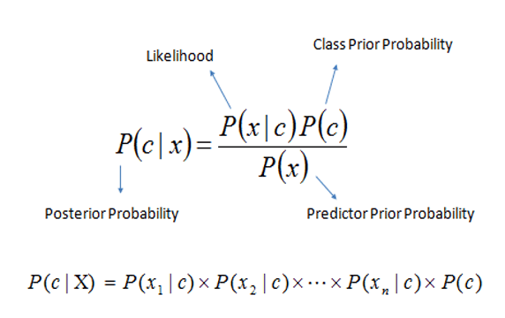

  - Posterior Probability in Naïve Bayes Classifier- answer
  - Prior Probability in Naïve Bayes Classifier
  - Entropy in Decision Tree classifier
  - None of the above

- The following formula is used to calculate __________
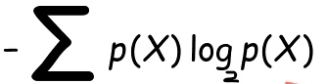

  - Information Gain
  - Entropy- answer
  - Probability of an event
  - None of the above

- Which algorithm is not a type of Parametric Learning?

- Logistic Regression
- Naïve Bayes
- K-Nearest Neighbors- answer
- Simple Neural Networks

- What is Machine learning?

- The autonomous acquisition of knowledge through the use of computer programs- answer
- The autonomous acquisition of knowledge through the use of manual programs
- The selective acquisition of knowledge through the use of computer programs
- The selective acquisition of knowledge through the use of manual programs

- Which of the factors affect the performance of learner system does not include?

- Representation scheme used
- Training scenario
- Type of feedback
- Good data structures- answer

- Which system is based on static or permanent structures?

- Adaptive system
- Non-adaptive system- answer
- Both
- None of the above

- Which is not a type of supervised learning algorithm?

- K-Nearest Neighbor
- Decision Tree
- K-means- answer
- Linear Regression

- From following, which are the approaches to Machine Learning?

- Supervised Learning
- Unsupervised Learning
- Reinforcement Learning
- All of the above- answer

- In which type of Learning, both features and labels are given to an algorithm?

- Supervised Learning- answer
- Unsupervised Learning
- Reinforcement Learning
- None of the above

- In which type of learning, the algorithm maps input variable to output variable?

- Supervised Learning- answer
- Unsupervised Learning
- Reinforcement Learning
- None of the above

- Which is not a type of Supervised Learning?

- Classification
- Regression
- Clustering- answer
- None of the above

- Which approach should be use to e-mail spam filtering?

- Classification- answer
- Clustering
- Regression
- Association

- Which approach should be use to predict sales of a supermarket?

- Classification
- Clustering
- Regression- answer
- Association

- In which learning technique, the system discovers patterns from dataset?

- Supervised Learning
- Unsupervised Learning- answer
- Reinforcement Learning
- None of the above

- In which type of learning, the problem can be solved without knowing labels?

- Supervised Learning
- Unsupervised Learning- answer
- All of the above
- None of the above

- Which type of problem discovers groups of data based on similarities?

- Clustering- answer
- Association
- Regression
- None of the above

- Which type of problem discovers rules to describe large data?

- Clustering
- Association- answer
- Regression
- None of the above

- From the following, which is best suited to build a game of chess?

- Supervised Learning
- Unsupervised Learning
- Deep Learning- answer
- None of the above

- In which type, rewards and punishments are given as a feedback?

- Supervised Learning
- Unsupervised Learning
- Reinforcement Learning- answer
- None of the above

- Which approach should be use for automatic labelling?

- Supervised Learning
- Unsupervised Learning- answer
- Reinforcement Learning
- None of the above

- From the options, which application you should solve by deep learning for the best performance?

- Spam filtering
- Image classification- answer
- Sales prediction
- Automatic labelling

- A neural network model is said to be inspired from the human brain.Which of the following statement(s) correctly represents a real neuron?

- A neuron has a single input and a single output only
- A neuron has multiple inputs but a single output only
- A neuron has a single input but multiple outputs
- All of the above statements are valid- answer

- What is unsupervised learning?
- Features of group explicitly stated
- Number of groups may be known
- Neither feature & nor number of groups is known- answer
- None of the mentioned

- Which is not a correct statement with respect to Deep Learning?

- Large computing power is required
- Less complex than machine learning- answer
- Difficulty in interpreting the resulting models
- Requires large amount of labelled data

- Which algorithm is not a type of Non-parametric learning?

- Naïve bayes- answer
- C4.5
- K-Nearest Neighbor
- Support Vector Machines

- In which type, the training data is modelled very well?

  - Underfitting
  - Overfitting- answer
  - Both
  - Not a and b

- Which model gives poor performance on training data?

  - Underfitting- answer
  - Overfitting
  - Both
  - None of the above

Unit 1: Two marks questions
- The goal(s) of the supervised learning system is (are) ___________
- Training a system that must also work with samples never seen before.
- To allow the model to develop a generalization ability and avoid a common problem called over fitting
- Supervisor: to provide the agent with a precise measure of its error
- All of the above- answer

- Identify the type of model for the given problem

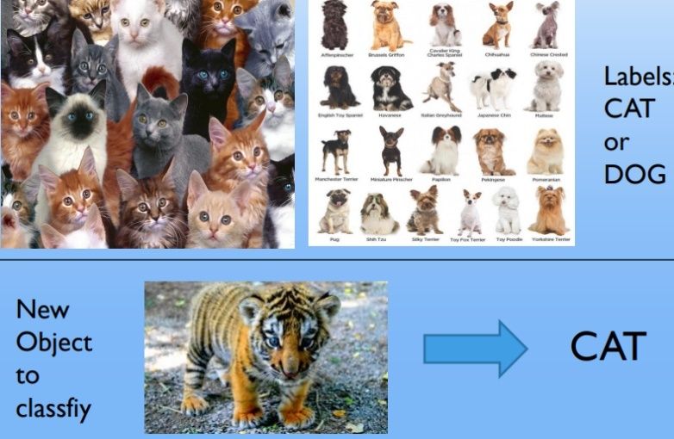
- Reinforcement learning
- Supervised learning- answer
- Un supervised learning
- Semi supervised learning

- The goal (s) of Classification techniques is (are) __________
- Try to find the best separating hyperplane (in this case, it's a linear problem).
- Reduce the number of misclassifications
- Increasing the noise-robustness
- All of these- answer

- Consider D be a training set of n samples , each sample is represented by X of m features , X = (x1, x2, x3 …… xn), Consider C classes : C1, C2…… Cc.
Bayesian classifier predicts that tuple X belongs to class Ci iff.
- P(Ci/X) > P(Cj/X) for i<= j<=c , j != i Thus we maximize P(Ci/X) - answer
- P(Ci/X) < P(Cj/X) for i<= j<=c , j != i Thus we maximize P(Ci/X)
- P(Ci/X) > P(Cj/X) for i<= j<=c , j != i Thus we maximize P(Cj/X)
- None of the above

- The problem of high variance and low bias is called__________
- Over-fitting- answer
- Underfitting
- Normal fitting
- Best fitting

- Identify the type of Machine learning approach to solve the given problems:
Decision Support System to predict the decision to play Match or not to play
- Reinforcement learning
- Supervised learning- answer
- Un supervised learning
- Semi supervised learning

- Identify the type of Machine learning approach to solve the given problems:
Grouping of documents retrieved by Google Search Engine
  - Reinforcement learning
  - Supervised learning
  - Un supervised learning- answer
  - Semi supervised learning

- Identify the type of Machine learning approach to solve the given problems:
System to predict price of product in next year
a. Reinforcement learning
b. Supervised learning- answer
c. Unsupervised learning
d. Semi supervised learning

- Identify the type of Machine learning approach to solve the given problems:
System to predict the suitable treatment
        - Reinforcement learning
        - Supervised learning
        - Un supervised learning
        - Semi supervised learning

- Identify the type of Machine learning approach to solve the given problems:
System for Driverless Car
a. Reinforcement learning- answer
b. Supervised learning
c. Unsupervised learning
d. Semi supervised learning

- Which is true for AI, ML and DP
              - AI>ML>DP- answer
              - DP>ML>AI
              - ML>AI>DP
              - DP>ML>AI

MCQ’s on Unit 2: Feature selection (Two marks)

1. For creating Training and Test datasets which statements are true?
a. Both datasets must reflect the original distribution
b. The original dataset must be randomly shuffled before the split phase in order to avoid correlation between consequent elements
c. Both a and b - answer
d. None of the above

2. SK-Learn provides which function to create train and test data:
a. train_test_split- answer
b. test_train_split
c. TestTrainSplit
d. Split_test_train

- In scikit-learn LabelEncoder class:
- Adopts a dictionary-oriented approach,
- Associating to each category label a progressive integer number,
- That is an index of an instance array called classes_
- All of the above- answer

4. Scikit-learn class Imputer fills the holes using a strategy based on the:
a. mean
b. median
c. frequency (the most frequent entry)
d. All of the above- answer

- Consider 3 dimensional dataset given below
x | y | z
1 | Nan | 2
2 | 3 | nan
-1 | 4 | 2
SK-Learn Imputer mean strategy will fill missing values with
a. 3, 2
b. 4, 2
c. 3.5, 2 - answer
d. Difficult to tell
6. Consider 3 dimensional dataset given below
x | y | z
1 | Nan | 2
2 | 3 | nan
-1 | 4 | 2
SK-Learn Imputer median strategy will fill missing values with
a. 3, 2
b. 4, 2
c. 3.5, 2 - answer
d. Difficult to tell

7. Consider 3 dimensional dataset given below
x | y | z
1 | Nan | 2
2 | 3 | nan
-1 | 4 | 2
SK-Learn Imputer most_frequent strategy will fill missing values with
a. 3, 2- answer
b. 4, 2
c. 3.5, 2
d. Difficult to tell

8. Which statement(s) is (are) true for SK-Learn MinMaxScaler ?
a. Works well for cases when the distribution is not Gaussian
b. Works well when the standard deviation is very small
c. It is sensitive to outliers
d. All of these- answer

9. _________________ uses the interquartile range , which makes it robust to outliers.
a. MonMaxScaler
b. Standard Scaler
c. Robust Scaler- answer
d. None of these

10. Consider Q1=31 and Q3=119. The inter quartile range (IQR) will be______
a. 88 - answer
b. -88
c. 150
d. -150
MCQs on unit 2 (One mark question)
- Which of the following contains train_test_split() function

- sklearn.feature_extraction
- sklearn.preprocessing
- sklearn.model_selection- answer
- sklearn.decomposition

- Default value of test_size in train_test_split() when both test_size and train_size are none

- 0.33
- 0.25 - answer
- 0.50
- 0.20

- The LabelEncoder class, adopts which approach?

- Dictionary-oriented- answer
- List-oriented
- Tree-oriented
- Map-oriented

- FeatureHasher class in scikit-learn adopts which hashing technique:

- SHA256
- MD5
- MurmurHash 3- answer
- BLAKE3

- Which of the following is best option to handle missing data?

  - Removing the whole line
  - Creating sub-model to predict those features
  - Using an automatic strategy to input them according to the other known values- answer
  - Inserting random values

- When performing regression or classification, which of the following is the correct way to preprocess the data?
- Normalize the data → PCA → training - answer
- PCA → normalize PCA output → training
- Normalize the data → PCA → normalize PCA output → training
- None of the above
- What is pca.components_ in Sklearn?
- Set of all eigen vectors for the projection space - answer
- Matrix of principal components
- Result of the multiplication matrix
- None of the above options
- How do you handle missing or corrupted data in a dataset?
- Drop missing rows or columns
- Replace missing values with mean/median/mode
- Assign a unique category to missing values
- All of the above - answer
- The class KernelPCA, which performs a PCAwith?
  - non-linearly separable data sets - answer
  - linearly separable data sets
  - categorical data sets
  - Heterogeneous data sets

- Principal component analysis is a method to select only a subset of features which contain the largest amount of?

  - Total covariance
  - Total variance - answer
  - Total count
  - Mean

- In the following loss function which parametercontrols the level of sparsity?
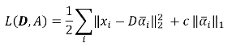
  - x_{i}
  - c - answer
  - D
  - α_{i}

- Which parameter determines the number of atoms in scikit-learn DictioanryLearning class?

  - alpha
  - n_jobs
  - n_components - answer
  - tol

- In KernalPCA the default value for gamma is?

  - 1.0/number of features - answer
  - 2.0/number of features
  - 10/number of features
  - None of above

- Non negative matrix factorization algorithm optimizes a loss function based on?

  - L1 Norm
  - Frobenius norm - answer
  - linalgnorm
  - matrix norm

- Which of the following encoding technique is efficient to deal with large number of possible categories?

  - Effect Encoding
  - Feature Hashing
  - One Hot Encoding
  - Bin counting scheme - answer

- Which scaling technique scales data without being affected by outliers?

  - Robust Scaling - answer
  - Min Max Scaling
  - Standardized Scaling
  - Z-score Scaling

- Which feature selection technique use recursive approach?

  - Filter Methods
  - Wrapper Methods - answer
  - Embedded Methods
  - Subset Methods

- From the following which can be applied on dataset with more than one dimension?

  - Mean
  - Standard Deviation
  - Covariance - answer
  - Variance

- In principal component analysis the sparse loadings can be obtained by imposing which constraint on regression coefficients:

  - Ridge
  - Lasso - answer
  - Linear
  - Logistic

- What provides better statistical regularization?

  - Sparse PCA - answer
  - Kernel PCA
  - Non-negative Matrix Factorization
  - Atom Extraction

- Eigen vector with ____ Eigen value is the principle component of dataset.

  - Lowest
  - Highest - answer
  - Mean
  - Zero

- Trace is equal to the ___ of the Eigen values.

  - Difference
  - Sum - answer
  - Product
  - Mean

- In which scaling technique the upper and lower can be specified by user?

  - Robust Scaling
  - Min Max Scaling - answer
  - Standardized Scaling
  - Z-score Scaling

- Principal component analysis (PCA) can be used with variables of any mathematical types: quantitative, qualitative, ora mixture of these types.

  - True
  - False - answer

- Variances and covariances can be computed for variables of any mathematical types: quantitative, qualitative, or a mixture of these types.

  - True
  - False - answer

Unit- 3: Regression (One mark)
1. A process by which we estimate the value of dependent variable on the basis of one or more independent variables is called:
a. Correlation
b. Regression - answer
c. Residual
d. Slope
2. All data points falling along a straight line is called:
a. Linear relationship - answer
b. Non linear relationship
c. Residual
d. Scatter diagram
3. A relationship where the flow of the data points is best represented by a curve is called:
a. Linear relationship
b. Nonlinear relationship - answer
c. Linear positive
d. Linear negative

4. The value we would predict for the dependent variable when the independent variables are all equal to zero is called:
(a) Slope
(b) Sum of residual
(c) Intercept - answer
(d) Difficult to tell

5. The predicted rate of response of the dependent variable to changes in the independent variable is called:
(a) Slope - answer
(b) Intercept
(c) Error
(d) Regression equation
6. The slope of the regression line of Y on X is also called the:
(a) Correlation coefficient of X on Y
(b) Correlation coefficient of Y on X
(c) Regression coefficient of X on Y
(d) Regression coefficient of Y on X - answer
8. In simple linear regression, the numbers of unknown constants are:
(a) One
(b) Two - answer
(c) Three
(d) Four
9. In simple regression equation, the numbers of variables involved are:
(a) 0
(b) 1
(c) 2 - answer
(d) 3
10. If the value of any regression coefficient is zero, then two variables are:
(a) Qualitative
(b) Correlation
(c) Dependent
(d) Independent- answer
11. In SK-Learn Linear Regression offers two instance variables, __________ and ____________
- intercept_ and coef_ - answer
- Intercept and coef
- Slope and Intercept
- Slope and Coef
12. _________ regression imposes an additional shrinkage penalty to the ordinary least squares loss function to limit its squared L2 norm:

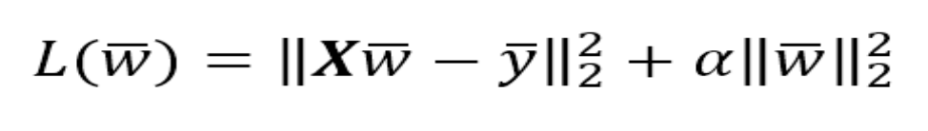
- Lasso
- LassoCV
- Ridge - answer
- ElasticNet
13. _____________ regressor imposes a penalty on the L1 norm of w to determine a potentially higher number of null coefficients:

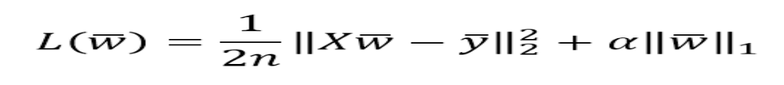
- Lasso - answer
- RidgeCV
- Ridge
- ElasticNet

14. A Regression approach to avoid the problem of outliers is offered by _______________
a) Linear Regression
b) Logistic Regression
c) RANSAC Regressor - answer
d) Polynomial Regressor

15. Model with high variance and low bias is called_________________
a) Over-fitted model - answer
b) Under-fitted model
c) Best fitted
d) None of the above

16. ________ occurs when our model neither fits the training data nor generalizes on the new data.
a) Over-fitting
b) Under-fitting - answer
c) Best fitting
d) None of the above

17. ________________ is the process of adding information in order to solve an ill-posed problem or to prevent overfitting

a) Under-fitting
b) Regularization - answer
c) Best fitting
d) None of the above

18. ____________ selects the only some feature while reduces the coefficients of others to zero. This property is known as feature selection

- Lasso - answer
- RidgeCV
- Ridge
- ElasticNet
19. ______ combines both Lasso and Ridge Regression into one model with two penalty factors, one proportional to L1 norm and other proportional to L2 norm.
- LassoCV
- RidgeCV
- ElasticNet - answer
- None of the above
20. ____________minimizes the cost function by gradually updating the weight values.

- Gradient Descent - answer
- Perceptron
- Grid search
- None of the above

21. _______ is a technique allows using linear models even when the dataset has strong non-linearities. The idea is to add some extra variables computed from the existing ones and using (in this case) only polynomial combinations.

a) Linear Regression
b) Logistic Regression
c) RANSAC Regressor
d) Polynomial Regressor - answer
22. The Regression technique that uses sigmoid function is called________________
a) Linear Regression
b) Logistic Regression - answer
c) RANSAC Regressor
d) Polynomial Regressor

23. Confusion Matrix can be used to measure the performance of _______________ model.
a) Linear Regression
b) Logistic Regression - answer
c) RANSAC Regressor
d) Polynomial Regressor
24. The residual is defined as the difference between the:
a) actual value of y and the estimated value of y - answer
b) actual value of x and the estimated value of x
c) actual value of y and the estimated value of x
d) actual value of x and the estimated value of y

25)Which of the following methods do we use to find the best fit line for data in Linear
Regression?
A) Least Square Error
B) Maximum Likelihood
C) Logarithmic Loss
D) Both A and B
Answer:(A)

26)True- False: Overfitting is more likely when you have a huge amount of data to train.
A) TRUE
B) FALSE
Solution: (B)

27) What will happen when you apply very large penalty in the case of Lasso?
A) Some of the coefficients will become zero
B) Some of the coefficients will be approaching to zero but not absolute zero
C) Both A and B depending on the situation
D) None of these
Solution: (A)

28) Generally, which of the following method(s) is used for predicting continuous dependent
variable?
1. Linear Regression 2. Logistic Regression
A) 1 and 2
B)only 1
C)only 2
D)None of these
Solution:(B)

29)Full form of ROC is
A)Regression Operation Characteristics Curve
B)Receiver Operating Characteristics Curve
C)Regression Operating Characteristics Curve
D)Ridge Operation Characteristics Curve
Solution:(B)

30.F score is given by :
A)F=2*(precision+recall)/precision*recall
B)F=(precision+recall)/precision*recall
C)F=2*(precision*recall)/(precision+recall)
D)F=precision+recall

31)Which is L1 regression
A)Lasso
B)Ridge
C)polynomial
D)Isotonic
Answer A

32)Which of the following is true about “Ridge” or “Lasso” regression methods in case of feature
selection?
A) Ridge regression uses subset selection of features
B)Lasso regression uses subset selection of features
C)Both use subset selection of features
D)None of the above
Solution:(B)

33)SSE can never be
(A) larger than SST
(B) smaller than SST
(C)equal to 1
(D)equal to zero
Solution:(A)

34) 1. Which of the following is correct about regularized regression?
a) Can help with bias trade-off
b) Cannot help with model selection
c) Cannot help with variance trade-off
d) All of the mentioned
Solution:(A)

35) Which of the following statement is true about outliers in Linear regression?
A) Linear regression is sensitive to outliers
B) Linear regression is not sensitive to outliers
C) Can’t say
D) None of these
Solution: (A)

36) What do you expect will happen with bias and variance as you increase the size of training
data?
A) Bias increases and Variance increases
B) Bias decreases and Variance increases
C) Bias decreases and Variance decreases
D) Bias increases and Variance decreases
Solution: (D)

37)A Pearson correlation between two variables is zero but, still, their values can still be related
to each other.
A) TRUE
B) FALSE
Solution: (A)

38) Which of the following statement(s) is / are true for Gradient Decent (GD) and Stochastic
Gradient Decent (SGD)?
1. In GD and SGD, you update a set of parameters in an iterative manner to minimize the
error function.
2. In SGD, you have to run through all the samples in your training set for a single update of
a parameter in each iteration.
3. In GD, you either use the entire data or a subset of training data to update a parameter in
each iteration.
A) Only 1
B) Only 2
C) Only 3
D) 1 and 2
Solution:(A)

39) When hypothesis tests and confidence limits are to be used, the residuals are assumed
to follow the __________distribution.
A) Formal
B) Mutual
C) Normal
D) Abnormal
Solution:(C)

40)The error due to simplistic assumptions made by the model in fitting the data is called as
A)variance
B)bias
C)MSE
D)none of these
Solution:(B)

41)ROC curves show the trade-off between which parameters
A)TPR and FPR
B)TNR And TPR
C)FPR and TNR
D)FPR and FNR
Solution:(A)
42)The accuracy of the model can be measured by
A)The area above ROC curve
B)The area under ROC curve
C)All of the above
D)None of the above
Solution:(B)

43) Least square method calculates the best-fitting line for the observed data by minimizing the sum of the squares of the _______ deviations.
a) Vertical
b) Horizontal
c) Both of these
d) None of these
Solution:(A)
Unit-3 (Two marks)
1. The regression line yhat = 3 + 2x has been fitted to the data points (4,8), (2,5), and (1,2). The residual sum of squares will be:
a) 10
b) 15
c) 13
d) 22 - answer
2. Suppose you have trained a logistic regression classifier and it outputs a new example x with a prediction ho(x) = 0.2. This means
- Our estimate for P(y=1 | x)
- Our estimate for P(y=0 | x) - answer
- Our estimate for P(y=1 | x)
- Our estimate for P(y=0 | x)

3. A regression analysis between sales (in $1000) and advertising (in $100) resulted in the following least squares line: yhat = 75 +6x. This implies that if advertising is $800, then the predicted amount of sales (in dollars) is:
a. $4875 - answer
b. $123,000
c. $487,500
d. $12,300
4. The value for SSE equals zero. This means that the coefficient of determination (r^2) must equal:
a. 0.0.
b. -1.0.
c. 2.3.
d. 1.0 - answer

5. Below equation shows the loss function of ____________________
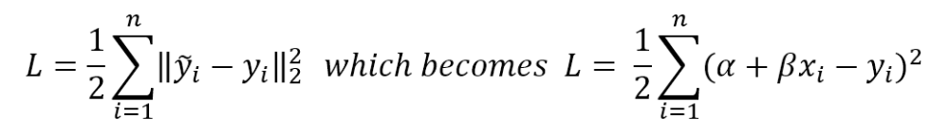
- Logistic Regression Model
- Linear Regression Model - answer
- Gaussian Naïve Bayes Model
- Polynomial Model
6. For the given results of a recently conducted study on the correlation of the number of hours spent driving with the risk of developing acute backache. The Intercept of the line is_______.

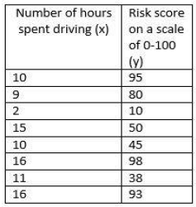
- 12.58 - answer
- 10.58
- 11.85
- 10.85
7. For the given results of a recently conducted study on the correlation of the number of hours spent driving with the risk of developing acute backache. The slope of the line is_______.
- 4.59 - answer
- 10.58
- 5.85
- 10.85
8. for the given vector of outputs the Mean squared error is ________.
y_true = [3, -0.5, 2, 7]
y_pred = [2.5, 0.0, 2, 8]

- 0.45
- 0.375 - answer
- 0.56
- None of the above
9)The correct relationship between SST, SSR, and SSE is given by;
a) SSR = SST + SSE
b) SST = SSR + SSE
c) SSE = SSR – SST
d) all of the above
Solution:(B)

10)Stochastic gradient descent performs less computation per update than batch gradient descent.
A)True
B)False
Solution:(A)

11)A parameter that is external to model and whose value cannot be estimated from data is called as
A)Hyperparameter
B)Model Parameter
C)Outlier
D)Regularization constant
Solution:(A)

12)Which strategy is used for tuning hyperparameters
A)Gradient Descent
B)Feature Scaling
C)Regularization
D)Grid Search
Solution:(D)

13) Which is another term for true positive rate
A)precision
B)Recall
C)Specificity
D)Fscore
Solution:(B)

14)The most widely used metrics and tools to assess a classification model are:
A)Confusion matrix
B)Cost-sensitive accuracy
C)Area under the ROC curve
D)All of the above
Solution:(D)

15)Regularization term in ridge regression is
A) λ (sum of the absolute value of coefficients)
B) λ (sum of the square of coefficients)
C)λ square
D)None on these
Solution:(B)

16) In practice, Line of best fit or regression line is found when _____________
a) Sum of residuals (Σ(Y – h(X))) is minimum
b) Sum of the absolute value of residuals (Σ|Y-h(X)|) is maximum
c) Sum of the square of residuals ( Σ (Y-h(X))2) is minimum
d) Sum of the square of residuals ( Σ (Y-h(X))2) is maximum
Solution:(C)

Unit- 4 : Naïve Bayes and SVM
(one mark)
1. Naive bayes falls under which category-
- Unsupervised classification learning
- Supervised classification learning
- Semi- supervised classification learning
- Reinforcement learning
Ans - b
2. What machine learning task is the Naive Bayes algorithm used for?
- dimensionality reduction
- clustering
- classification
- regression
Ans - c
3. Naive Bayes assumption about data is-
- input is independent, conditional on the output label.
- input is dependent, conditional on the output label.
- input is independent, not conditional on the output label.
- input is dependent, not conditional on the output label.
Ans - a

4. Bayes rule:
- P(A |B) = P(B|A) .P(B) / P(A)
- P(A |B) = P(B|A) .P(A) / P(B)
- P(A |B) = P(B|A) .P(A)
- P(A |B) = P(B|A) .P(B)
Ans - b

5. Which is not a main type of naive bayes classifier -
- Bernoulli naive bayes
- Multinomial naive bayes
- Gaussian naive bayes
- Complement Naive bayes
Ans - d

6. Which type of naive bayes classifier is suited for imbalanced datasets -
- Bernoulli naive bayes
- Multinomial naive bayes
- Gaussian naive bayes
- Complement Naive bayes
Ans - b

7. Which type of naive bayes classifier is best suited for document classification problem -
- Bernoulli naive bayes
- Multinomial naive bayes
- Gaussian naive bayes
- Complement Naive bayes
Ans - b

8. Which type of naive bayes classifiers is usually used for yes/no type boolean predictores-
- Bernoulli naive bayes
- Multinomial naive bayes
- Gaussian naive bayes
- Complement Naive bayes
Ans - a

9. Naive Bayes is termed as 'Naive' because it assumes-
- Dependence between every pair of feature in the data.
- It is multiclass classifier
- It is not multiclass classifier
- Independence between every pair of feature in the data.
Ans- d
10. SVM Classifiers and Linear Classifiers are strictly:
- Probabilistic Binary Linear Classifier
- Probabilistic Multiclass classifier
- Non Probabilistic Binary Linear Classifier
- Non Probabilistic Multiclass classifier
Ans - c
11. SVM falls under which category-
- Unsupervised classification learning
- Supervised classification learning
- Semi- supervised classification learning
- Reinforcement learning
Ans - b
- The effectiveness of an SVM depends upon:
- Selection of Kernel
- Kernel Parameters
- Soft Margin Parameter C
- All of the above
Ans- D
9. Which of the following is true about Naive Bayes ?
  - Assumes that all the features in a dataset are equally important
  - Assumes that all the features in a dataset are independent
  - Both A and B - answer
  - None of the above options

(Two marks)
1. One marble jar has several different colored marbles inside of it. It has 1 red, 2 green, 4 blue, and 8 yellow marbles. All the marbles are the same size and shape. If Peter takes out a marble from the jar without looking, what is the probability that he will NOT choose a yellow marble.
- 7/15
- 8/15
- 7/8
- 5/8
Ans- a

2. If we train a Naive Bayes classifier using infinite training data that satisfies all of its modeling assumptions , then in general, what can we say about the training error (error in training data) and test error (error in held-out test data)?
- It may not achieve either zero training error or zero test error
- It will always achieve zero training error and zero test error.
- It will always achieve zero training error but may not achieve zero test error.
- It may not achieve zero training error but will always achieve zero test error.
Ans - a

3. If P(A) = 0.10, P(B) = 0.05.and P(B|A) = 7%. Find P(A|B)-
- 0.35
- 0.34
- 0.14
- 0.15
Ans - c
4. Which method is provided by scikit learn to tackle large scale classification for which full training set might not fit in memory-
- Memory_manage method
- Partial_manage method
- Partial_fit method
- None of the above
Ans - c
5. If I am using all features of my dataset and I achieve 100% accuracy on my training set, but ~70% on validation set, what should I look out for?
- Underfitting
- Nothing, the model is perfect
- Overfitting
- None of the above
Ans- C

6. What is/are true about kernel in SVM?
1.. Kernel function map low dimensional data to high dimensional space
2. It’s a similarity function
- 1
- 2
- 1 and
- None of these
Ans- C

7. The performance of SVM depends on which factors
- the number of training instances
- the distribution of the data
- linear vs. non-linear problems
- input scale of the features
- All of the above
Ans - e

8. What do you mean by generalization error in terms of the SVM?
- How far the hyperplane is from the support vectors
- How accurately the SVM can predict outcomes for unseen data
- How much you want to avoid misclassification of each training example
- How far the influence of a single training example reaches.
Ans- b

9. What is regularisation parameter tells in SVM-
- How far the hyperplane is from the support vectors
- How accurately the SVM can predict outcomes for unseen data
- How much you want to avoid misclassification of each training example
- How far the influence of a single training example reaches.
Ans - c

10. What is gamma parameter tells in SVM-
- How far the hyperplane is from the support vectors
- How accurately the SVM can predict outcomes for unseen data
- How much you want to avoid misclassification of each training example
- How far the influence of a single training example reaches.
Ans - d

11. The SVM’s are less effective when:
- The data is linearly separable
- The data is clean and ready to use
- The data is noisy and contains overlapping points
- None of the above
Ans- c

12. Which of the following are real world applications of the SVM?
- Text and Hypertext Categorization
- Image Classification
- Clustering of News Articles
- All of the above
Ans- d

13. What is the kernel trick -
- Polynomial and exponential kernels calculate the separation line in lower dimensions.
- Polynomial and exponential kernels calculate the separation line in higher dimensions.
- Polynomial or exponential kernels calculate the separation line in lower dimensions.
- Polynomial or exponential kernels calculate the separation line in higher dimensions.
Ans - b

