電通二乙微處理器實驗 實驗結報

實驗名稱 | Lab01
組別 |  | 組員 | 黃賴鑫

- 實驗目的
使用Tinkercad模擬Arduino UNO電路及程式，使LED發出S.O.S訊號
- 實驗步驟
使用Tinkercad模擬Arduino UNO 接上LED電路，修改程式將LED輸出改為Pin9，修改程式，使LED閃爍間格分別增加為2倍及1/2倍，截圖，畫出電路圖
- 程式碼
void setup()
{
pinMode(9, OUTPUT);
}
void loop()
{
digitalWrite(9, HIGH);
delay(100); // Wait for 100 millisecond(s)
digitalWrite(9, LOW);
delay(100); // Wait for 100 millisecond(s)
digitalWrite(9, HIGH);
delay(100); // Wait for 100 millisecond(s)
digitalWrite(9, LOW);
delay(100); // Wait for 100 millisecond(s)
digitalWrite(9, HIGH);
delay(100); // Wait for 100 millisecond(s)
digitalWrite(9, LOW);
delay(100); // Wait for 100 millisecond(s)
digitalWrite(9, HIGH);
delay(300); // Wait for 300 millisecond(s)
digitalWrite(9, LOW);
delay(100); // Wait for 100 millisecond(s)
digitalWrite(9, HIGH);
delay(300); // Wait for 300 millisecond(s)
digitalWrite(9, LOW);
delay(100); // Wait for 100 millisecond(s)
digitalWrite(9, HIGH);
delay(300); // Wait for 300 millisecond(s)
digitalWrite(9, LOW);
delay(100); // Wait for 100 millisecond(s)
digitalWrite(9, HIGH);
delay(100); // Wait for 100 millisecond(s)
digitalWrite(9, LOW);
delay(100); // Wait for 100 millisecond(s)
digitalWrite(9, HIGH);
delay(100); // Wait for 100 millisecond(s)
digitalWrite(9, LOW);
delay(100); // Wait for 100 millisecond(s)
digitalWrite(9, HIGH);
delay(100); // Wait for 100 millisecond(s)
digitalWrite(9, LOW);
delay(100); // Wait for 100 millisecond(s)
}
- 實驗結果及分析
LED發出S.O.S(三短/三長/三短)
- 心得討論
這次的作業是用Tindercad模擬Arduino 使LED發出訊號，其實如果以前接過麵包板應該都會做這一次的作業，發出S.O.S訊號的程式碼有點多看起來會有點雜。
- 修正電路圖

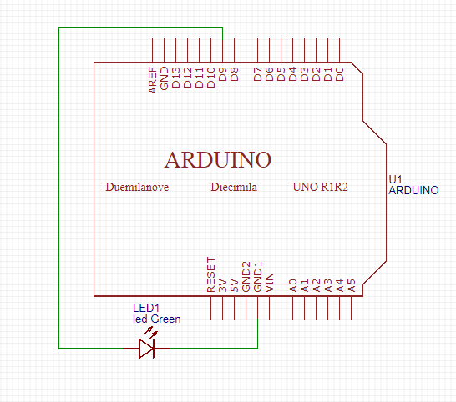
7.修正程式碼
void setup()
{
pinMode(9, OUTPUT);
}
void loop()
{
digitalWrite(9, HIGH);
delay(100); // Wait for 100 millisecond(s)
digitalWrite(9, LOW);
delay(100); // Wait for 100 millisecond(s)
digitalWrite(9, HIGH);
delay(100); // Wait for 100 millisecond(s)
digitalWrite(9, LOW);
delay(100); // Wait for 100 millisecond(s)
digitalWrite(9, HIGH);
delay(100); // Wait for 100 millisecond(s)
digitalWrite(9, LOW);
delay(100); // Wait for 100 millisecond(s)
digitalWrite(9, HIGH);
delay(300); // Wait for 300 millisecond(s)
digitalWrite(9, LOW);
delay(100); // Wait for 100 millisecond(s)
digitalWrite(9, HIGH);
delay(300); // Wait for 300 millisecond(s)
digitalWrite(9, LOW);
delay(100); // Wait for 100 millisecond(s)
digitalWrite(9, HIGH);
delay(300); // Wait for 300 millisecond(s)
digitalWrite(9, LOW);
delay(100); // Wait for 100 millisecond(s)
digitalWrite(9, HIGH);
delay(100); // Wait for 100 millisecond(s)
digitalWrite(9, LOW);
delay(100); // Wait for 100 millisecond(s)
digitalWrite(9, HIGH);
delay(100); // Wait for 100 millisecond(s)
digitalWrite(9, LOW);
delay(100); // Wait for 100 millisecond(s)
digitalWrite(9, HIGH);
delay(100); // Wait for 100 millisecond(s)
digitalWrite(9, LOW);
delay(100); // Wait for 100 millisecond(s)

}

