天津理工大学考试试卷答案
2007 ～ 2008 学年度第 1 学期
《计算机网络原理》 期末考试试卷答案

课程代码： 0660086 试卷编号： 1-A 命题日期： 2007 年 12 月 10 日
答题时限： 120 分钟 考试形式：闭卷笔试

得分统计表：
大题号  总分 | 一 | 二 | 三 | 四 | 五

PART Ⅰ: Choice (2 point per question – total: 30 points)
Instructions: Select one of the letters beside the choice that is the best answer for each question.
得分

Q | 1 | 2 | 3 | 4 | 5 | 6 | 7 | 8 | 9 | 10 | 11 | 12 | 13 | 14 | 15
A | B | A | C | D | A | C | B | D | C | C | A | D | D | A | B

1. Which of the following services does not the transport layer provide for theapplication layer?
  - In-order delivery of data segments between processes
  - Best effort delivery of data segments between communicating hosts
  - Multiplexing and demultiplexing of transport layer segments
  - Congestion control
2. What are the two of the most importmant protocols in the Internet?
A. TCP and IP
B. TCP and UDP
C. TCP and SMTP
D. ARP and DNS
3. The Internet provides two services to its distributed applications: a connection oriented reliable service and a ( ).
A. connection oriented unreliable service
B. connectionless reliable service
C. connectionless unreliable service
D. In order data transport service
4. Processes on two different end systems communicate with each other by exchanging ( ) across the computer network.
A. packets
B. datagram
C. frames
D. messages
5. The job of delivering the data in a transport-layer segment to the correct socket is called ( ).
A. demultiplexing
B. multiplexing
C. TDM
D. FDM

6. Two important reasons that the Internet is organized as a hierarchy of networks for the purposes of routing are:
- Least cost and maximum free circuit availability
- Message complexity and speed of convergence
- Scale and administrative autonomy
- Link cost changes and link failure
7. Which of characters is not distance-vector algorithm’s characters？（ ）
A. iterative
B. global
C. asynchronous
D. distributed
8. The length of IPV6 address is （ ）bits.
A. 32
B. 48
C. 64
D. 128
9. The host component of a CIDR address of the form a.b.c.d/25 can contain addresses for:
- 2²⁵ hosts (minus “special” hosts)
- 512 hosts (minus “special” hosts)
- 2⁽³²⁻²⁵⁾ hosts (minus “special” hosts)
- 25 hosts (minus “special” hosts)
10. The primary function of the address resolution protocol (ARP) that resides in Internet hosts and routers is:
- To provide LAN router functions
- To translate between LAN addresses and physical interface addresses
- To translate IP addresses to LAN addresses
- To calculate the shortest path between two nodes on a LAN
11. The POP3 protocol runs over ____ and uses port ____.
A. TCP 110
B. UDP 110
C. UDP 25
D. TCP 25
12. When a destination host transport layer receives data from the network layer, it unambiguously identifies the appropriate process to pass the data to by using a triplet consisting of:
A. Source port #, destination IP address, and source IP address
B. Destination port #, source port #, process ID#
C. Destination port #, source port #, destination IP address
D. Destination port #, source port #, source IP address
13. From the list below, select the items found in the TCP segment structure that are not found in the UDP segment structure:
A. Application Generated Data
B. Destination Port #
C. Source Port #
D. Sequence #
14. The RIP routing protocol is based on an algorithm that is:
A. Based on information received only from link “neighbors”
B. A link state algorithm
C. An OSPF algorithm
D. A centralized routing algorithm
15. With an exterior routing protocol, which of the following issues generally dominates the routing decisions?
A. Geographical distance between AS’s
B. Policy
C. Number of AS’s traversed
D. Current congestion levels in the AS’s

PART Ⅱ: Briefly answer the following questions. (Total: 40 points)．
得分

1．(3points) What is the difference between a host and end system? List the types of end systems. Is a Web Server an end system?
答：There is no difference. Throughout this text, the words “host” and “end system” are
used interchangeably. End systems include PCs, workstations, Web servers, mail
servers, Internet-connected PDAs, WebTVs, etc.

2．(3points) Please briefly describe the function of the five layers in TCP/IP architecture
(NOTE: include the protocol data unit)
答：
1．应用层，提供各种网络应用，运行网络应用程序。Message。
2．运输层，提供端到端进程之间的数据传输。Segment。
3．网络层，主机到主机的传输。Datagram
4．链路层，相邻节电数据传输，frame
5．物理层，透明传输比特流，bit stream.
3. (3points) 3. (3points) Consider accessing your email with POP. Suppose you have configured your pop mail client to operate in the down-load-and-delete mode. Complete the following transaction.
C: list
S: 1 498
S: 2 912
S: .
C: retr 1
S: blah blah …
S: …………blah
S: .
?
?
?
答：C: dele 1
C: retr 2
S: (blah blah …
S: ………..blah)
S: .
C: dele 2
C: quit

4. (3points) Where can queuing occur in a router? Briefly explain the conditions that lead to such queuing.
答：Queuing can occur at both the input ports and the output ports of a router. Queuing occurs at the output port when the arriving rate of packets to the outgoing link exceeds the link capacity. Queue occurs on an input port when the arriving rate of packets exceeds the switch capacity; head-of-the-line blocking can also cause queuing at the input ports.

5. (3points) Describe why an application developer might choose to run an application over UDP rather than TCP.
答：An application developer may not want its application to use TCP’s congestion
control, which can throttle the application’s sending rate at times of congestion.
Often, designers of IP telephony and IP videoconference applications choose to run
their applications over UDP because they want to avoid TCP’s congestion control.
Also, some applications do not need the reliable data transfer provided by TCP.

6. (3points) Suppose Client A initiates a Telnet session with Server S. At about the same time, Client B also initiates a Telnet session with Server S. Provide possible source and destination port number for
a. The segments sent from A to S
b. The segments sent from B to S
c. The segments sent from S to A
d. The segments sent from S to B
e. If A and B are different hosts, is it possible that the source port number in the segments from A to S is the same as that from B to S?
f. How about if they are the same host?
答：source port
numbers
destination port
numbers
a. A →S 467 23
b. B →S 513 23
c. S →A 23 467
d. S →B 23 513
e. yes
f. no

7. (4points) Fill in the blank:
1) RIP advertisements typically announce the number of ( hops ) to various destinations.
2) BGP updates announce the ( ASs ) to various destinations
3) For Selective Repeat protocol, sequence number space >=( 2 )times window size.
4) The efficiency of Slotted ALOHA =( 2 ) times bigger than Pure ALOHA.

8. (3points)Consider sending a packet over a path of N links. Assume that each packet has L bits. Each link transmits at R bps. The network is lightly loaded so that there are no queuing delays. Propagation delay and node processing delay are negligible. Suppose the network is a packet-switched datagram network and a connectionless service is used. Now suppose each packet has 2h bits of header. How long does it take to send the packet?
答： (L+2h)/R*N

9.(3points)If all the links in the Internet were to provide the reliable delivery service, would the TCP reliable delivery service be redundant? Why or Why not?
答: Although each link guarantees that an IP datagram sent over the link will be received at the other end of the link without errors, it is not guaranteed that IP datagrams will arrive at the ultimate destination in the proper order. With IP, datagrams in the same TCP connection can take different routes in the network, and therefore arrive out of order. TCP is still needed to provide the receiving end of the application the byte stream in the correct order. Also, IP can lose packets due to routing loops or equipment failures.
10. (Total 4 points)CDMA
Suppose that four nodes using CDMA (Code Division Multiple Access) protocol to transport their data. The chipping sequences are listed respectively as below:
A: (-1,+1,–1,+1,+1,+1,–1,-1)
B: (-1, +1,–1, –1,–1,–1, +1,-1)
C: (-1,–1,–1,+1,+1,–1,+1,+1)
D: (-1,–1,+1,–1,+1,+1,+1,-1)

(Computing process is needless)
Suppose that a CDMA receiver has received an encoded data as (-1,+1,-3,+1,-1,-3,+1,+1) from an aggregate signal channel in one bit-slot time, which node/nodes has/have sent data? What’s the corresponding data bit each of them sent? (3points)
Answer: A send nothing, B send 1, C sends 1, D sends 0.
11.(2points) In the figure below, H1 remains in same IP subnet, briefly describe how the switch would know which AP is associated with H1 when H1 is moving within BSS1 and BSS2.
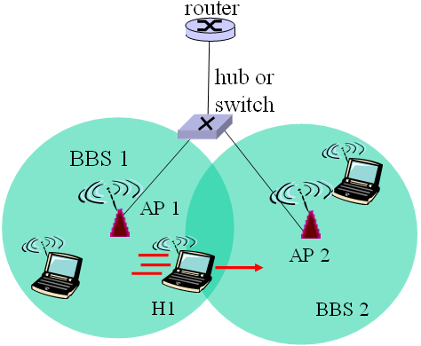
答：通过自学习的方法
12. (3points) This question is about the “GSM: handoff with common MSC”. According to the figure below, ordering the 8 steps.
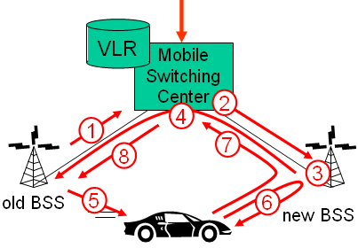
A. Old BSS informs MSC of impending handoff, provides list of 1⁺ new BSSs
B. Old BSS tells mobile: perform handoff to new BSS
C. New BSS allocates radio channel for use by mobile
D. New BSS signals MSC, old BSS: ready
E. MSC-old BSS resources released
F. MSC sets up path (allocates resources) to new BSS
G. Mobile signals via new BSS to MSC: handoff complete. MSC reroutes call
H. Mobile, new BSS signal to activate new channel
Answer: AFCDBHGE
13. (3points) Why is an ARP query sent within a broadcast frame? Why is an ARP response sent within a frame with a specific destination MAC address?
答：An ARP query is sent in a broadcast frame because the querying host does not which
adapter address corresponds to the IP address in question. For the response, the
sending node knows the adapter address to which the response should be sent, so
there is no need to send a broadcast frame (which would have to be processed by all
the other nodes on the LAN).

PART Ⅲ: Answer the following questions. (Total: 30 points)．
得分

1. (total: 15 points) Consider the network shown below. Run Dijkstra’s algorithm to compute the shortest paths from A to all other nodes in the network. While selecting the next node, if several nodes have the same min cost, select the one with lowest id, (e.g., if B and D have the same min cost, then select B).
A
D
B
C
E
4
1
3
5
3
1
3
K
M
J
F
G
H
I
L
2
4
6
2
3
2
3
2
7
3
2
4
5

Determine the routing table (destination, next-node, and cost) at node A.

Destination | Next Node | Cost
B | B | 4
C
D
E
F
G
I
J
K
L
M

答：
Destination | Next Node | Cost
B | B | 4
C | B | 5
D | D | 3
E | B | 6
F | F | 2
G | F | 6
I | B | 10
J | K | 7
K | K | 5
L | D | 5
M | B | 8

2. (10points)Consider the following plot of TCP window size as a function of time.
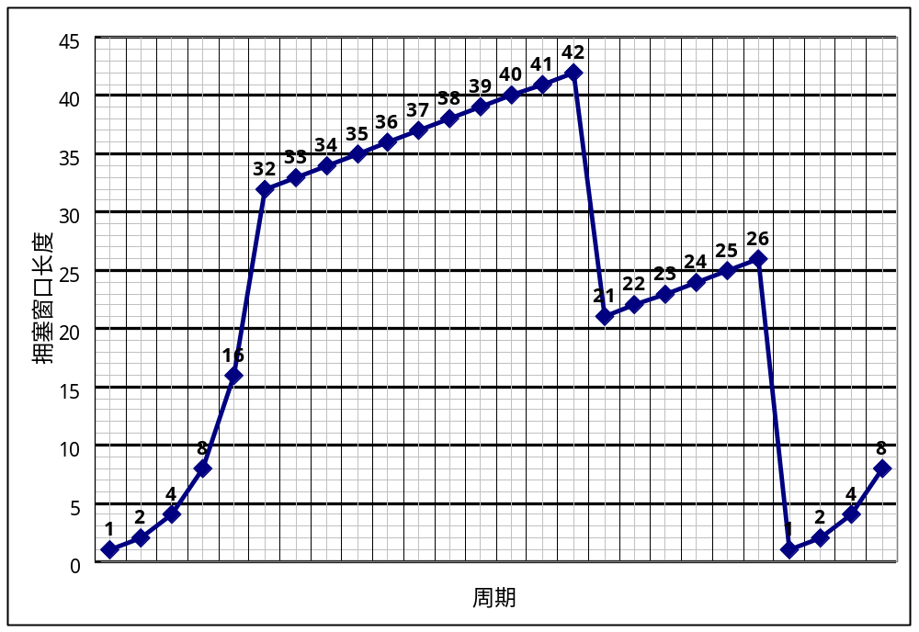Assuming TCP Reno is protocol experiencing the behavior show above, answer the following question.
    - Identify the intervals of time when TCP slow start is operating.
    - Identify the intervals of time when TCP congestion avoidances is operating.
    - After the 16th transmission round, is segment loss detected by a triple duplicate ACK or by a timeout?
    - After the 22nd transmission round, is segment loss detected by a triple duplicate ACK or by a timeout?
    - What is the initial value of Threshold an the first transmission round?
    - What is the value of Threshold an the 18th transmission round?
    - What is the value of Threshold an the 24th transmission round?
    - During what transmission round is the 70th segment sent?
    - Assuming a packet loss is detected after the 26th round by the receipt of a triple duplicate ACK, what will be the values of the congestion-window size and of Threshold?
Answer:
a) TCP slowstart is operating in the intervals [1,6] and [23,26]
b) TCP congestion avoidance is operating in the intervals [6,16] and [17,22]
c) After the 16th transmission round, packet loss is recognized by a triple duplicate ACK. If there was a timeout, the congestion window size would have dropped to 1.
d) After the 22nd transmission round, segment loss is detected due to timeout, and hence the congestion window size is set to 1.
e) The threshold is initially 32, since it is at this window size that slowtart stops and congestion avoidance begins.
f) The threshold is set to half the value of the congestion window when packet loss is detected. When loss is detected during transmission round 16, the congestion windows size is 42. Hence the threshold is 21 during the 18th transmission round.
g) The threshold is set to half the value of the congestion window when packet loss is detected. When loss is detected during transmission round 16, the congestion windows size is 42. Hence the threshold is 21 during the 18th transmission round.

h) During the 1st transmission round, packet 1 is sent; packet 2-3 are sent in the 2nd transmission round; packets 4-7 are sent in the 3rd transmission round; packets 8-15 are sent in the 4th transmission round; packets15-31 are sent in the 5th transmission round; packets 32-63 are sent in the 6th transmission round; packets 64 – 96 are sent in the 7th transmission round. Thus packet 70 is sent in the 7th transmission round.
i) The congestion window and threshold will be set to half the current value of the congestion window (8) when the loss occurred. Thus the new values of the threshold and window will be 4.

3. (5points) This elementary problem begins to explore propagation delay and transmission delay, two central concepts in data networking. Consider two hosts, A and B, connected by a single link of rate R bps. Suppose that the two hosts are separated by m meters, and suppose the propagation speed along the link is s meters/sec. Host A is to send a packet of size L bits to Host B

- Ignoring processing and queuing delays, obtain an expression for the end-to-end delay.

- Suppose Host A begins to transmit the packet at time t=0. At time t=d_{trans}, where is the last bit of the packet?

- Suppose d_{prop} is greater than d_{trans}. At time t=d_{trans}, where is the first bit of the packet?

- Suppose s=2.5×10⁸, L=100bits,and R=28kbps. Find the distance m so that d_{trans}. Equals d_{trans}
答：
a. m/s+L/R
b. The bit is just leaving Host A.
c. The first bit is in the link and has not reached Host B.
d. 893m

