天津理工大学考试试卷
2005 ～ 2006 学年度第 2 学期
《计算机网络技术》 期末考试试卷

课程代码： 0600100 试卷编号： 1-A 命题日期： 2006 年 5 月 20 日
答题时限： 120 分钟 考试形式：闭卷笔试

得分统计表：
大题号  总分 | 一 | 二 | 三 | 四 | 五

PART Ⅰ: Single Choice (1 point per question – total: 20 points)
Instructions: Select one of the letters beside the choice that is the best answer for each question.
得分

Q | 1 | 2 | 3 | 4 | 5 | 6 | 7 | 8 | 9 | 10 | 11 | 12 | 13 | 14 | 15 | 16 | 17 | 18 | 19 | 20
A

1. Which of the following services does the Internet network layer provide for the Internet transport layer?
  - In-order delivery of data segments between processes
  - Best effort delivery of data segments between communicating hosts
  - Multiplexing and demultiplexing of transport layer segments
  - Congestion control
2. The main task of the Internet’s Domain Name System (DNS) is to:
- Translate port numbers to IP addresses
- Specify the standards for Internet domain names
- Provide an authority for registering domain names
- Translate mnemonic names to IP addresses
- RDT3.0’s receiver FSM is same to:
a) RDT1.0 b) RDT2.1 c) RDT2.2 d) RDT2.0
4. The Transmission Control Protocol (TCP) provides which of the following services?
  - End-to-end station addressing
  - Application multiplexing
  - Inter network routing
  - Medium access control (MAC)
- When a destination host transport layer receives data from the network layer, it unambiguously identifies the appropriate process to pass the data to by using a triplet consisting of:
- Source port #, destination IP address, and source IP address
- Destination port #, source port #, process ID#
  - Destination port #, source port #, destination IP address
- Destination port #, source port #, source IP address
- Given that the requested information is not available at any intermediate databases, a non-iterated DNS query from a requesting host would follow the path:
- Root name server, local name server, authoritative name server
- Authoritative name server, root name server, host name server
- Local name server, root name server, local name server, authoritative name server
  - Local name server, root name server, authoritative name server
- From the list below, select the items found in the TCP segment structure that are not found in the UDP segment structure:
- Application Generated Data
- Destination Port #
- Source Port #
  - Sequence #
- Select the four essential steps, briefly described, for terminating a TCP connection between a client and a server, assuming that the initiating host is the client:
- Client sends TCP segment with ACK0 and final sequence number
- Client sends TCP segment with FIN =1 and goes into FIN_WAIT state
- Server sends TCP segment to ACK the client’s FIN request and enters CLOSE_WAIT state
- Server sends TCP segment with FIN=0
- Server sends TCP segment with FIN=1
- Client sends TCP segment with to ACK server’s FIN and enters second FIN_WAIT state
- Client sends TCP segment with FIN=0
a) 2，3，5，6 b) 5，1，2，3 c) 1，3，5，7 d) 2，3，4，6
- The RIP routing protocol is based on an algorithm that is:
  - Based on information received only from link “neighbors”
  - A link state algorithm
  - An OSPF algorithm
  - A centralized routing algorithm
- When compensating for link cost changes in the distance vector algorithm, it can generally be said that:
- Increased costs are propagated quickly, i.e., “bad news” travels fast
- Decreased costs are propagated rapidly, i.e., “good news” travels fast
- Decreased costs do not converge
- None of the above
- Two important reasons that the Internet is organized as a hierarchy of networks for the purposes of routing are:
- Least cost and maximum free circuit availability
- Scale and administrative autonomy
- Message complexity and speed of convergence
- Link cost changes and link failure
- With an exterior routing protocol, which of the following issues generally dominates the routing decisions?
- Geographical distance between AS’s
- Policy
- Number of AS’s traversed
- Current congestion levels in the AS’s
- The host component of a CIDR address of the form a.b.c.d/22 can contain addresses for:
- 2⁽³²⁻²²⁾ hosts (minus “special” hosts)
- 512 hosts (minus “special” hosts)
- d times 22 hosts
- 10 hosts (minus “special” hosts)
- As an IP datagram travels from its source to its destination:
- the source IP address is changed at each router to identify the sending router
- the router uses the destination IP address to consult its routing table
- the router does not use the IP addresses in the datagram
- the destination IP address is changed at each router to reflect the next hop
- From the list below, choose the bit pattern which could be a valid generator value for the CRC code (R) 11010:
- 1110
- 011010
- 100101
- 10011
- The primary function of the address resolution protocol (ARP) that resides in Internet hosts and routers is:
- To provide LAN router functions
- To translate between LAN addresses and physical interface addresses
- To translate between IP addresses and LAN addresses
- To calculate the shortest path between two nodes on a LAN
- Consider sending a 1300 byte IPv4 datagram into a link that has an MTU of 500 bytes:
- Three fragments are created.
- Four fragments are created.
- Three fragments are created with offsets 0, 500 1000
- The last fragment consists of exactly 300 bytes of data from the original datagram
- Suppose one IPv6 router wants to send a datagram to another IPv6 router, but the two are connected together via an intervening IPv4 router. If the two routers use tunneling, then:
- The sending IPv6 router creates an IPv4 datagram and puts it in the data field of an IPv6 datagram.
- The sending IPv6 router creates one or more IPv6 fragments, none of which is larger than the maximum size of an IPv4 datagram.
- The sending IPv6 router creates an IPv6 datagram and puts it in the data field of an IPv4 datagram.
- The sending IPv6 router creates an IPv6 datagram and intervening IPv4 router will reject the IPv6 datagram
- Which of the following was an important consideration in the design of IPv6
- fixed length 40-byte header and specified options to decrease processing time at IPv6 nodes
- 128-bit addresses to extend the address space
- different types of service (flows) defined
- all of the above
- A network bridge table is used to perform the following:
- Mapping MAC addresses to bridge port numbers
- Forwarding frames directly to outbound ports for MAC addresses it handles
- Filtering (discarding) frames that are not destined for MAC addresses it handles
- All of the above
PART Ⅱ: True / False (1 points per question – total:15 points)
Instructions: Mark the symbol “√” (for True) if the statement is correct, or the symbol “χ” (for False) if the statement is incorrect.
得分

Q | 1 | 2 | 3 | 4 | 5 | 6 | 7 | 8 | 9 | 10 | 11 | 12 | 13 | 14 | 15
A
- The Internet’s Transport Layer protocol provides reliable data transfer between end systems.
- Networks should be designed such that the Traffic Intensity value for each network node is less than 1.
- The maximum size of a single UDP segment is limited to 2¹⁶ –1 bits.
- FTP uses two separate TCP connections, one to port 20 and one to port 21, and is said to send its commands “out of band”.
- During the first step of a TCP connection handshake between a client and a server, the server receives a TCP segment with a null sequence number and the SYN bit set to 1.
- TCP congestion control is designed to prevent buffer overflow in network end-systems.
- Due to the characteristics of its congestion avoidance algorithm, TCP can be said to be a “fair” protocol with regard to sharing available bandwidth among users of a common transmission link.
- In the Internet, interior routers in the same autonomous system execute the same routing algorithm to compute routing paths.
- All link layer protocols that support IP have the same frame structure (i.e., length of frame, number and length of header fields).
- Routers sometimes use transport layer protocols, such as TCP or UDP, to exchange routing table information with each other.
- Any node in the IP network defined by 192.118.15.0/24 would be required to have an IP address of the form 192.118.15.xxx.
- Pure Aloha is more efficient than Slotted-Aloha.
- The entries in a bridge table need to be configured by the network administrator.
- Layer-2 switches can be used to isolate one LAN segment’s collision domain from that of another LAN segment.
- The Time Division Multiplexing (TDM) channel partitioning protocol is appealing because it eliminates collisions and is perfectly fair with regard to bandwidth availability.

PART Ⅲ: Briefly answer each of the following questions. (1 points per question – total: 20 points)
得分
1. Explain the difference between connection-oriented messaging service and connectionless messaging service.

2. Explain the difference between go-back-N and selective repeat.

3. Where can queuing occur in a router? Briefly explain the conditions that lead to such queuing.

4. Satellite links often exhibit high propagation times and low transmission speed. What does this mean?

5. The difference between UDP and IP packets is minimal. Why shouldn’t applications use IP directly?

6. Can two computers that have a different implementation of the same protocol exchange messages? Explain your answer.

7. What are the differences between routing and forwarding? Briefly explain each of them.

8. Briefly explain the formula “lastByteSent-lastByteAcked≤min {CongWin ,RcvWin}”. If necessary, you can draw a figure to describe your answer.

9. Ethernet follows a CSMA/CD protocol scheme. Explain how this scheme works.

10. For a sliding window protocol, it is necessary to have the window size at most half of the range of sequence numbers. Why?

PART Ⅳ: Answer each of the following questions. (Total: 55 points)
得分

1. (total: 6 points) Consider the network shown below. Run Dijkstra’s algorithm to compute the shortest paths from A to all other nodes in the network. While selecting the next node, if several nodes have the same min cost, select the one with lowest id, (e.g., if B and D have the same min cost, then select B).
A
D
B
C
E
4
1
3
5
3
1
3
K
M
J
F
G
H
I
L
2
4
6
2
3
2
3
2
7
3
2
4
5

Determine the routing table (destination, next-node, and cost) at node A.

Destination | Next Node | Cost
B
C
D
E
F
G
I
J
K
L
M
2. (total: 6 points) Reno congestion control algorithm.
Consider TCP Reno (the one that uses both timeout and 3 duplicate ACKs to detect packet losses). Remember the receiver sends cumulative ACK whenever a segment is received and assume that our TCP implementation discards out-of-order segments, so as in Go-Back-N, the sender should re-transmit all packets starting from base when a packet loss is detected. Remember congestion window needs to be adjusted before retransmission.
A server application has 26 TCP segments (packets) (that are numbered as 1, 2, 3… 26) to send to the receiver site. Assume that the sender started from slow start with a congestion window of 1 and continued according to TCP Reno congestion control algorithm. The initial Threshold value was 4. The timeout duration at the sender is set to RTT. Assume that the sender sends a number of TCP segments and receives all ACKs just before the next RTT (ignore the time between back-to-back sent segments). Finally, assume that 15th and 21st segments got lost during their first transmission.
Now, by using the above information, your task is to complete the blank entries in the below table until all the segments are sent and all the ACKs are successfully received. If you want, you can use the chart below to work out your solution before filling in the table below.

Cong. Win.
CHART
9
8
7
6
5
4
3
2
1

0 1 2 3 4 5 6 7 8 9 10 11 RTT

TABLE
RTT | Threshold | Congestion Window | Segments that are sent
0 | 4 | 1 | 1
1 | 4 | 2 | 2, 3
2
3
4
5
6
7
8
9
10
11
3. (5 points) Match the terms with their best corresponding definition or concepts. Join them together with lines.
SYN,ACK |  | A layer 4 protocol
Spanning Tree Algorithm |  | One of their primary jobs involves RFCs
repeater |  | Techniques to efficiently use IP addresses
IETF |  | This model lacks a setup and tear down phase
VLSM,CIDR |  | This layer 2 technology helps prevent bridge loops in Ethernet LANs and also in token ring LANs
connectionless |  | You might this layer 2 technology in token ring LANs, but not in Ethernet LANs
Full-duplex |  | Something you might find in the 3-way handshake
UDP |  | An example of a wire link technology
Source route bridging |  | The ability to talk and listen at the same time
Optical fiber cabling |  | This device moves bits from one data link network to another without inspecting the frame’s contents

4. (total: 8 points) Caching and delays.
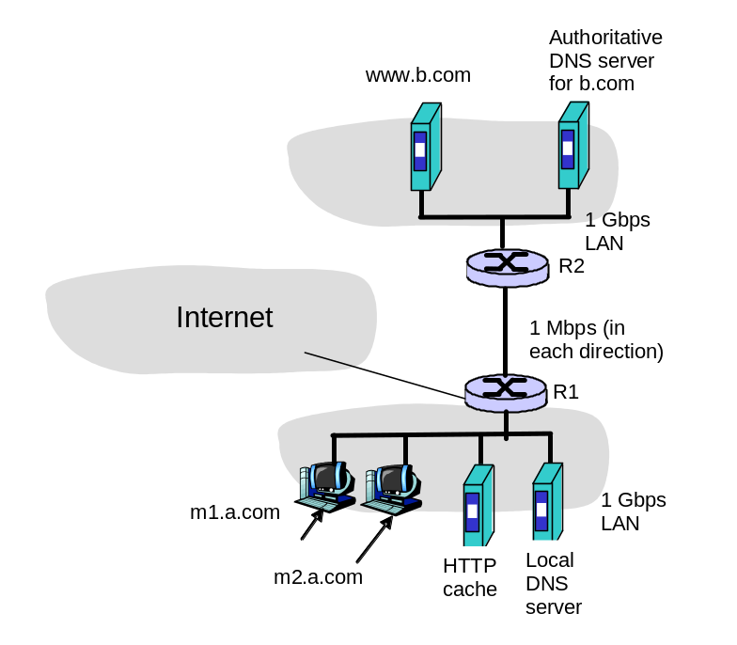Consider the networks shown in the figure below. There are two user machines m1.a.com and m2.a.com in the network a.com. Suppose the user at m1.a.com types in the URL www.b.com/bigfile.htm into a browser to retrieve a 1Gbit (1000 Mbit) file from www.b.com.

a)(5points)List the sequence of DNS and HTTP messages sent/received from/by m1.a.com as well as any other messages that leave/enter the a.com network that are not directly sent/received by m1.a.com from the point that the URL is entered into the browser until the file is completely received. Indicate the source and destination of each message. You can assume that every HTTP request by m1.a.com is first directed to the HTTP cache in a.com and that the cache is initially empty, and that all DNS requests are iterated queries.

b) (3points) Now assume that machine m2.a.com makes a request to exactly the same URL that m1.a.com made. List the sequence of DNS and HTTP messages sent/received from/by m2.a.com as well as any other messages that leave/enter the a.com network that are not directly sent/received by m2.a.com from the point that the URL is entered into the browser until the file is completely received. Indicate the source and destination of each message. [Hint: make sure you consider caching here]

5. (total: 11 points) Addressing, and following the data
Consider the simple network shown below:
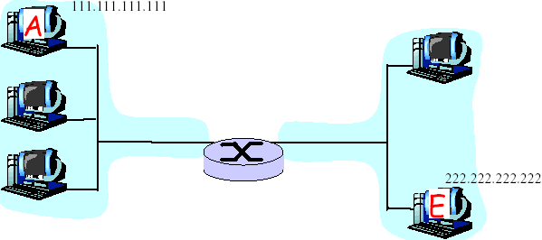
B
C
D
R2
R1
a) Write down an IP address for all interfaces at all hosts and routers in the network. The IP addresses for A and E are as given. You should assign IP addresses so that interfaces on the same network have the same network-part of their IP address. Indicate the number of bits in the network-part of this address.
B |  | R1
C |  | R2
D

b) Choose physical addresses (LAN addresses) for only those interfaces on the path from A to E.
A |  | E
B |  | R1
C |  | R2
D
Can these addresses be the same as in part a)? Why?

c) Now focus on the actions taken at both the network and data link layers at sender A, the intervening router, and destination E in moving an IP datagram from A to E:
①How do A, E and the router determine the IP addresses needed for the IP datagram?

②What, specifically, are the addresses in the IP datagram that flows from A to the router?
Source IP |  | Destination IP

What, specifically, are the addresses in the IP datagram that flows from the router to E.?
Source IP |  | Destination IP
③What are three other fields found in an IP datagram?

④How do A, E and the router determine the physical (LAN) addresses needed for the data link layer frame?

d) Suppose that the router in the figure below is replaced by a bridge.
①How would the IP addresses change in this case?

②How would the physical (LAN) addresses change in this case?

③How would does a learning bridge learn the physical addresses of the attached hosts

PART Ⅴ: (total: 6 points) About the labs.
The following transcript is a mail transfer session between hosts A and B using TCP/IP. According to the session, answer the questions.
A: 220 umass.edu simple mail transfer service ready
B: HELO sanfan.edu
A: 250 umass.gov Hello sanfan.edu, please to meet you
B: MAIL FROM: <alice@sanfan.edu>
A: 250 mail accepted
B: RCPT TO: <bob@umass.edu>
A: 250 recipient accepted
B: RCPT TO: <tom@umass.edu>
A: 550 no such user here
B: RCPT TO: <lucy@umass.edu>
A: 250 recipient accepted
B: DATA
A: 354 start mail input; end with <CR><LF>.<CR><LF>
B: Date: Sat 14 June 2003 13:26:31 BJ
B: From: alice@sanfan.edu
B: . . . . . .
B: . . . . . .
B: . . . . . .
B: .
A: 250 OK
B: QUIT
A: 221 umass.edu service closing transmission channel.
Questions:
1. What is the whole name of the sender’s host? What is the user name of the sender?

2. How many users does the sender want to send the E-mail?

3. What is the whole name of the receiver’s host?

4. Which users can receive the E-mail?

5. For receiving the mail, what is the port number waiting for the connection on the receiver host?

6. What is the name of the transport layer protocol?

Optional Question (No Points for this exam)：This final examination was:
a. Easier than I expected b. About what I expected c. Harder than I expected

