Answer sheet
2005-2006第二学期计算机网络试卷1A答案
PART Ⅰ: Single Choice (1 points per question – total: 20 points)
Q | 1 | 2 | 3 | 4 | 5 | 6 | 7 | 8 | 9 | 10 | 11 | 12 | 13 | 14 | 15 | 16 | 17 | 18 | 19 | 20
A | b | d | c | b | d | d | d | a | a | b | b | b | a | b | c | c | a | c | d | d

PART Ⅱ: True / False (1 points per question – total:15 points)
Q | 1 | 2 | 3 | 4 | 5 | 6 | 7 | 8 | 9 | 10 | 11 | 12 | 13 | 14 | 15
A | χ | √ | χ | √ | χ | χ | χ | √ | χ | √ | √ | χ | χ | √ | χ

PART Ⅲ: Briefness questions. (2 points per question – total:20 points)
1. Explain the difference between a connection-oriented messaging service and a connectionless messaging service. (2 points)
A connection-oriented service requires that a peer first sets up a connection to the target peer before data can be exchanged. In a connectionless service, messages are sent directly to a peer, requiring that the address is part of each message.
2. Explain the difference between go-back-N and selective repeat. (2 points)
With go-back-N, whenever a receiver detects a missing or damaged frame k, all frames succeeding k are ignored and the sender is forced to start retransmission at frame k. With selective repeat, it is possible to retransmit only frame k; the receiver buffers successive frames.
3. Where can queuing occur in a router? Briefly explain the conditions that lead to such queuing. (2 points)
Queuing can occur at both the input ports and the output ports of a router. Queuing occurs at the output port when the arriving rate of packets to the outgoing link exceeds the link capacity. Queue occurs on an input port when the arriving rate of packets exceeds the switch capacity; head-of-the-line blocking can also cause queuing at the input ports.

4. Satellite links often exhibit high propagation times and low transmission speed. What does this mean? (2 points)
It means that it can take a long time for the start of a signal that represents a bit to reach the sender, and that the number of bits that can be transmitted per time unit is low.
5. The difference between UDP and IP packets is minimal. Why shouldn’t applications use IP directly? (2 points)
It is a matter of separating concerns: the transport layer should offer an interface to applications that hides the underlying network. For connectionless services, it does so by means of UDP. Furthermore, note that IP itself has no notion of ports. This type of address belongs to the abstraction provided by the transport layer and of which applications make heavy use. There is, in general, no way that an application can get an IP packet sent directly to an application.

6. Can two computers that have a different implementation of the same protocol exchange messages? Explain your answer. (2 points)
Yes, the protocol prescribes the format of messages, and the precise rules for message exchange. You can easily have different implementations of the same protocol.
7. What are the differences between routing and forwarding? Briefly explain each of them. (2 points)
Forwarding: move packets from router’s input to appropriate router output.
Routing: determine route taken by packets from source to destination.
8. Briefly explain the formula “lastByteSent-lastByteAcked≤min {CongWin ,RcvWin}”. If necessary, you can draw a figure to describe your answer. (2 points)
Due to the congestion control and flow control, TCP limits the amount of unacknowledged data at a sender may not exceed the minimum of congwin and Rcvwin.
9. Ethernet follows a CSMA/CD protocol scheme. Explain how this scheme works. (2 points)
CSMA/CD stands for Carrier Sense Multiple Access with Collision Detection. This means that when a node wants to transmit data, it (1) senses the carrier until no transmissions are detected, (2) starts transmission, and (3) continues to check for a collision. If a collision happens, the node stops and waits a random period before starting with step (1) again.
10. For a sliding window protocol, it is necessary to have the window size at most half of the range of sequence numbers. Why? (2 points)
Suppose a receiver has just received frame #N, and it advances its window such that (a new) frame #N is allowed to be transmitted. If the acknowledgement for the receipt of frame #N was lost, then the sender will eventually retransmit the original frame, but which will now be considered as fresh frame by the receiver.
PART Ⅳ: Answer each of the following questions. (Total: 39 points)
1. (total: 6 points)
Destination | Next Node | Cost
B | B | 4
C | B | 5
D | D | 3
E | B | 6
F | F | 2
G | F | 6
I | B | 10
J | K | 7
K | K | 5
L | D | 5
M | B | 8

2. (total: 6 points) (2 points/column)
RTT | Threshold | CongWin | Segments that are sent
0 | 4 | 1 | 1
1 | 4 | 2 | 2, 3
2 | 4 | 4 | 4,5,6,7
3 | 4 | 5 | 8,9,10,11,12
4 | 4 | 6 | 13,14,15,16,17,18
5 | 3 | 3 | 15,16,17
6 | 3 | 4 | 18,19,20,21
7 | 2 | 2 | 21,22
8 | 2 | 3 | 23,24,25
9 | 2 | 4 | 26
10
11
3. (5 points) Match the terms with their best corresponding definition or concepts. Join them together with lines.
SYN,ACK● |  | ●A layer 4 protocol
Spanning Tree Algorithm● |  | ●One of their primary jobs involves RFCs
repeater● |  | ●Techniques to efficiently use IP addresses
IETF● |  | ●This model lacks a setup and tear down phase
VLSM,CIDR● |  | ●This layer 2 technology helps prevent bridge loops in Ethernet LANs and also in token ring LANs
connectionless● |  | ●You might use this layer 2 technology in token ring LANs, but not in Ethernet LANs
Full-duplex● |  | ●Something you might find in the 3-way handshake
UDP● |  | ●An example of a wire link technology
Source route bridging● |  | ●The ability to talk and listen at the same time
Optical fiber cabling● |  | ●This device moves bits from one data link network to another without inspecting the frame’s contents

4. (total: 8 points) Caching and delays. 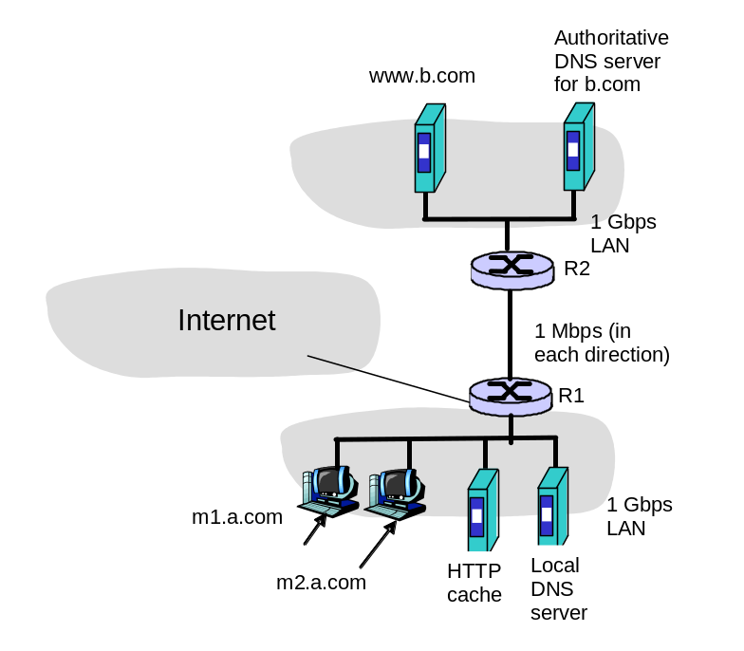Consider the networks shown in the figure below. There are two user machines m1.a.com and m2.a.com in the network a.com. Suppose the user at m1.a.com types in the URL www.b.com/bigfile.htm into a browser to retrieve a 1Gbit (1000 Mbit) file from www.b.com.

4.1. List the sequence of DNS and HTTP messages sent/received from/by m1.a.com as well as any other messages that leave/enter the a.com network that are not directly sent/received by m1.a.com from the point that the URL is entered into the browser until the file is completely received. Indicate the source and destination of each message. You can assume that every HTTP request by m1.a.com is first directed to the HTTP cache in a.com and that the cache is initially empty, and that all DNS requests are iterated queries.
- M1.a.com needs to resolve the name www.b.com to an IP address so it sends a DNS REQUEST message to its local DNS resolver.
- Local DNS server does not have any information so it contacts a root DNS server with a REQUEST message.
- Root DNS server returns name of DNS Top Level Domain server for .com.
- Local DNS server contacts .com TLD.
- TLD .com server returns authoritative name server for b.com .
- Local DNS server contacts authoritative name server for b.com.
- Authoritative name server for b.com returns IP address of www.b1.com..
- Local DNS server caches the DNS information; M1.a.com gets the information and knows that www.b.com’s IP address.
- HTTP client sends HTTP GET message to www.b1.com, which it sends to the HTTP cache in the a.com network.
- The HTTP cache does not find the requested document in its cache, so it sends the GET request to www.b.com.
- www.b.com receives the GET request.
- The 1 Gbit file is transmitted over the 1 Mbps link between R2 and R1.
- The 1Gbps file sends from R1 to the HTTP cache.
- Send the 1Gbps file from the HTTP cache to m1.a.com.
4.2. Now assume that machine m2.a.com makes a request to exactly the same URL that m1.a.com made. List the sequence of DNS and HTTP messages sent/received from/by m2.a.com as well as any other messages that leave/enter the a.com network that are not directly sent/received by m2.a.com from the point that the URL is entered into the browser until the file is completely received. Indicate the source and destination of each message. [Hint: make sure you consider caching here]
- m2.a.com needs to resolve the name www.b.com to an IP address so it sends a DNS REQUEST message to its local DNS resolver.
- The local DNS server looks in its cache and finds the IP address for www.b.com, since m1.a.com had just requested that that name be resolved, and returns the IP address to m2.b.com.
- HTTP client at m2.a.com sends HTTP GET message to www.b1.com, which it sends to the HTTP cache in the a.com network.
- The HTTP cache finds the requested document in its cache, so it sends a GET request with an If-Modified-Since to www.b.com.
- www.b.com receives the GET request. The document has not changed, so www.b.com sends a short HTTP REPLY message to the HTTP cache in a.com indicating that the cached copy is valid.
- Send the 1Gbps file from the HTTP cache to m2.a.com.

5． (Total: 14 points) Addressing, and following the data
Consider the simple network shown below:
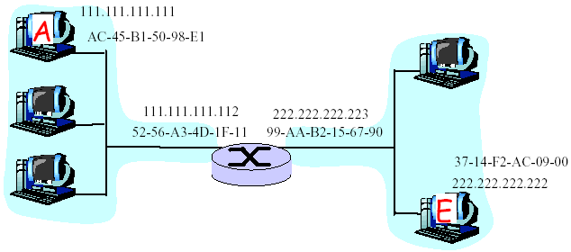
a) Write down an IP address for all interfaces at all hosts and routers in the network. The IP addresses for A and E are as given. You should assign IP addresses so that interfaces on the same network have the same network-part of their IP address. Indicate the number of bits in the network-part of this address.
If the network part of the address is 24 bits (/24), then all interfaces in the left network must be of the form 111.111.111.xxx, while the interfaces in the right part must be of the form 222.222.222.x
b) Choose physical addresses (LAN addresses) for only those interfaces on the path from A to E. Can these addresses be the same as in part a)? Why?
LAN addresses are 48 bits long and are very different from the 32bit IP addresses from part (a).
c) Now focus on the actions taken at both the network and data link layers at sender A, the intervening router, and destination E in moving an IP datagram from A to E:
1. How do A, E and the router determine the IP addresses needed for the IP datagram?
From their routing tables, which are computed via the routing algorithms.
2. What, specifically, are the addresses in the IP datagram that flows from A to the router?
Source: 111.111.111.111, destination: 222.222.222.222
What, specifically, are the addresses in the IP datagram that flows from the router to E.?
Source: 111.111.111.111, destination: 222.222.222.222
3. What are three other fields found in an IP datagram?
Hop count (TTL), upper layer protocol, options (see book/notes for others)
4. How do A, E and the router determine the physical (LAN) addresses needed for the data link layer frame?
Using the address resolution protocol (ARP)
d) Suppose that the router in the figure below is replaced by a bridge.
1. How would the IP addresses change in this case?
The IP addresses of A and E would have to have the same network part.
2. How would the physical (LAN) addresses change in this case?
They would stay the same in A and E.
3. How would does a learning bridge learn the physical addresses of the attached hosts.
When an attached host sent a frame through the bridge (e.g., arriving on interface x) the bridge would observe the LAN (physical) address of the sender, and then know that a host with that physical address was reachable via the interface (x) on which the original frame was received.
PART Ⅴ: (total: 6 points) About the labs.
Questions:
1. What is the whole name of the sender’s host? What is the user name of the sender?
sanfan.edu Alice
2. How many users does the sender want to send the E-mail?
3
3. What is the whole name of the receiver’s host?
umass.edu
4. Which users can receive the E-mail?
Bob Lucy
5. For receiving the mail, what is the port number waiting for the connection on the receiver host?
25
6. What is the name of the transport layer protocol?
TCP

