天津理工大学考试试卷答案
2006 ～ 2007 学年度第 2 学期
《计算机网络技术》 期末考试试卷答案

课程代码： 0600100 试卷编号： 1-A 命题日期： 2007 年 5 月 28 日
答题时限： 120 分钟 考试形式：闭卷笔试

得分统计表：
大题号  总分 | 一 | 二 | 三 | 四 | 五

PART Ⅰ: Choice (2 point per question – total: 20 points)
Instructions: Select one of the letters beside the choice that is the best answer for each question.
得分

Q | 1 | 2 | 3 | 4 | 5 | 6 | 7 | 8 | 9 | 10
A | B | D | B | C | B | C | B | A | C | A

1. Which of the following services does the Internet network layer provide for the Internet transport layer?
  - In-order delivery of data segments between processes
  - Best effort delivery of data segments between communicating hosts
  - Multiplexing and demultiplexing of transport layer segments
  - Congestion control
2. The main task of the Internet’s Domain Name System (DNS) is to:
- Translate port numbers to IP addresses
- Specify the standards for Internet domain names
- Provide an authority for registering domain names
- Translate mnemonic（记忆的） names to IP addresses
3. The maximum transfer unit(MTU) in Ethernet frame structure is ( )byte .
A. 1000
B. 1500
C. 800
D. 2000
4. Which is not plug and play in the following four items? ( )
A. DHCP
B. Hubs
C. Routers
D. Switches
5. Which of characters is not distance-vector algorithm’s characters？（ ）
A. iterative
B. global
C. asynchronous
D. distributed
6. The header of IPV6 is （ ）byte.
A. 80
B. 60
C. 40
D. 20
7. Two important reasons that the Internet is organized as a hierarchy of networks for the purposes of routing are:
- Least cost and maximum free circuit availability
- Scale and administrative autonomy
- Message complexity and speed of convergence
- Link cost changes and link failure
8. The host component of a CIDR address of the form a.b.c.d/22 can contain addresses for:
- 2⁽³²⁻²²⁾ hosts (minus “special” hosts)
- 512 hosts (minus “special” hosts)
- d times 22 hosts
- 10 hosts (minus “special” hosts)
9. The primary function of the address resolution protocol (ARP) that resides in Internet hosts and routers is:
- To provide LAN router functions
- To translate between LAN addresses and physical interface addresses
- To translate IP addresses to LAN addresses
- To calculate the shortest path between two nodes on a LAN
10. The FTP protocol runs over ____ and uses port ____.
A. TCP 21
B. TCP 80
C. UDP 20
D. TCP 110
PART Ⅱ: Briefly answer the following questions. (Total: 28 points)．
得分

1．(1points) Why is there a Web cache?
答：减少接入网络的流量、减小延迟

2．(2points) Please briefly describe the function of the five layers in TCP/IP architecture
(NOTE: include the protocol data unit)
答：
1．应用层，提供各种网络应用，运行网络应用程序。Message。
2．运输层，提供端到端进程之间的数据传输。Segment。
3．网络层，主机到主机的传输。Datagram
4．链路层，相邻节电数据传输，frame
5．物理层，透明传输比特流，bit stream.
3. (2points) What are the services of TCP?
答：
connection-oriented service
reliable, in-order byte-stream data transfer
flow control:
congestion control:

4. (2points) Please briefly compare: datagram network versus virtual circuit (VC) network.
答：数据报网络是面向非连接的服务，不可靠的服务，没有流量控制和拥塞控制。
虚电路网络是面向连接的网络，可以提供可靠的传输服务，具有流量控制和拥塞控制。

5. (2points) What is the difference between routing and forwarding?
答：Forwarding is about moving a packet from a router’s input link to the appropriate output link. Routing is about determining the end-to-routes between sources and destinations.

6. (3points) How big is MAC address space? The IPv4 address space? The IPv6 address space?
答：MAC: 2⁴⁸，IPv4：2³²；IPv6：2¹²⁸

7. (4points) Fill in the blank:
1) RIP advertisements typically announce the number of ( hops ) to various destinations.
2) BGP updates announce the ( ASs ) to various destinations
3) For Selective Repeat protocol, sequence number space >=( 2 )times window size.
4) The efficiency of Slotted ALOHA =( 2 ) times bigger than Pure ALOHA.

8. (2points)Consider sending M packets over a path of N links. Assume that each packet has L bits. Each link transmits at R bps. The network is lightly loaded so that there are no queuing delays. Propagation delay and node processing delay are negligible. Suppose the network is a packet-switched datagram network and a connectionless service is used. Now suppose each packet has 2h bits of header. How long does it take to send the packet? (all packets go through the same path)
答： (N+M-1)*((L + 2h) / R
9.(2points)If all the links in the Internet were to provide the reliable delivery service, would the TCP reliable delivery service be redundant? Why or Why not?
答: Although each link guarantees that an IP datagram sent over the link will be received at the other end of the link without errors, it is not guaranteed that IP datagrams will arrive at the ultimate destination in the proper order. With IP, datagrams in the same TCP connection can take different routes in the network, and therefore arrive out of order. TCP is still needed to provide the receiving end of the application the byte stream in the correct order. Also, IP can lose packets due to routing loops or equipment failures.
10. (Total 4 points)CDMA
Suppose that four nodes using CDMA (Code Division Multiple Access) protocol to transport their data. The chipping sequences are listed respectively as below:
A: (-1,–1,–1,+1,+1,–1,+1,+1)
B: (-1,–1,+1,–1,+1,+1,+1,-1)
C: (-1,+1,–1,+1,+1,+1,–1,-1)
D: (-1, +1,–1, –1,–1,–1, +1,-1)
(Computing process is needless)
Suppose that a CDMA receiver has received an encoded data as (-1,+1,-3,+1,-1,-3,+1,+1) from an aggregate signal channel in one bit-slot time, which node/nodes has/have sent data? What’s the corresponding data bit each of them sent? (3points)
Answer: A and D send 1, B sends 0, C sends nothing.
11.(2points) In the figure below, H1 remains in same IP subnet, briefly describe how the switch would know which AP is associated with H1 when H1 is moving within BSS1 and BSS2.
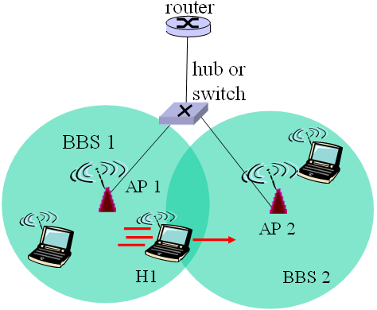
Answer: self-learning: switch will see frame from H1 and remember which switch port can be used to reach H1
12. (2points) This question is about the “GSM: handoff with common MSC”. According to the figure below, ordering the 8 steps.
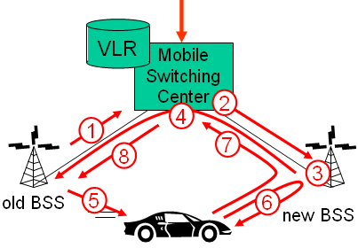
A. Old BSS informs MSC of impending handoff, provides list of 1⁺ new BSSs
B. Old BSS tells mobile: perform handoff to new BSS
C. New BSS allocates radio channel for use by mobile
D. New BSS signals MSC, old BSS: ready
E. MSC sets up path (allocates resources) to new BSS
F. MSC-old BSS resources released
G. Mobile signals via new BSS to MSC: handoff complete. MSC reroutes call
H. Mobile, new BSS signal to activate new channel
Answer: AECDBHGF

PART Ⅲ: Answer the following questions. (Total: 22 points)．
得分

1．(10points)Consider the following network. With the indicated link costs, use Dijkstra’s shortest-path algorithm to compute the shortest path from x to all network node. While selecting the next node, if several nodes have the same min cost, select the one with lowest id, (e.g., if x and y have the same min cost, then select x).
1
x
y
w
v
z
t
u
s
1
3
1
6
14
2
4
9
3
2
1
4
1

Step | N’ | D(s),p(s) | D(t),p(t) | D(u),p(u) | D(v),p(v) | D(w),p(w) | D(y),p(y) | D(z),p(z)
0
1
2
3
4
5
6

To complete the routing table of node x

Destination | Next Node | Cost
s | w | 6
t
u
v
w
y
z

答：
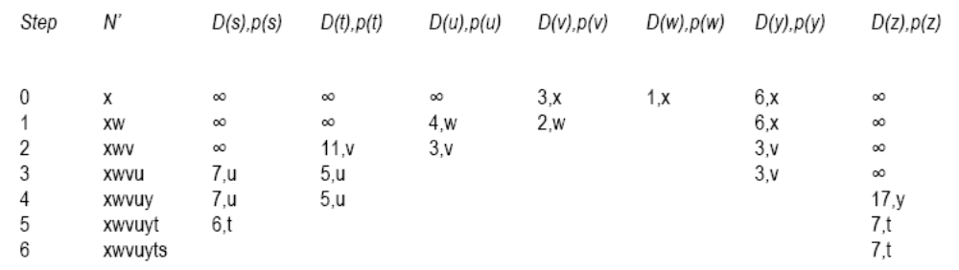
Destination | Next Node | Cost
s | w | 6
t | w | 5
u | w | 3
v | w | 2
w | w | 1
y | w | 3
z | w | 7

2. (9points)Consider the following plot of TCP window size as a function of time.
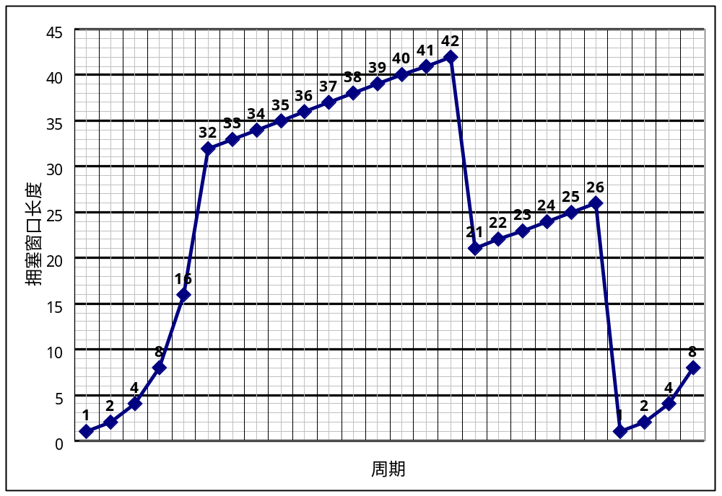Assuming TCP Reno is protocol experiencing the behavior show above, answer the following question.
    - Identify the intervals of time when TCP slow start is operating.
    - Identify the intervals of time when TCP congestion avoidances is operating.
    - After the 16th transmission round, is segment loss detected by a triple duplicate ACK or by a timeout?
    - After the 22nd transmission round, is segment loss detected by a triple duplicate ACK or by a timeout?
    - What is the initial value of Threshold an the first transmission round?
    - What is the value of Threshold an the 18th transmission round?
    - What is the value of Threshold an the 24th transmission round?
    - During what transmission round is the 70th segment sent?
    - Assuming a packet loss is detected after the 26th round by the receipt of a triple duplicate ACK, what will be the values of the congestion-window size and of Threshold?
Answer:
a) TCP slowstart is operating in the intervals [1,6] and [23,26]
b) TCP congestion avoidance is operating in the intervals [6,16] and [17,22]
c) After the 16th transmission round, packet loss is recognized by a triple duplicate ACK. If there was a timeout, the congestion window size would have dropped to 1.
d) After the 22nd transmission round, segment loss is detected due to timeout, and hence the congestion window size is set to 1.
e) The threshold is initially 32, since it is at this window size that slowtart stops and congestion avoidance begins.
f) The threshold is set to half the value of the congestion window when packet loss is detected. When loss is detected during transmission round 16, the congestion windows size is 42. Hence the threshold is 21 during the 18th transmission round.
g) The threshold is set to half the value of the congestion window when packet loss is detected. When loss is detected during transmission round 16, the congestion windows size is 42. Hence the threshold is 21 during the 18th transmission round.

h) During the 1st transmission round, packet 1 is sent; packet 2-3 are sent in the 2nd transmission round; packets 4-7 are sent in the 3rd transmission round; packets 8-15 are sent in the 4th transmission round; packets15-31 are sent in the 5th transmission round; packets 32-63 are sent in the 6th transmission round; packets 64 – 96 are sent in the 7th transmission round. Thus packet 70 is sent in the 7th transmission round.
i) The congestion window and threshold will be set to half the current value of the congestion window (8) when the loss occurred. Thus the new values of the threshold and window will be 4.

3. (3points)Consider the three-node topology show below. Compute the distance tables of node x after the first iteration of a synchronous version of the distance vector algorithm.
x
y
z
2
5
6

答：
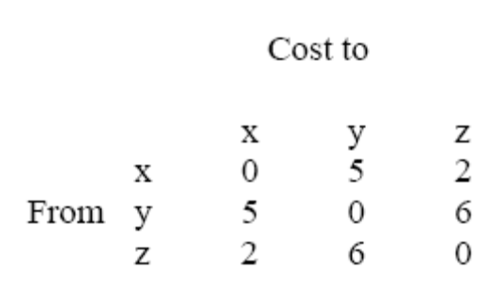

PART Ⅳ: Compositive questions. (Total: 30 points)
得分
The questions are based on the figure below. Each question is worth 1 point except Q17.Total 30 points.
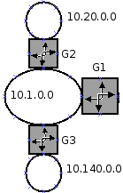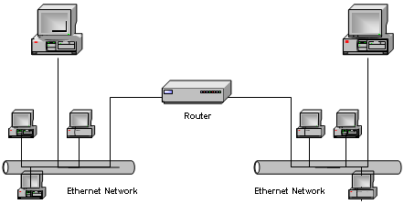
Internet
A small office network
A
B
C
D
E
F
G
H
R1
R2
Consider the small office network with 3 subnets and 3 gateways. The IP address of the ISP (Internet Service Provider) gateway is 64.28.10.1 and the IP addresses of the corporate gateways are:
G1: 10.1.1.1 and 64.28.10.7
G2: 10.1.1.2 and 10.20.0.1
G3: 10.1.1.3 and 10.140.0.1

Q1：According to the small office network, an Intranet must be a part of the Internet mainly used by a specific group of users.
A. true B. false

Q2. Request For Comments (RFC) are documents used to describe protocols like TCP and IP.
A. true B. false

Q3：The gateway G1 needs to have a NAT module to give access to the Internet to users on the small office network.
A. True B. False
Q4. Because the class C network 192.168.20.0 have only one byte for hosts addresses, you cannot use it to define subnets.
A. true B. false

Q5：The small office replaces its old wired Ethernet network by a brand new wireless Ethernet network. Which of the 4 layers of the TCP/IP stacks of the office computers will need to be upgraded?
A. only the application layer
B. only the physical layer
C. only the internet layer
D. both the internet and the physical layer
Q6：Consider the following partial (部分的) routing table of G1:
Kernel IP routing table
Destination Gateway Genmask Flags MSS Window irtt Iface
10.1.0.0 10.1.1.1 255.255.0.0 U 0 0 0 eth0
0.0.0.0 64.28.10.1 0.0.0.0 UG 0 0 0 eth1

Using the above routing table format, write the route for the destination network 10.20.0.0.
Answer:10.20.0.0 10.1.1.2 255.255.255.0 UG 0 0 0 eth0
Q7：In the same context as Q3, write the loopback route.
Answer:127.0.0.0 127.0.0.1 255.0.0.0 UH 0 0 0 L0
Q8：What happens on an Ethernet shared network if stations A and B both start transmitting at the same instant?
A. B will sense the transmission and wait a certain delay before another try
B. a collision will be detected in some reasonable time
C. A will sense the transmission and wait a certain delay before another try
D. each will transmit on its own channel

Q9：A TCP port is used
A. for multiplexing application data
B. to ensure a reliable connection oriented transmission
C. to keep track of connections in a NAT module
D. all of the above

Now we assume that A wants the service from the WEB server E.

Q10：A makes a web access by URL. What is the completed format of URL?
Answer: 协议://域名：端口号/路径/文件名
Q11：HTTP uses TCP rather than UDP. Why?
Answer: HTTP需要可靠数据传输。Web服务是不允许有数据丢失，使用弹性带宽，时间不敏感的。
Q12：Since TCP does not work with hostnames and also would not know how to find the HTTP server program at E, TCP must know
A. 32-bits IP address
B. 16-bits Port #
C. 48-bits MAC address
D. both A and B
E. All of the A, B and C

Q13：The translation of E’s hostname into an IP address is done via a database lookup. The distributed database used is called the Domain Name System (DNS).The Time To Live (TTL) parameter is used to limit the time devoted to a DNS name resolution request.
A. true B. false

Q14：A can deliver the IP datagram directly to E, only if it is on the same local network (“subnet”). But A and E are not on the same local network. How does A know this?
Answer: IP地址的网络地址部分不同。
Q15：To send an IP datagram to Router, A puts the IP datagram in an Ethernet frame, and transmits the frame. Ethernet uses different addresses, so-called Media Access Control (MAC) addresses. So A must first translate the IP address of the router into a MAC address by ARP. Briefly describe how the ARP translates the IP address into MAC address.
Answer: A broadcast the ARP request to all nodes in the same subnet with the IP address. The node who have the IP address unicast the response to A with its MAC address.
Q16：Let us look in detail at the Ethernet frame between A and the Router, which contains the TCP connection request to E. This is the frame in hexadecimal notation.
00e0 f923 a820 00a0 2471 e444 0800 4500 002c 9d08 4000 8006 8bff 808f 8990 808f 4715 065b 0050 0009 465b 0000 0000 6002 2000 598e 0000 0204 05b4
Fill in the blanks marked with A to J in the table.(Total 10,1 per row)
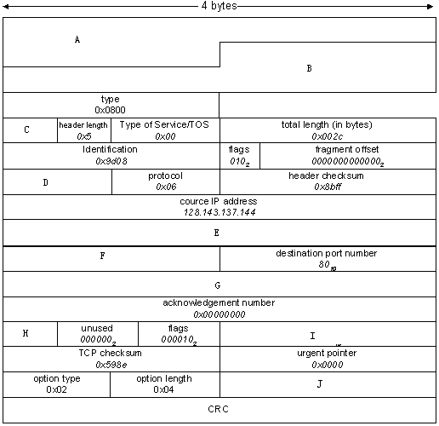
Answer:
Mark | Header field name  In English or short | value
A | Destination MAC Address | 00-e0-f9-23- a8-20 | Hex
B | Source MAC Address | 00-a0-24-71-e4-44 | Hex
C | Version | 4 | Hex
D | Time to Live (TTL) | 80 | Hex
E | Destination IP address | 128.143.71.21 | Decimal
F | Source Port Number | 1627 | Decimal
G | Sequence Number | 0009 465B | Hex
H | Header Length | 6 | Hex
I | Window Size | 8192 | Decimal
J | Maximum Segment Size(MSS) | 1460 | Decimal
Q17：Ordering the flowing steps of sending datagram from A to E via R. Assume A knows E IP address.
①A creates datagram with source A, destination E
②A uses ARP to get R’s MAC address
③A creates link-layer frame with R's MAC address as destination, frame contains A-to-E IP datagram
④A’s adapter sends frame
⑤R’s adapter receives frame
⑥R removes IP datagram from Ethernet frame, sees it’s destined to E
⑦R creates frame containing A-to-E IP datagram sends to E
⑧R uses ARP to get E’s MAC address
Answer: ①②③④⑤⑥⑧⑦
Q18：According to Q17, why the application data field in the Ethernet frame is empty?
Answer: It’s the first step of 3-way handshaking of TCP connection request.
Q19：In the Ethernet, we use the CSMA/CD, if A’s adapter detects another transmission while transmitting, aborts and sends jam signal. After aborting, adapter enters exponential backoff. Briefly describe, what’s the exponential backoff in CSMA/CD.
Answer: after the nth collision, adapter chooses a K at random from
{0,1,2,…,2m-1},m=min{n,10}. Adapter waits K·512 bit times .
Q20：If G2 is an Ethernet switch, it will take self-learning, filtering and forwarding. Fill in the blank.
When switch receives a frame
Index switch table using MAC destination address
If entry found for destination
Then {
If destination on segment from which frame arrived
Then ①
Else forward the frame on interface indicated
}
Else ②
Answer: ①: Forward the frame on interface indicated
②: Flood
Q21：In the figure below, the wrong pointer # is
A. 0 B. 1 C. 2 D. more than 3
