1. Consider the following plot of TCP window size as a function of time.
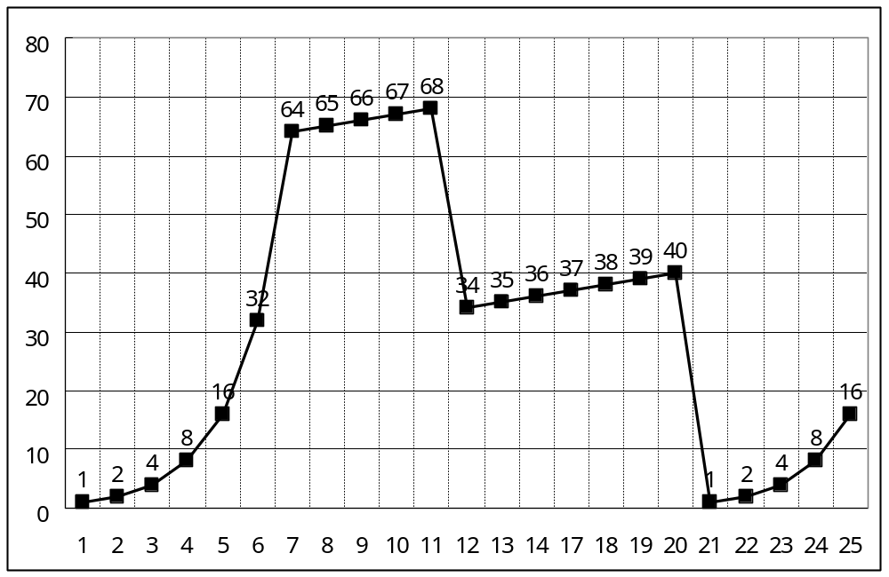
Assuming TCP Reno is protocol experiencing the behavior show above, answer the following question.
- Identify the intervals of time when TCP slow start is operating.
- Identify the intervals of time when TCP congestion avoidances is operating.
- After the 11th transmission round, is segment loss detected by a triple duplicate ACK or by a timeout?
- After the 20th transmission round, is segment loss detected by a triple duplicate ACK or by a timeout?
- What is the initial value of Threshold at the first transmission round?
- What is the value of Threshold at the 18th transmission round?
- What is the value of Threshold at the 24th transmission round?
- During what transmission round is the 70th segment sent?
- Assuming a packet loss is detected after the 25th round by the receipt of a triple duplicate ACK, what will be the values of the congestion-window size and of Threshold?

2. Consider the following plot of TCP Reno window size as a function of time.
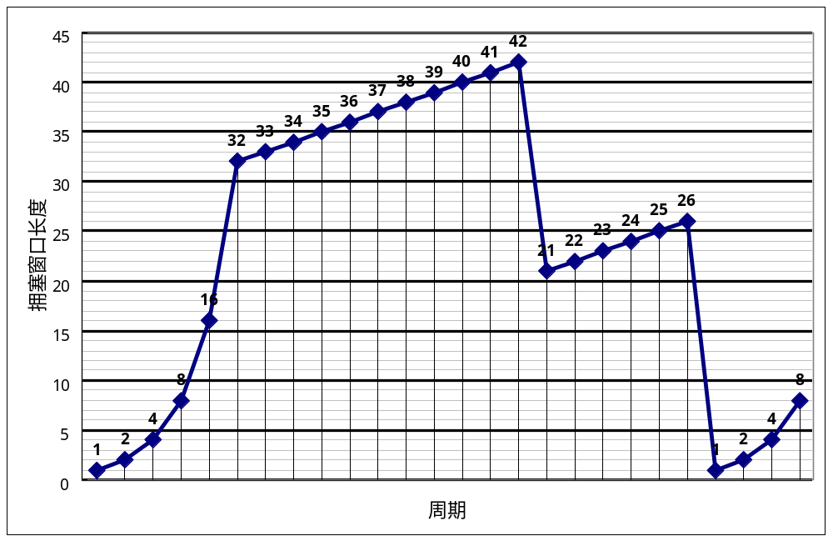
6
16
22
26
1
Transmission round
Congestion window size (segments)
    - Identify the intervals of time when TCP slow start is operating.
    - Identify the intervals of time when TCP congestion avoidances is operating.
    - After the 16th transmission round, is segment loss detected by a triple duplicate ACK or by a timeout?
    - After the 22nd transmission round, is segment loss detected by a triple duplicate ACK or by a timeout?
    - What is the initial value of Threshold in the first transmission round?
    - What is the value of Threshold in the 18th transmission round?
    - What is the value of Threshold in the 24th transmission round?
    - During what transmission round is the 70th segment sent?
    - Assuming a packet loss is detected after the 26th round by the receipt of a triple duplicate ACK, what will be the values of the congestion-window size and of Threshold?

答：
1 | 2 | 3 | 4 | 5 | 6 | 7 | 8 | 9
[1,6]  [23,26] | [6,16]  [17,22] | 3重复ACK | 超时 | 32 | 21 | 13 | 7th | 4 | 4

subsidiaries（子公司） are located in four places. The network structure is shown in the following figure. The3. A company headquarters (总部) and corporate headquarters has 50 hosts, subsidiary A has 25 hosts, subsidiary B has 10 hosts, and subsidiary C has 10 hosts. B and C are come from same subnet. If the company address block is 202.119.110.0/24, fill the cell ① ~ ⑥ with the host IP address or subnet mask in the following table.
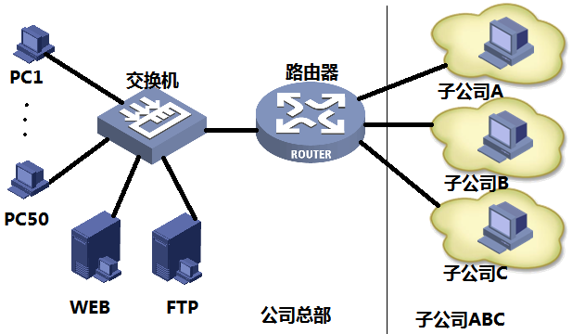
 | Range of Hosts IP addresses | Subnet Mask
headquarters | 202.119.110.129~202.119.110.① | 255.255.255.192
subsidiary A | 202.119.110.②~202.119.110.94 | 255.255.255.③
subsidiary B | 202.119.110.97~202.119.110.④ | 255.255.255.240
subsidiary C | 202.119.110.⑤~202.119.110.⑥ | 255.255.255.240

答：
No. | Value
① | 190
② | 65
③ | 224
④ | 110
⑤ | 113
⑥ | 126
计算过程：
- 主机数最多的子网有50个主机，因此取出主机最高2位（第25，26位），可划分成4个子网（00，01，10，11），每个子网可容纳2的6次方-2=62台主机。
- 总部取10子网，子网掩码为255.255.255.192（11000000）。主机地址范围为：
202．119．110．129（10 000001）
…….
202．119．110．190（10 111110）
- 子公司A只有25台主机，因此取01子网中1位（第27位）再次进行划分，划分成010，011两个子网，每个子网可容纳2的5次方-2=30台主机。子网掩码为255.255.255.224（11100000）。子公司A取010子网，主机地址范围为：
202．119．110．65（010 00001）
…….
202．119．110．94（010 11110）
4) 子公司B和C只有10台主机，因此可取011子网中1位（第28位）进行再次划分，划分成0110，0111两个子网。每个子网可容纳2的4次方-2=14台主机。子网掩码为255.255.255.240（11110000）。
子公司B取0110子网，主机地址范围为：
202．119．110．97（0110 0001）
…….
202．119．110．110（0110 1110）
子公司C取0111子网，主机地址范围为：
202．119．110．113（0111 0001）
…….
202．119．110．126（0111 1110）

4. The figure below shows a network with three routers and five hosts. The administrator of the network has assigned two subnet masks 192:168:1:0/29 and 192:168:2:0/30 to the Router 1. Router 2 can use three subnet masks 192:168:2:0/30, 192:168:3:0/30, and 192:168:4:0/30. Router 3 can use two subnet masks 192:168:4:0/30 and 192:168:5:0/29.
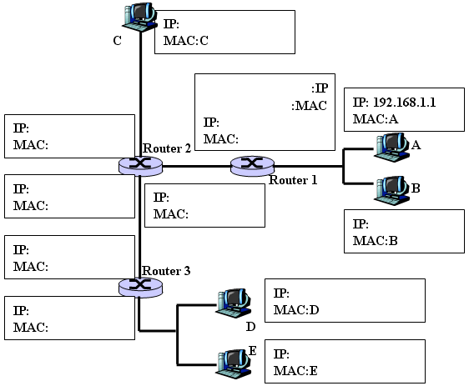
A computer network with 3 routers and 5 hosts.

Q1. Assign missing IP addresses (hosts and routers interfaces). Write your answer in the figure.
Q2. Assume that the MAC addresses of Router i are 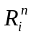 , n∈{1,2…}, (For example, Router 1 has two MAC addresses 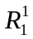 and 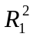). Assign the missing MAC addresses for all the routers. Write your answer in the figure.
Q3. Assume that the ARP tables in D and E are empty. Host D wants to send a packet to host C, and host E wants to send a packet to host A. Explain how the ARP tables of these two hosts should be updated.
Q4. Now assume that all ARP tables are up to date and host A wants to send an IP datagram to host C. Enumerate all the steps that should be taken to send this datagram. Please write the IP and MAC addresses of datagram and frames in routers and host.
Q5: Consider sending a 1500-bytes datagram into a link that has an MTU of 500 bytes. Suppose the original datagram is stamped with the identification number X. (Hint: The IPv4 header is 20bytes long.)
Q5a. Where does fragmentation happen? Where are the fragments reassembled?
Q5b. How many fragments are generated?
Q5c. In addition to the identification number, what are the fields in the generated IP datagram(s) that are related to fragmentation?
Q5d. What are the values of the fragmentation-related fields in the generated IP datagram(s)?
Q5e. What changes if IPv6 were used?
Q6. Assume that hosts A and E have a TCP connection established. Why does host A NOT directly use the MAC (LAN) address of host E when constructing its packets to send to host E?
Q7. An Ethernet V2 frame has 8 bytes preamble. What is the purpose of this preamble?

答
Q1 and Q2
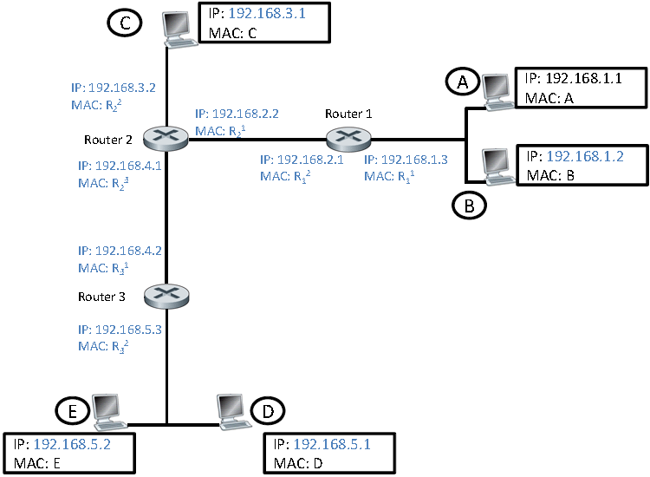
Q3. ARP in host E or D must determine the MAC address of 192.168.5.3. Host E sends out an ARP query packet within a broadcast Ethernet frame. Router 3 receives the query packet and sends to host E an ARP response packet. This ARP response packet is carried by an Ethernet frame with Ethernet destination address E. Host D does the same thing.
Q4.
(a) Datagram at host A: should be sent to 192.168.1.3
(b) Ethernet packet made at host A: destination MAC address
(c) Router 1 determines that the datagram should be forwarded to 192.168.2.2
(d) Router 1 makes an Ethernet packet with destination address .
(e) Router 2 determine that the datagram should be delivered to C.
(f) Router 2 makes an Ethernet packet with destination MAC address C.
Q5a. Fragmentation happens in the router preceding the link with the small MTU. The fragments are reassembled in the end system.
Q5b. The maximum size of the data field in each fragment = 480 (because there are 20 bytes IP header). Thus the number of required fragments =（1500-20）/480= 4.
Q5c. Flag and fragmentation offset.
Q5d. Each fragment will have an identical identification number. Each fragment except the last one will be of size 500 bytes (including the IP header). The last datagram will be of size 60 bytes (including the IP header). The offsets of the 4 fragments will be 0, 60, 120, 180. Each of the first 3 fragments will have flag=1; the last fragment will have flag=0.
Q5e. The router preceding the link with the small MTU will drop the packet and send an ICMP error message “Packet Too Big” back to the source. The source is responsible for adjusting the packet size.
Q6. Host A has no way of knowing the MAC address of host E on the other side of a router. A router does not pass broadcast ARP frames. In any case, the MAC address of the router port connecting host A’s LAN to host E’s LAN must be used to forward an A-to-E packet through the router. If some other MAC address (e.g., that of host E) were used, routing would not take place.
Q7. This preamble serves to delimit the frame for the receiving adapter. Specifically, the purpose of the preamble is to synchronize the receiver’s clock with the sender’s clock for the receipt of the frame.

5. The figure below shows a network with three routers and 7 hosts.
Q1. The administrator of the network has assigned three subnet masks 192.168.1.0/30,192.168.2.0/30and 192.168.3.0/30 to the Router 1, two subnet masks 192.168.2.0/30and 192.168.4.0/30 to Router 2, two subnet masks 192.168.3.0/30 and 192.168.5.0/30 to Router 3. Please assign IP addresses (all hosts and all routers interfaces). Write your answer in the figure.
R1
R2
R3

Q2. Write the functions of the following commands for assigning R1 on the lines.
<H3C>system-view
System View: return to User View with Ctrl+Z.
[H3C]sysname R1
[R1]interface e0/0
[R1-Ethernet0/0]ip address 192.168.1.1 255.255.255.252
----------------------------------------------------------------------------------------
[R1-Ethernet0/0]interface s1/0
[R1-Serial1/0]ip address 192.168.2.1 255.255.255.252
----------------------------------------------------------------------------------------
[R1-Serial1/0]ping 192.168.1.1
----------------------------------------------------------------------------------------
[R1-Serial1/0]quit
[R1]interface s2/0
[R1-Serial2/0]ip address 192.168.3.1 255.255.255.252
[R1-Serial2/0]ping 192.168.2.1
[R1-Serial2/0]quit
[R1] ip route-static 192.168.1.0 255.255.255.252. 192.168.2.1
---------------------------------------------------------------------------------------
[R1] ip route-static 192.168.3.0 255.255.255.252. 192.168.2.1
----------------------------------------------------------------------------------------

6. According to the following network’s topology with the indicated link costs, use Dijkstra’s shortest-path algorithm to compute the shortest path from x to all other nodes. While selecting the next node, if several nodes have the same min cost, select the one with lowest id, (e.g., if A and B have the same min cost, then select A).

3
x
y
w
v
z
t
u
s
1
3
1
6
10
2
4
9
3
2
1
4
1

1) Complete the routing table of node x.

Destination | Next Node | Cost
s | w | 7
t
u
v
w | w | 1
y
z

答：
Destination | Next Node | Cost
s | w | 7
t | w | 6
u | w | 4
v | w | 2
w | w | 1
y | w | 3
z | w | 8

2) Consider sending a 1500-bytes datagram into a link that has an MTU of 500 bytes. Suppose the original datagram is stamped with the identification (ID)number X (Hint: The IPv4 header is 20bytes long). How many fragments are generated? What are the values of the fragmentation-related fields in the generated IP datagram(s)?

答：The maximum size of the data field in each fragment = 480 (because there are 20 bytes IP header). Thus the number of required
fragments =（1500-20）/480= 4.
Each fragment will have an identical identification number. Each fragment except the last one will be of size 500 bytes (including the IP header). The last datagram will be of size 60 bytes. The offsets of the 4 fragments will be 0, 60, 120, 180. The fragflags of the 4 fragments will be 1, 1, 1, 0.

7. (total: 15 points) Consider the network shown below. Run Dijkstra’s algorithm to compute the shortest paths from A to all other nodes in the network. While selecting the next node, if several nodes have the same min cost, select the one with lowest id, (e.g., if B and D have the same min cost, then select B).
A
D
B
C
E
4
1
3
5
3
1
3
K
M
J
F
G
H
I
L
2
4
6
2
3
2
3
2
7
3
2
4
5

Determine the routing table (destination, next-node, and cost) at node A.

Destination | Next Node | Cost
B | B | 4
C
D
E
F
G
I
J
K
L
M

8．Configure the static route for the middle router travel to 10.0.1.0/24 and 10.0.5.0/24. Write the commands.
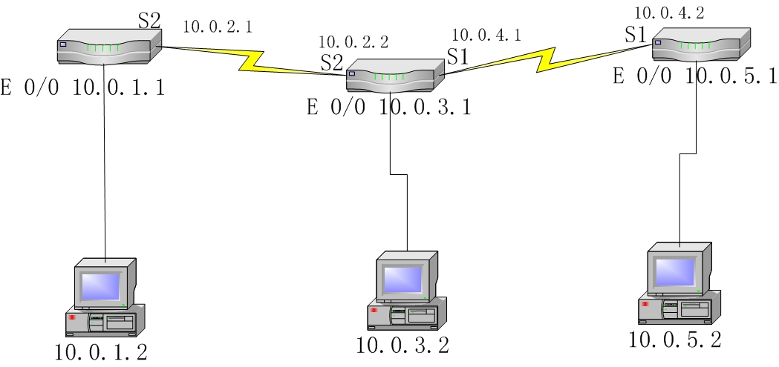
- To 10.0.1.0/24

- To 10.0.5.0/24

答：To 10.0.1.0/24
ip route-static 10.0.1.0 255.255.255.0 10.0.2.1

To 10.0.5.0/24
ip route-static 10.0.5.0 255.255. 255.0 10.0.4.2

9．The following transcript is a mail transfer session between hosts A and B using TCP/IP. According to the session, answer the questions.
A: 220 nankai.edu.cn simple mail transfer service ready
B: HELO tjut.edu.cn
A: 250 nankai.edu.cn Hello tjut.edu.cn, please to meet you
B: MAIL FROM: <sunny@tjut.edu.cn>
A: 250 mail accepted
B: RCPT TO: <bob@nankai.edu.cn>
A: 250 recipient accepted
B: RCPT TO: <tom@nankai.edu.cn>
A: 550 no such user here
B: RCPT TO: <alice@nankai.edu.cn>
A: 250 recipient accepted
B: DATA
A: 354 start mail input; end with <CR><LF>.<CR><LF>
B: Date: Sat 14 June 2003 13:26:31 BJ
B: From: sunny@tjut.edu.cn
B: . . . . . .
B: . . . . . .
B: .
A: 250 OK
B: QUIT
A: 221 nankai.edu.cn service closing transmission channel.
Questions:
Q1. What is the whole name of the sender’s host?
nankai.edu.cn
Q2. What is the user name of the sender?
sunny
Q 3. What is the whole name of the receiver’s host?
tjut.edu.cn
Q 4. How many users does the sender want to send the E-mail?
3
Q 5. What is the name of the transport layer protocol?
TCP
Q 6. Which users can not receive the E-mail?
tom
Q 7. For receiving the mail, what is the port number waiting for the connection on the receiver host?
25
Q 8. What does the SMTP mean?
Simple Message Transfer Protocol

10．The diagram below is the 5-layer TCP/IP model. Select the layer name (from A to E) , the layer function from (1 to 5) and the protocols (from a to e) to each layer (30 points)

Layer | Layer Name | Function | Protocols
5
4
3
2
1

A. physical layer B. link layer C. network layer D. transport layer E. application layer
1. supporting network applications 2. process-process data transfer 3. routing of datagrams from source to destination 4. data transfer between neighboring network elements 5. bits on the wire
a. HTTP b. SMTP c. DNS d. TCP e. UDP

Layer | Layer Name | Function | Protocols
5 | E | 1 | a b c
4 | D | 2 | d e
3 | C | 3
2 | B | 4
1 | A | 5

11．Describe the operation process of http://www.baidu.com . Explain how protocols of each layer of TCP/IP work.

简答题：
1．Explain how CSMA/CD works.
2. Draw the “3-way handshaking” figure, including SYN, ACK flags and seq#, ack#.
3．Explain the difference between TCP and UDP.
4．Explain the names and the main functions of TCP/IP five layer protocols.
5．Where can queuing occur in a router? Briefly explain the conditions that lead to such queuing.
6．Why is an ARP query sent within a broadcast frame? Why is an ARP response sent within a frame with a specific destination MAC address?
7．What is the difference between routing and forwarding?
8．Explain the difference between go-back-N and selective repeat.
9．Please describe switcher’s frame filtering/forwarding function, and describe its self-learning function.
10. Briefly describe the DNS query process.
11. Briefly describe TCP ACK generation mechanism.
12. Briefly describe Network Address Translation.

