**Acoustic & speech & signal processing顶会顶刊**

顶刊

APPLIED ACOUSTICS

Signal Processing Letters

IEEE Transactions on Audio Speech and Language Processing

Signal Processing

顶会

ICASSP

INTERSPEECH

WASPAA

IWNEAC

**Database**

Free internet databases

* [**Freesound**](https://freesound.org/browse/): crowdsourcing database

([ref-Freesound: a Platform for the Creation of Open Audio Datasets](database%20research/Freesound_ISMIR2017.pdf), ISMIR2017, citation 73)

优：数据量大；是很多dataset的母数据库

缺点：众包导致音频质量参差不齐；

* [**SoundBible**](http://soundbible.com/)
* [**UrbanSound & UrbanSound8K**](https://urbansounddataset.weebly.com/urbansound8k.html)**: urban sound taxonomy, with baseline**

(ref-[A Dataset and Taxonomy for Urban Sound Research](database%20research/Sound8K_ACMMM2014.pdf), ACM MM2014)

1. 4 top level groups: human, nature, **mechanical**, music
2. 10 low level classes: … gun shot …
3. Based on Freesound
4. UrbanSound8K: a subset of short audios (4s is enough for source identification)
5. Baseline对于纯gunshot的正确率在90%左右（MFCC+SVM）

优：有专门gunshot一类

缺点：基于Freesound

By google

* [**AudioSet**](https://research.google.com/audioset/dataset/gunshot_gunfire.html) **with baseline system**

([ref-AudioSet: an Ontology and Human-labeled Dataset for Audio Events, ICASSP2017, citation 599)](database%20research/Audioset_ICASSP2017.pdf)

1. video + audio

优：数据量最大

缺点：基于视频，需要视音频分离；AudioSet给出的只是Youtube ID；

Challenge

* [**DCASE2016**](http://www.cs.tut.fi/sgn/arg/dcase2016/) **with baseline system (MatLab implementation) & ranking**

1. Acoustic scene classification (TUT Acoustic **Scenes**2016)
2. Sound event detection in synthetic audio (Task2)
3. Sound event detection in real life audio (TUT Sound **Events**2016)

([ref-TUT Database for Acoustic Scene Classification and Sound Event Detection](database%20research/TUT_EUSIPCO2016.pdf))

1. Domestic audio tagging: home activity (CHiME-Home)

优：拾取工具较统一

缺点：综合性

* [**TRECVID**](https://www-nlpir.nist.gov/projects/trecvid/)**: multimedia event detection**

1. video + audio

缺点：需要音视频分离

* [**ESC**](https://dataverse.harvard.edu/dataset.xhtml?persistentId=doi:10.7910/DVN/YDEPUT)**: environmental sound**

([ref-ESC: Dataset for Environmental Sound Classification](database%20research/esc_ACM%20MM2015.pdf))

1. Constructed from Freesound sound clips

缺点：基于Freesound

**Related works**

**Urban Sound Event Classification-local & global feature, Jo. Applied Acoustics2017**

**(ref-Urban Sound Event Classification Based on Local and Global Features Aggregation)**

**Urban sound event -跑分**

**UrbanSound baseline**

MFCC + SVM_rbf

70%左右，针对gunshot有90%以上

**Urban Sound Event Classification-local & global feature, Jo. Applied Acoustics2017**

Local & global feature -> Mixture of Expert (feature fusion scheme) -> (f_local,f_global)

mean Average Precision(mAP) = 77.36%

**Event detection: state-of-the-art & pipelines**

**Motivation**

1. **与现有的声学事件检测pipeline相比（需要调研），我们针对枪声，长处在哪里，因为general acoustic event detection也可以检测枪声非枪声？**
2. **特别对对单纯gunshot的分辨能力很强，针对gunshot已经正确率达到90%以上;**

**可以针对emergency事件做文章，系统针对emergency事件进行检测，单纯的枪击检测过于侠义**[**(ref-Urban Sound Event Classification Based on Local and Global Features Aggregation)**](跑分/1-s2.0-S0003682X16302274-main.pdf) **-》 做acoustic scene classification(emergency)**

**VS**

**sound events detection(gunshot)** 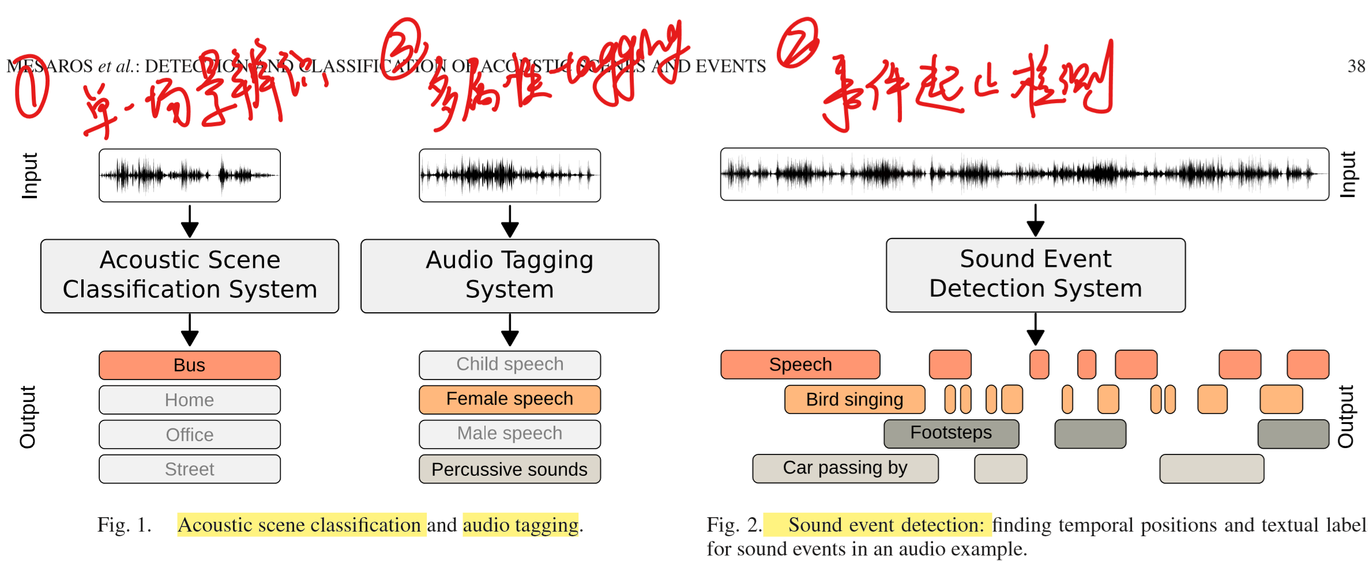

**方向1：gunshot detection – sound events detection**

**方向2：alert event detection(emergency) – acoustic scene classification**

**方向4：枪种类分析（数据集较难获取）**

**方向5：并发计数（overlapping）**

1. **做好data augmentation**
2. **选题关键：1.做的人少；2.可提升空间大**
3. **鸟声识别（DCASE2018，知网有部分研究，已有专利）**
4. **稀有声学事件识别（枪击）**
5. **抗欺骗系统**
6. **数据增强+枪声分类+枪声合成**

Robert C Maher

[Mahar枪声数据库：](http://www.montana.edu/rmaher/gunshots/gunshot_data.html)

* 音频播放有很大杂音
* Matlab分析看信噪比很高，非常接近理想波形（使用MaherDatasetSignalAnalysis.m分析），结果fig所在目录同数据所在目录

