**Q1. Concepts of Communication Network:**

A communication network is the pattern of directions in which information flows in the organization. Channels of communication (networks by which information flows) are either formal networks or informal networks. Formal networks follow the authority chain and are limited to task-related communications. The informal network (grapevine) is free to move in any direction, skip authority levels, and is as likely to satisfy group members' social needs as it is to facilitate task accomplishments. There are 5 types of communication network organizations:

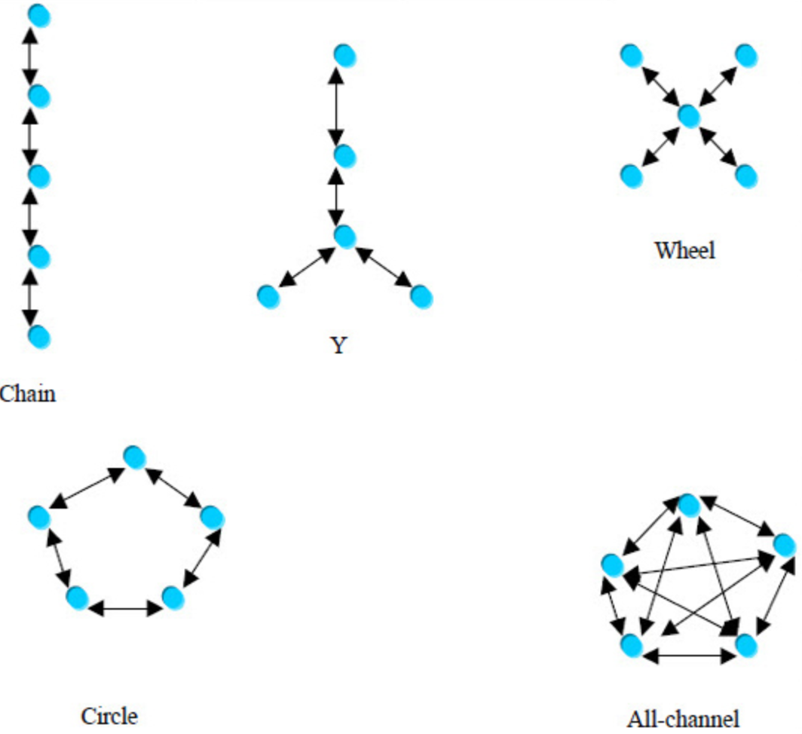

Reference:

<https://www.wisdomjobs.com/e-university/principles-of-management-and-organisational-behaviour-tutorial-366/communication-networks-12761.html>

(a general introduction of basic concepts in communication network)

**Q2. Development of Communication**

Basic theories in electromagnetic fields by Faraday, Maxwell and their fellows 🡪 Telegraph by Morse 🡪 telephone by Bell 🡪 Electromagnetic wave experiment by Hertz 🡪 mechanical switching system（机械式交换机）🡪 first wireless communication by Marconi 🡪 invention of transistor by Bell Lab 🡪 Electronic Switching System（程序控制交换机） 🡪 first wireless telephone in WWII by US military (SCR-300), based on FM 🡪 first mobile phone by Bell Lab in 1946 🡪 first **practical** mobile phone by Motorola in 1973 (1G, analogue communication, FDMA) 🡪 2G digital communication (GSM-TDMA VS CDMA) 🡪 3G(WCDMA VS CDMA2000 VS TD-SCDMA) 🡪 4G LTE

Reference:

<https://zhuanlan.zhihu.com/p/58540779>

(a brief history of the development of communication technology)

**Q3. 1G to 5G**

1G: analogue communication, FDMA, can do nothing but phone calls

2G: digital communication, European GSM uses TDMA, USA uses CDMA, text, SMS is available

3G: WCDMA in Europe, CDMA2000 in USA, TD-SCDMA in China, music transmission and web browsing become possible

4G: LTE(Long-Term Evolution), much faster, more stable, it increased the capacity and speed using a different radio interface together with core network improvements.

5G: eMBB, mMTC, URLLC, high frequency bands are used, massive MIMO is used (massive antenna essentially), low delay

Reference:

<https://zhuanlan.zhihu.com/p/58540779>

(a brief history of the development of communication technology)

<https://zhuanlan.zhihu.com/p/57798336>

(a comparation of 4G and 5G)

**Q4. Comparison among online course platforms**

腾讯会议：流畅度较好，但刚开始进入会议时候可能因为有人没有关闭麦克风而导致混乱

QQ视频：有比较多问题，课堂秩序往往比较混乱

中国大学MOOC：较多优质在线录播课程，可随时回看，问题在于互动操作欠缺，同时存在某些技术性问题（比如移动端兼容性）