**Problem 1**: Create the algorithm for asking to enter a numerical value and will display the next and the previous value.

*1st – Provide a name to this algorithm*

*2nd – Determine the input(s) and output(s)*

*3rd – Name the variables for input/output and determine the type*

*4th – Create simple logical steps in between the START and END that lead to a solution (you can use words like Write, Read, Display, Get, Set etc.), the text to be displayed should be in quotations, for affectation use* ***:=*** *or 🡸*

Name:

Variables:

1. **START**
2. **Read** the numerical value from the user and **store** it in variable **num**.
3. **Calculate** the next value by **adding 1** to **num** and **store** it in **next_val**.
4. **Calculate** the previous value by **subtracting 1** from **num** and **store** it in **prv_val.**
5. **Display** the text "The next value is: " followed by the value of **next_val**.
6. **Display** the text "The previous value is: " followed by the value of **prv_val**.
7. **END**END

*Create a C# console application (.NET Framework) based on your algorithm, after you test your app., compress your solution folder with zip and submit it on LEA of Omnivox before start working on the Problem 2 (next page).*

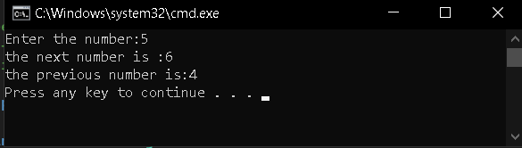

**Problem 2**:

Create the algorithm for displaying the result of the addition, subtraction, multiplication, and division of two numbers.

*1st – Provide a name to this algorithm*

*2nd – Determine the input(s) and output(s)*

*3rd – Name the variables for input/output and determine the type*

*4th – Create simple logical steps in between the START and END that lead to a solution (you can use words like Write, Read, Display, Get, Set etc.), the text to be displayed should be in quotations, for affectation use* ***:=*** *or 🡸*

Name:

Variables:

START

1. Create 2 variable num1 and num2
2. Add num1 and num2 and store the value in addition
3. Multiply num1 and num2 and store the value in multiply.
4. Same as division and subtraction.

END

*Create a C# console (.NET Framework) application based on your algorithm, after you test your app., compress your solution folder with zip and submit it on LEA of Omnivox*

*Submit this document containing your algorithms as well.*

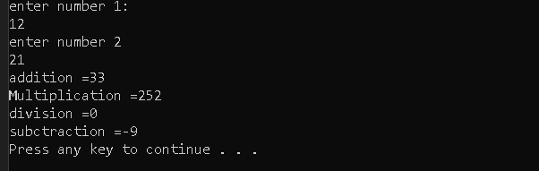*Thank you.*