Week 7 Checkpoint
  - Group 7 | Implementation lead: Jiajun Wu | Data and experimental design lead: Ji Zhao | 20 October 2026
  - Other Members (Coordinators): Zixian Li, Chaozhi Li, Renyu Li, Heyao Yuan
Status: The reference-tracking implementation for Figure 5/6 runs end-to-end. Qualitative reproduction and validation checks are complete.

1. Replication target and method
We selected Vrančić et al., A New Closed-Loop Control Paradigm Based on Process Moments (Mathematics, 2025). This checkpoint targets the reference-tracking experiments in Figures 5 and 6. The controller compares the reference with the estimated final output, rather than the current output: u_{c} = y/KPR + (KTR/KPR) (r - y_{inf}), with y_{inf} integrating (KPR u - y)/t_{ar}. In Figure 6, the applied input is saturated to 0 <= u <= 3.

2. Working implementation and evidence
A Python/NumPy/SciPy baseline runs both unlimited and saturated branches for KTR = 1, 3, 10, and 30. The second-order plant has KPR = 1.5, t_{ar} = 2.4 s, and a 0.4 s pure delay. It is discretized by zero-order hold at Ts = 0.001 s; a 400-sample input buffer implements the delay. The reference steps at t = 1 s, and the process-moment integral uses the actual applied input after saturation.
The run automatically generates Figure 5/6-style plots, input/output traces, a CSV log, time-series arrays, and validation checks. Checks for open-loop delay timing, input saturation bounds, and open-loop final values have all passed.
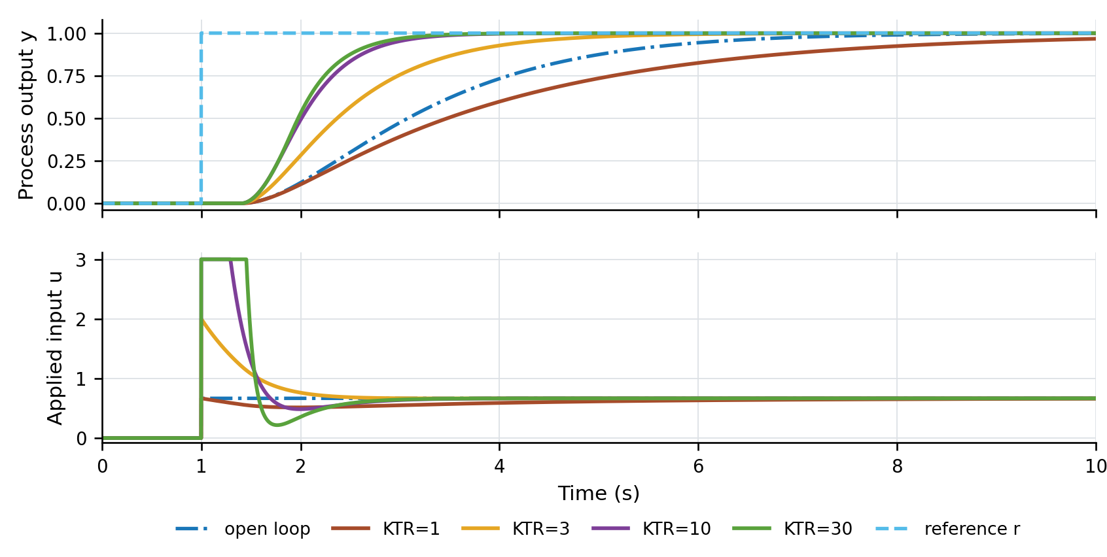
Preliminary execution trace for the saturated branch (Figure 6 target). The reference steps at t = 1 s; the applied input remains within [0, 3].

3. Deviations from the published method
The implementation uses Python and a discrete zero-order-hold model with an integer-sample delay buffer. This checkpoint implements reference tracking only; disturbance rejection, model mismatch, and exact reproduction of the paper's plotting settings remain outside the selected target.

4. Remaining risks and next actions
The paper does not specify exact solver tolerances or plotting settings, which may lead to minor numerical deviations. Next, we will overlay both generated branches against the published figures to investigate any remaining discrepancies before the final report.
Evidence files: replicate_process_moments.py, figure5_unlimited.png, figure6_saturated.png, metrics.csv, simulation_arrays.npz, and validation_checks.json are prepared for the team repository.

