Comparative Analysis of Q-Learning and DQN for Intelligent Taxi Dispatching

Dogyun Kwon *Iroo Jeon **Chanhee Jung, ***Jiyeong Hwang
Sungkyunkwan University

Abstract

Efficient vehicle dispatching is a critical component of modern Intelligent Transportation Systems, requiring intelligent sequential decision-making to optimize long-term performance. This study presents a comparative analysis of two foundational Reinforcement Learning (RL) algorithms—Tabular Q-Learning and Deep Q-Networks (DQN)—applied to the taxi dispatching problem. By formulating the problem as a Markov Decision Process within the Gymnasium Taxi-v3 environment, we evaluate the trade-offs between computational simplicity and state generalization. In the standard 5×5 grid, tabular Q-Learning serves as a robust baseline, achieving an average evaluation reward of 7.96 and a 1.000 success ratio, exhibiting simpler training and greater stability than DQN. However, scalability experiments expanding the grid to 15×15 demonstrate the critical limitations of tabular methods, as the Q-table grows linearly to 27,000 entries and performance deteriorates significantly. Under the same expanded conditions, DQN exhibits more graceful degradation, maintaining a measurably better reward profile (−900.00 vs. −1,465.74) due to the advantages of neural function approximation. Ultimately, this research confirms a scale-dependent view: while Q-Learning is highly practical for small discrete tasks, DQN provides a more promising direction for scaling toward complex, realistic dispatching systems.

1. Introduction

Efficient vehicle dispatching is a cornerstone of modern Intelligent Transportation Systems (ITS). While conventional heuristic-based "greedy" strategies—such as assigning the nearest available vehicle—are straightforward to implement, they often yield suboptimal long-term performance by neglecting future demand and strategic vehicle positioning. This creates a critical requirement for intelligent systems capable of optimizing cumulative efficiency rather than instantaneous gains.

The dispatching challenge is fundamentally a sequential decision-making problem. A taxi's current action—whether picking up a passenger or relocating to a high-demand zone—directly dictates its future state and subsequent earning potential. To address this, Reinforcement Learning (RL) provides a robust framework for agents to learn optimal policies through environmental interaction.

This paper presents a comparative analysis of two foundational RL algorithms: Tabular Q-Learning and Deep Q-Networks (DQN). By evaluating these models within the Gymnasium Taxi-v3 environment, we analyze the trade-offs between computational simplicity and the ability to generalize across complex states. Also, we evaluate both algorithms by incrementally increasing the environment's scale. Our findings establish a performance baseline for scaling toward sophisticated, city-scale autonomous dispatching systems.

The main contributions of this study are as follows:
- We formalize the taxi dispatching problem as an MDP and provide a quantitative performance comparison between value-based RL methods.
- We investigate the impact of state-space expansion on learning stability and convergence speed, providing empirical evidence on the scalability limits of tabular methods.

2. Related Works

The study of autonomous taxi dispatching through RL began prominently with Dietterich [1], which introduced the Taxi environment as a benchmark for hierarchical RL, specifically demonstrating the MAXQ decomposition method. While early works established the Markov Decision Process framework for dispatching, they were primarily constrained to small-scale, discrete state spaces where tabular methods were computationally feasible.

The landscape of RL was significantly transformed by the introduction of DQN. Mnih et al. [2] demonstrated that deep neural networks could successfully approximate Q-values in high-dimensional spaces using experience replay and target networks. This advancement shifted the way of dispatching research from small-scale grids to more complex urban simulations. In recent years, subsequent research, such as Zhou et al. [3], has extended these models to handle stochastic demand and environmental uncertainties, while Rajeh et al. [4] focused on Multi-Agent RL (MARL) for city-scale coordination.

Our work situates itself as a foundational comparative study, providing empirical evidence on how value-based RL algorithms transition from tabular lookups to functional approximations in a controlled environment.

3. Method

We formalize the taxi dispatching problem as a Markov Decision Process (MDP), represented by a tuple ($\text{S, A, P, R γ}$).

3.1 State Space
In the standard $\text{5} \text{×} \text{5}$ benchmark, the state space $S$ is a discrete set which consists of 500 possible states, derived from the product of the following components: 1. Taxi Coordinates, a grid of $\text{5} \text{×} \text{5} \text{=} \text{25}$ locations; 2. Passenger Location, 5 states (destinations and 1 state representing the passenger being inside the vehicle); 3. Destination, 4 designated landmarks {R, G, Y, B }.

To evaluate scalability, we extend this formulation to an N × N grid. As N increases, the state space grows quadratically, specifically $\left|\text{S} \right| \text{=} {\text{N} }^{\text{2}} \text{×} \text{5} \text{×} \text{4}$. This expansion is utilized to test the memory limits of the Q-table versus the generalization capabilities of the DQN's neural network.

3.2 Action Space & Reward function
The action space A consists of 6 discrete actions that the agent can execute at each time step:
- Movement: South (0), North (1), East (2), West (3)
- Operational: Pickup (4), Drop-off (5)
The reward function is designed to penalize inefficient movement and incentivize successful delivery. We define the reward R(s, a) as +20 if passenger is successfully delivered at the destination, -10 if Pickup or Drop-off action is wrongly attempted, and -1 for all other actions (step-wise movement penalty). The step-wise penalty of -1 is critical for encouraging the agent to find the shortest path, thereby minimizing idle cruising time.

3.3 Q-Learning Method
To establish a strong tabular baseline, we implemented Q-learning in the Gymnasium Taxi-v3 environment. Since Taxi-v3 has a fully discrete state-action structure with 500 states and 6 actions, a dense Q-table is a natural and efficient choice. In our implementation, the Q-table Q(s,ɑ) was initialized as a 500 × 6 matrix of zeros, where each entry stores the estimated long-term return of taking action ɑ in state s.
At each step, the agent selected an action using an ε-greedy policy. With probability ε, the agent explored by choosing a random action, and with probability 1 - ε, it exploited the current policy by choosing the action with the highest Q-value. The Q-values were updated using the standard temporal-difference rule:
Q(s,ɑ) ← Q(s,ɑ) + $\text{α}$[r + $\text{γ}$ max Q(s’,ɑ’) - Q(s,ɑ)]
Here, $\text{α}$ denotes the learning rate and $\text{γ}$ denotes the discount factor. In our experiments, we set $\text{α}$ = 0.1 and $\text{γ}$ = 0.99, which gave stable learning behavior while still allowing the agent to reflect future rewards. Each episode was limited to 200 steps, and the model was trained for 8,000 episodes.
We also adjusted the exploration schedule to make the learning process more practical than a basic implementation. The initial exploration rate was set to ε = 1.0, and it decayed multiplicatively by 0.9992 at every episode until reaching a minimum of 0.01. This schedule allowed the agent to explore sufficiently in the early stage and gradually move toward exploitation once the Q-values became more reliable.
In addition to the standard implementation, we introduced two practical improvements. First, when multiple actions had the same maximum Q-value, we applied random tie-breaking instead of always choosing the first action returned by argmax. This reduced unnecessary bias in action selection and made the learned policy less brittle. Second, instead of using only the final Q-table, we stored the best Q-table observed during training based on the highest 100-episode moving average reward. This helped preserve a stronger policy even when the later stage of training showed temporary fluctuations.
To analyze the learning process in more detail ways, we recorded the episode reward, episode length, and 100-episode moving average reward throughout training. These records were later used for performance visualization and comparison with DQN.

3.4 DQN Method
To address the scalability limitations of tabular Q-learning, we implemented a Deep Q-Network (DQN) agent for the same Taxi-v3 task. Unlike Q-learning, which stores a separate Q-value for every state-action pair in a table, DQN approximates the action-value function Q(s,a) using a neural network. This allows the agent to generalize across states and makes the method more suitable for larger state spaces, where an explicit Q-table becomes inefficient. In our implementation, the current state was encoded as a one-hot vector and used as the input to the Q-network, which outputs Q-values for all six actions at once. This design follows the standard idea of value function approximation for large-scale model-free reinforcement learning.
The Q-network was trained using the DQN framework with two hidden fully connected layers and ReLU activations. At each time step, the agent selected an action using an $\text{ε}$-greedy policy, balancing exploration and exploitation during training. The observed transition (s, a, r, s') was stored in a replay buffer, and random mini-batches were later sampled from this memory for training. The use of experience replay reduces the correlation between consecutive samples and improves data efficiency by reusing past experiences multiple times.
To stabilize training, we used a separate target network in addition to the online Q-network. The target value for each sampled transition was computed as
y = r + γ * max_a' Q_target(s', a')
The online Q-network was then updated by minimizing the mean-squared error between its predicted Q-value and this target. The target network parameters were copied from the online network at fixed intervals, which helped reduce the non-stationary target problem that often causes instability in naive neural Q-learning. This combination of neural function approximation, experience replay, and fixed target networks forms the core of DQN.
During training, we recorded episode reward, episode length, and the 100-episode moving average reward for later analysis. These metrics were used to compare the learning behavior of DQN with that of tabular Q-learning under the same Taxi-v3 environment. For evaluation, the learned policy was tested with greedy action selection over multiple episodes, and the average reward and average episode length were measured in the same way as in the Q-learning experiments.

4. Data and Experiment

All Q-learning experiments were conducted in the Gymnasium Taxi-v3 environment. The environment contains 500 discrete states and 6 discrete actions, making it suitable for tabular reinforcement learning. To improve reproducibility, random seeds were fixed during training and evaluation. During training, each episode was initialized with a deterministic seed offset, and the same approach was used in evaluation with a separate seed range.
We first trained a basic Q-learning model, and then trained an improved version with random tie-breaking and best-model checkpointing. For the basic version, performance was evaluated over 100 episodes using a greedy policy. For the improved version, evaluation was performed over 200 episodes using the saved best Q-table. When multiple actions shared the same maximum Q-value during evaluation, one of them was selected uniformly at random.
We used four evaluation metrics. The first was the average episode reward, which measures overall policy under the Taxi-v3 reward design. The second was the average number of steps, which indicates how efficiently the agent completed the task. The third was the success ratio, defined as the proportion of evaluation episodes with non-negative total reward. The fourth was the high-quality episode ratio, defined as the proportion of episodes with reward greater than or equal to 8. In addition, we visualized the training reward curve, moving average reward, episode length, and the distributions of evaluation rewards and evaluation steps.

5. Results
5.1 Q-Learning
The Q-learning agent showed a clear improvement over the course of training. In the early stage, rewards were heavily negative because the agent frequently made inefficient moves, and invalid pickup or drop-off actions. However, as training progressed and exploration gradually decreased, the policy became more structured, and the average reward improved steadily. In the improved implementation, the 100-episode moving average rose from -394.82 at episode 500 to positive values after the mid-training stage, and it reached 7.75 by episode 6,000. The best recorded 100-episode moving average reward was 8.23, indicating that the agent had learned a stable and efficient dispatching policy in the standard Taxi-v3 setting, as shown in Fig.1.
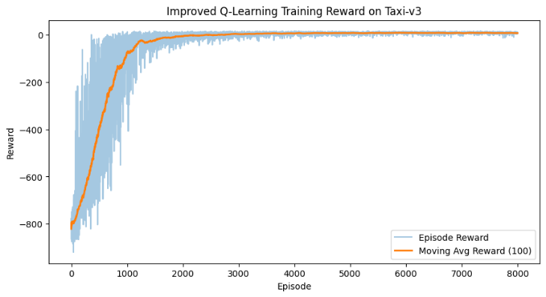
Fig. 1 Improved Q-Learning Training Reward on Taxi-v3
The basic Q-learning model already produced a strong result. Its average evaluation reward was 7.63, and the average number of steps was 13.37 over 100 evaluation episodes. This suggests that in a small discrete environment such as Taxi-v3, a tabular method can already learn an effective policy without requiring function approximation.
The improved Q-learning model performed slightly better and more consistently. Over 200 evaluation episodes, it achieved an average reward of 7.96 and an average episode length of 13.04 steps. The success ratio was 1.000, meaning that all evaluation episodes ended with non-negative total reward. In addition, the proportion of high-quality episodes with reward greater than or equal to 8 was 0.520. These results indicate that the added improvements did not simply raise the average score, but also made the learned policy more stable across repeated evaluations.
Another meaningful result is that episode length decreased as learning progressed. This is consistent with the reward design of Taxi-v3, where each unnecessary move incurs a penalty of -1. In other words, the agent did not simply learn to finish the task eventually; it learned to finish it with fewer wasted actions. This trend can be observed in Fig. 2, where the number of steps generally becomes lower and more stable in the later stage of training.
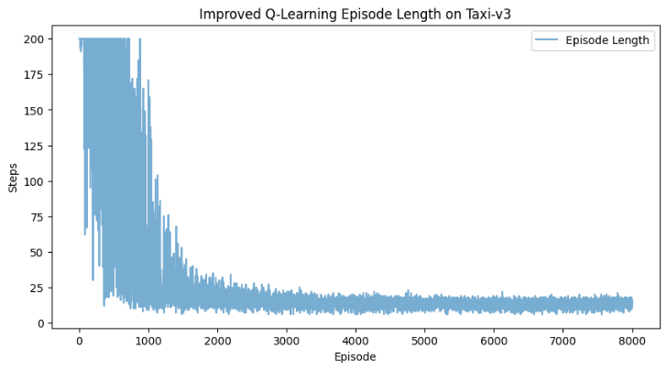
Fig. 2 Improved Q-Learning Episode Length on Taxi-v3
The evaluation reward distribution also supports this interpretation. As shown in Fig. 3, a large portion of the evaluation episodes are concentrated in a relatively favorable reward range, rather than being widely spread across poor outcomes. This suggests that the learned policy was not only high-performing on average, but also reliable from episode to episode.
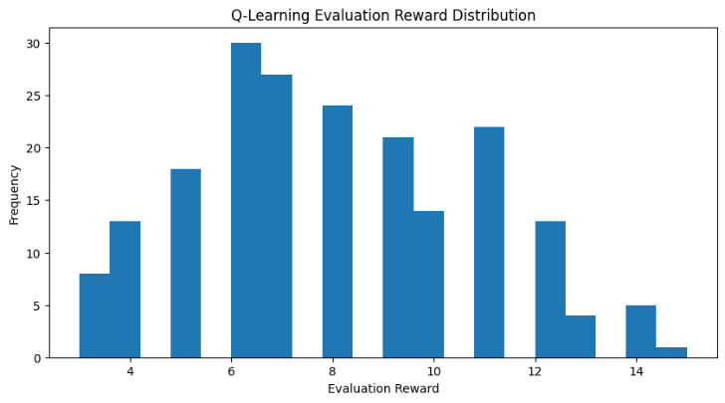
Fig. 3 Q-Learning Evaluation Reward Distribution
Overall, the Q-learning results show that tabular reinforcement learning remains a very strong baseline in small, fully discrete dispatching environments. Its implementation is simple, training is stable after sufficient exploration, and the final policy achieves both high reward and efficient task completion. At the same time, this strength depends on the fact that the state space is limited and explicitly enumerable. For this reason, in this study Q-learning serves as a strong baseline for the standard Taxi-v3 problem and a useful reference point for later comparison with DQN.

5.2 DQN
The DQN agent showed a clear learning trend in the Taxi-v3 environment. At the beginning of training, the episode rewards were strongly negative and highly unstable because the agent explored frequently and often received step penalties or invalid-action penalties. However, as training continued, the moving-average reward increased steadily. This indicates that the Q-network gradually learned more useful state-action values and improved its dispatching policy over time.
Figure 4 shows the reward curve of the DQN agent. Although the raw episode rewards remain noisy, which is common in deep reinforcement learning, the moving-average line rises from a very poor initial level to a much better range near the end of training. This upward trend suggests that the agent successfully moved from random exploration to more structured and effective decision making.
Figure 5 shows the episode length during training. In the early stage, many episodes reached the maximum step limit, meaning that the agent often failed to solve the task efficiently. As learning progressed, shorter episodes appeared more frequently, which implies that the agent was able to complete pickup-and-dropoff sequences with fewer unnecessary moves. Even though the step curve still contains fluctuations, the overall pattern supports the reward result and shows that the learned policy became more efficient over time.
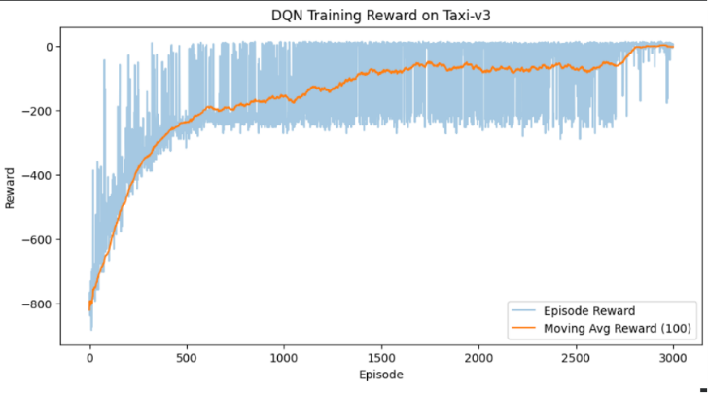
Fig. 4 DQN Training Reward on Taxi-v3
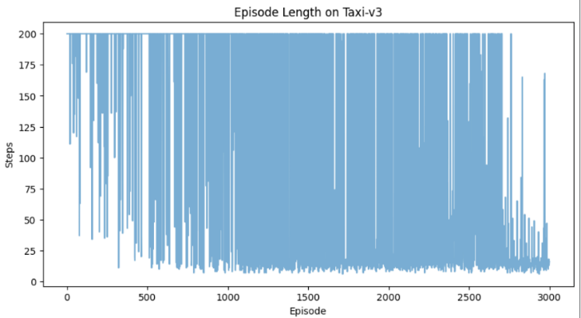
Fig. 5 DQN Episode Length on Taxi-v3
5.3 Comparison between Q-Learning and DQN
In the standard Taxi-v3 environment, tabular Q-learning remains a very strong baseline. Because the state space is relatively small and fully discrete, Q-learning can directly store and update all state-action values without approximation error. This usually leads to simpler training, faster convergence, and more stable behavior than DQN in the same small-scale setting.
By contrast, DQN learns the same task through a neural network. This gives it an important advantage in representation: it does not need to memorize every state-action pair in a table, and it can generalize across states through function approximation. However, in small environments such as Taxi-v3, this advantage is partly offset by higher computational cost, noisier learning curves, and greater sensitivity to hyperparameters such as learning rate, replay buffer size, batch size, and target network update interval.
Therefore, the comparison between the two methods depends on the scale of the problem. For the original Taxi-v3 benchmark, Q-learning is often more practical because it is simple and stable. On the other hand, DQN becomes more meaningful when the environment grows larger and the Q-table becomes too large to store or learn efficiently. In that sense, Q-learning is a strong baseline for small discrete dispatching tasks, while DQN provides a more scalable direction for larger and more complex taxi dispatching problems.

6. Conclusion

This study presented a comparative analysis of tabular Q-Learning and Deep Q-Networks (DQN) for the taxi dispatching problem, formulated as a Markov Decision Process within the Gymnasium Taxi-v3 environment. On the standard 5×5 benchmark, tabular Q-Learning served as a remarkably strong baseline, achieving an average evaluation reward of 7.96 with a success ratio of 1.000 across 200 episodes, while our practical improvements—random tie-breaking and best-model checkpointing—further stabilized the learned policy. DQN also learned the task successfully but exhibited noisier learning curves and greater sensitivity to hyperparameters, confirming that the overhead of function approximation is difficult to justify when the state space is small enough for a dense Q-table.
The scalability experiment, however, revealed the fundamental limitation of the tabular approach. As the grid expanded from 5×5 (500 states) to 15×15 (4,500 states) under a fixed training budget, the Q-table grew linearly to 27,000 entries while the average evaluation reward deteriorated from −13.50 to −1,465.74. DQN degraded as well, but retained a measurably better reward profile at the largest scale (−900.00 vs. −1,465.74 at 15×15), suggesting that neural function approximation offers a more graceful degradation path when the environment grows beyond what tabular methods can efficiently cover. Taken together, these results support a scale-dependent view of value-based RL: Q-Learning remains the more practical choice for small discrete dispatching tasks, whereas DQN provides a more promising direction as the state space expands toward realistic sizes.
Several limitations qualify our conclusions. First, the scalability experiments used a fixed budget of 1,500 episodes regardless of state-space size, so the observed performance gap reflects sample efficiency under equal compute rather than asymptotic capability; with substantially longer training or better-tuned hyperparameters, both methods—particularly DQN—would likely improve further. Second, our ScalableTaxiEnv preserves the four-corner pickup/drop-off structure of Taxi-v3, meaning the state explosion arises from taxi coordinates alone rather than from richer demand patterns, stochastic passenger arrivals, or multi-vehicle coordination that characterize real-world Intelligent Transportation Systems. These factors should be addressed before the trends reported here can be extrapolated to city-scale deployment.

Reference
[1] T. G. Dietterich, “Hierarchical Reinforcement Learning with the MAXQ Value Function Decomposition,” arXiv.org. Accessed: Apr. 20, 2026. [Online]. Available: https://arxiv.org/abs/cs/9905014v1.
[2] V. Mnih et al., “Human-level control through deep reinforcement learning,” Nature, vol. 518, no. 7540, pp. 529–533, Feb. 2015, doi: 10.1038/nature14236.
[3] X. Zhou, L. Wu, Y. Zhang, Z.-S. Chen, and S. Jiang, “A robust deep reinforcement learning approach to driverless taxi dispatching under uncertain demand,” Information Sciences, vol. 646, p. 119401, Oct. 2023, doi: 10.1016/j.ins.2023.119401.
[4] T. M. Rajeh, Z. Luo, M. H. Javed, F. Alhaek, and T. Li, “A Clustering-Based Multi-Agent Reinforcement Learning

