FAST-NUCES
Fundamentals of Software Engineering Spring 2026
LitLog
Personal Reading Tracker & Habit Visualizer
Iteration 1 Deliverable Report

Zahra Saeed 24L-2512
Romaisa Sajjad 24L-2608
Khadija Faiz 24L-2554
Submission Date: March 22, 2026

1.Project Introduction:
LitLog is a personal reading tracker and habit visualizer designed to help users manage their entire reading journey in one place. Readers often struggle to remember which books they have read, track their current progress, or recall their thoughts on finished books. LitLog solves this by providing a clean, organized desktop web application where users can add books, organize them across shelves, write personal notes, set reading goals, and receive book recommendations all stored securely in a local SQL Server database.
This document covers the Sprint 1 deliverable, which includes Module 1 (User Authentication and Book Entry) and Module 2 (Bookshelf and Search). The sprint ran from March 8 to March 22, 2026.
Database Design: Entity Relationship Diagram
The ERD diagram below shows the 2 tables that make up the LitLog SQL Server database and their relationships for Iteration 1.
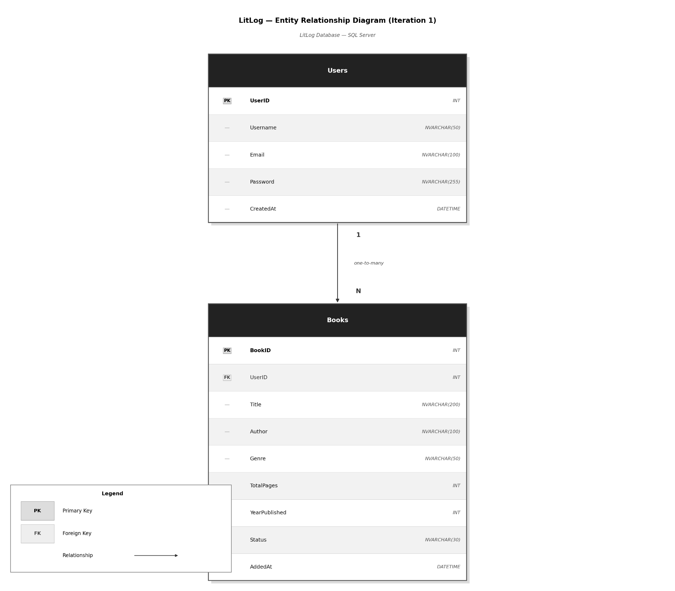

2.User Stories
The following user stories were selected for Sprint 1, covering Modules 1 and 2.

US-01: User Sign Up
Story ID: US-01 Story Title: User Sign Up | Priority: High  Estimated Hours: 4
User Story:
As a user, I want to create a new account by entering my username, email and password so that I can securely access my personal reading library.
Description:
This story involves building a registration screen where new users can create an account. The system must validate inputs, check for duplicate emails, hash the password before storage, and redirect the user to the login screen upon success.
Sub User Stories:
- As a user, I want to enter my username, email, and password to register.
- As a user, I want to receive a clear error if my email is already registered.
- As a user, I want my password to be stored securely.
- As a user, I want to be redirected to the login page after successful signup.

Acceptance Criteria:
- Registration form accepts username, email, and password fields.
- The system rejects duplicate email addresses with a clear error message.
- Passwords are hashed before being stored in the database.
- Successful registration redirects the user to the login screen.
- All fields are validated and empty fields show inline error messages.

US-02: User Log In
Story ID: US-02 Story Title: User Log In | Priority: High  Estimated Hours: 3
User Story:
As a user, I want to log in using my email and password so that I can access my saved book collection securely.
Description:
This story covers building the login screen where returning users authenticate themselves. The system verifies credentials against the database, handles failed attempts gracefully, and opens the main bookshelf dashboard on success.
Sub User Stories:
- As a user, I want to enter my email and password to log in.
- As a user, I want to see a generic error message if my credentials are wrong.
- As a user, I want to be taken to my bookshelf dashboard after logging in successfully.

Acceptance Criteria:
- Login form includes email and password fields.
- On incorrect credentials, a single generic error is shown.
- Successful login navigates the user to the bookshelf dashboard.
- Empty fields are validated before the form is submitted.
- User sessions are maintained so they do not need to re-login on every visit.

US-03: Add a Book
Story ID: US-03 Story Title: Add a Book | Priority: High  Estimated Hours: 5
User Story:
As a user, I want to add a book by searching it online.
Description:
This story involves building an Add Book form where users can enter all relevant details for a new book and save it to their library. The system stores the book in the database linked to the logged-in user and places it on the selected shelf by default.
Sub User Stories:
- As a user, I want to fill in the book title, author, genre, publication year, and total pages.
- As a user, I want to assign a reading status shelf when adding the book.
- As a user, I want to see the new book appear in my library immediately after saving.
- As a user, I want to see validation errors if I leave required fields empty.

Acceptance Criteria:
- Add Book form includes fields: Title (required), Author (required), Genre, Publication Year, Total Pages.
- User can select a shelf (Currently Reading, Want to Read, Finished, Did Not Finish) when adding.
- Book is saved to the database and displayed in the library immediately.
- Form shows an inline error if Title or Author is left blank.
- Duplicate book titles by the same author show a warning before saving.

US-04: Edit and Delete a Book
Story ID: US-04 Story Title: Edit and Delete a Book | Priority: Medium  Estimated Hours: 3
User Story:
As a user, I want to edit the details of a book or delete it from my library so that I can correct mistakes and keep my library up to date.
Description:
This story involves allowing users to modify existing book information or remove a book from their collection entirely. The edit screen pre-populates all current book details. Deletion requires a confirmation prompt to prevent accidental removal.
Sub User Stories:
- As a user, I want to open a book and edit any of its details.
- As a user, I want the edit form to be pre-filled with the current book information.
- As a user, I want to delete a book after confirming my choice.
- As a user, I want changes to be saved and reflected immediately in my library.

Acceptance Criteria:
- Edit option is available from the book detail view.
- Edit form pre-populates all existing fields for the selected book.
- Changes are saved to the database and reflected immediately in the bookshelf.
- Delete button triggers a confirmation dialog before removal.
- After deletion, the book is removed from the library and no longer appears on any shelf.

US-05: Bookshelf Management
Story ID: US-05 Story Title: Bookshelf Management | Priority: High  Estimated Hours: 4
User Story:
As a user, I want to organize my books into shelves and move them between shelves at any time so that I can clearly see which books I am reading, have finished, or plan to read.
Description:
This story covers the four-shelf system that is the core organisation mechanism of LitLog. Users can view all books grouped by their current status and reassign any book to a different shelf through a simple interaction on the book card.
Sub User Stories:
- As a user, I want to see my books separated into four shelves: Currently Reading, Want to Read, Finished, and Did Not Finish.
- As a user, I want to move a book to a different shelf with a single click or selection.
- As a user, I want the shelf count to update immediately when I move a book.

Acceptance Criteria:
- The bookshelf screen displays four named sections, each showing the books assigned to that status.
- Each book card has an option (dropdown) to change its shelf.
- Moving a book updates its status in the database immediately.
- The book disappears from the previous shelf and appears on the new one without a page reload.
- Each shelf displays the correct count of books it contains.

US-06: Search and Filter Books
Story ID: US-06 Story Title: Search and Filter Books | Priority: Medium  Estimated Hours: 4
User Story:
As a user, I want to search my library by title or author and filter by genre or reading status so that I can quickly find any book in my collection.
Description:
This story involves adding a search bar and filter controls to the bookshelf screen. Users can type a title or author name to narrow down results in real time, and apply filters to show only books matching a specific genre or shelf status.
Sub User Stories:
- As a user, I want to type in a search bar and see matching books instantly.
- As a user, I want to filter books by genre.
- As a user, I want to filter books by reading status (shelf).
- As a user, I want to combine search and filters at the same time.
- As a user, I want to see a message if no books match my search or filter.

Acceptance Criteria:
- A search bar is visible on the bookshelf screen.
- Typing in the search bar filters results in real time by title or author name.
- A genre dropdown filter shows only books in the selected genre.
- A status filter shows only books on the selected shelf.
- Search and filters can be used simultaneously.
- If no results match, a friendly message is displayed (e.g. 'No books found').

3.Sprint 1 Structured Specifications
Four structured specifications are provided below for the highest-priority user stories in Sprint 1.

Specification 1: US-01: User Sign Up
US-01 | User Sign Up
Story ID | US-01 | Priority | High
Risk | Low | Estimated Hours | 4
Dependencies | Database must be set up. Users table must exist.
Description | This specification covers the user registration feature. A new user must be able to create a personal account by providing a unique username, a valid email address, and a password. The system must validate all inputs, reject duplicate emails, securely hash the password before storing it, and redirect the user to the login screen upon successful registration.
Acceptance Criteria | - The registration form displays fields for username, email, and password.  - The system validates that no field is left empty before submission.  - Duplicate email addresses are rejected with a clear error message.  - Passwords are hashed using a secure algorithm before being stored in the database.  - Successful registration redirects the user to the login screen.  - A success message is shown confirming the account has been created.

Specification 2: US-02: User Log In
US-02 | User Log In
Story ID | US-02 | Priority | High
Risk | Low | Estimated Hours | 3
Dependencies | US-01 must be completed. Users table must contain at least one registered account.
Description | This specification covers the login feature for returning users. The user enters their registered email and password. The system checks the credentials against the database, handles incorrect attempts with a generic error message to prevent information leakage, and navigates the user to their bookshelf dashboard on success. The session must persist so the user does not need to log in again on every visit.
Acceptance Criteria | - Login form displays fields for email and password.  - Empty fields are validated and show an inline error before submission.  - Incorrect credentials display a single generic error message.  - Successful login navigates the user to the bookshelf dashboard.  - User session is maintained across the application after login.  - A logout option is available that ends the session and returns to the login screen.

Specification 3 : US-03: Add a Book
US-03 | Add a Book
Story ID | US-03 | Priority | High
Risk | Medium | Estimated Hours | 5
Dependencies | US-01 and US-02 must be completed. Users, Books, UserBooks, Genres, and ReadingStatuses tables must exist.
Description | This specification covers the book entry feature. A logged-in user must be able to manually add a new book to their library by filling in the book details including title, author, genre, publication year, and total pages. The user also selects an initial reading status shelf. The book is saved to the database and immediately displayed in the correct shelf on the bookshelf screen.
Acceptance Criteria | - Add Book form includes fields for title, author, genre, publication year, and total pages.  - Title and author are required fields — form does not submit without them.  - Users can select an initial shelf from a dropdown (Currently Reading, Want to Read, Finished, Did Not Finish).  - The book is saved to the database linked to the logged-in user's account.  - The new book appears immediately on the correct shelf after saving.  - A warning is shown if a book with the same title and author already exists in the library.

Specification 4 :US-05: Bookshelf Management
US-05 | Bookshelf Management
Story ID | US-05 | Priority | High
Risk | Medium | Estimated Hours | 4
Dependencies | US-01, US-02, and US-03 must be completed. UserBooks and ReadingStatuses tables must be populated.
Description | This specification covers the four-shelf organisation system that is the core of LitLog. The bookshelf screen must display all of the user's books grouped under their current reading status. The user must be able to move any book to a different shelf at any time. The shelf counts and book positions must update immediately without requiring a page refresh.
Acceptance Criteria | - The bookshelf screen displays four clearly labelled sections: Currently Reading, Want to Read, Finished, and Did Not Finish.  - Each section shows all books currently assigned to that status.  - Each book card displays an option to change its shelf.  - Changing a shelf updates the book's status in the database immediately.  - The book moves from the old shelf to the new shelf without a full page reload.  - Each shelf heading displays the correct count of books it currently contains.
4.Scrum Board
The following snapshots document the state of the Trello board at three key points during Sprint 1.

Snapshot 1:Sprint Start (March 8, 2026)
All six user stories are loaded into the Sprint Backlog. No work has started yet.
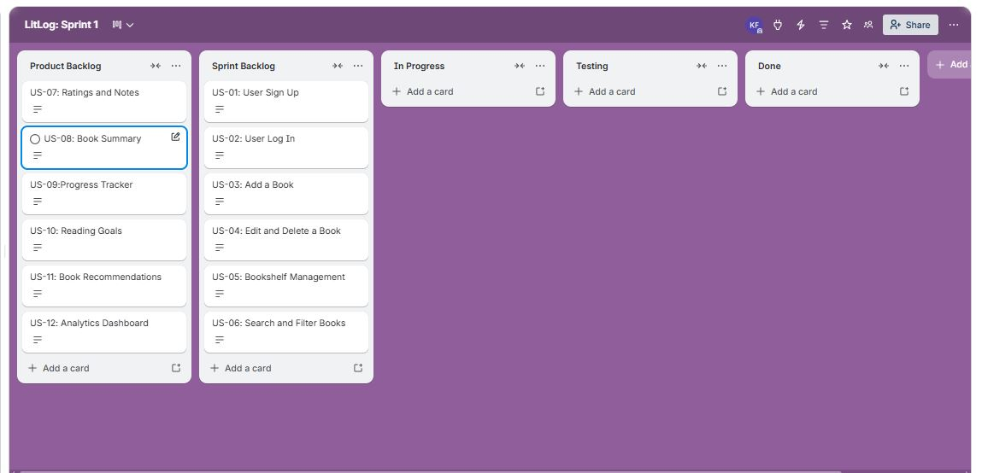

Snapshot 2 : Mid Sprint (March 15, 2026)
US-01 and US-02 are completed. US-03 and US-05 are in progress. US-04 and US-06 remain in the Sprint Backlog.
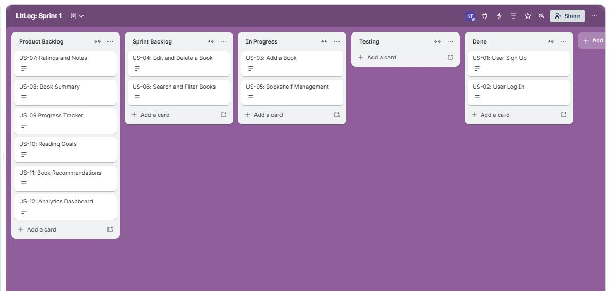

Snapshot 3 :Sprint End (March 22, 2026)
All the completed user stories are moved to Done. Incomplete tasks were moved back to the Product Backlog and reprioritized for the next sprint.
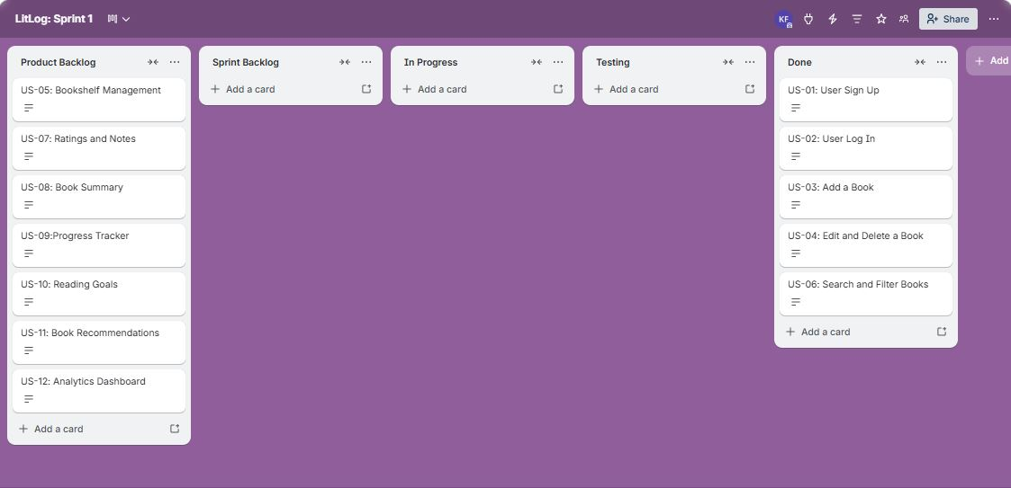

Burndown Chart:
The burndown chart below shows planned tasks remaining versus actual tasks remaining across the 14-day sprint.

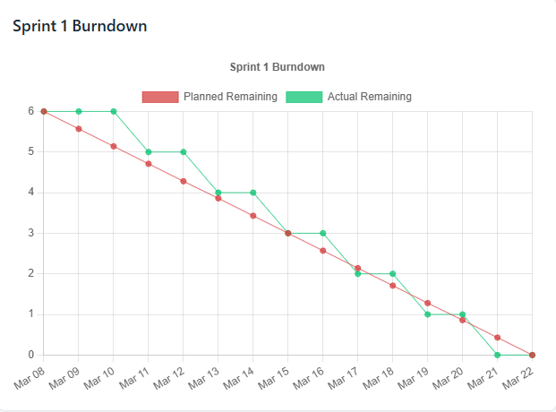

5.Non-Functional Requirements
The following non-functional requirements have been defined for LitLog using natural language specification.
1. Performance: The system should respond quickly to all user interactions involving the book library. Loading the full bookshelf with up to 500 books must complete within 2 seconds on standard hardware. Search and filter operations should return results in under 1 second regardless of library size. The reading progress bar and dashboard analytics must update instantly upon any change without requiring a page reload.
2. Usability: The application should be intuitive enough for users with no technical background. A new user must be able to create an account, add their first book, and assign it to a shelf within 5 minutes of opening the app for the first time. All buttons, shelves, and input fields must be clearly labelled with helpful placeholder text and tooltips where necessary. Error messages such as duplicate entries or empty required fields must be displayed in plain, understandable language rather than technical error codes.
3. Scalability: The system should handle growing personal libraries without any degradation in performance. It must support a minimum of 500 books per user account and at least 10 active reading goals simultaneously without lag. The database schema and backend architecture should be designed to allow future features such as cloud sync, social sharing, or multi-device access to be added without requiring a full redesign of existing modules.
4. Reliability: The application should operate consistently without data loss or unexpected crashes during normal use. It must not crash more than once in 8 hours of continuous use under typical conditions. Any book entry, rating, note, or progress update made by the user must be saved to the database immediately upon confirmation so that no data is lost if the application is closed unexpectedly. In the event of a failure, the user's last recorded state must be fully recoverable upon restarting the application.
5. Security: The system must protect user account information and personal reading data at all times. Each user must only be able to access their own books, notes, goals, and recommendations and no user should be able to view or modify another user's data. Any failed login attempt should display a generic error message rather than specifying whether the username or password was incorrect, to prevent information leakage.
6. Compatibility: The application must function correctly across the most commonly used desktop environments. It must fully support Windows 10 and above without any loss of features or visual inconsistencies. The interface layout must remain usable and properly formatted at screen resolutions as low as 1280×720 and as high as 1920×1080. All fonts, icons, and UI components must render consistently regardless of the operating system or display scaling settings used on the host machine.

6.Implementation Screenshots
The following screenshots demonstrate the working implementation of Sprint 1 features.
Backend
Add New Book:
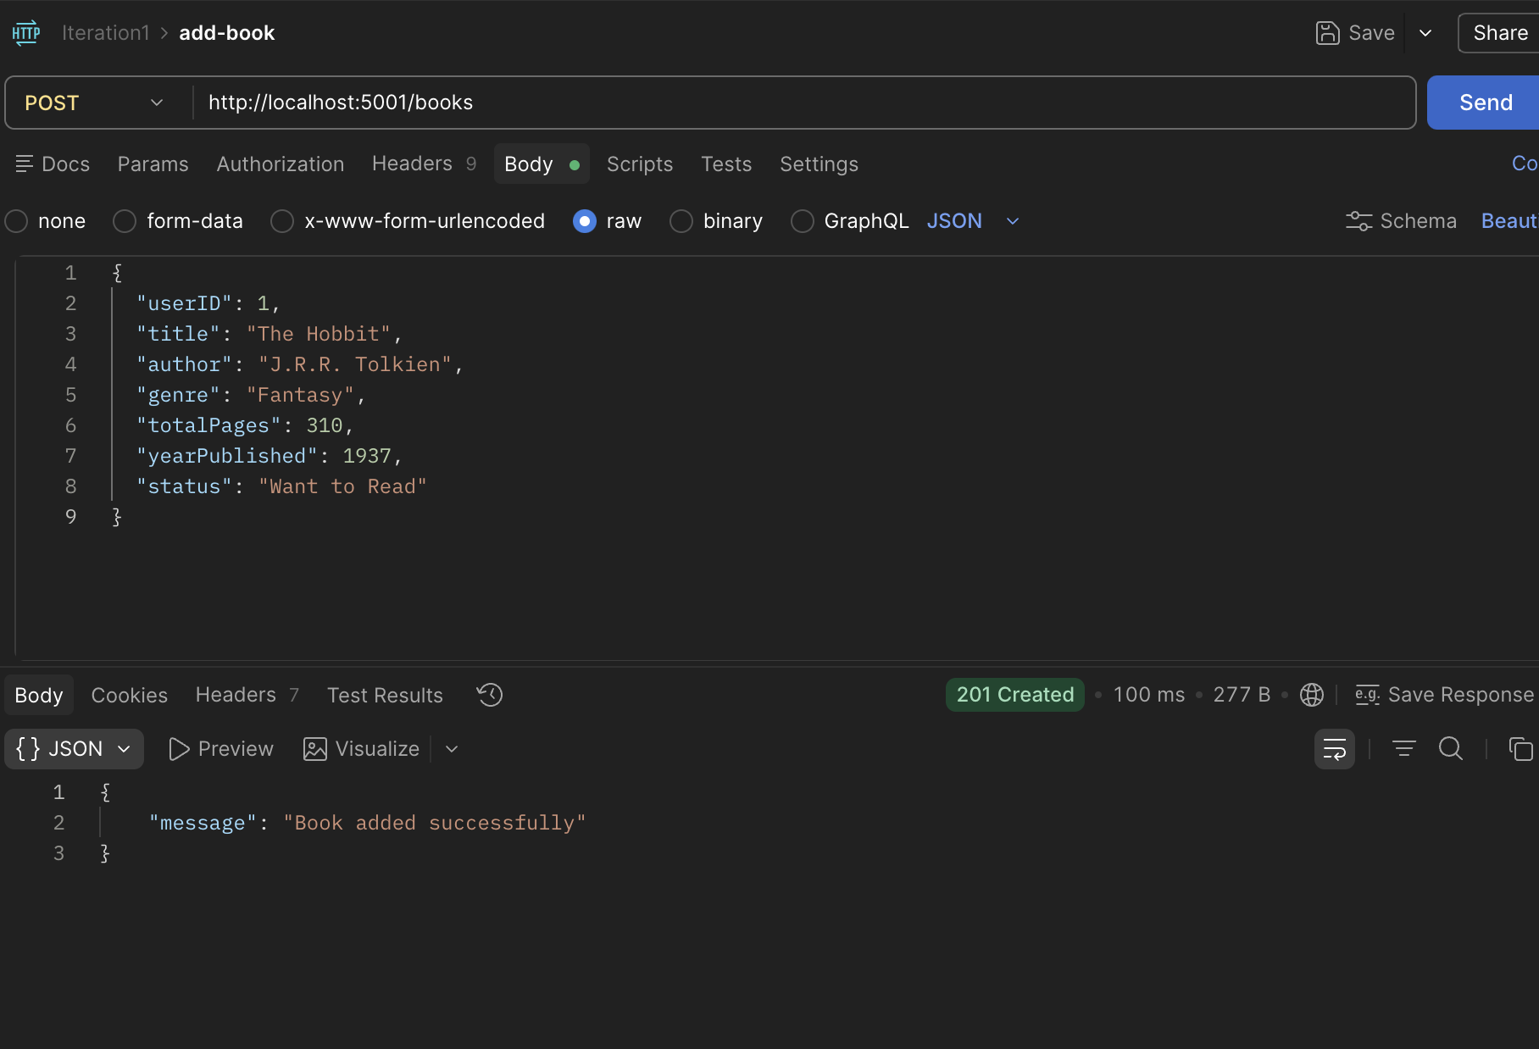
Delete Book:
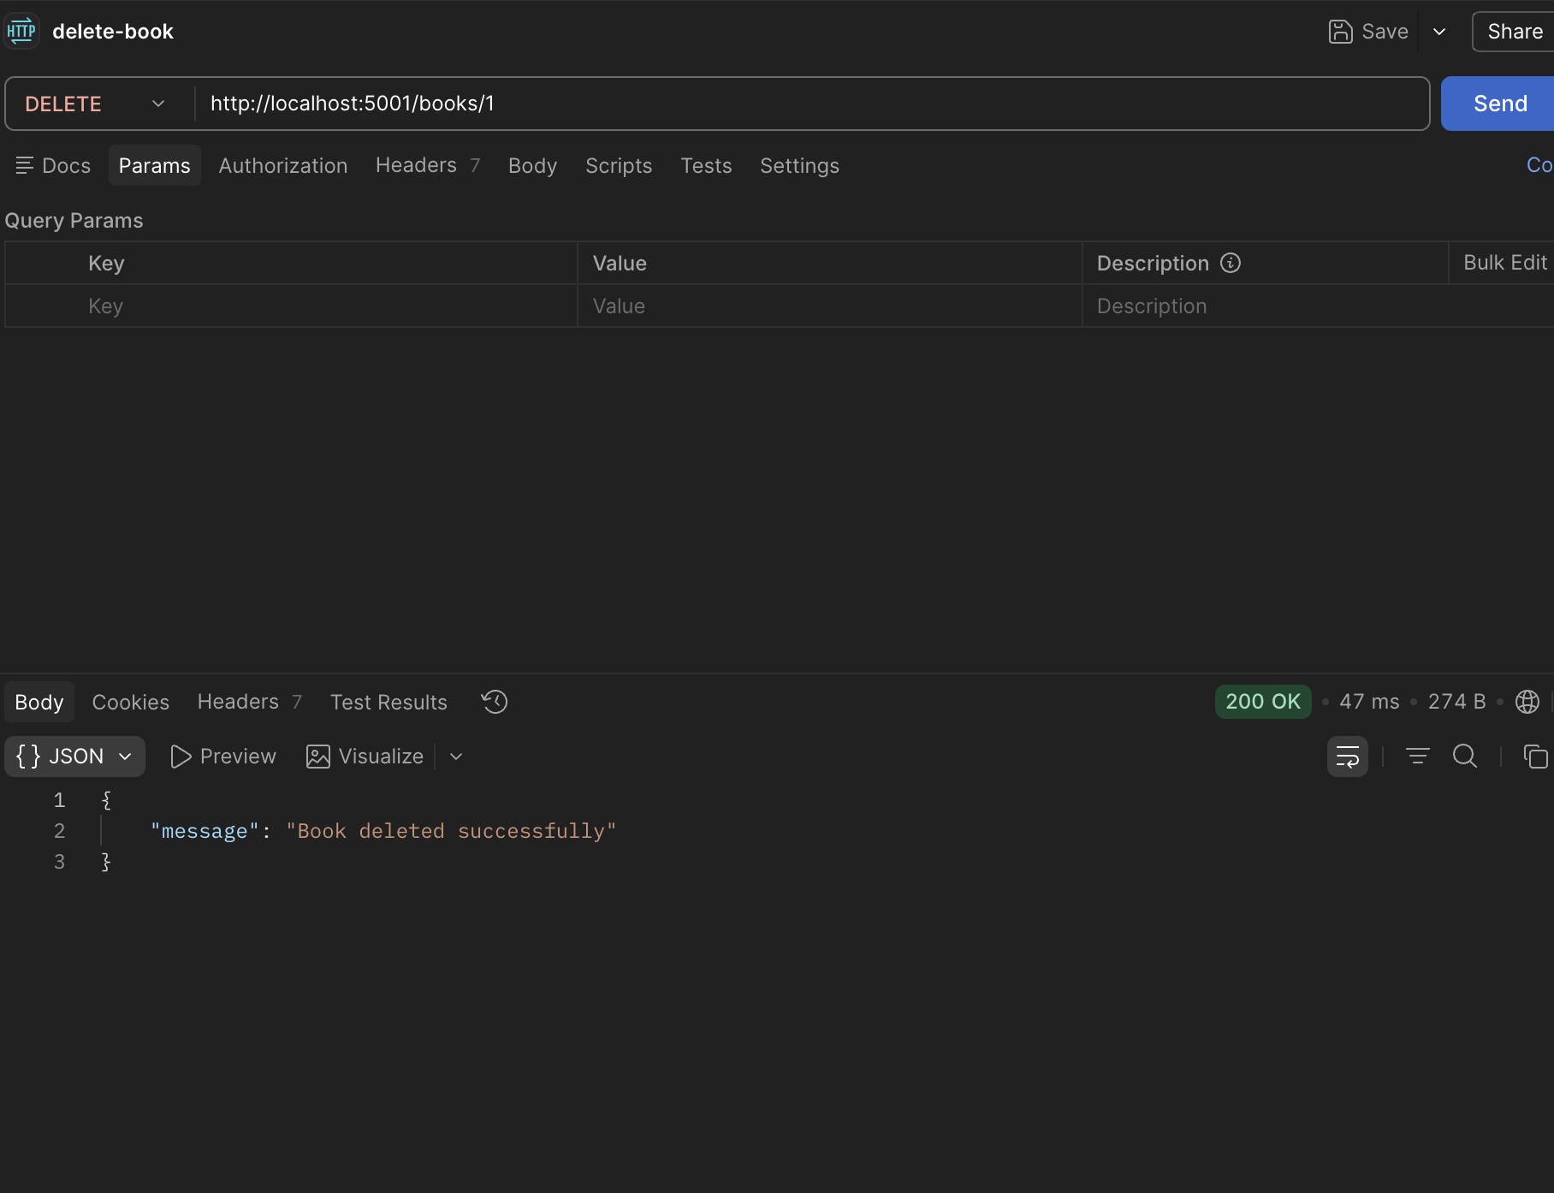

Filter by Status:
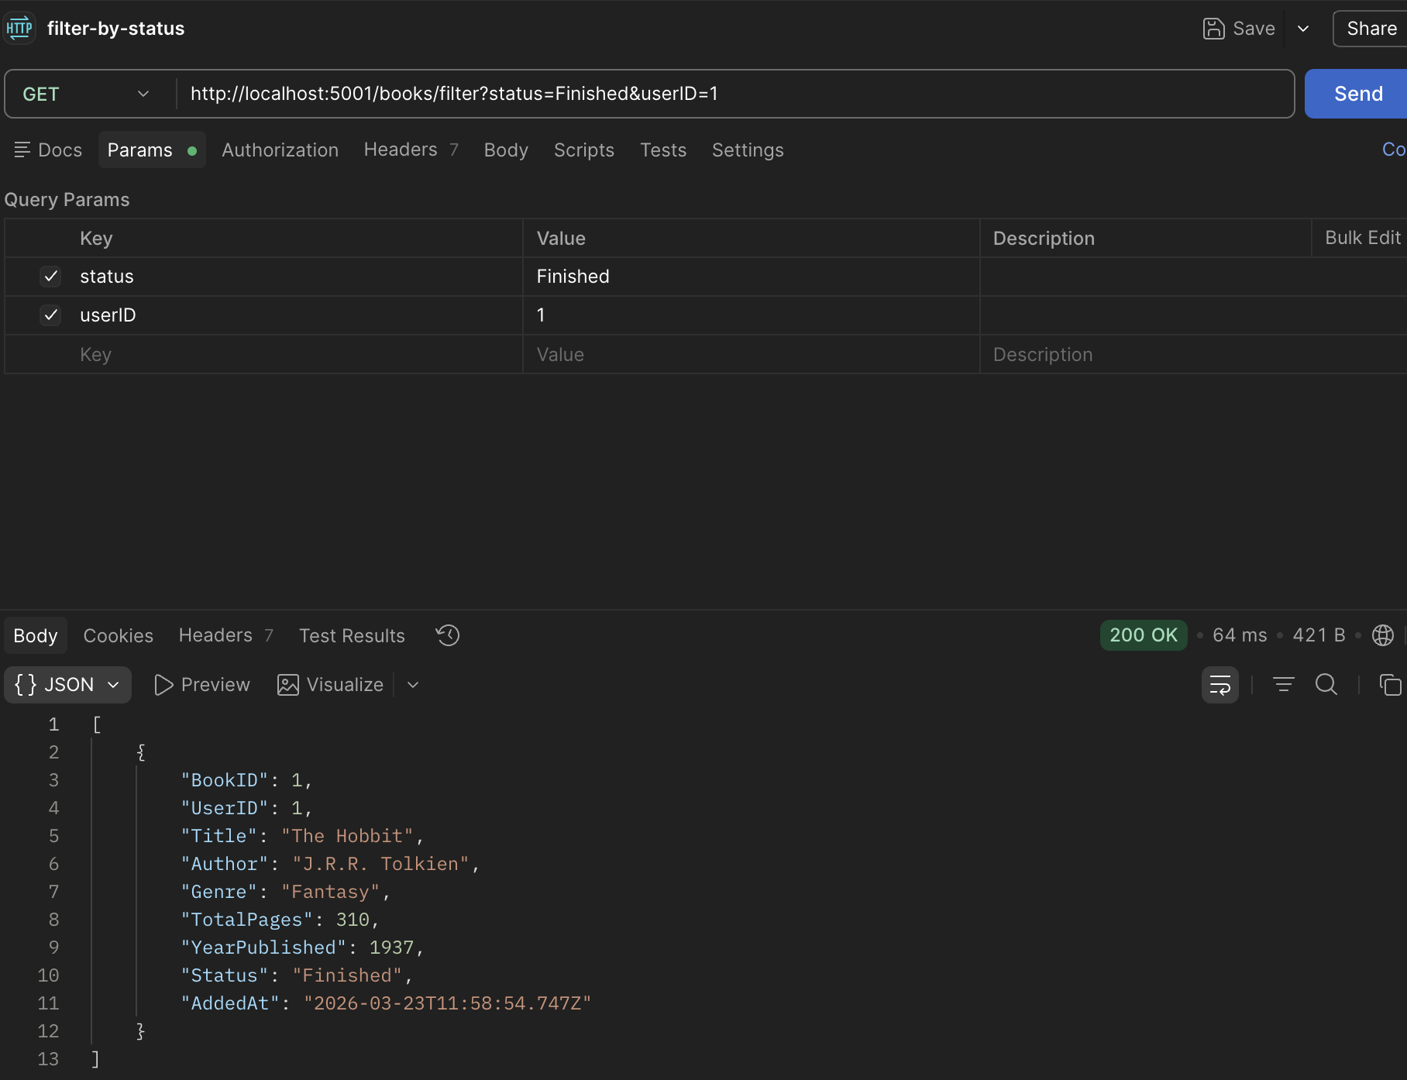
Get Users Books:
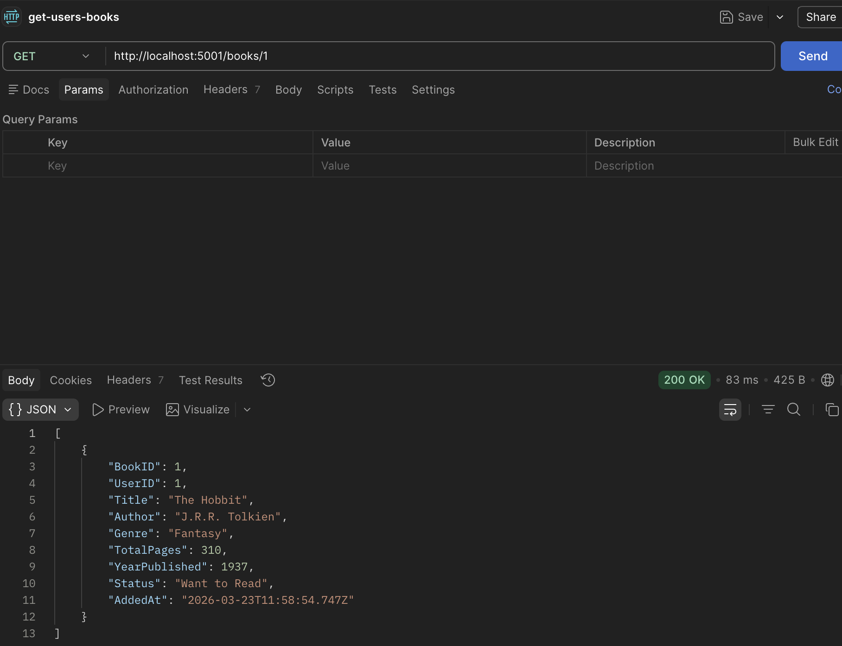

Dashboard:
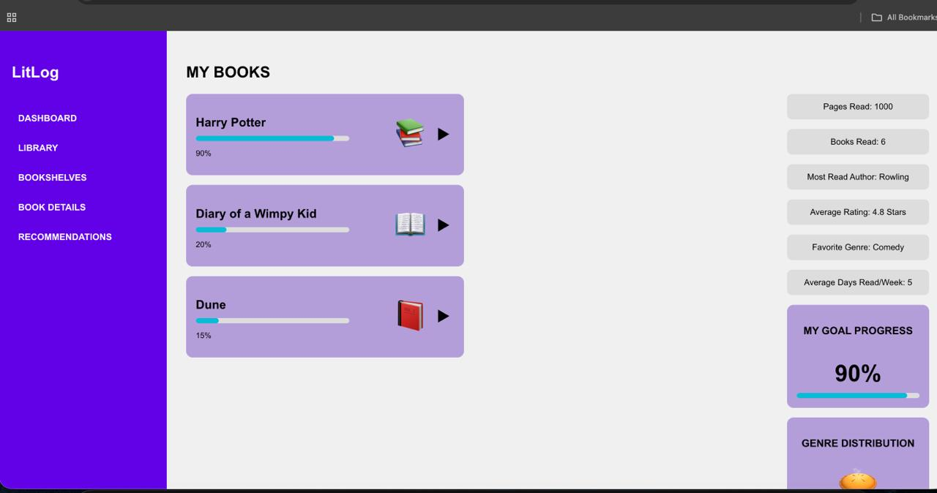

User Login:
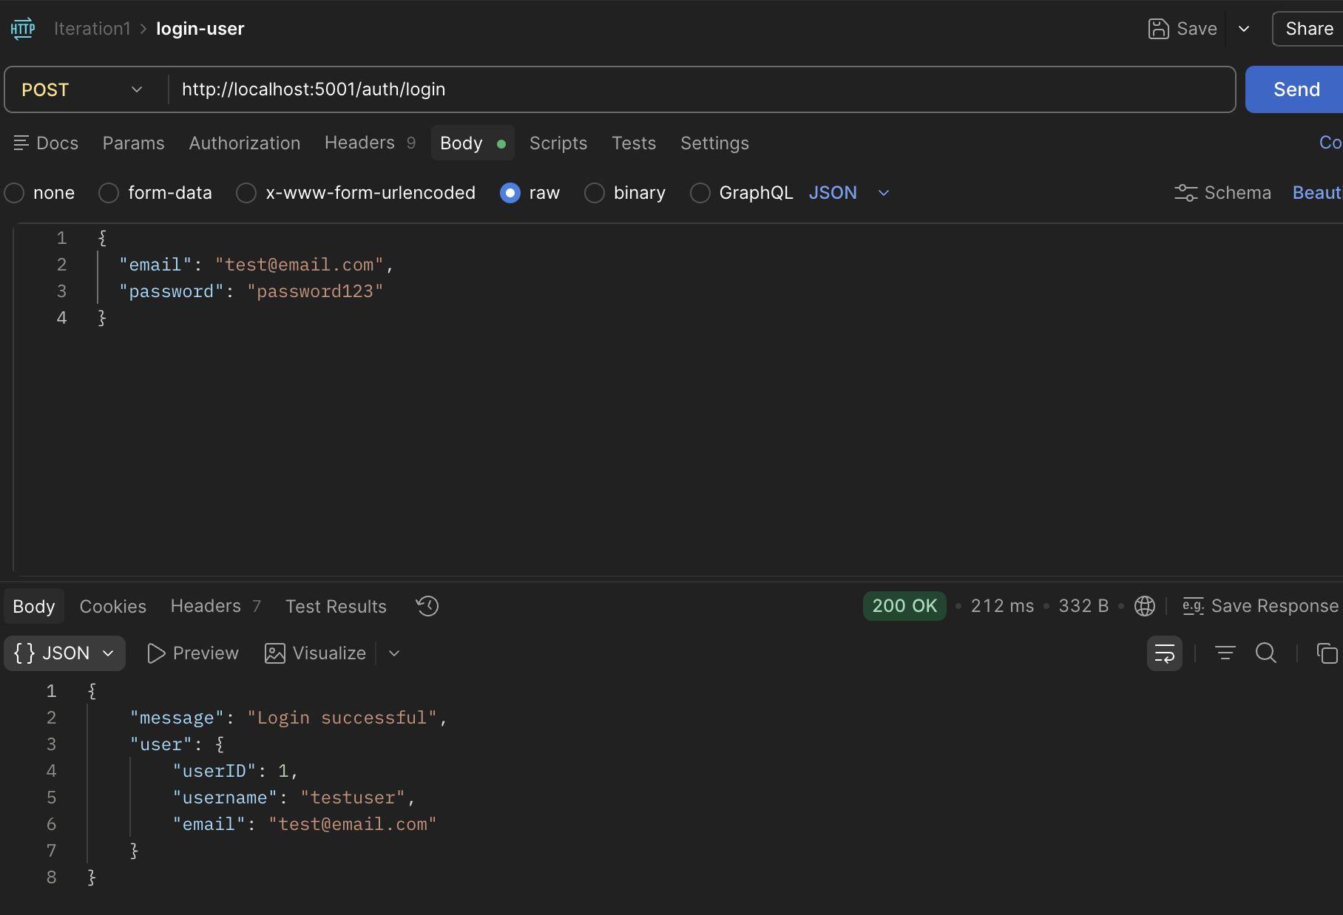

Register New User:
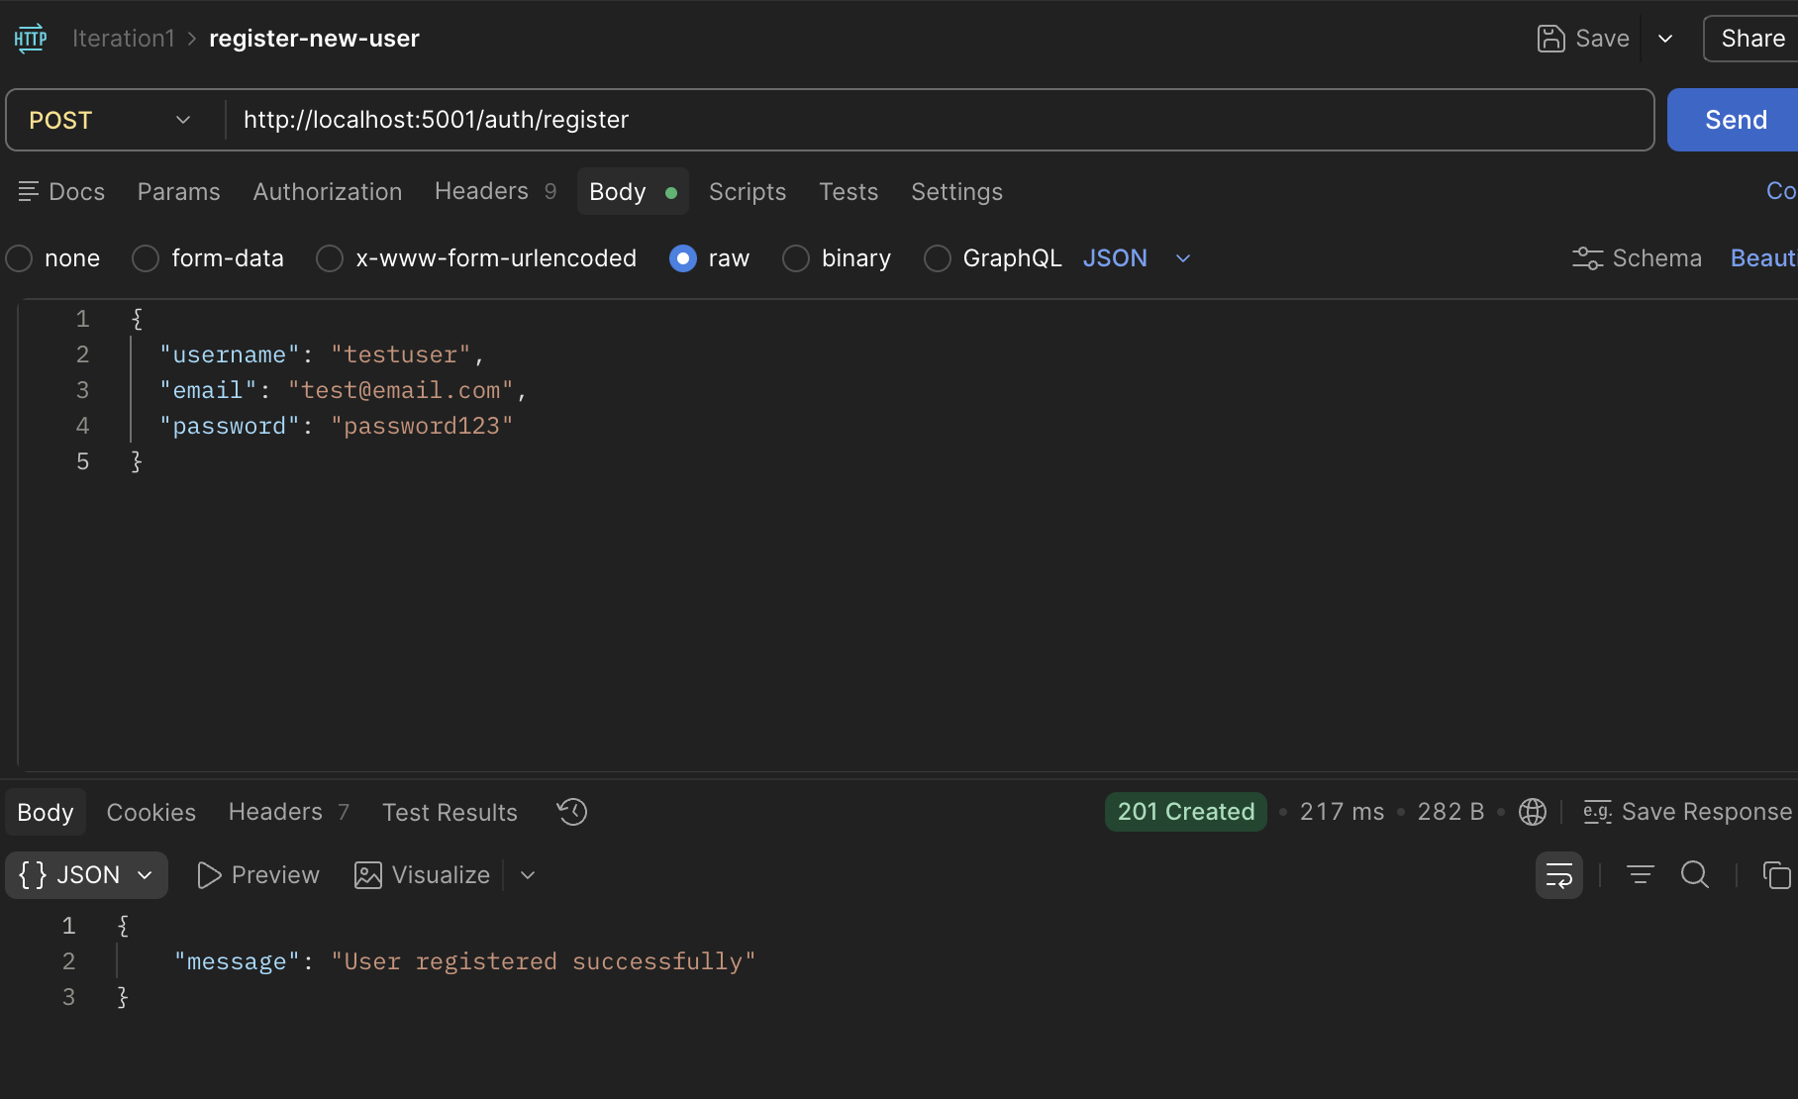

Search Book:
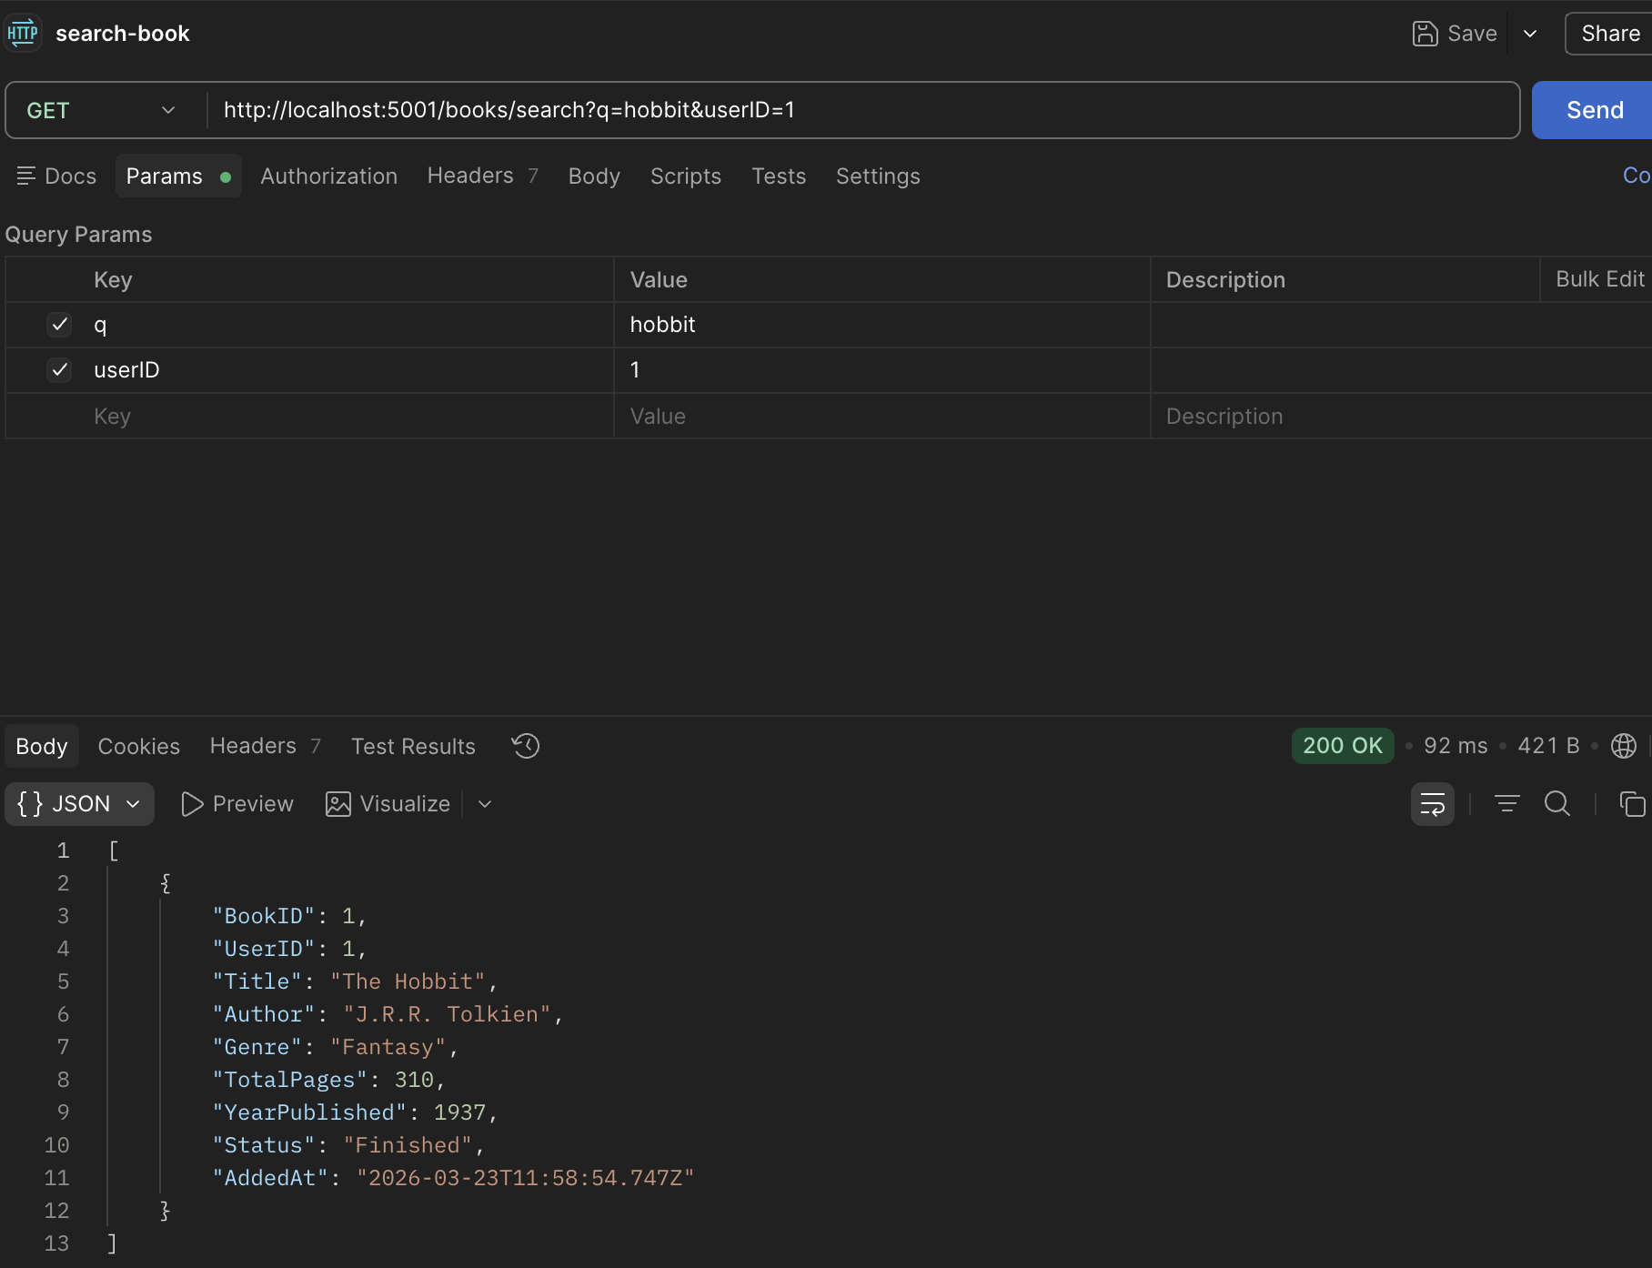
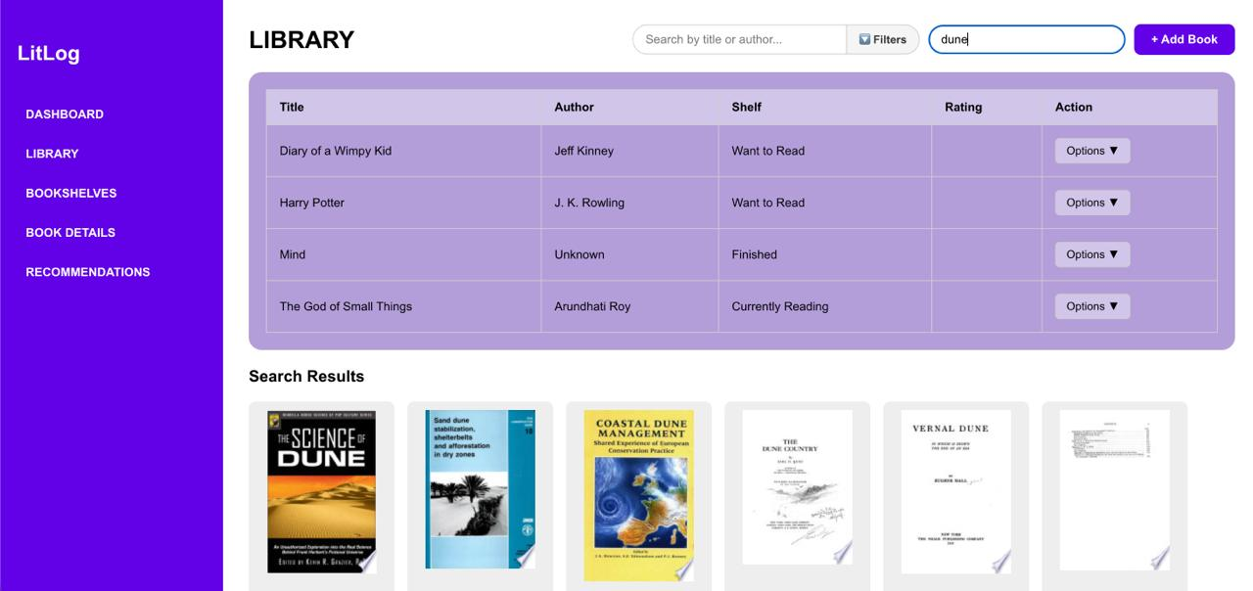
Update Book:
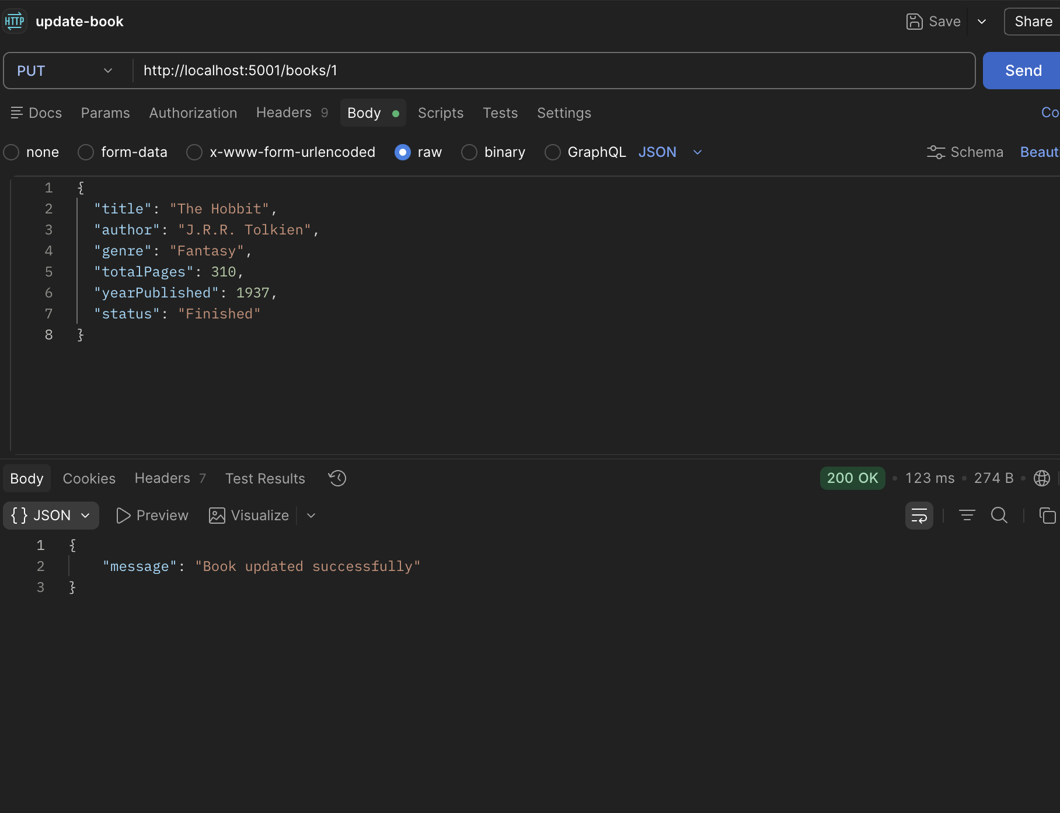
Move the Shelf:
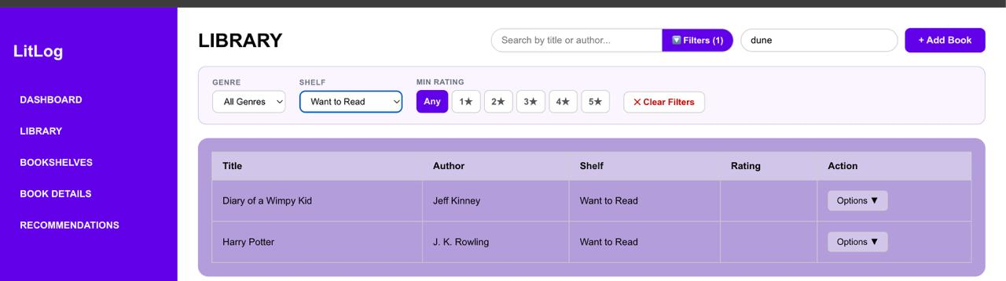
Edit Book:
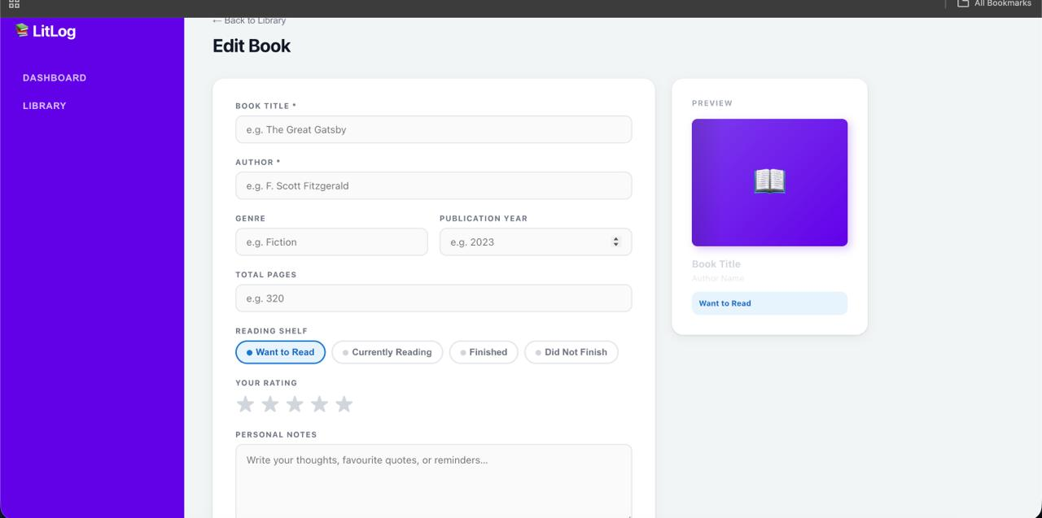

7.Work Division
The following table outlines the contribution of each team member during Sprint 1.
Team Member | Tasks Completed | Role
Khadija Faiz | Sprint backlog, user stories, structured specifications, NFRs, Trello board management, report assembly, database schema, ERD diagram | Scrum Master
Zahra Saeed | Backend: database setup, SQL Server schema, API endpoints, authentication logic, book management, sessions | Backend Developer
Romaisa Sajjad | Frontend: signup, login, add book, bookshelf, shelf management, search and filter UI  Designing C# Windows Forms UI, building Add/Edit/Delete book forms, implementing search and filter screens, end-to-end testing of Sprint 1 features | Frontend Developer

All team members collaborated on sprint planning, daily check-ins, and reviewing each other's work before the final submission. The Team Lead (Khadija Faiz) was responsible for ensuring the documentation matched the implemented features and that all acceptance criteria were verified before the sprint was closed.

