TRANSACCION ATC
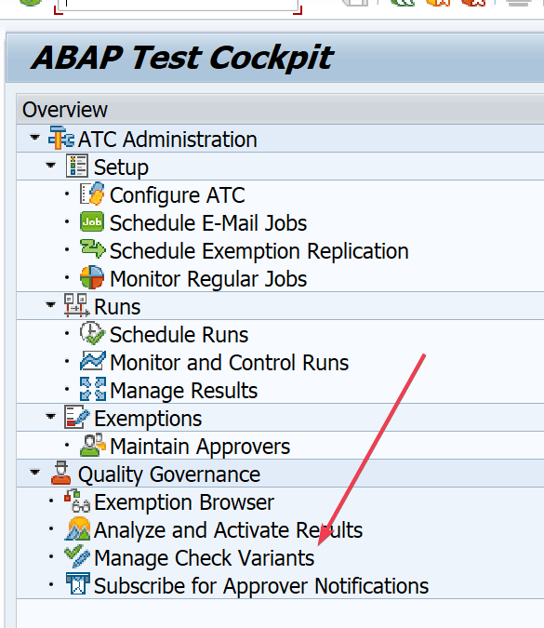

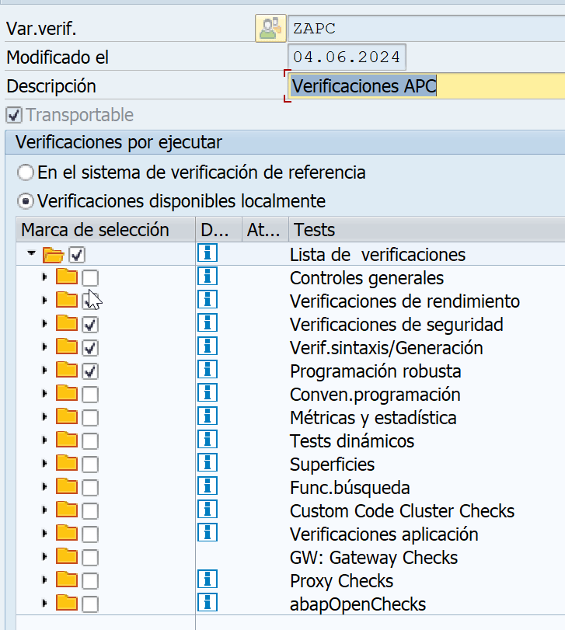

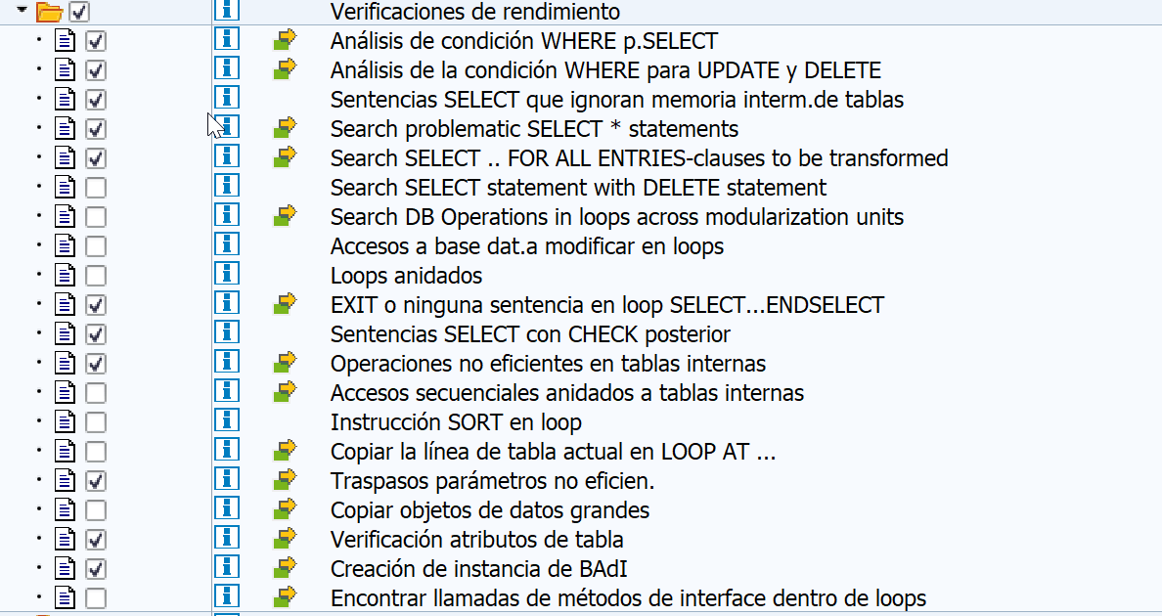
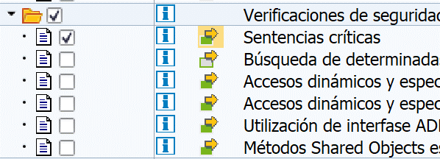
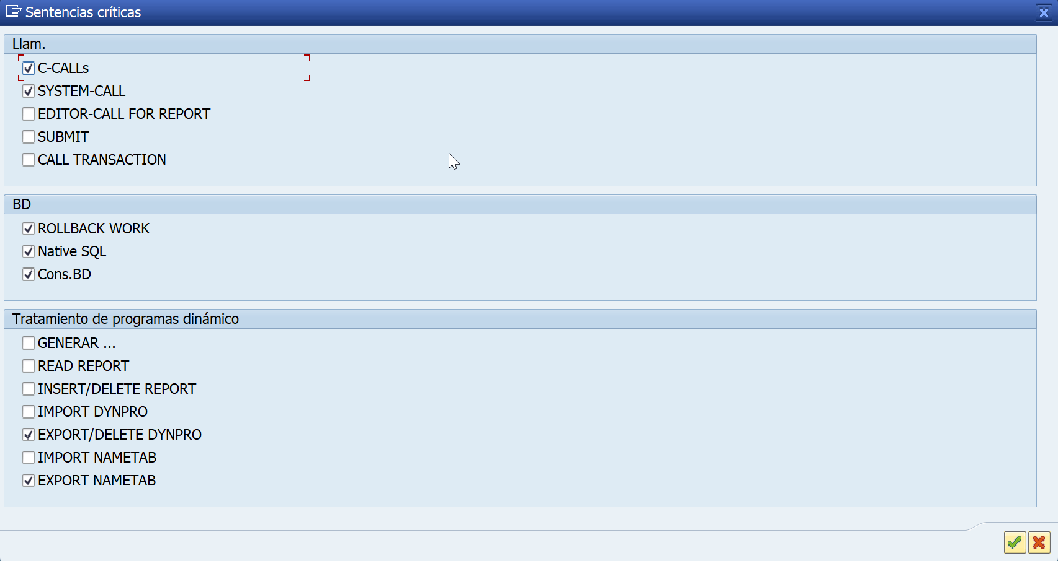

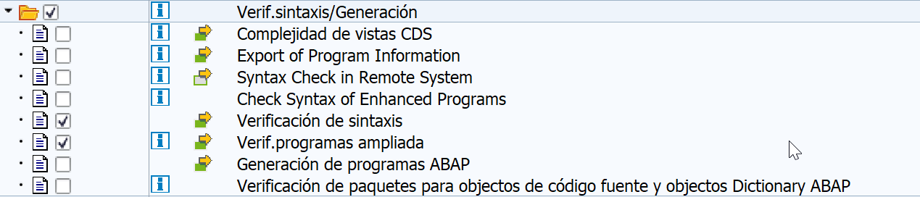

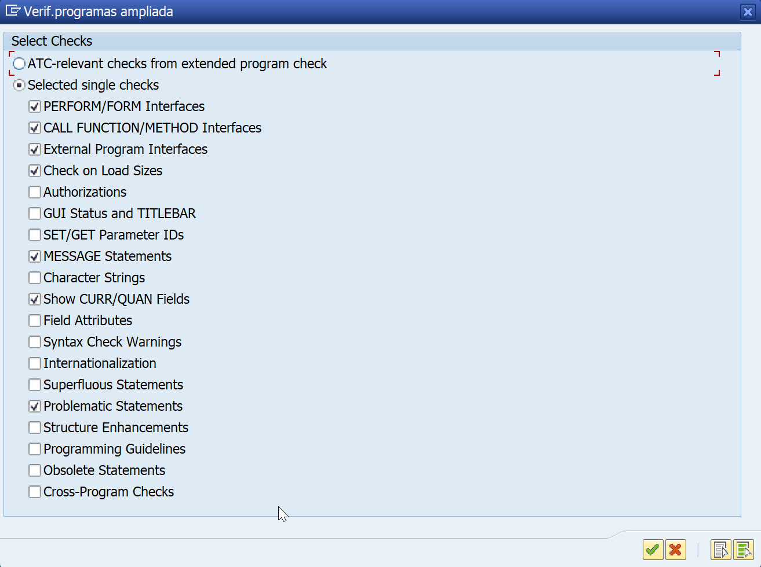

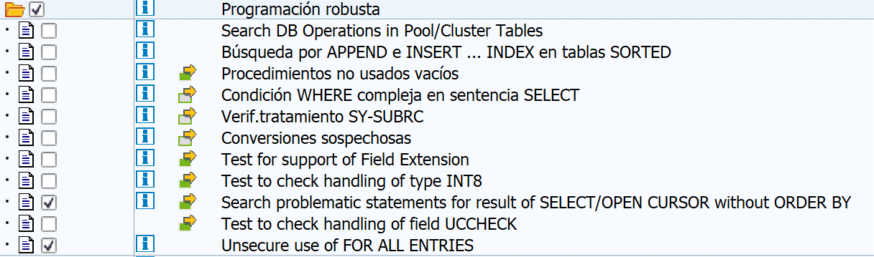

BADI VERIFICACION AUTOMATICA

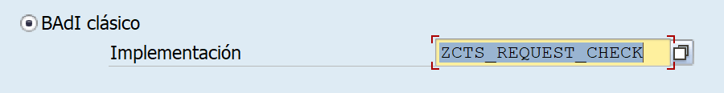
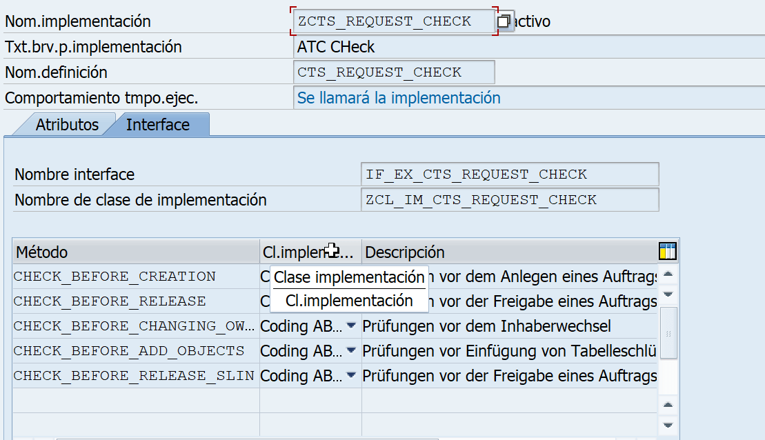

IF_EX_CTS_REQUEST_CHECK~CHECK_BEFORE_RELEASE

METHOD if_ex_cts_request_check~check_before_release.
* DATA: lv_exit TYPE char10.
*
* CALL FUNCTION 'TRINT_TDR_USER_COMMAND'
* EXPORTING
* iv_object = request
* iv_type = 'TASK'
* iv_command = 'CHAO'
* IMPORTING
* ev_exit = lv_exit.
* DATA: lv_field TYPE char70.
* FIELD-SYMBOLS: <fs_okcode> TYPE any.
*
* lv_field = '(SAPLSTR7)GV_OKCODE'.
* ASSIGN (lv_field) TO <fs_okcode>.
* IF <fs_okcode> EQ 'CANC'.
* RAISE cancel.
* ENDIF.
DATA is_ok TYPE abap_bool VALUE abap_true.
* Sólo para usuario APC
IF sy-uname <> zcl_c=>usuario_ap.
RETURN.
ENDIF.
* Sólo en estas transacciones
IF NOT ( sy-tcode = 'SE09' OR sy-tcode = 'YAP' ).
RETURN.
ENDIF.
IF sy-tcode = 'YAP'.
GET PARAMETER ID 'ZNO_VERIF' FIELD DATA(l_no_verif).
IF l_no_verif = 'X'.
RETURN.
ENDIF.
ENDIF.
* Si en alguna OT no queremos verificación ponemos esto
IF text CS '¡!'.
RETURN.
ENDIF.
* Si hemos confirmado previamente una OT, lo miramos, si no a veces entra en bucel.
GET PARAMETER ID 'ZOT' FIELD DATA(l_ot).
IF request = l_ot.
RETURN.
ENDIF.
* Si existe, mejor la variante ZAPC
SELECT SINGLE checkvname FROM scichkv_hd "#EC CI_NOFIRST
INTO @DATA(l_checkvname) "#EC CI_NOORDER
WHERE checkvname = 'ZAPC'.
IF sy-subrc <> 0.
SELECT SINGLE checkvname_new FROM scichkv_alter
INTO @l_checkvname
WHERE checkvname_def = 'TRANSPORT'.
ENDIF.
IF l_checkvname IS INITIAL.
RETURN.
ENDIF.
TRY.
DATA(or_factory) = NEW cl_satc_api_factory( ).
DATA(it_objects) = cl_satc_object_set_factory=>create_for_transport( request )->if_satc_object_set~get_object_keys( ).
DATA(or_objects) = cl_satc_object_set_factory=>create_for_object_keys( it_objects ).
DATA(or_variant) = NEW cl_satc_ci_check_variant( ).
or_variant->set_name( l_checkvname ). " check variant
DATA(l_desc) = |Transport release { request } |.
DATA(or_run_config) = or_factory->create_run_config_with_chk_var( i_object_set = or_objects
i_check_variant = or_variant
i_description = CONV #( l_desc ) ).
DATA(or_run_controller) = or_factory->create_run_controller( or_run_config ).
or_run_controller->run( IMPORTING e_result_access = DATA(or_result_access) ).
or_result_access->get_findings( IMPORTING e_findings = DATA(it_f) ).
LOOP AT it_f ASSIGNING FIELD-SYMBOL(<wa_f>) WHERE ( kind = 'E' OR kind = 'W' ) " errors/warnings
AND exceptn <> 'P'. " pseudo comments and pragmas
is_ok = abap_false.
* EXIT.
IF <wa_f>-kind = 'E'.
DATA(l_error) = 'X'.
ENDIF.
ENDLOOP.
CATCH cx_satc_failure cx_satc_not_found INTO DATA(cx).
DATA(exc_text) = cx->get_text( ).
MESSAGE exc_text TYPE 'E'.
is_ok = abap_false.
CATCH cx_satc_empty_object_set cx_satc_invalid_argument INTO cx. " ok, if transport is empty or contains only non-checkable objects
exc_text = cx->get_text( ).
MESSAGE exc_text TYPE 'S'.
ENDTRY.
IF is_ok = abap_true.
MESSAGE 'Validaciones correctas' TYPE 'S'.
ELSE.
* "we only get the execution ID with this “dirty” cast:
* DATA(or_result_access_int) = CAST CL_SATC_AC_RESULT_ACCESS( or_result_access ).
* or_result_access_int->display_result( ).
SELECT display_id FROM satc_ac_resulth "#EC CI_GENBUFF "#EC CI_BYPASS
INTO @DATA(l_display_id)
UP TO 1 ROWS
WHERE title = @l_desc
AND chk_profile_name = @l_checkvname
AND scheduled_by = @sy-uname
ORDER BY scheduled_on_ts DESCENDING.
ENDSELECT.
IF sy-subrc = 0.
CALL FUNCTION 'SATC_AC_DISPL_RESULT_BY_EXEC'
EXPORTING
i_execution_id = l_display_id
EXCEPTIONS
xpt_no_results = 1
xpt_not_authorized = 2
xpt_display_used = 3
OTHERS = 4.
ENDIF.
IF sy-subrc <> 0.
MESSAGE 'Errores de ATC revise objetos' TYPE 'I'.
ENDIF.
IF l_error = 'X'.
DATA(l_titulo) = 'Errores de verificación'.
ELSE.
l_titulo = 'Advertencias en verificación'.
ENDIF.
IF zcl_ap_popup=>confirmar( titulo = l_titulo
texto = 'Confirme si desea seguir liberando'
opcion = 'N' ) = 'X'.
IF l_error = 'X'.
IF zcl_ap_popup=>confirmar( titulo = 'Errores de verificación'
texto = '¿Realmente estás seguro?'
opcion = 'N' ) = ''.
RAISE cancel.
ENDIF.
ENDIF.
ELSE.
RAISE cancel.
ENDIF.
ENDIF.
SET PARAMETER ID 'ZOT' FIELD request.
ENDMETHOD.

MODIFICACIONES AL ESTANDAR PARA PODER BUSCAR ULTIMAS OTS

* INCLUDE LSCTSREQFH1
*FORM user_command_0110.
*
* CASE sy-ucomm.
* WHEN 'AT_LINE_DELETE'.
* PERFORM delete_attribute.
* ENDCASE.
*
* if sy-ucomm = 'F4' AND SY-UNAME = ZCL_C=>USUARIO_aP.
* PERFORM f4_se09 IN PROGRAM ZAP_OTS CHANGING TRheader.
* ENDIF.
*

*INCLUDE LSTR8F01
*FORM user_command.
* DATA: lv_ok TYPE c,
* lv_answer TYPE c,
* lv_del_idx TYPE i.
*
* IF SY-UNAME = ZCL_C=>USUARIO_AP AND KO013-AS4TEXT IS INITIAL.
* FIELD-SYMBOLS <FS>.
* ASSIGN ('(SAPLSEDTATTR)TRDIR-NAME') TO <FS>.
* PERFORM f4_se09_OBJ IN PROGRAM ZAP_OTS USING <FS> CHANGING KO013-AS4TEXT.
* ENDIF.

