Riding The Wind 설계서

목차

1. Work Breakdown Structure

2. Usecase Diagram

3. Entity Relation Diagram

4. Class Diagram

5. Screen Design

Work Breakdown Structure

Usecase Diagram

Entity Relation Diagram

Class Diagram

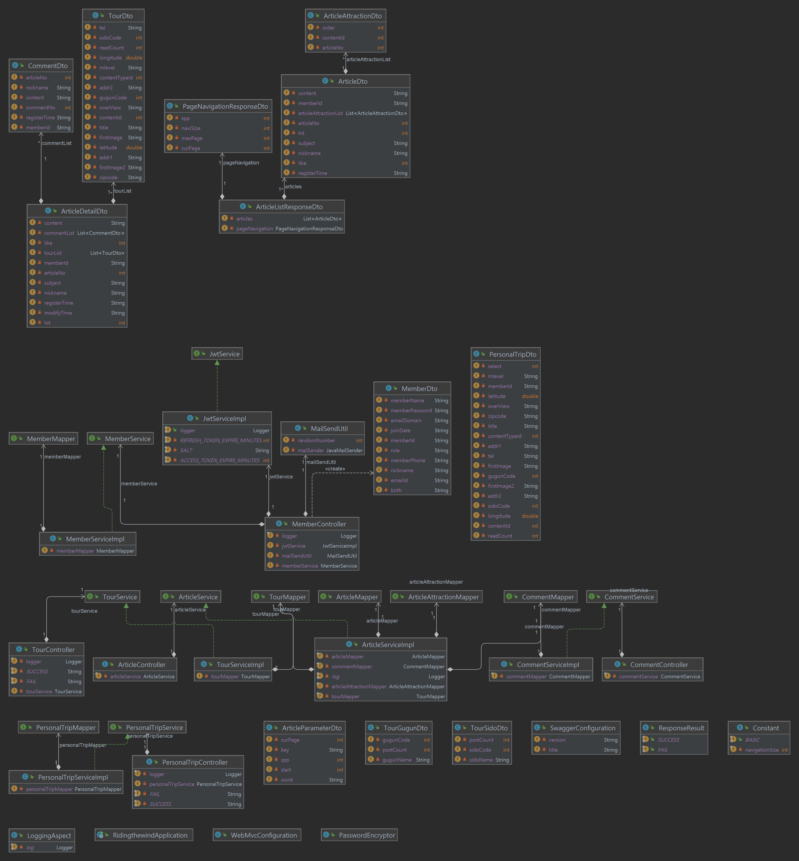

Screen Design