# 论文1

## 建筑施工企业青年员工离职倾向影响因素研究 （建管系）

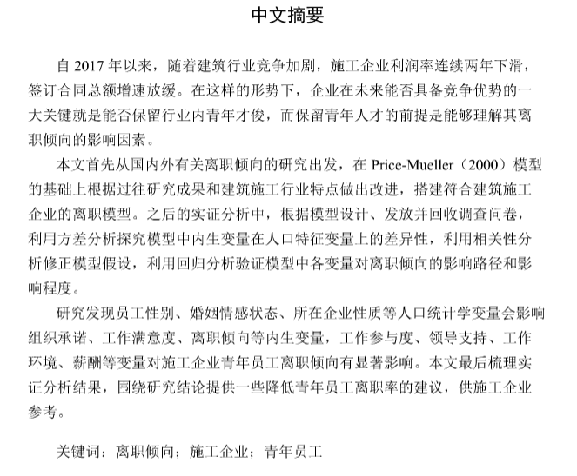

ABSTRACT

Since 2017, with the intensification of competition in the construction industry, the profit **rate** of construction companies has declined for two consecutive years, and the growth rate of total contracted contracts has slowed down. Under such circumstances, one of the keys to whether a company can have a competitive advantage in the future is whether it can retain young talents in the industry. The premise of retaining young talents is to understand the influencing factors of their turnover intention.

This paper starts from the research on turnover intention at home and abroad, **and** revises the Price-Mueller (2000) model based on the past research results and the characteristics of the construction industry. In the subsequent empirical analysis, I issued and recycled questionnaires according to the model design, used variance analysis to explore the differences of endogenous variables **regarding to** the population characteristics variables, used correlation analysis to correct model hypotheses, and used regression analysis to verify the paths and their impacts in the model.

The study finds that demographic variables such as employee gender, marital emotional state, and the nature of the company **will** affect endogenous variables such as organizational commitment, job satisfaction, and turnover intention. Work participation, leadership support, work environment **and** salary have a significant impact on employee turnover. At the end of the paper, the results of empirical analysis are sorted out, and some suggestions for reducing the turnover rate of young employees are provided for reference by construction companies.

总结：这篇文章的问题主要是时态方面，作者基本上用的是一般现在时。但是在叙述具体**调查过程、描述自己做过的工作**的时候，一般用过去时态；阐述研究结果/实验结果时，所用的时态存在争议。（见附录）

# 论文2

## 水泥基材料水蒸气吸附特性研究 （土木系）

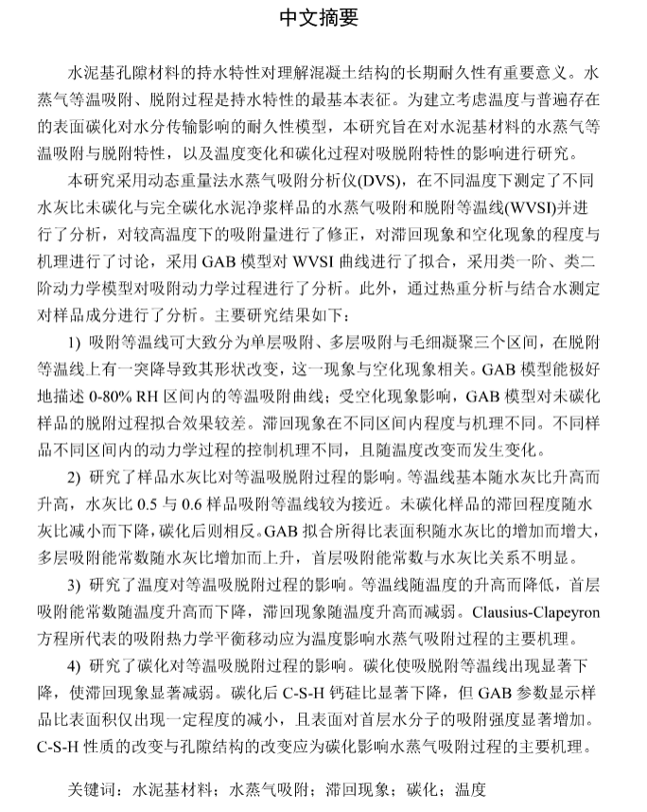

ABSTRACT

Moisture properties of cement-based porous materials are of crucial importance for comprehending the long-term durability of concrete structures, which is commonly characterized by the water vapor sorption processes at a constant temperature. ln order to establish a durability model which takes temperature effect and surface carbonation into consideration, this study aims at investigating the water vapor sorption characteristics of cement-based materials**, and** analyzing the influence of temperature and carbonation on the sorption processes.

Water vapor sorption experiments were conducted with a dynamic vapor sorption (DYS) instrument in this study, on a series of noncarbonated and carbonated **hcp** samples with different w/c ratios at different temperatures. **The sorption isotherms (WVSI)** were investigated and the moisture content measured at higher temperatures **were** calibrated with experimental data. The extents and mechanisms of **hysteresis and cavitation phenomenon** were discussed. The GAB model was applied to fit the WVSIs, the pseudo-first order and pseudo-second order equations were adopted to fit the sorption kinetic processes. In addition, thermogravimetric analysis and measurement of chemically bound water were conducted on the samples to determine the compositions of samples. The main results are as follows.

1) The adsorption isotherms can be divided into three parts, according to the mechanisms of monolayer adsorption, multilayer adsorption and capillary condensation. A sudden drop of moisture content was observed in the desorption isotherms, which is believed to be related to cavitation phenomenon **occurred** in the gel pores. The GAB model can perfectly describe the adsorption isotherms, while being not suitable for describing the desorption isotherms of noncarbonated samples due to cavitation phenomenon. The extents and mechanisms of hysteresis phenomenon are different in different RH stages. The corresponding models and controlling mechanisms of sorption kinetics differ with RH stages, samples and temperatures**;**

2) The influence of w/c ratios **was** researched. The isotherms rise with higher w/c ratios, and the adsorption isotherms of samples with w/c = 0.5 and 0.6 are close to each other. For noncarbonated samples, the hysteresis decreases with lower w/c ratios, while the tendency is reversed for carbonated samples. ln terms of GAB parameters, the specific surface area and the multilayer adsorption energy constant increase with **higher w/c ratio**, while the monolayer adsorption energy constant shows no obvious relationship with w/c ratio;

3) The influence of higher temperatures on WVSIs was investigated. The isotherms are lowered and the monolayer adsorption constant reduces with higher temperatures, indicating that the sorption processes are hindered by rising temperatures. The hysteresis phenomenon **are** weakened at higher temperatures. The temperature dependency of sorption isotherms was analyzed with Clausius-Clapeyron equation, which describes the shift of thermodynamic sorption equilibrium induced by the increase of temperature; and

4) The influence of carbonation on WVSIs was investigated. Carbonation can significantly reduce the moisture content at equilibrium and weaken the hysteresis phenomenon. The GAB parameters show that the specific surface area decreased modestly and the sorption energy of surface increased significantly after carbonation, while the Ca/Si ratios of C-S-H in the carbonated samples are notably reduced. The impact of carbonation process on sorption isotherms **are** attributed to the alternation of C-S-H composition and structure, along with the lower pore distribution in the 1-9 nm radius range.

# 论文3

## 钢-混凝土组合渡槽设计与受力性能研究 （土木系）

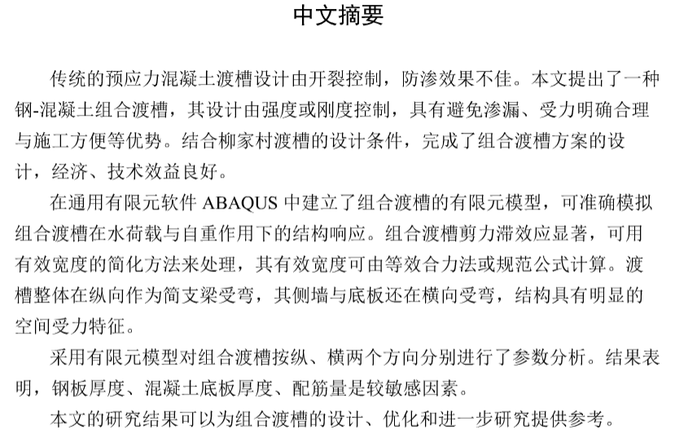

ABSTRACT

The design of traditional prestressed concrete aqueducts is controlled by avoiding cracking. Nevertheless, those aqueducts are plagued by the leakage problem. This dissertation presents one kind of steel-concrete composite aqueduct whose design is controlled by strength or stiffness. Composite aqueducts possess advantages such as good leakage prevention, explicit and reasonable load path, convenient construction, etc. The structural design of a composite aqueduct is completed according to the condition of Liujiacun aqueduct, realizing favorable economic and technical **benefit**.

A finite element model based on the general FE software ABAQUS is proposed to simulate the structural response of the composite aqueduct precisely. **Obvious** shear lag effect is observed in the analysis, which can be simply dealt **with** adapting effective width. The effective width of composite aqueducts can be calculated using equivalent force method or code formulas. As a simply supported beam, the composite aqueduct is under bending in the longitudinal direction. In the meanwhile, its bottom flange and two webs are under bending in the transverse direction so that the whole structure demonstrates conspicuous spatial stress characteristics.

Based on the proposed model, several parameter analyses of the composite aqueduct are conducted in the longitudinal direction and the transverse direction, respectively. The results show that thickness of the steel plate, thickness of the concrete bottom flange and reinforcement amount are relatively sensitive parameters.

The results in this dissertation can provide reference for the design, optimization and further study of composite aqueducts.

# 论文4

## 磷建筑石膏发泡保温砌块的制备及性能研究（土木系）

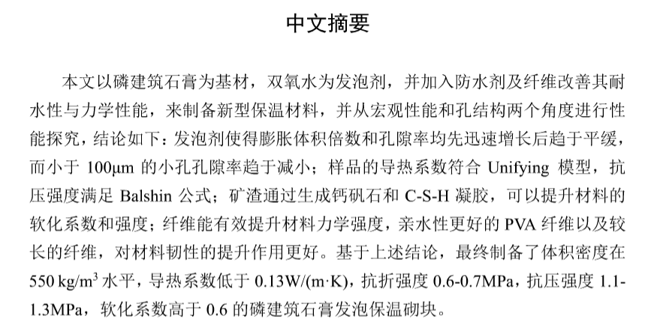

ABSTRACT

In this paper, a novel foam insulation material is prepared with phosphorus building gypsum as raw material, hydrogen peroxide as **foaming agent**, and waterproof agent and fiber added to improve the water resistance and mechanical properties. The performance of the sample is studied from macroscopic performance and pore structure, and the following conclusions can be drawn: with increasing H2O2 content, the expansion volume **multiple** and the total porosity **increase** rapidly first and then **plateau**, while the **micro porosity** tends to decrease; the thermal conductivity of the sample is in accordance with the Unifying model, and the compressive strength conforms to the Balshin formula; the slag can increase the softening coefficient and strength of the material by forming ettringite and C-S-H gel; the fiber can effectively increase the strength of the sample, **and** the longer PVA fiber with better hydrophilicity **have** a better effect on the toughness of the sample. Based on the above investigation, the phosphorus building gypsum foam insulation block has a bulk density of 550kg/m3, a thermal conductivity of less than 0.13W/(m·K), a flexural strength of 0.6-0.7MPa, a compressive strength of 1.1-1.3MPa, and a softening coefficient of more than 0.6.

# 论文5

## 微重力条件下的颗粒流变研究 （土木系）

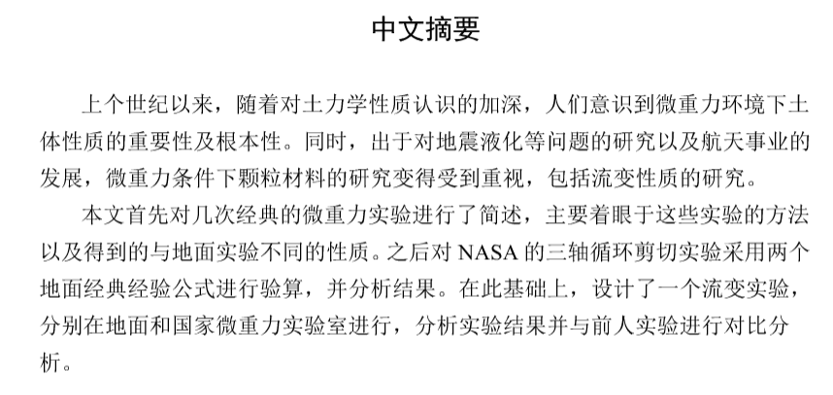

ABSTRACT

Since the last century, with the deepening of the understanding of the nature of soil mechanics, people have realized the importance and fundamentality of the soil properties in the microgravity environment. At the same time, due to the research on seismic liquefaction and other issues**, and** the development of aerospace industry, the research of granular materials under microgravity conditions has received attention, including the study of rheological properties.

In this paper, several classic microgravity experiments **are** briefly described, focusing on the methods of these experiments and the different properties obtained from ground experiments. Afterwards, NASA's three-axis cyclic shear test was performed using two ground classic empirical formulas and the results were analyzed. On this basis, a rheological experiment was designed, which was carried out **in the ground** and national microgravity laboratories, and the experimental results were analyzed and compared with previous experiments.

# 论文6

## 循环荷载作用下土工合成材料加固路基超重力试验研究（水利系）

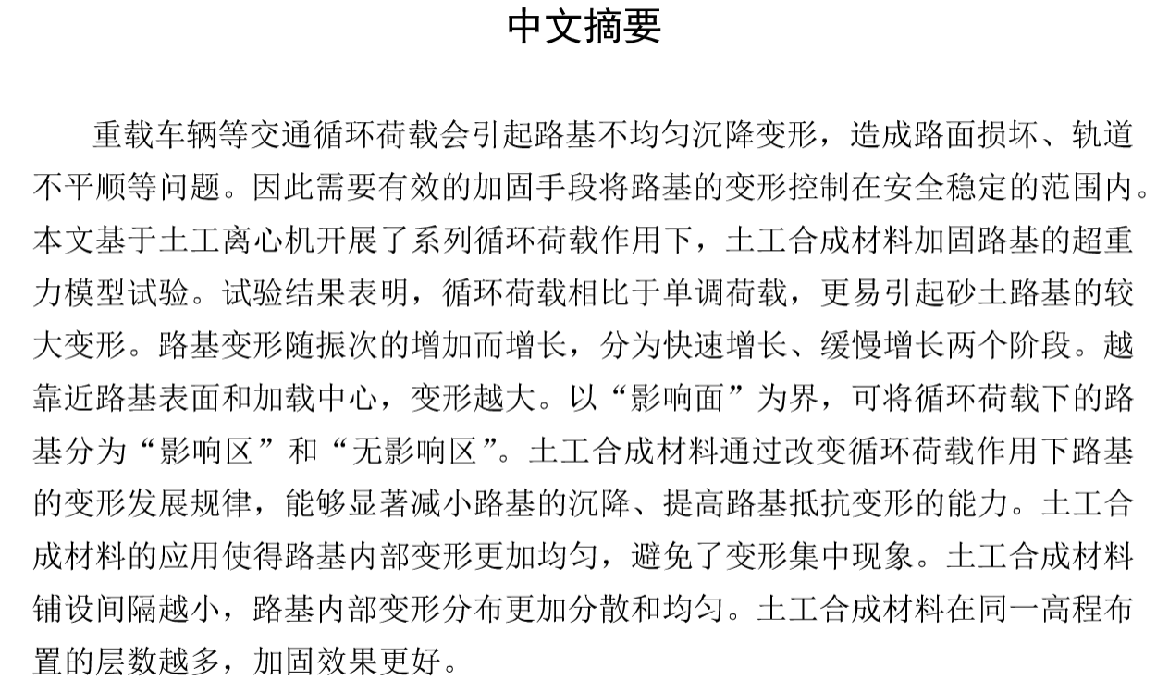

ABSTRACT

The uneven deformation of roadbed will cause serious safety accidents, which is easily caused by the cyclic load of overload vehicles. Therefore, effective reinforcement is necessary to control the deformation of roadbed in a safe and stable range. Based on the geotechnical centrifuge, the supergravity model test of geotextile reinforced roadbed under a series of cyclic loads is carried out in this paper. The test results show that cyclic load is more likely to cause obvious deformation of sand roadbed than monotonic load. The deformation of roadbed increases with the increasing vibrations. The deformation could be divided into two stages, rapid **growthandslow** growth. The larger deformation appears near the roadbed surface and loading center. The roadbed under cyclic load can be divided into influence zone and non-influence zone **when** the influence surface is taken as the boundary. The geotextile can significantly reduce the vertical displacement settlement of roadbed and improve the resistance to deformation. The application of geotextile makes the deformation inside the roadbed more **uniformand** avoids deformation concentration. Reducing the distance between geotextile can make the deformation distribution more uniform. Increasing the thickness of geotextile at the same elevation can improve the reinforcement effect.

# 论文7

## 夏玉米生长变化对蒸散发的影响（水利系）

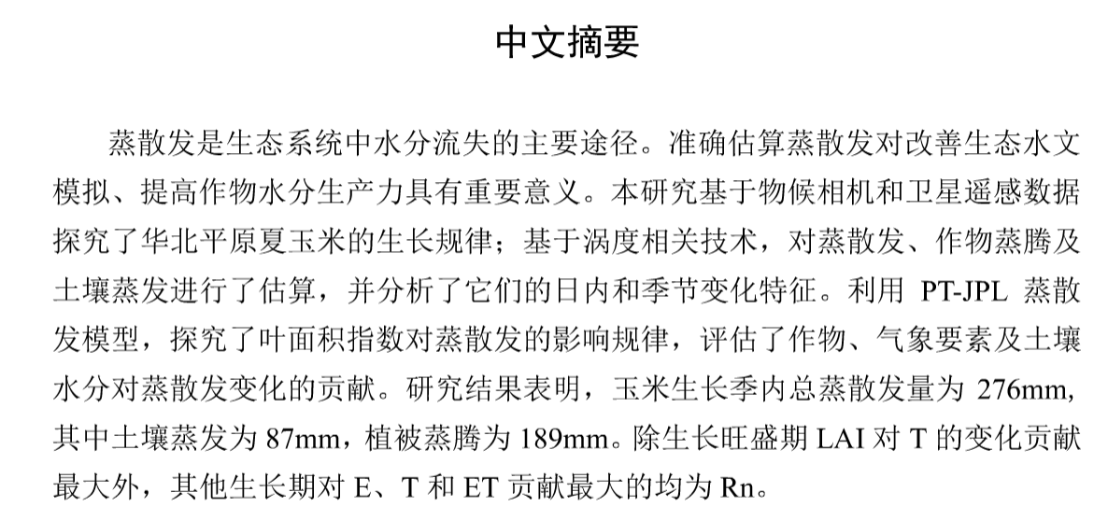

ABSTRACT

Evapotranspiration (ET) is the main pathway for water loss in an ecosystem. Accurate estimation of evapotranspiration and its components is of great significance for improving ecohydrological modelling and increasing crop water productivity. In this study, we explored the growth regulation of summer maize in the North China Plain based on the phenological camera and satellite remote sensing data. We also estimated evapotranspiration, crop transpiration (T) and soil evaporation (E) based on the eddy covariance **(EC)**technique. Then the characteristics of their diurnal and seasonal variations were analyzed. In addition, **using the PT-JPL model**, the effect of leaf area index on evapotranspiration was explored, and the **contribution** of vegetation, meteorological factors and soil water content to evapotranspiration was evaluated respectively. The results showed that the **seasonalcumulative** ET was 276mm, where E was 87 mm and T was 189 mm. The most contributing factor to T during the boom period was LAI, and the greatest contribution to E, T and ET in other growth **petiods** came from net radiation.

# 论文8

## 苏禄海海啸风险的数值模拟研究（水利系）

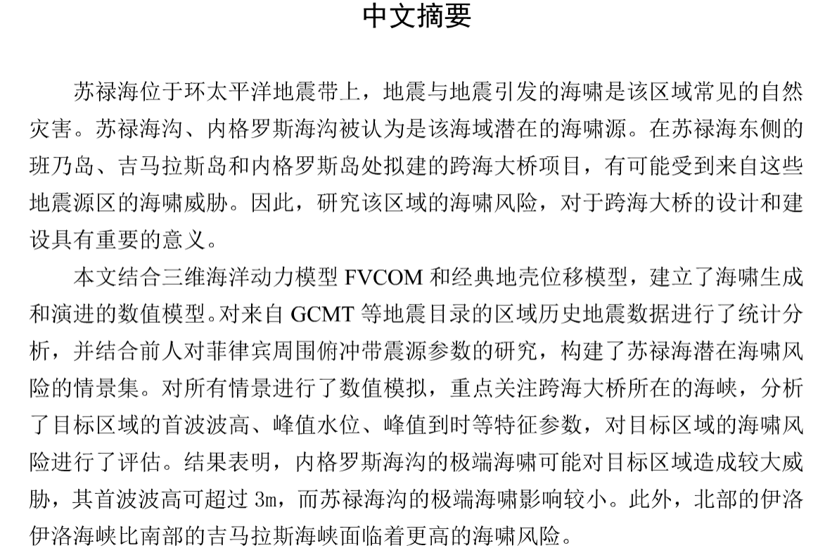

ABSTRACT

**Sulu Sea** is located on the Pacific Rim seismic belt. Earthquakes and seismic tsunamis are common natural disasters in this region. **Sulu Trench and Negros Trench** are considered as potential sources of **seismic tsunami**. The proposed sea-crossing bridges connecting Panay Island, Guimaras Island and Negros Island are likely to be threatened by tsunamis from these trenches. Therefore, a study on tsunami risk in this region is of great significance for the design and construction of the sea-crossing bridges.

A numerical model of tsunami generation and propagation is established by combining the 3D hydrodynamic model FVCOM and Okada's model on surface deformation due to shear and tensile faults. A set of potential tsunami scenarios in Sulu Sea is constructed based on the statistical analysis of the regional historical seismic data from the Global Centroid Moment Tensor Project and previous studies on the focal parameters of the subduction zone around the Philippines. Focusing on the Strait where the sea-crossing bridge is located, all scenarios are simulated. The characteristic parameters such as the arrival time of **tsunami wave**, the wave height and peak value of the first large wave are analyzed, and the tsunami risk in the target area is evaluated. It is found that the extreme tsunami generated from the Negros Trench **pose** a greater threat to the area of concern, which can cause **3m tsunami** in the west mouth of Hoilo Strait, and the risk from the Sulu Trench is much lower. In addition, the Iloilo Strait in the north faces a higher tsunami risk than the **Gimaras** Strait in the south.

# 论文9

## 典型堰塞湖冲刷泄洪模拟与分析（水利系）

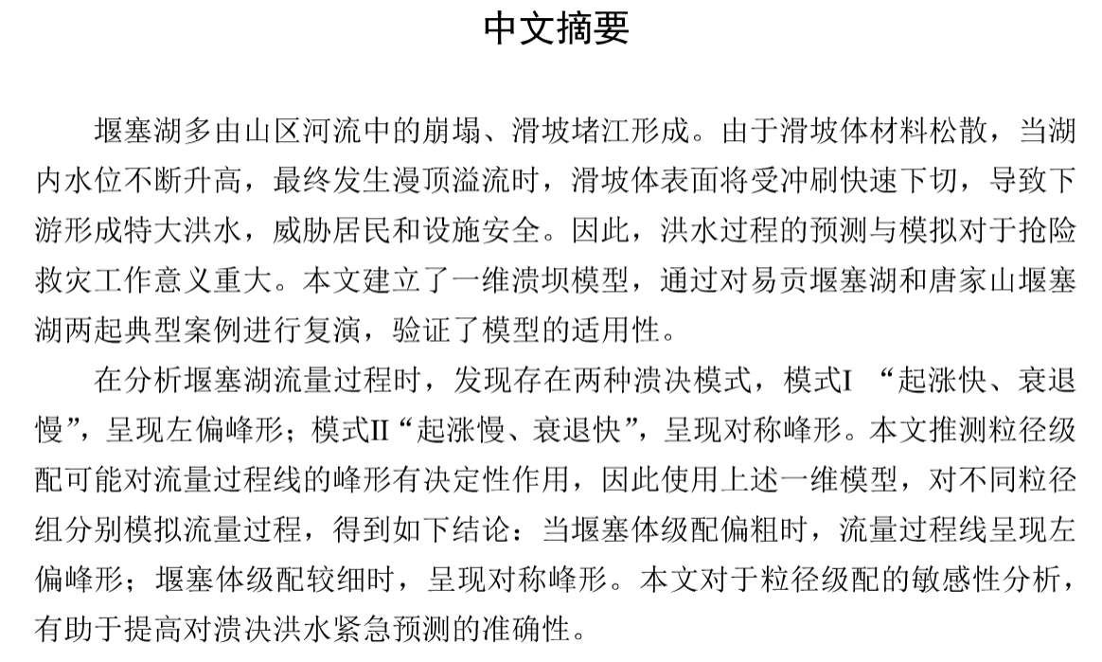

ABSTRACT

The barrier lake is usually formed by collapse and landslides in mountain rivers. Because of the loose material of the landslide surface, when the water level in the lake keeps rising and eventually overtopping overflow occurs, the surface of the landslide body will be eroded and cut down rapidly, resulting in the formation of huge floods downstream and threatening the safety of residents and facilities. Therefore, the prediction and simulation of flood process **is** of great significance for emergency. This article uses a one-dimensional dam-break model, and verifies the applicability of the model by simulating two typical cases of Yigong and Tangjiashan barrier lakes.

In the analysis of the discharge process of the barrier lake, two kinds of dam-break modes are found: mode I, "rising fast, declining slowly", showing a left-sided peak shape; mode II, "rising slowly, declining fast", showing a symmetrical peak shape. This article speculates that grain size distribution of the dam may play a decisive role in the peak shape of **flow process line**. Therefore, the one-dimensional model is used to simulate the flow process for different GSD groups. The following conclusions are drawn: when the gravel of the dam is rough, the flow process line presents a left-sided peak shape; when the gravel of the dam is fine, it presents a symmetrical peak shape. The sensitivity analysis of grain size distribution in this article is helpful to improve the accuracy of emergency prediction of **dam-break flood**.

# 论文10

## 极端冷环境下人体热舒适特征及改善措施研究（建筑学院）

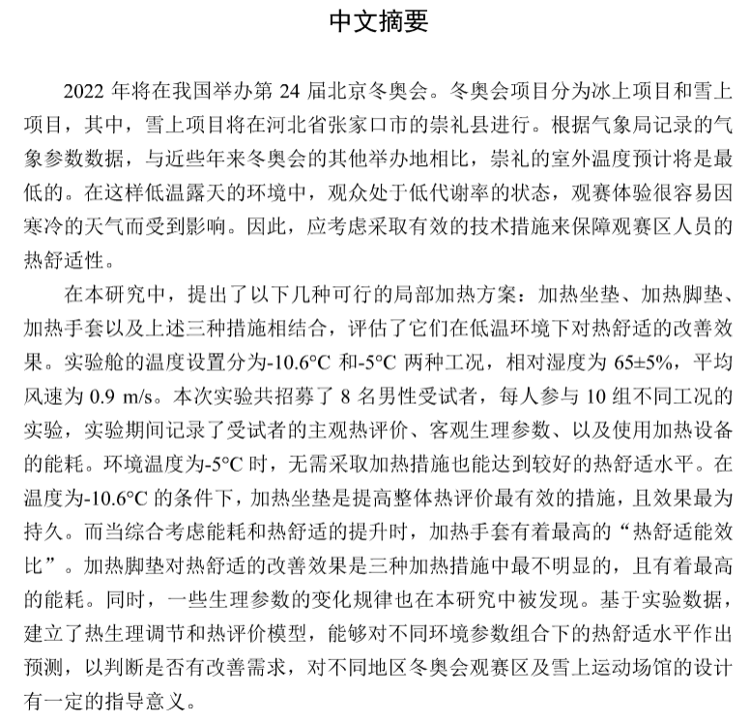

ABSTRACT

The snow events of the 2022 Winter Olympic Games will be held in Chongli, Hebei Province, China. According to the Meteorological records, the outdoor temperature in Chongli is expected to be the lowest, comparing to the hosts of recently past Winter Olympics. In such a **low temperature** open-air environment, the audience **is** in a low metabolic rate slate, thus the experience of watching games is easily affected by the cold. Therefore, how to ensure the thermal comfort for the audience should be considered.

In this study, several feasible localized heating measures were put forward: heating cushion, heating foot cushion, heating gloves and combination of the above three, to evaluate their improvement effect on thermal comfort in low temperature environment. The temperature settings of the cryogenic cabin included -10.6°C and -5°C, while the relative humidity was 65±5% and the mean air velocity was 0.9 m/s. Eight male subjects participated in this experiment, and their subjective evaluations and physiological parameters when using different local body heating measures were recorded. The energy consumption of each heating measure was recorded as well. When the ambient temperature is -5°C, an ideal thermal comfort level can also be achieved without heating measures. Under the condition of -10.6°C, the results show that heating cushion is the most effective measure in improving the overall thermal evaluation and has the most durable effect. However, regarding the "output-input ratio" which considers both the increase of thermal comfort and energy consumption, the ratio of heating gloves is the highest. With the most energy consumption to achieve **similar thermal comfort level**, the heating footpad is the least effective measure among the three. Some changes of physiological parameters were also found in this study. Based on the experimental data, a thermal evaluation model was established, which can predict the thermal comfort level under different combinations of environmental parameters to judge whether there is improvement demand. It has certain guiding significance for the design of the winter Olympic Games viewing area or other snow sports venues in different regions.

# 附录

关于论文时态的网络资料：

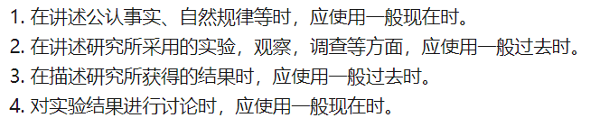

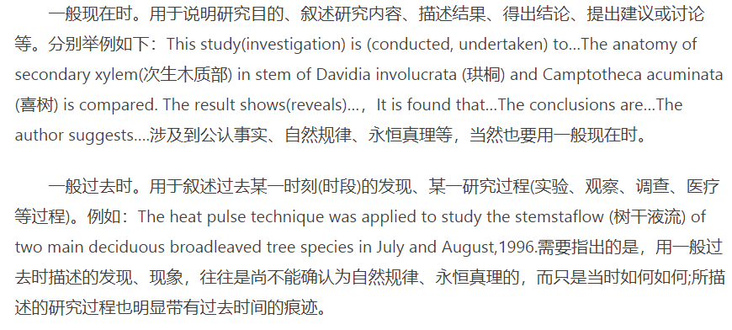

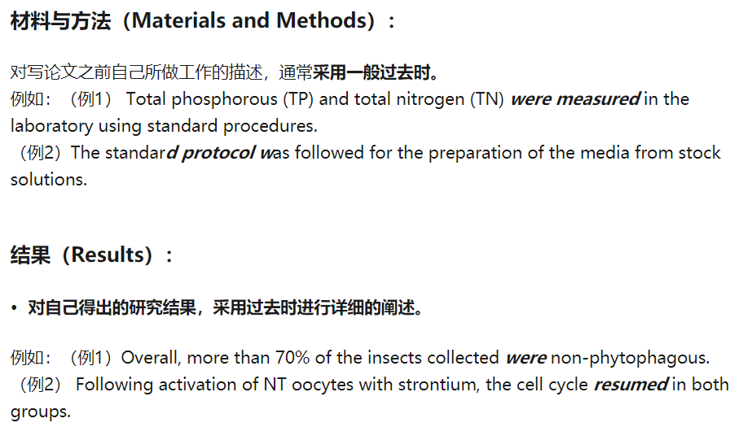

关于冠词用法的网络资料：

