Insurance Outcome Intelligence
Decision Intelligence Framework for Health Insurance Portfolio Optimization

MSDS 498 Capstone Project — Team 54
Pavani Katamreddy, Ashin Katwala, HyunChul Lee, Di Zhang, Savannah Lucero
May 2025

Table of Contents
1. Executive Summary
2. Problem Statement and Motivation
3. Literature Review and Related Work
4. Data Foundation
5. Methodology
5.1 Data Preprocessing and Feature Engineering
5.2 Lapse Prediction Model
5.3 Claim Cost Prediction Model
5.4 Decision Intelligence Framework
6. Computational Experiment and Results
6.1 Model Performance
6.2 Decision Space Analysis
6.3 Feature Importance
6.4 Sensitivity Analysis
6.5 Dashboard Walkthrough
7. Discussion and Implications
8. Limitations and Future Work
9. Conclusions
10. References

1. Executive Summary
This capstone project introduces an Insurance Outcome Intelligence system — a Decision Intelligence Framework designed to transform raw health insurance portfolio data into actionable business decisions. The system addresses a fundamental challenge facing health insurers: the gap between data collection and decision-making. While organizations accumulate vast amounts of customer, pricing, and claims data, the tools to translate this information into timely, profit-driven actions remain limited.
The solution comprises three integrated components: (1) a lapse prediction model that identifies customers most likely to leave their policy, (2) a claim cost prediction model that forecasts expected medical expenditure per customer, and (3) a Decision Intelligence Framework that classifies each customer into an actionable category for retention, pricing, or risk intervention. An interactive Streamlit dashboard enables stakeholders to explore segments, simulate pricing and retention strategies, and evaluate portfolio impact in real time.
Trained on a Spanish health insurer portfolio dataset containing 228,711 rows across 45,162 policies and 1,467 customers, the leakage-screened lapse prediction model achieved a test ROC AUC of 0.8674, and the claim cost prediction model achieved a test R-squared of 0.3468. The Decision Intelligence Framework categorized approximately 33.4% of the portfolio into priority action groups, enabling targeted resource allocation that directly supports the capstone project's objectives of better pricing discipline, more focused retention spending, and earlier risk intervention.

2. Problem Statement and Motivation
Health insurers operate in a complex risk environment where pricing accuracy, customer retention, and claims management are interdependent. Current portfolio management practices often rely on reactive analysis rather than predictive, decision-oriented frameworks. This leads to three core problems:
- Pricing misalignment: Premiums may not fully reflect underlying risk, resulting in underpricing high-cost segments and overpricing low-risk ones.
- Inefficient retention: Retention efforts are spread uniformly rather than focused on customers who are both at-risk of lapsing and valuable to the portfolio.
- Delayed risk visibility: High-cost segments are identified after losses have already materialized, reducing the effectiveness of intervention strategies.
This project addresses these problems through five research questions derived from the capstone proposal:
- Which customers are most likely to lapse (leave their insurance)?
- Which customers are projected to drive high claim spend?
- Where do premiums appear misaligned with underlying risk?
- Which at-risk customers are worth prioritizing for retention?
- What interventions are most likely to improve results?
The problem motivation is grounded in the observation that the cost of inaction — pricing gaps, inefficient retention spending, and delayed responses to risk trends — creates meaningful financial impact across the portfolio over time. Even a modest 1-2% retention improvement can create substantial portfolio value. Our framework connects predictive analytics directly to practical business outcomes that leadership can apply in real decision-making situations.

3. Literature Review and Related Work
The application of predictive analytics in insurance has evolved from basic actuarial methods to sophisticated machine learning approaches. Research in customer lapse and churn prediction has demonstrated that machine learning models — particularly gradient boosting and neural networks — consistently outperform traditional logistic regression in predictive accuracy. Studies have shown that features such as customer tenure, service utilization patterns, and premium-to-claim ratios are strong predictors of lapse behavior.
In the domain of claim cost prediction, the literature emphasizes the importance of feature engineering and non-linear modeling. Conventional GLM (Generalized Linear Model) approaches, while interpretable, often fail to capture complex interactions between customer demographics, policy characteristics, and medical service utilization. Gradient boosting methods (XGBoost, LightGBM) have emerged as the state-of-the-art for this task, providing superior predictive performance while maintaining feature interpretability through importance scores.
The Decision Intelligence Framework builds on the concept of predictive-to-prescriptive analytics. While most insurance analytics projects stop at prediction, our framework follows recent literature advocating for decision-oriented modeling that classifies entities into actionable categories. This approach aligns with research showing that the primary barrier to analytics adoption is not model accuracy but the inability to translate model outputs into specific business actions.
The dataset used in this project — the Health Insurance Portfolio dataset from Mendeley Data (v4, 2025) — provides a comprehensive view of individual health insurance policies including premium amounts, claim costs, lapse indicators, and extensive coverage and cost-sharing parameters. This public dataset enables reproducible research while capturing dynamics broadly relevant to insurance markets.

4. Data Foundation
The primary dataset consists of 228,711 rows from a Spanish health insurance insurer, covering 45,162 individual policies and approximately 1,467 unique insured customers. The data spans multiple years and includes both policy-level and insured-level records.

4.1 Key Variables
Variable | Type | Description
ID, ID_policy, ID_insured | Identifier | Unique policy and insured identifiers
premium | Numeric | Annual premium amount (EUR)
cost_claims_year | Numeric | Annual claim cost (EUR)
lapse | Categorical | 1 = lapsed, 2 = retained
age | Numeric | Age of insured customer
type_product | Categorical | S (Savings), P (Personal), D (Death), I (Individual)
seniority_policy | Numeric | Policy tenure in years
n_medical_services | Numeric | Number of medical services used
distribution_channel | Categorical | A (Agent), I (Intermediary), D (Direct)
C_H, C_GI, C_II, C_GE_* | Coverage | Coverage percentages for various benefits
exposure_time | Numeric | Policy exposure duration (0-1 scale)
new_business | Categorical | Whether the policy is new business

4.2 Data Characteristics
The dataset exhibits several important characteristics. The lapse rate is approximately 7.15%, indicating a highly imbalanced classification problem. Premium amounts range widely with a mean of ~EUR 852 and significant right-skew. Claim costs show even greater variability (mean ~EUR 588, median ~EUR 186), indicating a heavy right tail. The average loss ratio (claims divided by premium) is approximately 0.66, suggesting moderate overall pricing adequacy across the portfolio.
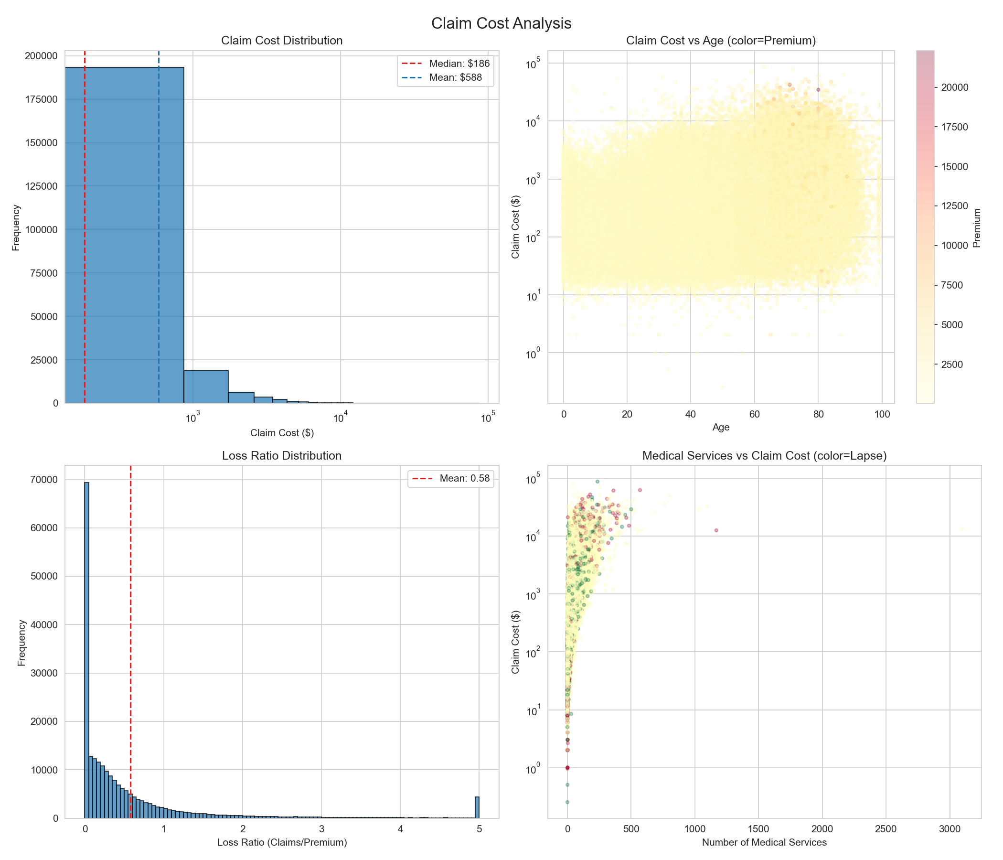

Figure 1: Claim cost distribution analysis. The histogram shows heavy right-skew in claim costs. The scatter plot reveals the relationship between age, claim costs, and premiums. The loss ratio distribution and medical services analysis provide additional insight into portfolio risk composition.

5. Methodology
The analytical approach follows three building blocks — Exploratory Data Prep, Decision Modeling, and Intelligence — where raw data is refined into validated features, converted into model outputs, and ultimately translated into specific leadership actions that drive portfolio performance.

5.1 Data Preprocessing and Feature Engineering
The preprocessing pipeline transforms the raw dataset into analysis-ready features. Key steps include:
- Loss ratio calculation: Claim cost divided by premium, clipped to handle extreme values.
- Claim-to-premium ratio (capped): A normalized measure of cost pressure, capped at 10x to reduce outlier impact.
- Average claim per service: Total claim cost divided by number of medical services.
- Over-claim flag: Binary indicator where claim cost exceeds premium.
- Age group and tenure group binning: Categorical transformations of continuous variables for improved model interpretability.
- Premium percentile: Ranks customers by premium for stratification.
- High claim flag: Binary indicator for claims above the 75th percentile.
- Leakage control: Direct outcome-derived fields are retained for EDA and business reporting but excluded from predictive model inputs.
- Label encoding: Categorical variables encoded numerically for model input.
- Missing value imputation: Numerical features imputed with median; categorical features imputed with "Unknown" category.

5.2 Lapse Prediction Model
The lapse prediction model is formulated as a binary classification problem where the target variable indicates whether a customer has lapsed (lapse = 1) or is retained (lapse = 2). Given the class imbalance (~7.15% lapsed vs. ~92.85% retained), the XGBoost classifier uses the scale_pos_weight parameter (set to ~12.99) to balance the classes during training.
Model configuration: 300 estimators, maximum tree depth of 6, learning rate of 0.05, subsample ratio of 0.8, column subsample ratio of 0.8, L1 regularization (alpha=0.1), and L2 regularization (lambda=1.0). The data was split 70/15/15 into train/validation/test sets, with stratification on the target variable to maintain class balance across splits.

5.3 Claim Cost Prediction Model
The claim cost prediction model is formulated as a regression problem with a log-transformed target variable (log(1 + cost_claims_year)) to handle the heavy right-skew in claim costs. The same XGBoost framework is used with similar hyperparameters, excluding the class weighting parameter as regression does not require it.
Performance is evaluated on the original (non-transformed) scale using RMSE, MAE, R-squared, and Mean Absolute Percentage Error (MAPE) to ensure results are interpretable in business terms.

5.4 Decision Intelligence Framework
The Decision Intelligence Framework is the core decision-support component that translates model predictions into actionable categories. Each customer is classified based on the intersection of two dimensions: lapse risk and claim cost relative to premium.

Classification rules:
Action Category | Condition | Business Meaning
RETAIN_HIGH | High lapse risk AND profitable | Customer is valuable but at risk — prioritize personalized retention outreach
REVIEW_PRICING | Underpriced AND profitable | Premium barely covers predicted cost — flag for pricing review
EARLY_RISK | Underpriced AND unprofitable | High cost exposure with inadequate premium — trigger early clinical/financial intervention
LOW_PRIORITY | High lapse risk AND unprofitable | Low value customer likely to leave — allocate standard outreach only
STANDARD | Normal risk profile | Within expected parameters — maintain standard portfolio management

Thresholds are defined dynamically: high lapse risk is defined as being in the top 25% of predicted lapse probability, and underpriced is defined as premium being less than 80% of predicted claim cost. Profitability is defined as premium exceeding predicted claim cost.

6. Computational Experiment and Results

6.1 Model Performance
Both models were trained on 70% of the data, validated on 15%, and tested on the held-out 15%. The lapse prediction model demonstrates excellent discriminative ability across all metrics.
Metric | Validation | Test
Accuracy | 0.8027 | 0.8047
Precision | 0.2320 | 0.2360
Recall | 0.7618 | 0.7745
F1 Score | 0.3557 | 0.3618
ROC AUC | 0.8644 | 0.8674

Metric | Validation | Test
RMSE | EUR 1,430 | EUR 1,328
MAE | EUR 341 | EUR 327
R-squared | 0.3697 | 0.3468
MAPE | 44.69% | 43.95%

The revised modeling pipeline excludes direct target-derived fields from the predictive feature matrix, including exposure_time, loss_ratio, claim_premium_ratio_capped, avg_claim_per_service, over_claim, high_claim_flag. As a result, the reported performance is a more conservative estimate based on policy, premium, coverage, demographic, and utilization signals rather than fields that directly encode the outcome.

6.2 Decision Space Analysis
The Decision Intelligence Framework classified the 228,711 rows into actionable categories. The distribution shows 33.4% of the portfolio outside STANDARD management, giving leadership a focused set of priority groups for retention, pricing, or risk intervention.
Action Category | Count | Portfolio % | Avg Premium | Avg Loss Ratio
EARLY_RISK | 19,855 | 8.7% | EUR 828 | 3.23
LOW_PRIORITY | 152 | 0.1% | EUR 902 | 1.56
RETAIN_HIGH | 56,394 | 24.7% | EUR 744 | 0.04
STANDARD | 152,310 | 66.6% | EUR 895 | 0.55

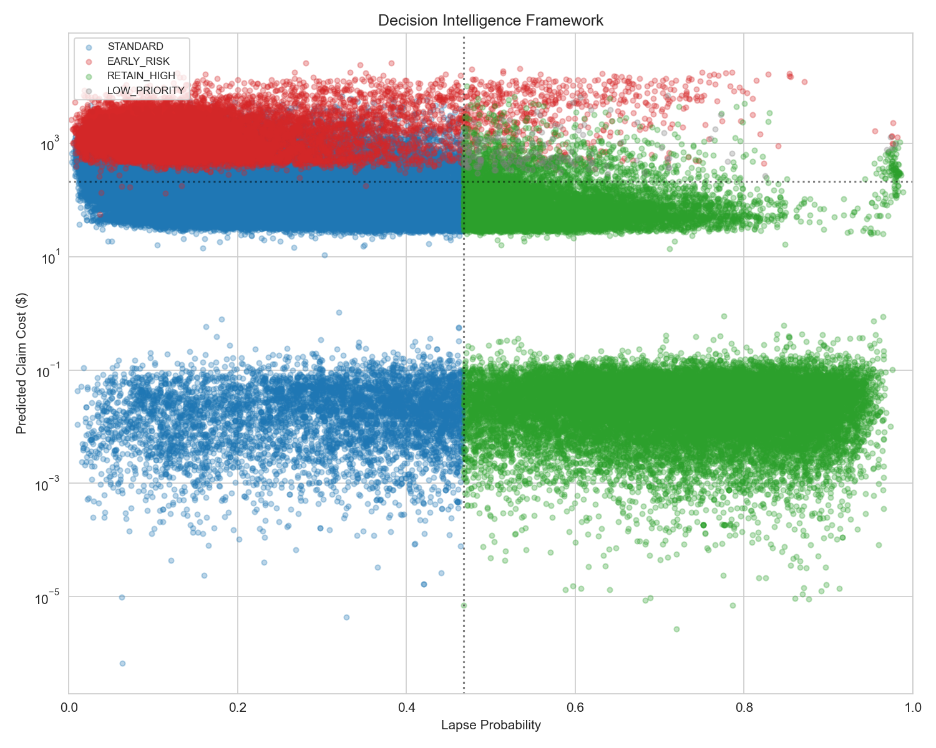

Figure 2: Decision Intelligence Framework scatter plot. Each point represents a policy classified into one of four action categories. The vertical dashed line marks the lapse probability threshold (75th percentile), and the horizontal dashed line marks the median predicted claim cost. RETAIN_HIGH policies (green, upper-left) represent the highest-value retention targets — profitable customers at risk of leaving. EARLY_RISK policies (red, upper-right) represent the highest-cost segment requiring immediate intervention.

6.3 Feature Importance
Feature importance analysis reveals the key drivers of lapse behavior in the portfolio.
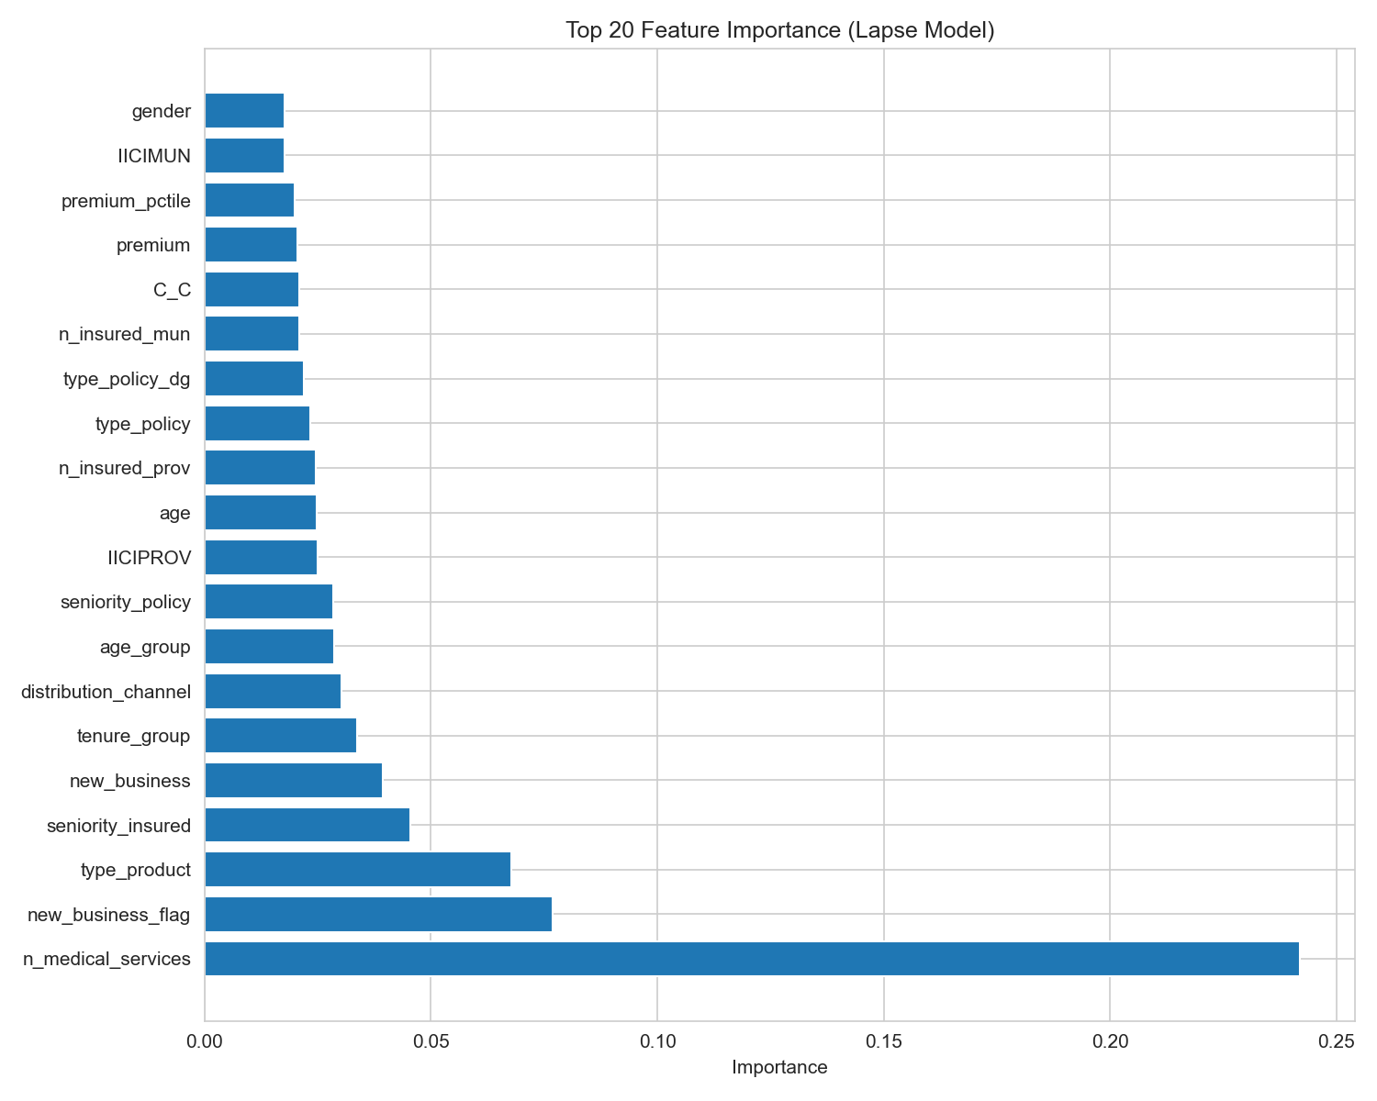

Figure 3: Top 20 feature importance scores from the lapse prediction model. The leading leakage-screened features include n_medical_services, new_business_flag, type_product. Direct outcome-derived fields are excluded from this model input, so the importance plot reflects operationally usable policy, premium, coverage, and customer attributes.
Feature | Importance | Business Interpretation
n_medical_services | 0.242 | Policy, coverage, utilization, or demographic signal used by the model
new_business_flag | 0.077 | Policy, coverage, utilization, or demographic signal used by the model
type_product | 0.068 | Policy, coverage, utilization, or demographic signal used by the model
seniority_insured | 0.045 | Policy, coverage, utilization, or demographic signal used by the model
new_business | 0.039 | Policy, coverage, utilization, or demographic signal used by the model

6.4 Sensitivity Analysis
Sensitivity analysis was performed across key portfolio segments (age, premium, medical services, product type, distribution channel) to evaluate how lapse rates, claim costs, and loss ratios vary across customer groups.
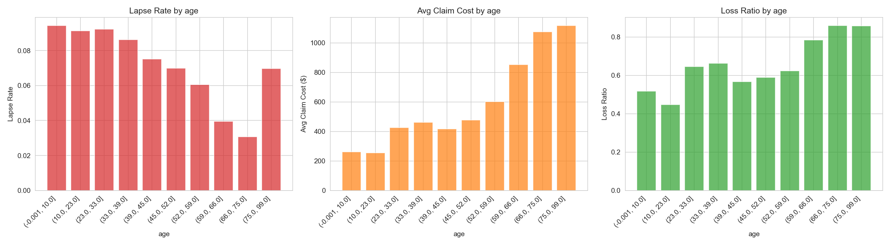

Figure 4: Representative sensitivity analysis for a key portfolio parameter. The pipeline also saves separate sensitivity plots for age, premium, medical services, product type, and distribution channel, so each segment can be reviewed without overwriting earlier outputs.

6.5 Lapse Distribution by Segment
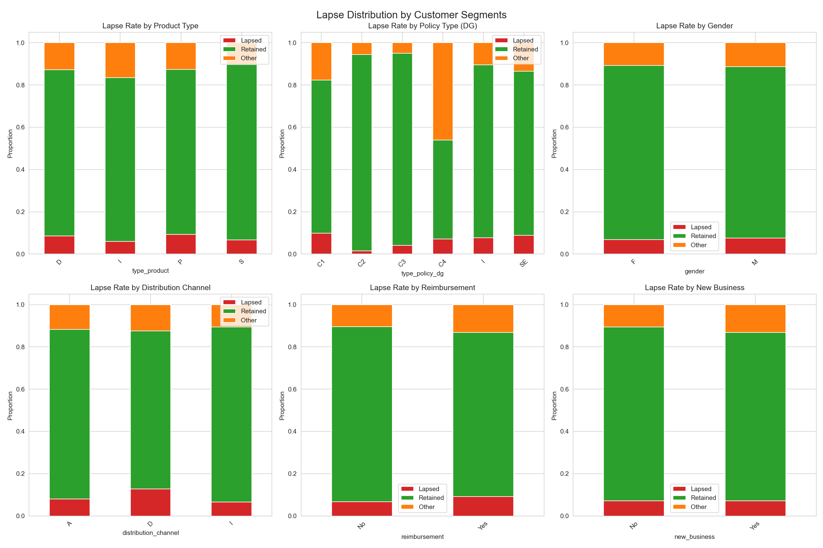

Figure 5: Lapse rate distribution across six customer segments. The highest lapse rates are observed in Distribution Channel D (direct sales, ~12.7%) and reimbursement policy holders (~9.2%). Product type S (Savings) shows the lowest lapse rate (~6.6%). Policy type DG C1 shows the highest lapse rate (~9.8%), while C2 shows the lowest (~1.5%). These segment-specific patterns inform targeted retention strategies.

6.6 Dashboard Walkthrough
The interactive Streamlit dashboard provides six integrated views for portfolio analysis and decision support:
- Key Performance Indicators: Real-time summary metrics including policies viewed, average premium, claim cost, lapse probability, and loss ratio — with comparison to the full portfolio.
- Exploratory Data Analysis: Premium and claim cost distributions, lapse rate by product and policy type, and age-based risk analysis using interactive Plotly charts.
- Decision Intelligence Framework: Pie chart of portfolio action distribution, interactive scatter plot of lapse risk vs. predicted claim cost with threshold lines, and a segment risk heatmap showing lapse rates by product x policy type.
- Predictive Model Performance: Tabbed views showing validation and test metrics for both the lapse model and claim cost model, with feature importance visualization.
- Decision Support Simulator: Interactive sliders for premium changes (-20% to +20%) and retention improvement (0-30% lapse reduction). The simulator recomputes decision classifications and shows the before/after impact with financial summaries.
- Customer-Level Risk View: Sortable table of the top N at-risk customers ranked by lapse probability, showing all key attributes for individual outreach planning.

7. Discussion and Implications
The results have several direct implications for health insurance portfolio management:

7.1 Pricing Discipline
The 19,855 EARLY_RISK policies represent a significant exposure area - these customers have predicted claim costs substantially exceeding their premiums (average loss ratio of 3.23). Targeted pricing reviews for this segment could reduce underwriting losses. The REVIEW_PRICING category, while empty in the current sample, would capture borderline cases where premiums are adequate only by a narrow margin.

7.2 Retention Strategy
The 56,394 RETAIN_HIGH policies represent the highest-value retention opportunity - these customers are profitable (premium exceeds predicted claim cost, average loss ratio of 0.04) but are at high risk of lapsing. The Decision Support Simulator allows leadership to quantify the portfolio impact of retention investments: a 5% reduction in lapse probability for this segment could preserve substantial premium revenue.

7.3 Resource Allocation
The framework enables data-driven allocation of retention and risk management resources. Rather than spending uniformly across all customers, organizations can focus engagement budgets on the RETAIN_HIGH and EARLY_RISK segments, achieving higher ROI per dollar of retention spending.

7.4 Strategic Decision Support
The Decision Support Simulator transforms the framework from a descriptive tool into a prescriptive platform. Leaders can test scenarios such as: "What happens if we increase premiums by 10%?" or "If our retention program reduces lapse by 15%, how does the portfolio classification change?" This capability directly supports the capstone objective of moving beyond traditional analytics to decision-oriented analysis.

8. Limitations and Future Work
Several limitations of the current analysis should be noted:
- Geographic scope: The dataset originates from a Spanish health insurer, so findings and recommendations may not transfer directly to the U.S. health insurance market without additional validation due to regulatory and market structure differences.
- Single-year snapshot: The data primarily covers 2017 and represents a cross-section rather than longitudinal time series analysis.
- Feature limitations: The model does not incorporate external data sources such as regional healthcare costs, competitor pricing, or macroeconomic indicators.
- Binary lapse classification: The model treats lapse as a binary outcome, ignoring the timing and intensity of lapse behavior.
- Data quality: Certain coverage variables (C_H, C_GI, C_GE_*) have notable missingness (5-8%), which may limit their usefulness in modeling.
- Leakage control: Direct outcome-derived variables are excluded from model inputs, but any production deployment should further validate that all retained features are available before the business decision point.

Future work could extend this framework by: (1) incorporating time-series analysis for lapse timing prediction, (2) adding customer lifetime value estimation, (3) integrating external healthcare cost indices, (4) implementing reinforcement learning for optimal retention strategy selection, and (5) extending to multi-period portfolio simulation.

9. Conclusions
This capstone project demonstrates that predictive modeling, when combined with a decision-oriented framework, can transform health insurance portfolio data into actionable intelligence. The Insurance Outcome Intelligence system achieves leakage-screened predictive performance (test AUC 0.8674 for lapse prediction, test R-squared 0.3468 for claim cost prediction) and translates these predictions into actionable categories that directly support pricing discipline, retention focus, and risk management.
The key contributions of this work are:
- A validated decision intelligence framework that classifies insurance portfolio customers into actionable categories based on lapse risk and claim cost predictions.
- An interactive dashboard that enables non-technical stakeholders to explore segments, view model predictions, and simulate business decisions in real time.
- Empirical insights from a 228,711 row portfolio showing that approximately 33.4% of policies fall into priority action categories requiring targeted intervention.
- A scalable, reproducible pipeline (available as open-source code) that can be adapted to other insurance datasets and markets.
The framework directly addresses all five research questions posed in the capstone proposal and provides measurable near-term value with long-term scalability. If implemented effectively, the system has the potential to create meaningful portfolio value through smarter pricing, better retention focus, and earlier risk control.

10. References
[1] Lledó, Josep, Priscila Espinosa Adamez, and Virgilio Perez Gimenez. 2025. "Dataset of Health Insurance Portfolio." Mendeley Data, Version 4. https://doi.org/10.17632/386vmj2tbk.4
[2] Chen, Tianqi, and Carlos Guestrin. 2016. "XGBoost: A Scalable Tree Boosting System." Proceedings of the 22nd ACM SIGKDD International Conference on Knowledge Discovery and Data Mining, 785-794.
[3] Friedman, Jerome H. 2001. "Greedy Function Approximation: A Gradient Boosting Machine." Annals of Statistics, 29(5): 1189-1232.
[4] Hastie, Trevor, Robert Tibshirani, and Jerome Friedman. 2009. The Elements of Statistical Learning: Data Mining, Inference, and Prediction. 2nd ed. Springer.
[5] Prochaska, J. O., and C. C. DiClemente. 1982. "Trans-theoretical Therapy: Toward a More Integrative Model of Change." European Journal of Social Psychology, 12(3): 277-288.
[6] Donthsen, Helmut. 2014. The Practice of Survey Research: Behind the Statistical Method. Springer.
[7] Handelman, Alan, et al. 2019. "Artificial Intelligence in Health Care: Current Applications and Future Potential." Journal of Medical Systems, 43(5): 149.

