IT5010: Assignment #1

Practical Project – Case Study

Report

|  |  |
| --- | --- |
| **Student Name:** |  |
| **Student ID:** |  |
| **Due Date:** |  |

1

**Contents**

1. Executive Summary 2

2. Network Diagram 3

3. Quotation 3

4. (D) Communication Channel Security 4

5. (E). Support Call Prioritisation 5

7. References 5

# Executive Summary

(Explain the scenario and summarise your work in a short paragraph.)

# Network Diagram

(Enter a network Diagram here and give an explanation. You can use [www.draw.io](http://www.draw.io) to draw the network

diagram online. Make sure all components are labelled.)

|  |
| --- |
|  |

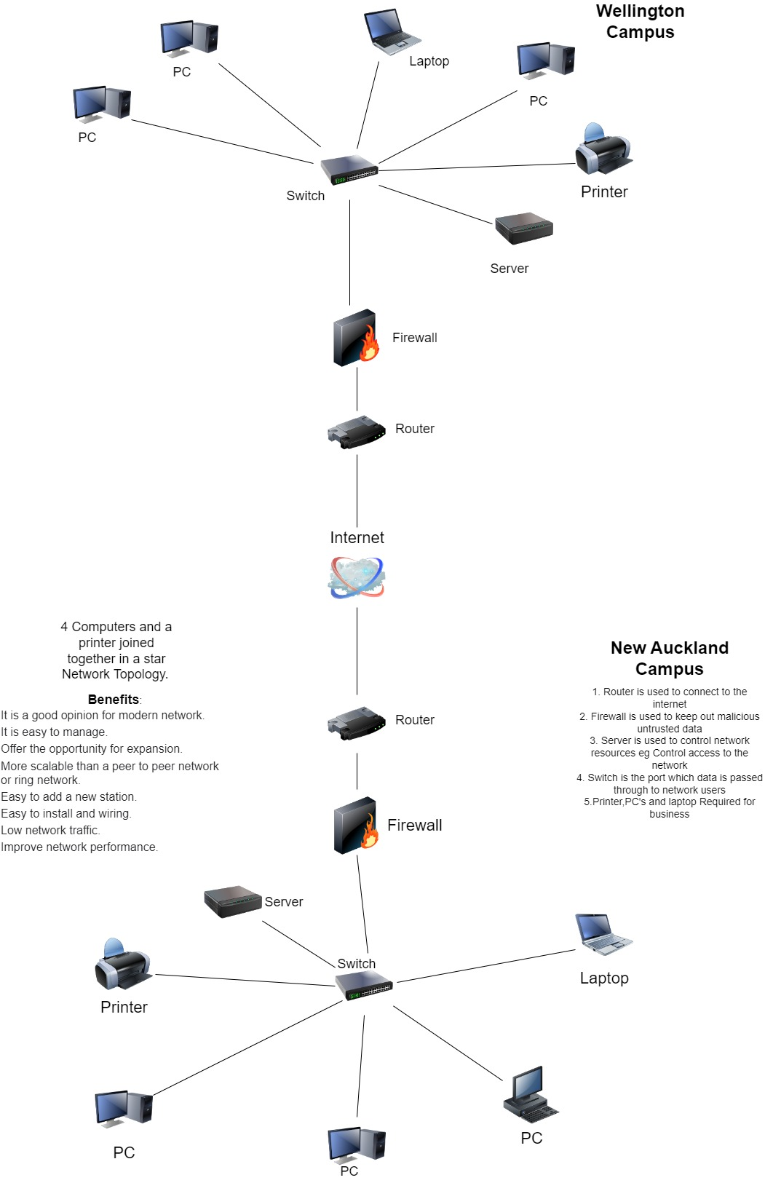

# Quotation

(Fill in the table to answer Tasks A, C and E)

|  |  |  |  |  |
| --- | --- | --- | --- | --- |
| Items | Cost | Rationale and justification for each component | Reference |  |
| PC’s, Keyboard, mouse, Monitor and 1 year firewall software (Bundle) | $1448.54 x 3 | Cheap and runs on Ryzen AMD 5 (More than enough specs for business use) | <https://www.pbtech.co.nz/product/WKSLEN5190379/Lenovo-ThinkCentre-M75Q-G2-Tiny-Business-PC-AMD-Ry> |  |
| Laptop | $977.50 x 1 | Cheap and runs on i5 (more than enough specs for business use) | <https://www.pbtech.co.nz/product/NBKLEN150200/Lenovo-V15-G2-Business-Laptop-156-FHD-Intel-i5-113> |  |
| Printer | $784.99 x 1 | Cheap, Prints Colour, Scanner, copies and can send fax | <https://www.pbtech.co.nz/product/PTRCNN1260776/Canon-MAXIFY-GX4060-MegaTank-4-in-1-Small-Business> |  |
| Switch | $529 x 1 | Number of ports x 8, Number of POE Ports x 8 and management level 2.  Good switch for small business with possibility for expansion and cheap | <https://www.pbtech.co.nz/product/SWHAUB5681/Aruba-Instant-On-1930-JL681A-8-Port-Smart-Managed> |  |
| Server | $1198.99 x 1 | 6 bays included, processor 2700 Mhz, Memory size 8 Gb and 1GB RJ45 Ports x2 (Good strong server with possibility for expansion) | <https://www.pbtech.co.nz/product/NASQNP65310/QNAP-TS-653D-8G-Business-Mid-End-6-Bay-NAS-Server> |  |
| Firewall | $1383.75 x 1 (Includes software suite for 1 year) | 1 GbE interfaces in a desktop form factor, SD-Branch ready, High connection count, Fast DPI performance and Low TCO (Good firewall and is software included) | - <https://thetechgeeks.co.nz/products/sonicwall-tz270?variant=44125605855550> |  |
| Router | $701.22 x 1 | Wireless Technology 802.11ax, Wireless Transmission Speed 4800Mbps, Wi-Fi bands Triple, Ethernet Ports 5 and USB Ports 1.  (Good For Small Office, up to 4800 Mbps and has multiple ports) | <https://www.pbtech.co.nz/product/NETSYN6600/Synology-Router-RT6600AX-11ax-router-with-25Gbps-b> |  |

|  |  |  |  |
| --- | --- | --- | --- |
| Software(Call management/Customer service) | Support enterprise package x $159.84 (a month) | Call management software (Call Prioritization), AI Chat bots to talk with customers when voice chat is unavailable, Business hours expanded, multiple apps, multilingual support and automatic redaction (Very Strong software capable of running the show) | <https://www.zendesk.com/au/pricing/support/?utm_source=google&utm_medium=Search-Paid&utm_network=g&utm_campaign=SE_AW_AP_AU_EN_N_Sup_NB_Core_Zeta_All_H&matchtype=b&utm_term=customer%20service%20software&utm_content=608646347491&theme=&gclid=EAIaIQobChMIyaqn08Lh_QIVtZhmAh3jJgBZEAAYASABEgJvYPD_BwE> |
| Ethernet cables 10m | $22.44 x 5 | 5 x Ehternet cables capable of delivering high speeds More than enough for business needs | <https://www.dicksmith.co.nz/dn/buy/office-catch-5m-10m-20m-30m-50m-cat6-ethernet>  -lan-network-cable-100m1000mbps-high-quality-7329373094045-42139875541149/ |
|  |  |  |  |
|  |  |  |  |

Overall Cost $10,193.11

($20,000 Budget - $10,193.11 = $9,806.89 Remaining of budget)

# (D) Communication Channel Security

(Explain how you will secure the communication channel between the two sites.)

# (E). Support Call Prioritisation

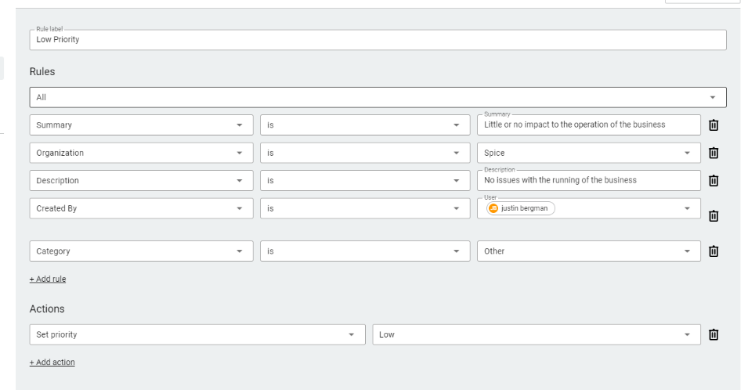Support call prioritization is how to deal with issues that arise in the business, Low Priority are issues that have no impact on the business running. Medium Priority is when multiple components are down, but business is still running. High Priority is when components are critical, and the business is offline. This is shown through my work in Spice works by creating rules to deal with certain Problems and to categorize them into Priority groups.

1. **Summary**

(Reflect on your learning and the challenges of designing a network solution)

# References

(APA (7th) format can be found in Canvas on the ‘Referencing Format’

e.g., Rasmussen, C. (2021, October 12). Icy ‘glue’ may control pace of Antarctic ice-shelf breakup. National

Aeronautics and Space Administration.

https://www.nasa.gov/feature/jpl/icy-glue-may-control-pace-of-antarctic-ice-shelf-breakup)