**1) Design a form with input fields for text, radio buttons, check boxes and a submit button.**

<!DOCTYPE html>

<html>

<head>

<title>Input Field</title>

</head>

<body>

<form action="" method="post">

<label for="name">Name:</label>

<input type="text" id="name" name="name" required><br><br>

<label for="email">Email:</label>

<input type="email" id="email" name="email" required><br><br>

<label>Gender:</label>

<input type="radio" id="male" name="gender" value="male" required>

<label for="male">Male</label>

<input type="radio" id="female" name="gender" value="female">

<label for="female">Female</label><br><br>

<label>Languages known:</label>

<input type="checkbox" id="english" name="languages[]" value="english">

<label for="english">English</label>

<input type="checkbox" id="hindi" name="languages[]" value="hindi">

<label for="spanish">Hindi</label>

<input type="checkbox" id="french" name="languages[]" value="french">

<label for="french">French</label><br><br>

<input type="submit" value="Submit">

</form>

</body>

</html>

**OUTPUT:-**

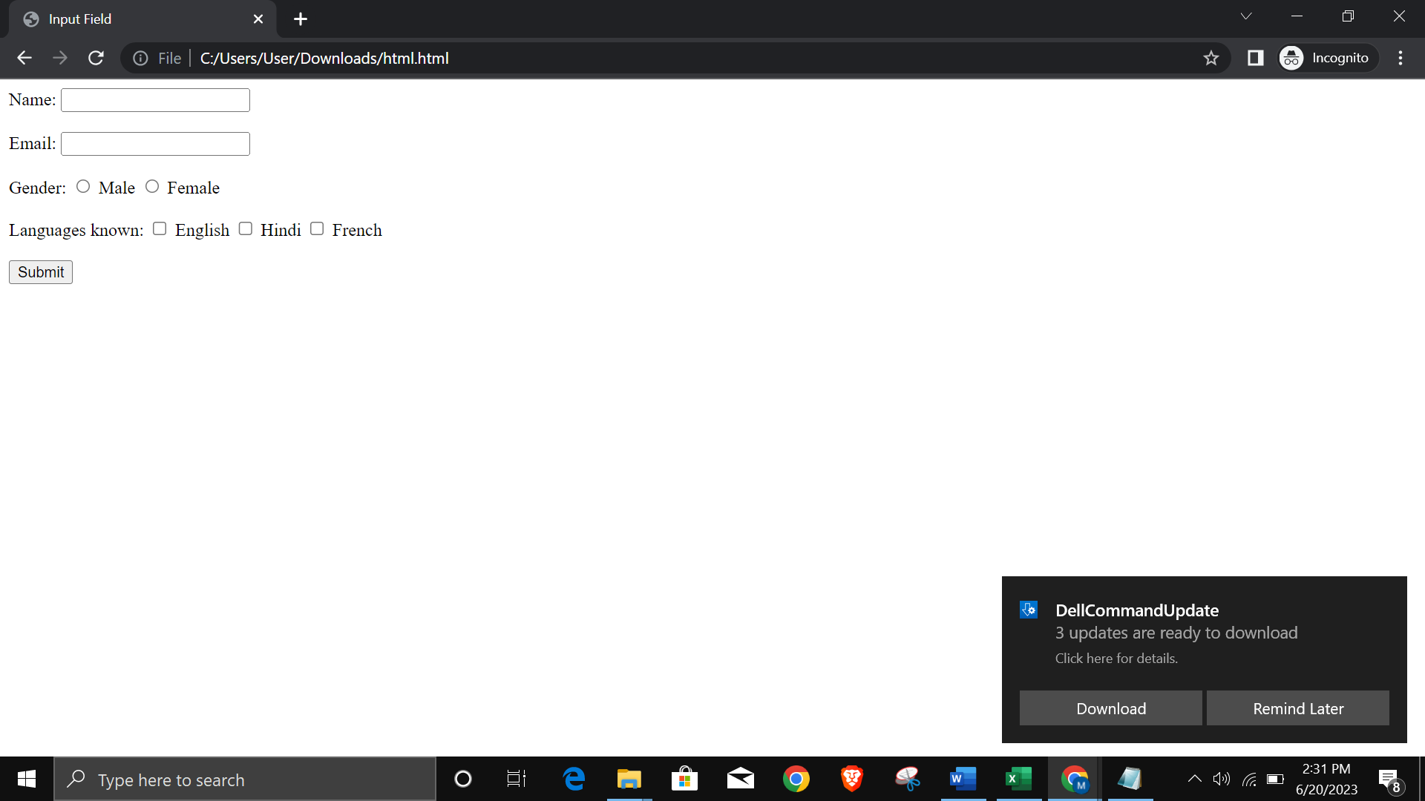

**2) Design a Web page using HTML5 containing two articles each having ¾ sections. Use aside for highlighting some additional info. about articles. Set header (Title) and Footer (Copyright Info.) elements.**

<!DOCTYPE html>

<html>

<head>

<title>My Web Page</title>

</head>

<body>

<header>

<h1>Welcome to My Web Page</h1>

</header>

<article>

<section style="width: 75%;">

<h2>Article 1</h2>

<p>Introduction to html</p>

</section>

<aside style="width: 25%;">

<h3>Additional Information</h3>

<p>The HyperText Markup Language or HTML is the standard markup language for documents designed to be displayed in a web browser. It is often assisted by technologies such as Cascading Style Sheets and scripting languages such as JavaScript.</p>

</aside>

</article>

<article>

<section style="width: 75%;">

<h2>Article 2</h2>

<p>Introduction to css</p>

</section>

<aside style="width: 25%;">

<h3>Additional Information</h3>

<p>Cascading Style Sheets is a style sheet language used for describing the presentation of a document written in a markup language such as HTML or XML. CSS is a cornerstone technology of the World Wide Web, alongside HTML and JavaScript.</p>

</aside>

</article>

<footer>

<p>&copy; 2023 My Web Page. All rights reserved.</p>

</footer>

</body>

</html>

**OUTPUT:-**

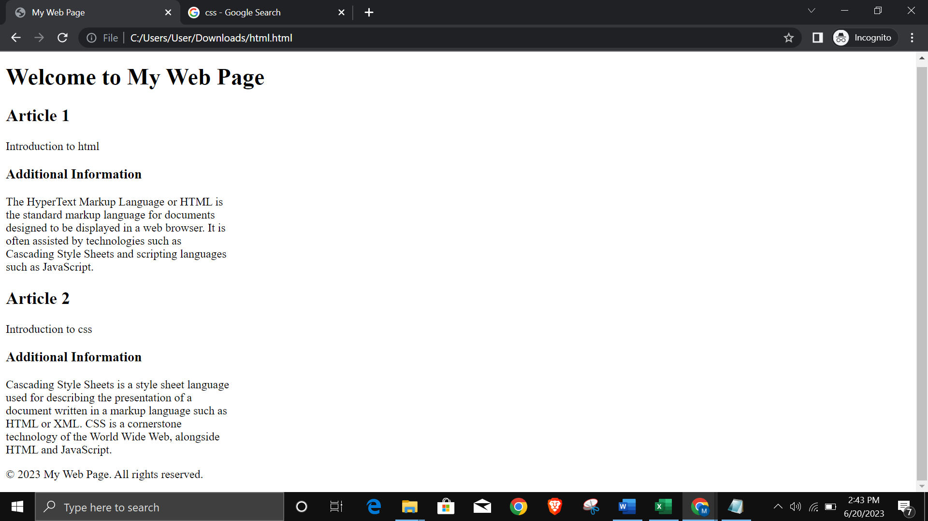

**3) Design a Web page using HTML5 containing table tag**

<!DOCTYPE html>

<html>

<head>

<title>Table Example</title>

<style>

table {

border-collapse: collapse;

}

th, td {

border: 1px solid black;

padding: 8px;

text-align: left;

}

th {

background-color: #f2f2f2;

}

</style>

</head>

<body>

<table>

<thead>

<tr>

<th>Name</th>

<th>Age</th>

<th>City</th>

</tr>

</thead>

<tbody>

<tr>

<td>John </td>

<td>25</td>

<td>Pune</td>

</tr>

<tr>

<td>Smith</td>

<td>22</td>

<td>Pune</td>

</tr>

<tr>

<td>johnson</td>

<td>23</td>

<td>Pune</td>

</tr>

</tbody>

</table>

</body>

</html>

**OUTPUT:-**

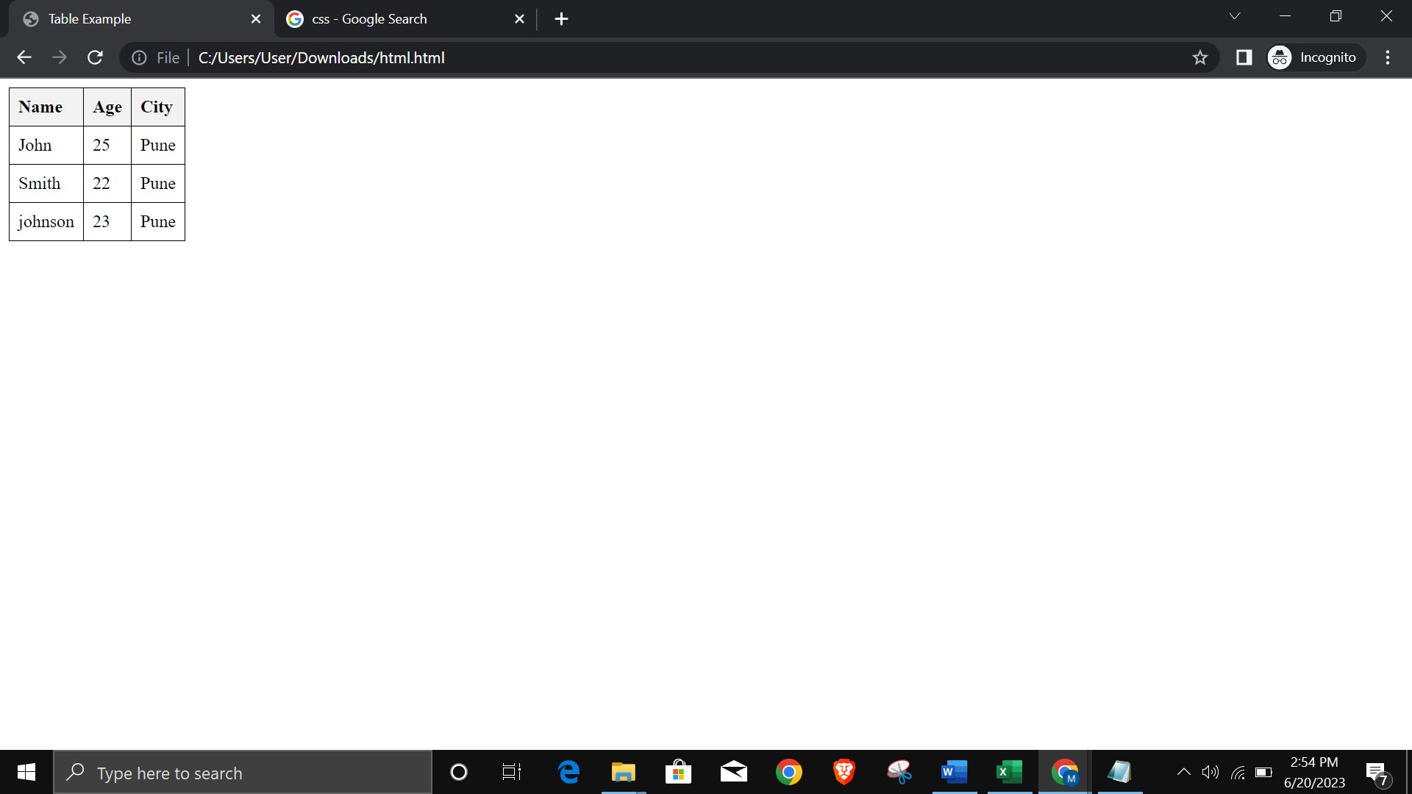

**4) Design a Web page using HTML5 to demonstrate input, output tag. Perform addition of two numbers and display the sum.**

<!DOCTYPE html>

<html>

<head>

<title>Addition </title>

<script>

function calculateSum() {

var num1 = parseInt(document.getElementById('num1').value);

var num2 = parseInt(document.getElementById('num2').value);

var sum = num1 + num2;

document.getElementById('result').value = sum;

}

</script>

</head>

<body>

<h1>Addition of two numbers</h1>

<label for="num1">Number 1:</label>

<input type="number" id="num1" name="num1"><br><br>

<label for="num2">Number 2:</label>

<input type="number" id="num2" name="num2"><br><br>

<button onclick="calculateSum()">Calculate Sum</button><br><br>

<label for="result">Result:</label>

<output id="result" name="result"></output>

</body>

</html>  
  
**OUTPUT:-**

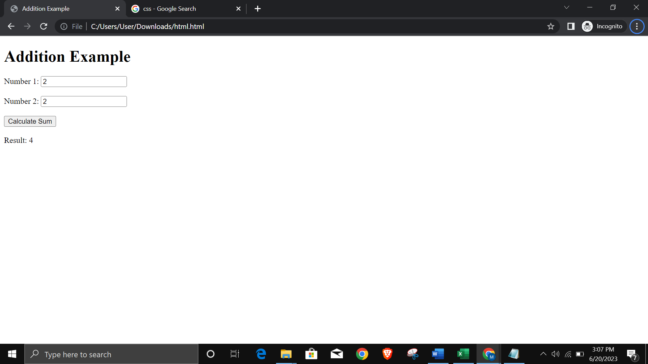

**5) Design a login form.**

<!DOCTYPE html>

<html>

<head>

<title>Login Form</title>

</head>

<body>

<div>

<h2>Login Form</h2>

<form action="login.php" method="post">

<label for="username">Username:</label>

<input type="text" id="username" name="username" required><br><br>

<label for="password">Password:</label>

<input type="password" id="password" name="password" required><br>

<input type="submit" value="Login">

</form>

</div>

</body>

</html>  
  
**OUTPUT:-**

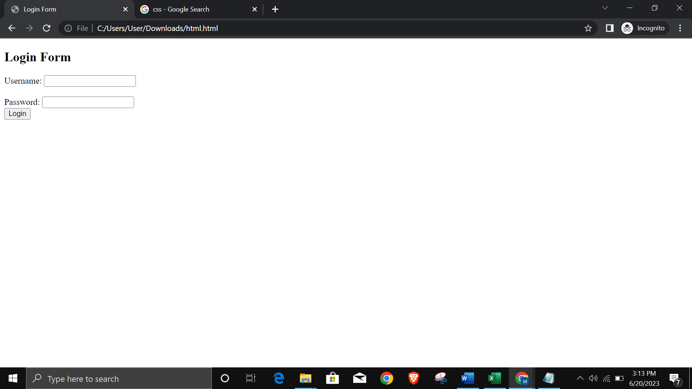

**6) Write a HTML code for canvas scale() Method. Draw a rectangle and scale it to 200%.**

<!DOCTYPE html>

<html>

<head>

<title>Canvas Scale Example</title>

</head>

<body>

<canvas id="myCanvas" width="400" height="200"></canvas>

<script>

var canvas = document.getElementById("myCanvas");

var ctx = canvas.getContext("2d");

// Draw original rectangle

ctx.fillStyle = "red";

ctx.fillRect(50, 50, 100, 50);

// Scale the canvas to 200%

ctx.scale(2, 2);

// Draw scaled rectangle

ctx.fillStyle = "blue";

ctx.fillRect(50, 50, 100, 50);

</script>

</body>

</html>  
  
**OUTPUT:-**

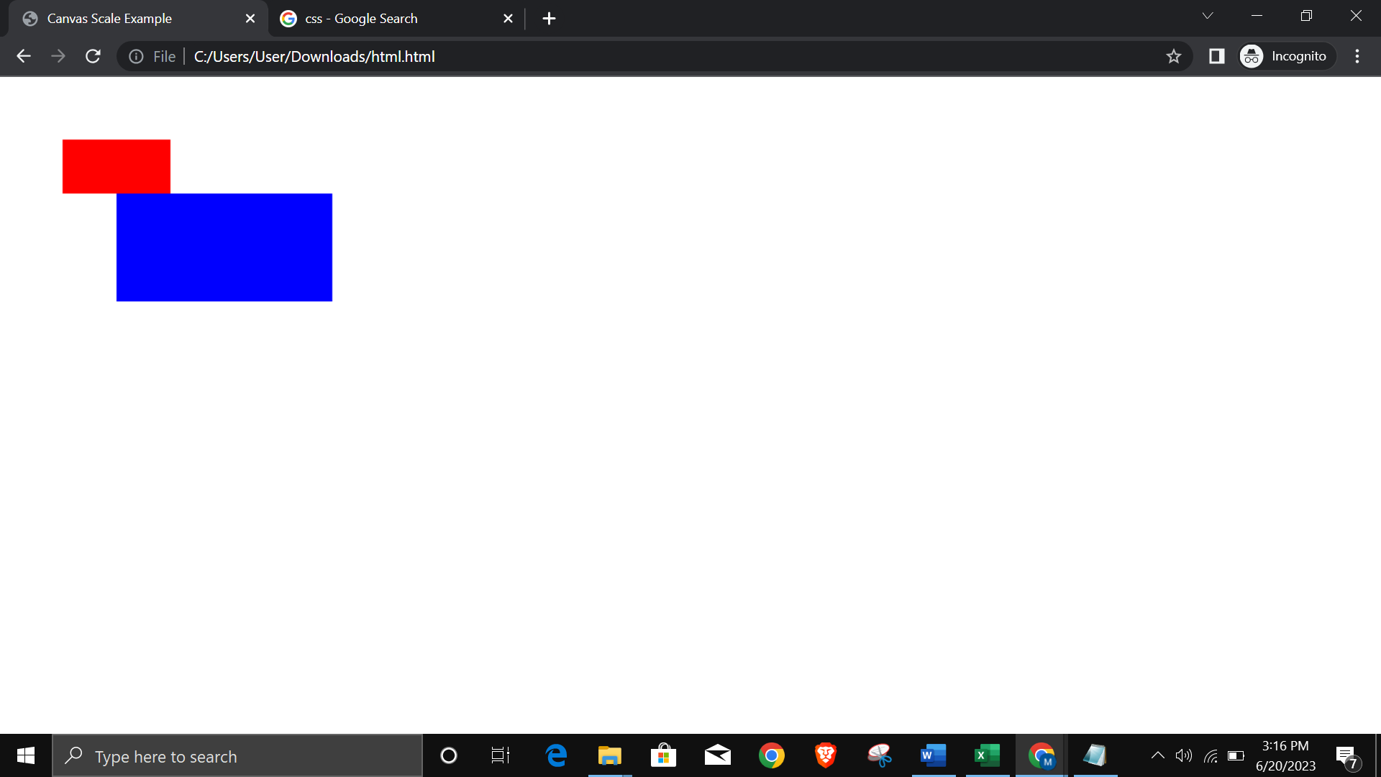

**7) Draw a rectangle and rotate it by 30 degrees.**

<!DOCTYPE html>

<html>

<head>

<title>Canvas Rotate Example</title>

</head>

<body>

<canvas id="myCanvas" width="400" height="200"></canvas>

<script>

var canvas = document.getElementById("myCanvas");

var ctx = canvas.getContext("2d");

// Draw original rectangle

ctx.fillStyle = "red";

ctx.fillRect(50, 50, 100, 50);

// Rotate the canvas by 30 degrees

ctx.translate(100, 75);

ctx.rotate(30 * Math.PI / 180);

ctx.translate(-100, -75);

// Draw rotated rectangle

ctx.fillStyle = "blue";

ctx.fillRect(50, 50, 100, 50);

</script>

</body>

</html>  
  
**OUTPUT:-**

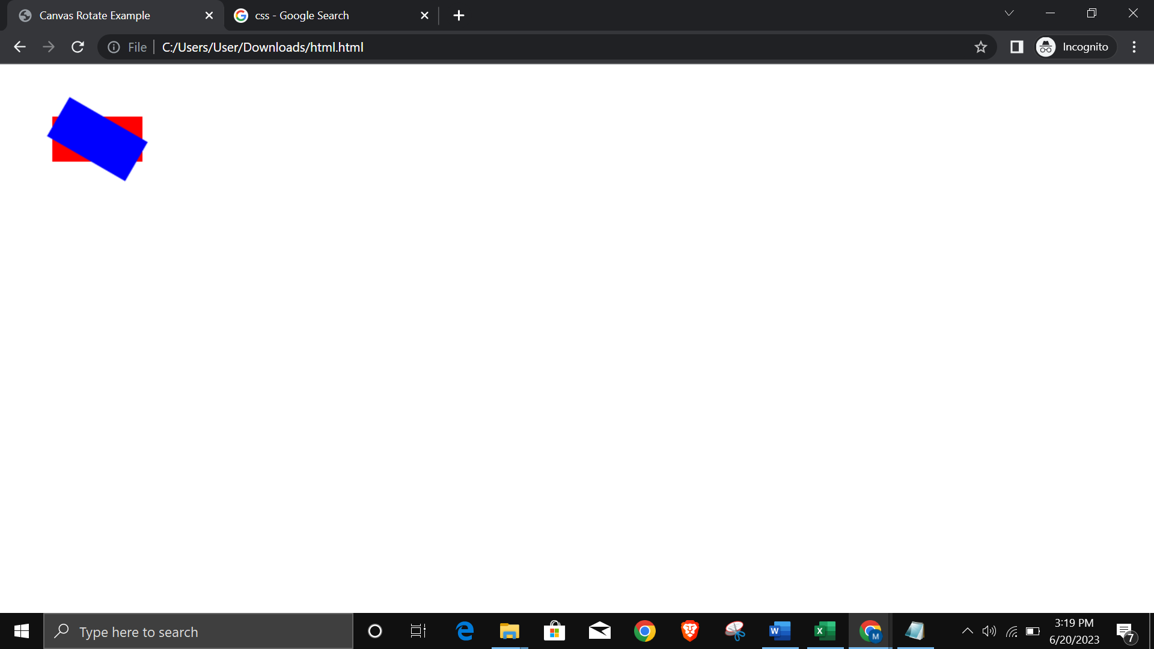

**8) Draw a square and demonstrate Canvas shadowOffsetX/ shadowOffsetY Property**

<!DOCTYPE html>

<html>

<head>

<title>Canvas Shadow Offset Example</title>

</head>

<body>

<canvas id="myCanvas" width="400" height="400"></canvas>

<script>

var canvas = document.getElementById("myCanvas");

var ctx = canvas.getContext("2d");

// Set shadow properties

ctx.shadowColor = "rgba(0, 0, 0, 0.5)";

ctx.shadowBlur = 10;

// Draw square with shadow

ctx.fillStyle = "red";

ctx.shadowOffsetX = 10;

ctx.shadowOffsetY = 10;

ctx.fillRect(50, 50, 100, 100);

</script>

</body>

</html>  
  
**OUTPUT:-**

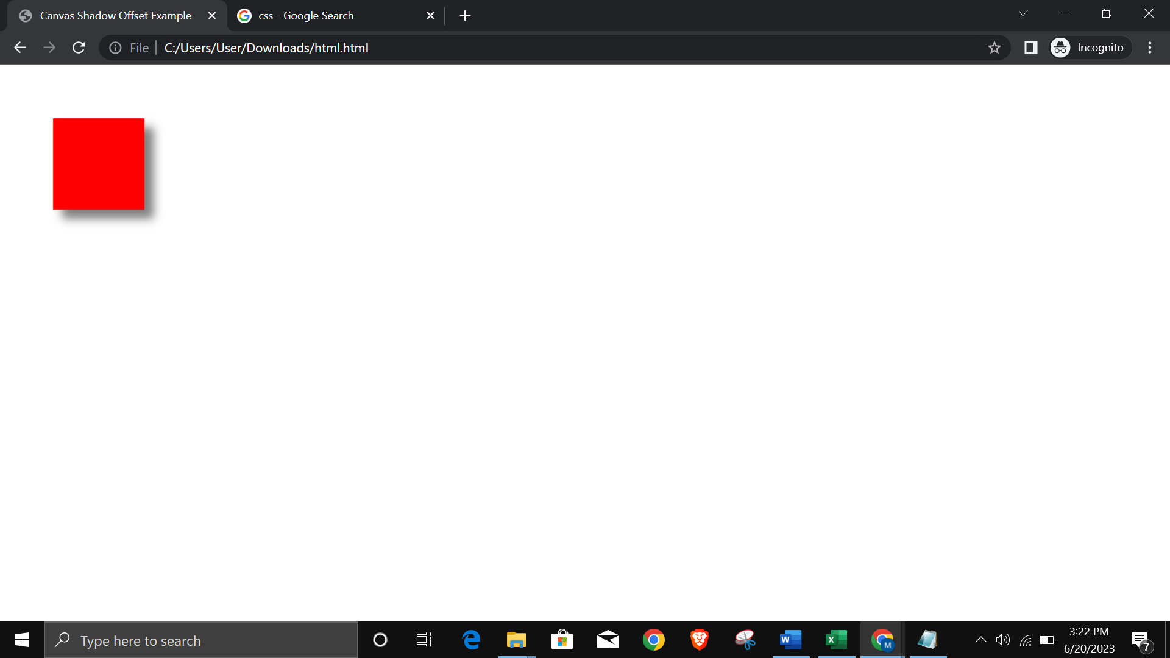

**9) Write a NodeJS program to show current date & time using user defined module.**

// datetime.js

exports.getCurrentDateTime = function() {

const currentDate = new Date();

return currentDate.toISOString();

};

// app.js

const datetimeModule = require('./datetime');

// Call the getCurrentDateTime function from the user-defined module

const currentDateTime = datetimeModule.getCurrentDateTime();

console.log('Current Date and Time:', currentDateTime);

**OUTPUT:-**

Current Date and Time: 2023-06-19T12:34:56.789Z

const myModule1 = {

ct : new Date()

}

module.exports.myModule1 = myModule1;

console.log(module.exports);

var {myModule1} = require("./datetime.js");

console.log(myModule1.ct);

**10. Write a NodeJS Program using built-in modules to split the query string into readable parts.**

Ans :

const stringToSplit = "Hello, world! This is a sample string.";

const delimiter = " "; // Split the string by spaces

const parts = stringToSplit.split(delimiter);

console.log(parts);

**OUTPUT:-**

[ 'Hello,', 'world!', 'This', 'is', 'a', 'sample', 'string.' ] var http = require('http');

var url = require('url');

http.createServer(function(req, res) {

res.writeHead(200, {'Content-Type' : 'text/html'});

var q = url.parse(req.url, true).query;

console.log("Contents in q is :", q);

var q_splitText = q.movie +" "+q.actress + " "+q.actor;

console.log("Contents in q_splitText is :", q_splitText);

res.end(q_splitText);

}).listen(2000);

console.log("Server is started at port 2000")

/?actor=gov&actress=

**11. Write a NodeJS program for multiplication of 2 numbers using event handling. Call** **multiplication function as an event call.**

const EventEmitter = require('events');

var e1 = new EventEmitter();

function func1(a,b){

console.log(“the multiplication result is:”,a*b);

}

e1.on('events',func1);

e1.emit('events',5,5);

**OUTPUT:-**

The multiplication result is: 35

**12. Write a Program in Angular 8 to demonstrate the structural directives - ngIf, ngFor, ngSwitch.**

.html

<!-- app.component.html -->

<h1>Welcome to Angular 8</h1>

<p *ngIf = "show">Hello{{ faculty }}</p>

<p *ngIf = "!show">Hello{{ person }}</p>

<p *ngif ="show ; elsePart">hello{{ faculty }}</p>

<ng-template #elsePart>Hello{{ person }}</ng-template>

<table border="1px">

<thead>

<th>Name</th>

<th>phy</th>

<th>chem</th>

<th>maths</th>

<th>total</th>

<th>per</th>

</thead>

<tbody>

<ng-container *ngFor ="let s of st;">

<tr>

<td>{{s.sname}}</td>

<td>{{s.phy}}</td>

<td>{{s.chem}}</td>

<td>{{s.maths}}</td>

<td>{{s.phy+s.chem+s.maths}}</td>

<td>{{(s.phy+s.chem+s.maths)/3 | number:'1.2-2'}}</td>

</tr>

</ng-container>

</tbody>

</table>

.ts

// app.component.ts

import { Component } from '@angular/core';

@Component({

selector: 'app-root',

templateUrl: './app.component.html',

styleUrls: ['./app.component.css']

})

export class AppComponent {

title = 'AngApp';

faculty ='prof smith';

person = 'alhena';

show : boolean = true;

maxMath = 0;

mathTopper = 0;

choice = 2;

isRed: boolean =true;

isBold: boolean = false;

textColor: string = 'blue';

fontSize: number = 20;

st : studs[] =[{ sname: 'John' , phy :76, chem :65, maths : 70},

{ sname: 'Alhena' , phy :76, chem :65, maths : 75},

{ sname: 'alice' , phy :76, chem :65, maths : 80},

{ sname: 'gausiya' , phy :76, chem :65, maths : 90},

];

}

class studs{

sname : string ="";

phy : number=100;

chem : number=100;

maths : number=100;

}

**13. Write a Program in Angular 8 to demonstrate the attribute directives - ngClass, ngStyle.**

.html

<!-- app.component.html -->

<h1 [ngClass]="{ 'red': isRed, 'bold': isBold }">Welcome to Angular!</h1>

<p [ngStyle]="{ 'color': textColor, 'font-size': fontSize + 'px' }">Hello, Angular!</p>

.ts

// app.component.ts

import { Component } from '@angular/core';

@Component({

selector: 'app-root',

templateUrl: './app.component.html',

styleUrls: ['./app.component.css']

})

export class AppComponent {

isRed: boolean = true;

isBold: boolean = false;

textColor: string = 'blue';

fontSize: number = 20;

}

**14. Write Angular code to generate components Student & Teacher in “myFirstAngularApp”. Student component will display students list and Teacher component will display teacher list.(Use Routing).**

Ans:

ng new myFirstAngularApp

ng generate component student

ng generate component teacher

app-routing.module.ts

import { NgModule } from '@angular/core';

import { Routes, RouterModule } from '@angular/router';

import { StudentComponent } from './student/student.component';

import { TeacherComponent } from './teacher/teacher.component';

const routes: Routes = [

{ path: 'students', component: StudentComponent },

{ path: 'teachers', component: TeacherComponent }

];

@NgModule({

imports: [RouterModule.forRoot(routes)],

exports: [RouterModule]

})

export class AppRoutingModule { }

app.component.html

<h1>Welcome to the home page</h1>

<br>

<a routerLink="/Student">Student Component</a>

<br>

<a routerLink="/Teacher">Teacher Component</a>

<router-outlet></router-outlet>

Student.component.html

<p>Welcome to Student componenet</p>

<table border="1px">

<thead>

<th>Name</th>

<th>rollno</th>

</thead>

<tbody>

<ng-container *ngFor ="let s of st;">

<tr>

<td>{{s.sname}}</td>

<td>{{s.rollno}}</td>

</tr>

</ng-container>

</tbody>

</table>

Student.component.ts

import { Component } from '@angular/core';

@Component({

selector: 'app-student',

templateUrl: './student.component.html',

styleUrls: ['./student.component.css']

})

export class StudentComponent {

st : studs[] =[{ sname: 'John' , rollno:76},

{ sname: 'Alhena' ,rollno:71},

{ sname: 'alice' , rollno:34},

{ sname: 'gausiya' , rollno:56},

];

}

class studs{

sname : string ="";

rollno : number=100;

}

**15. Write a PHP program to create a multidimensional array to store student details (RollNo, Name, Marks) & assign 6 students’ information to it.**

**i. Display all student details in a table.**

**ii. Display all First Class student details in a table.**

**iii. Display all Second Class student details in a table.**

Ans

<?php

// Create a multidimensional array to store student details

$students = array(

array('RollNo' => 1, 'Name' => 'John', 'Marks' => 85),

array('RollNo' => 2, 'Name' => 'Jane', 'Marks' => 70),

array('RollNo' => 3, 'Name' => 'David', 'Marks' => 95),

array('RollNo' => 4, 'Name' => 'Sarah', 'Marks' => 80),

array('RollNo' => 5, 'Name' => 'Michael', 'Marks' => 65),

array('RollNo' => 6, 'Name' => 'Emily', 'Marks' => 75)

);

// Display all student details in a table

echo "<h2>All Students</h2>";

echo "<table border='1'>";

echo "<tr><th>Roll No</th><th>Name</th><th>Marks</th></tr>";

foreach ($students as $student) {

echo "<tr>";

echo "<td>" . $student['RollNo'] . "</td>";

echo "<td>" . $student['Name'] . "</td>";

echo "<td>" . $student['Marks'] . "</td>";

echo "</tr>";

}

echo "</table>";

// Display first class student details in a table

echo "<h2>First Class Students</h2>";

echo "<table border='1'>";

echo "<tr><th>Roll No</th><th>Name</th><th>Marks</th></tr>";

foreach ($students as $student) {

if ($student['Marks'] >= 80) {

echo "<tr>";

echo "<td>" . $student['RollNo'] . "</td>";

echo "<td>" . $student['Name'] . "</td>";

echo "<td>" . $student['Marks'] . "</td>";

echo "</tr>";

}

}

echo "</table>";

// Display second class student details in a table

echo "<h2>Second Class Students</h2>";

echo "<table border='1'>";

echo "<tr><th>Roll No</th><th>Name</th><th>Marks</th></tr>";

foreach ($students as $student) {

if ($student['Marks'] >= 60 && $student['Marks'] < 80) {

echo "<tr>";

echo "<td>" . $student['RollNo'] . "</td>";

echo "<td>" . $student['Name'] . "</td>";

echo "<td>" . $student['Marks'] . "</td>";

echo "</tr>";

}

}

echo "</table>";

?>

**16. Write a PHP program to add cookies (username, institute name) & display all the cookies created.**

Ans: <?php

// Set cookies for username and institute name

$username = "John Doe";

$institute = "ABC Institute";

// Set the cookies to expire in 1 hour (3600 seconds)

$expiration = time() + 3600;

setcookie("username", $username, $expiration);

setcookie("institute", $institute, $expiration);

// Display all the created cookies

echo "<h2>All Cookies</h2>";

echo "<table border='1'>";

echo "<tr><th>Cookie Name</th><th>Cookie Value</th></tr>";

if (isset($_COOKIE) && count($_COOKIE) > 0) {

foreach ($_COOKIE as $name => $value) {

echo "<tr>";

echo "<td>" . $name . "</td>";

echo "<td>" . $value . "</td>";

echo "</tr>";

}

} else {

echo "<tr><td colspan='2'>No cookies set</td></tr>";

}

echo "</table>";

?>

**17. Write a PHP program to demonstrate session maintenance for the user.**

Ans

<?php

session_start();

$_SESSION['username']="Alhena";

$_SESSION['favcat']="Books";

echo "We have saved your session "?>

<?php

session_start();

if(isset($_SESSION['username'])){

echo "Welcome".$_SESSION['username'];

echo "<br> Your fav category is :".$_SESSION['favcat'];

echo "<br>";

}

else{

echo " Please login again "

}

?>

<html>

<body>

<form action="sessionlog.php">

<input type="submit">

</form>

</body>

</html>

<?php

session_start();

session_unset();

session_destroy();

echo "<br> You have been logged out";

?>

**18. Write a PHP program to create “Student_Master” table in MySQL having fields roll no, name, marks for 3 subjects. Calculate total, percentage for each student. Insert minimum 5 records. Display the marksheet for each student in proper format.**

Ans:

<?php

// Connect to the MySQL database

$servername = "localhost";

$username = "username_db";

$password = "";

$dbname = "my_database";

$conn = mysqli_connect($servername, $username, $password, $dbname);

// Check the database connection

if (!$conn) {

die("Connection failed: " . mysqli_connect_error());

}

// Create the "Student_Master" table

$sql = "CREATE TABLE IF NOT EXISTS Student_Master (

roll_no INT(11) PRIMARY KEY,

name VARCHAR(255) NOT NULL,

subject1 INT(3) NOT NULL,

subject2 INT(3) NOT NULL,

subject3 INT(3) NOT NULL

)";

if (mysqli_query($conn, $sql)) {

echo "Table 'Student_Master' created successfully!<br>";

} else {

echo "Error creating table: " . mysqli_error($conn);

}

// Insert sample records into the table

$sql = "INSERT INTO Student_Master (roll_no, name, subject1, subject2, subject3)

VALUES

(1, 'John Doe', 80, 90, 85),

(2, 'Jane Smith', 70, 75, 80),

(3, 'David Johnson', 90, 80, 75),

(4, 'Sarah Williams', 85, 75, 90),

(5, 'Michael Brown', 80, 85, 80)";

if (mysqli_query($conn, $sql)) {

echo "Records inserted successfully!<br>";

} else {

echo "Error inserting records: " . mysqli_error($conn);

}

// Calculate total and percentage for each student

$sql = "SELECT roll_no, name, subject1, subject2, subject3,

(subject1 + subject2 + subject3) AS total,

((subject1 + subject2 + subject3) / 3) AS percentage

FROM Student_Master";

$result = mysqli_query($conn, $sql);

if (mysqli_num_rows($result) > 0) {

// Display the marksheet for each student

echo "<h2>Marksheet</h2>";

echo "<table border='1'>";

echo "<tr><th>Roll No</th><th>Name</th><th>Subject 1</th><th>Subject 2</th><th>Subject 3</th><th>Total</th><th>Percentage</th></tr>";

while ($row = mysqli_fetch_assoc($result)) {

echo "<tr>";

echo "<td>" . $row['roll_no'] . "</td>";

echo "<td>" . $row['name'] . "</td>";

echo "<td>" . $row['subject1'] . "</td>";

echo "<td>" . $row['subject2'] . "</td>";

echo "<td>" . $row['subject3'] . "</td>";

echo "<td>" . $row['total'] . "</td>";

echo "<td>" . $row['percentage'] . "%</td>";

echo "</tr>";

}

echo "</table>";

} else {

echo "No records found";

}

// Close the database connection

mysqli_close($conn);

?>